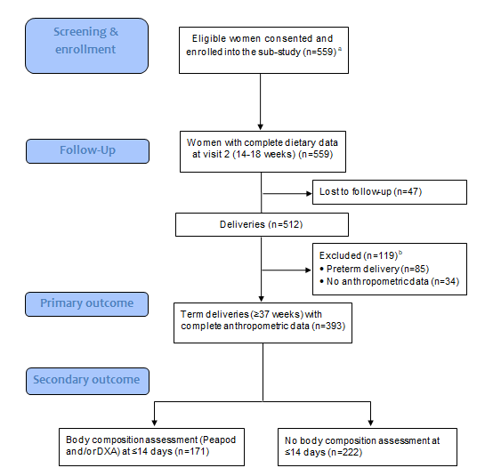
Supplementary figure 1: Flow chart of participants within the Soweto First 1000-Day Study (S 1000) sub-study ªOf eligible women approached at the Fetal Medicine Unit at Chris Hani Baragwanath Academic Hospital (CHBH), 85% consented to participate. Women who refused to participate were not different in age, BMI, or education, but participants were more likely to be married ^{b}Mother-neonate pairs excluded from the final analyses were not different in any baseline maternal characteristics: age, parity, HIV/treatment status, smoking, marital status, education, household SES, weight, height, BMI

Supplementary table 1: Factor loadings of various foods or food groups in the Traditional diet pattern after principal component analysis (n=393)
Traditional diet pattern
Food or food group | Factor loading
Other vegetables | 0.366
Beans and pulses | 0.319
Green vegetables | 0.299
Salad vegetables | 0.292
Boiled and baked potatoes | 0.230
Maize, sorghum and oat porridge | 0.220
Vegetable dishes | 0.220
Root vegetables | 0.218
Offal and traditional meats | 0.204
Chicken and turkey | 0.196
Other fruit | 0.175
Crackers | 0.167
Citrus fruit | 0.165
Crisps and popcorn | 0.162
Diet soft drinks | 0.162
Rice and pasta | 0.141
Eggs and egg dishes | 0.114
Tinned vegetables | 0.112
Fish and seafood | 0.095
Puddings | 0.083
Red meat | 0.075
Miscellaneous (soup powder,  condiments, sauces, etc.) | 0.073
Brown and wholemeal bread | 0.072
Cakes and biscuits | 0.063
Yoghurt, buttermilk and maas | 0.063
Cream | 0.061
Nuts and nut spreads | 0.044
Soft drinks | 0.044
Cooking fats and salad oils | 0.043
Reduced-fat milk | 0.041
Cooked and tinned fruit | 0.029
Full-fat milk | 0.012
Processed meat | 0.009
Sweets and chocolate | 0.009
Added sugar (teaspoons) | 0.007
Decaffeinated tea and coffee | 0.006
Dried fruit | -0.003
Fruit juice | -0.020
Tea and coffee | -0.024
Fat cakes and samosas | -0.045
Reduced-fat spread | -0.045
Roast potatoes and chips | -0.052
Full-fat spread | -0.056
Quiche and pizza | -0.056
Sweet spreads | -0.091
Breakfast cereals | -0.093
Cheese and cottage cheese | -0.103
White bread | -0.188
Explained variance (%) | 6.8
Foods or food groups with factor loadings ≥0.2 were classified as characteristic to the dietary pattern and therefore used to describe it (illustrated in bold)
Supplementary table 2: Neonatal anthropometry and body composition according to maternal and neonatal characteristics in urban black South Africans
 | Total sample (n=393) | Weight to length ratio (kg/m) | Sub-sample (n=171) | Fat mass index (kg/m³)^{b}
 | % | Median (IQR) | % | Median (IQR)
Maternal variables
Demographic and health characteristics
Maternal age, y
<25 | 91 | 6.4 (5.8-6.8) | 34 | 3.6 (2.9-4.4)
25-29 | 105 | 6.3 (5.9-6.7) | 42 | 3.8 (3.0-4.2)
30-34 | 97 | 6.5 (6.0-6.9) | 46 | 3.9 (2.9-4.8)
35-39 | 79 | 6.2 (5.6-6.7) | 39 | 3.6 (2.8-4.6)
≥40 | 21 | 6.4 (6.1-6.7) | 10 | 3.2 (2.1-4.6)
P-valueª |  | 0.052 |  | 0.520
Parity
Para 0 | 97 | 6.1 (5.6-6.6) | 44 | 3.1 (2.6-3.7)
Para 1 | 177 | 6.4 (6.0-6.8) | 71 | 3.9 (3.2-4.7)
Para ≥2 | 119 | 6.4 (6.0-6.8) | 56 | 3.9 (2.9-4.8)
P-valueª |  | 0.010 |  | 0.004
HIV status
HIV-negative | 258 | 6.4 (6.0-6.8) | 114 | 3.6 (2.9-4.2)
HIV-positive (antenatal ART) | 92 | 6.4 (5.8-6.8) | 42 | 3.9 (2.9-4.8)
HIV-positive (pre-pregnancy ART) | 43 | 6.3 (5.8-6.7) | 15 | 4.0 (3.5-5.5)
P-valueª |  | 0.826 |  | 0.066
Smokes/chews tobacco
No | 341 | 6.4 (5.9-6.8) | 148 | 3.6 (3.0-4.6)
Yes | 52 | 6.2 (5.9-6.6) | 23 | 3.4 (2.4-4.7)
P-valueª |  | 0.450 |  | 0.489
Socio-economic characteristics
Maternal education
Primary | 7 | 6.4 (5.6-6.5) | 4 | 4.1 (3.6-4.7)
Secondary | 277 | 6.4 (5.9-6.8) | 118 | 3.6 (2.9-4.6)
Tertiary | 109 | 6.3 (6.0-6.8) | 49 | 3.6 (2.9-4.6)
P-valueª |  | 0.496 |  | 0.655
Marital status [n=387]
Single | 236 | 6.4 (5.8-6.8) | 103 | 3.6 (2.9-4.7)
Married/cohabiting | 151 | 6.4 (5.9-6.8) | 64 | 3.8 (3.0-4.6)
P-valueª |  | 0.613 |  | 0.594
Household socio-economic status
Low | 51 | 6.2 (6.0-6.5) | 23 | 3.7 (2.7-4.0)
Medium | 315 | 6.4 (5.9-6.8) | 135 | 3.6 (2.9-4.7)
High | 27 | 6.4 (5.7-6.8) | 13 | 3.1 (2.8-4.6)
P-valueª |  | 0.518 |  | 0.464
Anthropometry
BMI at recruitment, kg/m² (<14 weeks)
Normal weight (18.5-24.9) | 136 | 6.3 (5.8-6.6) | 55 | 3.6 (2.7-4.0)
Overweight (25-29.9) | 137 | 6.3 (5.8-6.8) | 62 | 3.9 (2.9-4.7)
Obese (≥30) | 120 | 6.5 (6.0-6.9) | 54 | 3.7 (3.2-4.6)
P-valueª |  | 0.028 |  | 0.488
GWG, kg/week
Inadequate | 79 | 6.3 (5.5-6.7) | 35 | 3.6 (2.5-4.6)
Adequate | 86 | 6.2 (5.7-6.6) | 39 | 3.6 (2.5-4.6)
Excessive | 228 | 6.4 (6.0-6.9) | 97 | 3.7 (2.9-4.7)
P-valueª |  | 0.007 |  | 0.593
Traditional dietary pattern adherence
Traditional
T1 (high) | 131 | 6.3 (5.9-6.8) | 71 | 3.8 (3.1-4.6)
T2 | 131 | 6.4 (6.0-6.8) | 55 | 3.7 (2.5-4.4)
T3 (low) | 131 | 6.3 (5.8-6.7) | 45 | 3.6 (2.8-4.6)
P-valueª |  | 0.368 |  | 0.441
Neonatal variables
Sex
Male | 204 | 6.4 (5.9-6.8) | 97 | 3.5 (2.5-4.4)
Female | 189 | 6.4 (5.9-6.7) | 74 | 3.7 (3.2-4.8)
P-valueª |  | 0.947 |  | 0.034
Gestational age at birth, w
37-38 | 144 | 6.2 (5.7-6.7) | 71 | 3.6 (2.9-4.6)
39-40 | 219 | 6.4 (6.0-6.8) | 87 | 3.7 (2.8-4.6)
41-42 | 30 | 6.5 (6.1-7.2) | 13 | 3.4 (3.0-3.7)
P-valueª |  | 0.003 |  | 0.744
Abbreviations: ART, antiretroviral treatment; BMI, body mass index; FMI, fat mass index; GWG, gestational weight gain; WLR, weight-to-length ratio IoM GWG ranges (kg/week): inadequate, normal weight <0.35, overweight <0.23, obese <0.17; adequate, normal weight 0.35-0.50, overweight 0.23-0.33, obese 0.17-0.27; excessive, normal weight >0.50, overweight >0.33, obese >0.27 ªKruskal-Wallis test; significant results are presented in bold (p<0.05) ^{b}Measured by air displacement plethysmography (ADP; Peapod) or dual-energy x-ray absorptiometry (DXA) corrected for the measurement differences between techniques

