SUPPLEMENTARY MATERIAL

**Database search strategy**

“Energy Drinks”[Mesh] OR “Carbonated Beverages”[Mesh] OR sweetened beverages OR fructose beverages OR sugary beverages OR caloric beverages OR soda OR pop OR soft drinks OR cola OR fruit drinks OR sports drinks OR fruitades OR vitamin water OR lemonade OR iced tea OR squash OR juice OR sweetened drinks OR energy drinks OR caloric drinks OR sugary drinks OR sweetened beverage OR fructose beverage OR sugary beverage OR caloric beverage OR sugary drink OR soft drink OR fruit drink OR sports drink OR energy drink OR caloric drink OR “Fructose OR Levulose OR Fleboplast Levulosa OR Levulosa, Fleboplast OR Levulosa Grifols OR Levulosado Vitulia OR Levulosa Braun OR Levulosado Braun OR Levulosa Ife OR Levulosado Bieffe Medit OR Apir Levulosa OR Levulosa, Apir OR Levulosa Mein OR Plast Apyr AND "Cholesterol, HDL"[Mesh] OR alpha-Lipoprotein Cholesterol OR Cholesterol, alpha-Lipoprotein OR“alpha Lipoprotein Cholesterol OR HDL Cholesterol OR High Density Lipoprotein Cholesterol OR Cholesterol, HDL2 OR HDL2 Cholesterol OR HDL(2) Cholesterol OR Cholesterol, HDL3 OR HDL3 Cholesterol OR HDL(3) Cholesterol OR “Triglycerides"[Mesh]” OR Triacylglycerol OR Triacylglycerols OR "Hyperlipidemias"[Mesh] OR Hyperlipemia OR Hyperlipemias OR Hyperlipidemia OR Lipidemia OR Lipidemias OR Lipemia OR Lipemias OR lipaemia OR lipaemias OR "Cholesterol, VLDL"[Mesh] OR VLDL Cholesterol OR Pre-beta-Lipoprotein Cholesterol OR Cholesterol, Pre-beta-Lipoprotein OR Pre beta Lipoprotein Cholesterol OR Very Low Density Lipoprotein Cholesterol OR Prebetalipoprotein Cholesterol OR Cholesterol, Prebetalipoprotein OR "Lipoproteins, VLDL"[Mesh] OR VLDL Lipoproteins OR Prebeta-Lipoproteins OR Prebeta Lipoproteins OR Very-Low-Density Lipoproteins OR Lipoproteins, Very-Low-Density OR Very Low Density Lipoproteins OR Pre-beta-Lipoproteins OR Pre beta Lipoproteins OR Lipoproteins, VLDL2 OR VLDL2 Lipoproteins OR Lipoprotein VLDL II OR Lipoproteins, VLDL1 OR VLDL1 Lipoproteins OR Lipoproteins, VLDL I OR Lipoproteins, VLDL3 OR VLDL3 Lipoproteins OR Lipoproteins, VLDL III OR "Cholesterol, LDL"[Mesh] OR Low Density Lipoprotein Cholesterol OR beta-Lipoprotein Cholesterol OR Cholesterol, beta-Lipoprotein OR beta Lipoprotein Cholesterol OR LDL Cholesterol OR Cholesteryl Linoleate, LDL OR LDL Cholesteryl Linoleate OR "Apolipoproteins"[Mesh] OR apoliproteins AND “Epidemiology”[MESH] OR “Epidemiologic Studies”[MESH] OR “Intervention Studies” [MESH] OR “cohort” OR “cohorts” OR “incident” OR “incidence” OR “prospective” OR “follow-up” OR “predict” OR “predicted” OR “prediction” OR “prognosis” OR “case-control” OR “case-cohort” OR “cross-sectional” OR “observational” OR “observe” OR “observed” OR “association” OR “associations” OR “associated” OR “intervention” OR “interventions” OR “clinical trial” OR “clinical trials” OR “randomized” OR “randomised” OR “randomly” OR “random” OR (overview[TI] OR review[TI] OR synthesis[TI] OR summary[TI] OR cochrane[TI] OR analysis[TI]) AND (reviews[TI] OR meta-analyses[TI] OR articles[TI] OR umbrella[TI])) OR "umbrella review"[TIAB] OR (meta-review[TIAB] OR metareview[TIAB]) OR ((overview*[TI] OR reviews[TI]) AND (systematic[TI] OR cochrane[TI])) OR (reviews[TIAB] AND (meta[TIAB] OR published[TIAB] OR quality[TIAB] OR included[TIAB] OR summar*[TIAB])) OR ("cochrane reviews"[TIAB]) OR (evidence[TI] AND (reviews[TI] OR meta-analyses[TI]))



**Fig. S1**. Funnel plot of the effect of fructose or other carbohydrate consumption on postprandial triglycerides. The solid line represents the pooled effect estimate expressed as the mean difference (MD) for each analysis. Dashed lines present pseudo-95% confidence intervals and the circles represent effect estimates for each included study

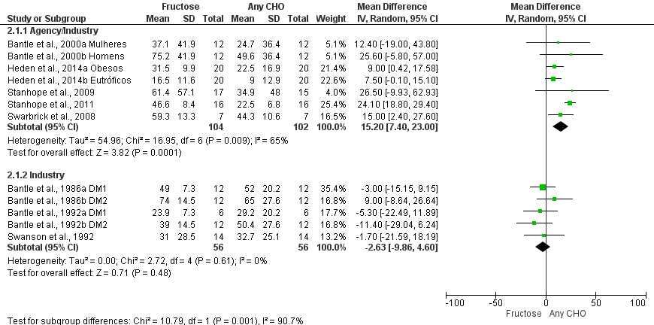

**Fig. S2**. Forest plot of the effect of fructose or other carbohydrate consumption on postprandial triglycerides according to financing. The estimation for each group (subtotal) is detailed. The data are in mean difference and CI 95% (mg/dL) of the delta between fasting and 4h-peak TG. Significance values for the random effect model. CHO: carbohydrate.

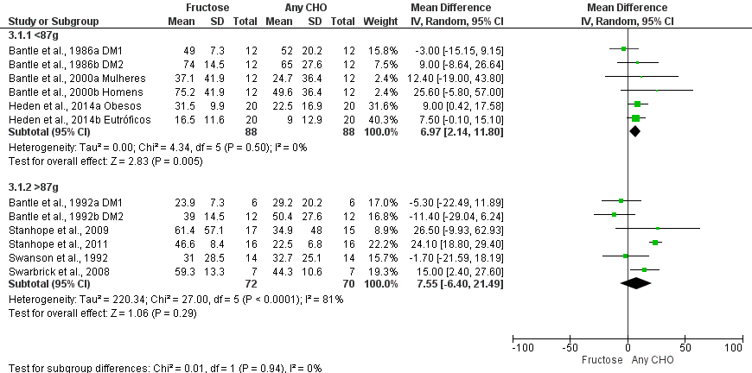

**Fig. S3**: *Forest plot* of the effect of fructose or other carbohydrate consumption on postprandial triglycerides according with the amount of carbohydrate offered. The estimation for each group (subtotal) is detailed. The data are in mean difference and CI 95% (mg/dL) of the delta between fasting and 4 h-peak. Significance values for the random effect model. CHO: carbohydrate. <87 g: less than 87 g of fructose or comparison component. >87 g: more than 87 g of fructose or comparison component.

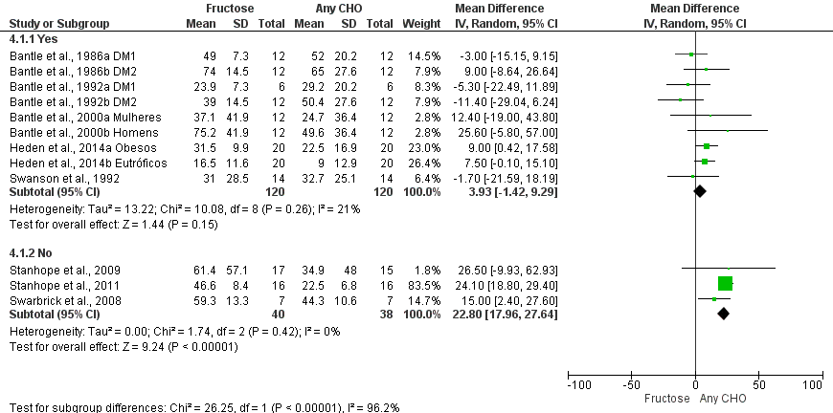

**Fig. S4**: Forest plot of the effect of fructose or other carbohydrate consumption on postprandial triglycerides according with study randomization. The estimation for each group (subtotal) is detailed. The data are in mean difference and CI 95% (mg/dL) of the delta between fasting and 4 h-peak. Significance values for the random effect model. CHO: carbohydrate.

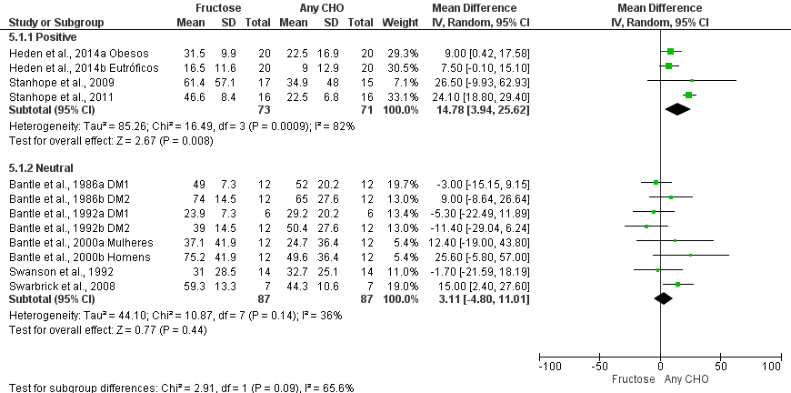

**Fig. S5**: Forest plot of the effect of fructose or other carbohydrate consumption on postprandial triglycerides according with the energetic balance evaluated. The estimation for each group (subtotal) is detailed. The data are in mean difference and CI 95% (mg/dL) of the delta between fasting and 4 h-peak. Significance values for the random effect model. CHO: carbohydrate.

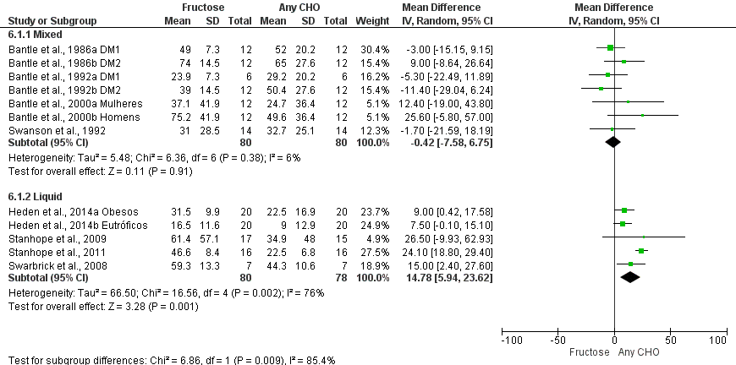

**Fig. S6**: Forest plot of the effect of fructose or other carbohydrate consumption on postprandial triglycerides according with the form of carbohydrate offered. The estimation for each group (subtotal) is detailed. The data are in mean difference and CI 95% (mg/dL) of the delta between fasting and 4 h-peak. Significance values for the random effect model. CHO: carbohydrate.

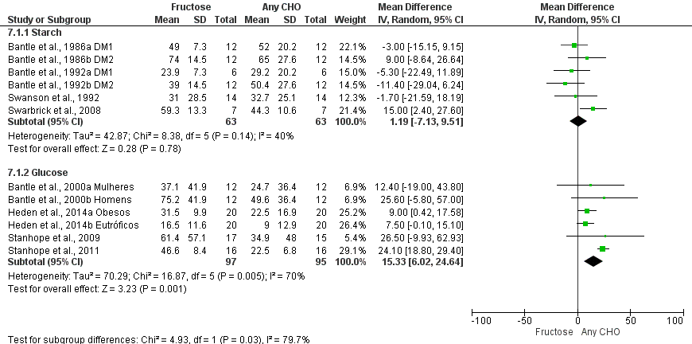

**Fig. S7**: Forest plot of the effect of fructose or other carbohydrate consumption on postprandial triglycerides according with comparison component. The estimation for each group (subtotal) is detailed. The data are in mean difference and CI 95% (mg/dL) of the delta between fasting and 4 h-peak. Significance values for the random effect model. CHO: carbohydrate.

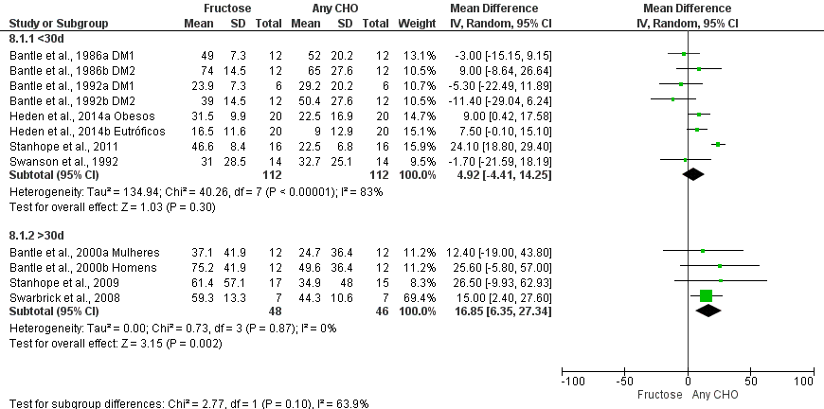

**Fig. S8**: Forest plot of the effect of fructose or other carbohydrate consumption on postprandial triglycerides according with time of intervention (follow up). The estimation for each group (subtotal) is detailed. The data are in mean difference and CI 95% (mg/dL) of the delta between fasting and 4 h-peak. Significance values for the random effect model. CHO: carbohydrate. <30d: less than 30 days; >30d: more than 30 days

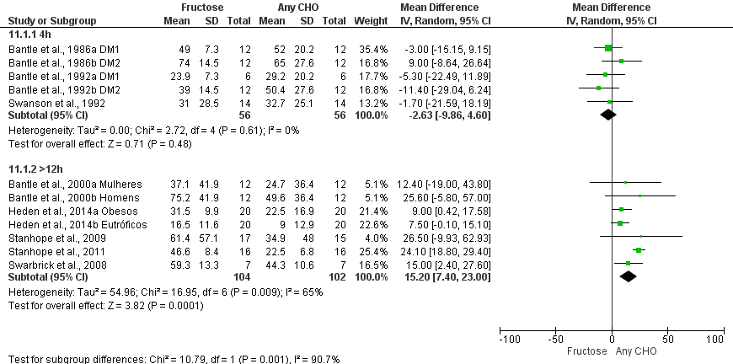

**Fig. S9**: Forest plot of the effect of fructose or other carbohydrate consumption on postprandial triglycerides according with length of analysis. The estimation for each group (subtotal) is detailed. The data are in mean difference and CI 95% (mg/dL) of the delta between fasting and 4 h-peak. Significance values for the random effect model. CHO: carbohydrate. 4h: interventions until 4h of analysis; >12h: interventions with more than 12h of analysis