Supplementary data – Validation of the specificity of primary antibodies used for western blotting in the study
To validate the specificity of the antibodies used in the western blotting study, both negative controls excluding primary antibody incubation and positive controls with known expressed tissue type were conducted.
For minus primary negative control, two 10% mini-Protean TGX gels (Biorad, USA) were prepared. For each gel, 10 µg of the Precision Plus protein dual color standard (Biorad, USA) and 20µg of each of the three human fungiform papillae protein samples were loaded. After being separated and transferred onto the PVDF membranes, both of the blots were blocked with 5% non-fat milk in Tris Buffered Saline containing 0.1% Tween-20 (TBST) for 1h at room temperature. One blot was incubated in goat anti-mouse IgG-HRP (Biorad, secondary antibody used for anti-CD36 primary antibody) and the other with goat anti-rabbit IgG-HRP (Biorad, secondary antibody used for the other fat taste receptor and ion channel antibodies) for 1h at room temperature. After being rinsed in TBST for 5 times (5min each), the blots were visualised with the ECL system (Biorad, USA). The results were shown in Supplementary Figure 1A and B. Both of the blots did not show any bands for any of the sample lanes.
The types of positive tissue used for validation were summaries in Table 1. The mouse tissues were collected from three wild-type mice. Proteins were extracted from the mouse heart, intestine, spleen samples with PARIS kit (ThermoFisher, USA). The positive control samples were gone through the western blotting analysis following the procedure described in the Materials and Methods section. Representative results were shown in Figure 1C. In the blot, clear bands were detected for CD36 (78kDa-88kDa), FFAR4 (37kDa-50kDa), FFAR2 (40kDa-50kDa), GPR84 (40kDa-50kDa) and KCNA2 (50kDa-70kDa) in specific tissues, which indicated the functionality of the primary antibodies used in Table 1.
Table 1. Positive control tissues selected for validating the primary antibodies.
Antibody | Catalogue number | Dilution | Positive tissue | Reference
anti-CD36 | sc7309 | 1:500 | mouse heart | [1]
anti-FFAR4 | ab118757 | 1:1000 | mouse intestine | [2]
anti-FFAR2 | SAB4501283 | 1:500 | mouse intestine | [3]
amti-GPR84 | sc99106 | 1:1000 | mouse spleen | [4]
anti-KCNA2 | ab65789 | 1:1000 | mouse heart | GEO* dataset (GSE23028)
*GEO represents the gene expression omnibus dataset of the National Centre for Biotechnology Information (NCBI). The number in the bracket refers to the reference series.
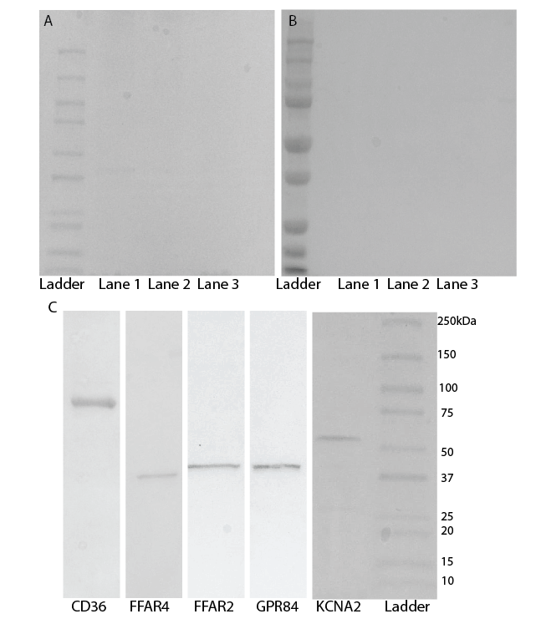
Figure 1. Validation of the antibodies used for western blotting analysis. A and B represent the minus primary antibody negative control stained with goat anti-mouse IgG-HRP and goat anti-rabbit IgG-HRP respectively. The samples loaded in lane 1, 2 and 3 were human fungiform papillae protein samples. C shows the positive controls stained with the primary antibodies. The ladders used were the Precision Plus protein dual color standard (Biorad, USA).

References
- Abumrad, N. A., & Goldberg, I. J. (2016). CD36 actions in the heart: lipids, calcium, inflammation, repair and more?. Biochimica et Biophysica Acta (BBA)-Molecular and Cell Biology of Lipids, 1861(10), 1442-1449.
- Tanaka, T., Katsuma, S., Adachi, T., Koshimizu, T. A., Hirasawa, A., & Tsujimoto, G. (2008). Free fatty acids induce cholecystokinin secretion through GPR120. Naunyn-Schmiedeberg's archives of pharmacology, 377(4-6), 523-527.
- Kim, M. H., Kang, S. G., Park, J. H., Yanagisawa, M., & Kim, C. H. (2013). Short-chain fatty acids activate GPR41 and GPR43 on intestinal epithelial cells to promote inflammatory responses in mice. Gastroenterology, 145(2), 396-406.
- Wang, J., Wu, X., Simonavicius, N., Tian, H., & Ling, L. (2006). Medium-chain fatty acids as ligands for orphan G protein-coupled receptor GPR84. Journal of Biological Chemistry, 281(45), 34457-34464.

