**Online Supplementary Material**

1. **Additional methodological details:**

Assessment of covariables

Eight covariates were selected for their known association with maternal weight gain; maternal age, parity, pre-pregnant BMI, maternal educational level, pre-pregnant physical activity, maternal energy intake, off-spring birth weight and exclusive breastfeeding duration. From the MBRN we obtained information on parity and off-spring birth weight. Parity was assessed by the following question: “Mother’s previous pregnancies/births with responses, number of live births, stillborn (24 weeks or more), miscarriages/stillborn (12-23 weeks) and miscarriages (under 12 weeks). Childs birthweight and length were recorded in the notification for the MBRN.

The baseline MoBa questionnaire to mothers provided data on maternal age, maternal height, pre-pregnant weight, maternal education, pre-pregnant smoking and pre-pregnant physical activity. Maternal age was age at delivery given in years. Mother’s weights were assessed with the following question: What did you weigh at the time you became pregnant and what do you weigh now (in kilograms). Further maternal height weight was assessed: How tall are you? (In cm). The mother’s education was assessed with the following question: What education do you have. Seven alternatives were given: 9- year secondary school, 1-2 year high school, technical school, 3-year high school general studies, junior college, Regional technical college, 4-year university degree (Bachelor’s degree, nurse, teacher, engineer), University, technical college, more than 4 years (Master’s degree, medical doctor, PhD), other education. Participants were to tick off indicating the highest level of education they had completed and the current studies if they were still studying. Pre-pregnant smoking was assessed by: “Did you smoke during the last 3 months before you became pregnant this time?” with response alternatives: No, Sometimes, and then how many cigarettes per week, and Daily and how many cigarettes per day. Physical activity was assessed by one question: “How often do you usually exercise at the present time?” A list of 14 alternative activities (including other) were listed. These activities were: Walking, Brisk walking, Running/jogging/orienteering, Bicycling, Training studio/weight training, Special gymnastics/aerobics for pregnant women, Aerobics/gymnastics/dance without running and jumping, Aerobics/gymnastics with running and jumping, Dancing (swing/rock/folk), Skiing, Ball sports, Swimming, Riding and Other. Response alternatives were: never, 1-3 times a month, Once a week, Twice a week, 3 times or more a week. All activities were summed and the variable were recoded into the following categories; regular (3 times per week or more), irregular (1-2 times per week), light (1-3 times per month), none (never).

Energy intake was extracted from calculations based on the MoBa FFQ answered around week 22 of pregnancy. This questionnaire comprises of 255 food items, covering diet during the first half of pregnancy. The frequency of consumption was given per day, per week and/or per month, depending on the food item. Predefined portion sizes were only applied to bread and drinks. FoodCalc and the Norwegian Food Composition Table were used to calculate food and nutrient intakes. The MoBa follow-up questionnaires at 6 and 18 months post-delivery provided data on exclusive breastfeeding duration. The questionnaire at 6 months includes questions: What did you give your child to drink during the first week of life, with response alternatives, breast milk, water, sugar water, formula, other (specify), don’t know/don’t remember. In addition, a question on: “What has your child been given to drink during the first 6 months of his/her life? The participants were to tick off for each month the child had been given the relevant drink (breast milk, standard Collett formula, Collett formula with Omega 3, Standard NAN formula, Nan HA1 formula, other milk (specify), water, squash/juice. To calculate exclusive breastfeeding variables on solid food was also included. The question was posed: how old was your child when you started giving him/her this food for the first time? Then the participants are to enter the age in months. This is entered for 16 foods and one open space to enter other foods. Exclusive breastfeeding was then defined as being breastfed and not given any other drink of solid food in the time one is exclusively breast fed. In the questionnaire from 18 months, participants are asked: What type of milk has your baby been given since he/she was 6 months old? Participants may enter more than one cross for each milk type responding to whether the child has been given eg. breast milk age 6-8 moths, 9-11 months, 12-14 months and 15-18 months. This is used to calculate breast feeding duration in months.

Parity was presented as five categories for description, but collapsed to nulliparous versus parous in the analyses. Marital status was dichotomized as cohabiting with partner versus not cohabiting with partner. Maternal education was divided into three categories; <13 years, 13-16 years, and ≥17 years. Pre-pregnant smoking was categorized as “never”, “occasional”, “daily” for description, but collapsed into two categories in the analyses: pre-pregnant smoking versus pre-pregnant non-smoking for the analytic purposes. Pre-pregnant physical activity was categorized as “never”, “less than once weekly”, “1-2 times weekly” and “≥ 3 times weekly”, but dichotomized to “ < once weekly” versus “ ≥ once weekly” for the analysis. Maternal energy intake is presented as mean (SD) for description, but was divided into quintiles for the analyses. Off spring birth weight was treated as a continuous variable. Duration of exclusive breastfeeding was categorized as; “not initiated or not fully breastfed at 1 month”, “one month”, “two months”, “three months”, “four months”, “five months” and “six months”. Gestational weight gain was computed from pre-pregnancy BMI and weight at delivery and coded according to Institute of Medicine’s (2009) recommendations regarding optimal gestational weight gain.

1. **Additional information/ results supporting the main text**



Figure S1. Spaghetti plot of postpartum individual BMI trajectories in 50 randomly selected women.

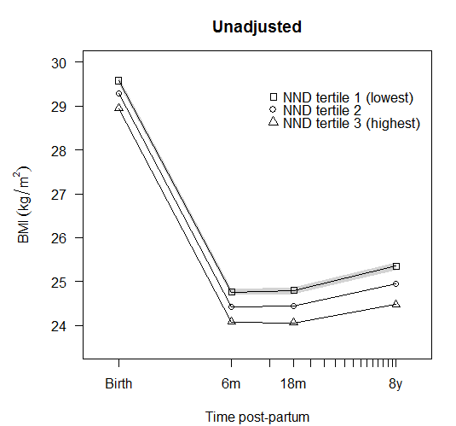 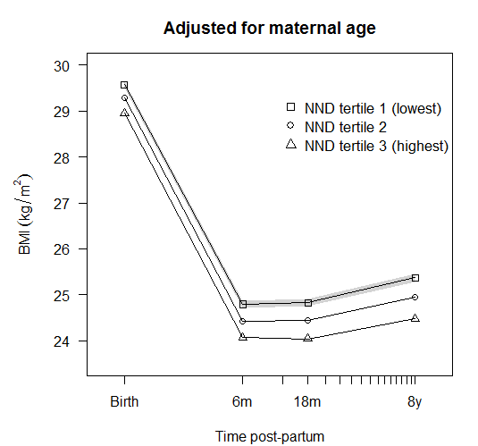 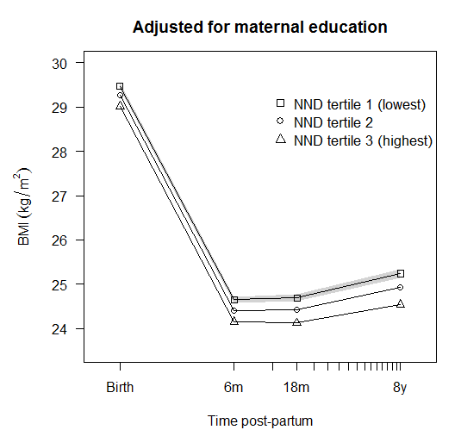

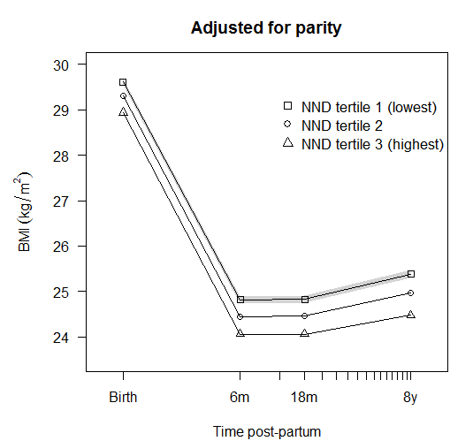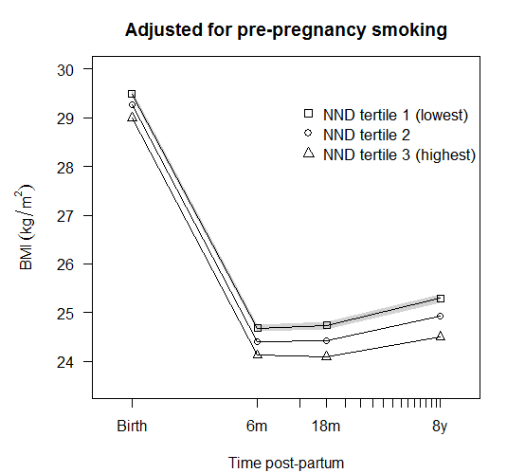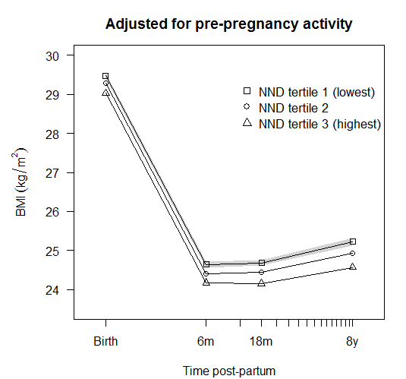

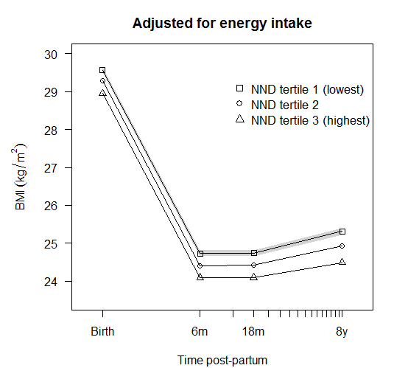 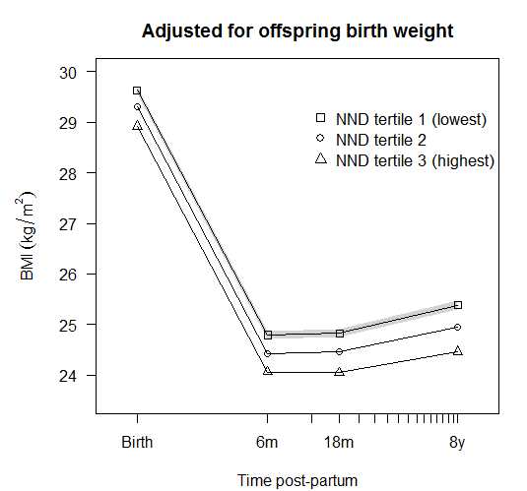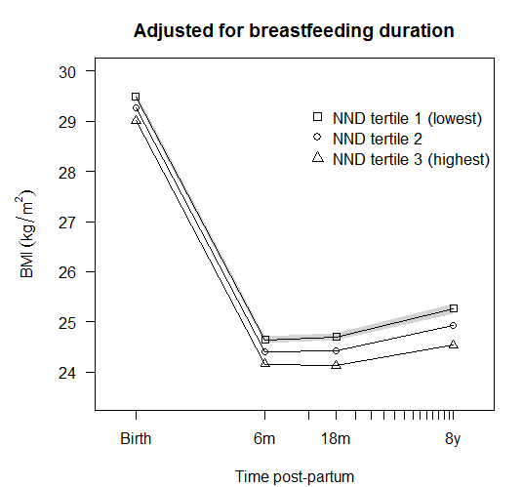

Figure S2 Plots of predicted mean post-partum BMI trajectory for each category of NND adherence in the crude model and then adjusting for each confounder or mediator in turn.

1. **Sensitivity and secondary analyses**

3.1 Using different knot points

Table S1. Associations between NND and post-partum BMI with spline knots at 6months and 3y (N=55056)

|  |  |  |  |  |  |  |  |
| --- | --- | --- | --- | --- | --- | --- | --- |
|  |  | Crude |  | Model (a) |  | Model (b) |  |
| Maternal BMI |  | β (95% CI) | p | β (95% CI) | p | β (95% CI) | p |
| At birth (kg.m2) | NND lowest tertile | Ref |  | Ref |  | Ref |  |
|  | NND middle tertile | -0.29 (-0.38, -0.20) | <0.001 | -0.13 (-0.22, -0.04) | 0.003 | -0.10 (-0.18, -0.01) | 0.033 |
|  | NND highest tertile | -0.63 (-0.72, -0.54) | <0.001 | -0.32 (-0.41, -0.22) | <0.001 | -0.25 (-0.34, -0.16) | <0.001 |
| 0 to 6m (kg.m2 per year) | NND lowest tertile | Ref |  | Ref |  | Ref |  |
|  | NND middle tertile | -0.10 (-0.18, -0.02) | 0.020 | -0.10 (-0.18, -0.02) | 0.020 | -0.07 (-0.16, 0.01) | 0.089 |
|  | NND highest tertile | -0.10 (-0.18, -0.02) | 0.016 | -0.10 (-0.18, -0.01) | 0.029 | -0.04 (-0.13, 0.04) | 0.30 |
| 6 to 36m (kg.m2 per year) | NND lowest tertile | Ref |  | Ref |  | Ref |  |
|  | NND middle tertile | -0.01 (-0.06, 0.01) | 0.37 | -0.00 (-0.02, 0.02) | 0.8 | -0.01 (-0.03, 0.01) | 0.40 |
|  | NND highest tertile | -0.04 (-0.06, -0.02) | <0.001 | -0.03 (-0.05, -0.00) | 0.022 | -0.04 (-0.06, -0.01) | 0.001 |
| 36 to 96m (kg.m2 per year) | NND lowest tertile | Ref |  | Ref |  | Ref |  |
|  | NND middle tertile | -0.01 (-0.03, 0.01) | 0.38 | -0.01 (-0.03, 0.02) | 0.35 | -0.01 (-0.03, 0.01) | 0.35 |
|  | NND highest tertile | -0.01 (-0.03, 0.01) | 0.16 | -0.02 (-0.04, 0.00) | 0.076 | -0.02 (-0.04, 0.00) | 0.082 |

Model a: adjusted for maternal age, parity, education, pre-pregnant smoking, physical activity, energy intake and offspring birthweight

Model b: model a + exclusive breast feeding duration.

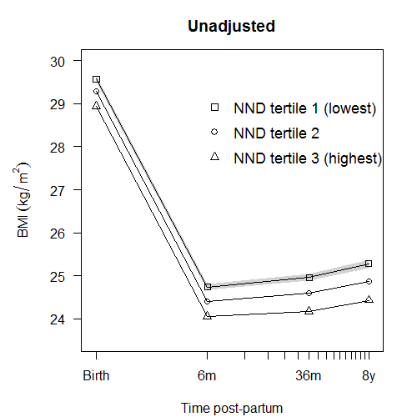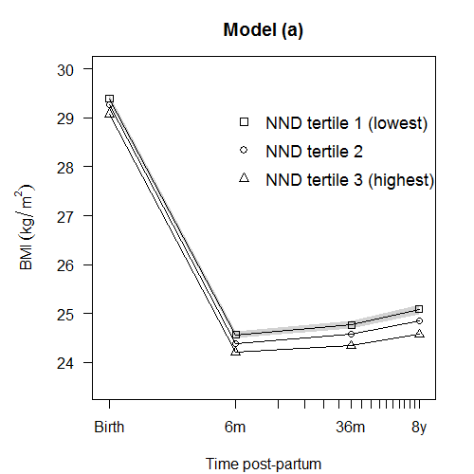 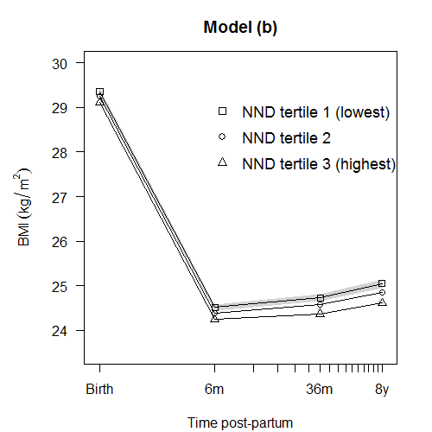

Figure S3. Plots of predicted mean trajectory for each category of NND adherence in the unadjusted model and models (a)* and (b)*, with knots at 6months & 3y.

*Model a: adjusted for pre-pregnant BMI, off spring birth weight, maternal age, parity, education, pre-pregnant smoking, physical activity, and energy intake

Model b: model a + exclusive breastfeeding duration.

* 1. Excluding preterm births

Table S2. Associations between NND and post-partum BMI with spline knots at 6months and 3y after excluding preterm births (N=52427)

|  |  |  |  |  |  |  |  |
| --- | --- | --- | --- | --- | --- | --- | --- |
|  |  | Crude |  | Model (a) |  | Model (b) |  |
| Maternal BMI |  | β (95% CI) | p | β (95% CI) | p | β (95% CI) | p |
| At birth (kg.m2) | NND lowest tertile | Ref |  | Ref |  | Ref |  |
|  | NND middle tertile | -0.28 (-0.38, -0.19) | <0.001 | -0.13 (-0.22, -0.04) | 0.004 | -0.10 (-0.19, -0.01) | 0.034 |
|  | NND highest tertile | -0.64 (-0.72, -0.54) | <0.001 | -0.33 (-0.42, -0.23) | <0.001 | -0.25 (-0.35, -0.16) | <0.001 |
| 0 to 6m (kg.m2 per year) | NND lowest tertile | Ref |  | Ref |  | Ref |  |
|  | NND middle tertile | -0.11 (-0.19, -0.02) | 0.014 | -0.11 (-0.19, -0.02) | 0.014 | -0.08 (-0.17, 0.01) | 0.070 |
|  | NND highest tertile | -0.08 (-0.17, 0.00) | 0.051 | -0.10 (-0.19, 0.13) | 0.024 | -0.04 (-0.13, 0.04) | 0.32 |
| 6 to 18m (kg.m2 per year) | NND lowest tertile | Ref |  | Ref |  | Ref |  |
|  | NND middle tertile | -0.02 (-0.06, 0.02) | 0.35 | -0.01 (-0.05, 0.03) | 0.7 | -0.02 (-0.07, 0.02) | 0.34 |
|  | NND highest tertile | -0.06 (-0.10, -0.01) | 0.01 | -0.02 (-0.07, 0.02) | 0.30 | -0.05 (-0.09, -0.00) | 0.048 |
| 36 to 96m (kg.m2 per year) | NND lowest tertile | Ref |  | Ref |  | Ref |  |
|  | NND middle tertile | -0.01 (-0.02, 0.06) | 0.29 | -0.01 (-0.02, -0.01) | 0.39 | -0.01 (-0.02, 0.01) | 0.33 |
|  | NND highest tertile | -0.02 (-0.04, -0.01) | 0.002 | -0.02 (-0.04, -0.01) | 0.006 | -0.02 (-0.04, -0.01) | 0.003 |

Model a: adjusted for maternal age, parity, education, pre-pregnant smoking, physical activity, energy intake and offspring birthweight

Model b: model a + exclusive breastfeeding duration.

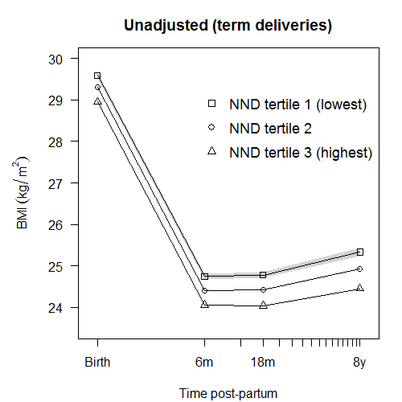 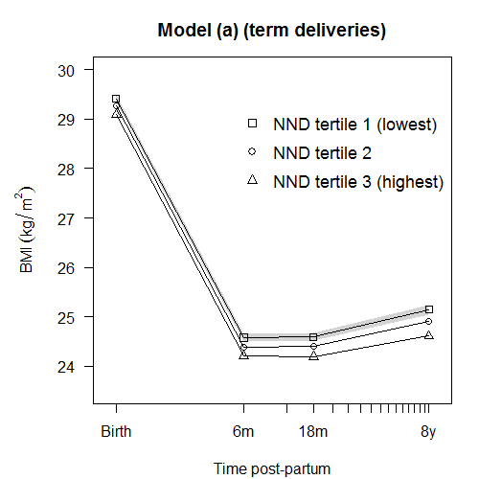 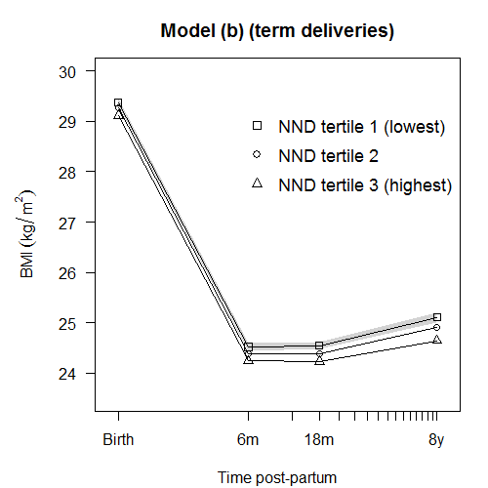

Figure S4. Plots of predicted mean trajectory for each category of NND adherence after excluding preterm births (N=52427) in the unadjusted model and models (a)* and (b)*, with knots at 6months & 3y.

*Model a: adjusted for maternal age, parity, education, pre-pregnant smoking, physical activity, energy intake and offspring birthweight

Model b: model a + exclusive breast feeding duration.

3.3 Association of NND with postpartum trajectories of overweight

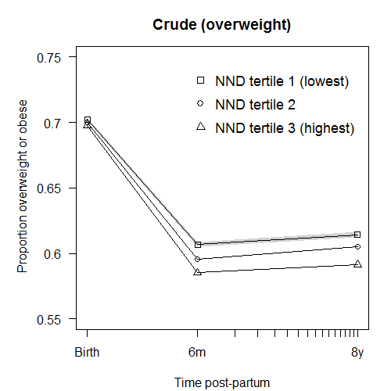 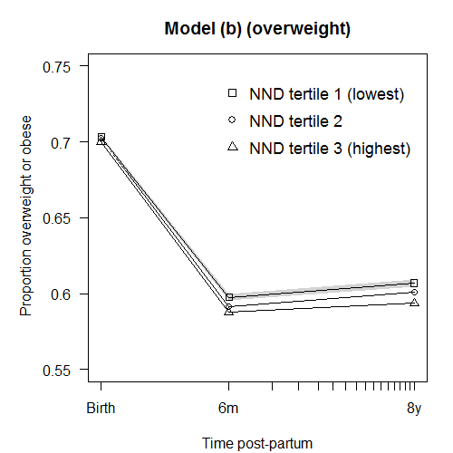 

Figure S5. Plots of predicted marginal proportion of mothers overweight or obese (>25 kg.m2) for each category of NND adherence (N=55056) in the unadjusted (crude) model and models (a)* and (b)* with a single knot at 6 months†.

*Model a: adjusted for maternal age, parity, education, pre-pregnant smoking, physical activity, energy intake and offspring birthweight

Model b: model a + exclusive breast feeding duration.

†Models with knots at 6 months and 18 months did not converge and so were simplified to a single knot. Note also that the marginal estimates were only estimated at the knot points and so the linear connecting lines are a simplification.

**4 Results including adjustment for pre-pregnancy BMI & gestational weight gain.**

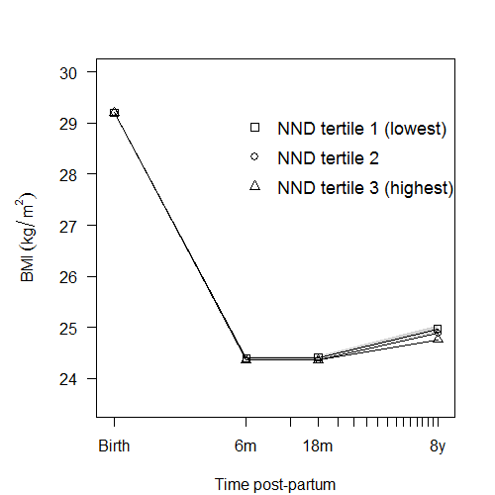

Figure S6: Predicted marginal mean BMI trajectory for each category of NND adherence score in model (a) (confounder adjusted)* with additional adjustment for pre-pregnancy BMI. For clarity, only the 95% CI for NND tertile 1 (lowest) is shown (grey).

*Adjusted for pre-pregnancy maternal BMI, maternal age, parity, education, pre-pregnant smoking, physical activity, energy intake and offspring birthweight

Table S3. Associations between NND and post-partum BMI including adjustment for maternal pre-pregnancy BMI*

|  |  |  |  |
| --- | --- | --- | --- |
|  |  |  |  |
| Maternal BMI |  | β (95% CI) | p |
| At birth (kg.m2) | NND lowest tertile | Ref |  |
|  | NND middle tertile | -0.00 (-0.04, -0.04) | 0.96 |
|  | NND highest tertile | -0.00 (-0.04, -0.04) | 0.98 |
| 0 to 6m (kg.m2 per year) | NND lowest tertile | Ref |  |
|  | NND middle tertile | -0.08 (-0.16, -0.00) | 0.037 |
|  | NND highest tertile | -0.07 (-0.15, 0.01) | 0.087 |
| 6 to 18m (kg.m2 per year) | NND lowest tertile | Ref |  |
|  | NND middle tertile | 0.00 (-0.04, 0.05) | 0.95 |
|  | NND highest tertile | -0.02 (-0.06, 0.03) | 0.48 |
| 18 to 96m (kg.m2 per year) | NND lowest tertile | Ref |  |
|  | NND middle tertile | -0.01 (-0.02, 0.01) | 0.32 |
|  | NND highest tertile | -0.02 (-0.04, -0.01) | 0.001 |

*Model contains knots at 6 and 18m & used complete cases (N=55056) similar to the main analysis

Adjusted for maternal age, parity, education, pre-pregnant smoking, physical activity, energy intake and offspring birthweight

Table S4. Associations between maternal pre-pregnancy BMI and NND score.

|  |  |  |  |  |  |
| --- | --- | --- | --- | --- | --- |
|  |  |  | NND group |  |  |
|  |  | Tertile 1 (lowest) | Tertile 2 (middle) | Tertile 3 (highest) | p-value |
| BMI before pregnancy | kg/m2 | 23.9 | 23.6 | 23.3 | <0.001 |

**5 Results including adjustment for gestational weight gain, and for gestational weight gain and pre-pregnancy BMI combined.**

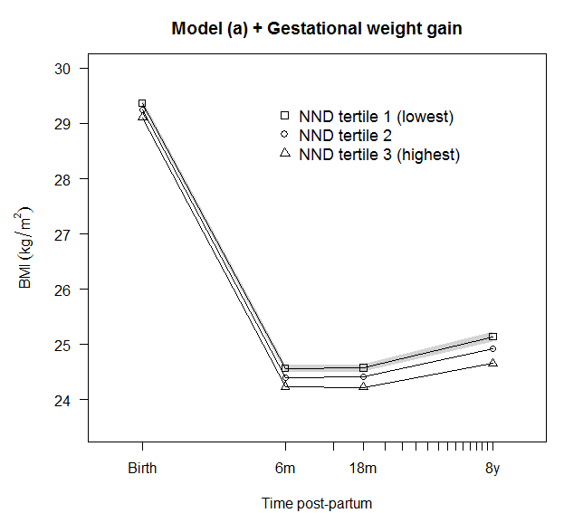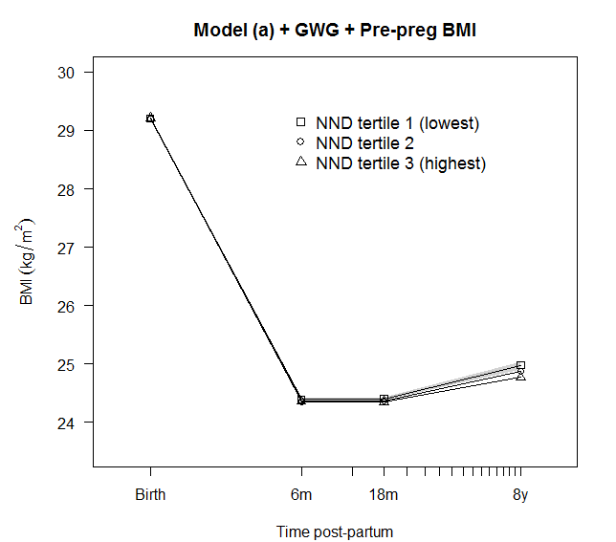

Figure S7: Predicted marginal mean BMI trajectory for each category of NND adherence score in model (a) (confounder adjusted)* with additional adjustment for gestational weight gain (GWG)† (left plot), and model (a)* with additional adjustment for GWG and pre-pregnancy BMI† (right plot). For clarity, only the 95% CI for NND tertile 1 (lowest) is shown (grey).

*Model (a): adjusted for maternal age, parity, education, pre-pregnant smoking, physical activity, energy intake and offspring birthweight

†Gestational weight gain was defined according to BMI specific 2009 IOM (Institute of Medicine 2009) recommendations indicating optimal gestational weight gain according to prepregnancy BMI

Table S5. Associations between NND and post-partum BMI including adjustment for (i) confounders (model a in main text)* and gestational weight gain (GWG)†, and (ii) confounders (model a in main text) and gestational weight gain and pre-pregnancy BMI.

|  |  |  |  |  |  |  |
| --- | --- | --- | --- | --- | --- | --- |
|  |  |  |  |  |  |  |
|  |  | Model (a) + GWG |  | Model (a) + GWG + Pre-pregnancy BMI | |
| Maternal BMI |  | β (95% CI) | p | β (95% CI) | p |
| At birth (kg.m2) | NND lowest tertile | Ref |  | Ref |  |
|  | NND middle tertile | -0.12 (-0.20, -0.04) | 0.005 | -0.00 (-0.03, 0.03) | 0.9 |
|  | NND highest tertile | -0.26 (-0.34, -0.17) | <0.001 | -0.02 (-0.01, 0.04) | 0.30 |
| 0 to 6m (kg.m2 per year) | NND lowest tertile | Ref |  | Ref |  |
|  | NND middle tertile | -0.11 (-0.18, -0.03) | 0.005 | -0.09 (-0.16, -0.01) | 0.021 |
|  | NND highest tertile | -0.14 (-0.22,- 0.06) | <0.001 | -0.09 (-0.17, -0.02) | 0.018 |
| 6 to 18m (kg.m2 per year) | NND lowest tertile | Ref |  | Ref |  |
|  | NND middle tertile | 0.00 (-0.04, 0.04) | 0.99 | -0.00 (-0.04, 0.04) | 0.97 |
|  | NND highest tertile | -0.03 (-0.06, 0.02) | 0.22 | -0.02 (-0.06, 0.02) | 0.28 |
| 18 to 96m (kg.m2 per year) | NND lowest tertile | Ref |  | Ref |  |
|  | NND middle tertile | -0.01 (-0.02, 0.01) | 0.34 | -0.01 (-0.02, 0.01) | 0.30 |
|  | NND highest tertile | -0.02 (-0.03, -0.01) | 0.007 | -0.02 (-0.04, -0.01) | 0.002 |

*Model (a): adjusted for maternal age, parity, education, pre-pregnant smoking, physical activity, energy intake and offspring birthweight. Model contains knots at 6 and 18m & used complete cases (N=55056) similar to the main analysis

†Gestational weight gain was defined according to BMI specific 2009 IOM (Institute of Medicine (2009)) recommendations indicating optimal gestational weight gain according to prepregnancy BMI.

Table S6. Associations between maternal gestational weight gain and NND score.

|  |  |  |  |  |  |
| --- | --- | --- | --- | --- | --- |
|  |  |  | NND group |  |  |
|  |  | (lowest) | (middle) | (highest) | p-value* |
| Gestational weight gain | Optimal | 4582 (33.1%) | 6426 (34.3%) | 7303 (36.0%) |  |
|  | Excessive | 6569 (47.5%) | 8713 (46.5%) | 9137 (45.0%) | <0.001 |
|  | Inadequate | 2681 (19.4%) | 3603 (19.2%) | 3852 (19.0%) |  |

*Chi-squared test

Reference: IOM (Institute of Medicine) and, NRC (National Research Council) (2009) Weight gain during pregnancy: re-examining the guidelines. Washington, DC; The National Academies Press