Supplementary table 1: Consumption levels of Mediterranean diet components (servings/day) in the Fenland Study (n=12,417).
 | Mean(SD) intake in servings/day, mean intake in g/day
 | Total cohort | Men | Women | P-value¹
 | n=12,417 | n=5,735 | n=6,682
Dietary components²
Vegetables | 4.7 (2.4), 270 | 4.1 (2.0), 230 | 5.3 (2.6), 304 | <0.001
Legumes | 0.8 (0.5), 64 | 0.8 (0.5), 59 | 0.9 (0.6), 68 | <0.001
Fruits | 2.9 (2.3), 255 | 2.3 (2.0), 213 | 3.3 (2.4), 291 | <0.001
Nuts | 0.2 (0.4), 6.6 | 0.2 (0.4), 6.2 | 0.3 (0.4), 7.1 | 0.014
Cereals | 3.2 (1.5), 194 | 3.2 (1.6), 187 | 3.2 (1.5), 200 | 0.39
Dairy | 2.6 (1.1), 387 | 2.5 (1.1), 377 | 2.7 (1.1), 396 | <0.001
Fish | 0.4 (0.3), 46 | 0.4 (0.3), 41 | 0.4 (0.4), 50 | <0.001
Red meat | 0.5 (0.3), 45 | 0.5 (0.3), 47 | 0.4 (0.3), 44 | <0.001
White meat | 0.3 (0.2), 37 | 0.3 (0.2), 34 | 0.3 (0.2), 39 | <0.001
Processed meat | 0.6 (0.4), 34 | 0.6 (0.4), 38 | 0.5 (0.4), 30 | <0.001
Eggs | 0.3 (0.3), 19 | 0.3 (0.3), 18 | 0.3 (0.3), 20 | 0.002
Potatoes | 0.8 (0.4), 94 | 0.8 (0.4), 93 | 0.7 (0.4), 95 | 0.53
Alcohol | 0.9 (1.2), 9.5 | 1.1 (1.3), 12.2 | 0.7 (0.9), 7.1 | <0.001
Sweets | 3.0 (2.6), 201 | 3.1 (2.5), 189 | 2.9 (2.6), 211 | <0.001
Olive oil (g/day) | 5.0 (12.3) | 5.4 (13.6) | 4.6 (11.1) | <0.001
Total energy intake (kcal/day) | 1968.1 (689.2) | 2108.4 (730.0) | 1847.6 (627.8) | <0.001
¹ P-value for differences in intake between men and women.
² Intake of each dietary component adjusted to a 2000 kcal/day diet using the residual method. For alcohol, estimates in servings/day were based on alcoholic beverages, and estimates in g/day were based on total alcohol (ethanol).

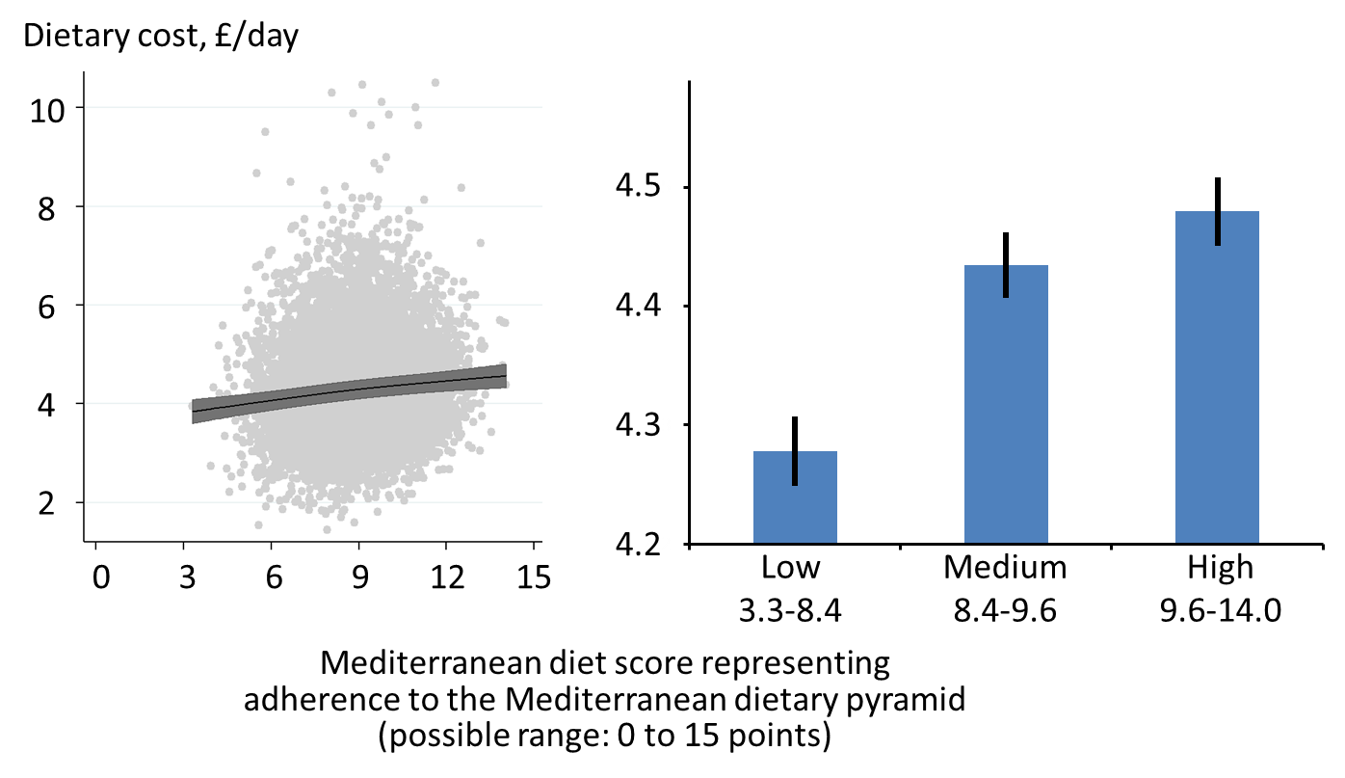

Supplementary figure 1. Associations of adherence to the Mediterranean diet with dietary cost in the Fenland Study (n=12,417). Both panels have a horizontal axis of the Mediterranean diet score (continuous scale on the left, categorical groups on the right); and a vertical axis of dietary cost in £/day. The left panel is the residual plot after regressing food cost onto model covariates in the most adjusted model (age, sex, test site, education level, occupation, household income, marital status, body-mass index, physical activity, and smoking status). From the model adjusting for the same covariates, the fitted regression line with 95% confidence intervals is drawn: regression coefficients per 4 points of the Mediterranean diet score were £0.26 (95% confidence interval: 0.21-0.31) per day, or equivalent to £1.87 (1.50-2.19) per week.

Supplementary table 2: Multivariable adjusted dietary cost (£/day) by adherence to the Mediterranean diet in the Fenland Study (n=12,417).¹
 | Dietary cost (£/day) by adherence to Mediterranean diet (point)² |  |  | p for trend
 | Low (3.3-8.4) | Medium (8.4-9.6) | High (9.6-14.0)
Total dietary cost | 4.26 (4.23, 4.29) | 4.42 (4.39, 4.45) | 4.47 (4.44, 4.49) | <0.001
Cost of adherence³ | 3.93 (3.90, 3.96) | 4.10 (4.07, 4.13) | 4.16 (4.13, 4.19) | <0.001
Cost of rest of diet³ | 0.34 (0.34, 0.35) | 0.34 (0.33, 0.34) | 0.32 (0.32, 0.33) | <0.001
Cost of dietary components
Vegetables | 0.56 (0.54, 0.58) | 0.70 (0.68, 0.73) | 0.84 (0.81, 0.87) | <0.001
Fruits | 0.33 (0.32, 0.35) | 0.48 (0.46, 0.50) | 0.59 (0.57, 0.62) | <0.001
Dairy | 0.38 (0.36, 0.40) | 0.39 (0.37, 0.41) | 0.39 (0.37, 0.41) | 0.394
Red meat | 0.80 (0.77, 0.83) | 0.61 (0.59, 0.63) | 0.37 (0.36, 0.39) | <0.001
Fish | 0.19 (0.18, 0.21) | 0.26 (0.25, 0.28) | 0.34 (0.32, 0.36) | <0.001
Alcohol | 0.35 (0.33, 0.37) | 0.34 (0.33, 0.36) | 0.32 (0.30, 0.34) | 0.016
Cereals | 0.21 (0.19, 0.22) | 0.23 (0.21, 0.24) | 0.24 (0.23, 0.26) | 0.003
White meat | 0.25 (0.24, 0.27) | 0.25 (0.24, 0.27) | 0.23 (0.22, 0.25) | 0.173
Sweets | 0.28 (0.26, 0.30) | 0.24 (0.23, 0.26) | 0.21 (0.20, 0.23) | <0.001
Processed meat | 0.23 (0.21, 0.24) | 0.19 (0.18, 0.20) | 0.14 (0.13, 0.15) | <0.001
Legumes | 0.10 (0.09, 0.11) | 0.12 (0.11, 0.13) | 0.14 (0.12, 0.15) | <0.001
Eggs | 0.07 (0.06, 0.08) | 0.08 (0.07, 0.09) | 0.09 (0.08, 0.10) | 0.001
Potatoes | 0.08 (0.08, 0.09) | 0.07 (0.06, 0.08) | 0.05 (0.05, 0.06) | <0.001
Nuts | 0.02 (0.01, 0.02) | 0.03 (0.02, 0.03) | 0.05 (0.04, 0.06) | <0.001
Olive oil | 0.01 (0.01, 0.01) | 0.02 (0.01, 0.02) | 0.02 (0.01, 0.02) | 0.005
¹ Daily dietary cost and dietary intake adjusted to a 2000 kcal/day diet using the residual method. All estimates adjusted for age, sex, test site, education level, occupation, household income, marital status, objectively measured physical activity (energy expenditure), smoking status and body-mass index. Results based on single imputed dataset, after confirming no difference in beta coefficients between single and multiple (10) imputations.
² The score (possible range from 0 to 15) represents dietary adherence to the Mediterranean dietary pyramid. The three categories were created by using tertiles. Dietary components were organised from highest to lowest cost based on high adherence.
³ Cost of adherence refers to total cost for all components included in the score of adherence to the Mediterranean diet (i.e. sum of dietary components listed); cost of rest of diet refers to any food items included in food frequency questionnaire, but not included in the adherence score.

Supplementary table 3: Contribution of socio-economic factors in explaining the association of adherence to the Mediterranean diet with dietary cost by strata of socio-economic variables in the Fenland Study (n=12,417).
 | % of adults | Difference in daily dietary cost (95% CI) (£/day)  by adherence to the Mediterranean dietary pyramid  (0-15 points)¹ |  | % attenuation  (95% CI)²
 |  | Reference model | Reference model plus socioeconomic variables
Test site³
Wisbech | 27.0 | 0.37 (0.29,0.46) | 0.32 (0.23,0.40) | 15.0 (7.89, 22.0)
Ely | 36.9 | 0.26 (0.19,0.32) | 0.22 (0.15,0.29) | 13.9 (6.31, 21.4)
Cambridge | 36.1 | 0.16 (0.09,0.23) | 0.10 (0.02,0.17) | 41.4 (12.3, 70.5)
 |  | p<0.001⁴ | p<0.001⁴
Education level⁵
Compulsory | 19.9 | 0.35 (0.25,0.45) | 0.32 (0.22,0.42) | 6.64 (-0.18, 13.5)
Further | 46.2 | 0.30 (0.24,0.36) | 0.27 (0.20,0.33) | 12.2 (6.65, 17.7)
Higher | 33.9 | 0.05 (-0.03,0.12) | 0.03 (-0.04,0.11) | not estimated²
 |  | P<0.001⁴ | p<0.001⁴
Household income
≤ £25,000 | 32.9 | 0.28 (0.21,0.36) | 0.27 (0.19,0.35) | 5.43 (-3.45, 14.3)
£25,001 to £44,775 | 34.2 | 0.22 (0.15,0.29) | 0.18 (0.11,0.26) | 16.2 (3.74, 28.6)
≥ £44,776 | 33.0 | 0.14 (0.07,0.22) | 0.13 (0.06,0.21) | 6.91 (11.2, 25.0)
 |  | p=0.001⁴ | p=0.002⁴
Occupation⁶
Routine/Tech/Other | 41.5 | 0.29 (0.23,0.36) | 0.28 (0.21,0.35) | 4.75 (-2.02, 11.5)
Manager/ Professional | 58.5 | 0.15 (0.10,0.21) | 0.13 (0.08,0.19) | 12.8 (1.25, 24.4)
 |  | p<0.001⁴ | p=0.001⁴
¹ β coefficients from linear regression for daily dietary cost (£/day) by adherence to the Mediterranean dietary pyramid estimated based on 10 imputations, with strata defined based on non-imputed data. Daily dietary cost and dietary intake were adjusted to a 2000 kcal/day diet using the residual method. Reference model was adjusted for age, sex, objectively measured physical activity (energy expenditure), smoking status and BMI. Additional adjustment was made for socio-economic variables including education level, household income, marital status, test site and occupation, with exception for the stratified variable.
² Percentage attenuation of the estimates by adjustment for socioeconomic variables (derived from 5000 bootstrap samples). For the estimate without significant association with and without the adjustment (higher education level), % attenuation was not estimated.
³ Of the three sites, Cambridge was the least deprived, followed by Ely, and Wisbech was the most deprived.
⁴ p for interaction modifying association of adherence to the Mediterranean diet with daily dietary cost by socio-economic variables.
⁵ Compulsory includes ‘school leaving certificate’, ‘CSE’, ‘GCE O level or GCSE’; Further includes ‘matriculation’, ‘GCE A level, AS level, highers’, ‘technical college exams, city & guilds’, ‘HND, GNVQ’, ‘completed apprenticeship’, ‘secretarial college exams’, ‘teaching diploma, HNC, NVQ’, ‘trade certificates’; Higher includes ‘university degree’.
⁶ Routine/Tech/Others includes clerical, technical, semi-routine and routine jobs; Manager/Professional includes modern professional, senior manager, middle management, traditional professional jobs.

