**Suppl. Table 1.** Expression of the αE integrin and the CD62L selectin in Th cells (CD4+CD8-), DP cells (CD4+CD8+), Tc (CD8+CD4-) and B (CD45RA+) lymphocytes in mesenteric lymph nodes from the four groups of the study.

|  |  |  |  |  |  |  |  |  |  |
| --- | --- | --- | --- | --- | --- | --- | --- | --- | --- |
|  |  | |  | **Th cells**  **(**CD4+CD8-) | **DP cells**  (CD4+CD8+) | | | **Tc cells**  (CD8+CD4-) | **B cells**  (CD45RA+) |
| **Day 14** | **αE+ CD62L- (%)** | **Reference** | | 1.1 ± 0.2 | | 3.0 ± 0.8 | 1.5 ± 0.2 | | 3.4 ± 1.0 |
| **Leptin** | | 1.0 ± 0.5 | | 2.6 ± 0.7 | 1.3 ± 0.4 | | 1.1 ± 0.5 |
| **Adiponectin** | | 0.7 ± 0.1 | | 2.1 ± 0.5 | 1.7 ± 0.2 | | 2.3 ± 0.7 |
| **WPC** | | 0.8 ± 0.3 | | 2.8 ± 0.6 | 1.5 ± 0.2 | | 4.4 ± 2.1 |
| **αE+ CD62L+ (%)** | **Reference** | | 0.6 ± 0.2 | | 6.0 ± 1.1 | 1.6 ± 0.4 | | 0.5 ± 0.2 |
| **Leptin** | | 0.4 ± 0.1 | | 3.8 ± 1.0 | 0.7 ± 0.4 | | 1.2 ± 0.7 |
| **Adiponectin** | | 0.3 ± 0.1 | | 3.9 ± 0.6 | 1.0 ± 0.2 | | 1.1 ± 0.4 |
| **WPC** | | 0.4 ± 0.1 | | 4.0 ± 1.2 | 0.8 ± 0.3 | | 0.2 ± 0.1 |
| **αE- CD62L+ (%)** | **Reference** | | 55.1 ± 1.8 | | 68.6 ± 2.1 | 62.0 ± 2.4 | | 35.0 ± 4.6 |
| **Leptin** | | 54.6 ± 2.6 | | 70.0 ± 2.2 | 58.7 ± 2.2 | | 45.6 ± 6.4 |
| **Adiponectin** | | 52.0 ± 1.9 | | 68.7 ± 1.2 | 60.3 ± 1.6 | | 43.9 ± 3.8 |
| **WPC** | | 51.3 ± 1.2 | | 67.7 ± 2.5 | 59.0 ± 2.3 | | 33.3 ± 6.6 |
| **αE- CD62L- (%)** | **Reference** | | 43.3 ± 2.0 | | 22.4 ± 2.1 | 34.9 ± 2.8 | | 61.1 ± 4.8 |
| **Leptin** | | 44.1 ± 2.3 | | 23.7 ± 1.6 | 39.4 ± 2.4 | | 52.1 ± 6.3 |
| **Adiponectin** | | 47.0 ± 2.0 | | 25.3 ± 1.2 | 37.0 ± 1.5 | | 52.7 ± 4.1 |
| **WPC** | | 47.6 ± 1.3 | | 25.5 ± 2.1 | 38.7 ± 2.5 | | 62.2 ± 5.0 |
| **Day 21** | **αE+ CD62L-(%)** | **Reference** | | 1.3 ± 0.2 | | 3.9 ± 1.0 | 1.0 ± 0.1 | | 3.1 ± 0.8 |
| **Leptin** | | 0.9 ± 0.1 | | 2.5 ± 0.6 | 1.5 ± 0.8 | | 2.0 ± 0.7 |
| **Adiponectin** | | 1.1 ± 0.1**‡** | | 2.9 ± 0.9 | 3.9 ± 1.8 | | 2.6 ± 0.7 |
| **WPC** | | 0.9 ± 0.1 | | 1.6 ± 0.4 | 2.6 ± 1.3 | | 1.6 ± 0.4 |
| **αE+ CD62L+ (%)** | **Reference** | | 0.8 ± 0.2 | | 5.2 ± 0.9 | 1.2 ± 0.3 | | 0.3 ± 0.1 |
| **Leptin** | | 0.5 ± 0.1 | | 2.3 ± 0.2* | 0.7 ± 0.2 | | 0.2 ± 0.1 |
| **Adiponectin** | | 0.6 ± 0.1**‡** | | 3.2 ± 0.5 | 1.1 ± 0.2 | | 0.4 ± 0.1 |
| **WPC** | | 0.5 ± 0.1 | | 2.3 ± 0.3* | 1.0 ± 0.2 | | 0.3 ± 0.1 |
| **αE- CD62L+ (%)** | **Reference** | | 61.6 ± 1.7**‡** | | 70.8 ± 2.4 | 65.9 ± 2.4 | | 53.4 ± 3.2**‡** |
| **Leptin** | | 60.4 ± 1.8 | | 73.5 ± 1.6 | 63.6 ± 2.0 | | 54.0 ± 4.9 |
| **Adiponectin** | | 57.4 ± 2.5 | | 73.6 ± 3.2 | 60.4 ± 3.0 | | 59.2 ± 2.8**‡** |
| **WPC** | | 58.2 ± 1.5**‡** | | 73.9 ± 2.0 | 63.6 ± 1.7 | | 60.2 ± 3.6**‡** |
| **αE- CD62L- (%)** | **Reference** | | 36.2 ± 1.7**‡** | | 20.5 ± 2.0 | 31.9 ± 2.3 | | 43.2 ± 2.8**‡** |
| **Leptin** | | 38.3 ± 1.6 | | 21.6 ± 1.4 | 34.3 ± 1.7 | | 43.8 ± 4.9 |
| **Adiponectin** | | 40.9 ± 2.4 | | 20.4 ± 2.4 | 34.6 ± 3.0 | | 37.8 ± 2.5**‡** |
| **WPC** | | 40.4 ± 1.5**‡** | | 22.2 ± 1.7 | 32.7 ± 2.4 | | 38.0 ± 3.6**‡** |

WPC, whey protein concentrate. Values are expressed as mean ± S.E.M. (n = 8‑14 pups per group analyzed in uniplicates). Statistical differences: * P<0.05 vs*.* reference R group (ANOVA). **‡** P<0.05 vs. same group data at day 14 (ANOVA).

**Suppl.Figure 1.** Rat body weight gain during the suckling period from the four groups Reference, leptin, adiponectin and whey protein concentrate (WPC). Results are expressed as percentage of body weight gain from day 1 and represented as mean ± S.E.M. (n = 9–36 pups per group).



**Suppl. Figure 2.** Representative histograms of the CD62L selectin/αE integrin pattern in the total lymphocytes from the mesenteric lymph nodes of reference (a), leptin (b), adiponectin (c) and whey protein concentrate (WPC) (d) groups at day 21. In each quadrant the values expressed as mean ± S.E.M. (n = 9–12 pups per group analyzed in uniplicates) are included. Statistical differences: **‡** P<0.05 vs. same group at day 14 (ANOVA).

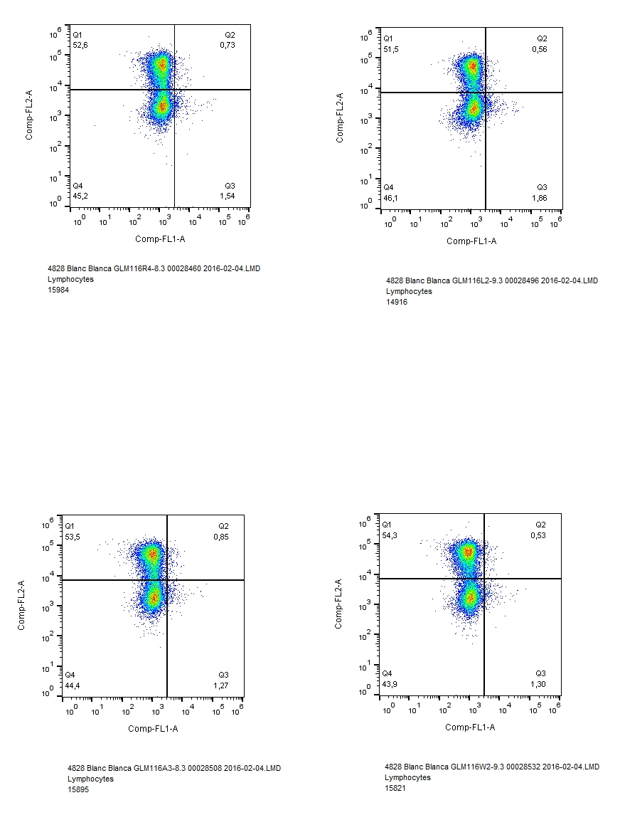

60.9 ± 1.6 ‡

0.5 ± 0.1

37.2 ± 1.4 ‡

1.4 ± 0.3

**(b)**

**Leptin – Day 21**



61.5 ± 1.7 ‡

1.0 ± 0.2

35.9 ± 1.7 ‡

1.6 ± 0.2

**(a)**

**Reference – Day 21**

**CD62L selectin**



56.7 ± 2.4

0.8 ± 0.1

40.1 ± 2.2 ‡

2.5 ± 0.7

**(c)**

**Adiponectin – Day 21**



58.9 ± 1.3 ‡

0.7 ± 0.1

38.7 ± 1.5 ‡

1.9 ± 0.6

**(d)**

**WPC – Day 21**

**αE integrin**