Polyunsaturated fatty acid status at birth and childhood allergy-related phenotypes: a pooled analysis of the MEFAB and RHEA birth cohorts

Nikos Stratakis, Marij Gielen, Katerina Margetaki, Renate H. M. de Groot, Maria Apostolaki, Georgia Chalkiadaki, Marina Vafeiadi, Vasiliki Leventakou, Roger W. Godschalk, Manolis Kogevinas, Euripides G. Stephanou, Maurice P. Zeegers, Leda Chatzi.

Table of Contents
Supplementary Table S1. Comparison of subject characteristics in MEFAB and RHEA between those included and not included in the main analyses 2
Supplementary Table S2. Associations of primary PUFAs (polyunsaturated fatty acids) of interest with asthma ever at 6-7 years of age in MEFAB and RHEA cohorts, separately and in pooled analysis 3
Supplementary Table S3. Associations of primary PUFAs (polyunsaturated fatty acids) of interest with current rhinitis and eczema at 6-7 years of age in MEFAB and RHEA cohorts, separately and in pooled analysis 4
Supplementary Table S4. Associations (pooled analysis) of primary PUFAs (polyunsaturated fatty acids) of interest with allergy-related phenotypes at 6-7 years of age after adjusting only for child sex and age 5
Supplementary Table S5. Associations of secondary PUFAs (polyunsaturated fatty acids) of interest with current wheeze and asthma at 6-7 years of age in MEFAB and RHEA cohorts, separately and in pooled analysis 6
Supplementary Table S6. Associations of secondary PUFAs (polyunsaturated fatty acids) of interest with current rhinitis and eczema at 6-7 years of age in MEFAB and RHEA cohorts, separately and in pooled analysis 7
Supplementary Table S7. Associations of primary PUFAs (polyunsaturated fatty acids) of interest with current wheeze symptoms at 9 months and 4 years of age in the RHEA cohort 8
Supplementary Table S8. Associations (pooled analysis) of primary PUFAs (polyunsaturated fatty acids) of interest with allergic disease-related phenotypes at 6-7 years of age after including birth weight and gestational age in multivariable models 9
Supplementary Table S9. Assessment of effect measure modification by parent atopy in the association of the total n-3:n-6 PUFA ratio with current symptoms of asthma, rhinitis, and eczema at 6-7 years in the pooled dataset 10
Supplementary Table S10. Assessment of effect measure modification by sex in the association of the total n-3:n-6 PUFA ratio with current symptoms of asthma, rhinitis, and eczema at 6-7 years in the pooled dataset 11
Supplementary Fig. S1. Flow chart of the MEFAB participants 12
Supplementary Fig. S2. Flow chart of the RHEA participants 13
Supplementary Fig. S3. Directed acyclic graph for the association of fatty acid status at birth with allergic disease-related symptoms in childhood. 14
Text accompanying Supplementary Fig. S3 15

Supplementary Table S1. Comparison of subject characteristics in MEFAB and RHEA between those included and not included in the main analyses
(Mean values and standard deviations; number of subjects and percentages)
 | MEFAB |  |  |  |  |  |  |  | RHEA
 | Subjects not included (n 910) |  |  | Subjects included (n 293) |  |  |  |  |  | Subjects not included (n 1150) |  |  | Subjects included (n 213)
 | n | % |  | n | % | P* |  |  |  | n | % |  | n | % | P*
Parental characteristics
Maternal age at birth (years) |  |  |  |  |  | 0·01 |  |  |  |  |  |  |  |  | 0·56
Mean | 29·1 |  |  | 29·8 |  |  |  |  |  | 29·6 |  |  | 29·8
SD | 4·3 |  |  | 4·2 |  |  |  |  |  | 5·0 |  |  | 4·8
Maternal BMI at study entry (kg/m²) |  |  |  |  |  | 0·06 |  |  |  |  |  |  |  |  | 0·28
Mean | 24·2 |  |  | 23·6 |  |  |  |  |  | 25·2 |  |  | 25·7
SD | 4·2 |  |  | 3·9 |  |  |  |  |  | 4·6 |  |  | 5·8
Gestational weight gain (kg) |  |  |  |  |  | 0·06 |  |  |  |  |  |  |  |  | 0·68
Mean | 11·6 |  |  | 11·1 |  |  |  |  |  | 14·1 |  |  | 13·8
SD | 4·6 |  |  | 4·0 |  |  |  |  |  | 6·0 |  |  | 6·1
Maternal smoking in pregnancy | 226 | 26·3 |  | 67 | 23·3 | 0·31 |  |  |  | 151 | 19·4 |  | 29 | 13·7 | 0·06
Parity at birth, multiparous | 203 | 23·4 |  | 87 | 29·7 | 0·03 |  |  |  | 654 | 56·9 |  | 116 | 54·5 | 0·53
Area-based socio-economic status at birth, high† | 253 | 38·2 |  | 94 | 36·3 | 0·10 |  |  |  |  | - |  | - |  | -
Parental education, high | - | - |  | - | - | - |  |  |  | 282 | 36·4 |  | 91 | 42·9 | 0·12
Child characteristics
Sex, female | 409 | 45·0 |  | 131 | 44·7 | 0·93 |  |  |  | 580 | 50·4 |  | 90 | 42·3 | 0·03
Gestational age (weeks) |  |  |  |  |  | 0·92 |  |  |  |  |  |  |  |  | 0·46
Mean | 39·9 |  |  | 39·9 |  |  |  |  |  | 38·3 |  |  | 38·2
SD | 1·7 |  |  | 1·6 |  |  |  |  |  | 1·5 |  |  | 1·5
Birth weight (grams) |  |  |  |  |  | 0·48 |  |  |  |  |  |  |  |  | 0·61
Mean | 3271 |  |  | 3296 |  |  |  |  |  | 3208 |  |  | 3191
SD | 511 |  |  | 516 |  |  |  |  |  | 454 |  |  | 434
Breastfeeding, yes | - | - |  | - | - | - |  |  |  | 656 | 85·1 |  | 178 | 86·3 | 0·53
Cord blood n-3 PUFAs (wt %) |  |  |  |  |  | 0·87 |  |  |  |  |  |  |  |  | 0·25
Mean | 6·90 |  |  | 6·89 |  |  |  |  |  | 5·25 |  |  | 5·38
SD | 1·58 |  |  | 1·59 |  |  |  |  |  | 1·29 |  |  | 1·12
Cord blood n-6 PUFAs (wt %) |  |  |  |  |  | 0·52 |  |  |  |  |  |  |  |  | 0·11
Mean | 32·08 |  |  | 32·16 |  |  |  |  |  | 32·44 |  |  | 32·06
SD | 1·68 |  |  | 1·69 |  |  |  |  |  | 3·03 |  |  | 2·35
wt %, weight percentage of total fatty acids measured.
* P values for difference were estimated using Student’s t test for continuous and Pearson's χ2 test for categorical variables.
† Area-based socio-economic status at birth was determined based on the postal code of the place of residence.

Supplementary Table S2. Associations of primary PUFAs (polyunsaturated fatty acids) of interest with asthma ever at 6-7 years of age in MEFAB and RHEA cohorts, separately and in pooled analysis‡
(Relative risks (RRs) and 95% confidence intervals)
 | Asthma ever§
 | MEFAB (n 293) |  |  | RHEA (n 213) |  |  | Pooled (n 506)
 | RR | 95% CI |  | RR | 95% CI |  | RR | 95% CI
ALA | 0·47 | 0·24, 0·93* |  | 1·02 | 0·66, 1·58 |  | 0·79 | 0·57, 1·09††
EPA+DHA | 0·67 | 0·46, 0·98* |  | 0·59 | 0·39, 0·89* |  | 0·65 | 0·49, 0·86**†
Total n-3 PUFAs | 0·66 | 0·46, 0·96* |  | 0·60 | 0·40, 0·92* |  | 0·65 | 0·49, 0·86**†
LA | 1·48 | 1·01, 2·17* |  | 0·90 | 0·56, 1·44 |  | 1·17 | 0·90, 1·52†
AA | 1·28 | 0·85, 1·93 |  | 0·89 | 0·57, 1·41 |  | 1·06 | 0·78, 1·43†
Total n-6 PUFAs | 1·27 | 0·86, 1·87 |  | 0·79 | 0·52, 1·19 |  | 1·02 | 0·77, 1·36†
Total n-3:n-6 ratio | 0·64 | 0·44, 0·93* |  | 0·70 | 0·44, 1·11 |  | 0·67 | 0·49, 0·90**†
AA, arachidonic acid (C_{20:4n-6}); ALA, a-Linolenic acid (C_{18:3n-3}); DHA, docosahexaenoic acid (C_{22:6n-3}); EPA, eicosapentaenoic acid (C_{20:5n-3}); LA, linoleic acid (C_{18:2n-6}); total n-3 (n-6) PUFAs, the sum of n-3 (n-6) PUFAs present in the chromatogram.
P value for PUFA exposure-outcome association: *P<0·05; **P<0·01.
P value for PUFA exposure-cohort interaction: †P for interaction >0.10; ††P for interaction =0.07.
‡ Relative risks (RRs) and their 95% CIs were calculated using generalized linear models for binary outcomes (modified Poisson) adjusted for maternal age, maternal BMI at study entry, gestational weight gain, maternal smoking during pregnancy, parity, parental education, parent atopy, child age at outcome assessment, child sex, and for the pooled estimate, a cohort indicator. Effect estimates correspond to a standard deviation score (SDS) increase in PUFAs and to a unit increase in the total n-3:n-6 ratio.
§ Asthma ever was defined as ever-reported doctor diagnosis of asthma.

Supplementary Table S3. Associations of primary PUFAs (polyunsaturated fatty acids) of interest with current rhinitis and eczema at 6-7 years of age in MEFAB and RHEA cohorts, separately and in pooled analysis‡

(Relative risks (RRs) and 95% confidence intervals)
 | Current rhinitis§ |  |  |  |  |  |  |  |  | Current eczema||
 | MEFAB (n 293) |  |  | RHEA (n 213) |  |  | Pooled (n 506) |  |  | MEFAB (n 293) |  |  | RHEA (n 213) |  |  | Pooled (n 506)
 | RR | 95% CI |  | RR | 95% CI |  | RR | 95% CI |  | RR | 95% CI |  | RR | 95% CI |  | RR | 95% CI
ALA | 1·02 | 0·86, 1·21 |  | 1·06 | 0·57, 1·96 |  | 1·02 | 0·87, 1·21† |  | 0·82 | 0·59, 1·13 |  | 1·21 | 0·67, 2·19 |  | 0·92 | 0·73, 1·17†
EPA+DHA | 0·88 | 0·68, 1·14 |  | 0·64 | 0·32, 1·30 |  | 0·84 | 0·66, 1·07† |  | 0·99 | 0·74, 1·33 |  | 0·82 | 0·46, 1·46 |  | 0·94 | 0·73, 1·22†
Total n-3 PUFAs | 0·87 | 0·68, 1·13 |  | 0·65 | 0·32, 1·31 |  | 0·84 | 0·65, 1·07† |  | 0·98 | 0·73, 1·33 |  | 0·83 | 0·46, 1·49 |  | 0·94 | 0·73, 1·22†
LA | 1·01 | 0·77, 1·33 |  | 1·28 | 0·79, 2·07 |  | 1·10 | 0·84, 1·44† |  | 1·00 | 0·74, 1·37 |  | 1·38 | 0·98, 1·96 |  | 1·16 | 0·91, 1·47†
AA | 1·07 | 0·80, 1·43 |  | 0·92 | 0·49, 1·74 |  | 1·05 | 0·80, 1·39† |  | 1·04 | 0·74, 1·47 |  | 0·73 | 0·49, 1·10 |  | 0·96 | 0·74, 1·26†
Total n-6 PUFAs | 1·10 | 0·83, 1·45 |  | 1·13 | 0·71, 1·80 |  | 1·11 | 0·87, 1·42† |  | 0·98 | 0·71, 1·36 |  | 1·20 | 0·74, 1·94 |  | 1·05 | 0·80, 1·38†
Total n-3:n-6 ratio | 0·88 | 0·67, 1·15 |  | 0·63 | 0·33, 1·21 |  | 0·82 | 0·64, 1·06† |  | 1·00 | 0·73, 1·36 |  | 0·77 | 0·45, 1·31 |  | 0·92 | 0·71, 1·20†
AA, arachidonic acid (C_{20:4n-6}); ALA, a-Linolenic acid (C_{18:3n-3}); DHA, docosahexaenoic acid (C_{22:6n-3}); EPA, eicosapentaenoic acid (C_{20:5n-3}); LA, linoleic acid (C_{18:2n-6}); PUFA, polyunsaturated fatty acid; total n-3 (n-6) PUFAs, the sum of n-3 (n-6) PUFAs present in the chromatogram.
P value for PUFA exposure-cohort interaction: †P for interaction >0·10.
‡ Relative risks (RRs) and their 95% CIs were calculated using generalized linear models for binary outcomes (modified Poisson) adjusted for maternal age, maternal BMI at study entry, gestational weight gain, maternal smoking during pregnancy, parity, parental education, parent atopy, child age at outcome assessment, child sex, and for the pooled estimate, a cohort indicator. Effect estimates correspond to a standard deviation score (SDS) increase in PUFAs and to a unit increase in the total n-3:n-6 ratio.
§ Current rhinitis was defined as presence of sneezing or a runny or blocked nose in the last 12 months without common cold or flu.
|| Current eczema was defined presence of an itchy rash in the last 12 months that affected any of the following places: the folds of the elbows, behind the knees, in front of the ankles, under the buttocks, or around the neck, ears or eyes.

Supplementary Table S4. Associations (pooled analysis; n 506) of primary PUFAs (polyunsaturated fatty acids) of interest with allergy-related phenotypes at 6-7 years of age after adjusting only for child sex and age‡

(Relative risks (RRs) and 95% confidence intervals)
 | Current wheeze§ |  |  | Current asthma|| |  |  | Current rhinitis¶ |  |  | Current eczema‡‡
 | RR | 95% CI |  | RR | 95% CI |  | RR | 95% CI |  | RR | 95% CI
ALA | 0·91 | 0·69, 1·20† |  | 0·61 | 0·32, 1·17† |  | 1·02 | 0·85, 1·22† |  | 0·92 | 0·73, 1·16†
EPA+DHA | 0·59 | 0·44, 0·79***† |  | 0·51 | 0·32, 0·79**† |  | 0·86 | 0·68, 1·09† |  | 0·98 | 0·77, 1·25†
Total n-3 PUFAs | 0·58 | 0·43, 0·78***† |  | 0·49 | 0·31, 0·76**† |  | 0·86 | 0·68, 1·09† |  | 0·98 | 0·76, 1·26†
LA | 1·32 | 1·08, 1·61**† |  | 1·40 | 1·01, 1·94*† |  | 1·10 | 0·85, 1·42† |  | 1·10 | 0·87, 1·40†
AA | 1·33 | 0·99, 1·80†† |  | 1·27 | 0·84, 1·93† |  | 1·06 | 0·82, 1·38† |  | 0·95 | 0·73, 1·23†
Total n-6 PUFAs | 1·62 | 1·16, 2·27**† |  | 1·45 | 0·98, 2·16† |  | 1·12 | 0·88, 1·41† |  | 1·03 | 0·80, 1·34†
Total n-3:n-6 ratio | 0·52 | 0·38, 0·72***† |  | 0·44 | 0·27, 0·70**† |  | 0·85 | 0·66, 1·08† |  | 0·96 | 0·75, 1·24†
AA, arachidonic acid (C_{20:4n-6}); ALA, a-Linolenic acid (C_{18:3n-3}); DHA, docosahexaenoic acid (C_{22:6n-3}); EPA, eicosapentaenoic acid (C_{20:5n-3}); LA, linoleic acid (C_{18:2n-6}); total n-3 (n-6) PUFAs, the sum of n-3 (n-6) PUFAs present in the chromatogram.
P value for PUFA exposure-outcome association: *P<0·05; **P<0·01; *** P<0·001.
P value for PUFA exposure-cohort interaction: †P for interaction >0.10; ††P for interaction <0.05.
‡ Relative risks (RRs) and their 95% CIs were calculated using generalized linear models for binary outcomes (modified Poisson) adjusted for child age at outcome assessment, child sex, and a cohort indicator. Effect estimates correspond to a standard deviation score (SDS) increase in PUFAs and to a unit increase in the total n-3:n-6 ratio.
§ Current wheeze was defined as presence of wheezing or whistling in the chest in the last 12 months.
|| Current asthma was defined as a positive answer to both ever-reported doctor diagnosis of asthma and presence of wheezing or whistling in the chest in the last 12 months.
¶ Current rhinitis was defined as presence of sneezing or a runny or blocked nose in the last 12 months without common cold or flu.
‡‡ Current eczema was defined presence of an itchy rash in the last 12 months that affected any of the following places: the folds of the elbows, behind the knees, in front of the ankles, under the buttocks, or around the neck, ears or eyes.

Supplementary Table S5. Associations of secondary PUFAs (polyunsaturated fatty acids) of interest with current wheeze and asthma at 6-7 years of age in MEFAB and RHEA cohorts, separately and in pooled analysis‡
(Relative risks (RRs) and 95% confidence intervals)
 | Current wheeze§ |  |  |  |  |  |  |  |  |  |  | Current asthma||
 | MEFAB (n 293) |  |  | RHEA (n 213) |  |  | Pooled (n 506) |  |  |  |  |  | MEFAB (n 293) |  |  |  |  |  | RHEA (n 213) |  |  |  |  | Pooled (n 506)
 | RR | 95% CI |  | RR | 95% CI |  | RR | 95% CI |  |  |  |  |  | RR | 95% CI |  |  | RR |  | 95% CI |  |  | RR |  | 95% CI
n-3 DPA | 0·68 | 0·41, 1·11 |  | - | - |  | - | - |  |  |  |  |  | 0·60 | 0·31, 1·16 |  |  | - |  | - |  |  | - |  | -
n-6 GLA | 1·12 | 0·70, 1·79 |  | 1·26 | 0·91, 1·74 |  | 1·11 | 0·84, 1·46† |  |  |  |  |  | 1·06 | 0·57, 1·96 |  |  | 1·53 |  | 0·86, 2·72 |  |  | 1·11 |  | 0·72, 1·72†
n-6 DGLA | 0·67 | 0·43, 1·04 |  | 1·23 | 0·87, 1·74 |  | 0·92 | 0·67, 1·27†† |  |  |  |  |  | 0·40 | 0·23, 0·72** |  |  | 1·67 |  | 0·97, 2·90 |  |  | 0·74 |  | 0·43, 1·28††
n-6 Osbond acid | 0·63 | 0·37, 1·09 |  | - | - |  | - | - |  |  |  |  |  | 0·79 | 0·41, 1·53 |  |  | - |  | - |  |  | - |  | -
DGLA, dihomo-γ-linolenic acid (C_{20:3n-6}); DPA, docosapentaenoic acid (C_{22:5n-3}); GLA, γ-Linolenic acid (C_{18:3n-6}); Osbond acid, C_{22:5n-6}.
P value for PUFA exposure-outcome association: **P<0·01.
P value for PUFA exposure-cohort interaction: †P for interaction > 0·10; ††P for interaction <0·05.
‡ Relative risks (RRs) and their 95% CIs were calculated using generalized linear models for binary outcomes (modified Poisson) adjusted for maternal age, maternal BMI at study entry, gestational weight gain, maternal smoking during pregnancy, parity, parental education, parent atopy, child age at outcome assessment, child sex, and for the pooled estimate, a cohort indicator. Effect estimates correspond to a standard deviation score (SDS) increase in PUFAs and to a unit increase in the total n-3:n-6 ratio.
§ Current wheeze was defined as presence of wheezing or whistling in the chest in the last 12 months.
|| Current asthma was defined as a positive answer to both ever-reported doctor diagnosis of asthma and presence of wheezing or whistling in the chest in the last 12 months.

Supplementary Table S6. Associations of secondary PUFAs (polyunsaturated fatty acids) of interest with current rhinitis and eczema at 6-7 years of age in MEFAB and RHEA cohorts, separately and in pooled analysis‡
(Relative risks (RRs) and 95% confidence intervals)
 | Current rhinitis§ |  |  |  |  |  |  |  |  |  |  | Current eczema||
 | MEFAB (n 293) |  |  | RHEA (n 213) |  |  | Pooled (n 506) |  |  |  |  |  | MEFAB (n 293) |  |  |  |  |  | RHEA (n 213) |  |  | Pooled (n 506)
 | RR | 95% CI |  | RR | 95% CI |  | RR | 95% CI |  |  |  |  |  | RR | 95% CI |  |  | RR |  | 95% CI |  | RR | 95% CI
n-3 DPA | 0·8 | 0·62, 1·03 |  | - | - |  | - | - |  |  |  |  |  | 1·04 | 0·74, 1·45 |  |  | - |  | - |  | - | -
n-6 GLA | 1·35 | 1·06, 1·72* |  | 0·67 | 0·39, 1·17 |  | 1·10 | 0·89, 1·36††† |  |  |  |  |  | 0·93 | 0·69, 1·26 |  |  | 1·46 |  | 1·05, 2·04* |  | 1·08 | 0·84, 1·4††
n-6 DGLA | 1·09 | 0·82, 1·44 |  | 0·88 | 0·54, 1·43 |  | 1·01 | 0·79, 1·29† |  |  |  |  |  | 0·87 | 0·68, 1·13 |  |  | 1·41 |  | 0·99, 2·01 |  | 1·01 | 0·81, 1·26†††
n-6 Osbond acid | 0·86 | 0·64, 1·15 |  | - | - |  | - | - |  |  |  |  |  | 0·98 | 0·74, 1·31 |  |  | - |  | - |  | - | -
DGLA, dihomo-γ-linolenic acid (C_{20:3n-6}); DPA, docosapentaenoic acid (C_{22:5n-3}); GLA, γ-Linolenic acid (C_{18:3n-6}); Osbond acid, C_{22:5n-6}.
P value for PUFA exposure-outcome association: *P<0·05.
P value for PUFA exposure-cohort interaction: †P for interaction > 0·10; ††P for interaction =0·07; †††P for interaction <0·05.
‡ Relative risks (RRs) and their 95% CIs were calculated using generalized linear models for binary outcomes (modified Poisson) adjusted for maternal age, maternal BMI at study entry, gestational weight gain, maternal smoking during pregnancy, parity, parental education, parent atopy, child age at outcome assessment, child sex, and for the pooled estimate, a cohort indicator. Effect estimates correspond to a standard deviation score (SDS) increase in PUFAs and to a unit increase in the total n-3:n-6 ratio.
§ Current rhinitis was defined as presence of sneezing or a runny or blocked nose in the last 12 months without common cold or flu.
|| Current eczema was defined presence of an itchy rash in the last 12 months that affected any of the following places: the folds of the elbows, behind the knees, in front of the ankles, under the buttocks, or around the neck, ears or eyes.

Supplementary Table S7. Associations of primary PUFAs (polyunsaturated fatty acids) of interest with current wheeze symptoms at 9 months and 4 years of age in the RHEA cohort (n 213)*
(Relative risks (RRs) and 95% confidence intervals)
 | Current wheeze†
 | 9 months (n 228) |  | 4 years (n 222)
 | RR (95% CI) |  | RR (95% CI)
ALA | 0·99 (0·76, 1·28) |  | 1·57 (0·68, 3·60)
EPA+DHA | 1·00 (0·79, 1·28) |  | 0·74 (0·38, 1·44)
Total n-3 PUFAs | 1·02 (0·80, 1·29) |  | 0·75 (0·39, 1·44)
LA | 0·90 (0·71, 1·15) |  | 1·57 (0·98, 2·53)
AA | 1·08 (0·86, 1·35) |  | 0·54 (0·29, 1·01)
Total n-6 PUFAS | 1·03 (0·79, 1·34) |  | 0·86 (0·35, 2·11)
Total n-3:n-6 ratio | 1·02 (0·79, 1·31) |  | 0·84 (0·41, 1·72)
AA, arachidonic acid (C_{20:4n-6}); ALA, a-Linolenic acid (C_{18:3n-3}); DHA, docosahexaenoic acid (C_{22:6n-3}); EPA, eicosapentaenoic acid (C_{20:5n-3}); LA, linoleic acid (C_{18:2n-6}); total n-3 (n-6) PUFAs, the sum of n-3 (n-6) PUFAs present in the chromatogram.
* Relative risks (RRs) and their 95% CIs were calculated using generalized linear models for binary outcomes (modified Poisson) adjusted for maternal age, maternal BMI at study entry, gestational weight gain, maternal smoking during pregnancy, parity, parental education, parent atopy, child age at outcome assessment, and sex. Effect estimates correspond to a standard deviation score (SDS) increase in PUFAs and to a unit increase in the total n-3:n-6 ratio.
† Current wheeze was defined as presence of wheezing or whistling in the chest since birth at 9 months of age (n/N= 62/228) and in the last 12 months at 4 years of age (n/N=10/222).

Supplementary Table S8. Associations (pooled analysis; n 506) of primary PUFAs (polyunsaturated fatty acids) of interest with allergic disease-related phenotypes at 6-7 years of age after including birth weight and gestational age in multivariable models†
(Relative risks (RRs) and 95% confidence intervals)
 | Current wheeze‡ |  |  | Current asthma§ |  |  | Current rhinitis|| |  |  | Current eczema¶
 | RR | 95% CI |  | RR | 95% CI |  | RR | 95% CI |  | RR | 95% CI
ALA | 0·91 | 0·70, 1·18 |  | 0·59 | 0·29, 1·17 |  | 1·03 | 0·87, 1·21 |  | 0·90 | 0·70, 1·15
EPA+DHA | 0·61 | 0·44, 0·84** |  | 0·47 | 0·27, 0·80** |  | 0·83 | 0·64, 1·08 |  | 0·86 | 0·66, 1·13
Total n-3 PUFAs | 0·60 | 0·44, 0·83** |  | 0·44 | 0·26, 0·75** |  | 0·82 | 0·63, 1·07 |  | 0·86 | 0·65, 1·13
LA | 1·18 | 0·92, 1·51 |  | 1·28 | 0·83, 1·97 |  | 1·09 | 0·81, 1·45 |  | 1·20 | 0·94, 1·52
AA | 1·34 | 0·98, 1·84 |  | 1·38 | 0·89, 2·15 |  | 1·06 | 0·80, 1·40 |  | 0·93 | 0·71, 1·21
Total n-6 PUFAs | 1·49 | 1·05, 2·13* |  | 1·42 | 0·94, 2·15 |  | 1·10 | 0·86, 1·41 |  | 1·07 | 0·81, 1·40
Total n-3:n-6 ratio | 0·55 | 0·39, 0·78** |  | 0·40 | 0·23, 0·70** |  | 0·81 | 0·62, 1·07 |  | 0·84 | 0·63, 1·12
AA, arachidonic acid (C_{20:4n-6}); ALA, a-Linolenic acid (C_{18:3n-3}); DHA, docosahexaenoic acid (C_{22:6n-3}); EPA, eicosapentaenoic acid (C_{20:5n-3}); LA, linoleic acid (C_{18:2n-6}); total n-3 (n-6) PUFAs, the sum of n-3 (n-6) PUFAs present in the chromatogram.
P value for PUFA exposure-outcome association: *P<0·05; **P<0·01.
† Relative risks (RRs) and their 95% CIs were calculated using generalized linear models for binary outcomes (modified Poisson) adjusted for maternal age, maternal BMI at study entry, gestational weight gain, maternal smoking during pregnancy, parity, birth weight, gestational age, parental education, parent atopy, child age at outcome assessment, sex, and a cohort indicator. Effect estimates correspond to a standard deviation score (SDS) increase in PUFAs and to a unit increase in the total n-3:n-6 ratio.
‡ Current wheeze was defined as presence of wheezing or whistling in the chest in the last 12 months.
§ Current asthma was defined as a positive answer to both ever-reported doctor diagnosis of asthma and presence of wheezing or whistling in the chest in the last 12 months.
|| Current rhinitis was defined as presence of sneezing or a runny or blocked nose in the last 12 months without common cold or flu.
¶ Current eczema was defined presence of an itchy rash in the last 12 months that affected any of the following places: the folds of the elbows, behind the knees, in front of the ankles, under the buttocks, or around the neck, ears or eyes.

Supplementary Table S9. Assessment of effect measure modification by parent atopy in the association of the total n-3:n-6 PUFA ratio with current symptoms of asthma, rhinitis, and eczema at 6-7 years in the pooled dataset
 | n |  | Current asthma |  |  |  |  |  |  |  | Current rhinitis |  |  |  |  |  |  |  | Current eczema
 |  |  | RR | 95% CI |  |  | P value |  |  |  | RR | 95% CI |  | P value |  |  |  |  | RR | 95% CI |  |  | P value
Parent atopy, no | 283 |  | 0·48 | 0·28, 0·82 |  |  | 0·01 |  |  |  | 0·84 | 0·59, 1·21 |  | 0·36 |  |  |  |  | 0·90 | 0·58, 1·38 |  |  | 0·63
Parent atopy, yes | 223 |  | 0·38 | 0·17, 0·83 |  |  | 0·02 |  |  |  | 0·82 | 0·59, 1·15 |  | 0·25 |  |  |  |  | 0·97 | 0·69, 1·36 |  |  | 0·86
Measure of effect modification on multiplicative scale:
For current asthma: RR = 0·94 (95% CI 0·38, 2·34); P=0·90
For current rhinitis: RR = 0·92 (95% CI 0·56, 1·51); P=0·74
For current eczema: RR = 1·02 (95% CI 0·60, 1·73); P=0·94
Measure of effect modification on additive scale:
For current asthma: RERI = -0·31 (95% CI -1·87, 1·26); P= 0·70
For current rhinitis: RERI = 0·04 (95% CI -0·88, 0·95); P= 0·94
For current eczema: RERI = 0·21 (95% CI -1·04, 1·46); P= 0·74
Effect estimates were adjusted for maternal age, maternal BMI at study entry, gestational weight gain, maternal smoking during pregnancy, parity, parental education, child age at outcome assessment, child sex, and a cohort indicator.

Supplementary Table S10. Assessment of effect measure modification by sex in the association of the total n-3:n-6 PUFA ratio with current symptoms of asthma, rhinitis, and eczema at 6-7 years in the pooled dataset
 | n |  | Current asthma |  |  |  |  |  |  |  | Current rhinitis |  |  |  |  |  |  |  | Current eczema
 |  |  | RR | 95% CI |  |  | P value |  |  |  | RR | 95% CI |  | P value |  |  |  |  | RR | 95% CI |  |  | P value
Child sex, male | 285 |  | 0·47 | 0·27, 0·80 |  |  | <0·01 |  |  |  | 1·00 | 0·72, 1·39 |  | 0·98 |  |  |  |  | 0·95 | 0·67, 1·35 |  |  | 0·77
Child sex, female | 221 |  | 0·27 | 0·17, 0·43 |  |  | <0·001 |  |  |  | 0·61 | 0·37, 1·01 |  | 0·06 |  |  |  |  | 0·84 | 0·53, 1·34 |  |  | 0·47
Measure of effect modification on multiplicative scale:
For current asthma: RR = 0·80 (95% CI 0·38, 1·69); P=0·56
For current rhinitis: RR = 0·57 (95% CI 0·32, 1·01); P=0·06
For current eczema: RR = 0·88 (95% CI 0·52, 1·49); P=0·63
Measure of effect modification on additive scale:
For current asthma: RERI = 0·58 (95% CI -0·09, 1·26); P= 0·09
For current rhinitis: RERI = -1·83 (95% CI -5·60, 1·94); P= 0·34
For current eczema: RERI = -0·41 (95% CI -1·89, 1·07); P= 0·59
Effect estimates were adjusted for maternal age, maternal BMI at study entry, gestational weight gain, maternal smoking during pregnancy, parent atopy, parity, parental education, child age at outcome assessment, and a cohort indicator.

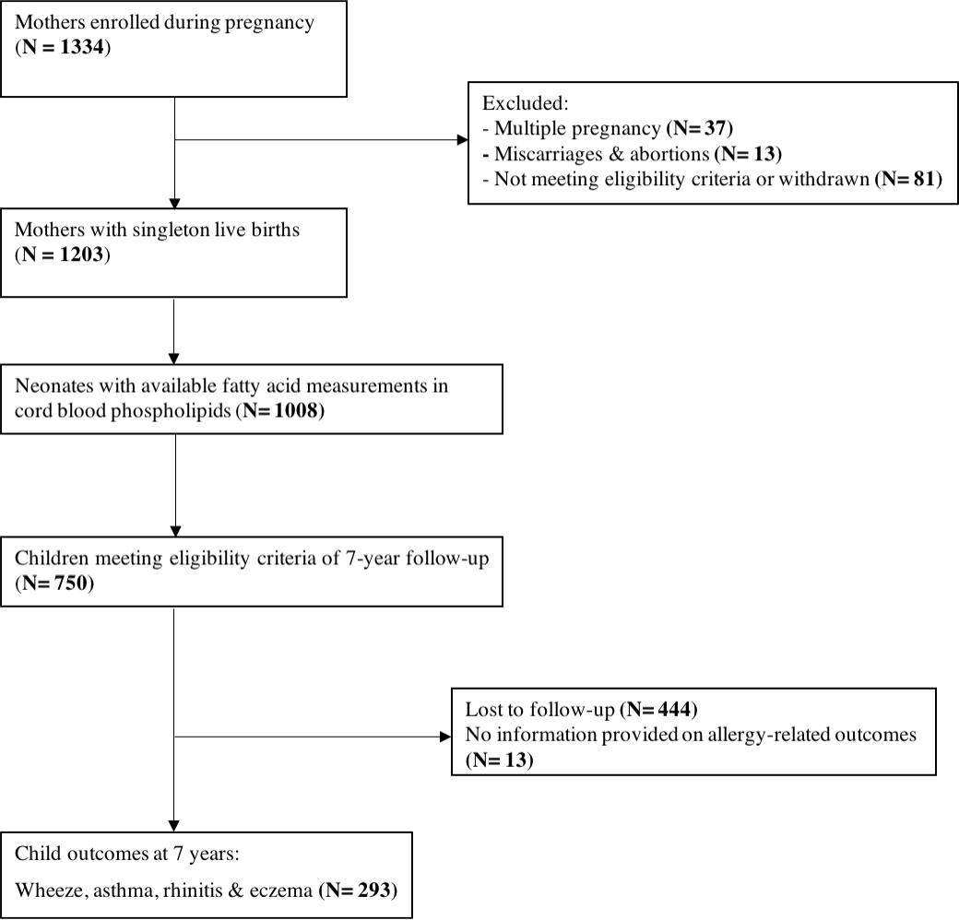

Supplementary Fig. S1. Flow chart of the MEFAB participants

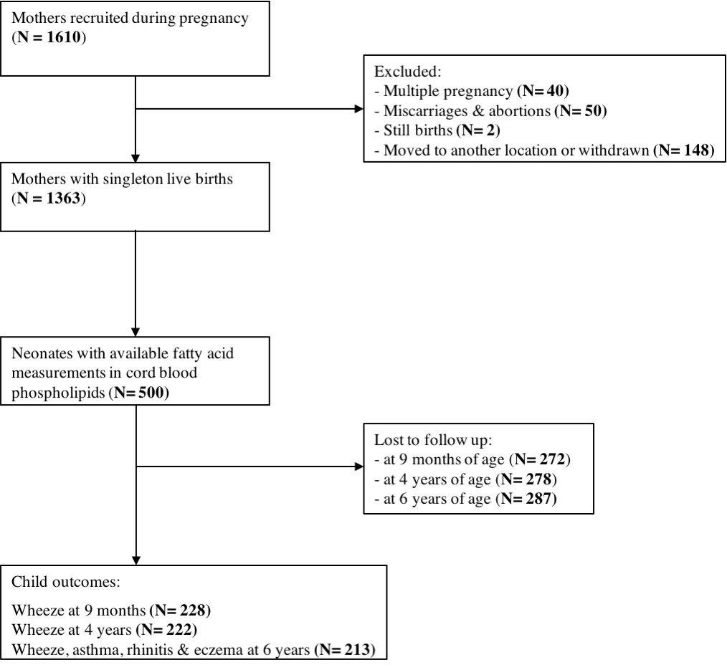

Supplementary Fig. S2. Flow chart of the RHEA participants

Supplementary Fig. S3. Directed acyclic graph for the association of fatty acid status at birth with allergic disease-related symptoms in childhood.

Text accompanying Supplementary Fig. S3
In our models, selection of covariates for adjustment was based on a directed acyclic graph (DAG) approach. A DAG is a graphical tool that enables the visualization of the associations among the exposure of interest, the outcome(s) being studied, and all other related characteristics. It represents a conceptual model, and provides a structured way to present an overview of the research question and its context, therefore aiding in identifying the presence of confounding and ways to resolve it⁽¹⁾. Below, we use some illustrative examples for the reader who has not previous experience with DAGs. For those who are more interested in the concept of DAGs, there are some excellent reviews on this topic^{(1,2,3)}.
Arrows in DAGs represent direct effects of one factor on another, either protective or harmful. Moreover, arrows should follow time order, or else the diagram contradicts the basic principle that causes must precede their effects. The arrows and their direction are drawn based on prior knowledge. For instance, in Supplemental Figure 3, parental education, as a proxy of SES status, can affect both prenatal fatty acid exposure^{(4,5)} and childhood allergic disease symptoms⁽⁶⁾, so the arrows point away from parental education towards fatty acid status at birth as well as towards child allergic disease symptoms. The path from fatty acid status at birth towards child allergy via parental education is called a backdoor path because it starts with an arrowhead towards fatty acid status at birth, the exposure. The presence of a backdoor path in DAG identifies the presence of confounding. The path from prenatal fatty acids via gestational age to child allergy is not a backdoor path, as the first arrow points away from the exposure. There is good evidence to suggest that high exposure to n-3 long-chain PUFAs even in the last weeks of gestation increases the duration of gestation^{(7,8)}. Hence, gestational age is not a cause of prenatal PUFA exposure, but prenatal PUFAs can be regarded as a cause of gestational age. Additionally, the arrow from gestational age to child allergy indicates that gestational age predicts child allergy symptoms; an association that is supported by good epidemiological evidence⁽⁹⁾. Gestational age is therefore in the causal pathway between fatty acid status and child allergy.
In our study, the DAG was drawn using DAGitty (www.dagitty.net)⁽¹⁰⁾, a user friendly software that allows the instant identification of minimum but sufficient sets of factors to control for in the analysis in order to resolve confounding. The adjustment set in our study included the following covariates: maternal age, maternal BMI at study entry, gestational weight gain, maternal smoking during pregnancy, parental education, parity, parent atopy, child age and sex. Through this adjustment set, the backdoor paths from fatty acid status at birth towards child allergy are blocked.
Below, we present references for the assumed relationships in our DAG (Supplementary Fig. 3):

Parental education | → prenatal PUFA status:^{(4,5)}  → child allergy-related symptoms:⁽⁶⁾  → smoking during pregnancy:⁽¹¹⁾
 | → child BMI:⁽¹²⁾
Maternal age | → smoking during pregnancy:⁽¹¹⁾
 | → child BMI:⁽¹³⁾
 | → gestational age/birthweight:⁽¹⁴⁾
Maternal BMI | → prenatal PUFA status:⁽¹⁵⁾
 | → gestational age/birthweight:⁽¹⁶⁾
 | → child BMI:⁽¹⁷⁾
 | → child allergy-related symptoms:⁽¹⁸⁾
Gestational weight gain | → gestational age/birthweight:⁽¹⁶⁾
 | → child BMI:⁽¹⁹⁾
 | → child allergy-related symptoms:⁽¹⁸⁾
Smoking during pregnancy | → birthweight/gestational age:^{(20,21)}
 | → child BMI:⁽²²⁾
 | → child allergy-related symptoms:⁽²³⁾
Parity | → prenatal PUFA status:⁽²⁴⁾
 | → child allergy-related symptoms:^{(25,26)}
Parent atopy | → prenatal PUFA status:⁽²⁷⁾
 | → child allergy-related symptoms:⁽²⁸⁾
Prenatal PUFA status | → birthweight/gestational age:^{(8,29)}
Child sex | → prenatal PUFA status:⁽³⁰⁾
 | → allergy-related symptoms:⁽³¹⁾
Gestational age/birth weight | → child allergy-related symptoms:^{(32,33)}
Child BMI | → allergy-related symptoms:⁽³⁴⁾

References

1. Shrier I, Platt RW (2008) Reducing bias through directed acyclic graphs. BMC Med Res Methodol 8, 70.
2. Greenland S, Pearl J, Robins JM (1999) Causal diagrams for epidemiologic research. Epidemiology 10, 37-48.
3. Glymour MM, Greenland S (2008) Causal Diagrams. In Modern Epidemiology Vol 3, pp. 183–209 [KJ Rothman and S Greenland, editors]. Lippencott-Raven Publishers: Philadelphia.
4. Wennberg M, Tornevi A, Johansson I et al. (2012) Diet and lifestyle factors associated with fish consumption in men and women: a study of whether gender differences can result in gender-specific confounding. Nutr J 11, 101.
5. Steenweg-de Graaff JC, Tiemeier H, Basten MG et al. (2015) Maternal LC-PUFA status during pregnancy and child problem behavior: the Generation R Study. Pediatr Res 77, 489-497.
6. Gehring U, Pattenden S, Slachtova H et al. (2006) Parental education and children's respiratory and allergic symptoms in the Pollution and the Young (PATY) study. Eur Respir J 27, 95-107.
7. Olsen SF, Hansen HS, Sorensen TI et al. (1986) Intake of marine fat, rich in (n-3)-polyunsaturated fatty acids, may increase birthweight by prolonging gestation. Lancet 2, 367-369.
8. Olsen SF, Hansen HS, Sommer S et al. (1991) Gestational age in relation to marine n-3 fatty acids in maternal erythrocytes: a study of women in the Faroe Islands and Denmark. Am J Obstet Gynecol 164, 1203-1209.
9. Sonnenschein-van der Voort AM, Arends LR, de Jongste JC et al. (2014) Preterm birth, infant weight gain, and childhood asthma risk: a meta-analysis of 147,000 European children. J Allergy Clin Immunol 133, 1317-1329.
10. Textor J, Hardt J, Knuppel S (2011) DAGitty: a graphical tool for analyzing causal diagrams. Epidemiology 22, 745.
11. Vardavas CI, Patelarou E, Chatzi L et al. (2010) Factors associated with active smoking, quitting, and secondhand smoke exposure among pregnant women in Greece. J Epidemiol 20, 355-362.
12. Muthuri SK, Onywera VO, Tremblay MS et al. (2016) Relationships between Parental Education and Overweight with Childhood Overweight and Physical Activity in 9-11 Year Old Children: Results from a 12-Country Study. PLoS One 11, e0147746.
13. Savage T, Derraik JG, Miles HL et al. (2013) Increasing maternal age is associated with taller stature and reduced abdominal fat in their children. PLoS One 8, e58869.
14. Lawlor DA, Mortensen L, Andersen AM (2011) Mechanisms underlying the associations of maternal age with adverse perinatal outcomes: a sibling study of 264 695 Danish women and their firstborn offspring. Int J Epidemiol 40, 1205-1214.
15. Vidakovic AJ, Jaddoe VW, Gishti O et al. (2015) Body mass index, gestational weight gain and fatty acid concentrations during pregnancy: the Generation R Study. Eur J Epidemiol 30, 1175-1185.
16. Nohr EA, Vaeth M, Baker JL et al. (2008) Combined associations of prepregnancy body mass index and gestational weight gain with the outcome of pregnancy. Am J Clin Nutr 87, 1750-1759.
17. Yu Z, Han S, Zhu J et al. (2013) Pre-pregnancy body mass index in relation to infant birth weight and offspring overweight/obesity: a systematic review and meta-analysis. PLoS One 8, e61627.
18. Forno E, Young OM, Kumar R et al. (2014) Maternal obesity in pregnancy, gestational weight gain, and risk of childhood asthma. Pediatrics 134, e535-546.
19. Mourtakos SP, Tambalis KD, Panagiotakos DB et al. (2015) Maternal lifestyle characteristics during pregnancy, and the risk of obesity in the offspring: a study of 5,125 children. BMC Pregnancy Childbirth 15, 66.
20. Kayemba-Kay's S, Geary MP, Pringle J et al. (2008) Gender, smoking during pregnancy and gestational age influence cord leptin concentrations in newborn infants. Eur J Endocrinol 159, 217-224.
21. Li CQ, Windsor RA, Perkins L et al. (1993) The impact on infant birth weight and gestational age of cotinine-validated smoking reduction during pregnancy. JAMA 269, 1519-1524.
22. von Kries R, Toschke AM, Koletzko B et al. (2002) Maternal smoking during pregnancy and childhood obesity. Am J Epidemiol 156, 954-961.
23. Gilliland FD, Li YF, Peters JM (2001) Effects of maternal smoking during pregnancy and environmental tobacco smoke on asthma and wheezing in children. Am J Respir Crit Care Med 163, 429-436.
24. Hornstra G (2000) Essential fatty acids in mothers and their neonates. Am J Clin Nutr 71, 1262S-1269S.
25. Ball TM, Castro-Rodriguez JA, Griffith KA et al. (2000) Siblings, day-care attendance, and the risk of asthma and wheezing during childhood. N Engl J Med 343, 538-543.
26. Bernsen RM, de Jongste JC, van der Wouden JC (2003) Birth order and sibship size as independent risk factors for asthma, allergy, and eczema. Pediatr Allergy Immunol 14, 464-469.
27. Duchen K, Bjorksten B (2001) Polyunsaturated n-3 fatty acids and the development of atopic disease. Lipids 36, 1033-1042.
28. Alford SH, Zoratti E, Peterson EL et al. (2004) Parental history of atopic disease: disease pattern and risk of pediatric atopy in offspring. J Allergy Clin Immunol 114, 1046-1050.
29. Grootendorst-van Mil NH, Tiemeier H, Steenweg-de Graaff J et al. (2017) Maternal plasma n-3 and n-6 polyunsaturated fatty acids during pregnancy and features of fetal health: Fetal growth velocity, birth weight and duration of pregnancy. Clin Nutr.
30. Decsi T, Kennedy K (2011) Sex-specific differences in essential fatty acid metabolism. Am J Clin Nutr 94, Suppl. 6, S1914-S1919.
31. Almqvist C, Worm M, Leynaert B et al. (2008) Impact of gender on asthma in childhood and adolescence: a GA2LEN review. Allergy 63, 47-57.
32. Mebrahtu TF, Feltbower RG, Greenwood DC et al. (2015) Birth weight and childhood wheezing disorders: a systematic review and meta-analysis. J Epidemiol Community Health 69, 500-508.
33. Been JV, Lugtenberg MJ, Smets E et al. (2014) Preterm birth and childhood wheezing disorders: a systematic review and meta-analysis. PLoS Med 11, e1001596.
34. Gilliland FD, Berhane K, Islam T et al. (2003) Obesity and the risk of newly diagnosed asthma in school-age children. Am J Epidemiol 158, 406-415.

