Supplementary material

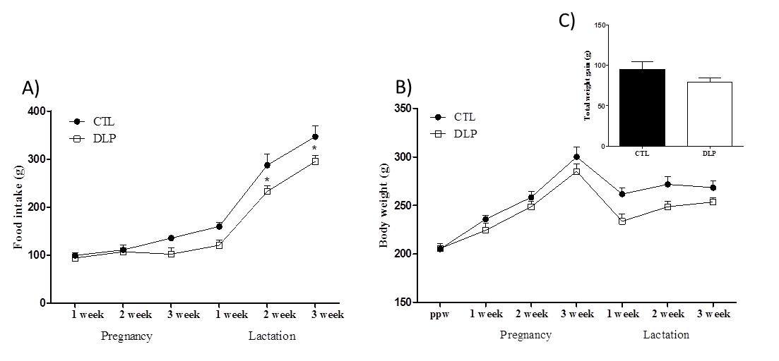
Supplementary Fig. 1. Measurement of food intake (B), body weight (B) and total body weight gain (C) in dams that received a control or dyslipidemic diet during pregnancy and lactation. Groups: control (CTL, n = 5) and dyslipidemic group (DLP). Data are presented as means ± SEM. *p<0.05 using two-way ANOVA, followed by Bonferroni’s post-hoc test or Student’s t-test.

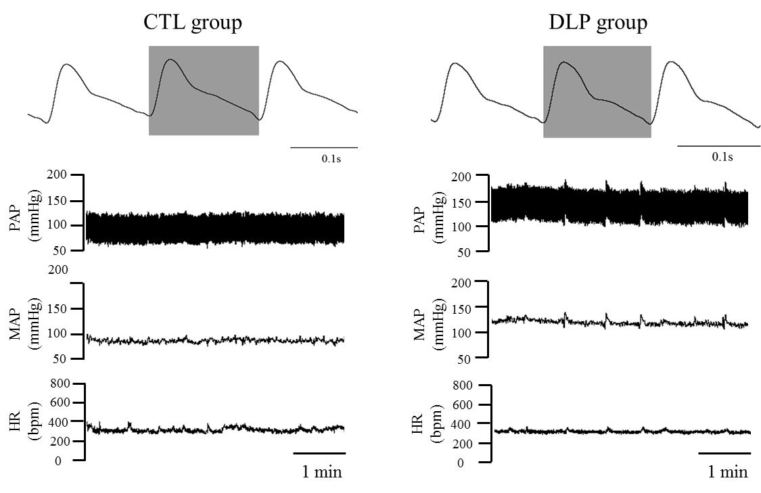
Supplementary Fig. 2. Representative baseline recordings of pulsatile arterial pressure (PAP), mean arterial pressure (MAP) and hear rate (HR) in male offspring from control and dyslipidemic dams.

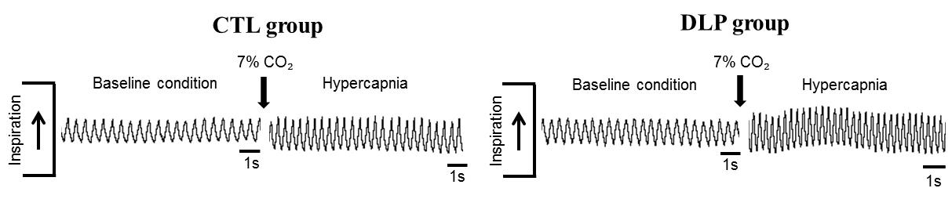
Supplementary Fig. 3. Breathing recordings of one representative offspring from control and dyslipidemic dams at 90 days during at rest and after hypercapnia stimulation (7% CO₂).

