Online Supporting Material

OSM-Table 1: Dietary intake, whole blood n-3 LCPUFA status and physical activity at 13 years in the children in the three groups
 | HF |  | OO |  | FO |  | P_{Group*sex} | P_{FOvsOO}
 | Boys | Girls | Boys | Girls | Boys | Girls
n | 18 | 18 | 16 | 17 | 19 | 12
Energy intake (MJ/day) | 10.2±3.5 | 9.2±3.0 | 10.5±3.8 | 9.6±4.3 | 10.1±3.5 | 7.4±2.5 | 0.408 | 0.255
Carbohydrate intake (E%) | 55.1±4.9 | 51.3±3.6 | 52.7±4.9 | 53.5±5.1 | 53.5±4.8 | 52.1±3.9 | 0.414 | 0.849
Fat intake (E%) | 29.2±4.0 | 33.2±3.5 | 31.9±4.0 | 30.2±4.0 | 31.9±6.3 | 32.2±4.3 | 0.462 | 0.457
Protein intake (E%) | 15.8±2.6 | 15.5±1.9 | 15.4±2.6 | 16.3±2.5 | 14.6±2.5 | 15.8±1.2 | 0.845 | 0.265
Physical activity (cpm) | 878±260 | 751±164 (15) | 930±242 (15) | 738±176 (16) | 832±176 (13) | 719±253 (11) | 0.525 | 0.343
Physical activity (cpm) | 452±139 | 372±101 (15) | 459±150 (15) | 369±124 (16) | 400±87 (13) | 353±136 (11) | 0.539 | 0.291

Data are given as mean ± SD with n in parenthesis if different from column n. The given P-values (for the main effect (P_{FOvsOO}) and for the sex × treatment interaction (P_{Group*sex})) are based on a statistical comparisons of the two randomized groups (FO vs. OO) by ANCOVA adjusting for sex and age.
DHA, docosahexaenoic acid; EPA, eicosapentaenoid acid; FA%, % of total whole blood fatty acids; E%, percent of energy.

Online Supporting Material

OSM-Table 2: Whole blood fatty acid composition at 13 years of the children in the three groups
 | HF | OO | FO | FO vs OO  p
 | (n = 18) | (n = 18) | (n = 13)
SFA | 41.8 ± 2.7 | 41.8 ± 2.2 | 42.0 ± 2.1 | 0.868
MUFA | 23.6 ± 2.1 | 24.8 ± 2.1 | 24.0 ± 2.2 | 0.310
PUFA | 26.6 ± 3.5 | 25.4 ± 2.6 | 26.0 ± 3.0 | 0.613
n-6 PUFA | 23.7 ± 3.0 | 22.8 ± 2.4 | 23.2 ± 2.6 | 0.665
18:2n-6 | 15.9 ± 2.0 | 15.5 ± 2.1 | 15.3 ± 1.9 | 0.877
20:3n-6 | 1.05 ± 0.20 | 1.06 ± 0.24 | 1.00 ± 0.26 | 0.485
20:4n-6 | 5.50 ± 1.11 | 4.90 ± 0.81 | 5.49 ± 1.03 | 0.112
22:4n-6 | 0.71 ± 0.14 | 0.69 ± 0.16 | 0.74 ± 0.11 | 0.434
22:5n-6 | 0.17 ± 0.04 | 0.17 ± 0.04 | 0.18 ± 0.04 | 0.773
n-3PUFA | 2.89 ± 0.70 | 2.66 ± 0.65 | 2.79 ± 0.62 | 0.599
18:3n-3 | 0.33 ± 0.12 | 0.33 ± 0.17 | 0.34 ± 0.13 | 0.859
20:5n-3 | 0.38 ± 0.20 | 0.31 ± 0.14 | 0.33 ± 0.11 | 0.731
22:5n-3 | 0.65 ± 0.13 | 0.62 ± 0.10 | 0.65 ± 0.11 | 0.595
22:6n-3 | 1.50 ± 0.41 | 1.37 ± 0.44 | 1.45 ± 0.40 | 0.612
n-6/n-3PUFA | 8.5 ± 1.7 | 9.0 ± 2.2 | 8.5 ± 1.3 | 0.538
Total FA | 177 ± 40 | 178 ± 44 | 176 ± 32 | 0.940
Data are given as mean ± SD of individual fatty acids and fatty acid classes expressed as % of total whole blood fatty acids (FA%) and total whole blood fatty acid as in µg/mL. Data from girls and boys are combined as they did not differ. The statistical comparisons of the two randomized groups (FO vs. OO) were performed by ANCOVA adjusting for sex and age and values in girls and boys were compared by t-test. Eicosapentaenoic acid were not normally distributed and thus, also compared using a Mann-Whitney U-test (p=0.689).
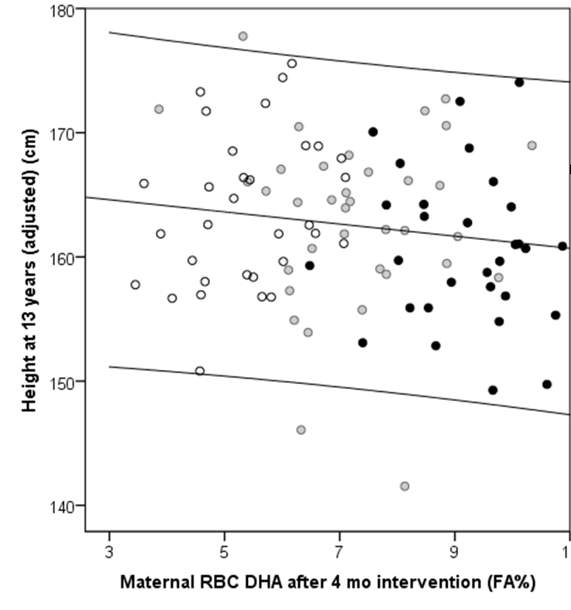
OSM-Figure 1. Association between height at 13 years of age adjusted for exact age, sex, and breastfeeding and maternal erythrocyte docosahexaenoic acid (RBC DHA) at the end of the intervention period in the three groups (the maternal fish oil supplemented group in black, the olive oil control group in white and the maternal high fish intake reference group in grey). The regression lines are given with 95% prediction interval.

