Online Supplemental Material. Supplementary Figure 1. Exclusion criteria for the study population

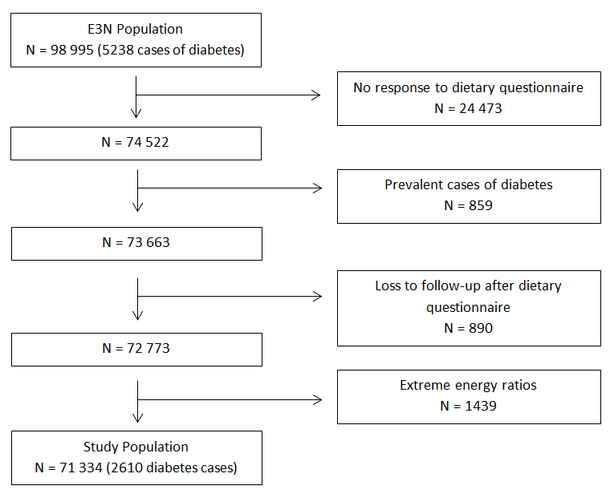
Online Supplemental Material. Supplementary Table 1. BMI stratified Cox proportional hazards ratios [95% CI] of the risk of incident type 2 diabetes by fatty acid consumption in g/day in the E3N study cohort (n=71 334)
 |  |  |  | BMI <25kg/m² (n=57 408) |  |  | BMI ≥ 25kg/m² (n=13 926)
Variable (g/day) |  |  | No. of cases/noncases |  | Model 1 | Model 2 | No. of cases/noncases | Model 1 | Model 2
SFA
 | <33.3 |  | 357/18660 |  | 1 (Reference) | 1 (Reference) | 486/4038 | 1 (Reference) | 1 (Reference)
 | 33.3-38.9 |  | 350/18599 |  | 1.04 [0.90-1.21] | 1.06 [0.88-1.27] | 497/4093 | 1.07 [0.94-1.21] | 1.07 [0.92-1.25]
 | ≥ 38.9 |  | 389/19053 |  | 1.17 [1.01-1.35] | 1.13 [0.89-1.43] | 531/4281 | 1.10 [0.97-1.24] | 1.03 [0.85-1.26]
 | P for trend |  |  |  | 0.04 | 0.33 |  | 0.15 | 0.76
MUFA
 | <28.7 |  | 349/19102 |  | 1 (Reference) | 1 (Reference) | 436/3653 | 1 (Reference) | 1 (Reference)
 | 28.7-33.3 |  | 361/18622 |  | 1.12 [0.96-1.30] | 1.06 [0.91-1.25] | 478/4080 | 1.02 [0.89-1.16] | 1.00 [0.87-1.15]
 | ≥ 33.3 |  | 386/18588 |  | 1.21 [1.05-1.41] | 1.12 [0.95-1.33] | 600/4679 | 1.12 [0.99-1.27] | 1.09 [0.94-1.26]
 | P for trend |  |  |  | 0.02 | 0.19 |  | 0.06 | 0.20
PUFA
 | <12.0 |  | 324/19468 |  | 1 (Reference) | 1 (Reference) | 396/3353 | 1 (Reference) | 1 (Reference)
 | 12.0-15.3 |  | 378/18765 |  | 1.16 [1.00-1.35] | 1.16 [0.99-1.34] | 457/3939 | 0.97 [0.85-1.11] | 0.97 [0.85-1.11]
 | ≥ 15.3 |  | 394/18079 |  | 1.23 [1.06-1.43] | 1.22 [1.05-1.42] | 661/5120 | 1.02 [0.90-1.16] | 1.02 [0.89-1.16]
 | P for trend |  |  |  | <0.01 | 0.01 |  | 0.65 | 0.70
n-6 PUFA
 | <10.5 |  | 329/19388 |  | 1 (Reference) | 1 (Reference) | 405/3419 | 1 (Reference) | 1 (Reference)
 | 10.5-13.7 |  | 383/18755 |  | 1.16 [1.00-1.34] | 1.13 [0.97-1.31] | 457/3945 | 0.97 [0.85-1.12] | 0.93 [0.82-1.07]
 | ≥ 13.7 |  | 384/18169 |  | 1.18 [1.02-1.37] | 1.13 [0.96-1.32] | 652/5048 | 1.02 [0.90-1.15] | 0.95 [0.83-1.08]
 | P for trend |  |  |  | 0.04 | 0.17 |  | 0.68 | 0.52
n-3 PUFA
 | < 1.3 |  | 325/19544 |  | 1 (Reference) | 1 (Reference) | 340/3332 | 1 (Reference) | 1 (Reference)
 | 1.3-1.6 |  | 365/18748 |  | 1.13 [0.97-1.31] | 1.08 [0.92-1.26] | 454/3972 | 1.14 [0.99-1.31] | 1.15 [0.99-1.33]
 | ≥ 1.6 |  | 406/18020 |  | 1.28 [1.10-1.48] | 1.19 [1.01-1.40] | 720/5108 | 1.36 [1.20-1.55] | 1.38 [1.20-1.59]
 | P for trend |  |  |  | <0.01 | 0.04 |  | <0.0001 | <0.0001
TFA
 | < 1.4 |  | 370/18265 |  | 1 (Reference) | 1 (Reference) | 550/4356 | 1 (Reference) | 1 (Reference)
 | 1.4-1.7 |  | 335/18689 |  | 0.92 [0.80-1.07] | 0.89 [0.75-1.06] | 549/3966 | 0.95 [0.84-1.08] | 0.92 [0.79-1.06]
 | ≥ 1.7 |  | 391/19358 |  | 1.07 [0.93-1.23] | 0.98 [0.78-1.21] | 505/4000 | 1.07 [0.95-1.21] | 1.03 [0.86-1.24]
 | P for trend |  |  |  | 0.32 | 0.86 |  | 0.26 | 0.73

*Model 1: adjusted for daily energy intake, alcohol consumption and non-dietary factors: level of education, family history of diabetes, physical activity, hypertension, hypercholesterolaemia, and smoking status; Model 2: Model 1 + tertile groups of remaining fatty acid groups
†MUFA, monounsaturated fatty acids; n-3 PUFA, omega-3 polyunsaturated fatty acids; n-6 PUFA, omega-6 polyunsaturated fatty acids; PUFA, polyunsaturated fatty acids; SFA, saturated fatty acids; TFA, trans unsaturated fatty acids

Online Supplemental Material. Supplementary Table 2. Sensitivity analysis of the risk of type 2 diabetes by fatty acid consumption, exclusion of 388 women who developed diabetes in the 5 years after study inclusion (Hazard ratios [95%CI]) (N=70 946)

Variable (g/day) |  | No. of cases/noncases | Univariate | Model 1 | Model 2 | Model 3
SFA
 | <33.3 | 717/22698 | 1 (Reference) | 1 (Reference) | 1 (Reference) | 1 (Reference)
 | 33.3-38.9 | 721/22692 | 1.04 [0.94-1.15] | 1.1 [0.99-1.22] | 1.11 [0.98-1.26] | 1.07 [0.94-1.21]
 | ≥ 38.9 | 784/23334 | 1.13 [1.02-1.25] | 1.18 [1.06-1.30] | 1.13 [0.96-1.34] | 1.08 [0.92-1.28]
 | P for trend |  | 0.02 | <0.01 | 0.15 | 0.35
MUFA
 | <28.7 | 671/22755 | 1 (Reference) | 1 (Reference) | 1 (Reference) | 1 (Reference)
 | 28.7-33.3 | 706/22702 | 1.1 [0.99-1.22] | 1.13 [1.02-1.26] | 1.08 [0.96-1.21] | 1 [0.89-1.12]
 | ≥ 33.3 | 845/23267 | 1.31 [1.18-1.45] | 1.33 [1.20-1.48] | 1.24 [1.10-1.39] | 1.07 [0.95-1.21]
 | P for trend |  | <0.0001 | <0.0001 | <0.001 | 0.21
PUFA
 | <12.0 | 607/22821 | 1 (Reference) | 1 (Reference) | 1 (Reference) | 1 (Reference)
 | 12.0-15.3 | 718/22704 | 1.19 [1.07-1.32] | 1.17 [1.05-1.30] | 1.15 [1.03-1.29] | 1.06 [0.95-1.18]
 | ≥ 15.3 | 897/23199 | 1.47 [1.33-1.64] | 1.36 [1.22-1.51] | 1.31 [1.18-1.46] | 1.09 [0.98-1.21]
 | P for trend |  | <0.0001 | <0.0001 | <0.0001 | 0.13
n-6 PUFA
 | <10.5 | 618/22807 | 1 (Reference) | 1 (Reference) | 1 (Reference) | 1 (Reference)
 | 10.5-13.7 | 727/22700 | 1.18 [1.06-1.32] | 1.16 [1.04-1.29] | 1.1 [0.99-1.23] | 1.05 [0.94-1.17]
 | ≥ 13.7 | 877/23217 | 1.42 [1.28-1.57] | 1.31 [1.18-1.45] | 1.18 [1.06-1.32] | 1.03 [0.92-1.15]
 | P for trend |  | <0.0001 | <0.0001 | <0.01 | 0.72
n-3 PUFA
 | < 1.3 | 583/22876 | 1 (Reference) | 1 (Reference) | 1 (Reference) | 1 (Reference)
 | 1.3-1.6 | 694/22720 | 1.21 [1.08-1.35] | 1.19 [1.07-1.33] | 1.13 [1.01-1.27] | 1.06 [0.95-1.19]
 | ≥ 1.6 | 945/23128 | 1.61 [1.45-1.78] | 1.54 [1.39-1.71] | 1.4 [1.24-1.57] | 1.21 [1.08-1.36]
 | P for trend |  | <0.0001 | <0.0001 | <0.0001 | <0.001
TFA
 | < 1.4 | 782/22621 | 1 (Reference) | 1 (Reference) | 1 (Reference) | 1 (Reference)
 | 1.4-1.7 | 680/22745 | 0.88 [0.79-0.98] | 0.93 [0.84-1.04] | 0.88 [0.78-0.99] | 0.9 [0.80-1.01]
 | ≥ 1.7 | 760/23358 | 0.88 [0.79-0.98] | 0.93 [0.84-1.04] | 0.88 [0.78-0.99] | 0.9 [0.80-1.01]
 | P for trend |  | 0.71 | 0.53 | 0.34 | 0.88

*Model 1: adjusted for daily energy intake, alcohol consumption and non-dietary factors: level of education, family history of diabetes, physical activity, hypertension, hypercholesterolaemia, and smoking status; Model 2: Model 1 + tertile groups of remaining fatty acid groups; Model 3: Model 2 + BMI
†MUFA, monounsaturated fatty acids; n-3 PUFA, omega-3 polyunsaturated fatty acids; n-6 PUFA, omega-6 polyunsaturated fatty acids; PUFA, polyunsaturated fatty acids; SFA, saturated fatty acids; TFA, trans unsaturated fatty acids
Online Supplemental Material. Supplementary Table 3. Cox proportional hazards ratios [95% CI] of the risk of incident type 2 diabetes by omega-3 and omega-6 fatty acid consumption (g/day) after adjustment on meat consumption (g/day) in the E3N study cohort (N=71 334) with BMI stratification
Variable |  | No. of cases/noncases | n = 71 334 | No. of cases/noncases | BMI <25kg/m² (n=57 408) | No. of cases/noncases | BMI ≥ 25kg/m² (n=13 926)
ALA
 | <0.90 | 757/22784 | 1 (Reference) | 358/19213 | 1 (Reference) | 399/3571 | 1 (Reference)
 | 0.90-1.14 | 843/22696 | 1.00 [0.90-1.12] | 365/18649 | 0.93 [0.79-1.09] | 478/4047 | 1.08 [0.93-1.24]
 | ≥ 1.14 | 1010/23244 | 1.03 [0.92-1.15] | 373/18450 | 0.90 [0.76-1.08] | 637/4794 | 1.17 [1.01-1.35]
 | P for trend |  | 0.60 |  | 0.28 |  | 0.04
DPA
 | <0.05 | 610/22931 | 1 (Reference) | 307/19912 | 1 (Reference) | 303/3019 | 1 (Reference)
 | 0.05-0.08 | 805/22734 | 1.06 [0.93-1.21] | 364/18723 | 1.09 [0.90-1.31] | 441/4011 | 1.07 [0.90-1.27]
 | ≥ 0.08 | 1195/23059 | 1.21 [1.03-1.42] | 425/17677 | 1.16 [0.91-1.48] | 770/5382 | 1.33 [1.08-1.64]
 | P for trend |  | 0.01 |  | 0.26 |  | <0.01
AA
 | <0.19 | 579/22961 | 1 (Reference) | 327/20068 | 1 (Reference) | 252/2893 | 1 (Reference)
 | 0.19-0.25 | 750/22790 | 1.08 [0.96-1.22] | 329/18869 | 0.98 [0.83-1.16] | 421/3921 | 1.27 [1.07-1.50]
 | ≥ 0.25 | 1281/22973 | 1.40 [1.23-1.59] | 440/17375 | 1.31 [1.09-1.59] | 841/5598 | 1.68 [1.41-2.00]
 | P for trend |  | <0.0001 |  | <0.01 |  | <0.0001

*Models adjusted for daily energy intake, alcohol consumption level of education, family history of diabetes, physical activity, hypertension, hypercholesterolaemia, and smoking status and tertile groups of remaining fatty acids
†AA, arachidonic acid (20:4n6); ALA, α-linolenic acid (18:3n3); DPA, docosapentaenoic acid (22:5n3)

