Supplementary Table 1. Composition of the experimental diets (calculated values).

 | HFI | HFR | HFR | HFR
 | 100% ad libitum | 75% ad libitum | 60% ad libitum | 50% ad libitum
Ingredients (g/kg)
Casein HCl | 195 | 256 | 322 | 379
L-Cystine | 2.50 | 3.28 | 4.13 | 4.86
Corn starch | 250 | 196 | 135 | 87
Sucrose | 142 | 112 | 78 | 50
Oils * | 295 | 295 | 300 | 302
Alpha-cellulose | 50.3 | 50.21 | 50.1 | 50.0
AIN 93M Mineral mix | 48.5 | 63.7 | 80.2 | 94.4
AIN 93VX Vitamin mix | 13.9 | 18.2 | 23.0 | 27.0
Choline chloride | 2.78 | 3.64 | 4.59 | 5.40
Energy
Total (MJ/kg) | 20.17 | 19.89 | 19.70 | 19.62
Protein (%) | 15.6 | 20.6 | 26.4 | 31.3
Lipid (%) | 54.5 | 55.6 | 56.8 | 57.8
Carbohydrate (%) | 29.9 | 23.8 | 16.8 | 10.8

HFI, high-fat induction diet; HFR, high-fat restriction diet.
*: blend of 78.4% high-oleic sunflower oil and 21.6% sunflower oil in the HFI- and HFR-OLE diets, rich in oleic acid (18:1 n-9); 100% rapeseed oil in the HFI- and HFR-ALA diets, rich in a-linolenic acid (18:3 n-3); 33.2% fish oil, 40.3% high-oleic sunflower oil and 26.5% sunflower oil in the HFI- and HFR-LC diets, rich in n-3 long-chain polyunsaturated fatty acids.

Supplementary Table 2. Primer sequences used in quantitative RT-PCR analysis.

Gene name | Forward primer | Reverse primer
HPRT | TCCATTCCTATGACTGTAGATTTTATCAG | AAATTTTATGTCCCCCGTTGACT
Fbxo32 | GGACTTCTCGACTGCCATCCT | CAGCTCCAACAGCCTTACTACGT
Murf1 | GGTGCCTACTTGCTCCTTGTG | CAGTTCAGTCTTCTGTCCTTGGAA
Psma1 | AGAAAGACCACAGAGAAAAGC | TACCACCCAATACATTACAGC
Ubb | CGCACCCTCTCTGACTACA | GCCCTCTTTATCCTGGATCT
Capn2 | GCTGGAGGAAGAAGATGAAG | GTTTTTGCTGAGGTGGATG
Ctsd | ACACTGGCTCCTCTAACCTG | TCCACCTTGATACCTCCTAAG
InsR | CCAATGGCAACATCACACACTA | TTCAGCCCTTTGAGACAATAATCC

HPRT, hypoxanthine phosphoribosyltransferase; Fbxo32, F-box protein 32 (or MAFbx); MuRF1, muscle ring finger-1 (or E3 ubiquitin protein ligase); Psma1, proteasome subunit, alpha type 1; Ubb, ubiquitin B; Capn2, calpain-2; Ctsd, cathepsin D; InsR, insulin receptor.

Supplementary Table 3. Fatty acid composition (mol/100 mol) of polar lipids in the Gastrocnemius muscle after a 8-week energy restriction.

 | OLE-AL | OLE-R | ALA-R | LC-R | Restriction | Dietary FA
C16:0 | 17.21±0.40^{bc} | 17.11±0.27^{bc} | 17.85±0.35^{ac} | 18.69±0.47ª* | 0.1318 | 0.0180
C18:0 | 14.99±0.28ª | 15.02±0.18ª | 13.12±0.19^{b}*** | 13.61±0.20^{b}*** | 0.0001 | <0.0001
C22:0 | 1.70±0.20 | 1.69±0.26 | 1.77±0.24 | 2.01±0.18 | 0.6376 | 0.5865
Total SFA | 34.28±0.34^{ac} | 34.20±0.18^{ac} | 33.18±0.27^{bc} | 34.88±0.51ª | 0.6308 | 0.0038
C16:1 n-9 | 0.36±0.01ª | 0.30±0.01^{b} | 0.31±0.01^{b}* | 0.27±0.01^{b}*** | 0.0003 | 0.2356
C16:1 n-7 | 0.26±0.02^{b} | 0.23±0.02^{b} | 0.28±0.02^{b} | 0.53±0.04ª*** | 0.0172 | <0.0001
C18:1 n-9c | 13.09±0.26ª | 13.15±0.60ª | 11.65±0.36^{ac} | 10.90±0.54^{bc}** | 0.0344 | 0.0044
C18:1 n-7 | 2.53±0.0^{b} | 2.55±0.06^{b} | 3.63±0.07ª*** | 2.63±0.07^{b} | <0.0001 | <0.0001
C20:1 n-9 | 0.17±0.01^{b} | 0.17±0.04^{b} | 0.26±0.01ª* | 0.14±0.01^{b} | 0.4960 | 0.0008
Total MUFA | 16.45±0.30 | 16.48±0.68 | 16.22±0.43 | 14.53±0.61* | 0.2642 | 0.0282
C18:2 n-6c | 13.94±1.25^{c} | 15.46±1.36^{b}** | 17.08±0.80ª*** | 18.15±0.79ª*** | <0.0001 | <0.0001
C20:3 n-6 | 0.46±0.05 | 0.46±0.04 | 0.52±0.05 | 0.50±0.16 | 0.2725 | 0.2233
C20:4 n-6 | 17.86±0.38ª | 17.52±0.39ª | 13.31±0.23^{b}*** | 7.40±0.242^{c}*** | <0.0001 | <0.0001
C22:4 n-6 | 1.03±0.03ª | 0.83±0.02^{b}*** | 0.29±0.01^{c}*** | 0.14±0.03^{d}*** | <0.0001 | <0.0001
C22:5 n-6 | 2.72±0.20ª | 1.99±0.16^{b}*** | 0.30±0.05^{c}*** | 0.34±0.03^{c}*** | <0.0001 | <0.0001
Total n-6 | 36.36±0.41ª | 36.53±0.56ª | 31.75±0.32^{b}*** | 27.61±0.29^{c}*** | <0.0001 | <0.0001
LC n-6 | 22.23±0.49ª | 20.88±0.40ª* | 14.53±0.19^{b}*** | 9.18±0.30^{c}*** | <0.0001 | <0.0001
C18:3 n-3 | 0.05±0.0^{b} | 0.05±0.01^{b} | 0.48±0.03ª*** | 0.10±0.02^{b} | <0.0001 | 0.0001
C20:3 n-3 | 1.02±0.11 | 0.99±0.08 | 1.07±0.12 | 1.07±0.10 | 0.8386 | 0.8339
C20:5 n-3 | 0.20±0.03^{b} | 0.16±0.04^{b} | 0.31±0.02^{b} | 1.04±0.07ª*** | <0.0001 | <0.0001
C22:5 n-3 | 1.08±0.05^{c} | 1.07±0.04^{c} | 2.77±0.11ª*** | 1.78±0.04^{b}*** | <0.0001 | <0.0001
C22:6 n-3 | 10.52±10.43^{c} | 10.41±0.26^{c} | 14.19±0.20^{b}*** | 18.93±0.66ª*** | <0.0001 | <0.0001
Total n-3 | 12.91±0.48^{c} | 12.79±0.27^{c} | 18.85±0.22^{b}*** | 23.08±0.71ª*** | <0.0001 | <0.0001
LC n-3 | 12.88±0.48^{c} | 12.75±0.27^{c} | 18.37±0.23^{b}*** | 22.98±0.72ª*** | <0.0001 | <0.0001
Total PUFA | 49.27±0.48 | 49.32±0.65 | 50.60±0.29 | 50.59±0.74 | 0.1897 | 0.1837

Values are means ± SD for 11-12 rats per group. Only fatty acids (FA) accounting for more than 1% or with physiologically relevant are given. SFA, saturated fatty acid; MUFA, monounsaturated fatty acid; LC, long chain; ND, not detected (detection limit 0.1-0.2% of total FA). AL, ad libitum; R, restricted; OLE, diet rich in oleic acid (18:1 n-9); ALA, diet rich in α-linolenic acid (18:3 n-3); LC, diet rich in n-3 long-chain polyunsaturated fatty acids.
Mean values within a row sharing a same superscript letter or without superscript letter were not significantly different at P<0.05 according to post-hoc Tukey-Kramer analysis.
*, p<0.05; **, p<0.01; ***, p<0.001 compared to the OLE-AL group according to Dunnett’s test.
Supplementary Table 4. Fatty acid composition (mol/100 mol) of neutral lipids in the Gastrocnemius muscle after a 8-week energy restriction.

 | OLE-AL | OLE-R | ALA-R | LC-R | Restriction | Dietary FA
C14:0 | 0.66±0.02^{b} | 0.58±0.02^{b} | 0.63±0.02^{b} | 1.33±0.03ª*** | <0.0001 | <0.0001
C16:0 | 13.44±0.24^{b} | 12.84±0.26^{b} | 13.69±0.32^{b} | 15.84±0.26ª*** | 0.1099 | 0.0006
C18:0 | 4.59±0.22 | 4.86±0.23 | 4.18±0.15 | 4.67±0.13 | 0.5309 | 0.3721
Total SFA | 19.55±0.48^{b} | 19.10±0.44^{b} | 19.61±0.45^{b} | 23.02±0.36ª*** | 0.0864 | 0.0065
C16:1 n-7 | 1.66±0.12^{b} | 1.42±0.08^{b} | 1.73±0.15^{b} | 2.88±0.13ª*** | 0.3106 | 0.0004
C18:1 n-9c | 51.53±0.68ª | 51.30±0.92ª | 44.62±0.52^{b}*** | 40.95±0.37^{b}*** | 0.0002 | <0.0001
C18:1 n-7 | 2.18±0.04^{b} | 2.28±0.21^{b} | 4.09±005ª*** | 3.20±0.08ª* | 0.004 | <0.0001
Total MUFA | 56.37±0.76ª | 56.04±0.80ª | 52.03±0.535^{b}*** | 48.10±0.40^{b}*** | 0.0013 | 0.0003
C18:2 n-6c | 18.58±0.31^{b} | 18.84±0.29^{b} | 19.61±0.17^{b} | 21.61±0.35ª*** | 0.0217 | <0.0001
C20:3 n-6 | 0.13±0.01 | 0.14±0.01 | 0.16±0.01 | 0.17±0.01 | 0.1293 | 0.8622
C20:4 n-6 | 2.51±0.24^{ab} | 2.76±0.27ª | 2.33±0.11^{ab} | 1.33±0.08^{b} | 0.5374 | 0.0129
C22:4 n-6 | 0.32±0.01ª | 0.30±0.02ª | 0.17±0.01^{b}** | 0.14±0.02^{b}*** | 0.0021 | <0.0001
C22:5 n-6 | 0.36±0.04ª | 0.31±0.03ª | 0.02±0.014^{b}*** | 0.14±0.03^{b}*** | 0.0003 | <0.0001
Total n-6 | 22.19±0.31^{ab} | 22.61±0.32^{b} | 22.52±0.22^{ab} | 23.76±0.32ª* | 0.2186 | 0.0250
LC n-6 | 3.45±0.27^{ab} | 3.64±0.31ª | 2.81±0.13^{ab} | 1.94±0.10^{b}* | 0.2736 | 0.0088
C18:3 n-3 | 0.33±0.06^{b} | 0.27±0.03^{b} | 2.66±0.09ª*** | 0.40±0.02^{b} | <0.0001 | <0.0001
C20:5 n-3 | 0.08±0.01^{b} | 0.12±0.02^{b} | 0.12±0.01^{b} | 0.56±0.04ª*** | <0.0001 | <0.0001
C22:5 n-3 | 0.14±0.01^{b} | 0.16±0.01^{b} | 0.57±0.03ª*** | 0.76±0.04ª*** | <0.0001 | <0.0001
C22:6 n-3 | 0.83±0.10^{b} | 1.11±0.12^{bc} | 1.75±0.11^{ac}*** | 2.58±0.20ª*** | 0.0005 | 0.0041
Total n-3 | 1.89±0.19^{b} | 2.25±0.17^{b} | 5.84±0.22ª*** | 5.12±0.28ª*** | <0.0001 | <0.0001
LC n-3 | 1.56±0.16^{b} | 1.97±0.18^{bc} | 3.15±0.26^{ac}*** | 4.64±0.28ª*** | 0.0003 | 0.0005
Total PUFA | 24.08±0.41^{b} | 24.86±0.43^{b} | 28.36±0.30ª*** | 28.87±0.32ª*** | <0.0001 | <0.0001

Values are means ± SD for 11-12 rats per group. Only fatty acids (FA) accounting for more than 1% or with physiologically relevant are given. SFA, saturated fatty acid; MUFA, monounsaturated fatty acid; LC, long chain; ND, not detected (detection limit 0.1-0.2% of total FA) AL, ad libitum; R, restricted; OLE, diet rich in oleic acid (18:1 n-9); ALA, diet rich in α-linolenic acid (18:3 n-3); LC, diet rich in n-3 long-chain polyunsaturated fatty acids.
Mean values within a row sharing a same superscript letter or without superscript letter were not significantly different at P<0.05 according to post-hoc Tukey-Kramer analysis.
*, p<0.05; **, p<0.01; ***, p<0.001 compared to the OLE-AL group according to Dunnett’s test.

Supplementary Figure 1. Relative phosphorylation level of Gastrocnemius muscle proteins involved in insulin signaling.

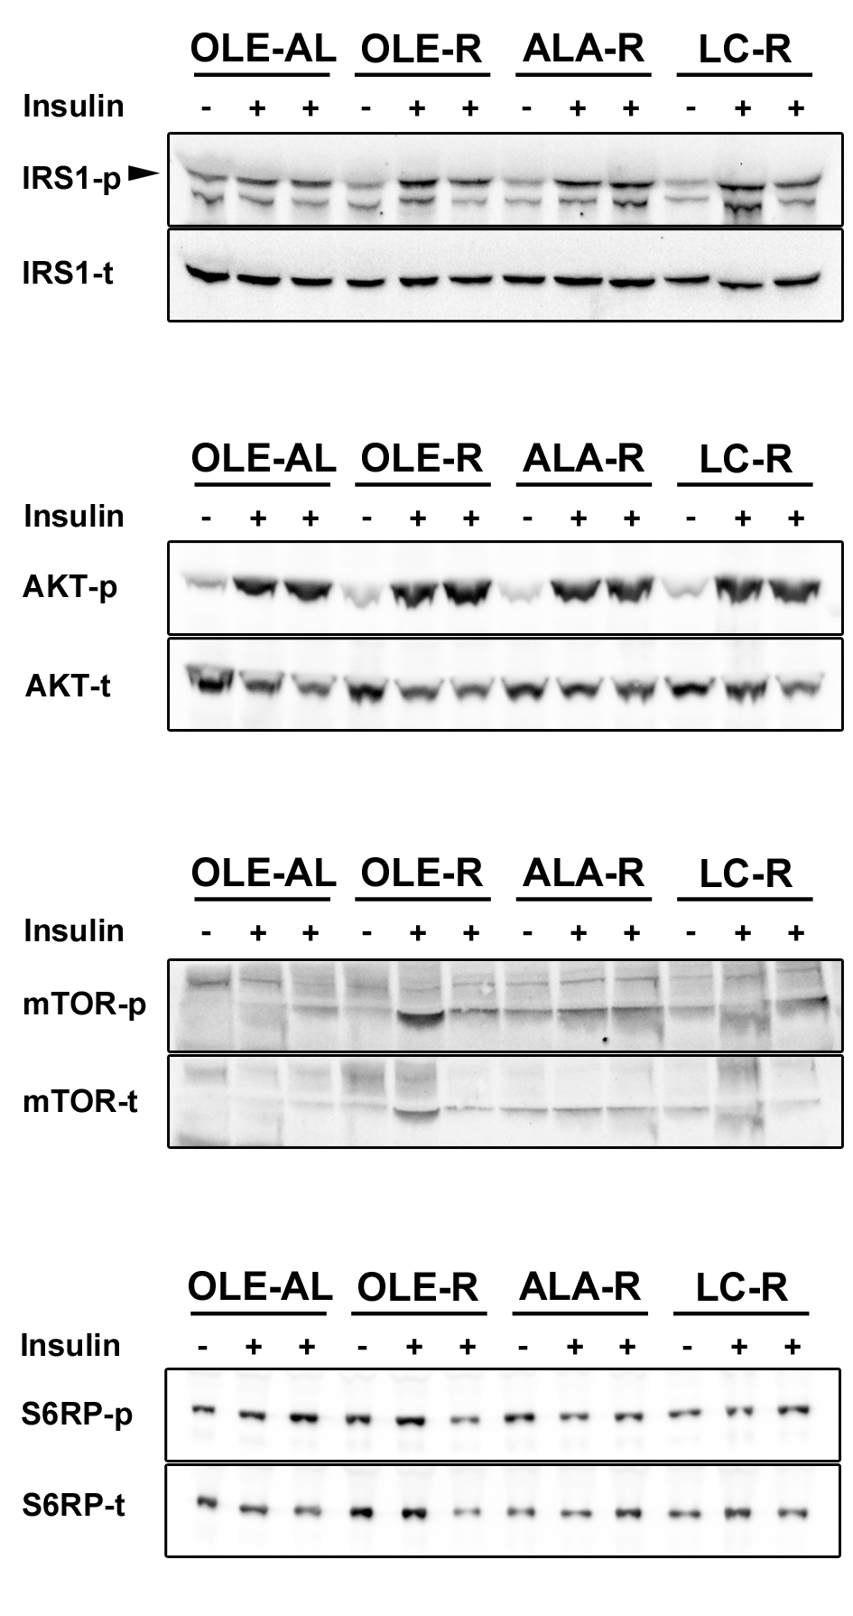

(-) rats receiving an injection of saline solution; (+) rats receiving an injection of insulin at 1UI/Kg; IRS1, insulin receptor substrate 1; AKT, protein kinase B (PKB); mTOR, mammalian target of rapamycin; S6RP, phosphorylated S6 ribosomal protein. AL, ad libitum; R, restricted; OLE, diet rich in oleic acid (18:1 n-9); ALA, diet rich in α-linolenic acid (18:3 n-3); LC, diet rich in n-3 long-chain polyunsaturated fatty acids.

