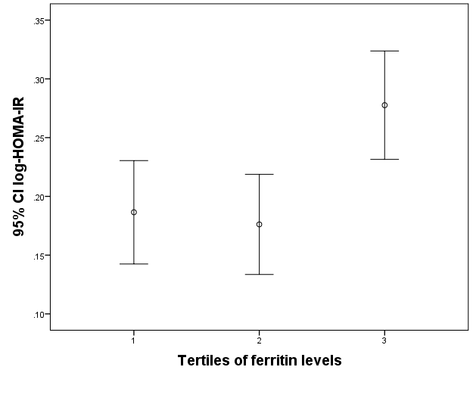
Supplementary figure 1. Levels of HOMA-IR by sex/menopausal status-specific tertiles of ferritin in the whole group. Levels of HOMA-IR were significantly higher in the highest tertile of ferritin vs. tertiles 2 and 1 (P=0.0019 ANOVA / P=0.0139 ANCOVA). Covariates for ANCOVA were: age, fibrinogen levels, HbA1C, smoking status (yes/no/ex-smoker), alcohol consumption (no/yes), treatment with insulin and/or hypoglycemic drugs (yes/no), BMI and sex/menopausal status (premenopausal women [reference] / postmenopausal women/men). Analyses were performed with transformed values of skewed variables: square of age, square root of glycosylated hemoglobin, and logarithm of fibrinogen and body mass index. Further adjustment for cardiovascular disease, diabetes (excluding treatment with insulin and/or hypoglycemic drugs in the model), physical at work (sitting [reference], light, moderate, and hard), and physical activity at leisure (sitting [reference], light, moderate, and hard) did not affect the difference in log-HOMA-IR across tertiles of ferritin (P=0.039 ANCOVA).

