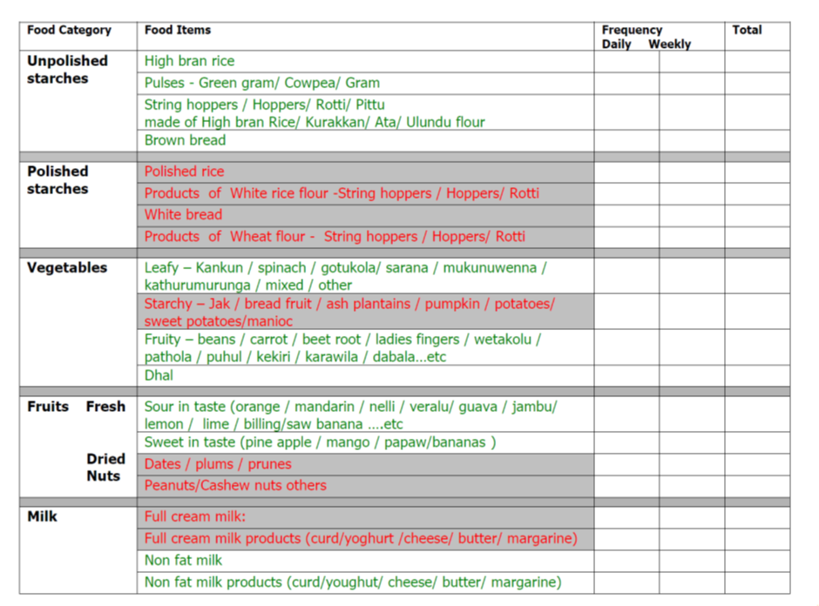Supplementary data: Dietary data collection sheet showing number of recommended and non-recommended items completed at baseline, and each year of the 5-year trial.

\*

\*Sweets and beverages refer to tea and coffee which have sugar or honey added.