Online Supporting Material
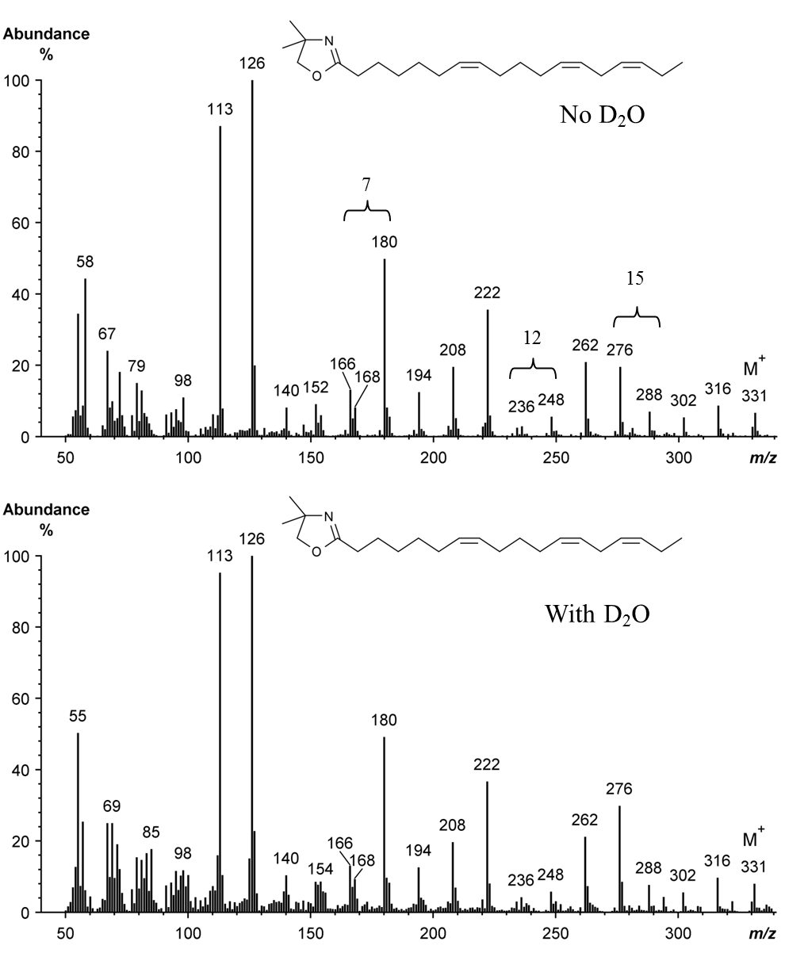
Supplementary Fig. S1. Mass spectrum of the 4,4-dimethyloxazoline derivative of cis-7,cis-12,cis-15-18 : 3 formed from α-linolenic acid during incubations with strained rumen contents diluted with buffer prepared using deionized water or deuterium oxide. A molecular ion at m/z 331 confirmed the octadecatrienoic acid structure. Gaps of 12 atomic mass units between m/z 168 and 180, 236 and 248 and 276 and 288 located double bonds at Δ7, 12 and 15, respectively. Comparison of the mass spectrum of cis-7,cis-12,cis-15-18 : 3 formed during incubations with or without deuterium oxide provided no evidence of labelling.
Online Supporting Material
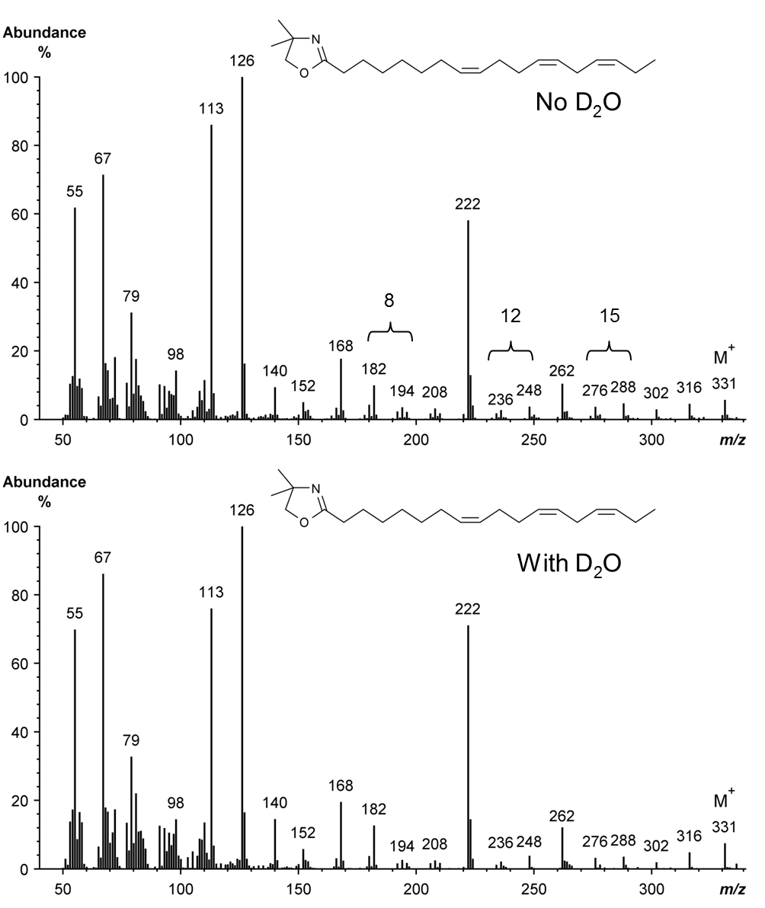

Supplementary Fig. S2. Mass spectrum of the 4,4-dimethyloxazoline derivative of cis-8,cis-12,cis-15-18 : 3 synthesized from α-linolenic acid during incubations with strained rumen contents diluted with buffer prepared using deionized water or deuterium oxide. A molecular ion at m/z 331 confirmed an octadecatrienoic acid structure. Gaps of 12 atomic mass units between m/z 182 and 194, 236 and 248 and an abundant ion at m/z 222 confirmed a Δ8,12 double bond arrangement. The double bond at Δ15 was located based on a gap of 12 atomic mass units at m/z 276 and 288. Comparison of the mass spectrum of cis-8,cis-12,cis-15-18 : 3 formed during incubations with or without deuterium oxide provided no evidence of labelling.
Online Supporting Material
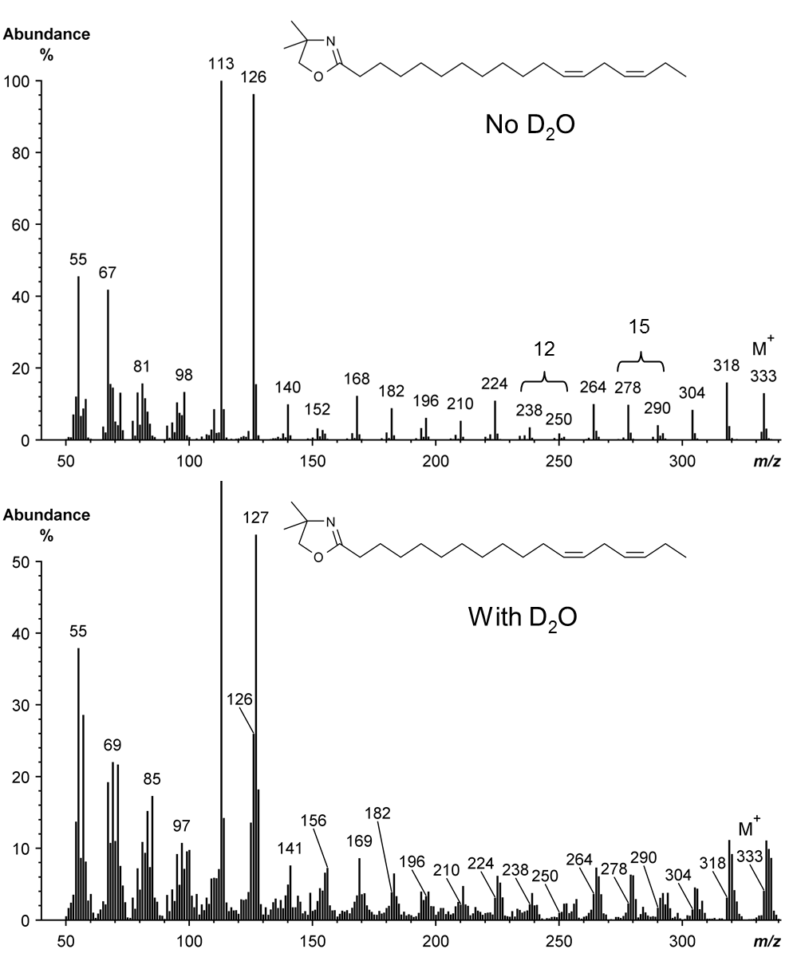

Supplementary Fig. S3. Mass spectrum of the 4,4-dimethyloxazoline derivative of cis-12,cis-15-18 : 2 synthesized from α-linolenic acid during incubations with strained rumen contents diluted with buffer prepared using deionized water or deuterium oxide. Gaps of 12 atomic mass units between m/z 238 and 250 and 278 and 290 located double bonds at ∆12 and ∆15, respectively. Due to the low abundance, the position of labels on the fatty acid moiety during incubations with deuterium-containing buffer could not be established.

