Supplementary table 1. Energy adjusted fatty acid intakes (g/d) in medians with interquartile ranges (IQR) for the three measurements of the food frequency questionnaire (FFQ) and the weighted average 24 hour dietary recalls (24HDRs) in 63 men
 |  |  | FFQ1 |  |  | FFQ2 |  |  | FFQ3 |  |  | 24HDR
 |  |  | Median | IQR |  | Median | IQR |  | Median | IQR |  | Median | IQR
SFA | Total |  | 42.6 | (32.7 - 54.5) |  | 40.8* | (31.3 - 49.8) |  | 39.2** | (29.4 - 47.5) |  | 42.3* | (31.2 - 49.2)
 | Butyric acid | 4:0 | 0.54 | (0.33 - 0.89) |  | 0.43*** | (0.27 - 0.70) |  | 0.46** | (0.31 - 0.68) |  | 0.56 | (0.37 - 0.76)
 | Caproic acid | 6:0 | 0.40 | (0.24 - 0.62) |  | 0.31*** | (0.19 - 0.50) |  | 0.33** | (0.22 - 0.49) |  | 0.39 | (0.27 - 0.56)
 | Caprylic acid | 8:0 | 0.30 | (0.20 - 0.40) |  | 0.23*** | (0.15 - 0.38) |  | 0.23** | (0.16 - 0.35) |  | 0.28 | (0.20 - 0.37)
 | Capric acid | 10:0 | 0.58 | (0.35 - 0.75) |  | 0.47*** | (0.31 - 0.66) |  | 0.46** | (0.32 - 0.72) |  | 0.50** | (0.35 - 0.65)
 | Lauric acid | 12:0 | 2.05 | (1.32 - 2.71) |  | 1.68** | (1.12 - 2.44) |  | 1.57** | (1.03 - 2.14) |  | 1.69 | (1.26 - 2.36)
 | Myristic acid | 14:0 | 4.4 | (3.1 - 5.5) |  | 3.9** | (2.5 - 5.1) |  | 3.9* | (2.5 - 4.7) |  | 4.0 | (2.8 - 5.1)
 | Pentadecylic acid | 15:0 | 0.56 | (0.41 - 0.73) |  | 0.48*** | (0.33 - 0.65) |  | 0.50** | (0.34 - 0.64) |  | 0.54 | (0.38 - 0.71)
 | Palmitic acid | 16:0 | 20.1 | (15.7 - 26.1) |  | 19.0** | (14.5 - 22.9) |  | 18.9*** | (14.4 - 21.5) |  | 19.5** | (14.1 - 22.8)
 | Margaric acid | 17:0 | 0.44 | (0.31 - 0.53) |  | 0.40*** | (0.28 - 0.46) |  | 0.39** | (0.28 - 0.48) |  | 0.39 | (0.31 - 0.50)
 | Stearic acid | 18:0 | 9.4 | (7.5 - 12.3) |  | 9.1* | (7.1 - 11.2) |  | 8.6** | (6.8 - 10.6) |  | 9.4 | (7.2 - 11.4)
MUFA | Total |  | 40.5 | (31.9 - 51.7) |  | 38.6 | (30.6 - 49.7) |  | 36.8* | (29.4 - 45.2) |  | 37.2** | (29.0 - 45.4)
 | Oleic acid | 18:1n-9 | 19.9 | (14.6 - 26.7) |  | 19.5 | (13.7 - 25.2) |  | 18.8** | (14.2 - 24.2) |  | 20.0 | (15.4 - 26.7)
TFA | Total |  | 4.2 | (3.1 - 6.1) |  | 4.0* | (3.0 - 5.1) |  | 3.8** | (2.7 - 5.2) |  | 3.8* | (2.7 - 5.2)
PUFA | Total |  | 23.1 | (17.6 - 31.0) |  | 23.2 | (18.8 - 29.9) |  | 22.2 | (16.7 - 28.2) |  | 18.3*** | (14.4 - 23.7)
n-6 | Total |  | 16.9 | (12.4 - 22.3) |  | 17.7 | (12.9 - 21.3) |  | 15.9 | (12.7 - 20.5) |  | 12.7*** | (9.1 - 15.3)
 | Linoleic acid | 18:2n-6 | 16.7 | (12.4 - 22.2) |  | 17.6 | (12.8 - 20.9) |  | 15.8 | (12.6 - 20.3) |  | 12.5*** | (8.9 - 15.1)
 |  |  |  |  |  |  |  |  |  | Table continues on next page
 | Arachidonic Acid | C20:4n-6 | 0.02 | (0.02 - 0.04) |  | 0.02 | (0.02 - 0.04) |  | 0.02* | (0.02 - 0.03) |  | 0.03** | (0.02 - 0.05)
n-3 | Total |  | 1.58 | (1.24 - 2.11) |  | 1.56 | (1.17 - 2.01) |  | 1.52* | (1.08 - 1.93) |  | 1.47* | (1.00 - 1.94)
 | Alpha-linolenic acid | 18:3n-3 | 1.44 | (1.09 - 1.87) |  | 1.44 | (1.02 - 1.86) |  | 1.36* | (0.94 - 1.72) |  | 1.24** | (0.88 - 1.67)
 | Eicosapentanoic acid | C20:5n-3 | 0.03 | (0.01 - 0.05) |  | 0.02 | (0.01 - 0.05) |  | 0.03 | (0.01 - 0.05) |  | 0.02 | (0.00 - 0.12)
 | Docosahexanoic acid | C22:6n-3 | 0.07 | (0.04 - 0.13) |  | 0.06* | (0.04 - 0.12) |  | 0.06 | (0.04 - 0.12) |  | 0.05 | (0.02 - 0.17)
Abbreviations: SFA, saturated fatty acid; MUFA, monounsaturated fatty acid; TFA, trans fatty acid; PUFA, polyunsaturated fatty acid
*p-value<0.05; **p-value <0.005; ***p-value <0.0001 for significance of difference in median intake compared to FFQ1 as tested with the Wilcoxon Signed ranks test

Supplementary table 2. Energy adjusted fatty acid intakes (g/d) in medians with interquartile ranges (IQR) for the three measurements of the food frequency questionnaire (FFQ) and the weighted average 24 hour dietary recalls (24HDRs) in 58 women.
 |  |  | FFQ1 |  |  | FFQ2 |  |  | FFQ3 |  |  | 24HDR
 |  |  | Median | IQR |  | Median | IQR |  | Median | IQR |  | Median | IQR
SFA | Total |  | 36.8 | (33.8 - 41.6) |  | 35.6 | (32.5 - 39.4) |  | 33.8 | (29.9 - 36.8) |  | 34.8 | (30.8 - 38.2)
 | Butyric acid | 4:0 | 0.53 | (0.42 - 0.65) |  | 0.46 | (0.39 - 0.62) |  | 0.47 | (0.33 - 0.54) |  | 0.63 | (0.45 - 0.76)
 | Caproic acid | 6:0 | 0.39 | (0.30 - 0.46) |  | 0.33 | (0.28 - 0.44) |  | 0.34 | (0.23 - 0.39) |  | 0.45 | (0.32 - 0.53)
 | Caprylic acid | 8:0 | 0.27 | (0.21 - 0.32) |  | 0.26 | (0.19 - 0.30) |  | 0.24 | (0.18 - 0.28) |  | 0.25 | (0.21 - 0.32)
 | Capric acid | 10:0 | 0.50 | (0.44 - 0.60) |  | 0.50 | (0.39 - 0.58) |  | 0.47 | (0.38 - 0.53) |  | 0.48 | (0.40 - 0.56)
 | Lauric acid | 12:0 | 1.72 | (1.36 - 2.01) |  | 1.60 | (1.34 - 1.92) |  | 1.51 | (1.12 - 1.81) |  | 1.60 | (1.32 - 1.96)
 | Myristic acid | 14:0 | 3.8 | (3.2 - 4.6) |  | 3.7 | (3.0 - 4.2) |  | 3.4 | (2.8 - 3.9) |  | 3.7 | (3.0 - 4.3)
 | Pentadecylic acid | 15:0 | 0.51 | (0.44 - 0.61) |  | 0.48 | (0.37 - 0.61) |  | 0.45 | (0.37 - 0.52) |  | 0.51 | (0.40 - 0.61)
 | Palmitic acid | 16:0 | 16.7 | (15.4 - 19.3) |  | 16.7 | (14.2 - 17.7) |  | 15.7 | (13.4 - 17.0) |  | 15.5 | (13.8 - 17.4)
 | Margaric acid | 17:0 | 0.37 | (0.31 - 0.41) |  | 0.35 | (0.31 - 0.40) |  | 0.32 | (0.29 - 0.36) |  | 0.35 | (0.31 - 0.40)
 | Stearic acid | 18:0 | 8.1 | (7.1 - 9.0) |  | 7.9 | (7.1 - 8.7) |  | 7.5 | (6.4 - 8.1) |  | 7.4 | (6.7 - 8.4)
MUFA | Total |  | 33.2 | (29.9 - 38.3) |  | 32.7 | (29.7 - 36.5) |  | 30.3 | (27.3 - 35.5) |  | 29.1 | (26.8 - 33.2)
 | Oleic acid | 18:1n-9 | 16.8 | (14.9 - 19.2) |  | 16.3 | (14.3 - 18.8) |  | 15.9 | (13.2 - 17.6) |  | 15.3 | (13.0 - 17.5)
TFA | Total |  | 3.3 | (2.7 - 4.2) |  | 3.3 | (2.5 - 4.2) |  | 3.0 | (2.53 - 3.81) |  | 3.1 | (2.6 - 3.8)
PUFA | Total |  | 20.1 | (16.9 - 23.5) |  | 19.3 | (16.3 - 24.4) |  | 19.1 | (16.2 - 22.5) |  | 14.4 | (11.9 - 16.9)
n-6 | Total |  | 15.0 | (11.5 - 17.2) |  | 13.7 | (11.4 - 17.1) |  | 13.7 | (10.7 - 15.8) |  | 8.6 | (7.4 - 11.2)
 | Linoleic acid | 18:2n-6 | 14.8 | (11.4 - 17.1) |  | 13.5 | (11.2 - 16.7) |  | 13.5 | (10.6 - 15.6) |  | 8.4 | (7.3 - 11.1)
 |  |  |  |  |  |  |  |  |  | Table continues on next page
 | Arachidonic Acid | 20:4n-6 | 0.03 | (0.02 - 0.04) |  | 0.02 | (0.02 - 0.03) |  | 0.03 | (0.02 - 0.03) |  | 0.04 | (0.02 - 0.07)
n-3 | Total |  | 1.43 | (1.15 - 1.71) |  | 1.34 | (1.09 - 1.72) |  | 1.3 | (1.07 - 1.47) |  | 1.13 | (0.88 - 1.39)
 | Alpha-linolenic acid | 18:3n-3 | 1.26 | (1.04 - 1.53) |  | 1.15 | (0.98 - 1.52) |  | 1.11 | (0.97 - 1.36) |  | 0.99 | (0.78 - 1.21)
 | Eicosapentanoic acid | 20:5n-3 | 0.04 | (0.01 - 0.06) |  | 0.03 | (0.01 - 0.05) |  | 0.03 | (0.01 - 0.04) |  | 0.02 | (0.00 - 0.04)
 | Docosahexanoic acid | 22:6n-3 | 0.08 | (0.03 - 0.13) |  | 0.07 | (0.03 - 0.11) |  | 0.07 | (0.04 - 0.10) |  | 0.06 | (0.03 - 0.14)
Abbreviations: SFA, saturated fatty acid; MUFA, monounsaturated fatty acid; TFA, trans fatty acid; PUFA, polyunsaturated fatty acid
*p-value<0.05; **p-value <0.005; ***p-value <0.0001 for significance of difference in median intake compared to FFQ1 as tested with the Wilcoxon Signed ranks test

Supplementary figures 1 to 44. Bland-Altman plots of energy adjusted intakes of fatty acids for men (in blue) and women (in red) separately.

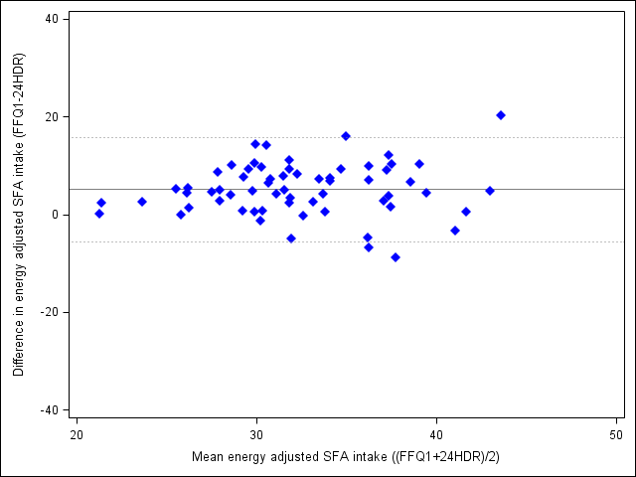 | 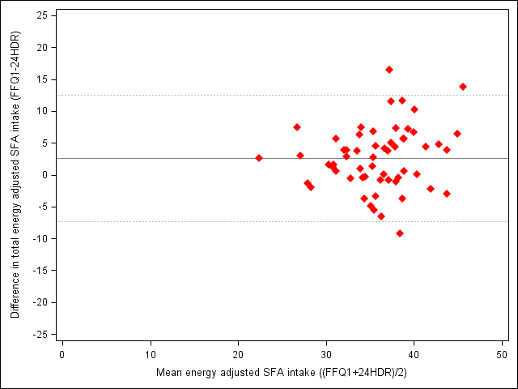
Figure 1. | Figure 2.
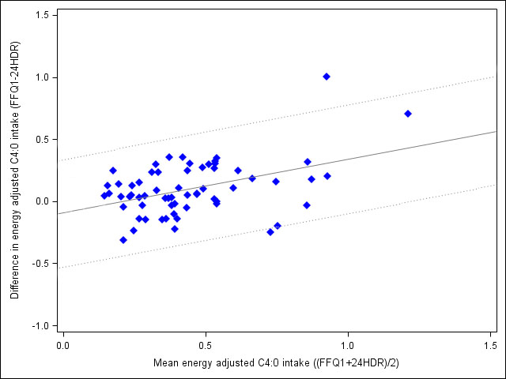 | 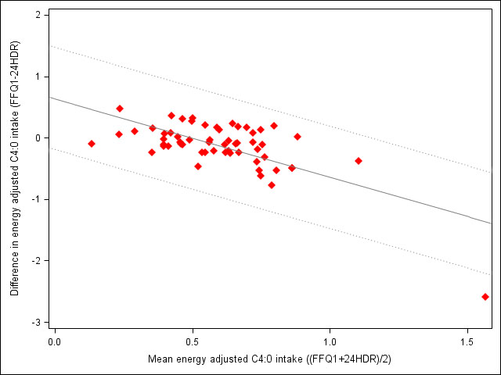
Figure 3. | Figure 4.
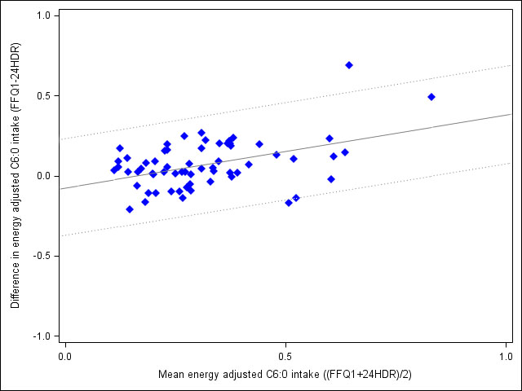 | 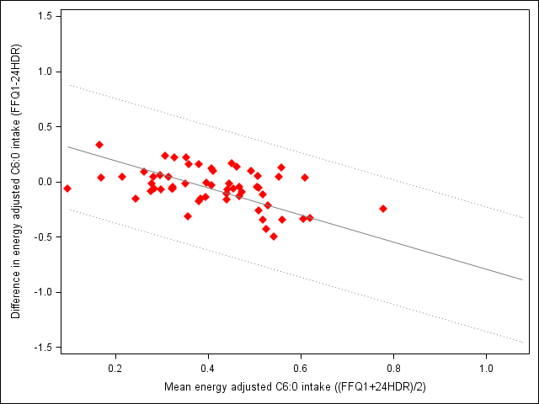
Figure 5. | Figure 6.

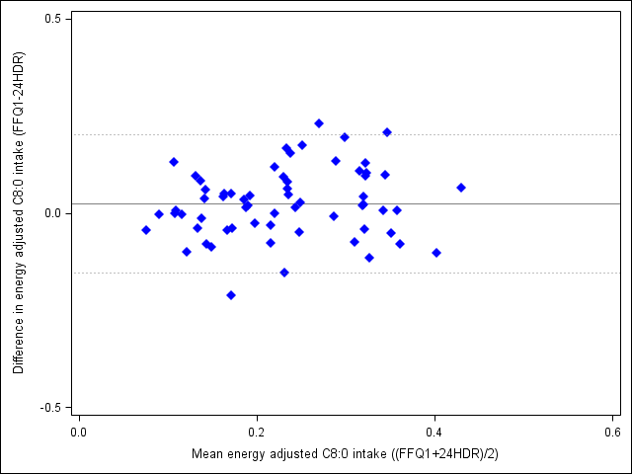 | 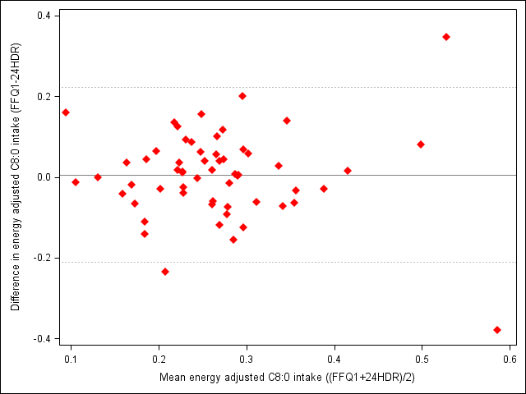
Figure 7. | Figure 8.
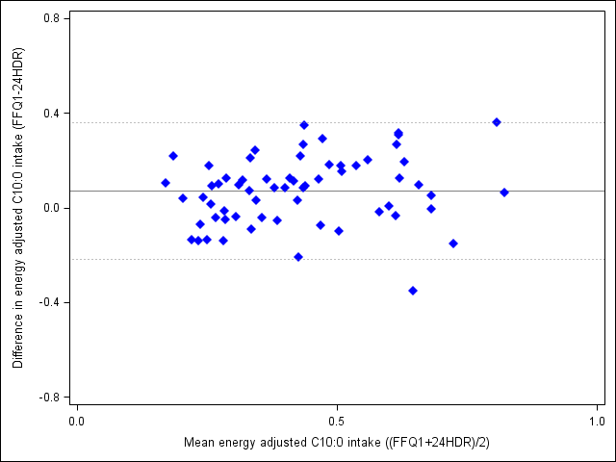 | 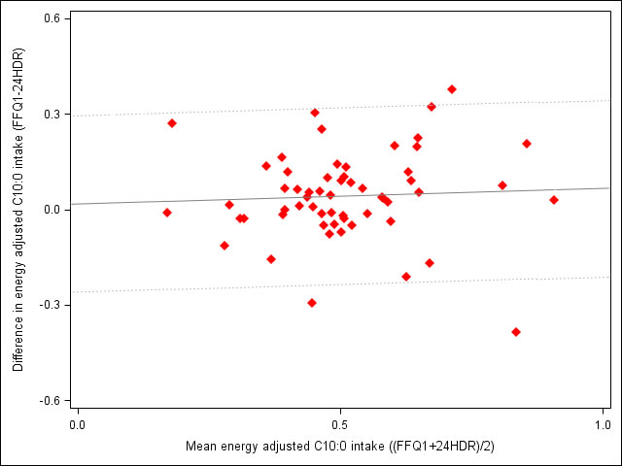
Figure 9. | Figure 10.
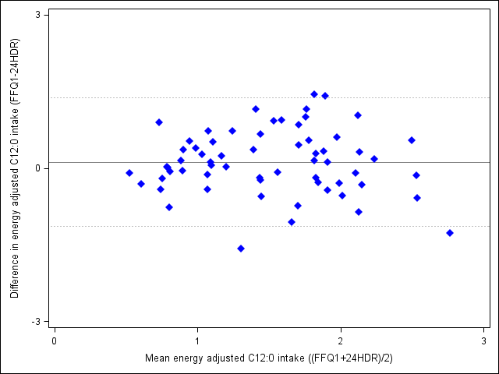 | 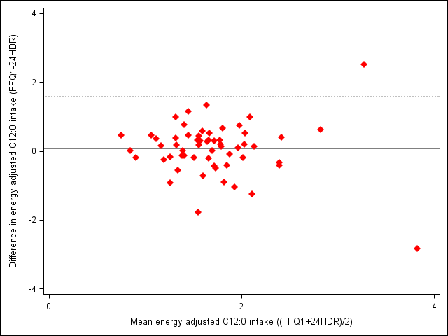
Figure 11. | Figure 12.

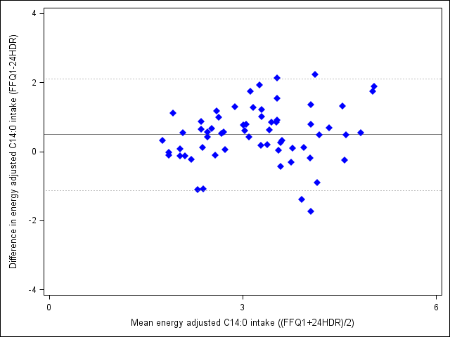 | 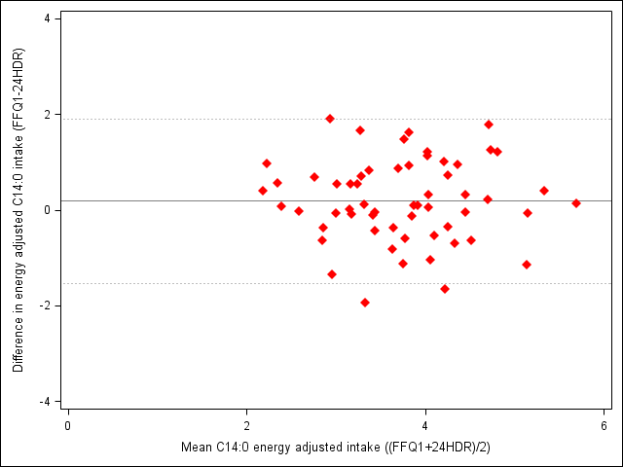
Figure 13. | Figure 14.
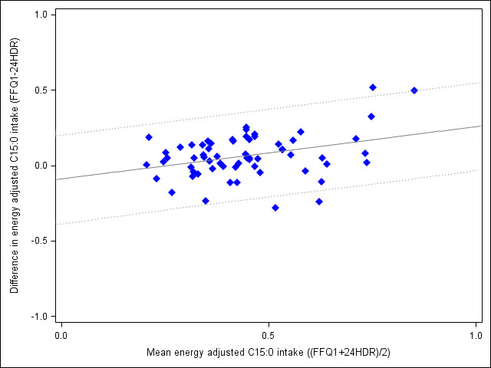 | 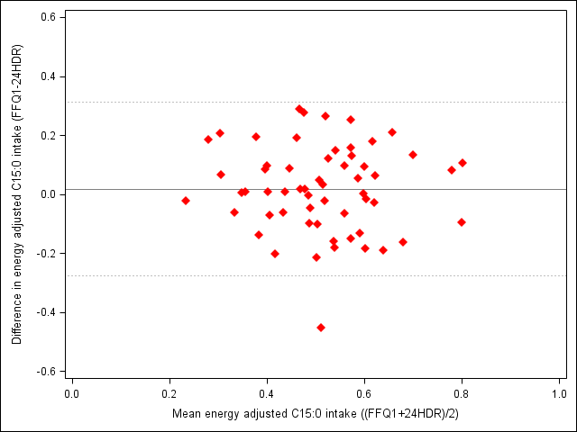
Figure 15. | Figure 16.
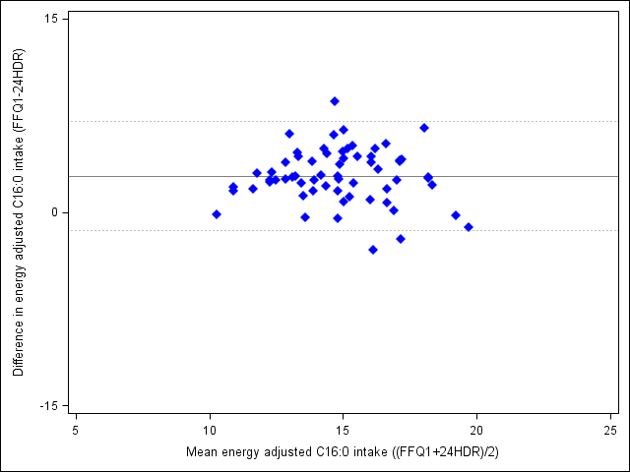 | 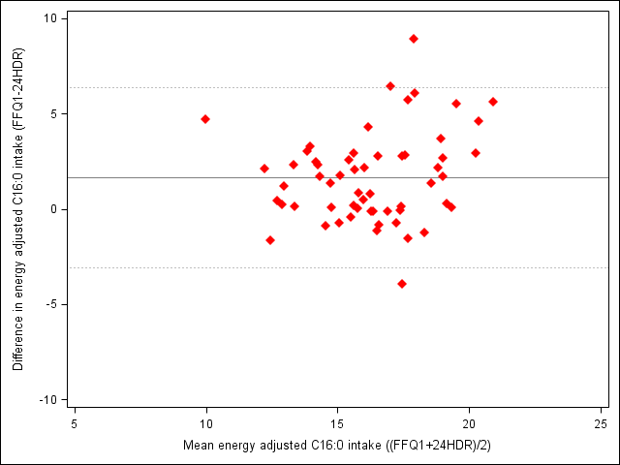
Figure 17. | Figure 18.

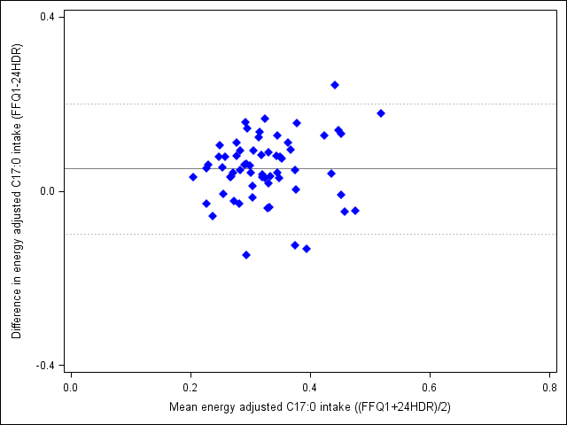 | 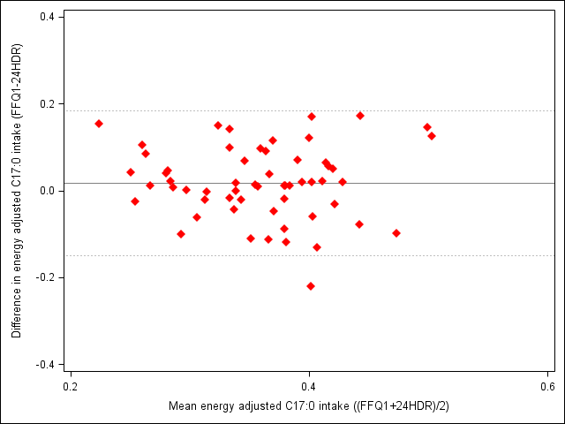
Figure 19. | Figure 20.
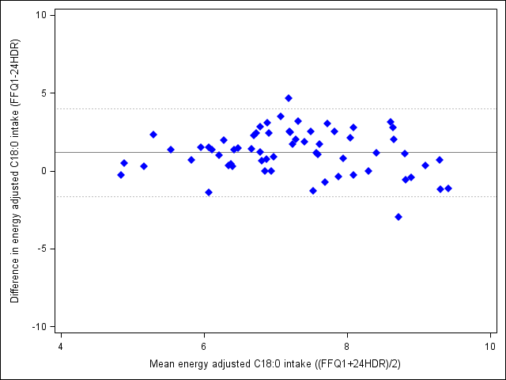 | 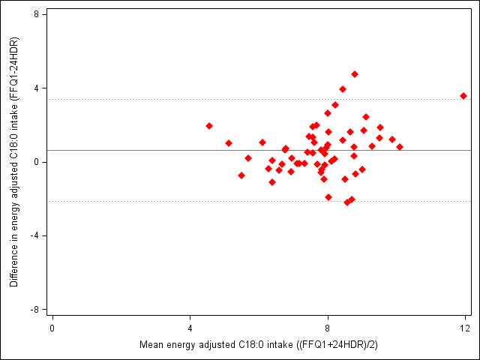
Figure 21. | Figure 22.
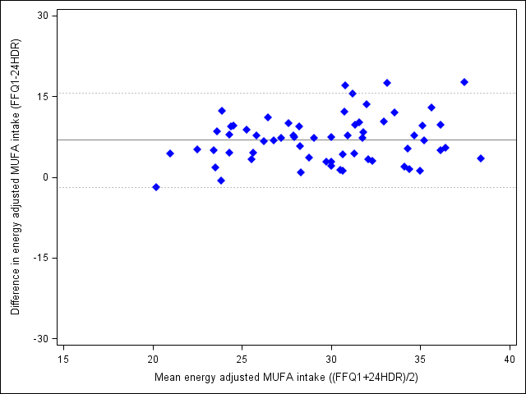 | 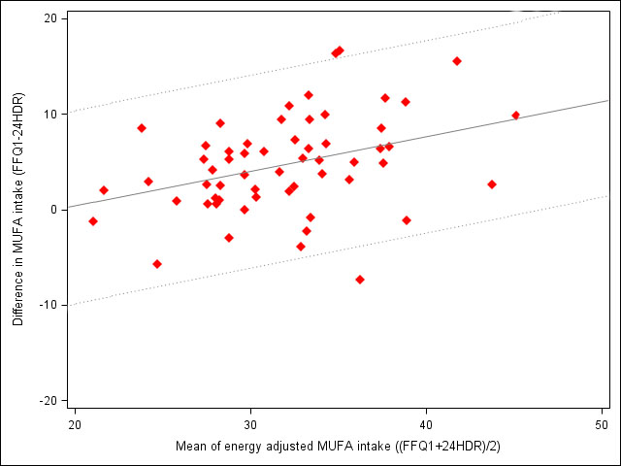
Figure 23. | Figure 24.

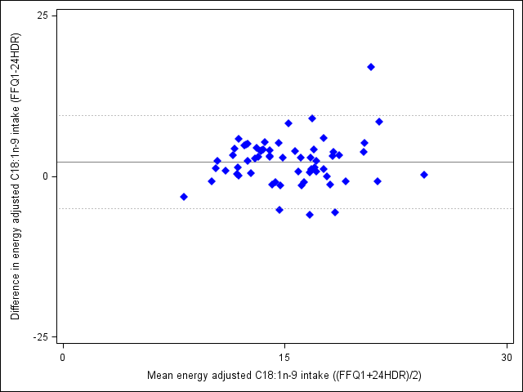 | 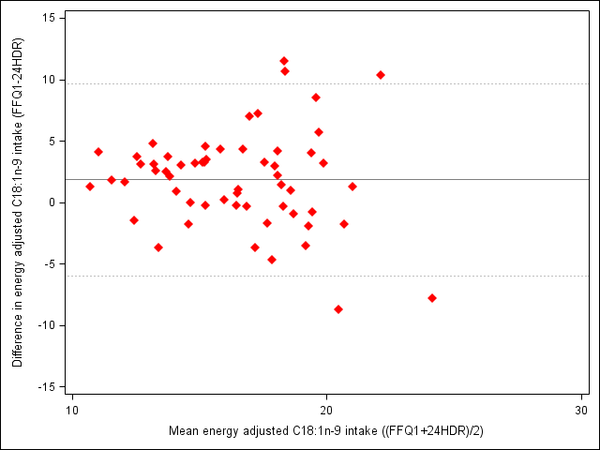
Figure 25. | Figure 26.
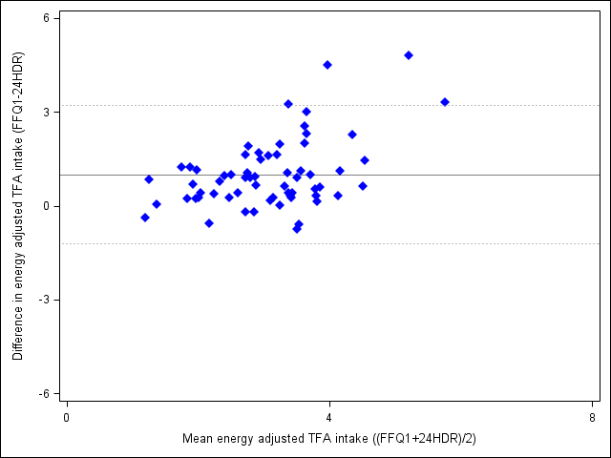 | 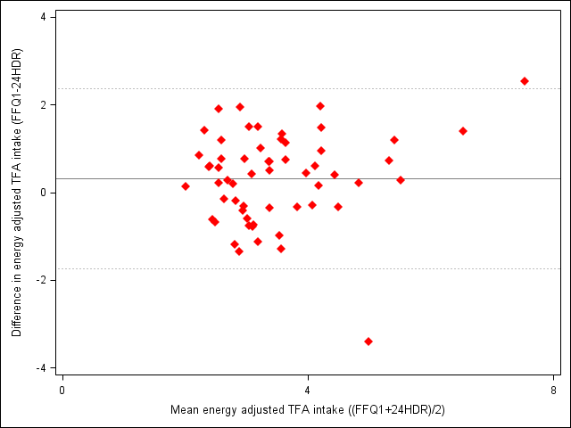
Figure 27. | Figure 28.
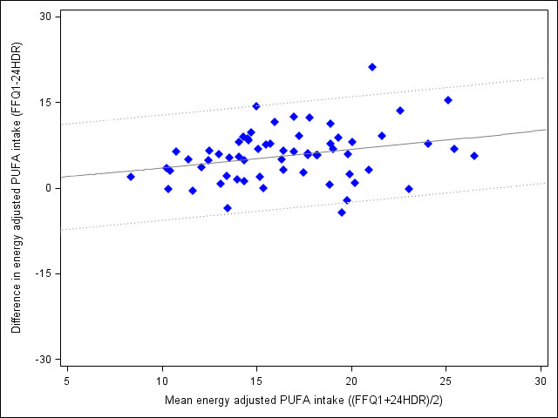 | 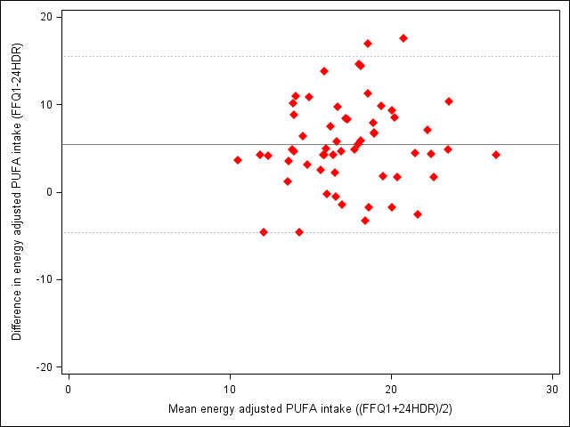
Figure 29. | Figure 30.

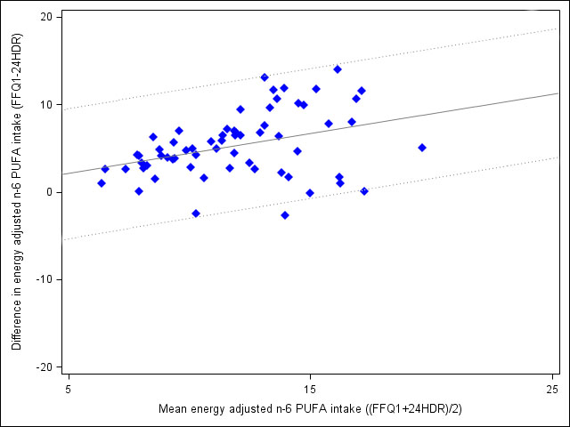 | 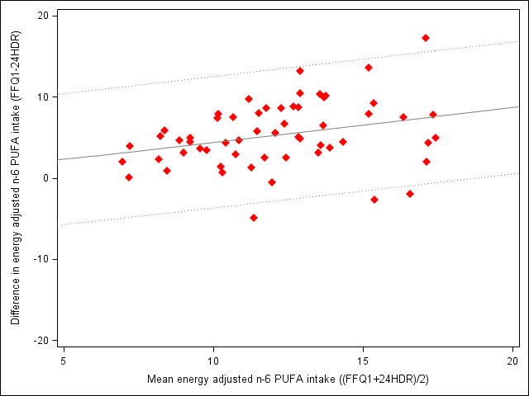
Figure 31. | Figure 32.
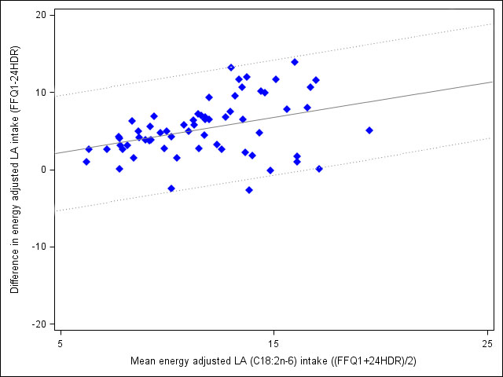 | 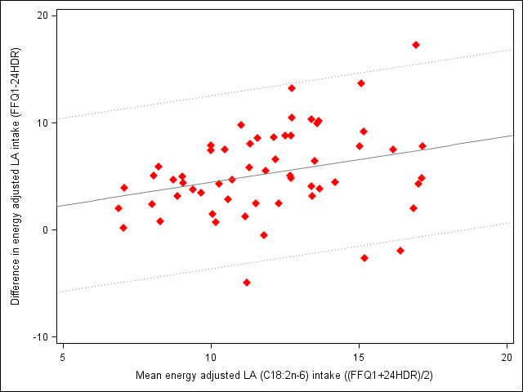
Figure 33. | Figure 34.
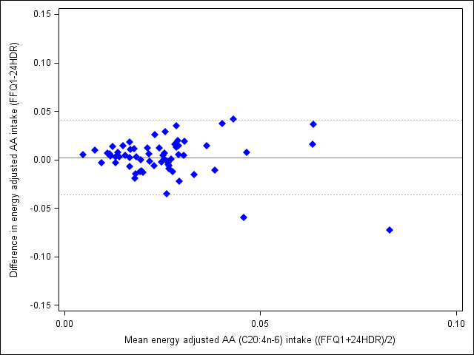 | 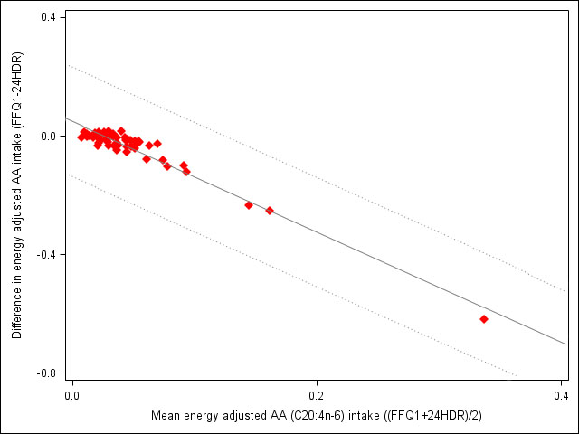
Figure 35. | Figure 36.

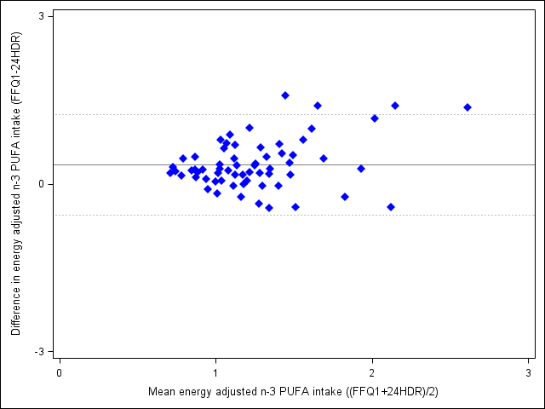 | 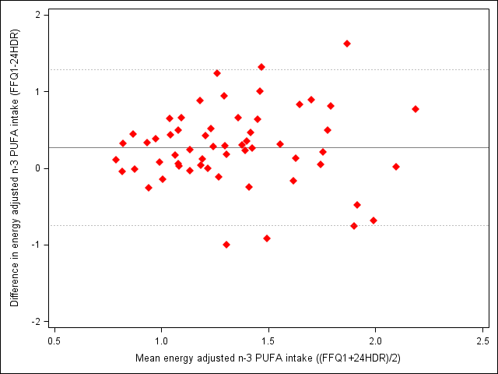
Figure 37. | Figure 38.
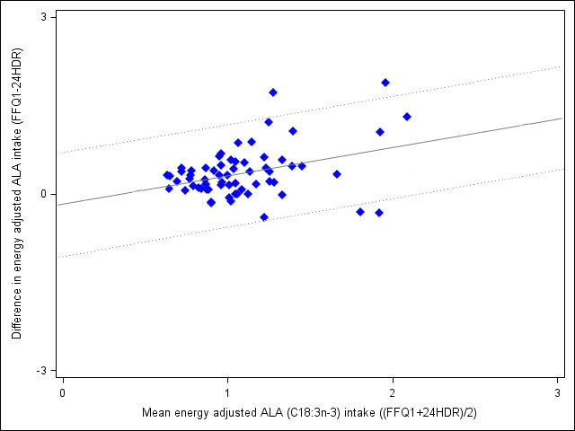 | 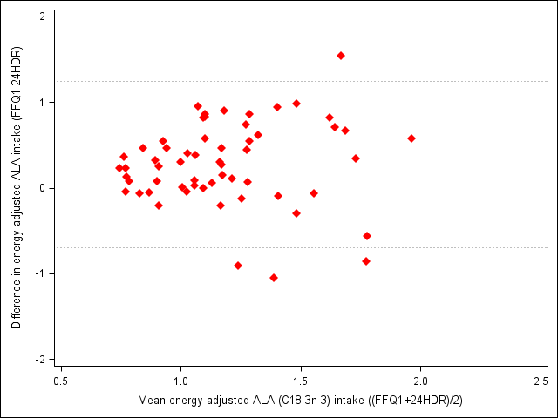
Figure 39. | Figure 40.
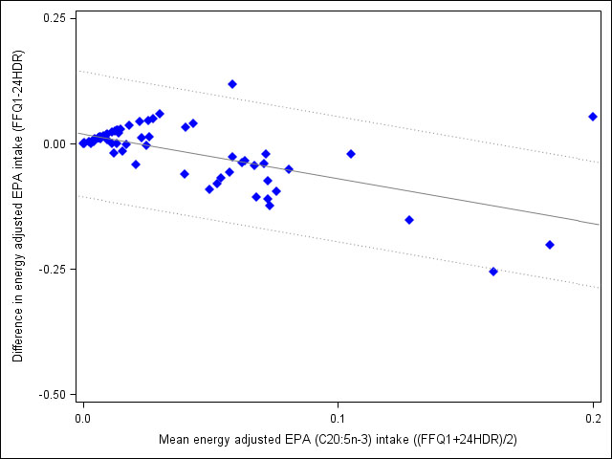 | 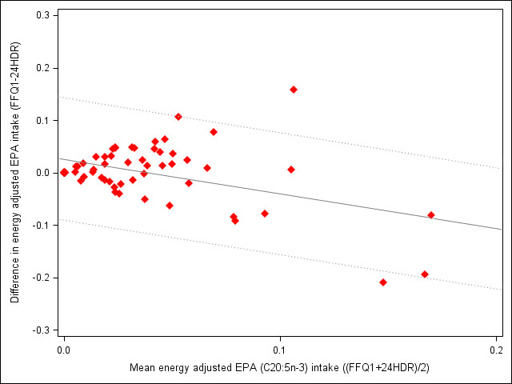
Figure 41. | Figure 42.

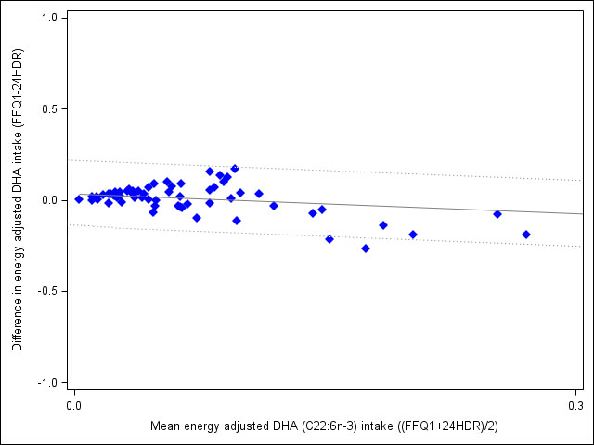 | 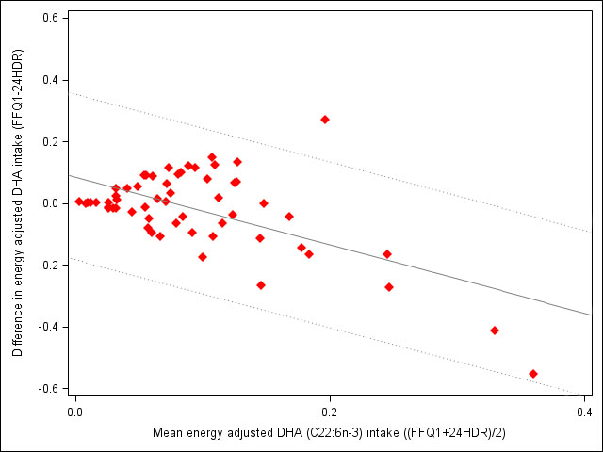
Figure 43. | Figure 44.

