Supplementary Fig. S1. Melting curves and standard curves of reference and target genes.
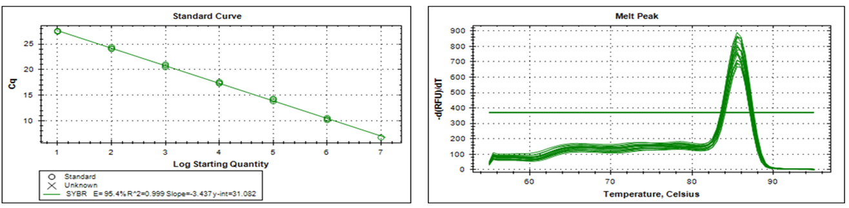
Fig. S1 A. Melting curve & standard curve of ALP

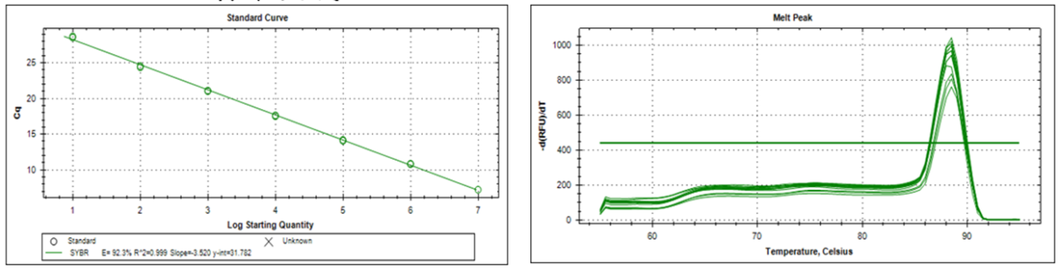
Fig. S1 B. Melting curve & standard curve of CK

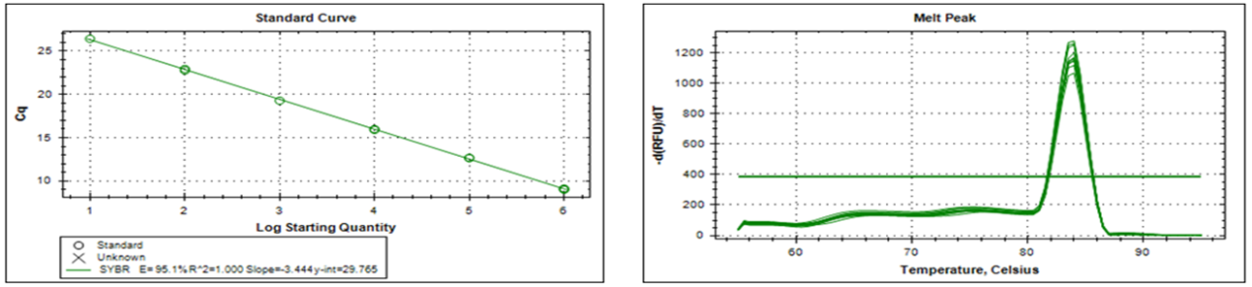
Fig. S1 C. Melting curve & standard curve of LDH

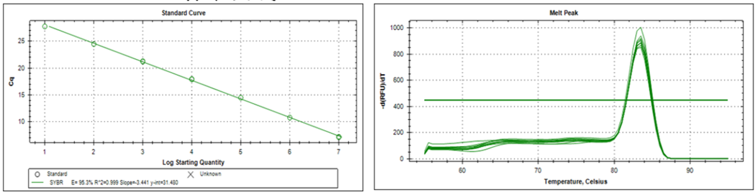
Fig. S1 D. Melting curve & standard curve of EGF-R

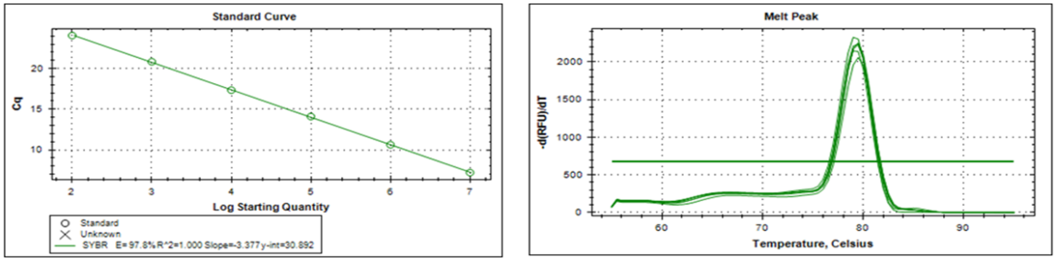
Fig. S1 E. Melting curve & standard curve of Sucrase

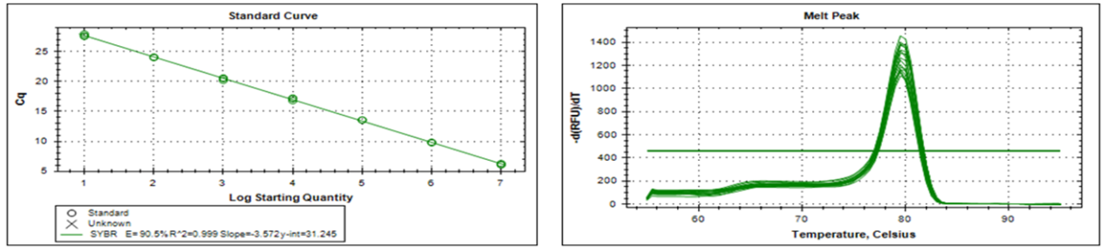
Fig. S1 F. Melting curve & standard curve of B2M

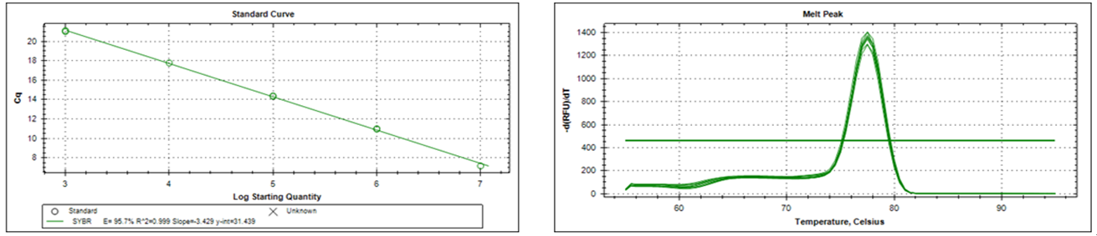
Fig. S1 G. Melting curve & standard curve of HMBS

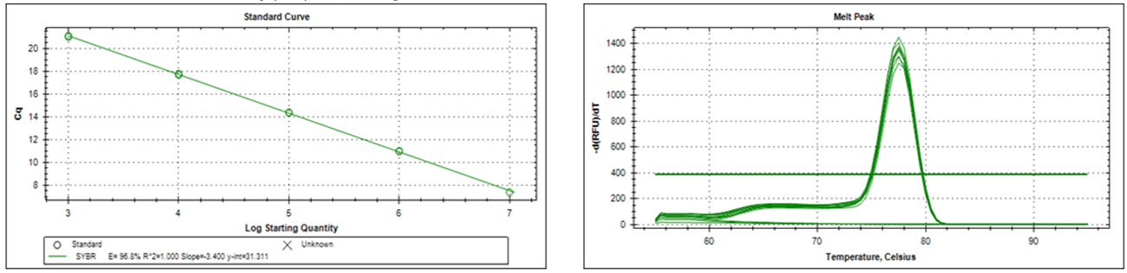
Fig. S1 H. Melting curve & standard curve of HPRT1

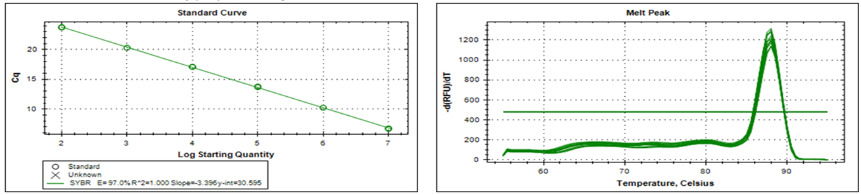
Fig. S1 J. Melting curve & standard curve of B-actin

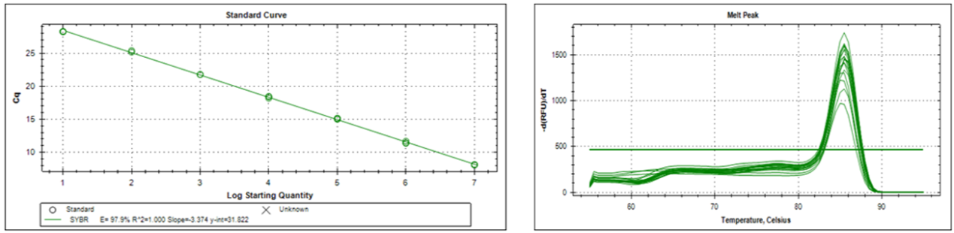
Fig. S1 H. Melting curve & standard curve of 18S

Supplementary Fig. S2. Agarose gel electrophoresis identification of gene-specific primers of reference and target genes for qPCR.
Agarose gel (2%) electrophoresis showing amplification of specific band at the expected size for each reference gene. Lane M: D₂₀₀₀ DNA Marker (100-2000bp), Lane 1: B2M, Lane 2: HMBS, Lane 3: HPRT1, Lane 4: B-actin, Lane 5: 18S, Lane 6: ALP, Lane 7: CK, Lane 8: LDH, Lane 9: EGF-R, Lane 10: Sucrase.

