Appendix 1, Supplementary online material.
Conducting the Equivalence test in different statistical packages. In these examples, equivalence at 5 and 15µg are shown to demonstrate the contrast output when the methods are determined to be equivalent and when they are not equivalent. The dataset is also available on request (marijka@uow.edu.au) to replicate the analyses.
- R
In R equivalence testing can be conducted easily using the package “equivalence” (www.cran.r-project.org/web/packages/equivalence/equivalence.pdf)

The tost command (in bold) can be used for paired or independent data, by specifying a single variable the paired test is used. The test is conducted on the bias, the difference between the methods. In this analysis this variable is called “bias” and the dataset is called “iodine”. The bias is the difference between the x24hrR (average of 3 24 hour recalls) and the FFQ (food frequency questionnaire)

tost(iodine$bias, y=NULL, alpha=0.05, epsilon=5)
$mean.diff
[1] 2.284939

$se.diff
[1] 4.91133

$alpha
[1] 0.05

$ci.diff
[1] -5.889338 10.459215
attr(,"conf.level")
[1] 0.9

$df
df
79

$epsilon
[1] 5

$result
[1] "not rejected"

$p.value
[1] 0.2909752

$check.me
[1] -0.430123 5.000000
attr(,"conf.level")
[1] 0.4180496

The P value is >0.05 (0.2909752) and indicates the methods are not equivalent.

tost(iodine$bias, y=NULL, alpha=0.05, epsilon=15)
$mean.diff
[1] 2.284939

$se.diff
[1] 4.91133

$alpha
[1] 0.05

$ci.diff
[1] -5.889338 10.459215
attr(,"conf.level")
[1] 0.9

$df
df
79

$epsilon
[1] 15

$result
[1] "rejected"

$p.value
[1] 0.00572852

$check.me
[1] -10.43012 15.00000
attr(,"conf.level")
[1] 0.988543

The P value is <0.05 (0.00572852) and indicates the methods are equivalent.

- In SAS V9.3 (SAS Inc, Cary NC), equivalence testing is available through the PROC TTEST procedure, in SAS it is necessary to specify that the test is paired and the values for the FR and FFQ are used. SAS also produces graphical output. As mentioned in the text, the SAS macro concord⁽¹⁾ produces equivalence tests and Philip Dixon⁽²⁾ provides syntax on determining equivalence using the PROC MIXED procedure in an online archive EquivSlope.sas http://www.esapubs.org/archive/ecol/E086/094/suppl-1.htm

Proc ttest data=iodine tost(-5,5);
paired FR*FFQ;
run;

The SAS System

The TTEST Procedure

Difference: FR - FFQ
N | Mean | Std Dev | Std Err | Minimum | Maximum
80 | -2.2849 | 43.9283 | 4.9113 | -119.8 | 76.2301

Mean | 95% CL Mean |  | Std Dev | 95% CL Std Dev
-2.2849 | -12.0607 | 7.4908 | 43.9283 | 38.0178 | 52.0318

TOST Level 0.05 Equivalence Analysis
Mean | Lower Bound |  | 90% CL Mean |  |  | Upper Bound | Assessment
-2.2849 | -5 | > | -10.4592 | 5.8893 | > | 5 | Not equivalent

Test | Null | DF | t Value | P-Value
Upper | -5 | 79 | 0.55 | 0.2910
Lower | 5 | 79 | -1.48 | 0.0710
Overall |  |  |  | 0.2910

The P value is >0.05 (0.2910) and indicates the methods are not equivalent.

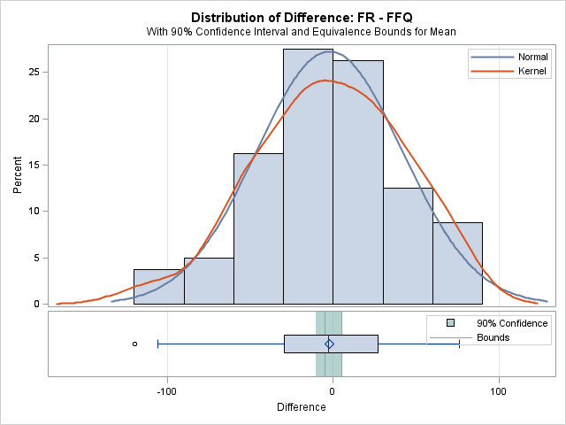

Proc ttest data=iodine tost(-15,15);
paired FR*FFQ;
run;

The SAS System

The TTEST Procedure

Difference: FR - FFQ
N | Mean | Std Dev | Std Err | Minimum | Maximum
80 | -2.2849 | 43.9283 | 4.9113 | -119.8 | 76.2301

Mean | 95% CL Mean |  | Std Dev | 95% CL Std Dev
-2.2849 | -12.0607 | 7.4908 | 43.9283 | 38.0178 | 52.0318

TOST Level 0.05 Equivalence Analysis
Mean | Lower Bound |  | 90% CL Mean |  |  | Upper Bound | Assessment
-2.2849 | -15 | < | -10.4592 | 5.8893 | < | 15 | Equivalent

Test | Null | DF | t Value | P-Value
Upper | -15 | 79 | 2.59 | 0.0057
Lower | 15 | 79 | -3.52 | 0.0004
Overall |  |  |  | 0.0057
The overall P value is less than 0.05 and indicates the methods are equivalent
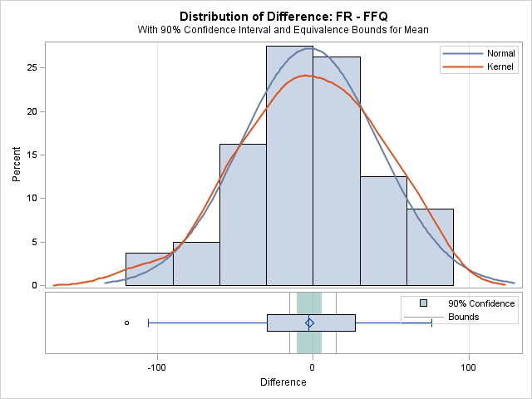
- In STATA V12 (StataCorp LP, College Station, TX) equivalence tests are available through a user written .ado file written by Alexis Dinno available from http://doyenne.com/stata/tost.html
tostt fr==ffq, eqvt(delta) eqvl(5)

Paired t test of mean equivalence
------------------------------------------------------------------------------
Variable | Obs Mean Std. Err. Std. Dev. [95% Conf. Interval]
---------+--------------------------------------------------------------------
fr | 80 124.2285 5.43549 48.6165 113.4094 135.0476
ffq | 80 126.5134 6.043544 54.0551 114.484 138.5428
---------+--------------------------------------------------------------------
D-diff | 7.284939 4.91133 -2.490819 17.0607
diff+D | 2.715061 4.91133 -7.060696 12.49082
------------------------------------------------------------------------------
mean(diff) = mean(fr - ffq)
Delta (D) = 5.0000 Delta expressed in same units as fr

Impossible to reject any Ho if Delta <= t-crit*s.e. ( 8.174 ). See help tostt.

df = 79

Ho: |diff| >= Delta:

t1 = 1.483 t2 = .5528

Ho1: Delta-diff >= 0 Ho2: diff+Delta <= 0
Ha1: Delta-diff < 0 Ha2: diff+Delta > 0
Pr(T > t1) = 0.0710 Pr(T > t2) = 0.2910

Both P values must be significant for the methods to be equivalent, therefore not equivalent

tostt fr==ffq, eqvt(delta) eqvl(15)

Paired t test of mean equivalence
------------------------------------------------------------------------------
Variable | Obs Mean Std. Err. Std. Dev. [95% Conf. Interval]
---------+--------------------------------------------------------------------
fr | 80 124.2285 5.43549 48.6165 113.4094 135.0476
ffq | 80 126.5134 6.043544 54.0551 114.484 138.5428
---------+--------------------------------------------------------------------
D-diff | 17.28494 4.91133 7.509181 27.0607
diff+D | 12.71506 4.91133 2.939304 22.49082
------------------------------------------------------------------------------
mean(diff) = mean(fr - ffq)
Delta (D) = 15.0000 Delta expressed in same units as fr
df = 79

Ho: |diff| >= Delta:

t1 = 3.519 t2 = 2.589

Ho1: Delta-diff >= 0 Ho2: diff+Delta <= 0
Ha1: Delta-diff < 0 Ha2: diff+Delta > 0
Pr(T > t1) = 0.0004 Pr(T > t2) = 0.0057

Both P values must be significant for the methods to be equivalent, therefore equivalent
- In SPSS V21 (IBM Corporation, Armonk NY) there is not an automated procedure to produce the two one sided tests. This can be done manually by conducting two one sample t tests using the upper and lower equivalence values and the bias as the test variable. This test only produces a two tailed output of significance which needs to be halved for the one tailed P value. If both of these are significant then the methods are equivalent. This can be demonstrated by comparing with the STATA output above. Note that halving the P values is approximate, exact one sided P values could be obtained from several free online calculators or by using R (for example 1-pt(3.519, df=80) returns P=0.003588676.
T-TEST
/TESTVAL=-5
/MISSING=ANALYSIS
/VARIABLES=bias
/CRITERIA=CI(.95).
T-TEST
/TESTVAL=5
/MISSING=ANALYSIS
/VARIABLES=bias
/CRITERIA=CI(.95).

One-Sample Test
 | Test Value = -5
 | t | df | Sig. (2-tailed) | Mean Difference | 95% Confidence Interval of the Difference
 |  |  |  |  | Lower | Upper
Bias | 1.483 | 79 | .142 | 7.28494 | -2.4908 | 17.0607

The P value of 0.142 must be halved to give 0.071 for the lower equivalence bound

One-Sample Test
 | Test Value = 5
 | t | df | Sig. (2-tailed) | Mean Difference | 95% Confidence Interval of the Difference
 |  |  |  |  | Lower | Upper
Bias | -.553 | 79 | .582 | -2.71506 | -12.4908 | 7.0607

The P value of 0.582 must be halved to give 0.291 for the upper equivalence bound. As neither of these are significant at the 0.05 level, the methods are not equivalent.

T-TEST
/TESTVAL=-15
/MISSING=ANALYSIS
/VARIABLES=bias
/CRITERIA=CI(.95).
T-TEST
/TESTVAL=15
/MISSING=ANALYSIS
/VARIABLES=bias
/CRITERIA=CI(.95).

One-Sample Test
 | Test Value = -15
 | t | df | Sig. (2-tailed) | Mean Difference | 95% Confidence Interval of the Difference
 |  |  |  |  | Lower | Upper
Bias | 3.519 | 79 | .001 | 17.28494 | 7.5092 | 27.0607

The P value of 0.001 must be halved to give P=0.0005 for the lower equivalence bound

One-Sample Test
 | Test Value = 15
 | t | df | Sig. (2-tailed) | Mean Difference | 95% Confidence Interval of the Difference
 |  |  |  |  | Lower | Upper
Bias | -2.589 | 79 | .011 | -12.71506 | -22.4908 | -2.9393
The P value of 0.011 must be halved to give P=0.006 for the upper equivalence bound. As BOTH of these tests are significant at the 0.05 level, the methods are equivalent.
The SPSS custom dialog box SPSS custom dialog developed by Weber & Popova⁽³⁾ available from http://www.medianeuroscience.org/equivalence_testing uses effect sizes based on Cohen’s d. In order to replicate the examples in this paper the equivalence bounds were converted to approximated effect sizes⁽⁴⁾ for the upper and lower bound using the pooled standard deviation of the difference between the methods and correlation from the paired t test and then averaged to create an overall effect size for the 5 and 15 equivalent ranges. The default values for Cohen’s small, medium and large effect sizes are also presented as an alternative approach.
For the equivalence bounds of (-5,5) the approximated effect size is 0.1328

*** Weber & Popova Dependent/Paired-Samples Equivalence Procedure ***
Based on the custom-entered delta

p based on p based on
actual value of delta half variance explained
Custom delta t df (two-tailed) (two-tailed)
____________ ________ ________ _____________________ _______________________

.133 -.47 79 .188 .382

For the equivalence bounds of (-15,15) the approximated effect size is 0.3734

*** Weber & Popova Dependent/Paired-Samples Equivalence Procedure ***
Based on the custom-entered delta

p based on p based on
actual value of delta half variance explained
Custom delta t df (two-tailed) (two-tailed)
____________ ________ ________ _____________________ _______________________

.373 -.47 79 .000 .038

Using the default Cohen’s effect sizes.

*** Weber & Popova Dependent/Paired-Samples Equivalence Procedure ***
Based on the Cohen's classification of effect sizes

t df Delta p, two-tailed
________ ________ ________ _____________

-.47 79 .10 .291
-.47 79 .30 .004
-.47 79 .50 .000

1. Groeneveld J (2011) Embedding equivalence t-test results in Bland Altman Plots visualising rater reliability. In Pharmaceutical Users Software Exchange, pp. SP06. Brighton, UK: PhUSE.
2. Dixon PM, Pechmann JHK (2005) A statistical test to show negligble trend. Ecology 86, 1751-1756.
3. Weber R, Popova L (2012) Testing equivalence in communication research: Theory and application. Communication methods and measures 6, 190-213.
4. Dunlap WP, Cortina JM, Vaslow JB et al. (1996) Meta-analysis of experiments with matched groups of repeated measures designs. Psychological Methods 1, 170-177.

