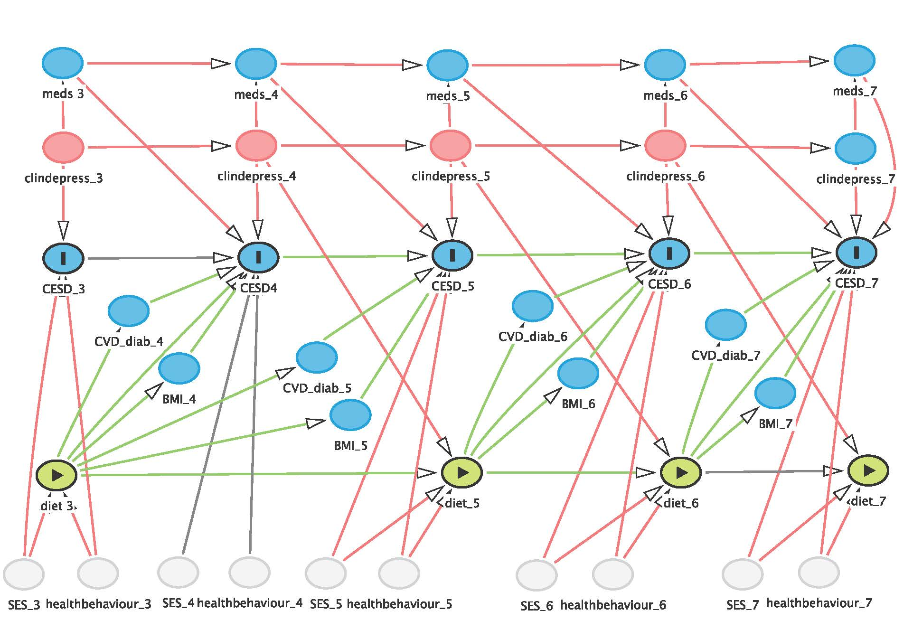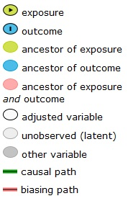

Supplemental Figure 1: Theoretical framework for the association between diet quality and depressive symptoms for women in the 1946-51 cohort of the Australian Longitudinal Study on Women’s Health. Diet quality (diet) was summarised using the Australian Recommended Food Score. Depressive symptoms were measured using the 10-item Centre for Epidemiologic Studies Depression Scale (CESD). Confounding variables were: socioeconomic (SES) indicators which include area of residence, average household income, marital status, and education; health behaviour (healthbehaviour) indicators which include physical activity and smoking status; self-reported physician diagnosis of depression (clindepress) and use of antidepressants (meds). BMI, diabetes (diab) and cardiovascular disease (CVD) were mediators and not adjusted for in statistical analyses. Numbers represent survey wave.

Supplemental Table 1: Associations between diet quality* quintiles and depressive symptoms for women in the 1946-51 cohort of the Australian Longitudinal Study on Women’s Health (n=11046)†, ‡
 |  | Q2 |  | Q3 |  | Q4 |  | Q5
 | n§ | β | 95% CI | β | 95% CI | β | 95% CI | β | 95% CI | P trend
Model 1 - Univariate | 11046 | -0.80 | -0.96, -0.64 | -1.18 | -1.34, -1.02 | -1.45 | -1.61, -1.29 | -1.70 | -1.87, -1.56 | 0.001
Model 2 | 9710 | -0.69 | -0.87, -0.52 | -0.96 | -1.14, -0.78 | -1.24 | -1.42, -1.06 | -1.52 | -1.71, -1.34 | 0.001
Model 3 | 9656 | -0.51 | -0.69, -0.33 | -0.68 | -0.87, -0.50 | -0.90 | -1.09, -0.72 | -1.13 | -1.32, -0.94 | 0.001
Model 4 | 9647 | -0.44 | -0.61, -0.27 | -0.60 | -0.78, -0.42 | -0.81 | -0.98, -0.63 | -1.01 | -1.19, -0.83 | 0.001
* Summarised by the Australian Recommended Food Score ⁽¹⁾ as time-independent variable.
† Model 1 was the univariate analysis including only diet quality and depressive symptoms. Model 2 was adjusted for indicators of socioeconomic status: area of residence, marital status, average household income, and education. Model 3 was adjusted as for model 2 and for smoking status and physical activity as time-independent variable. Model 4 was adjusted as for model 3 and self-reported physician diagnosis of depression and use of antidepressants.
‡ Coefficients and 95% CI for depressive symptoms in each diet quality quintiles compared to the lowest quintile.
§ Number of participants varies because of missing data for the covariates.

REFERENCE
- Collins CE, Young AF, Hodge A (2008) Diet Quality Is Associated with Higher Nutrient Intake and Self-Rated Health in Mid-Aged Women. J Am Coll Nutr 27, 146-157.

