Supplementary figure 1: Correlations of fold changes of stress proteins in the weight maintainers (A-D) and weight regainers (E-H) group during the diet phase (t0-t2). Correlation of HSP70 with HSP60 for WM n=9 (A), β-actin with HSP27 for WM n=8 (B), β-actin with SOD2 for WM n=8 (C), HSP27 with SOD2 for WM n=7 (D), HSP70 with HSP60 for WR n=9 (E), β-actin with HSP60 for WR n=9 (F), HSP27 with HSP60 for WR n=7 (G), HSP27 with Calnexin for WR n=4 (H). For all correlations shown here P< 0.01 with Pearson R’s and Spearman Rho’s correlation coefficients.

A
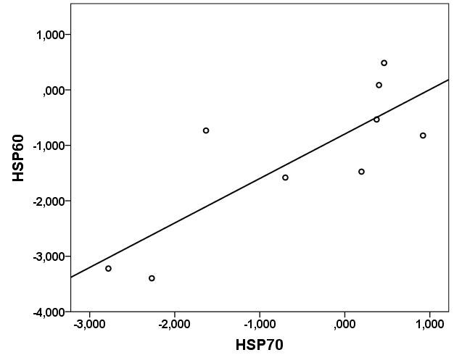

B 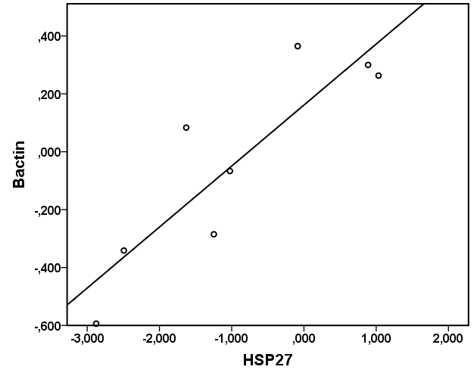

C 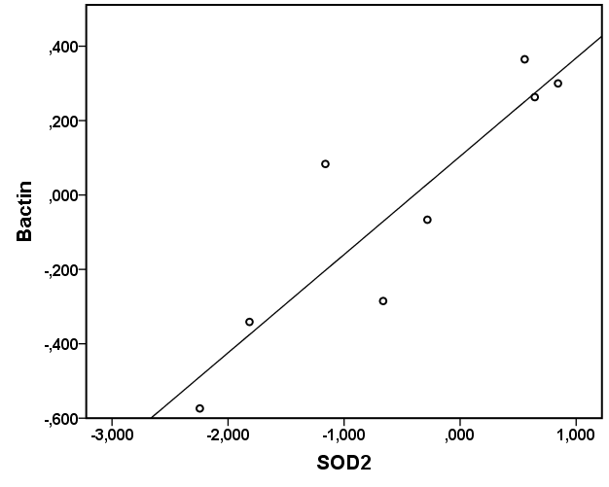

D 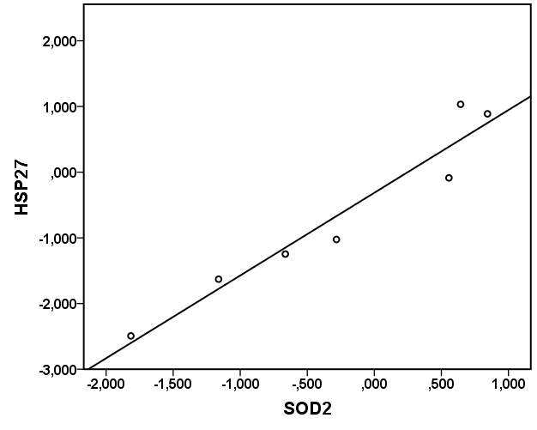

E
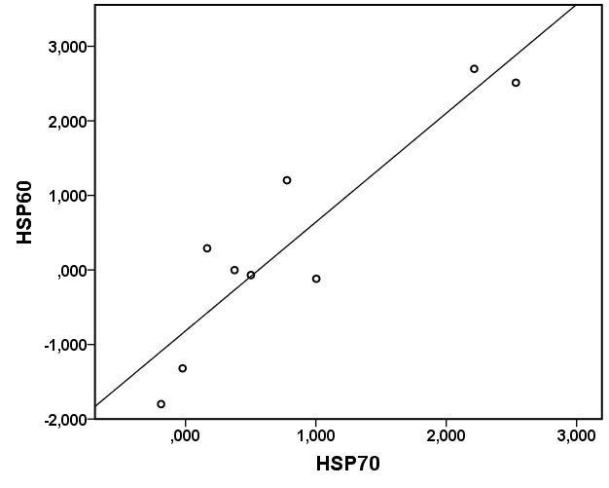

F 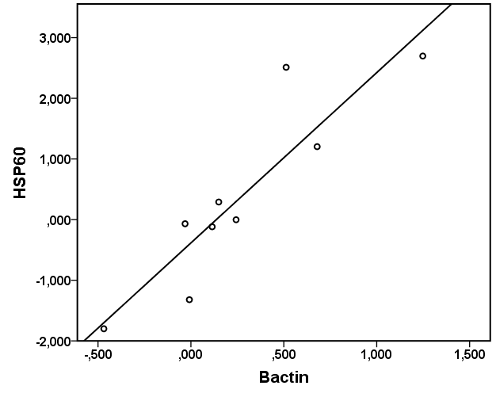

G 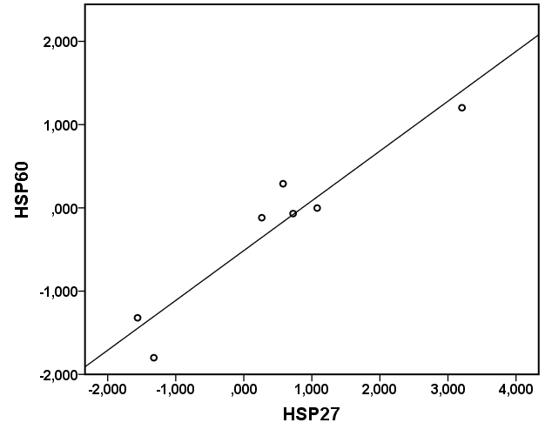

H 