SUPPLEMENT
TITLE PAGE
Title: Sesame fractions and lipid profiles: a systematic review and meta-analysis of controlled trials

Running title: sesame and lipid profiles

Authors: Saman Khalesi¹, Ernesta Paukste¹, Elham Nikbakht², Hossein Khosravi-Boroujeni¹
Affiliations:
¹ Population and Social Health Research Program, Menzies Health Institute Queensland and School of Medicine, Griffith University, Australia
² Menzies Health Institute Queensland, Molecular Basis of Disease and School of Medical Science, Griffith University, Australia

Correspondent author: Hossein Khosravi-Boroujeni
Population and Social Health Research Program, Menzies Health Institute Queensland and School of Medicine, Griffith University, Australia
Email: hossein.khosraviboroujeni@griffithuni.edu.au

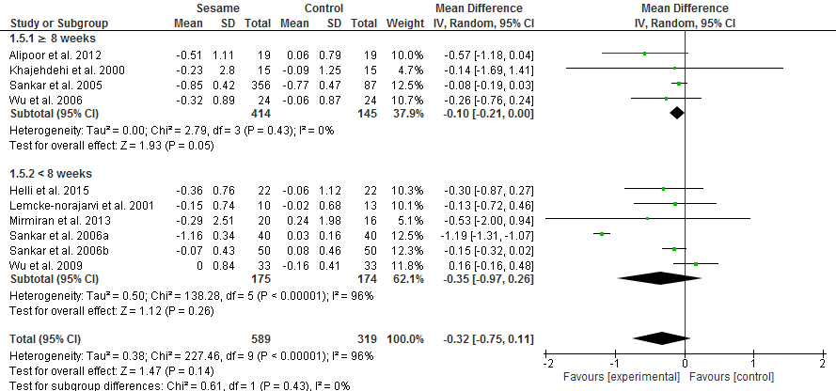
Figure S.1 Forest plot of the effect of sesame consumption on total cholesterol for the subgroup of duration of intervention
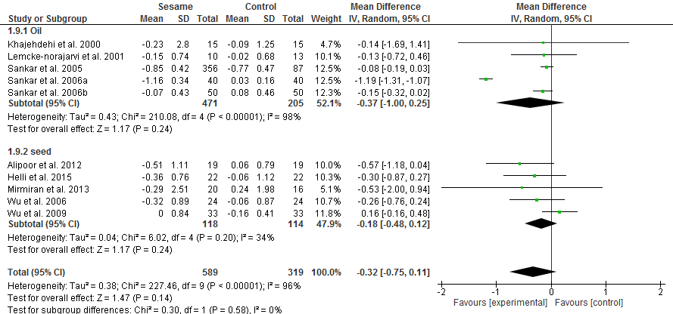
Figure S.2 Forest plot of the effect of sesame consumption on total cholesterol for the subgroup of source of sesame
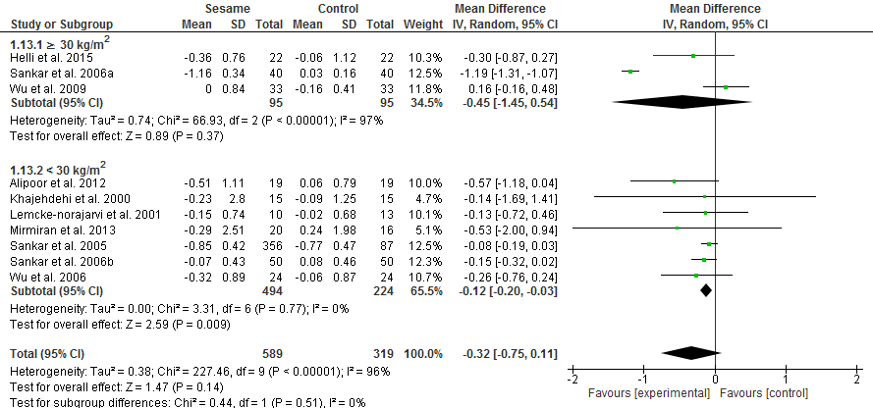
Figure S.3 Forest plot of the effect of sesame consumption on total cholesterol for the subgroup of baseline BMI of participants
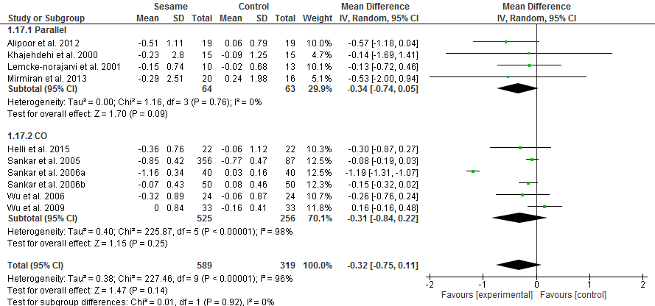
Figure S.4 Forest plot of the effect of sesame consumption on total cholesterol for the subgroup of the design of study
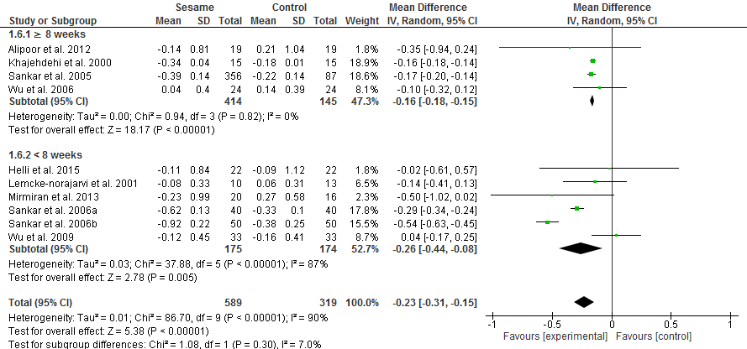
Figure S.5 Forest plot of the effect of sesame consumption on triglyceride for the subgroup of duration of intervention
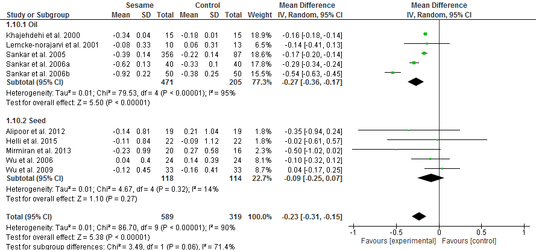
Figure S.6 Forest plot of the effect of sesame consumption on triglyceride for the subgroup of source of sesame
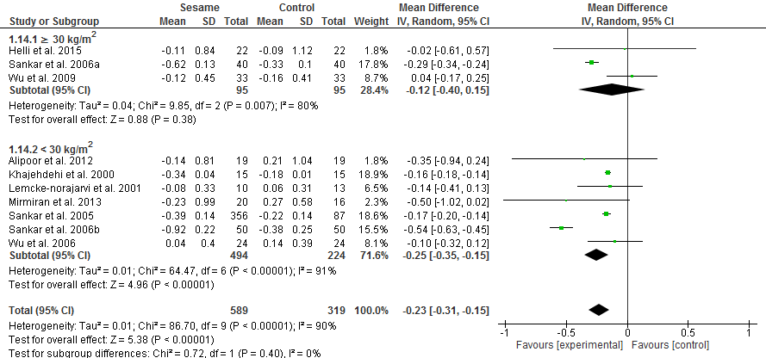
Figure S.7 Forest plot of the effect of sesame consumption on triglyceride for the subgroup of baseline BMI of participants
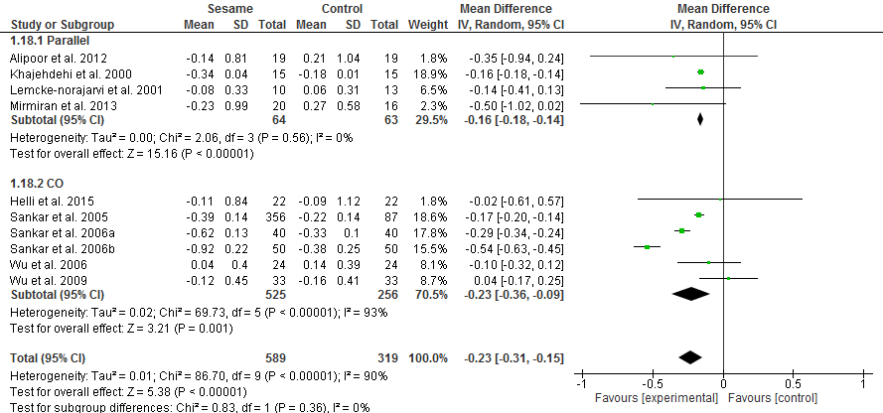
Figure S.8 Forest plot of the effect of sesame consumption on triglyceride for the subgroup of the design of study
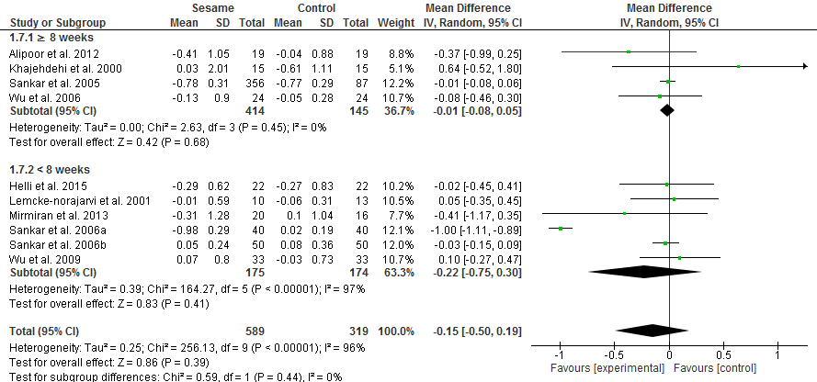
Figure S.9 Forest plot of the effect of sesame consumption on low-density lipoprotein for the subgroup of duration of intervention
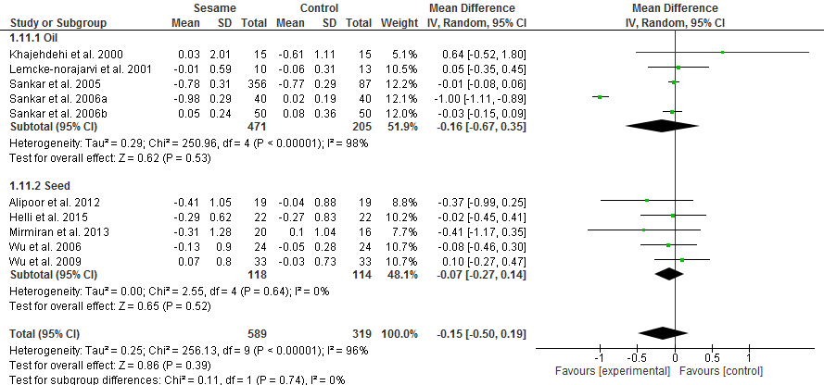
Figure S.10 Forest plot of the effect of sesame consumption on low-density lipoprotein for the subgroup of source of sesame
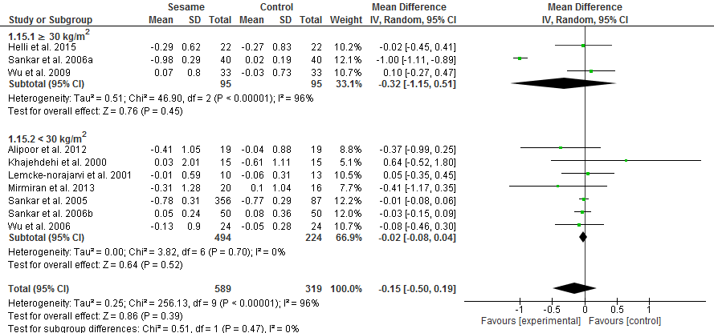
Figure S.11 Forest plot of the effect of sesame consumption on low-density lipoprotein for the subgroup of baseline BMI of participants
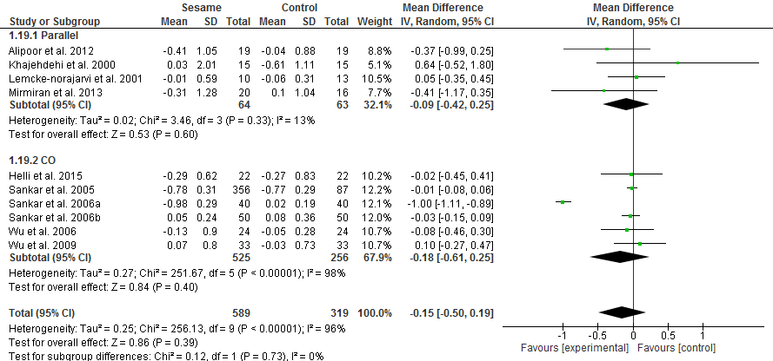
Figure S.12 Forest plot of the effect of sesame consumption on low-density lipoprotein for the subgroup of the design of study
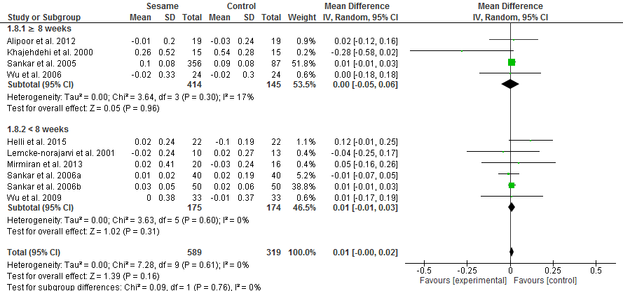
Figure S.13 Forest plot of the effect of sesame consumption on high-density lipoprotein for the subgroup of duration of intervention
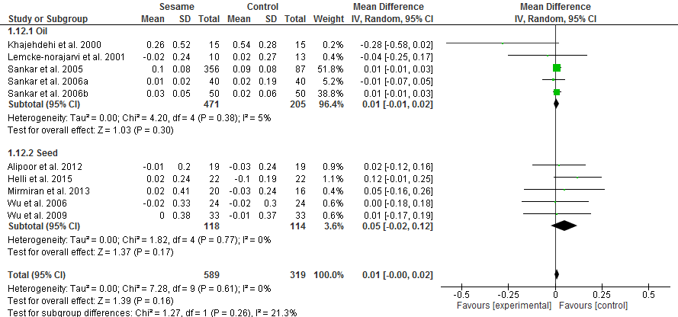
Figure S.14 Forest plot of the effect of sesame consumption on high-density lipoprotein for the subgroup of source of sesame
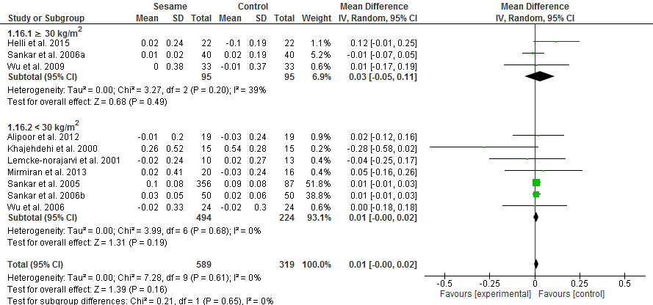
Figure S.15 Forest plot of the effect of sesame consumption on high-density lipoprotein for the subgroup of baseline BMI of participants
Figure S.16 Forest plot of the effect of sesame consumption on high-density lipoprotein for the subgroup of the design of study
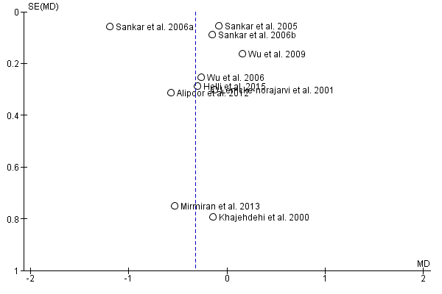
Figure S.17 Funnel plot of mean difference of trials against standard errors for the effect of sesame on total cholesterol

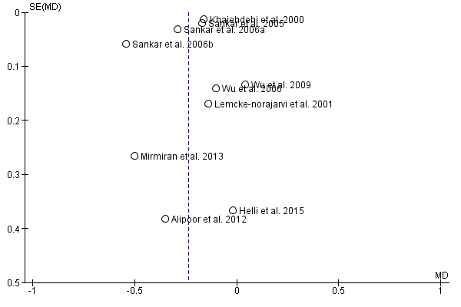
Figure S.18 Funnel plot of mean difference of trials against standard errors for the effect of sesame on triglyceride
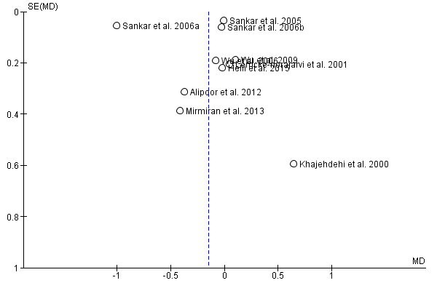
Figure S.19 Funnel plot of mean difference of trials against standard errors for the effect of sesame on low-density lipoprotein

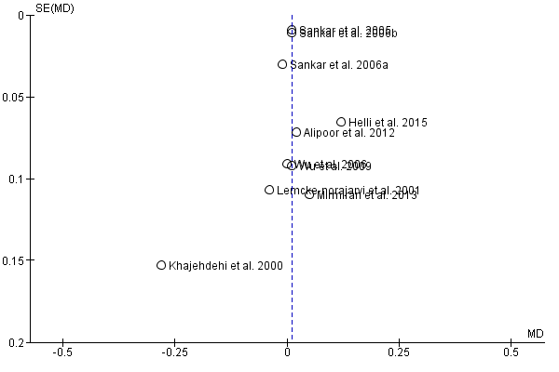
Figure S.20 Funnel plot of mean difference of trials against standard errors for the effect of sesame on high-density lipoprotein

Table S.21. Proximate composition of sesame seeds ⁽¹⁻³⁾
Crude protein | 21.78 ±1.47 (g/100g)
Crude lipid | 46.5 ± 1.01 (g/100g)
Crude fiber | 2.81 ± 0.75 (g/100g)
SFA | 16 (% oil)
MUFA | 40 (% oil)
PUFA | 43 (% oil)
Vitamin E | 0.597 mg/100ml
Lignans in oil | 11.51 mg/g
Lignans in seeds | 5.81 mg/g

Box S.22 : literature search terms and strategy

((Sesamin) OR (Sesamum) OR (Sesame Oil) OR (Sesamum))

AND

((Cholesterol) OR (Chol) OR (TC) OR (TChol) OR
(HDL) OR (HDL*) OR (high density lipoprotein) OR
(LDL)OR (LDL*) OR (low density lipoprotein) OR
(Triglycerides) OR (TG) OR (lipid profile))

References:

1. Jimoh W, Fagbenro O, Adeparusi E. Effect of processing on some minerals, anti-nutrients and nutritional composition of sesame (Sesamum indicum) seed meals. Elec J Env Agricult Food Chem. 2011;10(1):1864.
2. Nzikou J, Matos L, Bouanga-Kalou G, Ndangui C, Pambou-Tobi N, Kimbonguila A, et al. Chemical composition on the seeds and oil of sesame (Sesamum indicum L.) grown in Congo-Brazzaville. Adv J Food Sci Technol. 2009;1(1):6-11.
3. Youssef MKE, Eshak NS, Hana RS. Physicochemical Characteristics, Nutrient Content and Fatty Acid Composition of Nigella sativa Oil and Sesame Oil. Food and Public Health. 2012.

