NB no revisions requested or made to this document

**Supplementary material: Details of statistical methodology**

*School Discipline records – Full analysis*

Let $N_{i}(t,s)$ be the number of disciplinary events observed for pupil $i$ over a period running from time $t$ to time $s$, where $t<s$. Then

$$N_{i}\left(t,s\right)∼Poisson\left(\int_{t}^{s}{h_{i}\left(x\right)dx }\right), \left(1\right)$$

where *hi(x)* is the hazard rate for pupil *i* at time *x*. This hazard rate was specified as:

$$h_{i}\left(t\right)= λ_{i} \text{for }t\text{ in the baseline period} \\ and \\ h_{i}\left(t\right)= λ_{i}e^{α+ α_{A}\left(A_{i}\right)} \text{for }t\text{ in the treatment period}, (2)$$

with $A_{i}$ being an indicator variable taking the value 1 if the participant $i$ is in the active group, and 0 for the placebo group. Furthermore, we assumed the prior distribution $λ_{i} \sim Γ(r,k)$, with $r$ and $k$ as the shape and rate of the Gamma distribution, respectively. To ensure that the model output was not affected by the prior assumptions, we used a hierarchical model with vague hyperpriors on the $r$ and $k$, as discussed by Gelman (1) and Lambert *et al*. (2). We then calculated posterior estimates of $λ_{i}$ for all pupils. Through this formulation, each pupil was assigned their own underlying offence rate $λ_{i}$ and was consequently measured against his or her own baseline performance. Then the parameters in (2) were used to measure movements in offence rates form baseline to treatment periods. An overall movement was measured by $α$, while a movement experienced by pupils in the active group was measured by $α_{A}$.

Parameter estimation was carried out by Gibbs sampling (3), a Markov chain Monte Carlo (MCMC) technique (4). The calculations were executed using the JAGS software package (5) in R (R Foundation, Vienna). Once parameters had been estimated, they were interpreted as follows: a pupil with a baseline offence rate of $λ_{i}$, demonstrated an offence rate during the treatment period of $λ_{i}e^{α}$ if he or she was in the placebo group, and $λ_{i}e^{α+ α_{A}}$ if he or she was in the active group, where the mathematical constant *e*=2.71828… is the base of natural logarithms.

Note that, while individual offense-rate parameters appear in the model specification, no usable estimates are possible for these hundreds of individual-level parameters.

Specification of the rate ratios:

For a pupil in the placebo group,

$$\frac{\text{treatment offence rate}}{\text{baseline offence rate}}=e^{α}$$

while for a pupil in the active group,

$$\frac{\text{treatment offence rate}}{\text{baseline offence rate}}=e^{α+α_{A}}.$$

The stratified model, for which results are given in Table 7 in the paper, employed the following hazard rate:

$$h_{i}\left(t\right)={λe}^{κ \left(H_{i}\right)} \text{for }t\text{ in the baseline period}$$

$$and \\ h_{i}\left(t\right)=λe^{κ \left(H_{i}\right)+ α_{L}\left(1-H_{i}\right)+ α_{H}\left(H_{i}\right)+β_{HA}\left(H_{i}\right)\left(A_{i}\right)+ β_{LA}\left(1-H_{i}\right)\left(A_{i}\right)}$$ $\text{for }t\text{ in the treatment period}$,

with $A_{i}$ being and indicator variable taking 1 if subject $i$ is in the active group , and 0 otherwise, and $H_{i}$ being an indicator variable taking 1 if the subject is in the “high” group, and 0 otherwise. Notice that, as opposed to (2), this model does not allow for each pupil to have an individual underlying offence rate $λ_{i}$, but rather uses a universal rate of $λ.$ For this model, we used the prior $λ\sim Gamma(0.0001, 0.0001)$.

The model with discrepant response based on baseline behaviour:

For a pupil in the placebo group with high misbehaviour,

$$\frac{\text{treatment offence rate}}{\text{baseline offence rate}}=e^{α_{H}}$$

while for a pupil in the active group with high misbehaviour,

$$\frac{\text{treatment offence rate}}{\text{baseline offence rate}}=e^{α_{H}+β_{HA}}.$$

Similarly, for a pupil in the placebo group, with low misbehaviour,

$$\frac{\text{treatment offence rate}}{\text{baseline offence rate}}=e^{α_{L}}$$

and a pupil in the active group, with low misbehaviour will have

$$\frac{\text{treatment offence rate}}{\text{baseline offence rate}}=e^{α_{L}+β_{LA}}.$$

*School Discipline records – subgroup analysis with PUFA measurements*

The same Poisson process was used as (1) but with the hazard rate specified as:

$$h_{i}\left(t\right)= λ_{i}e^{β\left(Bloodpre_{i}\right)} \text{for }t\text{ in the baseline period} \\ and \\ h_{i}\left(t\right)= λ_{i}e^{α+ α_{A}\left(A_{i}\right)+ β(Bloodpost_{i})} \text{for }t\text{ in the treatment period}, (3)$$ where $Bloodpre_{i}$ and $Bloodpost_{i}$ are erythrocyte PUFA measurements taken before and end of the treatment period, respectively. As previously indicated, $A_{i}$ is an indicator variable taking 1 if subject *I* is in the active group and 0 for the placebo group. The hazard rate in (3) links the discipline rate during a period to the blood measurement assumed to be in effect over the same period. The significance of the blood measurements as a covariate was measured through the parameter $β$.

The model with influence of blood measurements:

For a pupil, in the placebo group, with blood data available

$$\frac{\text{treatment offence rate}}{\text{baseline offence rate}}=e^{α+β(Bloodpost_{i}-Bloodpre_{i})},$$

while for a pupil in the active group, with blood concentrations available,

$$\frac{\text{treatment offence rate}}{\text{baseline offence rate}}=e^{α+α_{A }+ β(Bloodpost_{i}-Bloodpre_{i})},$$

where $Bloodpre_{i}$ and $Bloodpost_{i}$ are erythrocyte PUFA measurements taken before and end of the treatment period, respectively.

**Supplementary References**

1. Gelman A (2006) Prior distributions for variance parameters in hierarchical models (comment on article by Browne and Draper). *Bayesian Analysis* **1**, 515-533.

2. Lambert PC, Sutton AJ, Burton PR *et al.* (2005) How vague is vague? A simulation study of the impact of the use of vague prior distributions in MCMC using WinBUGS. *Stat Med* **24**, 2401-2428.

3. Gelfand AE (1990) Sampling-based approaches to calculating marginal densities. *Journal of the American Statistical Association* **85**, 398.

4. Gilks W, Richardson S, Spiegelhalter D (1995) *Markov Chain Monte Carlo in Practice: Interdisciplinary Statistics*: Taylor & Francis.

5. Plummer M (2003) *JAGS: A program for analysis of Bayesian graphical models using Gibbs sampling*.

**Supplementary material: Supplementary tables**

Supplementary Table 1**.**  Potency of vitamins, minerals and PUFAs in active supplementation.

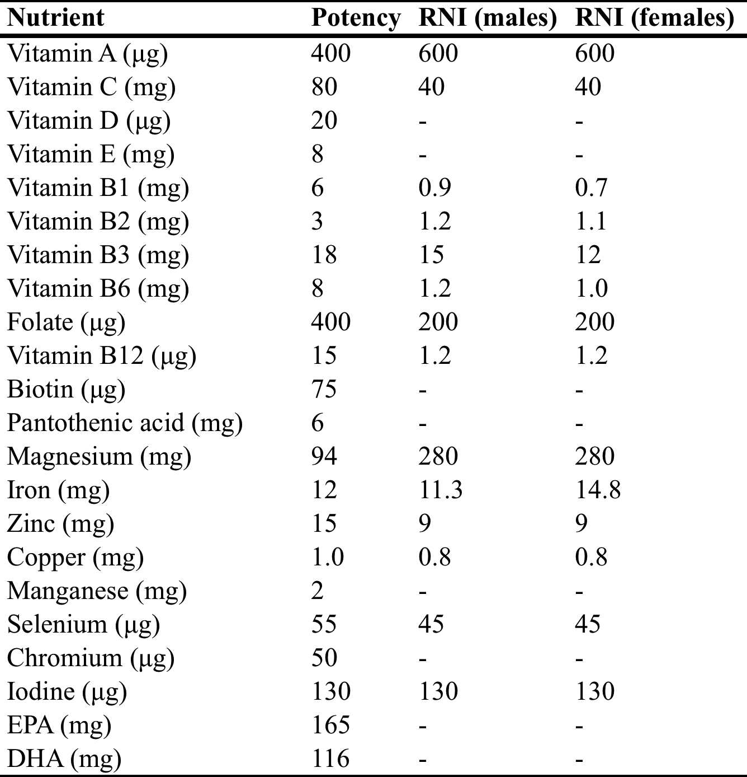

DHA, Docosahexanoic acid; EPA, Eicosapentanoic acid; RNI, Reference Nutrient Intake (UK); RNI for 14 year olds (mean age of participants); -,no RNI available

Supplementary Table 2**.** Baseline mean daily nutrient intake



Supplementary Table 3**.** Interpretation of Bayes factors

