

**Figure S1: Typical HPLC chromatograms for urine samples** **following ingestion of the OLE extract.**

Purple: 0-4 h; green: 4-8h; blue: 8-24h. HT (8.6 min), tyrosol (14.0 min), HVA (17.4 min), EDA (30.3 min), oleuropein (38.3 min) and EA (41.3 min) were identified using authentic standards whilst the peaks at 31.7, 34.1, 37.2 and 38.8 min were tentatively characterised as EDA/oleuropein metabolites by spectral mapping with EDA/oleuropein standards.

N.B. Tyrosol was identified in the urine of only one individual in the following amounts: 1.2 mg (0-4 hrs), 2.36 mg (4-8 hrs), 1.0 mg (8-24 hrs)

**Table S1: Baseline characteristics of the subjects**

|  |  |
| --- | --- |
| **Variable** | **Mean (±SD)** |
| Age (years) | 25.4 (5.6) |
| BMI (kg/m2) | 23.0 (2.1) |
| Waist:hip ratio | 0.8 (0.1) |
| Blood pressure (mm Hg) | 119.5 (10.9) / 72.1 (5.8) |
| Total cholesterol (mmol/L) | 4.3 (0.8) |
| Triglycerides (mmol/L) | 0.9 (0.4) |
| Glucose (mmol/L) | 5.13 (0.5) |

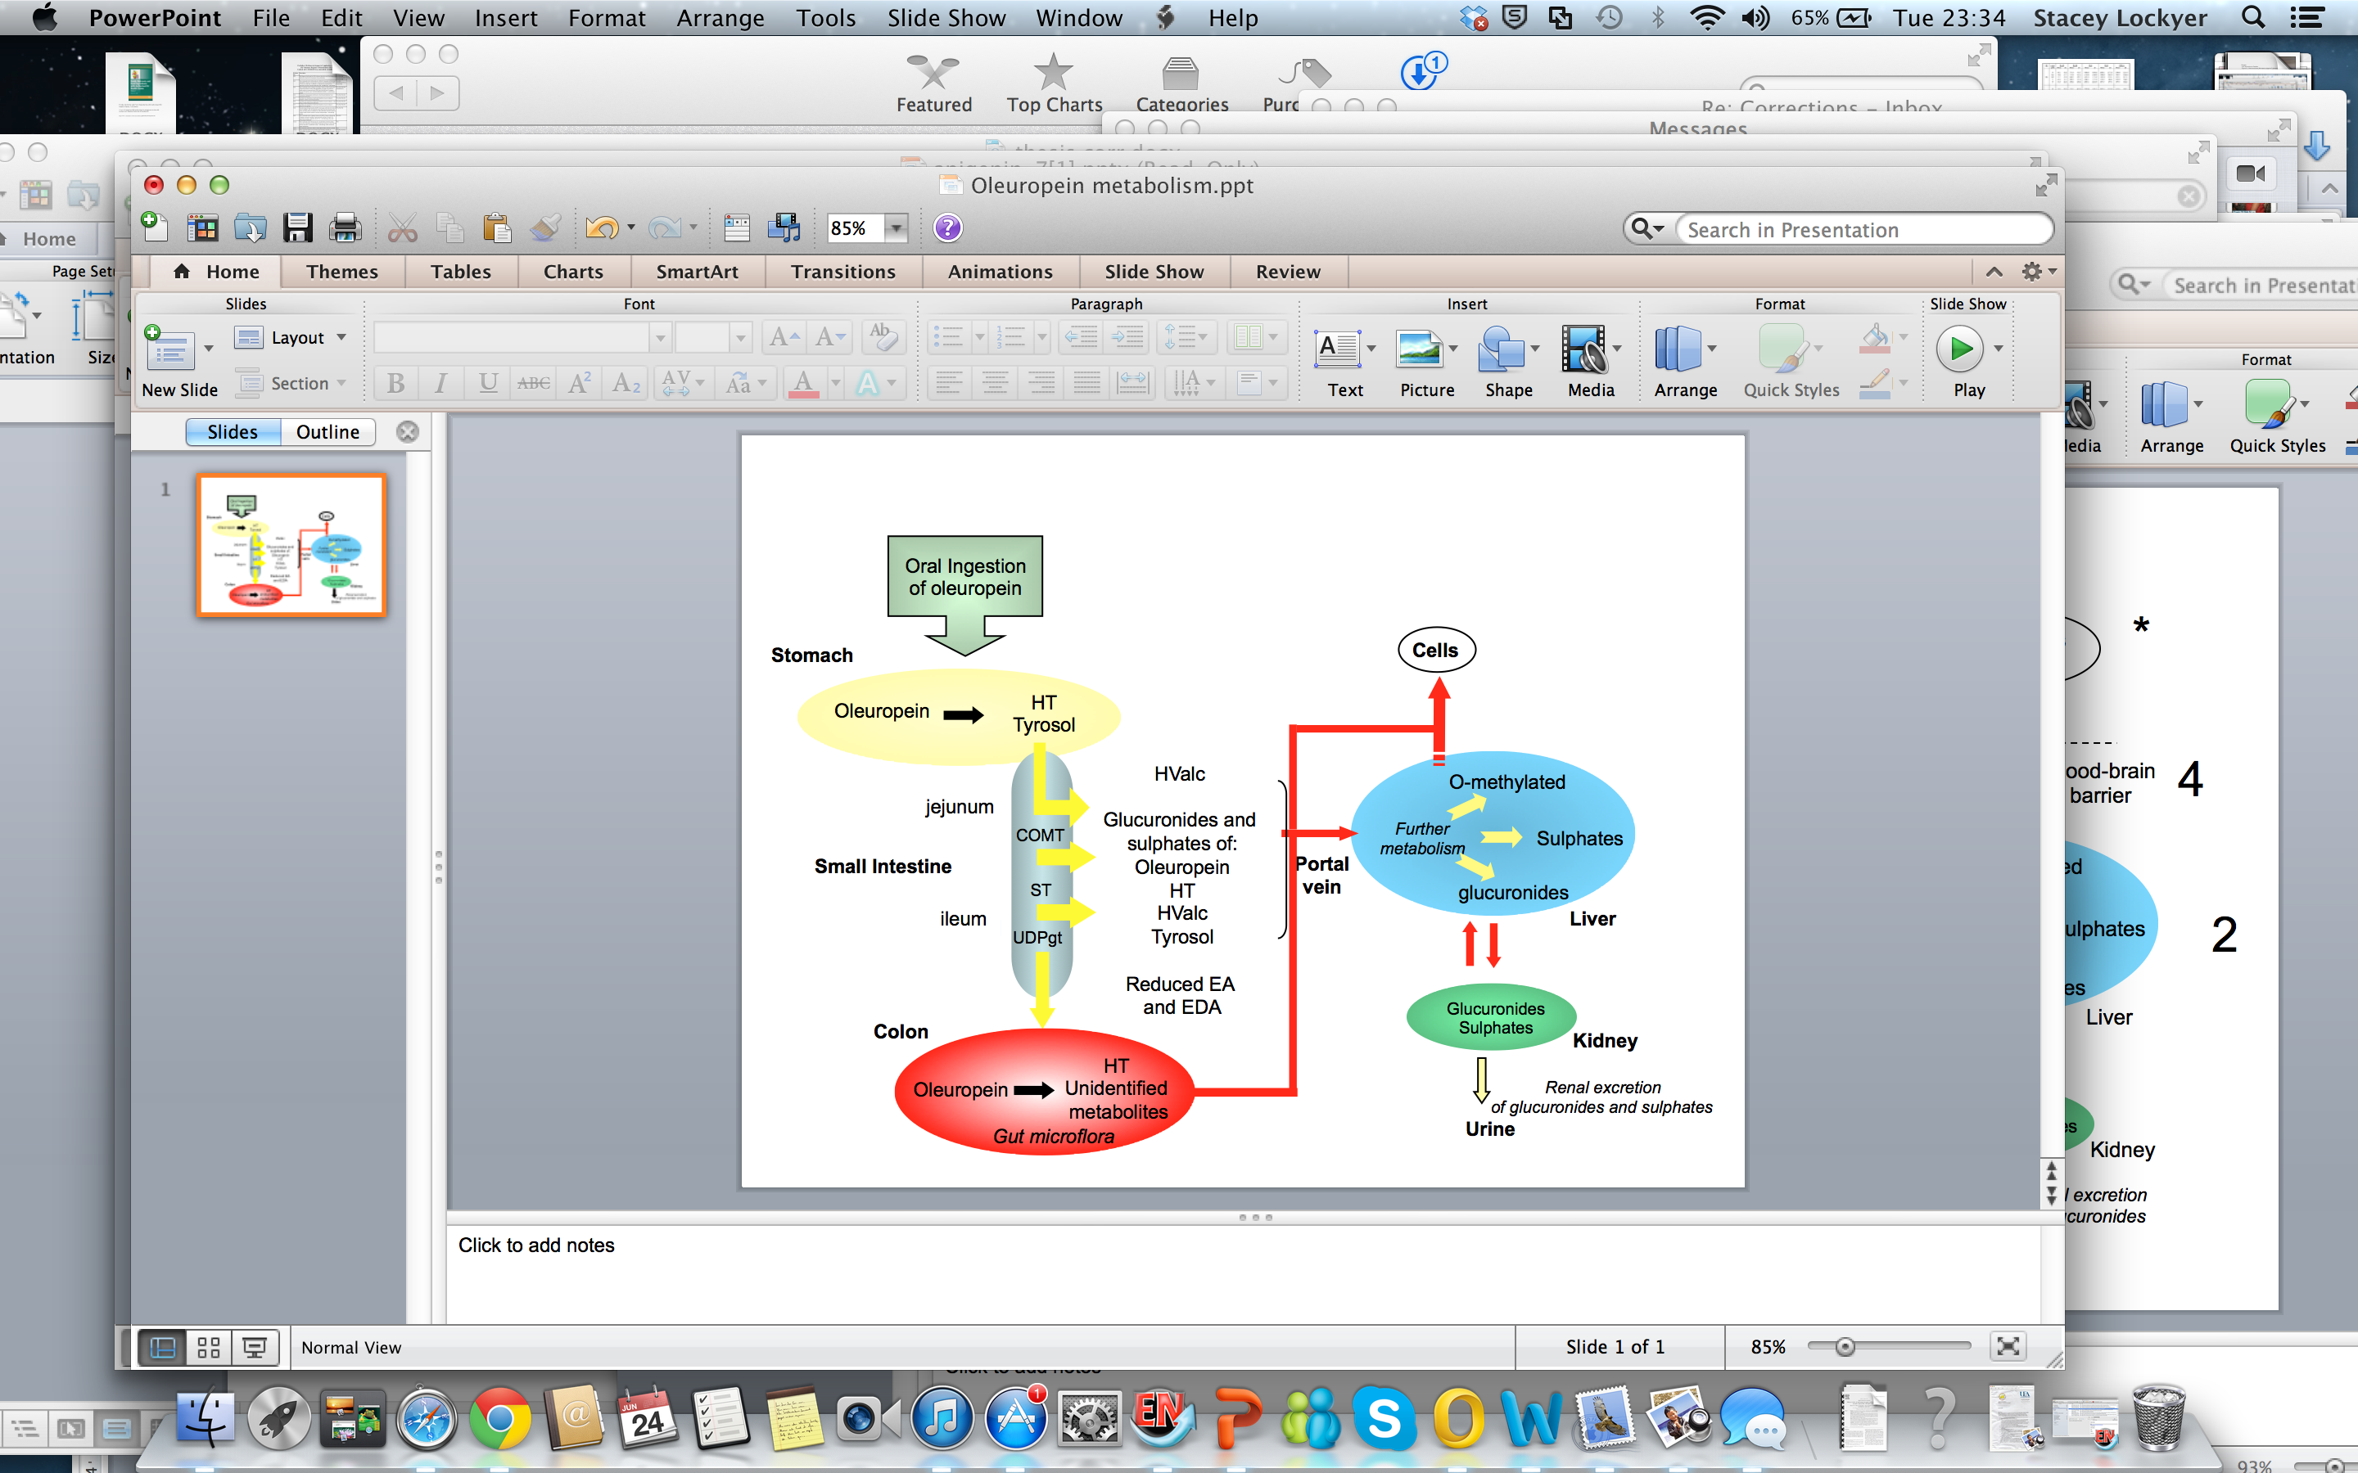

**Figure S2 Oleuropein metabolism in humans (based on Lockyer et. al 2012 (****1****))**

HT, hydroxytyrosol; HValc, homovanillic alcohol; COMT, catechol-O-methyl-transferase, ST, sulphurtransferase; UDPgt,

UDP-glucuronosyl transferase; EA, oleuropein aglycone; EDA, oleuropein aglycone di-aldehyde.

**References**

1. Lockyer S, Yaqoob P, Spencer JPE, Rowland I. Olive leaf phenolics and cardiovascular risk reduction: Physiological effects and mechanisms of action. Nutrition and Aging. 2012;1(2):125-40.