Suppl. table 1:

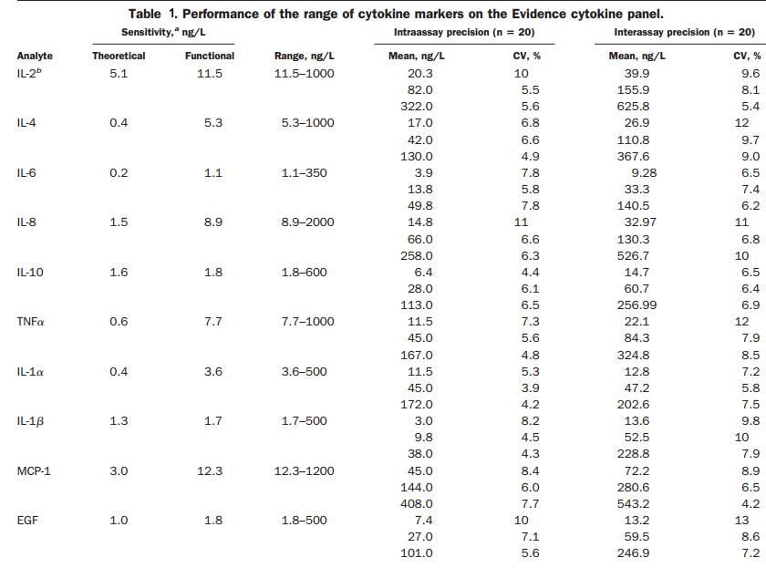
Three values provided for each cytokine relate to internal controls. Randox Cytokine Controls are intended for use as an assayed quality control in the routine monitoring of accuracy and precision for the analytes listed in this table. Each control contains all of the analytes listed overleaf. There are 3 levels of control; low, medium and high; level 1, 2 and 3 respectively (1).

Supplemental Reference:
- FitzGerald SP, Lamont JV, McConnell RI, Benchikh EO. Development of a high-throughput automated analyzer using biochip array technology. Clinical chemistry. 2005;51(7):1165-76.

Suppl. table 2

Suppl. Table 2. inflammatory score of cytokines and growth factors levels in metabolic syndrome
IFN-γ | 1
IL-1α | 2
IL-4 | 3
TNFα | 4
IL-1β | 5
IL-2 | 6
IL-8 | 7
hs-CRP | 8
IL-6 | 9
IL-10 | 10
VEGF | 11
EGF | 12
MCP-1 | 13
The most related markers were determined and ranked using regression coefficient of each marker in multivariate model multiple-by variation range of cytokines and growth factors level.

