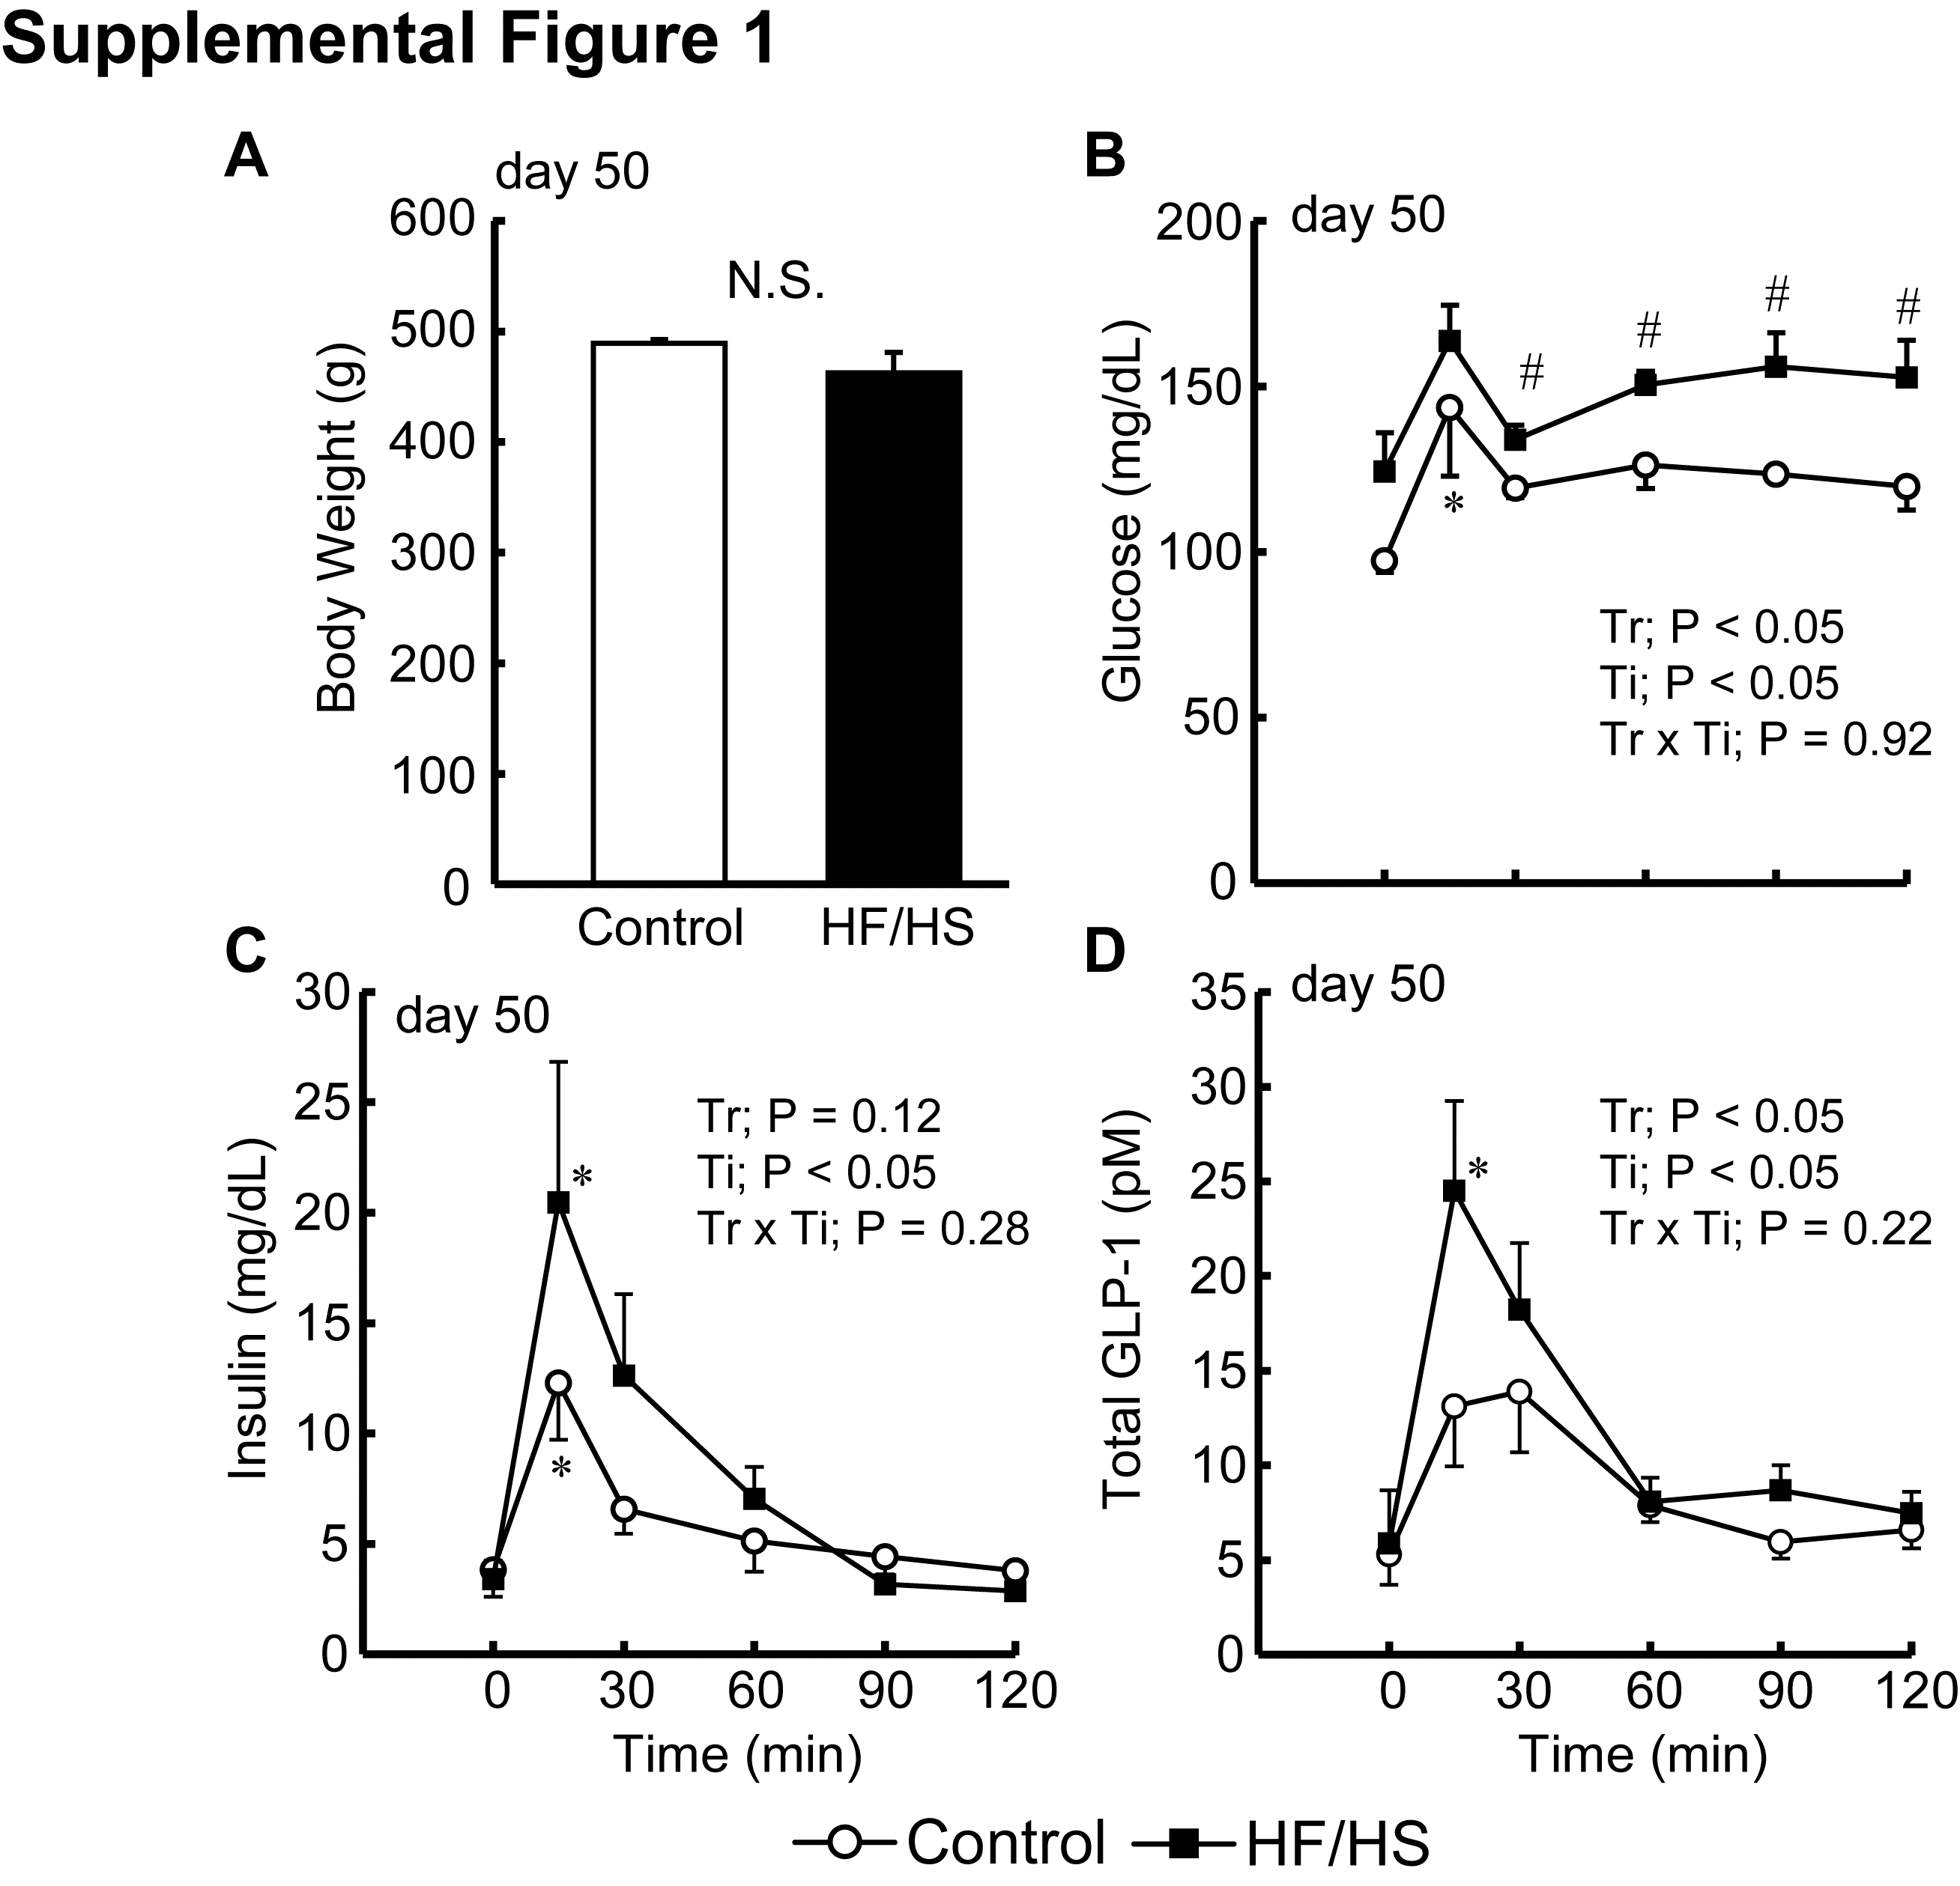
Supplemental Fig. 1. Postprandial glycemia and hormone levels in rats having similar body weights in control and HF/HS group at day 50
Data from 4 rats with higher body weight in control and 4 rats with lower body weight in HF/HS were selected. Rats were fed the control diet ad lib (open circle) and HF/HS diet ad lib (filled square), except for the day of the MTT. Average body weight of selected rats (A), changes in plasma glucose (B), insulin (C), and total GLP-1 (D) levels at day 50 were presented. Values are means ± SEM of 4 rats. P values for effects of treatment (Tr), time (Ti) and the interaction of treatment and time (Tr x Ti) calculated by two-way ANOVA was represented in each panels. # P < 0.05 vs control, * P < 0.05 vs basal level (Student’s t-test and Tukey-Krammer’s post-hoc test).

