**Box S1:** Algorithms and selection process used in the main search

Search Algorithms

* DASH AND diet* AND blood pressure/hypertension/glucose/glycaemia/lipid*/dyslipidaemia/diabetes/metabolic syndrome/insulin resistance/insulin/cholesterol/HDL cholesterol/LDL cholesterol/HOMA
* diet* AND approach* AND stop AND hypertension AND blood pressure glucose/glycaemia/lipid*/dyslipidaemia/diabetes/metabolic syndrome/insulin resistance/insulin/cholesterol/HDL cholesterol/LDL cholesterol/HOMA

Selection Process

The first screening phase was based on the analysis of titles and abstracts. When full agreement had been reached, the article was either discarded or moved to the next phase. In case of disagreement the article was moved to the next phase. Reference lists of included papers and relevant reviews were searched for articles potentially missed during the electronic search. In the second phase, the full text of the selected articles was assessed independently by two investigators (MS, SC). When full agreement had been reached the article was either discarded or moved to the next phase for full data extraction. In case of disagreement the article was evaluated by a third investigator (JL) and a final decision was reached by consensus.

**Box S2:** Variables extracted during the full-text phase

The variables extracted were: author, year of publication, country, study design, inclusion and exclusion criteria, study duration, run-in phase, intention to treat analysis, sample size, type of intervention (control and DASH diet), age, gender, gender and ethnicity distribution, randomisation procedure, blinding of measurements, compliance to the interventions, body mass index (BMI), dietary intervention, sodium intake (mg/day), weight loss during the study, baseline and post-intervention measurements of resting BP readings (systolic, diastolic), baseline and post-intervention measurements of glucose, total cholesterol, triglycerides, LDL and HDL concentrations.

When resting BP was not available and the study used ambulatory 24-hr BP monitoring, these measurements were included in the meta-analysis.

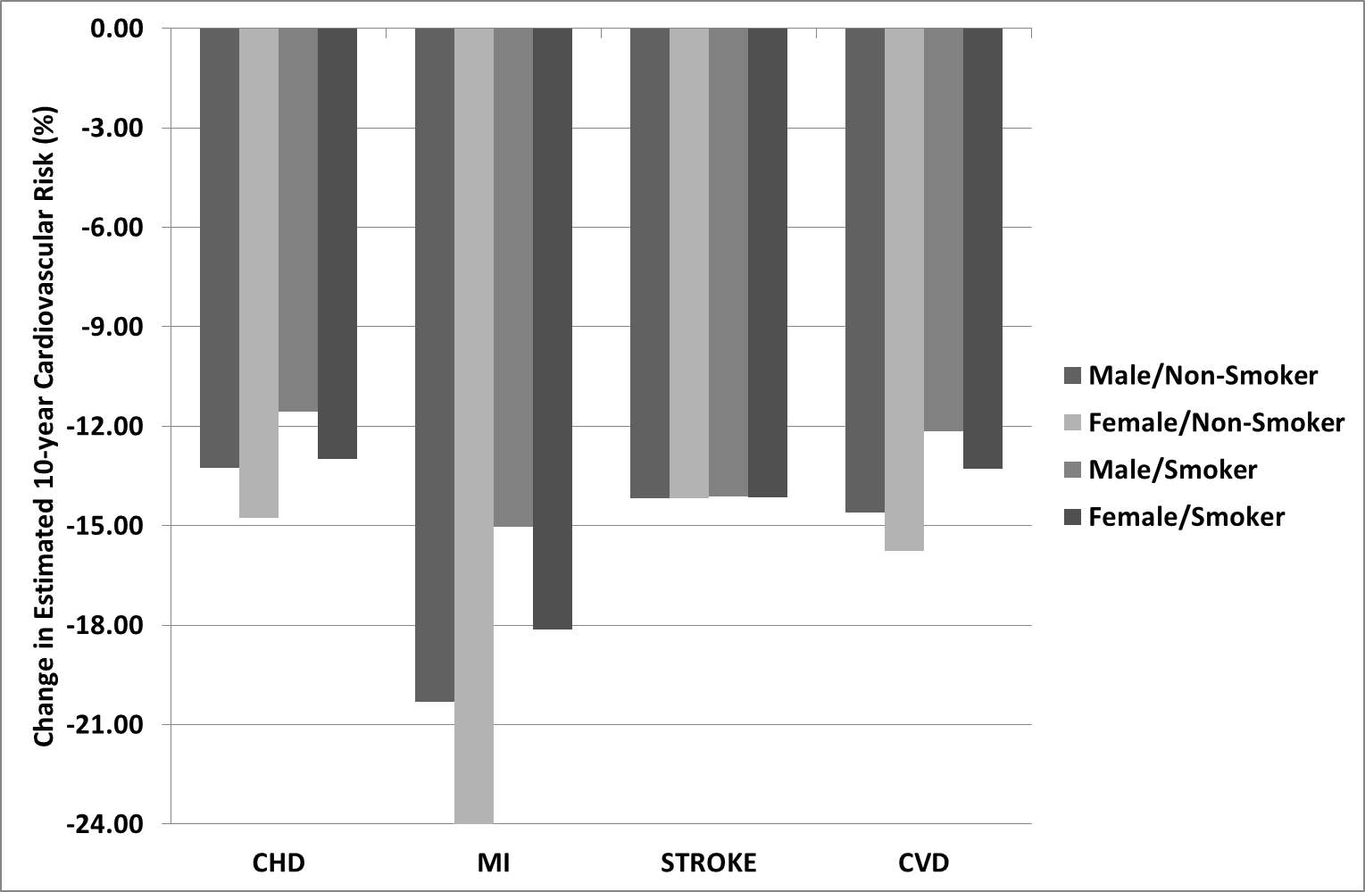

**Figure S1:** Percent change in 10-year probability of developing a cardiovascular event as a consequence of changes in systolic blood pressure, total cholesterol and HDL obtained in the meta-analysis. Risk scores have been calculated after stratification by gender and smoking status with the assumption that the same changes in cardiovascular risk factors occurred in the four groups. Baseline values entered in the models were: age (45years), systolic blood pressure (132.5mmHg), total cholesterol (199.7mg/dL) and HDL (48mg/dL). Cardiovascular risk scores were then calculated by entering the estimated mean changes obtained from the meta-analysis for systolic blood pressure (-5.2mmHg), total cholesterol (-7.9mg/dL) and HDL (+0.1mg/dL). CHD=coronary heart disease; MI= myocardial infarction; CVD=cardiovascular disease. All scores were calculated using Framingham equations[3].

 

**Systolic BP Diastolic BP HDL**

 

**Total Cholesterol Triglycerides Glucose**



**Figure S2:** Funnel Plots - Publication bias for each individual metabolic component. BP: blood pressure, HDL: high density lipoproteins, LDL: low density lipoproteins

**LDL**

|  |  |
| --- | --- |
| **Table S1:** Difference in sodium intake between the DASH dietary intervention and control group in each trial. | |
|  | Difference in Sodium Intake (mg/day) |
| Appel, 1997 | -110 |
| Sacks, 2001# | 33 |
| Appel, 2003 | 208 |
| Conlin, 2003 | 0 |
| Lopes, 2003-L | -645 |
| Lopes, 2003-Ob | -645 |
| Nowson, 2004 | -600 |
| Nowson, 2005 | -646 |
| Azadbakthy, 2005-M | -596 |
| Azadbakthy, 2005-W | -596 |
| Nowson, 2009 | -46 |
| Al Solamain, 2010-L | 10 |
| Al Solamain, 2010-Ob | -40 |
| Blumenthal, 2010 | -878 |
| Malloy, 2010 | -319 |
| Azadbakht, 2011 | -596 |
| Edwards, 2011* | NR |
| Lin, 2012 | -207 |
| Asemi, 2013 | -2481 |

*Sodium intake was not reported (NR) in the study. #Results from the DASH-Sodium trial. Average intake for each sodium group was calculated and the difference between the DASH and control group is reported in the table.

|  |  |  |  |  |  |  |  |  |  |
| --- | --- | --- | --- | --- | --- | --- | --- | --- | --- |
| Table S2: Sensitivity analysis to evaluate whether the removal of studies with missing information modified the effect size of selected cardiovascular risk factors | | | | | | | | | |
|  | Effect Size | | | | |  | Heterogeneity | | |
|  | N | Mean Difference | Upper Limit | Lower Limit | P Value |  | Q-Value | I2 | P Value |
| Glucose (mg/dL) | 9 | -3.5 | -7.4 | 0.3 | 0.07 |  | 22.1 | 63.2 | 0.005 |
| HDL (mg/dL) | 13 | 0.04 | -2.2 | 2.3 | 0.97 |  | 57.4 | 79.1 | <0.001 |
| LDL (mg/dL) | 11 | -4.8 | -9.0 | -0.6 | 0.02 |  | 16.8 | 40.9 | 0.07 |
| Total Cholesterol (mg/dL) | 12 | -8.1 | -12.3 | -3.8 | <0.001 |  | 17.4 | 36.8 | 0.09 |
| Triglycerides (mg/dL) | 13 | -0.4 | -5.6 | 4.7 | 0.86 |  | 8.1 | 0 | 0.77 |

N: number of studies; BP: blood pressure; HDL: high density lipoproteins; LDL: low density lipoproteins;

|  |  |  |  |  |  |  |
| --- | --- | --- | --- | --- | --- | --- |
| Table S3: Sensitivity analysis to evaluate the effects of potential confounding factors on the meta-analysis  results for each metabolic syndrome component | | | | | | |
|  |  | Studies  (N) | Mean  Difference | SE | p value | I2 |
| Study Design | | | | | | |
| Systolic BP  (mmHg) | CO | 6 | -5.7 | 1.9 | 0.004 | 92 |
| P | 13 | -4.5 | 0.6 | <0.001 | 15 |
| Diastolic BP  (mmHg) | CO | 6 | -2.9 | 0.9 | 0.002 | 75 |
| P | 13 | -2.5 | 0.3 | <0.001 | 13 |
| Cholesterol  (mg/dL) | CO | 6 | -6.1 | 2.4 | 0.01 | 0 |
| P | 7 | -8.3 | 3.5 | 0.01 | 53 |
| HDL  (mg/dL) | CO | 6 | 0.07 | 1.2 | 0.95 | 49 |
| P | 9 | 0.4 | 1.5 | 0.77 | 81 |
| LDL  (mg/dL) | CO | 6 | -2.1 | 2.5 | 0.39 | 36 |
| P | 7 | -5.9 | 2.7 | 0.03 | 36 |
| Glucose  (mg/dL) | CO | 5 | -2.1 | 3.1 | 0.49 | 70 |
| P | 5 | -4.7 | 1.5 | 0.001 | 0 |
| Triglycerides  (mg/dL) | CO | 6 | -0.3 | 4.5 | 0.94 | 0 |
| P | 9 | -0.4 | 3.1 | 0.87 | 0 |
| Feeding | | | | | | |
| Systolic BP  (mmHg) | CON | 5 | -4.4 | 0.8 | <0.001 | 0 |
| ADV | 14 | -5.3 | 1.2 | <0.001 | 82 |
| Diastolic BP  (mmHg) | CON | 5 | -2.5 | 0.6 | <0.001 | 29 |
| ADV | 14 | -2.5 | 0.6 | <0.001 | 54 |
| Cholesterol  (mg/dL) | CON | 2 | -15.0 | 2.4 | <0.001 | 0 |
| ADV | 11 | -4.6 | 2.5 | 0.02 | 0 |
| HDL  (mg/dL) | CON | 2 | -3.3 | 0.7 | <0.001 | 0 |
| ADV | 13 | 0.8 | 1.0 | 0.39 | 62 |
| LDL  (mg/dL) | CON | 2 | -10.9 | 2.7 | <0.001 | 0 |
| ADV | 11 | -2.1 | 1.6 | 0.18 | 14 |
| Glucose  (mg/dL) | CON | 0 | - | - | - | - |
| ADV | 9 | - | - | - | - |
| Triglycerides  (mg/dL) | CON | 2 | 2.7 | 4.1 | 0.51 | 0 |
| ADV | 13 | -2.3 | 3.2 | 0.47 | 0 |
| Control Diet | | | | | | |
| Systolic BP  (mmHg) | HD | 7 | -4.9 | 1.6 | 0.003 | 64 |
| TD | 12 | -5.3 | 1.1 | <0.001 | 80 |
| Diastolic BP  (mmHg) | HD | 7 | -3.2 | 1.0 | 0.002 | 46 |
| TD | 12 | -2.4 | 0.5 | <0.001 | 54 |
| Cholesterol  (mg/dL) | HD | 4 | -4.7 | 3.6 | 0.19 | 0 |
| TD | 9 | -8.8 | 2.5 | <0.001 | 41 |
| HDL  (mg/dL) | HD | 6 | 2.4 | 1.5 | 0.12 | 75 |
| TD | 9 | -2.1 | 0.6 | 0.001 | 6 |
| LDL  (mg/dL) | HD | 4 | -4.6 | 3.3 | 0.17 | 35 |
| TD | 9 | -3.6 | 2.4 | 0.12 | 44 |
| Glucose  (mg/dL) | HD | 4 | -10.7 | 5.4 | 0.04 | 55 |
| TD | 6 | -0.7 | 1.0 | 0.5 | 0 |
| Triglycerides  (mg/dL) | HD | 6 | -4.3 | 5.1 | 0.39 | 0 |
| TD | 9 | 0.9 | 2.9 | 0.75 | 0 |

A random model was applied to each subgroup to obtain the pooled estimate of the mean difference. Heterogeneity of the studies in each sub-group was evaluated using the I2 test. BP= blood pressure; HDL= high density lipoproteins; LDL= low density lipoproteins; P= parallel; CO= cross over; CON= controlled feeding (food was provided to participants); ADV= dietary advice (no food was provided); HD= healthy diet (exercise, weight loss, healthy dietary pattern); TD= typical diet.

|  |  |  |  |  |  |  |  |  |
| --- | --- | --- | --- | --- | --- | --- | --- | --- |
| Table S4: Assessment of publication bias and heterogeneity of meta-analyses for the cardiovascular risk factors  included in the meta-analysis | | | | | | | | |
|  | Egger's Intercept Test | | | |  | Heterogeneity | | |
|  | Intercept | SE | t-value | P Value |  | Q-Value | I2 | P Value |
| Systolic BP (mmHg) | -0.5 | 0.9 | 0.5 | 0.58 |  | 75.0 | 76.0 | <0.001 |
| Diastolic BP (mmHg) | -1.1 | 0.5 | 2.0 | 0.05 |  | 35.1 | 48.8 | 0.009 |
| Glucose (mg/dL) | -0.94 | 0.9 | 1.0 | 0.32 |  | 22.2 | 59.4 | 0.008 |
| HDL (mg/dL) | 0.3 | 1.1 | 0.3 | 0.79 |  | 57.6 | 75.6 | <0.001 |
| LDL (mg/dL) | 0.3 | 1.1 | 0.3 | 0.77 |  | 19.8 | 37.3 | 0.08 |
| Total Cholesterol (mg/dL) | -0.1 | 0.9 | 0.1 | 0.90 |  | 25.3 | 52.3 | 0.01 |
| Triglycerides (mg/dL) | -0.9 | 0.3 | 2.8 | 0.01 |  | 8.1 | 0 | 0.88 |

BP: blood pressure; HDL: high density lipoproteins; LDL: low density lipoproteins.