Supplemental Figure 3: Cumulative percentile distributions of red blood cell (RBC) folate concentrations by country from the Canadian Health Measures Survey, 2007-2009 (adjusted for microbiologic assay comparison with 95% CI, and unadjusted) and the National Health and Nutrition Examination Survey 2007-2008. Values exceeding 3500 nmol/L are not shown (n =32).

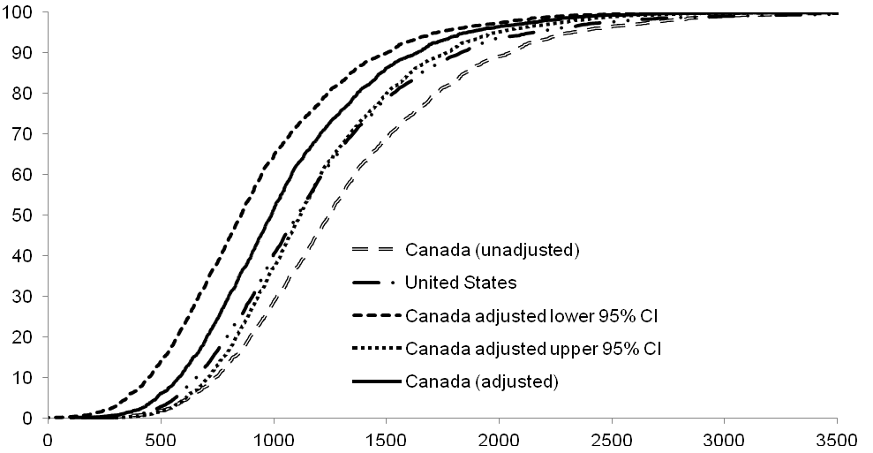
Percentile, %
RBC folate, nmol/L

Boundary assessment examining the lower and upper 95% CI for the conversion equation for the general population. For reference, figures also include lines indicating the unadjusted and method-adjusted Canadian values, as well as the American data.

