Supplementary material

Electronic search strategy (specifics as required for MEDLINE: 16.11.2013)
Limits used: “randomized controlled trials”, “humans”, and “Adult: 19+ years“
1. key word: “low fat diet”; 1969 results
("diet, fat-restricted"[MeSH Terms] OR ("diet"[All Fields] AND "fat-restricted"[All Fields]) OR "fat-restricted diet"[All Fields] OR ("low"[All Fields] AND "fat"[All Fields] AND "diet"[All Fields]) OR "low fat diet"[All Fields]) AND (Randomized Controlled Trial[ptyp] AND "humans"[MeSH Terms] AND "adult"[MeSH Terms])
2. key word: “high fat diet”; 1677 results
("diet, high-fat"[MeSH Terms] OR ("diet"[All Fields] AND "high-fat"[All Fields]) OR "high-fat diet"[All Fields] OR ("high"[All Fields] AND "fat"[All Fields] AND "diet"[All Fields]) OR "high fat diet"[All Fields]) AND (Randomized Controlled Trial[ptyp] AND "humans"[MeSH Terms] AND "adult"[MeSH Terms])
3. key word: “high carbohydrate diet”; 1620 results
(high[All Fields] AND ("carbohydrates"[MeSH Terms] OR "carbohydrates"[All Fields] OR "carbohydrate"[All Fields]) AND ("diet"[MeSH Terms] OR "diet"[All Fields])) AND (Randomized Controlled Trial[ptyp] AND "humans"[MeSH Terms] AND "adult"[MeSH Terms])
4. key word: “low carbohydrate diet”; 720 results
("diet, carbohydrate-restricted"[MeSH Terms] OR ("diet"[All Fields] AND "carbohydrate-restricted"[All Fields]) OR "carbohydrate-restricted diet"[All Fields] OR ("low"[All Fields] AND "carbohydrate"[All Fields] AND "diet"[All Fields]) OR "low carbohydrate diet"[All Fields]) AND (Randomized Controlled Trial[ptyp] AND "humans"[MeSH Terms] AND "adult"[MeSH Terms])

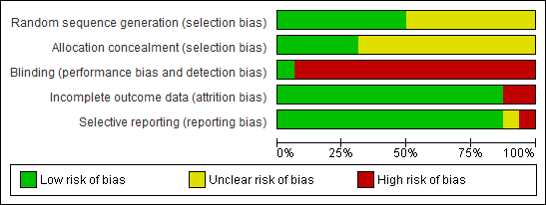
Figure S1: Risk of bias assessment tool. Across trials, information is either from trials at a low risk of bias (green), or from trials at unclear risk of bias (yellow), or from trials at high risk of bias (red).

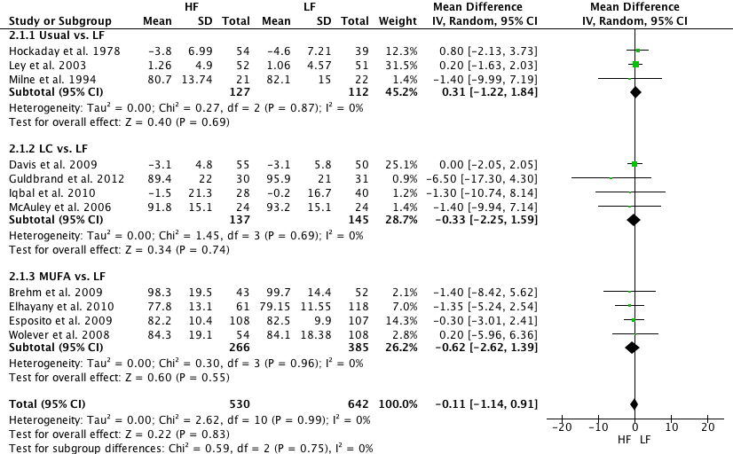
Figure S2. Forest plot showing pooled MD with 95% CI for body weight (kg) for 11 randomized controlled HF diet studies. For each HF study, the shaded square represents the point estimate of the intervention effect. The horizontal line joins the lower and upper limits of the 95% CI of these effects. The area of the shaded square reflects the relative weight of the study in the respective meta-analysis. The diamond at the bottom of the graph represents the pooled MD with the 95% CI for the 11 study groups. LC, low carbohydrate; LF, low fat; MUFA, monounsaturated fat.

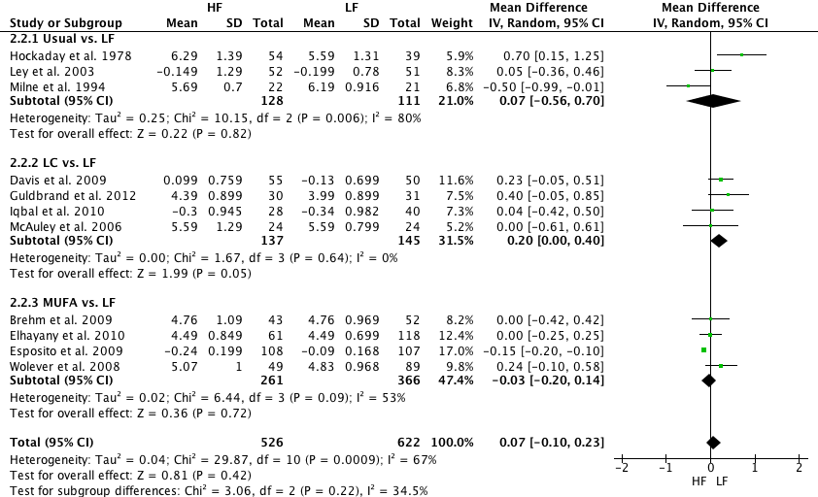Figure S3. Forest plot showing pooled MD with 95% CI for total cholesterol (mmol/L) for 11 randomized controlled HF diet studies. For each HF study, the shaded square represents the point estimate of the intervention effect. The horizontal line joins the lower and upper limits of the 95% CI of these effects. The area of the shaded square reflects the relative weight of the study in the respective meta-analysis. The diamond at the bottom of the graph represents the pooled MD with the 95% CI for the 11 study groups. LC, low carbohydrate; LF, low fat; MUFA, monounsaturated fat.
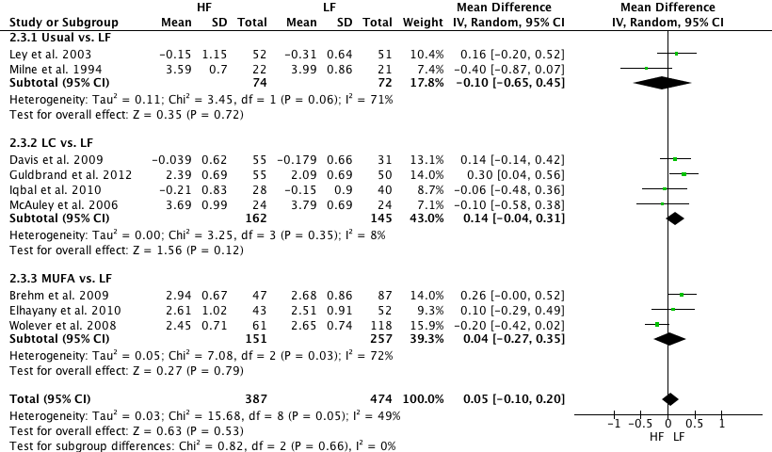
Figure S4. Forest plot showing pooled MD with 95% CI for low-density lipoprotein cholesterol (mmol/L) for 9 randomized controlled HF diet studies. For each HF study, the shaded square represents the point estimate of the intervention effect. The horizontal line joins the lower and upper limits of the 95% CI of these effects. The area of the shaded square reflects the relative weight of the study in the respective meta-analysis. The diamond at the bottom of the graph represents the pooled MD with the 95% CI for the 9 study groups. LC, low carbohydrate; LF, low fat; MUFA, monounsaturated fat.
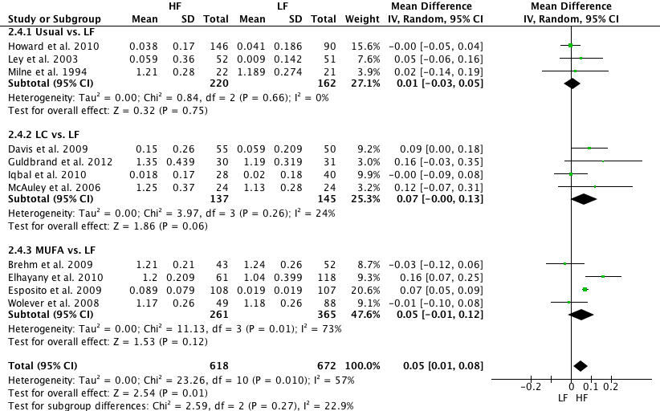
Figure S5. Forest plot showing pooled MD with 95% CI for high-density lipoprotein cholesterol (mmol/L) for 11 randomized controlled HF diet studies. For each HF study, the shaded square represents the point estimate of the intervention effect. The horizontal line joins the lower and upper limits of the 95% CI of these effects. The area of the shaded square reflects the relative weight of the study in the respective meta-analysis. The diamond at the bottom of the graph represents the pooled MD with the 95% CI for the 11 study groups. LC, low carbohydrate; LF, low fat; MUFA, monounsaturated fat.
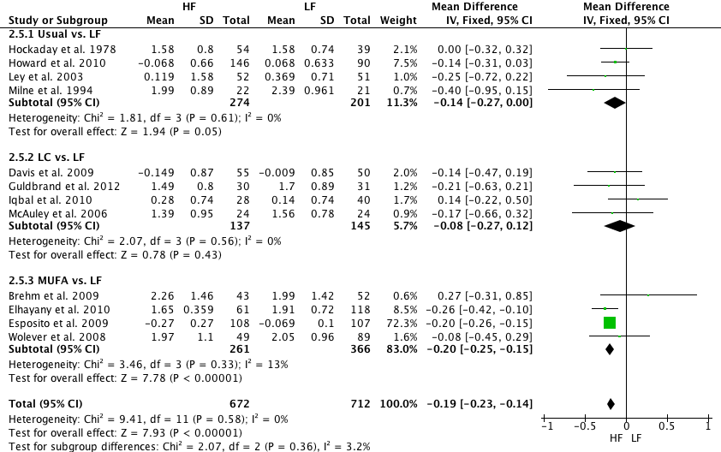
Figure S6. Forest plot showing pooled MD with 95% CI for triacylglycerols (mmol/L) for 12 randomized controlled HF diet studies. For each HF study, the shaded square represents the point estimate of the intervention effect. The horizontal line joins the lower and upper limits of the 95% CI of these effects. The area of the shaded square reflects the relative weight of the study in the respective meta-analysis. The diamond at the bottom of the graph represents the pooled MD with the 95% CI for the 12 study groups. LC, low carbohydrate; LF, low fat; MUFA, monounsaturated fat.
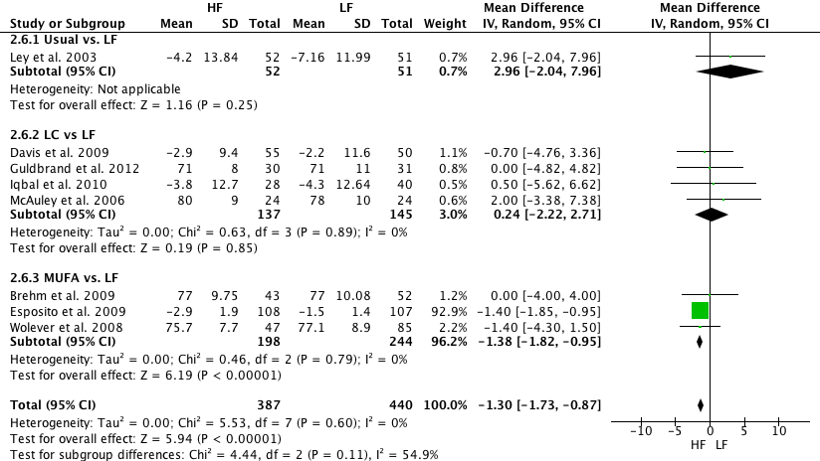
Figure S7. Forest plot showing pooled MD with 95% CI diastolic blood pressure (mmHg) for 8 randomized controlled HF diet studies. For each HF study, the shaded square represents the point estimate of the intervention effect. The horizontal line joins the lower and upper limits of the 95% CI of these effects. The area of the shaded square reflects the relative weight of the study in the respective meta-analysis. The diamond at the bottom of the graph represents the pooled MD with the 95% CI for the 8 study groups. LC, low carbohydrate; LF, low fat; MUFA, monounsaturated fat.
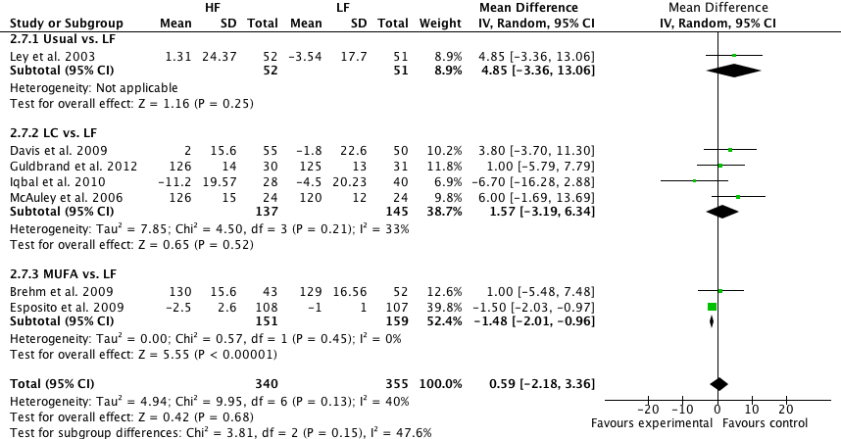
Figure S8. Forest plot showing pooled MD with 95% CI systolic blood pressure (mmHg) for 7 randomized controlled HF diet studies. For each HF study, the shaded square represents the point estimate of the intervention effect. The horizontal line joins the lower and upper limits of the 95% CI of these effects. The area of the shaded square reflects the relative weight of the study in the respective meta-analysis. The diamond at the bottom of the graph represents the pooled MD with the 95% CI for the 7 study groups. LC, low carbohydrate; LF, low fat; MUFA, monounsaturated fat.
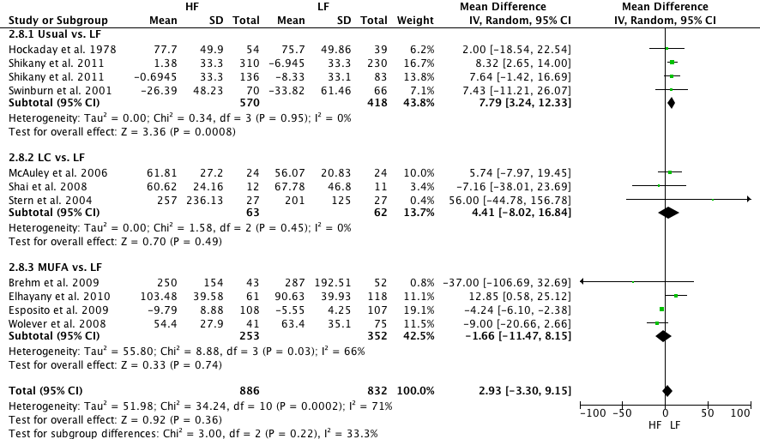
Figure S9. Forest plot showing pooled MD with 95% CI fasting insulin (pmol/L) for 10 randomized controlled HF diet studies. For each HF study, the shaded square represents the point estimate of the intervention effect. The horizontal line joins the lower and upper limits of the 95% CI of these effects. The area of the shaded square reflects the relative weight of the study in the respective meta-analysis. The diamond at the bottom of the graph represents the pooled MD with the 95% CI for the 10 study groups. LC, low carbohydrate; LF, low fat; MUFA, monounsaturated fat.
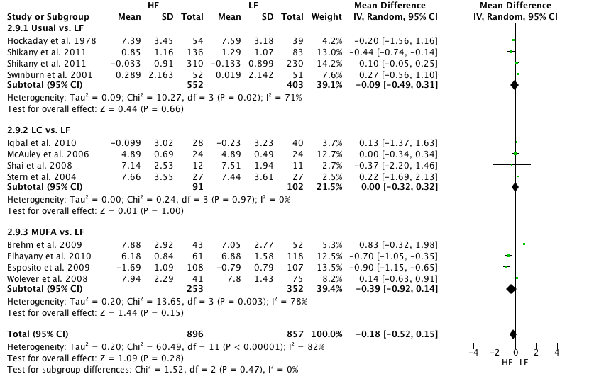Figure S10. Forest plot showing pooled MD with 95% CI fasting glucose (mmol/L) for 11 randomized controlled HF diet studies. For each HF study, the shaded square represents the point estimate of the intervention effect. The horizontal line joins the lower and upper limits of the 95% CI of these effects. The area of the shaded square reflects the relative weight of the study in the respective meta-analysis. The diamond at the bottom of the graph represents the pooled MD with the 95% CI for the 11 study groups. LC, low carbohydrate; LF, low fat; MUFA, monounsaturated fat.
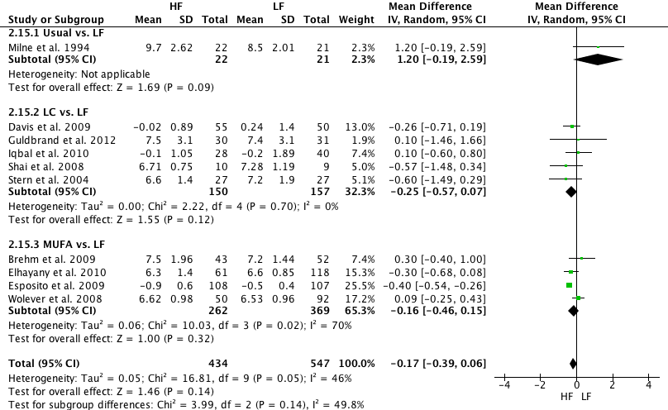
Figure S11. Forest plot showing pooled MD with 95% CI glycosylated hemoglobin (%) for 10 randomized controlled HF diet studies. For each HF study, the shaded square represents the point estimate of the intervention effect. The horizontal line joins the lower and upper limits of the 95% CI of these effects. The area of the shaded square reflects the relative weight of the study in the respective meta-analysis. The diamond at the bottom of the graph represents the pooled MD with the 95% CI for the 10 study groups. LC, low carbohydrate; LF, low fat; MUFA, monounsaturated fat.
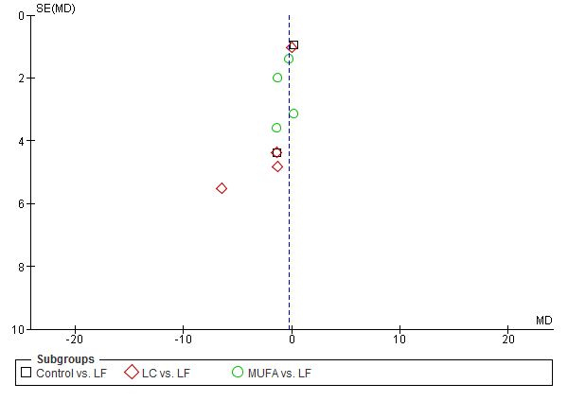
Figure S12. Funnel plot showing study precision against the MD effect estimate with 95% CIs for body weight. SE = Standard error

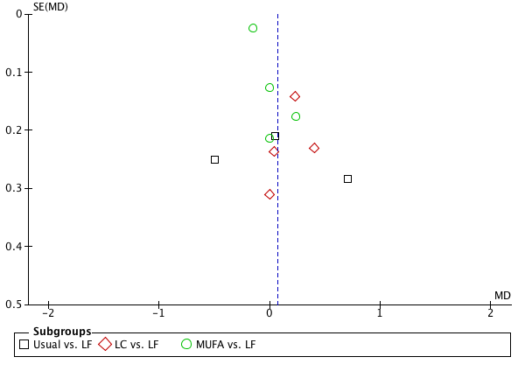
Figure S13. Funnel plot showing study precision against theMD effect estimate with 95% CIs for total cholesterol. SE = Standard error
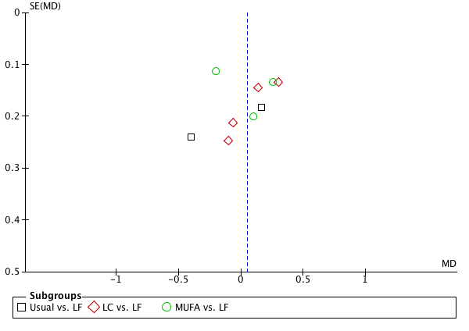
Figure S14. Funnel plot showing study precision against the MD effect estimate with 95% CIs for low-density lipoprotein cholesterol. SE = Standard error
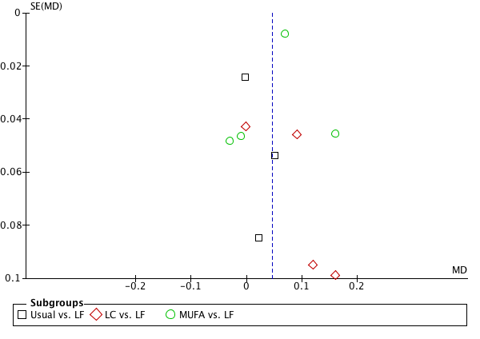
Figure S15. Funnel plot showing study precision against the MD effect estimate with 95% CIs for high-density lipoprotein cholesterol. SE = Standard error
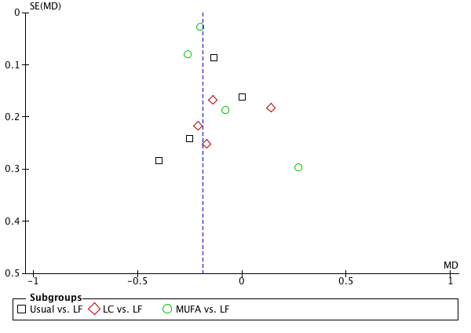
Figure S16. Funnel plot showing study precision against the MD effect estimate with 95% CIs for triacylglycerols. SE = Standard error
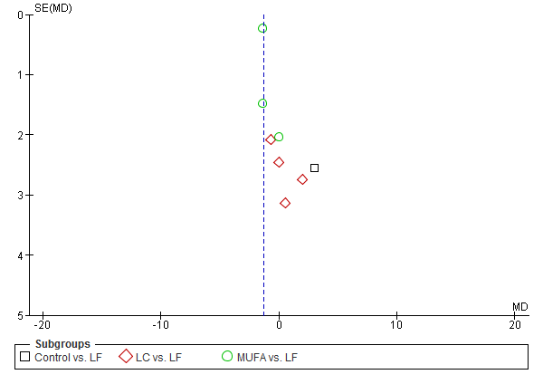
Figure S17. Funnel plot showing study precision against the MD effect estimate with 95% CIs for diastolic blood pressure. SE = Standard error 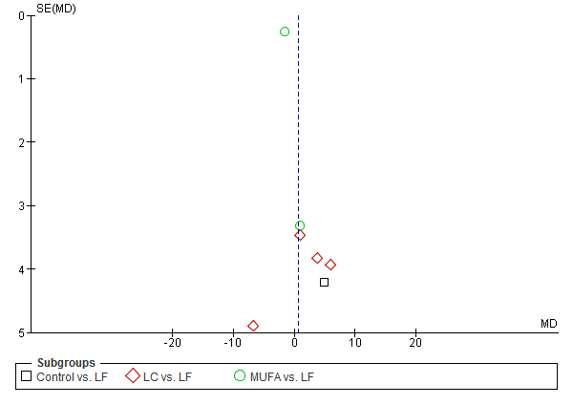Figure S18. Funnel plot showing study precision against the MD effect estimate with 95% CIs for systolic blood pressure. SE = Standard error
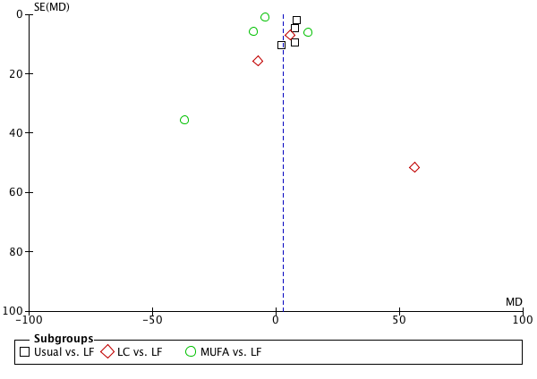
Figure S19. Funnel plot showing study precision against the WMD effect estimate with 95% CIs for fasting insulin. SE = Standard error
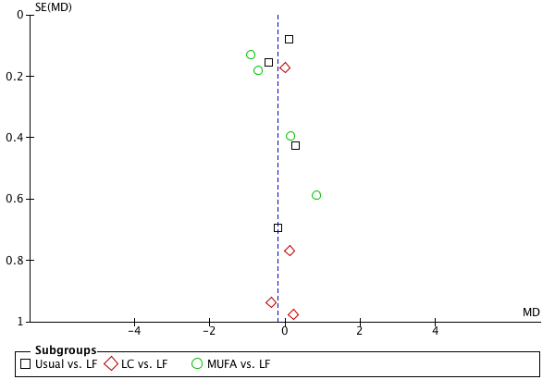Figure Figure S20. Funnel plot showing study precision against the MD effect estimate with 95% CIs for fasting glucose. SE = Standard error
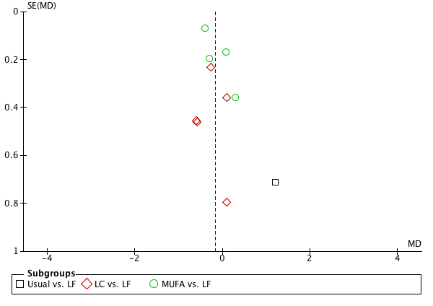Figure Figure S21. Funnel plot showing study precision against the MD effect estimate with 95% CIs for glycosylated hemoglobin (%). SE = Standard error
Table S1: Pooled estimates (change scores) of effect size (95% confidence intervals) expressed as mean differences for the effects of HF vs. LF diets on cardiovascular and metabolic risk factors.
Outcome parameter | No. of  Studies | Sample size | MD | 95% CI | p-values | Inconsistency I²
BW (kg) | 11 | 1053 | -0.54 | [-0.99, -0.10] | 0.02 | 0%
TC (mmol/L) | 11 | 1148 | 0.07 | [-0.07, 0.22] | 0.33 | 50%
LDL-C (mmol/L) | 9 | 836 | 0.03 | [-0.08, 0.13] | 0.60 | 0%
HDL-C (mmol/L) | 11 | 1290 | 0.05 | [0.02, 0.09] | 0.003 | 51%
TG (mmol/L) | 12 | 1384 | -0.18 | [-0.23, -0.13] | <0.00001 | 0%
DBP (mm Hg) | 8 | 827 | -1.33 | [-1.76, -0.90] | <0.00001 | 0%
SBP (mm Hg) | 7 | 695 | -0.77 | [-2.43, 0.88] | 0.36 | 13%
FG (mmol/L) | 10 | 1730 | -0.14 | [-0.55, 0.26] | 0.48 | 86%
FI (pmol/L) | 4 | 1164 | 4.36 | [-4.64, 13.36] | 0.34 | 84%
HbA1c (%) | 10 | 981 | -0.19 | [-0.36, -0.02] | 0.03 | 56%
Abbreviations: BW, body weight; CRP, c-reactive protein; DBP, diastolic blood pressure; HDL-C, high density lipoprotein cholesterol; HbA1c, glycosylated hemoglobin; HF, high fat, FG, fasting glucose, FI, fasting insulin; LDL-C, low density lipoprotein cholesterol; SBP, systolic blood pressure; LF, low fat; TC, total cholesterol; TG, triacyglycerols; MD, mean differences.

Table S2: Pooled estimates of effect size (95% confidence intervals) expressed as mean differences for the effects of HF vs. LF diets (both hypocaloric) on cardiovascular and metabolic risk factors.
Outcome parameter | No. of  Studies | Sample size | MD | 95% CI | p-values | Inconsistency I²
BW (kg) | 6 | 755 | -0.84 | [-2.76, 1.08] | 0.39 | 0%
TC (mmol/L) | 7 | 824 | 0.06 | [-0.16, 0.28] | 0.60 | 73%
LDL-C (mmol/L) | 5 | 556 | 0.00 | [-0.22, 0.23] | 0.97 | 64%
HDL-C (mmol/L) | 6 | 730 | 0.06 | [0.00, 0.11] | 0.04 | 59%
TG (mmol/L) | 7 | 824 | -0.20 | [-0.25, -0.15] | <0.00001 | 0%
DBP (mm Hg) | 4 | 503 | -1.37 | [-1.81, -0.94] | <0.00001 | 0%
SBP (mm Hg) | 3 | 371 | -1.47 | [-1.99, -0.95] | <0.00001 | 0%
FG (mmol/L) | 5 | 698 | -0.38 | [-0.87, 0.11] | 0.12 | 72%
FI (pmol/L) | 5 | 698 | -1.28 | [-9.60, 7.04] | 0.76 | 57%
HbA1c (%) | 6 | 735 | -0.07 | [-0.40, 0.25] | 0.66 | 66%
Abbreviations: BW, body weight; CRP, c-reactive protein; DBP, diastolic blood pressure; HDL-C, high density lipoprotein cholesterol; HbA1c, glycosylated hemoglobin; HF, high fat, FG, fasting glucose, FI, fasting insulin; LDL-C, low density lipoprotein cholesterol; SBP, systolic blood pressure; LF, low fat; TC, total cholesterol; TG, triacyglycerols; MD, mean differences.

Table S3: Pooled estimates of effect size (95% confidence intervals) expressed as mean differences for the effects of HF vs. LF diets (both ad libitum) on cardiovascular and metabolic risk factors.
Outcome parameter | No. of  Studies | Sample size | MD | 95% CI | p-values | Inconsistency I²
BW (kg) | 3 | 256 | 0.07 | [-1.27, 1.42] | 0.91 | 0%
TC (mmol/L) | 3 | 256 | 0.15 | [-0.06, 0.37] | 0.17 | 0%
LDL-C (mmol/L) | 3 | 212 | 0.16 | [-0.06, 0.38] | 0.15 | 0%
HDL-C (mmol/L) | 4 | 492 | 0.04 | [-0.01, 0.10] | 0.15 | 35%
TG (mmol/L) | 4 | 492 | -0.15 | [-0.29, -0.01] | 0.03 | 0%
DBP (mm Hg) | 3 | 256 | 1.07 | [-1.65, 3.79] | 0.44 | 0%
SBP (mm Hg) | 3 | 256 | 4.87 | [0.37, 9.36] | 0.03 | 0%
FG (mmol/L) | 3 | 910 | -0.06 | [-0.36, 0.24] | 0.68 | 71%
FI (pmol/L) | 3 | 943 | 7.86 | [3.44, 12.27] | 0.0005 | 0%
HbA1c (%) | 1 | 105 | -0.26 | [-0.71, 0.19] | 0.26 | /
Abbreviations: BW, body weight; CRP, c-reactive protein; DBP, diastolic blood pressure; HDL-C, high density lipoprotein cholesterol; HbA1c, glycosylated hemoglobin; HF, high fat, FG, fasting glucose, FI, fasting insulin; LDL-C, low density lipoprotein cholesterol; SBP, systolic blood pressure; LF, low fat; TC, total cholesterol; TG, triacyglycerols; MD, mean differences.

Table S4: Pooled estimates of effect size (95% confidence intervals) expressed as mean differences for the effects of HF vs. LF diets (study length: ≥ 2 years) on cardiovascular and metabolic risk factors.
Outcome parameter | No. of  Studies | Sample size | MD | 95% CI | p-values | Inconsistency I²
BW (kg) | 4 | 447 | -0.11 | [-1.60, 1.37] | 0.89 | 0%
TC (mmol/L) | 4 | 447 | 0.02 | [-0.22, 0.27] | 0.86 | 57%
LDL-C (mmol/L) | 3 | 276 | 0.11 | [-0.08, 0.29] | 0.25 | 0%
HDL-C (mmol/L) | 5 | 683 | 0.04 | [-0.01, 0.09] | 0.10 | 65%
TG (mmol/L) | 5 | 683 | -0.19 | [-0.24, -0.14] | <0.00001 | 0%
DBP (mm Hg) | 4 | 447 | 0.84 | [-0.64, 2.31] | 0.27 | 16%
SBP (mm Hg) | 4 | 447 | -0.95 | [-3.64, 1.74] | 0.49 | 24%
FG (mmol/L) | 4 | 1065 | -0.35 | [-0.92, 0.21] | 0.22 | 91%
FI (pmol/L) | 3 | 997 | 2.63 | [-6.63, 11.89] | 0.58 | 86%
HbA1c (%) | 4 | 363 | -0.38 | [-0.51, -0.25] | <0.00001 | 0%
Abbreviations: BW, body weight; CRP, c-reactive protein; DBP, diastolic blood pressure; HDL-C, high density lipoprotein cholesterol; HbA1c, glycosylated hemoglobin; HF, high fat, FG, fasting glucose, FI, fasting insulin; LDL-C, low density lipoprotein cholesterol; SBP, systolic blood pressure; LF, low fat; TC, total cholesterol; TG, triacyglycerols; MD, mean differences.

Table S5: Pooled estimates of effect size (95% confidence intervals) expressed as mean differences for the effects of HF vs. LF diets (study length: < 2 years) on cardiovascular and metabolic risk factors.
Outcome parameter | No. of  Studies | Sample size | MD | 95% CI | p-values | Inconsistency I²
BW (kg) | 6 | 632 | -0.40 | [-2.02, 1.23] | 0.63 | 0%
TC (mmol/L) | 7 | 701 | 0.09 | [-0.12, 0.31] | 0.38 | 53%
LDL-C (mmol/L) | 6 | 585 | -0.01 | [-0.21, 0.19] | 0.94 | 54%
HDL-C (mmol/L) | 6 | 607 | 0.06 | [-0.01, 0.12] | 0.11 | 57%
TG (mmol/L) | 7 | 701 | -0.18 | [-0.29, -0.06] | 0.003 | 0%
DBP (mm Hg) | 4 | 380 | -0.51 | [-2.41, 1.40] | 0.60 | 0%
SBP (mm Hg) | 3 | 248 | 3.30 | [-0.84, 7.43] | 0.12 | 0%
FG (mmol/L) | 7 | 1344 | -0.13 | [-0.44, 0.18] | 0.40 | 73%
FI (pmol/L) | 7 | 1344 | 5.26 | [-0.57, 11.09] | 0.08 | 36%
HbA1c (%) | 6 | 618 | -0.07 | [-0.37, 0.22] | 0.63 | 41%
Abbreviations: BW, body weight; CRP, c-reactive protein; DBP, diastolic blood pressure; HDL-C, high density lipoprotein cholesterol; HbA1c, glycosylated hemoglobin; HF, high fat, FG, fasting glucose, FI, fasting insulin; LDL-C, low density lipoprotein cholesterol; SBP, systolic blood pressure; LF, low fat; TC, total cholesterol; TG, triacyglycerols; MD, mean differences.

Table S6: Pooled estimates of effect size (95% confidence intervals) expressed as mean differences for the effects of HF vs. LF diets (high adherence) on cardiovascular and metabolic risk factors.
Outcome parameter | No. of  Studies | Sample size | MD | 95% CI | p-values | Inconsistency I²
BW (kg) | 6 | 627 | -0.12 | [-1.30, 1.06] | 0.85 | 0%
TC (mmol/L) | 6 | 627 | 0.06 | [-0.15, 0.27] | 0.59 | 63%
LDL-C (mmol/L) | 5 | 451 | 0.18 | [0.04, 0.32] | 0.01 | 0%
HDL-C (mmol/L) | 7 | 863 | 0.05 | [0.01, 0.09] | 0.03 | 56%
TG (mmol/L) | 7 | 863 | -0.19 | [-0.24, -0.14] | <0.00001 | 0%
DBP (mm Hg) | 6 | 627 | -1.14 | [-1.88, -0.41] | 0.002 | 4%
SBP (mm Hg) | 6 | 627 | 1.18 | [-1.74, 4.10] | 0.43 | 43%
FG (mmol/L) | 7 | 1297 | -0.14 | [-0.55, 0.27] | 0.51 | 86%
FI (pmol/L) | 7 | 1330 | 3.41 | [-4.13, 10.96] | 0.38 | 74%
HbA1c (%) | 6 | 549 | -0.37 | [-0.50, -0.25] | <0.00001 | 0%
Abbreviations: BW, body weight; CRP, c-reactive protein; DBP, diastolic blood pressure; HDL-C, high density lipoprotein cholesterol; HbA1c, glycosylated hemoglobin; HF, high fat, FG, fasting glucose, FI, fasting insulin; LDL-C, low density lipoprotein cholesterol; SBP, systolic blood pressure; LF, low fat; TC, total cholesterol; TG, triacyglycerols; MD, mean differences.

Table S7: Pooled estimates of effect size (95% confidence intervals) expressed as mean differences for the effects of HF vs. LF diets (low risk of bias) on cardiovascular and metabolic risk factors.
Outcome parameter | No. of  Studies | Sample size | MD | 95% CI | p-values | Inconsistency I²
BW (kg) | 3 | 438 | -0.53 | [-2.95, 1.89] | 0.67 | 0%
TC (mmol/L) | 3 | 414 | 0.12 | [-0.25, 0.49] | 0.54 | 81%
LDL-C (mmol/L) | 2 | 284 | -0.03 | [-0.37, 0.30] | 0.84 | 75%
HDL-C (mmol/L) | 3 | 414 | 0.06 | [-0.01, 0.12] | 0.08 | 47%
TG (mmol/L) | 3 | 413 | -0.20 | [-0.25, -0.15] | <0.00001 | 0%
DBP (mm Hg) | 3 | 408 | -1.39 | [-1.83, -0.95] | <0.00001 | 0%
SBP (mm Hg) | 2 | 276 | -1.49 | [-2.01, -0.96] | <0.00001 | 0%
FG (mmol/L) | 3 | 354 | -0.45 | [-1.27, 0.36] | 0.28 | 69%
FI (pmol/L) | 2 | 238 | -4.15 | [-6.00, -2.30] | <0.0001 | 0%
HbA1c (%) | 4 | 437 | -0.22 | [-0.58, 0.14] | 0.23 | 61%
Abbreviations: BW, body weight; CRP, c-reactive protein; DBP, diastolic blood pressure; HDL-C, high density lipoprotein cholesterol; HbA1c, glycosylated hemoglobin; HF, high fat, FG, fasting glucose, FI, fasting insulin; LDL-C, low density lipoprotein cholesterol; SBP, systolic blood pressure; LF, low fat; TC, total cholesterol; TG, triacyglycerols; MD, mean differences.

Section/topic | # | Checklist item | Reported on page #
TITLE
Title | 1 | Identify the report as a systematic review, meta-analysis, or both. | 1
ABSTRACT
Structured summary | 2 | Provide a structured summary including, as applicable: background; objectives; data sources; study eligibility criteria, participants, and interventions; study appraisal and synthesis methods; results; limitations; conclusions and implications of key findings; systematic review registration number. | 2
INTRODUCTION
Rationale | 3 | Describe the rationale for the review in the context of what is already known. | 3, 4
Objectives | 4 | Provide an explicit statement of questions being addressed with reference to participants, interventions, comparisons, outcomes, and study design (PICOS). | 3, 4
METHODS
Protocol and registration | 5 | Indicate if a review protocol exists, if and where it can be accessed (e.g., Web address), and, if available, provide registration information including registration number. | /
Eligibility criteria | 6 | Specify study characteristics (e.g., PICOS, length of follow-up) and report characteristics (e.g., years considered, language, publication status) used as criteria for eligibility, giving rationale. | 5
Information sources | 7 | Describe all information sources (e.g., databases with dates of coverage, contact with study authors to identify additional studies) in the search and date last searched. | 5, 6, 7
Search | 8 | Present full electronic search strategy for at least one database, including any limits used, such that it could be repeated. | 5,  Figure 1; Supplemental Information
Study selection | 9 | State the process for selecting studies (i.e., screening, eligibility, included in systematic review, and, if applicable, included in the meta-analysis). | 5, 6
Data collection process | 10 | Describe method of data extraction from reports (e.g., piloted forms, independently, in duplicate) and any processes for obtaining and confirming data from investigators. | 6, 7
Data items | 11 | List and define all variables for which data were sought (e.g., PICOS, funding sources) and any assumptions and simplifications made. | 6, 7  Table 1
Risk of bias in individual studies | 12 | Describe methods used for assessing risk of bias of individual studies (including specification of whether this was done at the study or outcome level), and how this information is to be used in any data synthesis. | 5, 6, 9  S Figure 1
Summary measures | 13 | State the principal summary measures (e.g., risk ratio, difference in means). | 7, 8  Table 2
Synthesis of results | 14 | Describe the methods of handling data and combining results of studies, if done, including measures of consistency (e.g., I²) for each meta-analysis. | 7, 8  Table 2  SFigure 2-11;  STable 1-7;

Page 1 of 2
Section/topic | # | Checklist item | Reported on page #
Risk of bias across studies | 15 | Specify any assessment of risk of bias that may affect the cumulative evidence (e.g., publication bias, selective reporting within studies). | 6, 7, 9, 13  SFigure 1
Additional analyses | 16 | Describe methods of additional analyses (e.g., sensitivity or subgroup analyses, meta-regression), if done, indicating which were pre-specified. | 6, 7, 9, 10  STable 1-7;
RESULTS
Study selection | 17 | Give numbers of studies screened, assessed for eligibility, and included in the review, with reasons for exclusions at each stage, ideally with a flow diagram. | 8  Figure 1  Supplemental Information
Study characteristics | 18 | For each study, present characteristics for which data were extracted (e.g., study size, PICOS, follow-up period) and provide the citations. | 8  Table 1
Risk of bias within studies | 19 | Present data on risk of bias of each study and, if available, any outcome level assessment (see item 12). | 6, 7, 9  SFigure 1
Results of individual studies | 20 | For all outcomes considered (benefits or harms), present, for each study: (a) simple summary data for each intervention group (b) effect estimates and confidence intervals, ideally with a forest plot. | 8, 9, 10  SFigure 2-11
Synthesis of results | 21 | Present results of each meta-analysis done, including confidence intervals and measures of consistency. | 8, 9, 10 Table 2  SFigure 2-11  STable 1-7;
Risk of bias across studies | 22 | Present results of any assessment of risk of bias across studies (see Item 15). | 6, 7, 9, 13  SFigure 1
Additional analysis | 23 | Give results of additional analyses, if done (e.g., sensitivity or subgroup analyses, meta-regression [see Item 16]). | 9, 10;  Table 2  STable 1-7;
DISCUSSION
Summary of evidence | 24 | Summarize the main findings including the strength of evidence for each main outcome; consider their relevance to key groups (e.g., healthcare providers, users, and policy makers). | 11, 14
Limitations | 25 | Discuss limitations at study and outcome level (e.g., risk of bias), and at review-level (e.g., incomplete retrieval of identified research, reporting bias). | 13, 14
Conclusions | 26 | Provide a general interpretation of the results in the context of other evidence, and implications for future research. | 14
FUNDING
Funding | 27 | Describe sources of funding for the systematic review and other support (e.g., supply of data); role of funders for the systematic review. | 14

From: Moher D, Liberati A, Tetzlaff J, Altman DG, The PRISMA Group (2009). Preferred Reporting Items for Systematic Reviews and Meta-Analyses: The PRISMA Statement. PLoS Med 6(6): e1000097. doi:10.1371/journal.pmed1000097
For more information, visit: www.prisma-statement.org.

