Supplementary Appendix

To assess the validity of the gold standard method of measuring food and energy intake, regressions of two independent measures of energy balance, for each individual, were examined. These were; (1) the average daily rate of weight change, which was calculated from the regression slopes of daily change in body weight and (2) the difference between energy intake and energy expenditure. Energy intake was from the laboratory weighed intake method and energy expenditure from the double labelled water measurement. If the estimates of energy intake were biased, then the regression line would not go through zero energy balance at zero rate of weight change per day, that is the intercepts of the regression lines with the Y axis would be significantly different from zero.

The intercepts of the regression lines of average rate of weight change and energy balance (Energy Intake – Energy Expenditure) did differ significantly from zero for all subjects combined (-0.019g/d, p = 0.039, Figure 1 of this appendix), and for the overweight subjects (BMI > 25kg/m²)(-0.038g/d, p=0.023, Figure 3 of this appendix). The intercepts were not significantly different from zero for the lean subjects (BMI ≤ 25kg/m²) (p = 0.750, Figure 3 of this appendix), or for males or females (p = 0.183 and p = 0.074 respectively, Figure 2 of this appendix).
The simple linear regressions were calculated assuming that the relationship between energy balance and weight change is the same under the conditions of positive and negative energy balances. This is not necessarily the case, as the energy cost of weight gain is higher than the energy cost of weight loss (Forbes et al. 1986; Hall 2007), and it may have been more appropriate to have used segmented linear regression analysis. However, doing so by calculating the regressions for subjects who were in positive and negative energy balance separately would have resulted in small numbers of subjects in each regression. Furthermore, some subjects, especially those near the boundary between weight gain and weight loss, may be incorrectly classified. With these caveats, the intercepts of the average rate of weight change and energy balance did not differ significantly from zero for any of the groups of subjects when the regressions were calculated separately for those in positive and negative energy balance (Table 1 of this Appendix).

Table 1
Subjects | Energy balance | n | Regression | Significance value of regression | Significance value of intercept
All subjects | Positive | 28 | +0.009 R=0.179 | 0.334 | 0.846
All subjects | Negative | 31 | +0.029 R=0.669 | <0.001 | 0.658
Males | Positive | 15 | +0.012 R=0.167 | 0.552 | 0.811
Males | Negative | 15 | +0.036 R=0.689 | 0.005 | 0.672
Females | Positive | 16 | +0.007 R=0.314 | 0.236 | 0.196
Females | Negative | 13 | +0.025 R=0.667 | 0.013 | 0.367
Lean | Positive | 13 | +0.018 R=0.390 | 0.187 | 0.718
Lean | Negative | 14 | +0.026 R=0.578 | 0.030 | 0.875
Overweight | Positive | 18 | +0.005 R=0.097 | 0.701 | 0.931
Overweight | Negative | 14 | +0.033 R=0.813 | <0.001 | 0.637

A scatter plot of the observation effect demonstrated that, in these 59 subjects at least, the effect was continuously distributed across level of actual energy intake (measured by the mean of the two Laboratory Weighed Intakes) and occurred in most subjects to some degree (Figure 4 of this appendix).
Actual energy intake was calculated as the average of the Laboratory Weighed Intake – Overt and the Laboratory Weight Intake – Covert to avoid introducing an apparent negative correlation that is a statistical artefact. Where random fluctuations occur in two variables X and Y, there tends to be is a negative correlation between X - Y and Y. One way to avoid this is to plot the difference between the two variables, X and Y, against the average of these.
The reporting effects for each of the dietary intake methods (Figures 5A-9A of this appendix), and the combined observation and reporting effects (Figures 5B-9B of this appendix), for each of the dietary intake methods compared to the mean of the two Laboratory Weighed Intakes also showed that the differences were continuously distributed and occurred in most subjects to some degree.

Forbes GB, Brown MR, Welle SL, Lipinski BA. Deliberate overfeeding in women and men: energy cost and composition of the weight gain. British Journal of Nutrition 1986; 56: 1±9.

Hall KD. What is the required energy deficit per unit weight loss? International Journal of Obesity. 2008 32(3): 573–576.

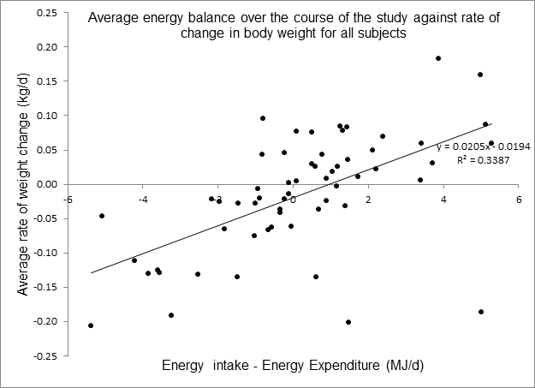
Figure 1. Average daily energy balance (energy intake – energy expenditure) over the course of the study against the average rate of weight change for all subjects.

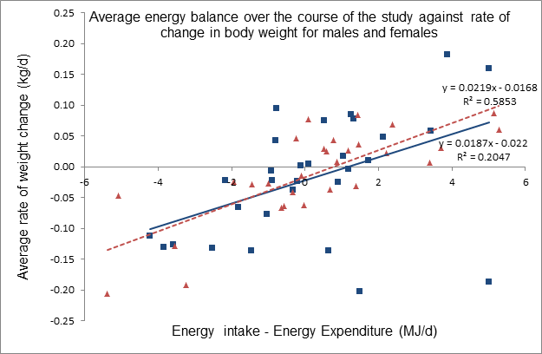
Figure 2. Average daily energy balance (energy intake – energy expenditure) over the course of the study against the average rate of weight change for males ( and ) and females (and ).

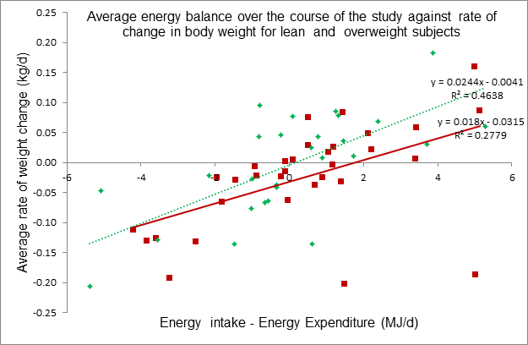
Figure 3. Average daily energy balance (energy intake – energy expenditure) over the course of the study against the average rate of weight change for lean (BMI ≤ 25kg/m² and ) and overweight (BMI > 25kg/m² and ) subjects.

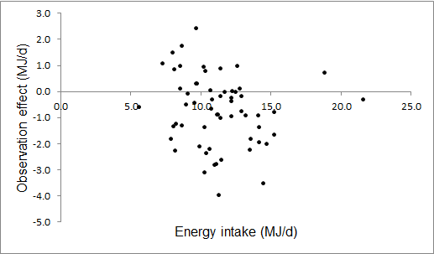
Figure 4. Distribution of the observation effect (Laboratory Weighed Intake Overt – Laboratory Weighed Intake Covert) on mean daily energy intake by observed mean daily energy intake (mean of Laboratory Weighed Intake Covert and Laboratory Weighed Intake Covert) for the 59 subjects.

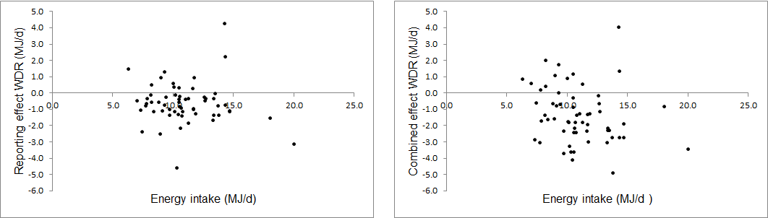
Figure 5A. Distribution of the reporting effect on mean daily energy intake of the Weighed Dietary Record method against mean daily energy intake for the 59 subjects.
Reporting effect (Y-axis) is (Weighed Dietary Record - Laboratory Weighed Intake Overt) and the X-axis is the mean of (Weighed Dietary Record and Laboratory Weighed Intake Overt).
Figure 5B. Distribution of the combined observation and reporting effects on mean daily energy intake of the Weighed Dietary Record method against mean daily energy intake for the 59 subjects.
The combined observation and reporting effects (Y-axis) is (Weighed Dietary Record - Laboratory Weighed Intake Covert) and the X-axis is the mean of (Weighed Dietary Record and Laboratory Weighed Intake Covert).

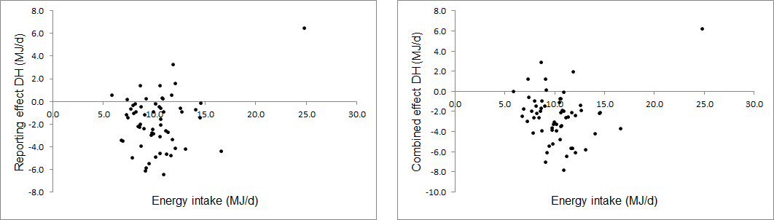
Figure 6B. Distribution of the combined observation and reporting effects on mean daily energy intake of the Diet History method against mean daily energy intake for the 59 subjects.
The combined observation and reporting effects (Y-axis) is (Diet History - Laboratory Weighed Intake Covert) and the X-axis is the mean of (Diet History and Laboratory Weighed Intake Covert).
Figure 6A. Distribution of the reporting effect on mean daily energy intake of the Diet History method against mean daily energy intake for the 59 subjects.
Reporting effect (Y-axis) is (Diet History - Laboratory Weighed Intake Overt) and the X-axis is the mean of (Diet History and Laboratory Weighed Intake Overt).
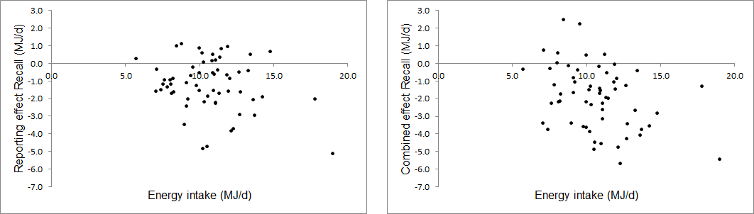
Figure 7A. Distribution of the reporting effect on mean daily energy intake of the 24-hour recall method against mean daily energy intake for the 59 subjects.
Reporting effect (Y-axis) is (24-hour recall - Laboratory Weighed Intake Overt) and the X-axis is the mean of (24-hour recall and Laboratory Weighed Intake Overt).
Figure 7B. Distribution of the combined observation and reporting effects on mean daily energy intake of the 24-hour recall method against mean daily energy intake for the 59 subjects.
The combined observation and reporting effects (Y-axis) is (24-hour recall - Laboratory Weighed Intake Covert) and the X-axis is the mean of (24-hour recall and Laboratory Weighed Intake Covert).

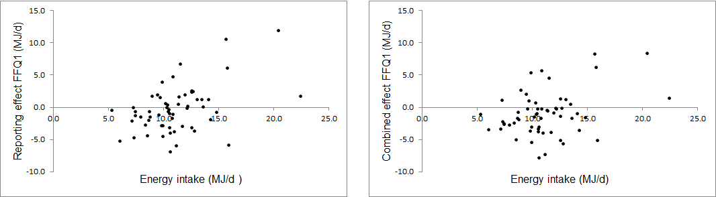
Figure 8A. Distribution of the reporting effect on mean daily energy intake of the Food Frequency Questionnaire (1) method against mean daily energy intake for the 59 subjects.
Reporting effect (Y-axis) is (Food Frequency Questionnaire (1) - Laboratory Weighed Intake Overt) and the X-axis is the mean of (Food Frequency Questionnaire (1) and Laboratory Weighed Intake Overt).
Figure 8B. Distribution of the combined observation and reporting effects on mean daily energy intake of the Food Frequency Questionnaire (1) method against mean daily energy intake for the 59 subjects.
The combined observation and reporting effects (Y-axis) is (Food Frequency Questionnaire (1) - Laboratory Weighed Intake Covert) and the X-axis is the mean of (Food Frequency Questionnaire (1) and Laboratory Weighed Intake Covert).

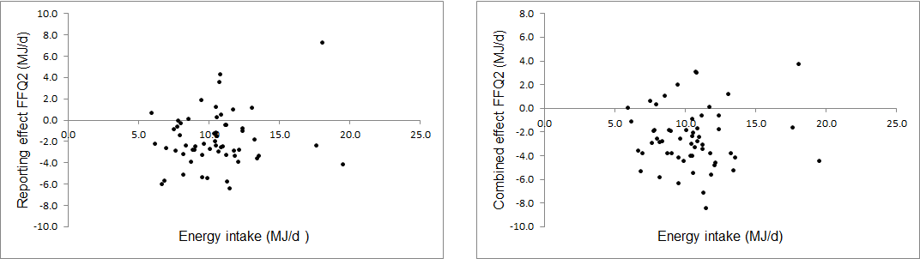
Figure 9A. Distribution of the reporting effect on mean daily energy intake of the Food Frequency Questionnaire (2) method against mean daily energy intake for the 59 subjects.
Reporting effect (Y-axis) is (Food Frequency Questionnaire (2) - Laboratory Weighed Intake Overt) and the X-axis is the mean of (Food Frequency Questionnaire (2) and Laboratory Weighed Intake Overt).
Figure 9B. Distribution of the combined observation and reporting effects on mean daily energy intake of the Food Frequency Questionnaire (2) method against mean daily energy intake for the 59 subjects.
The combined observation and reporting effects (Y-axis) is (Food Frequency Questionnaire (2) - Laboratory Weighed Intake Covert) and the X-axis is the mean of (Food Frequency Questionnaire (2) and Laboratory Weighed Intake Covert).

