25 October 2013 Director: Dr Matthew Taylor

Dr Graham Burdge
Editor-in-Chief
British Journal of Nutrition

Dear Dr Burdge

RE: STATEMENT OF ACCEPTANCE OF CONDITIONS FOR “THE EFFECTIVENESS OF PROBIOTICS ON LENGTH OF ILLNESS IN HEALTHY CHILDREN AND ADULTS WHO DEVELOP COMMON ACUTE RESPIRATORY INFECTIOUS CONDITIONS: A SYSTEMATIC REVIEW AND META-ANALYSIS”

I hereby declare that this submission represents original work that has not been previously published. It is not currently being considered for publication by another journal, and that if this submission is accepted by the British Journal of Nutrition, it will not be published elsewhere in the same form (in English or in any other language), without the consent of the Nutrition Society.

I can also confirm that each author has contributed and seen and approved of the contents in the manuscript. I have also provided a completed copy of the ‘Licence to Publish’ alongside this statement.

Yours sincerely

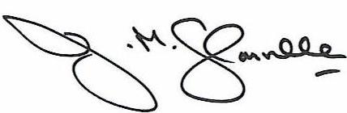

Julie Glanville

Associate Director

