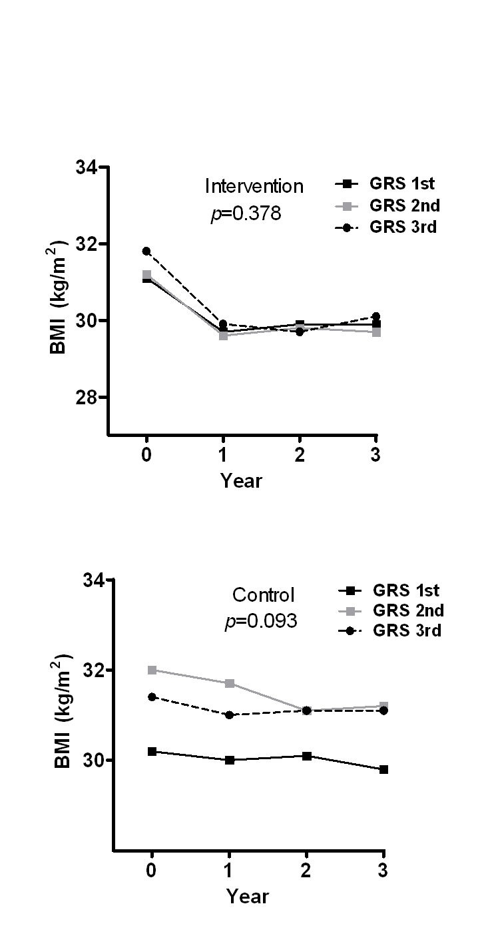
B
A
A

Supplementary figure 1. The mean BMI during the 3-year follow-up in each genetic risk score (GRS created of BMI-related SNPs) group in the intervention (A) and in the control (B) groups. Analyses are adjusted for age and sex and GRS was included as a continuous variable in the model
B

