Supplementary Material
Insulinotropic and β-cell protective action of cuminaldehyde, cuminol and an inhibitor isolated from Cuminum cyminum in streptozotocin induced diabetic rats

Swapnil B. Patil¹, Shreehari S. Takalikar¹, Madhav M. Joglekar¹, Vivek S. Haldavnekar², Akalpita U. Arvindekar^{1*}

¹Department of Biochemistry, Shivaji University, Kolhapur 416 004, India
²Ayurveda Clinic, Kolhapur 416008, India

Running title - Insulinotropic action of Cuminum cyminum

Supplementary Figure 1. A) GC-MS analysis of fraction 15th (sub-fraction 3rd of gradient 60:40) and B) Fragmentation pattern of major compound at RT 15.6

A)

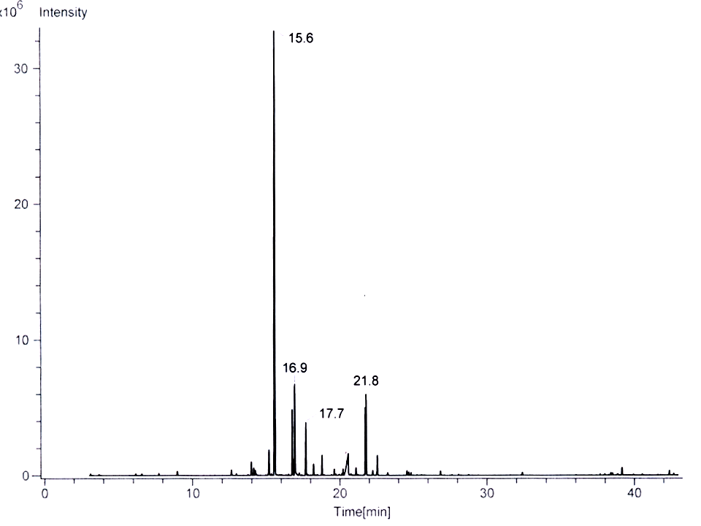
B)

Supplementary Figure 2. FTIR spectra of fraction 15th (sub-fraction 3rd of gradient 60:40)

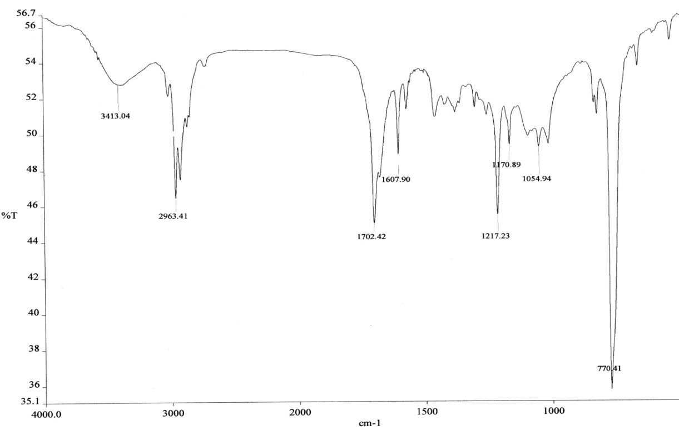

Supplementary Figure 3. H¹ NMR analysis of fraction 15th

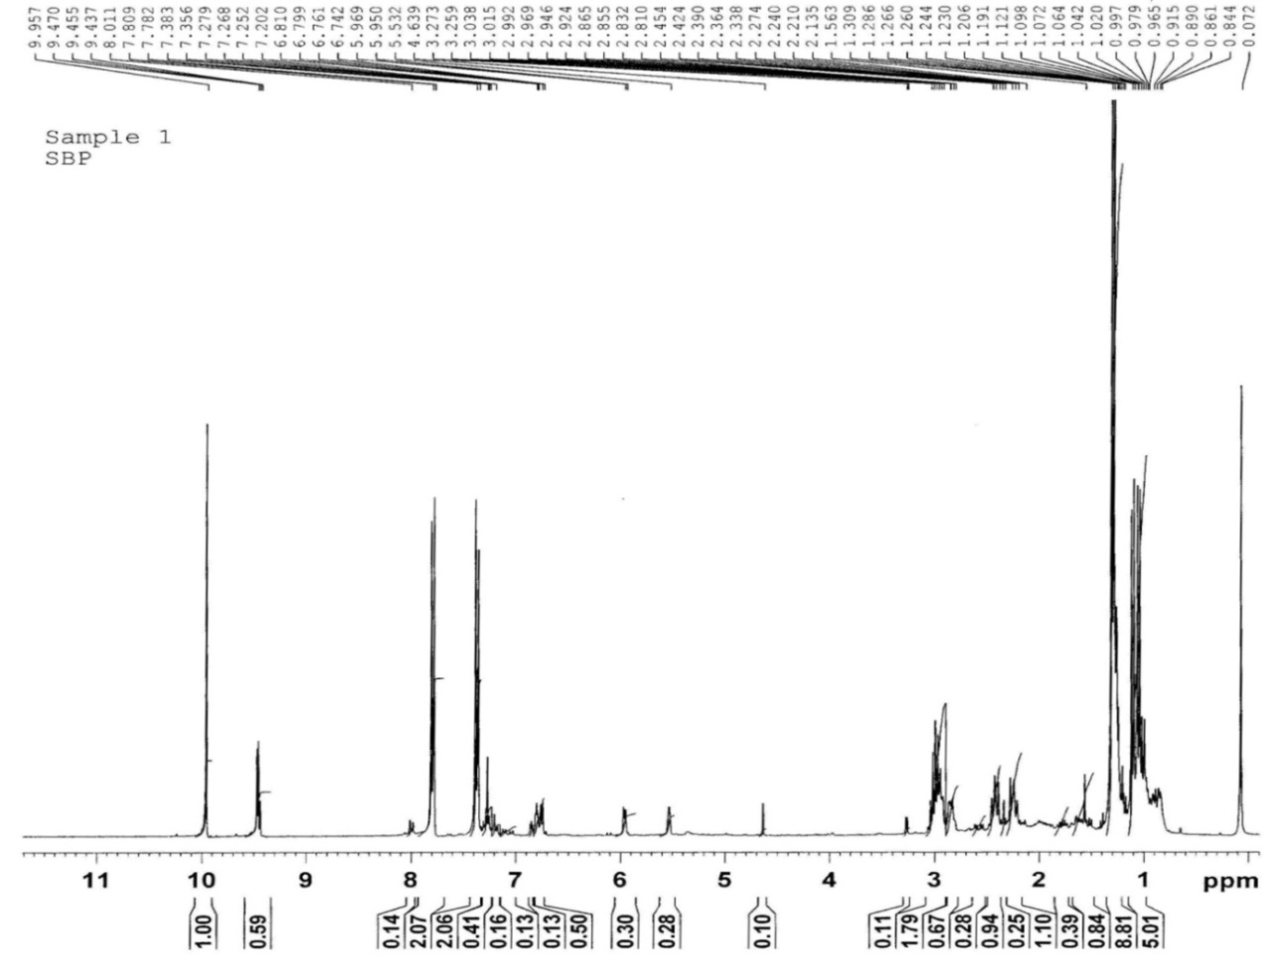
H8, H11
H7
H2, H6
H3, H5
H9

Supplementary Figure 4. A) GC-MS analysis of fraction 17th and B) Fragmentation pattern of major compound at RT 17.0 min.
A)
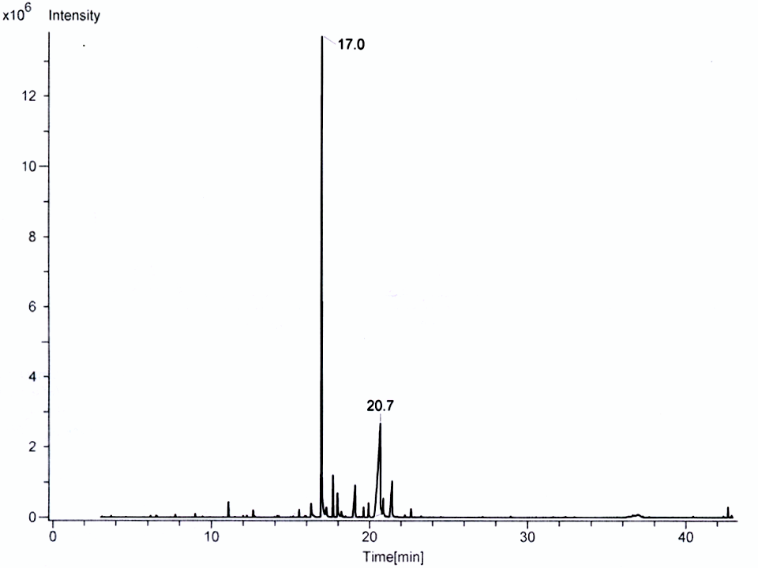
B)

Supplementary Figure 5. FTIR spectra of fraction 17th

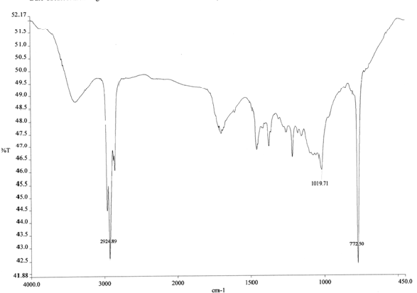

Supplementary Figure 6. ¹H NMR analysis of fraction 17th
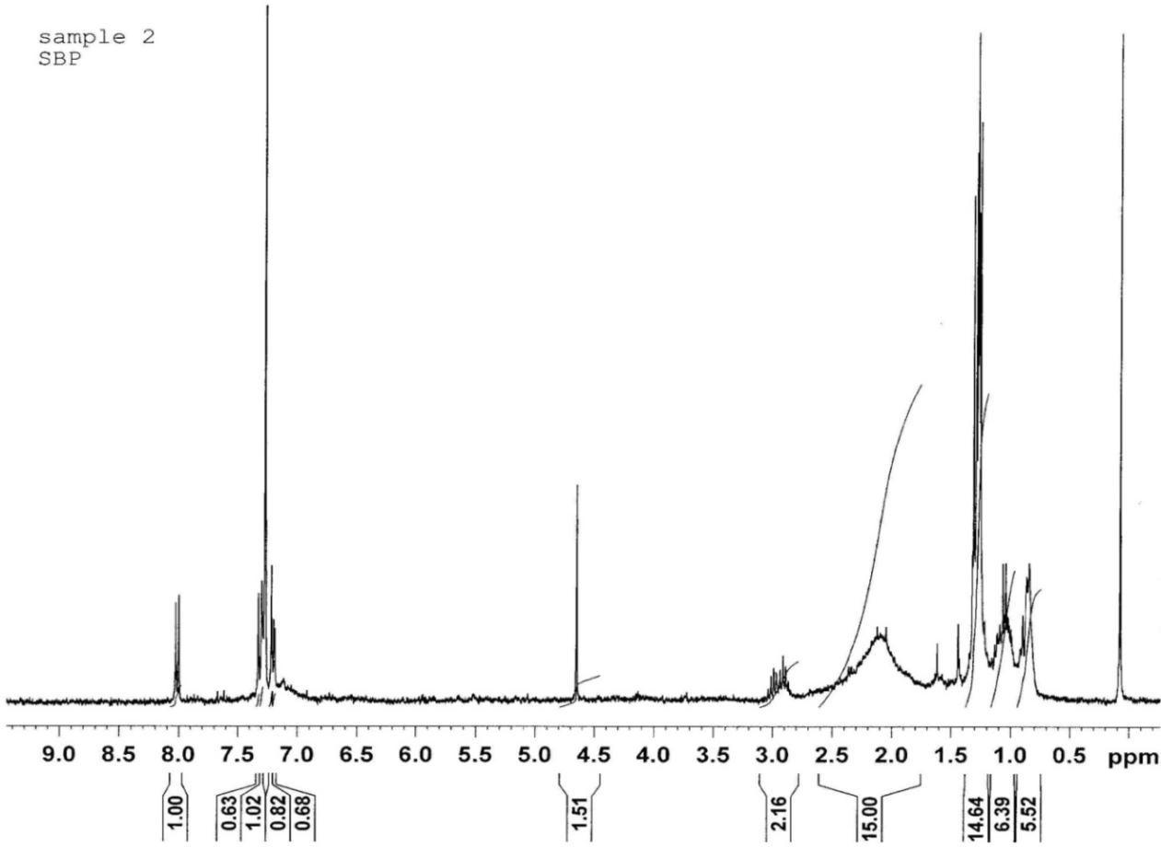
H10, H11
H8
H7
H3

Supplementary Figure 7. Dose dependent effect of cuminaldehyde and cuminol on insulin secretion.

Results are mean ± S.D.; n=6. *p<0.05 and †p<0.001 significant from 11.8 mM glucose control.

Supplementary Figure 8. A) GC-MS of insulin secretion inhibitory compound from fraction 100:0 (Sub fraction 2) and B) Mass fragmentation pattern of insulin secretion inhibitory compound from fraction 100:0 (Sub fraction 2) at RT 27.199

A)
Time [min]

B)
