Supplementary Material
Very low-carbohydrate ketogenic diet versus low-fat diet for long-term weight loss: meta-analysis of randomized controlled trials.

Search strategy used for MEDLINE (via PubMed)
#1 ("ketogenic diet"[MeSH Terms] OR ("ketogenic"[All Fields] AND "diet"[All Fields]) OR "ketogenic diet"[All Fields]) OR ("diet, carbohydrate-restricted"[MeSH Terms] OR ("diet"[All Fields] AND "carbohydrate-restricted"[All Fields]) OR "carbohydrate-restricted diet"[All Fields] OR ("low"[All Fields] AND "carbohydrate"[All Fields] AND "diet"[All Fields]) OR "low carbohydrate diet"[All Fields]) OR (very-low[All Fields] AND ("carbohydrates"[MeSH Terms] OR "carbohydrates"[All Fields] OR "carbohydrate"[All Fields]) AND ("diet"[MeSH Terms] OR "diet"[All Fields]))

#2 (("cardiovascular system"[MeSH Terms] OR ("cardiovascular"[All Fields] AND "system"[All Fields]) OR "cardiovascular system"[All Fields] OR "cardiovascular"[All Fields]) AND ("risk factors"[MeSH Terms] OR ("risk"[All Fields] AND "factors"[All Fields]) OR "risk factors"[All Fields]) OR ("weight loss"[MeSH Terms] OR ("weight"[All Fields] AND "loss"[All Fields]) OR "weight loss"[All Fields]))

#3 (randomized controlled trial [pt] OR controlled clinical trial [pt] OR randomized controlled trials [mh] OR random allocation [mh] OR double-blind method [mh] OR single-blind method [mh] OR clinical trial [pt] OR clinical trials [mh] OR ("clinical trial" [tw]) OR ((singl* [tw] OR doubl* [tw] OR trebl* [tw] OR tripl* [tw]) AND (mask* [tw] OR blind* [tw])) OR ("latin square" [tw]) OR placebos [mh] OR placebo* [tw] OR random* [tw] OR research design [mh:noexp] OR follow-up studies [mh] OR prospective studies [mh] OR cross-over studies [mh] OR control* [tw] OR prospectiv* [tw] OR volunteer* [tw]) NOT (animal [mh] NOT human [mh])

#4 #1 AND #2 AND #3

Imputations performed when it was not possible to retrieve data.
Source | Limitation | Action taken
Foster et al,⁽¹⁾ | Results shown in percentage | According to Furukawa et al,⁽²⁾ the values used in the meta-analysis of Noordman et al,⁽³⁾ which used data from Foster et al,⁽¹⁾ were imputed.
McAuley et al,⁽⁴⁾ | Did not report means of changes from baseline, only final means. | To avoid confounding in the forest plot, it was preferred to calculate the weight mean differences and to imput standard deviation through analysis of the correlation coefficient of other two studies^{(5, 6)} which had similar length of follow-up and all necessary data. All calculations were according to Higgins et al.⁽⁷⁾ Sensitivity analyses were undertaken and there was no evidence of changes in the results.
Shai et al,⁽⁸⁾ | Did not report final means and its standard deviation, neither the standard deviation from the mean changes from baseline. | Imputation by means of correlation coefficient was not possible, and by means of p-value yielded inconsistent standard deviation values. Therefore, the mean standard deviation of Foster et al⁽⁹⁾ and of Iqbal et al⁽¹⁰⁾ which had the same length of follow-up and similar sample size, were imputed for each parameter.

Full-texts excluded from the analysis and reasons for exclusion
Source | Reason to exclusion
Aydin et al,⁽¹¹⁾ | Less than 12 months of follow-up.
Bluher et al,⁽¹²⁾ | Did not report necessary data.
Elhayany et al,⁽¹³⁾ | Inadequate carbohydrate intake in the intervention group.
Fuentes et al,⁽¹⁴⁾ | Did not report necessary data.
Goldstein et al,⁽¹⁵⁾ | Inadequate carbohydrate intake in the intervention group.
Honemann et al,⁽¹⁶⁾ | Less than 12 months of follow-up.
Keogh et al,⁽¹⁷⁾ | Inadequate carbohydrate intake in the intervention group.
Leichtle et al,⁽¹⁸⁾ | Did not report necessary data.
Samaha et al,⁽¹⁹⁾ | Less than 12 months of follow-up.
Tsai et al,⁽²⁰⁾ | Same results as Stern et al⁽⁶⁾
Yancy et al,⁽²¹⁾ | Concomitant pharmacological intervention.

Intervention groups of the studies
Source | Group 1 | Group 2 | Group 3 | Group 4 | Chosen groups
Brinkworth et al,⁽⁵⁾ 2009 | CR.<20gCHO/day. Increased to 40g | CR. 46%CHO, 30%LIP | None | None | Groups 1 and 2
Dansinger et al, ⁽²²⁾ 2005 | <20g CHO per day, increased until 50g | 40% CHO, 30% PTN, 30%LIP | Point system diet + Exercises | Vegan with 10% LIP | Groups 1 and 4
Davis et al, ⁽²³⁾ 2009 | <25g in first two weeks. 5g increase per week | CR. 25%LIP. | None | None | Groups 1 and 2
Dyson et al, ⁽²⁴⁾ 2010 | <40gCHO/d. | 500kcal CR and <30%LIP | None | None | Groups 1 and 2
Foster et al, ⁽¹⁾ 2003 | 20gCHO/d. Gradual increases of 5g | CR. 60%CHO and 25%LIP | None | None | Groups 1 and 2
Foster et al, ⁽⁹⁾ 2010 | 20gCHO/d. Gradual increases of 5g | CR. 55%CHO and 30%LIP | None | None | Groups 1 and 2
Gardner et al, ⁽²⁵⁾ 2007 | <20g CHO per day, increased until 50g | 40% CHO, 30% PTN, 30%LIP | 55%-60% CHO and <10% saturated fat. | Vegan with 10% LIP | Groups 1 and 4
Iqbal et al, ⁽¹⁰⁾ 2010 | 30gCHO/d | 500kcal CR and <30%LIP. | None | None | Groups 1 and 2
Lim et al, ⁽²⁶⁾ 2010 | 4% CHO, 60% LIP. | 70% CHO, 10% LIP. | 50% CHO, 30%LIP. | No intervention | Groups 1 and 2
McAuley et al, ⁽⁴⁾ 2006 | 20g/d (2 weeks); 50g/d (8 weeks); Gradual increase | 40% CHO, 30% PTN, 30%LIP | Conventional diet rich in CHO and fiber. | None | Groups 1 and 3
Shai et al, ⁽⁸⁾ 2008 | 20g for 2 months. Increased to 120g. | CR. <30% LIP | Caloric restriction. 35% LIP. | None | Groups 1 and 2
Stern et al,⁽⁶⁾ 2004 | <30gCHO/d. | 500kcal CR and <30%LIP. | None | None | Groups 1 and 2
Truby et al, ⁽²⁷⁾ 2006 | 20g CHO per day. | Point system diet + Exercises | Meal replacement. | Fat restriction + exercises | Groups 1 and 3
CHO = Carbohydrate; CR = calorie-restricted; d = Day; LIP = Lipid; PTN = Protein

Countour-enhanced funnel-plots for (A) Body Weight, (B) Triglycerides, (C) HDL, (D) LDL, (E) Systolic Blood Pressure and (F)Diastolic Blood Pressure.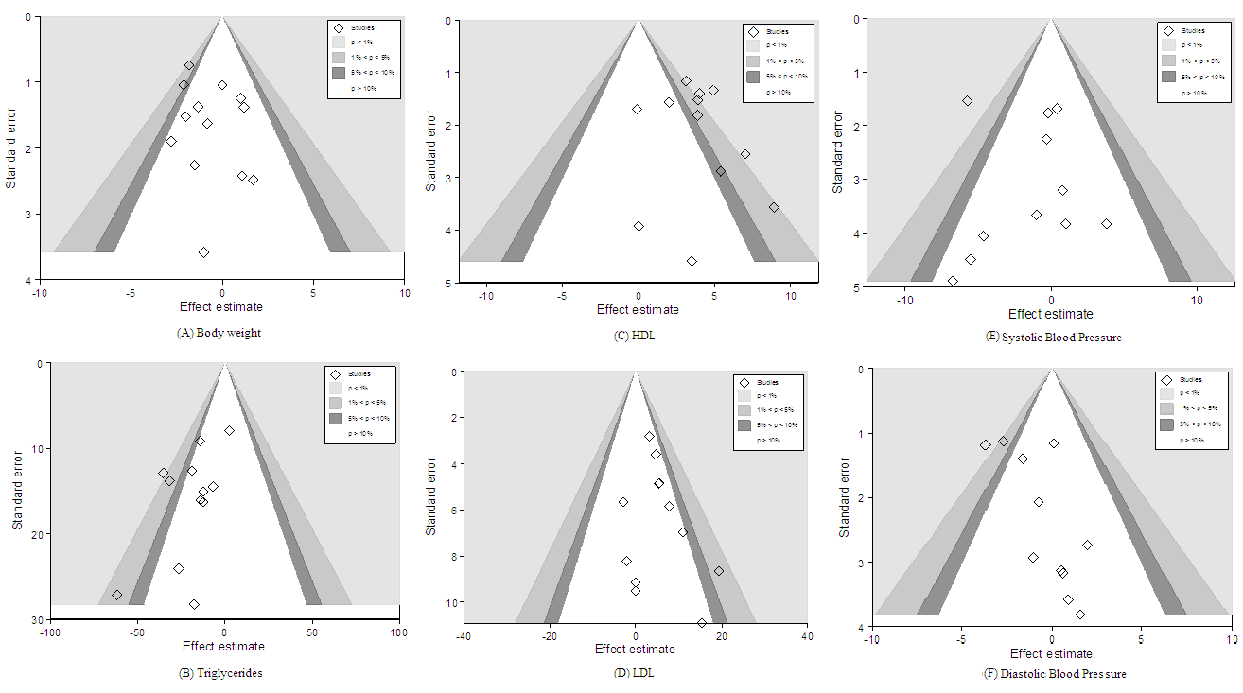

Absolute changes in [A] Fasting Blood Glucose, [B] Insulin, [C] HbA1c and [D] C-Reactive Protein

REFERENCES
1. Foster GD, Wyatt HR, Hill JO, et al. (2003) A randomized trial of a low-carbohydrate diet for obesity. N Engl J Med 348, 2082-90.

2. Furukawa TA, Barbui C, Cipriani A, Brambilla P, Watanabe N. (2006) Imputing missing standard deviations in meta-analyses can provide accurate results. J Clin Epidemiol 59, 7-10.

3. Nordmann AJ, Nordmann A, Briel M, et al. (2006) Effects of low-carbohydrate vs low-fat diets on weight loss and cardiovascular risk factors: a meta-analysis of randomized controlled trials. Arch Intern Med 166, 285-293.

4. McAuley KA, Smith KJ, Taylor RW, McLay RT, Williams SM, Mann JI. (2006) Long-term effects of popular dietary approaches on weight loss and features of insulin resistance. Int J Obes (Lond) 30, 342–349.

5. Brinkworth GD, Noakes M, Buckley JD, Keogh JB, Clifton PM. (2009) Long-term effects of a very-low-carbohydrate weight loss diet compared with an isocaloric low-fat diet after 12 mo. Am J Clin Nutr 90, 23–32.

6. Stern L, Iqbal N, Seshadri P, et al. (2004) The effects of low-carbohydrate versus conventional weight loss diets in severely obese adults: one-year follow- up of a randomized trial. Ann Intern Med 140, 778-785.

7. Higgins JPT, Deeks JJ, Altman DG. Special topics in statistics. In: Higgins JPT, Green S, eds. Cochrane Handbook for Systematic Reviews of Interventions Version 5.1.0 [updated March 2011]. http://www.cochrane-handbook.org. Accessed April 01, 2012.

8. Shai I, Schwarzfuchs D, Henkin Y, et al. (2008) Weight loss with a low-carbohydrate, mediterranean, or low-fat diet. N Engl J Med 359, 229-41.

9. Foster GD, Wyatt HR, Hill JO, et al. (2010) Weight and metabolic outcomes after 2 years on a low-carbohydrate versus low-fat diet: a randomized trial. Ann Intern Med 153, 147–157.
10. Iqbal N, Vetter ML, Moore RH, et al. (2010) Effects of a low-intensity intervention that prescribed a low-carbohydrate vs. a low-fat diet in obese, diabetic participants. Obesity (Silver Spring) 18, 1733–1738.

11. Aydin G. (2009) Auswirkungen einer Gewichtsreduktion durch eine kohlenhydratarme Diät auf kardiovaskuläre Risikofaktoren [Elektronische Ressource]. Deutsche Zentralbibliothek für Medizin,

12. Bluher M, Rudich A, Kloting N, et al. (2012) Two patterns of adipokine and other biomarker dynamics in a long-term weight loss intervention. Diabetes Care 35, 342–349.

13. Elhayany A, Lustman A, Abel R, Attal-Singer J, Vinker S. (2010) A low carbohydrate mediterranean diet improves cardiovascular risk factors and diabetes control among overweight patients with type 2 diabetes mellitus: a 1-year prospective randomized intervention study. Diabetes Obes Metab 12, 204-209.

14. Fuentes L, Waggoner AD, Mohammed BS, et al. (2009) Effect of moderate diet-induced weight loss and weight regain on cardiovascular structure and function. J Am Coll Cardiol. 54, 2376-2381.

15. Goldstein T, Kark JD, Berry EM, Adler B, Ziv E, Raz I. (2011) The effect of a low carbohydrate energy-unrestricted diet on weight loss in obese type 2 diabetes patients : a randomized controlled trial. E-Spen Eur E J Clin Nutr Metab. 6, e178-e186.

16. Honemann I, Ranke C, Austel A, et al. (2010) Veränderungen kardiovaskulärer Risikofaktoren unter drei aktuell diskutierten Ernährungsstrategien zur Gewichtsreduktion. Aktuel Ernahrungsmed 35, 227–235.

17. Keogh JB, Brinkworth GD, Clifton PM. (2007) Effects of weight loss on a low-carbohydrate diet on flow-mediated dilatation, adhesion molecules and adiponectin. Br J Nutr 98, 852–859.

18. Leichtle AB, Helmschrodt C, Ceglarek U, et al. (2011) Effects of a 2-y dietary weight-loss intervention on cholesterol metabolism in moderately obese men. Am J Clin Nutr 94, 1189–1195.

19. Samaha FF, Iqbal N, Seshadri P, et al. (2003) A low-carbohydrate as compared with a low-fat diet in severe obesity. N Engl J Med 348, 2074-81.

20.Tsai AG, Glick HA, Shera D, Stern L, Samaha FF. (2005) Cost-effectiveness of a low-carbohydrate diet and a standard diet in severe obesity. Obes Res 13, 1834–1840.

21. Yancy WS, Westman EC, McDuffie JR, et al. (2010) A randomized trial of a low-carbohydrate diet vs orlistat plus a low-fat diet for weight loss. Arch Intern Med 170, 136-145.

22. Dansinger ML, Gleason JA, Griffith JL, Selker HP, Schaefer EJ. (2005) Comparison of the atkins, ornish, weight watchers, and zone diets for weight loss and heart disease risk reduction: a randomized trial. JAMA 293, 43-53.

23. Davis NJ, Tomuta N, Schetcher C, et al. (2009) Comparative study of the effects of a 1-year dietary intervention of a low-carbohydrate diet versus a low-fat diet on weight and glycemic control in type 2 diabetes. Diabetes Care 32, 1147–1152.

24. Dyson PA, Beatty S, Matthews DR. (2010) An assessment of low-carbohydrate or low-fat diets for weight loss at 2 year’s follow-up. Diabet Med 27, 363–368.

25. Gardner CD, Kiazand A, Alhassan S, et al. (2007) Comparison of the atkins, zone, ornish, and learn diets for change in weight and related risk factors among overweight premenopausal women the a to z weight loss study: a randomized trial. JAMA 297, 969-977.

26. Lim SS, Noakes M, Keogh JB, Clifton PM. (2010) Long-term effects of a low carbohydrate, low fat or high unsaturated fat diet compared to a no-intervention control. Nutr Metab Cardiovasc Dis 20, 599-607.

27. Truby H, Baic S, deLooy A, et al. (2006) Randomised controlled trial of four commercial weight loss programmes in the UK: initial findings from the BBC “diet trials”. BMJ 332, 1309-1314.

