ADDITIONAL FILE 1
Bionaz M., Thering B.J., Loor J.J. Effect of PPARα Activation and Long-chain Fatty Acids on Expression of Genes Involved in Lipid Metabolism and Immune Response in Madin-Darby Bovine Kidney Cells. British Journal of Nutrition
Table of Contents
ADDITIONAL MATERIALS AND METHODS 3
RNA extraction and qPCR. 3
Relative mRNA abundance between measured transcripts. 4
Network Development by Ingenuity Pathway Analysis. 4
Hierarchical cluster among genes and treatments. 4
PPAR response elements (PPRE) analysis. 5
Alignment and 3D structure modeling of PPAR proteins. 6
ADDITIONAL RESULTS AND DISCUSSION 6
MDBK characterization by % relative abundance between transcripts. 6
PPRE analysis 6
Binding strength of PPARα-specific functional PPRE. 7
Binding strength of PPARγ and PPARβ/δ functional PPRE. 8
Correlation between PPRE and gene expression. 8
PPAR sequence similarity and 3D structure 9
PPARα homology analysis among mouse, human, and bovine. 9
Bovine PPAR isotype homology. 9
Comparison of WY treatment between MDBK and mouse and human hepatocytes 10
Effect of dietary and rumen-related LCFA on expression of selected genes 11
Dietary LCFA. 11
Rumen-related LCFA. 13
Effect of treatments on expression of selected genes clustered by main function 14
LCFA entry and intracellular transport. 14
Lipid metabolism. 15
PPAR signaling and glucose synthesis. 15
Immune response and acute phase proteins. 16
Comparison between MDBK and MacT cells treated with LCFA 16
S. Table 1. Description, main function(s), and sub-cellular primary localization(s) of products of the genes measured. 17
S. Table 2. qPCR performance of measured transcript. See median Ct values in S. Figure 1. 18
S. Table 3. Primer features. 19
S. Table 4. Comparative analysis of transcriptomics response to WY among species. 21
Comparison between measured genes in hepatocytes from Mouse and Human ⁽¹⁵⁾, and MDBK after treatment with Wy-14643. 21
S. Table 5. Summary table of comparative analysis among species. 22
S. Table 6. Analysis of PPRE for PPARα among measured genes 23
S. Table 7. Comparative analysis of PPRE between PPAR subtypes among measured genes 24
S. Table 8. Comparative alignment analysis between PPARα of Bos, Mus, and Homo 25
S. Table 8.1. Summary output from CLUSTALW with length of the proteins and overall score of alignment. 25
S. Table 8.2. Overall % conservation and % conservation of each domain composing PPARα protein between Bos taurus, Homo sapiens, and Mus musculus. 25
S. Table 8.3. Visualization of alignment obtained by CLUSTALW among PPARα protein between Bos taurus, Homo sapiens, and Mus musculus. 25
S. Table 9. Comparative alignment analysis between bovine PPARα, PPARγ, and PPARδ 27
S. Table 9.1. Summary output from CLUSTALW with length of the proteins and overall score of alignment. 27
S. Table 9.2. Overall % conservation and % conservation of each domain composing bovine PPAR proteins. 27
S. Table 9.3. Visualization of alignment obtained by CLUSTALW among PPAR proteins in Bos taurus. 27
S. Table 10. Correlation between effect of LCFA on MacT and MDBK cells 29
S. Figure 1. % relative abundance and Ct of measured genes 30
S. Figure 2. PPARα targets among measured genes as uncovered by IPA and previous literature 31
S. Figure 3. Functional PPRE analysis of bovine PPARα target genes 32
S. Figure 4. Functional PPRE analysis of non-bovine PPARα target genes 33
S. Figure 5. 3D structure of bovine LBD PPARα 36
S. Figure 6. 3D linear structure of bovine and mouse PPARα LBD 37
S. Figure 7. Superimposed 3D structure of bovine and mouse PPARα LBD 38
S. Figure 8. Superimposed 3D linear structure of bovine and mouse PPARα LBD 39
S. Figure 9. 3D surface structure of bovine and mouse PPARα LBD 40
S. Figure 10. Effect of 20:0 on gene networks. 41
S. Figure 11. Effect of c9,t11CLA on gene networks 42
S. Figure 12. Effect of t10,c12CLA on gene networks 43
S. Figure 13. Effect of 18:2 on gene networks 44
S. Figure 14. Effect of DHA on gene networks 45
S. Figure 15. Effect of 18:3 on gene networks 46
S. Figure 16. Effect of c9-18:1 on gene networks 47
S. Figure 17. Effect of t10-18:1 on gene networks 48
S. Figure 18. Effect of t11-18:1 on gene networks 49
S. Figure 19. Hierarchical clustering of gene expression data without statistical analysis 50
S. Figure 20. 3D surface structure of bovine PPARα, PPARγ, and PPARβ/δ 51
S. Figure 21. Temporal effect of 16:0 on expression of SPP1 52

ADDITIONAL MATERIALS AND METHODS

RNA extraction and qPCR.
RNA was extracted in a week after cell harvesting and preserved at -80ºC in RNA storage solution (Ambion, Austin, TX) until cleaning as previously described . Each sample harvested (6 well at 60-90% confluence with between 1.5x10⁶-2.5 x10⁶ cells/well) provided 28.3±6.0 μg RNA (a rough estimate of 14 fg/cell). Extracted RNA was preserved at -80ºC until use. Genomic DNA was removed from total RNA extracted with DNase using RNeasy Mini Kit columns (Qiagen, Germany). RNA concentration was measured using a NanoDrop ND-1000 spectrophotometer (www.nanodrop.com). The purity of RNA (A260/A280) was in average 2.10±0.03 and the samples results not contaminated with other chemicals, as determined by the A260/A230 ratio that was 1.91±0.32. cDNA was produced in less than a week after RNA extraction and preserved at 4ºC. cDNA was synthesized using 100 ng RNA, 1 µg dT18 (Operon Biotechnologies, AL), 1 µL 10 mmol/L dNTP mix (Invitrogen Corp., CA), 1 µL random primers (Invitrogen Corp., CA) and 10 µL DNase/RNase free water. The mixture was incubated at 65 °C for 5 min and kept on ice for 3 min. A total of 6 µL of master mix composed of 4.5 µL 5X First-Strand Buffer, 1 µL 0.1 M DTT, 0.25 µL (50 U) of SuperScriptTM III RT (Invitrogen Corp., CA) and 0.25 µL of RNase Inhibitor (10 U, Promega, WI) was added. The reaction was performed in an Eppendorf Mastercycler® Gradient using the following temperature program: 25 °C for 5 min, 50 °C for 60 min and 70 °C for 15 min. Sample cDNA was then diluted 1:4 with DNase/RNase free water. For the standard curve a cDNA was sensitized using a pool mRNA from a previous MDBK experiment .
Quantitative RT-PCR (qPCR) was performed using 4 µL diluted cDNA combined with 6 µL of a mixture composed of 5 µL 1 × SYBR Green master mix (Applied Biosystems, CA), 0.4 µL each of 10 µM forward and reverse primers and 0.2 µL DNase/RNase free water in a MicroAmpTM Optical 384-Well Reaction Plate (Applied Biosystems, CA). Each sample was run in triplicate and a 5 point relative standard curve plus the non-template control (NTC) were used. The reactions were performed in an ABI Prism 7900 HT SDS instrument (Applied Biosystems, CA) using the following conditions: 2 min at 50 °C, 10 min at 95 °C, 40 cycles of 15 s at 95 °C (denaturation) and 1 min at 60 °C (annealing + extension). The presence of a single PCR product was verified by the dissociation protocol using incremental temperatures to 95 °C for 15 s plus 65 °C for 15 s. Data were calculated with the 7900 HT Sequence Detection Systems Software (version 2.2.1, Applied Biosystems, CA). qPCR performance of each genes measured can be found in S. Table 2.
Primers were designed using Primer Express 2.0 or 3.0 with minimum amplicon size of 80 bp (when possible amplicons of 100-150 bp were chosen) and limited 3’ G+C (Applied Biosystems, CA). When possible, primer sets were designed to fall across exon-exon junctions. Primers were aligned against publicly available databases . Primer-pairs features are reported in S. Table 3. Primer sets were synthesized by Integrated DNA Technologies (Coralville, Iowa) and shipped as 25 nMol DNA oligo lyophilized by a standard desalting procedure. Primers were resuspended in DNase free water in a stock solution of 100 μM and diluted to 10 μM with DNase free water to produce a working solution. The working solution was discarded after 4 months. Prior to qPCR, primers were tested in a 20 µL PCR reaction using the same protocol described for qPCR except for the final dissociation protocol. For primer testing, a universal reference cDNA (RNA mixture from 5 different bovine tissues) was used to ensure identification of desired genes. Five μL of the PCR product were run in a 2% agarose gel stained with ethidium bromide. PCR product from the remaining 15 µL was purified using QIAquick® PCR Purification Kit (QIAGEN) and sequenced at the Core DNA Sequencing Facility of the Roy J. Carver Biotechnology Center at the University of Illinois, Urbana-Champaign. Only those primers that did not present primer-dimers, presented a single band at the expected size in the gel, and had the right amplification product (verified by sequencing) were used for qPCR. The accuracy of a primer pair was also evaluated by the presence of a unique peak during the dissociation step at the end of qPCR analysis. The final qPCR data were normalized using the geometric mean of RPS9, UXT, and RPS15A transcripts after testing 3 additional potential reference genes (MRPL39, MTG1, and PPP1R11) using geNorm as also previously reported . The accepted intra-assay variation for qPCR was < or = 10%.

Relative mRNA abundance between measured transcripts.
The relative % mRNA abundance between transcripts was calculated as previously reported using the median ∆Ct (∆Ct = Ct of the gene – geometrical mean Ct of internal control genes) corrected by efficiency (E), where % relative mRNA abundance = [1/E^{∆Ct}]/Σ[1/E^{∆Ct}] all measures genes × 100.

Network Development by Ingenuity Pathway Analysis.
Known networks among genes measured based on mouse, rat, and human literature were generated through the use of Ingenuity Pathways Analysis (IPA, Ingenuity® Systems, www.ingenuity.com). The dataset with gene identifiers, corresponding expression values (log2 transformed qPCR data relative to CTR), and pair-wise comparison corrected P-value were uploaded into IPA. To summarize results from our data we generated networks where custom arrows were added to account for new findings and arrows not demonstrated by our data were removed.

Hierarchical cluster among genes and treatments.
The hierarchical cluster to determine the similarity in expression of measured genes and the comparison between treatments was carried out using Genesis software . The analysis was carried out using the default distance measure (Euclidean) and the average linkage. Two hierarchical analyses were run, one using the statistical results and one using fold-change without statistical analysis. For the former, data were imported into the software as fold change only for genes with an overall statistical effect of treatments and with a statistical effect relative to CTR. For the latter, data were imported into the software only as fold change for all genes without considering statistical effects.

PPAR response elements (PPRE) analysis.
PPREs are formed by two hexameric core binding motifs (AGGTCA) in a direct repeat orientation with an optimal spacing of one nucleotide, The PPRE are located in the promoter or transcribed region of PPAR target genes . The PPRE is recognized by the DNA binding domain of the PPAR (after formation of a heterodimer with RXR), allowing the PPAR-RXR heterodimer to bind to the major groove of the DNA containing the PPAR target gene. Once bound with DNA there is a tridimensional change of the heterodimer which recruits several co-factors or co-activators. Those co-factors/co-activators participate actively in activating or repressing transcription . The preferred consensus PPRE differs slightly between PPAR isoforms , and the binding preference to the PPRE by the three PPAR subtypes differs based on the single nucleotide variation . The use of an in silico approach to find PPRE in the promoter or transcribed region of each tested gene and the evaluation of the binding strength in comparison with gene expression data can provide additional information in predicting bovine PPARα responsive genes. In addition, we ran the same analysis to uncover PPRE for PPARγ and PPARβ/δ with the aim to evaluate possible overlap between the three PPAR as well as the potential for LCFA to activate the other PPAR besides PPARα.
The analysis of PPRE was performed by the software RESearch . The gene sequences were extracted from Ensembl release 56 (features of the sequences are available in Additional file 2) and screened for putative PPRE of strong, medium, and weak predicted binding strength present in a distance of up to 20,000 bp from the transcription start site (TSS) and in the whole transcribed region. Except for SCD, whose sequence deposited in NCBI does not blast with the latest bovine genome release (Btau_4.0, released October 2007), we could obtain a sequence from Ensembl for all genes. The relative strength of the PPRE binding by the three PPAR subtypes was as previously reported . The overall PPRE strength (i.e., sum of strength of all PPRE), mean, max, and min of PPRE strength, overall number of PPRE, and number of PPRE for each strength category (consensus, strong, medium, and weak) were calculated for each PPAR isotype. In addition, we performed a large literature search to find published bovine PPRE for the measured genes. Only for FABP4 was the bovine PPRE available and details are reported in Additional file 2.

Alignment and 3D structure modeling of PPAR proteins.
The alignment analysis of the PPARα protein of mouse, human, and bovine and the alignment analysis between bovine PPARα, PPARγ, and PPARβ/δ was carried out using CLUSTALW (http://align.genome.jp/). Alignment of specific domains was carried out using LALIGN (http://www.ch.embnet.org/software/LALIGN_form.html). Tridimensional structure analysis of ligand binding domain was carried out using Swiss-Pdb Viewer (http://www.expasy.org/spdbv/).

ADDITIONAL RESULTS AND DISCUSSION

MDBK characterization by % relative abundance between transcripts.
The relative mRNA abundance is important information in characterizing the MDBK for in vitro studies. For instance, consistently low expression of marker genes (e.g., PPAR target genes) can be problematic in providing support for a specific hypothesis. The qPCR results are obtained by setting a threshold that captures the cycle number at which the increase in fluorescence is exponential. The crossing point between the threshold and the amplification curve is called Ct (cycle at the threshold). Larger the Ct lower the initial amount of cDNA (thus, mRNA). Therefore, the % of median Ct (corrected by ICG) between genes can be used to uncover the relative quantity of measured genes in MDBK; thus, it provide a transcriptomics characterization of the cells.
In MDBK we observed high relative % mRNA abundance for UCP2 (18.1%), ACSL5 (14.7%), SPP1 (12.1%), SOD1 (11.3%), HMGCS1 (8.2%), and ACSL4 (6.4%) (S. Figure 1). Low relative mRNA abundance was observed for HP (0.018%), SAA3 (0.010%), DBI (0.011%), CD36 (0.004%), ACSL6 (0.029%), LPIN1 (0.040%), ANGPTL4 (0.010%), and the lowest for FABP4 (0.0004%). Among ACSL isoforms ACSL4 (27.6% of ACSL isoform mRNA) and ACSL5 (63.8%) were the most abundant transcripts and among LPIN isoforms LPIN2 (79.7% of LPIN isoform mRNA) was the more abundant followed by LPIN3 (17.8%) and LPIN1 (2.8%). We also attempted to measure LPL, PCK1, SLC27A3, and IL1B, but their abundance was barely or no detectable, thus, results were deemed unreliable. A single dissociation peak was found in the qPCR analysis with the primer pairs for those genes, indicating that they were amplifying a single product, and as such, the primer information used is included in S. Table 3 for all except LPL which was reported previously .

PPRE analysis
The results of the in silico PPRE analysis (variation in the DR1-type response element) on genes whose expression was significantly up-regulated by WY, plus PPARA, are reported in S. Figure 4. This figure reports the functional PPRE for all three PPAR subtypes with the relative binding strength . Results of putative functional PPRE for all genes considered in the present manuscript are reported in S. Figure 5.

Binding strength of PPARα-specific functional PPRE.
Considering only the WY responsive genes in the present experiment (i.e., PPARα target genes in bovine, see above) the PPRE analysis (S. Figure 3, S. Table 6, and Additional file 2) suggested that: all genes with a significant increase in expression after treatment with WY had at least 6 weak PPRE [0.01-0.20 strength compared with consensus ]; except FABP4, all those genes had at least one putative PPRE with a medium (0.20-0.29) to strong (0.39-1.0) PPRE specific for PPARα; the strongest PPRE (0.67) was observed for CPT1A and SREBF1, the former at ca. 14,100 bp up-stream from the TSS while the latter in the transcribed region (ca. 2,900 bp down-stream the TSS); the ACSL1 presented the larger accumulative PPRE strength (PPRE sum in S. Table 6) and, together with ANGPTL4, CPT1A, SPP1, and SREBF1, had larger PPRE mean strength compared with other PPARα target genes; the only genes with more than one strong PPRE were ACSL1 (n=5) and ACSL3 (n=2) (S. Table 6); LPIN1 had the greatest number of medium strength PPRE (n=5) and also the greatest number of overall PPRE (i.e., considering all levels of binding strengths) (n=53) followed by PPARGC1A (n=45), and ACSL1 (n=40); ACSL1, ANGPTL4, LPIN1, CPT1A, and PPARGC1A had putative PPRE for PPARα with medium-strong binding distributed across the whole DNA sequence analyzed (20,000 bp up-stream TSS and the transcribed region); whereas, ACSL3, LPIN3, SPP1 had medium-strong PPRE only up-stream the TSS, and CD36, HMGCR, and SREBF1 in the transcribed region; many of the PPARα target genes in bovine from this experiment present a PPRE with a medium-strong binding for PPARγ and PPARβ/δ (75% of PPARα-responding genes had medium and/or strong binding strength for PPARγ-PPRE). These included ACSL1, ACSL3, FABP4, LPIN1, LPIN3, and PPARGC1A; exceptions to the previous point were SPP1 and HMGCR which have medium PPRE binding strength only for PPARα and only weak PPRE for the other isotypes.
Overall, the above observations appear to support the gene expression data (Figure 1 and 2 in the main body of the paper); however, the case of FABP4 appears in contradiction, because no medium-strong PPRE for PPARα were found (S. Figure 3). The FABP4 is the only bovine gene among the ones measured with a reported PPRE . The reported PPRE, however, was not among the ones considered by Heinaniemi et al. ; thus, did not resulted from the PPRE in silico analysis performed. We blasted the reported PPRE against the FABP4 sequence retrieved from Ensembl (Additional file 2). The reported PPRE blasted with the FABP4 sequence used but far up-stream the TSS (>8,000 bp) compared with what was previously reported (3,331 up-stream TSS).
The PPARα-PPRE analysis among the non-PPARα target genes highlighted several interesting points: many of those genes (12 out of 16 or 70%) have a medium strength PPRE for PPARα and all of them have a minimum of 4 to a maximum of 42 weak PPRE (Additional file 2). They also have a mean of 1.9 (range: 0-9) medium-strength PPRE/gene, a mean of 0.2 (range: 0-2) strong PPRE/gene; the largest number of overall putative PPRE and, in most cases, a comparable overall PPRE binding strength, as observed for ACOX1, three ACSL isoforms (4, 5, and 6), PC, LPIN2, and PPARA (S. Table 6); ACSL6, PC, and PPARA had the largest sum while DGAT1 and FABP3 had the largest mean of RE binding strength (S. Table 6); ACSL6 and SREBF2 each have one of the strongest PPRE (0.67) while FABP3 had a full consensus (i.e., 1.00 of strength or 100% binding strength). Our in-depth observations highlighted that the strong PPARα-PPRE in ACSL6 and SREBF2 were at >15,500 bp up-stream TSS which was farther up-stream from transcribed regions compare with CPT1A and SREBF1. Some of the genes with the weakest response to WY, such as ACSL4, HP, IL6, SOD1, and UCP2 (Figure 1 and 2 and Table 1 in main body of the paper) did not have any medium-strong PPRE for PPARα (S. Figure 4). In addition, FABP3, whose expression was numerically down-regulated by WY (Figure 1 in the main body of the paper), besides having the full consensus at ca. 20,000 bp up-stream the TSS, do not have any other medium-strong PPARα-PPRE along the entire sequence analyzed (S. Figure 4).

Binding strength of PPARγ and PPARβ/δ functional PPRE.
The analysis of PPRE for the non-responsive WY genes for the other two PPAR isotypes suggested that those genes are more sensitive to PPARγ than PPARα, with 94% and 65% of genes presenting a medium strength PPRE for PPARγ and PPARβ/δ, respectively, vs. 75% and 50% in PPARα-responsive genes (Additional file 2). The PPRE analysis indicated that, among the measured genes, PPRE for PPARγ compared with other PPARs was found in larger numbers for all strength types. It also had a higher overall PPRE strength, but the average strength was equal to the PPRE for PPARα (S. Table 7). The genes ACOX1, LPIN1, LPIN3, PC and UCP2 had a strong PPRE only for PPARγ and PPARβ/δ but not for PPARα; the genes DBI, SAA3, and SOD1 have a strong PPRE only for PPARγ (S. Figure 4). In addition, LPIN1 has a very strong PPRE (strength = 0.67) only for PPARγ in the promoter/up-stream position, while PC and PPARA have a very strong PPRE only for PPARγ in the far-downstream of the TSS. None of the genes considered have a very strong PPRE for PPARβ/δ, but ACSL1, DGAT1, and PPARGC1A have a very strong PPRE for both PPARγ and PPARβ/δ and none for PPARα. In contrast, SREBF1 has a very strong PPRE for PPARγ and PPARα but none for PPARβ/δ (S. Figure 4). The case of FABP3 is noteworthy because it only has, besides the consensus at ca. 20,000 bp up-stream TSS for all three PPAR isotypes, present two medium strength PPRE for PPARγ.

Correlation between PPRE and gene expression.
A correlation analysis was run in order to single-out some common patterns or relationships between in silico results and gene expression data. Considering the fact that the correlation analysis has the limitations of using discrete numbers (the PPRE strength) with continuous numbers (gene expression), the results clearly indicated a lack of any type of correlation between WY responsive genes and any of the parameters considered (e.g., overall strength, average strength, overall number of PPRE, overall number of PPRE for each strength-wise PPRE, and others, see Additional file 3). No relationships between genes affected by LCFA and the presence of a PPRE for the three PPAR isotypes were evident from the generated data (Additional file 3). In addition, the same analysis indicated a stronger correlation between PPARα and PPARγ for the number, overall strength, and number of medium-strength PPRE compared with the correlation between PPARα and PPARβ/δ. The latter comparison had a greater correlation for the number of strong PPRE (Additional file 3).

PPAR sequence similarity and 3D structure
The tri-dimensional structure of a portion of the hinge region and the entire ligand binding domain of the bovine PPARα is reported in S. Figures 5. The figure clearly depict the amino acids (with the side-chain) that are involved in determining the ligand entry site, the ligand binding site, the putative dimerization PPARα-RXR, and the steroid receptor coactivator 1 (SRC-1) interaction.

PPARα homology analysis among mouse, human, and bovine.
Features and alignment analysis of murine, human, and bovine PPARα are reported in S. Tables 8.1, 8.2, and 8.3. Results uncovered an overall high conservation between the 3 species (>90%), with bovine PPARα having a greater similarity to human (94.9%) than mouse (92.3%). The least conserved appeared to be the N-terminal domain also called A/B (from 80.8 to 86.9%), which is in line with a previous report . The ligand binding domain is overall highly-conserved between the three species, with mouse and bovine (97.8%) having greater conservation compared with other comparisons (92.4% in both). Interestingly, no differences were observed for the amino acids known to be responsible for ligand entry and binding and dimerization interface PPARα-RXR (S. Table 8.3).
The 3D analysis comparison between mouse and bovine PPARα (S. Figure 5-9) identified a large degree of conservation in many domains as uncovered by sequence alignment, but, unrecognized by sequence alignment analysis, we observed differences in spatial structure of the ligand-binding and the steroid receptor coactivator 1 (SRC-1) interaction domains. In particular, the residues Leu462 and Tyr466 of the ligand binding domain in bovine (bovine PPARα reference) result in a completely different spatial position compared with mouse, as well the residues Leu461 and Glu464 of the SRC-1. When the surface was visualized (which included molecular surface [with exclusion of hydrogen atoms] and electrostatic potential, see S. Figure 9) the differences were more evident. The bovine PPARα has an overall more neutral charge, particularly in the ligand pocket, compared with the highly-negatively charged mouse PPARα, which allow inferring that longer chained fatty acids (i.e., more neutral charged) are more easily accommodated. In this regard, the residues Leu462 and Tyr466 appear to provide a larger pocket in bovine compare to mouse PPARα (S. Figure 9).

Bovine PPAR isotype homology.
The three PPAR isotype proteins have an overall low conservation, with PPARα being more similar to PPARβ/δ (59.4%) than PPARγ (52.4%) (S. Tables 7.1, 7.2, and 7.3 in Additional file 1). The three proteins have a large degree of conservation in the DNA binding domain (>80%), but a low degree of conservation in the A/B domain (<21%). PPARα has a greater degree of conservation in the ligand binding domain with PPARβ/δ (70.7%) compared with PPARγ (63.6%).
The 3D image of the surface indicates that the LBD of the three bovine PPAR isotypes (S. Figure 20 in Additional file 1) has evident differences, particularly for the ligand pocket. The PPARα appears to have a larger pocket compared with the other two PPAR isotypes. In addition, the S. Figure 20 (Additional file 1) clearly indicates a larger negative charge for PPARγ followed by PPARα and PPARβ/δ, the latter being mostly positively charged. An in-depth crystallographic analysis of the three bovine PPAR isotypes, probably with the presence of agonists, needs to be performed in order to provide additional insight on the ability of the three PPAR to bind agonists such as LCFA.

Comparison of WY treatment between MDBK and mouse and human hepatocytes
In a recent study, whole genome microarrays of human and mouse hepatocytes treated with WY were used to identify PPARα target genes which are unique or overlap in the liver of the two species. We used those additional results to compare against our data for the common measured genes (S. Tables 4 and 5 in Additional file 1). Among those transcripts, only 4 were commonly up-regulated between mouse, human, and bovine (ACSL1, ACSL3, ANGPTL4, and CPT1A). In another study, CPT1A and ANGPTL4 were induced in rat liver after treatment with several PPARα agonists in vivo and in vitro, indicating that both genes are overlapping PPARα targets in mammals. The mRNA fold change of CPT1A in our study compared to a previous study suggest a stronger response/sensitivity of PPARα to WY in bovine compared with monogastrics. The analysis also revealed that ca. 57% of the genes overlapped between the three species and that bovine had a greater overlap with mouse compared with human (S. Table 5 in Additional file 1). In addition, the comparison between species uncovered that only MDBK cells (i.e., bovine) had increased expression of FABP4, HMGCR, LPIN1, LPIN3, and SPP1 by WY (S. Table 4 in Additional file 1). The partial overlap between our data generated in MDBK cells and those from non-ruminants should not be surprising due to the fact that large differences also exist among genes regulated by PPARα in hepatic tissue of mouse vs. human. It is important to keep in mind that transcriptomics profiles and responses to treatments can vary between in vitro and in vivo conditions as well, with a lower response more often observed in vitro. For example, the blunted response in expression of ACOX1 after treatment with WY in our experiment, which also has been previously reported in human hepatocytes, can be a consequence of the in vitro conditions as previously pointed out. Despite the fact that ACOX1 has been considered a reliable PPARα target in non-ruminants, particularly in rodents, recent data from our laboratory seem to indicate that ACOX1 is a weak PPARα target at least in dairy calf liver. It would be important to test the relevance of ACOX1 in mature dairy cow liver, which is exposed to substantially greater concentrations of non-esterified fatty acids particularly after parturition.

Effect of dietary and rumen-related LCFA on expression of selected genes

Dietary LCFA.
Among dietary LCFA, 16:0 and 18:0 and EPA elicited the largest changes in gene expression (Figure 1 and 2). All three LCFA appear to have increased both catabolic and anabolic utilization of LCFA (Figures 4 and 5). Results for the saturated LCFA confirm previous data obtained in hepatocytes from pre-ruminant calves, where increases in both acid-soluble products and TAG (both in the medium and cells) were observed with 1 mM 16:0 and 1 mM 18:0 conjugated with BSA (estimated concentration of free fatty acids at equilibrium with 1 mM LCFA are ca. 50-100 nM). However, in the same experiment 1 mM EPA did not increase acid-soluble products and only increased cellular TAG. Our data suggest that synthesis of cholesterol was induced with all three LCFA in MDBK cells but in previous work with bovine hepatocytes it increased only with 16:0. Overall the data indicate that saturated LCFA and EPA would increase uptake and utilization of NEFA along with increased formation of cholesterol. The increase in cholesterol synthesis can be considered a positive output for bovine liver because it is essential for the formation of lipoproteins to remove TAG. Our and previous data appear to be supported by a recent in vivo study where greater plasma cholesterol level was measured in late pregnant cows fed a palmitic acid-enriched diet.
In some species (e.g., cattle, mice, chickens), SCD activity is a crucial step for endogenous synthesis of cis9-18:1, incorporation into TAG, and synthesis/export of VLDL from liver. We observed a significant increase of SCD expression by 16:0 and 18:0 but no increase was observed with EPA treatment, thus, confirming previous data in humans. In the case of SCD, previous data from our laboratory demonstrated its up-regulation in liver early postpartum, suggesting that expression and activity of this enzyme play a role in lipid metabolism during a time when the metabolic demand is high and the risk of liver lipidosis the greatest. In addition, a beneficial role of SCD and dietary supplementation of saturated LCFA (16:0 and 18:0) in the prevention of liver lipidosis in periparturient dairy cows has been suggested by previous in vivo studies.
It was interesting that most of the dietary LCFA (16:0, 18:0, EPA, 18:2, and c9-18:1) increased the expression of SPP1 (Figure 2), with the response sustained up to 24h incubation with 16:0 (S. Figure 21 in Additional file 1). In mouse, both in vivo and in vitro, it has been shown that this gene is involved in the development of nonalcoholic steatohepatitis but also could play a role in signaling the onset of liver lipid accumulation. The large and continuous increases in expression of this gene observed in the present experiment seem to suggest such potential signaling role also in bovine.
The difference in regulation of expression of pro-inflammatory genes between the two saturated and EPA was noteworthy (Figure 2). The saturated LCFA elicited an evident increase in inflammation, at least considering expression of the measured genes; EPA appeared to have reduced (mostly through ⇓IL6) inflammation. The decrease of inflammation by EPA and increase of inflammation with 16:0 are not novel. The inflammatory response induced by palmitate appears to occur through activation of the NFκB transcription factor which in turn increases expression of IL6. In our case, the “putative transcription factor(s)” reported in Figure 4 could likely be NFκB; however, this remains to be proven experimentally in bovine.
Even though PPARA was not up-regulated significantly by the dietary LCFA in our study, up-regulation of its known co-activators PPARGC1A and LPIN1 was substantial in response to 16:0, 18:0, and EPA (Figures 1 and 2), suggesting that, besides activating PPARα through direct binding, those LCFA also increase its activation by enhancing availability of co-activators.
The other dietary LCFA (c9-18:1, 18:2, 18:3, and DHA) elicited only moderate effects on measured genes (Figures 1 and 2 and S. Figure 13-16 in Additional file 1) suggesting a general increase of LCFA uptake and oxidation, but a decrease (or no change) of TAG synthesis and increased cholesterol synthesis only with DHA. Previous work with dairy calf hepatocytes appears to partly support those data because it was observed that those LCFA induced a general increase of cellular TAG formation and a decrease of TAG released into the medium only with 18:2. In support of our data the same study showed an increase of cholesterol formation with DHA.

Rumen-related LCFA.
Far fewer changes were observed with LCFA that arise from ruminal metabolism (Figure 1 and 2). Of all rumen-derived FA investigated, 20:0 and c9,t11CLA elicited the most changes in gene expression (S. Figures 10 and 11 in Additional file 1). Phytanic acid (20:0) is a branched-chain fatty acid derived from ruminal metabolism of chlorophyll and as such its production and deposition in tissues or milk is probably greater in cattle fed forage-based diets. Phytanic acid is known to be a potent murine liver PPARα ligand but also activates the other two PPAR isoforms, at least in rat. Effect of 20:0 on gene expression of measured genes suggests a reduced TAG and cholesterol synthesis in MDBK (S. Figures 10 in Additional file 1). To our knowledge, no previous bovine cell culture work has been carried out with 20:0, but in rat hepatocytes it was demonstrated that it is involved in increasing glucose metabolism.
The functional response of measured genes with exogenous c9,t11CLA (or rumenic acid) and t10,c12CLA as inferred by network analysis (Figure 1 and 2) are partly consistent with previous findings. In fact, as all treatments in the present experiment, they increased expression of genes associated with oxidation of LCFA, which is commonly observed in rodents and humans fed with those CLA. However, the same effect was not observed in dairy calf hepatocyte cultures in response to CLA. In human and rodents it appears that in vivo c9,t11CLA increases while t10,c12CLA decreases lipid accumulation in adipocytes, but increases TAG and decreases cholesterol in murine liver. Our data summarized by gene networks in S. Figures 11 and 12 (Additional file 1) support an increase in TAG formation by c9,t11CLA and a decrease of both TAG and cholesterol synthesis by t10,c12CLA. In contrast to functional outcomes suggested by the network analysis of our data, in calf hepatocytes, incubation with t10,c12CLA led to greater accumulation of TAG than c9,t11CLA which also was observed in MacT cells. However, in calf hepatocytes t10,c12CLA appeared less lipogenic than 16:0 or DHA, which is more in line with our findings. Human hepatocytes treated with 100 μM t10,c12CLA increased cellular cholesterol concentration, which was not suggested by results from our study.
In non-ruminants, CLA and particularly c9,t11CLA have been demonstrated to be potent PPARα and PPARγ agonists. However, recent evidence strongly suggests that t10,c12CLA in human adipocytes is a PPARγ antagonist. Despite those evidence it has been argued that the principal target of CLA is liver X receptor-β. Our data suggest that c9,t11CLA can be a PPARα agonist while t10,c12CLA appears at best to be a weak PPARα agonist (Figure 6). This conclusion is also supported by data generated with reporter gene assays in immortalized monkey kidney cells.
The CLA have been reported to have anti-inflammatory effects both in vitro and in vivo in non-ruminant species. However, t10,c12CLA is pro-inflammatory in mouse adipocytes. Our data suggested a pro-inflammatory effect of c9,t11CLA (⇑ IL6, ⇑ SAA3) but only a mild (⇑ SPP1), if none, effect was observed for t10,c12CLA (Figure 2).
The other unsaturated LCFA (c9-18:1, t10-18:1, and t11-18:1) had very modest effects on expression of measured genes (Figure 1 and 2 and summary in S. Figures 16 and 18). Data from calf hepatocytes demonstrated an increase in β-hydroxybutyrate and TAG synthesis with 1 mM oleic acid. Those findings were only partly supported (i.e., ⇑ CPT1A) by data from our study. For the two trans-18:1 used in the present experiment there is less literature available, but it appears that in MDBK those LCFA have only minor functional effects. Vaccenic acid being a trans-fatty acid has been studied more extensively to test for deleterious effect on human health but no conclusive results are available. Our data also did not provide evidence of a pro-inflammatory effect of vaccenic or trans10-18:1.

Effect of treatments on expression of selected genes clustered by main function

LCFA entry and intracellular transport.
All treatments evaluated (LCFA and WY) resulted in substantially greater CD36 expression, a gene coding for a plasma membrane-bound protein involved in cellular fatty acid entry , with EPA followed by 16:0 and 20:0 being the most potent (Figure 1 in main body of the paper). Potential effects on intracellular activation of the fatty acids measured were assessed via ACSL isoforms. The saturated fatty acids 16:0 and 18:0 resulted in the greatest up-regulation of ACSL1 expression followed by WY and c9,t11-18:2 (Figure 1 in main body of the paper). Overall, among other ACSL isoforms measured, ACSL3 and ACSL5 were affected by treatments compared with CTR (Table 1 in main body of the paper). Up-regulation in expression of ACSL3 was observed with 16:0 and 18:0, as well as EPA and WY. ACSL5 expression was down-regulated in response to 18:3, 20:0, and EPA. ACSL4 and ACSL6 were not affected by treatments.
Intracellular transport of the fatty acids was assessed via DBI, FABP3, and FABP4. The DBI expression was not affected by any treatment (Table 1 in main body of the paper). The expression of FABP3 was lower with c9-18:1, EPA, and DHA (Figure 1 in main body of the paper). Despite numerically greater mRNA abundance of FABP4 with all treatments relative to CTR, significance was observed only with EPA and WY (Figure 1 in main body of the paper). For FABP4 the assessment of its mRNA with qPCR was in the lower limit of detection (median Ct = 32.2, S. Figure 2) in the MDBK cells, which could have artificially increased the variation between samples that, in turn, resulted in a larger SEM (Figure 1 in main body of the paper); therefore, the absence of significant effect due to treatments for the expression of this gene can be questionable.

Lipid metabolism.
Among catabolism-related genes, expression of CPT1A, encoding a protein that is important for fatty acid transfer into the mitochondria for oxidation, was up-regulated by all treatments (Figure 1 in main body of the paper); whereas, ACOX1, encoding a protein that is important for peroxisomal oxidation, and the uncoupling protein UCP2 remained unchanged from controls regardless of treatments (Table 1 in main body of the paper). The largest response for CPT1A was elicited by 16:0 followed by 20:0 and c9,t11CLA.
Among anabolic-related genes, SCD, which introduces a double bond into 16:0 and 18:0 primarily , had the largest up-regulation in expression with 16:0 and 18:0, but was significantly increased also with WY, t11-18:1, c9,t11-18:2, and EPA (Figure 1 in main body of the paper). Another gene measured involved in lipid synthesis was LPIN1, which catalyzes the removal of the final phosphate group during TAG synthesis . LPIN1 had increased transcription with WY, 16:0, 18:0, and EPA and had lower expression with 18:2, t10,c12CLA, 18:3, and 20:0 (Figure 1 in main body of the paper). The effect of treatments on transcription of LPIN2 and LPIN3 was very similar (Table 1 in main body of the paper). Both had greater expression with 16:0 and 18:0; however, LPIN3 expression also was greater with WY and c9,t11-18:2 and lower with EPA. The same treatments had a similar effect, albeit only numerical, on the expression of LPIN2. Expression of DGAT1, which catalyzes the final enzymatic step in the TAG formation , was down-regulated only by EPA (Figure 1 in main body of the paper).
Transcription of HMGCR and HMGCS1, two key genes for cholesterol synthesis, was up-regulated by 16:0, 18:0, EPA, and DHA (Figure 1 in main body of the paper). In addition, HMGCR expression was greater with WY and HMGCS1 expression was lower with 18:2, t10,c12CLA, and 20:0 (Figure 1 in main body of the paper). Effect of treatments on transcriptional regulation of cholesterol metabolism and lipogenesis was assessed by measuring expression of SREBF1 and SREBF2 (Figure 1 in main body of the paper). The expression of SREBF1, a lipogenic transcription factor, was greatest with 16:0 and 18:0 followed by WY, t10-18:1, and t11-18:1. Its expression was lower with 18:2, t10,c12CLA, and DHA. The expression of SREBF2, a transcription factor regulating cholesterol synthesis, was not affected by any LCFA or WY treatments and was only numerically up-regulated by 16:0 and 18:0.

PPAR signaling and glucose synthesis.
Expression of PPARA was not affected significantly by any LCFA or its ligand WY (Figure 2 in main body of the paper). Although not significant, c9,t11-CLA and 20:0 increased numerically expression of PPARA (Figure 2 in main body of the paper). PPARGCIA transcription was significantly up-regulated by 16:0, 18:0, EPA, and WY compare to CTR. The potential PPARα target gene ANGPTL4 [which is known to be under control of all three PPAR subtypes ] was greatly up-regulated with all treatments compare to CTR, the most dramatic being with 20:0, followed by WY, c9,t11CLA, and 18:3. The expression of PC, one of the two key genes involved in liver glucose synthesis, was down-regulated by EPA but was not affected by any other treatment.

Immune response and acute phase proteins.
A greater expression of IL6 compare to CTR was observed with 16:0, 18:0, and c9,t11CLA (Figure 2 in main body of the paper). In contrast, EPA resulted in lower transcription of IL6. Transcription of the acute phase proteins HP and SAA3 were both up-regulated by 16:0 and 18:0 (Figure 2 in main body of the paper). Expression of HP also was up-regulated by EPA. The c9,t11CLA treatment resulted in greater expression of SAA3 compare to CTR and tended to up-regulate the expression of HP. The expression of SPP1, a recently-identified cytokine and candidate gene for development of non-alcoholic fatty liver disease , was significantly up-regulated by most of the treatments relative to the CTR, including WY, all saturated (16:0, 18:0, and 20:0), c9-18:1, all 18:2 LCFA, and EPA (Figure 2 in main body of the paper). The greatest response was observed with 20:0 followed by EPA. In addition, using RNA extracted from a previous time course experiment where MDBK cells were treated with 150 μM of 16:0 for 24h , we observed a consistent increase in expression of SPP1 reaching 400% at 24h relative to CTR (S. Figure 21).

Comparison between MDBK and MacT cells treated with LCFA
A correlation analysis between expression elicited by LCFA in both studies is reported in S. Table 10. Results highlighted that only 50% of the genes measured in both studies had a significant positive correlation, i.e., DGAT1 (mostly due to the overall low response to LCFA in bovine), FABP3 (mostly due to down-regulation by trans-LCFA), SCD (due to up-regulation by saturated LCFA), SREBF1 (as a result of down-regulation by unsaturated LCFA), and SREBF2 (which showed the highest correlation). Among LCFA, the unsaturated had a more consistent effect between studies, particularly t10,c12CLA (S. Table 10). Those data highlight a tissue-specific (or cell-specific) response to LCFA in bovine. In this regard it is interesting that among genes measured in both studies, both cell lines had very similar relative % mRNA abundance [see S. Figure 1 and S. Figure 3 in ]. For example, both had low mRNA abundance of CD36 and FABP4, particularly before treatments.

S. Table 1. Description, main function(s), and sub-cellular primary localization(s) of products of the genes measured.

Gene | Description¹ | Primary Location² | Function¹
ACOX1 | Acyl-Coenzyme A oxidase 1, palmitoyl | PRX | FA oxidation
ACSL1 | Acyl-CoA synthetase long-chain family member 1 | PM, ER, MAM, LD | TAG synthesis
ACSL3 | Acyl-CoA synthetase long-chain family member 3 | LD | TAG synthesis
ACSL4 | Acyl-CoA synthetase long-chain family member 4 | MAM | TAG synthesis
ACSL5 | Acyl-CoA synthetase long-chain family member 5 | MITO, MAM, PM, ER | FA oxidation; TAG synthesis from imported FA
ACSL6 | Acyl-CoA synthetase long-chain family member 6 | Unknown | TAG synthesis; phospholipid synthesis
ANGPTL4 | Angiopoietin-like 4 | EC | Regulation of glucose and lipid metabolism
CD36 | CD36 molecule (thrombospondin receptor) | PM | FA transport
CPT1A | Carnitine palmitoyltransferase 1A | MM | FA oxidation
DBI | diazepam binding inhibitor or Acyl-CoA binding protein | N; PM | Acyl-CoA transport
DGAT1 | Diacylglycerol O-acyltransferase 1 | ER | TAG synthesis
FABP3 | Fatty acid binding protein 3 | CYTO | FA transport
FABP4 | Fatty acid binding protein 4 | CYTO | FA transport
HMGCR | 3-hydroxy-3-methylglutaryl-Coenzyme A reductase | ER | Cholesterol synthesis
HMGCS1 | 3-hydroxy-3-methylglutaryl-Coenzyme A synthase 1 | CYTO | Cholesterol synthesis
HP | Haptoglobin | EC | Acute Phase protein
IL6 | Interleukin 6 | EC | Immune reaction
LPIN1 | Lipin 1 | CYTO; N; ER | TAG synthesis; transcription
LPIN2 | Lipin 2 | CYTO; ER | TAG synthesis
LPIN3 | Lipin 3 | CYTO; ER | TAG synthesis
PC | Pyruvate carboxylase | MITO | Gluconeogenesis
PPARA | Peroxisome proliferator activated receptor alpha | N; CYTO | Gene transcription
PPARGC1A | PPAR gamma, coactivator 1 alpha | N | Gene transcription
SAA3 | Serum amyloid A3 | EC | Acute Phase protein
SCD | Stearoyl-CoA desaturase (delta-9-desaturase) | ER | TAG synthesis
SOD1 | Superoxide dismutase 1, soluble | CYTO | Conversion of superoxide radicals
SPP1 | Secreted phosphoprotein 1 (osteopontin) | EC | Cell adhesion, cytokine-like (among many)
SREBF1 | Sterol regulatory element binding transcription factor 1 | ER; GA; N | Gene transcription
SREBF2 | Sterol regulatory element binding transcription factor 2 | ER; GA; N | Gene transcription
UCP2 | Uncoupling protein 2 (mitochondrial, proton carrier) | MM | Uncouple oxidative phosphorylation
¹ Based on NCBI database and/or Supplementary Materials in
² CYTO = cytoplasm; EC = extracellular; ER = endoplasmic reticulum; GA = Golgi apparatus; MM = mitochondrial membrane; MAM = mitochondrial-associated membrane; MITO = mitochondria; N = nucleus; PM = plasma membrane; PRX = peroxisomes; LD = lipid droplet.

S. Table 2. qPCR performance of measured transcript. See median Ct values in S. Figure 1.

Gene | Median ∆Ctª | Slope | (R²)^{b} | Efficiency^{c}
ACOX1 | 5.0 | -3.01 | 0.996 | 2.15
ACSL1 | 4.9 | -2.91 | 0.997 | 2.21
ACSL3 | 4.2 | -2.83 | 0.995 | 2.26
ACSL4 | 1.9 | -2.67 | 0.994 | 2.37
ACSL5 | 1.3 | -2.77 | 0.996 | 2.30
ACSL6 | 8.9 | -2.63 | 0.993 | 2.40
ANGPTL4 | 11.0 | -3.20 | 0.994 | 2.05
CD36 | 12.4 | -3.15 | 0.989 | 2.08
CPT1A | 4.3 | -3.36 | 0.995 | 1.98
DBI | 10.9 | -3.28 | 0.990 | 2.02
DGAT1 | 5.2 | -2.81 | 0.996 | 2.27
FABP3 | 1.9 | -2.86 | 0.990 | 2.24
FABP4 | 14.1 | -3.02 | 0.984 | 2.14
HMGCR | 3.4 | -2.78 | 0.994 | 2.29
HMGCS1 | 1.5 | -2.77 | 0.997 | 2.30
HP | 9.6 | -2.91 | 0.993 | 2.21
IL6 | 4.2 | -2.76 | 0.995 | 2.30
LPIN1 | 7.7 | -2.63 | 0.997 | 2.40
LPIN2 | 4.5 | -3.18 | 0.998 | 2.06
LPIN3 | 5.5 | -2.63 | 0.994 | 2.40
PC | 4.0 | -2.81 | 0.993 | 2.27
PPARA | 7.3 | -2.78 | 0.993 | 2.29
PPARGC1A | 7.2 | -3.02 | 0.980 | 2.14
SAA3 | 9.1 | -2.30 | 0.990 | 2.72
SCD | 2.3 | -2.94 | 0.992 | 2.19
SOD1 | 1.4 | -2.86 | 0.997 | 2.24
SPP1 | 2.2 | -2.81 | 0.996 | 2.27
SREBF1 | 4.0 | -2.71 | 0.994 | 2.34
SREBF2 | 1.6 | -2.76 | 0.992 | 2.30
UCP2 | 0.9 | -2.74 | 0.990 | 2.32
ª The median ∆Ct was calculated as [Ct gene – geometric mean of Ct internal controls] for each sample.
^{b} R² represents the coefficient of determination of the standard curve.
^{c} Efficiency is calculated as [10^{(-1 / Slope)}]..

S. Table 3. Primer features.
GenBank accession number, hybridization position, sequence, and amplicon size of primers for Bos taurus used to analyze gene expression by qPCR.
Accession # | Gene | Primers¹ |  | Primers (5’-3’)² | bp³
BC102761 | ACOX1 | R.945 |  | CCATTAGCCGTCCGATACAGT | 99
 |  | F.1043 |  | GTTTATATTAGCTAGGGTTTAGATAATCCA
BC119914 | ACSL1 | F.1929 |  | GTAGGGCTCCTTTAGAAGAACTAGT | 120
 |  | R.2047 |  | ATAGATAGCCTTTAGACCTAGTTCAAAT
DV838064 | ACSL3 | F.243 |  | AACCAGCGCCCTCAGATATTAG | 135
 |  | R.377 |  | CCCCGAGTTCTAGGAATCCTTT
BC151816 | ACSL4 | F.963 |  | GCTAGGGACCAAAGGATACGTAT | 100
 |  | R.1062 |  | TCCAATCCTACAGCCATAGGTAAAG
BC116023 | ACSL5 | F.251 |  | AGCACGGAGAAGTATTTAGCCA | 116
 |  | R.366 |  | AAGGCCCATTAGTCAGACACAG
BC111155 | ACSL6 | F.967 |  | CTAGATTTCTCGGGCTTTCTAGA | 120
 |  | R.1086 |  | AGACGACGGACTAGGATAGACTCT
NM_001046043 | ANGPTL4 | F.28 |  | AGGAAGAGGCTAGCCCAAGAT | 109
 |  | R.136 |  | CCCTCTCTCCCTCTTCAAACAG
BC102899 | DBI | F.55 |  | AGGCTAGATTTTAGACAAGGCG | 141
 |  | R.195 |  | GATCTAACAGTAGCTAGGACACTCAATATC
X91503 | CD36 | F.743 |  | GTACAGATAGCAGCCTCATTTCC | 81
 |  | R.823 |  | TAGGACCTAGCAAATATCAGAGGA
XM_583309 | CPT1A | F.480 |  | CCTTCCCATTCCGCACTTT | 101
 |  | R.580 |  | GTCCTTAGTAATAGAGCCAGCTAGG
NM_174693 | DGAT1 | F.177 |  | CCACTAGGGACCTAGAGGTAGTC | 101
 |  | R.277 |  | GCATCACCACACACCAATTCA
DN518905 | FABP3 | F.458 |  | GAACTCGACTCCCAGCTTAGAA | 102
 |  | R.559 |  | AAGCCTACCACAATCATCGAAG
DV778074 | FABP4 | F.402 |  | TAGGTAGCTAGGAATAGTAGTCATAGA | 101
 |  | R.502 |  | TAGGAGTTCGATAGCAAACGTC
BE588673 | HMGCR | F.262 |  | GAGTAGGCAGGACCTCTAGTAGC | 121
 |  | R.382 |  | GCACCTCCACCAAGGCCTAT
AY581197 | HMGCS1 | F.499 |  | TTAGGCCAACTACATTCCCCA | 101
 |  | R.599 |  | CGCCGAGCGTAAGTTCTTCT
BC109668 | HP | F.1210 |  | GGTTCGGAAAACCATCGCTA | 101
 |  | R.1310 |  | CACTCGTAGTCCCCTCCACTC
BC123577 | IL6 | F.290 |  | TAGAGTAGTAGAAAGCAGCAAGGA | 101
 |  | R.390 |  | TCGCCTAGATTAGAACCCAGAT
DV797268 | LPIN1 | F.147 |  | TAGGCCACCAGAATAAAGCATAG | 101
 |  | R.247 |  | GCTAGACGCTAGGACAACAGG
DV828998 | LPIN2 | F.314 |  | CTTTAGACAACCCCTACCCGC | 103
 |  | R.416 |  | CACTCCATAGTAGGGACTCGG
EH174634 | LPIN3 | F.496 |  | AGGTAGTTCAAGATCGCCTAGC | 102
 |  | R.597 |  | CAGTAGACATCATTAGGGCCTAGT
BC114135 | PC | F.3218 |  | CCTAGCAGGGACCCAAGATT | 80
 |  | R.3297 |  | TAGGCCAAGGCTTTAGATAGTAG
BT020756 | PPARA | F.729 |  | CATAACGCGATTCGTTTTAGGA | 102
 |  | R.830 |  | CGCGGTTTCGGAATCTTCT
AB106107 | PPARGC1A | F.625 |  | AAAAGCCACAAAGACGTCCG | 101
 |  | R.725 |  | TCTAGCTAGCTAGTTCCGGTTCT
AF540564 | SAA3 | F.50 |  | GGGCATCATTTTCTAGCTTCCT | 106
 |  | R.155 |  | TTAGGTAAGCTCTCCACATAGTCTTTAG

S. Table 3. (continued).

Accession # | Gene | Primers¹ |  | Primers (5’-3’)² | bp³
AY241933 | SCD | F.665 |  | TCCTAGTTAGTTAGTAGCTTCATCC | 101
 |  | R.765 |  | GGCATAACGGAATAAGGTAGGC
BC102432 | SOD1 | F.256 |  | GGCTAGTACCAGTAGCAGGTCC | 101
 |  | R.356 |  | GCTAGTCACATTAGCCCAGGT
CK849100 | SPP1 | F.597 |  | CTTAGGCCTTTAGGCGTAGAGT | 101
 |  | R.697 |  | AGGAGATAGCATAGACGCACC
CO885324 | SREBF1 | F.168 |  | AGCCTAGGCAATAGTAGTAGAGAAG | 84
 |  | R.251 |  | GGCCTTAGTCAATAGGAGCTAGT
DV921555 | SREBF2 | F.45 |  | CCAGCGCTCTTAGAGTACCTAGA | 118
 |  | R.162 |  | CAGATAGACGTCTAGGGCCAA
BC102839 | UCP2 | F.366 |  | CCCCTACAGCCACTAGTAGAAGTT | 104
 |  | R.469 |  | TTAGGATCTAGTAGCCGGACTTTAG
¹ Primer direction (F – forward; R – reverse) and hybridization position on the sequence.
² Exon-exon junctions are underlined.
³ Amplicon size in base pairs (bp).

S. Table 4. Comparative analysis of transcriptomics response to WY among species.

Comparison between measured genes in hepatocytes from Mouse and Human , and MDBK after treatment with Wy-14643.
Red shade denotes up-regulation in expression, green shade denotes down-regulation in expression, and white shade not significant change in expression after treatment with Wy-14643.
Genes | Mouse | Human | Bovine | Genes | Mouse | Human | Bovine
ACOX1 | 1 | 1 | 0 | HP | 0 | 0 | 0
ACSL1 | 1 | 1 | 1 | IL6 | 0 | 0 | 0
ACSL3 | 1 | 1 | 1 | LPIN1 | 0 | 0 | 1
ACSL4 | 0 | 0 | 0 | LPIN2 | C | 0 | 0
ACSL5 | 0 | 1 | 0 | LPIN3 | 0 | 0 | 1
ACSL6 | 0 | 0 | 0 | PC | 0 | 0 | 0
ANGPTL4 | 1 | 1 | 1 | PPARA | 0 | 1 | 0
CD36 | 1 | 0 | 1 | PPARGC1A | -1 | 0 | 1
CPT1A | 1 | 1 | 1 | SAA3 | 0 | 0 | 0
DBI | 0 | 0 | 0 | SOD1 | 0 | 0 | 0
DGAT1 | 0 | 0 | 0 | SPP1 | 0 | 0 | 1
FABP3 | 0 | 0 | 0 | SCD1 | 1 | 0 | 1
FABP4 | 0 | 0 | 1 | SREBF1 | 1 | 0 | 1
HMGCR | -1 | 0 | 1 | SREBF2 | 0 | 0 | 0
HMGCS1 | 0 | 0 | 0 | UCP2 | 1 | 0 | 0

S. Table 5. Summary table of comparative analysis among species.
Summary of the comparative analysis among measured genes in hepatocytes from Mouse and Human , and MDBK.

 | Mouse | Human | Bovine
Unique Affected | 1 | 2 | 4
Unique UP | 1 | 2 | 6
Unique DOWN | 2 | 0 | 0
 | UP | No change | All | % measured genes
Overlap Mouse/Human | 5 | 13 | 18 | 60.0
Overlap Human/Bovine | 4 | 14 | 18 | 60.0
Overlap Mouse/Bovine | 7 | 15 | 22 | 73.3
Overlap all | 4 | 13 | 17 | 56.7
 | All |  |  | % measured genes
No overlap Mouse/Human | 8 |  |  | 26.7
No overlap Mouse/Bovine | 8 |  |  | 26.7
No overlap Human/Bovine | 12 |  |  | 40.0

S. Table 6. Analysis of PPRE for PPARα among measured genes
Number, sum, average, and maximum RE binding strength, and number of consensus, strong, medium, and weak putative PPRE for PPARα among genes considered in the present experiment (see Suppl. Excel file 1 for additional details). In grey shade and bold are the specific PPARα target genes confirmed in MDBK through activation by Wy-14643 (see Figure 2 and 3). In orange shade from dark to light are highlighted the values in each parameter (i.e., each column) from larger to smaller. Additional details and results from the same analysis for PPARγ and PPARβ/δ are reported in Suppl. Excel file 1.
 |  | PPRE strength |  |  |  | Average # PPRE
Gene | Count RE | Sum | Mean | Max |  | Consensus | Strong* | Medium* | Weak*
ACOX1 | 24 | 1.11 | 0.046 | 0.29 |  | 0 | 0 | 3 | 21
ACSL1 | 40 | 3.54 | 0.089 | 0.43 |  | 0 | 5 | 3 | 32
ACSL3 | 25 | 1.32 | 0.053 | 0.39 |  | 0 | 2 | 0 | 23
ACSL4 | 23 | 1.01 | 0.044 | 0.21 |  | 0 | 0 | 2 | 21
ACSL5 | 28 | 1.67 | 0.060 | 0.43 |  | 0 | 2 | 1 | 25
ACSL6 | 28 | 2.33 | 0.083 | 0.67 |  | 0 | 2 | 3 | 23
ANGPTL4 | 13 | 1.36 | 0.105 | 0.39 |  | 0 | 1 | 3 | 9
CD36 | 14 | 0.88 | 0.063 | 0.29 |  | 0 | 0 | 3 | 11
CPT1A | 16 | 1.35 | 0.084 | 0.67 |  | 0 | 1 | 1 | 14
DBI | 11 | 0.76 | 0.069 | 0.29 |  | 0 | 0 | 2 | 9
DGAT1 | 6 | 0.77 | 0.128 | 0.43 |  | 0 | 1 | 1 | 4
FABP3 | 10 | 1.24 | 0.124 | 1.00 |  | 1 | 0 | 0 | 9
FABP4 | 10 | 0.30 | 0.030 | 0.08 |  | 0 | 0 | 0 | 10
HMGCR | 17 | 0.58 | 0.034 | 0.21 |  | 0 | 0 | 1 | 16
HMGCS1 | 13 | 0.64 | 0.049 | 0.29 |  | 0 | 0 | 1 | 12
HP | 10 | 0.22 | 0.022 | 0.04 |  | 0 | 0 | 0 | 10
IL1B | 14 | 0.52 | 0.037 | 0.21 |  | 0 | 0 | 1 | 13
IL6 | 10 | 0.31 | 0.031 | 0.04 |  | 0 | 0 | 0 | 10
LPIN1 | 53 | 2.46 | 0.046 | 0.29 |  | 0 | 0 | 5 | 48
LPIN2 | 25 | 1.25 | 0.050 | 0.43 |  | 0 | 1 | 2 | 22
LPIN3 | 11 | 0.65 | 0.059 | 0.29 |  | 0 | 0 | 2 | 9
PC | 51 | 3.09 | 0.061 | 0.29 |  | 0 | 0 | 9 | 42
PCK1 | 7 | 0.40 | 0.057 | 0.21 |  | 0 | 0 | 1 | 6
PPARA | 27 | 2.44 | 0.090 | 0.43 |  | 0 | 1 | 6 | 20
PPARGC1A | 45 | 2.02 | 0.045 | 0.43 |  | 0 | 1 | 2 | 42
SAA3 | 10 | 0.67 | 0.067 | 0.21 |  | 0 | 0 | 2 | 8
SOD1 | 10 | 0.25 | 0.025 | 0.04 |  | 0 | 0 | 0 | 10
SPP1 | 8 | 0.70 | 0.088 | 0.29 |  | 0 | 0 | 2 | 6
SCLC27A3 | 18 | 1.65 | 0.092 | 0.67 |  | 0 | 1 | 3 | 14
SREBF1 | 21 | 1.75 | 0.083 | 0.67 |  | 0 | 1 | 2 | 18
SREBF2 | 21 | 1.90 | 0.091 | 0.67 |  | 0 | 2 | 1 | 18
UCP2 | 11 | 0.22 | 0.020 | 0.04 |  | 0 | 0 | 0 | 11

S. Table 7. Comparative analysis of PPRE between PPAR subtypes among measured genes
Summary of binding strength and number of peroxisome proliferator-activated receptor response element (PPRE) for all three PPAR isotypes for all genes considered in the present experiment (see Suppl. Excel file 2 and S. Figure 4 for details).

 |  | PPRE binding strength |  |  |  |  | Average # PPRE |  |  |  | % total PPRE
 | Count RE | Sum | Mean | Max | Min |  | Strong | Medium | Weak |  | Strong | Medium | Weak
 | PPRE-PPARα
Average | 19.7 | 1.23 | 0.06 | 0.35 | 0.01 |  | 0.7 | 1.9 | 17.1 |  | 3.3 | 10.0 | 86.5
SD | 12.5 | 0.9 | 0.0 | 0.2 | 0.000 |  | 1.1 | 1.9 | 10.9 |  | 4.5 | 7.9 | 8.9
%CV | 63.7 | 70.0 | 44.8 | 63.4 | 0.0 |  | 154.3 | 99.8 | 64.2 |  | 137.3 | 79.2 | 10.3
 | PPRE-PPARγ
Average | 27.3 | 1.74 | 0.06 | 0.45 | 0.01 |  | 1.3 | 2.6 | 23.5 |  | 4.5 | 9.6 | 85.7
SD | 16.1 | 1.3 | 0.0 | 0.2 | 0.000 |  | 1.2 | 2.3 | 13.8 |  | 4.1 | 6.1 | 8.1
%CV | 59.0 | 74.4 | 46.3 | 48.1 | 0.0 |  | 99.5 | 87.5 | 58.8 |  | 91.3 | 63.9 | 9.5
 | PPRE-PPARβ/δ
Average | 7.3 | 0.61 | 0.09 | 0.34 | 0.01 |  | 0.5 | 0.7 | 6.0 |  | 6.6 | 12.5 | 80.4
SD | 4.0 | 0.4 | 0.1 | 0.2 | 0.005 |  | 0.7 | 0.6 | 3.6 |  | 9.9 | 13.1 | 13.9
%CV | 55.6 | 71.7 | 63.5 | 67.0 | 43.6 |  | 135.1 | 88.2 | 60.5 |  | 149.5 | 105.0 | 17.3

S. Table 8. Comparative alignment analysis between PPARα of Bos, Mus, and Homo
Alignment analysis of PPARα proteins between Bos taurus (NP_001029208.1), Homo sapiens (NP_001001928.1), and Mus musculus (NP_035274.2). Multiple alignment was run using CLUSTALW (http://align.genome.jp/) and % overall conservation and % conservation of each single domain between the PPARα of the three species was run using LALIGN (http://www.ch.embnet.org/software/LALIGN_form.html) .

S. Table 8.1. Summary output from CLUSTALW with length of the proteins and overall score of alignment.
SeqA Name Len(aa) SeqB Name Len(aa) Score
==========================================================
1 Bos 470 2 Homo 468 94
1 Bos 470 3 Mus 468 91
2 Homo 468 3 Mus 468 92
==========================================================

S. Table 8.2. Overall % conservation and % conservation of each domain composing PPARα protein between Bos taurus, Homo sapiens, and Mus musculus.
 |  | Domain*
 | Overall | A/B (AF-1) | C (DBD) | D | E/F (LBD)
Bos vs Homo | 94.9 | 85.9 | 100 | 93.8 | 97.8
Bos vs Mus | 91.2 | 80.8 | 100 | 93.8 | 92.4
Homo vs Mus | 92.3 | 86.9 | 100 | 93.2 | 92.4
*A/B: N-terminal A/B domain containing a ligand-independent activation function (AF-1); C: DNA-binding domain. D: Hinge region. E/F: C-terminal ligand-binding domain (LBD) containing the ligand-dependent activation function (AF-2). Full description in .

S. Table 8.3. Visualization of alignment obtained by CLUSTALW among PPARα protein between Bos taurus, Homo sapiens, and Mus musculus.
Yellow dashed over line denotes A/B domain, blue dashed over line denotes C domain, red dashed over line denotes D domain, and green dashed over line denotes E/F domain (see 7.2 for explanation). Yellow shade denotes ligand entry site; green shade denotes ligand-binding; light blue shade denotes putative dimerization interface PPAR-RXR .
---------------------------------------A/B-----------------------------------------------------
Bos MEMVDTESPIGPLSPLEADDLESPLSADFLQEMGTIQEISQSIGEDSSGSFSFTEYQYLG
Homo --MVDTESPLCPLSPLEAGDLESPLSEEFLQEMGNIQEISQSIGEDSSGSFGFTEYQYLG
Mus --MVDTESPICPLSPLEADDLESPLSEEFLQEMGNIQEISQSIGEESSGSFGFADYQYLG
*******: *******.******* :******.**********:*****.*::*****

---------------------------------------A/B----------------------------------------C-----------
Bos SGPGSDGSVITDTLSPASSPSSVSYPAVPGSAEESSSIALNIECRICGDKASGYHYGVHA
Homo SCPGSDGSVITDTLSPASSPSSVTYPVVPGSVDESPSGALNIECRICGDKASGYHYGVHA
Mus SCPGSEGSVITDTLSPASSPSSVSCPVIPASTDESPGSALNIECRICGDKASGYHYGVHA
* ***:*****************: *.:*.*.:**.. **********************

S. Table 8.3 (cont.)
---------------------------------C---------------------------------------------D--------
Bos CEGCKGFFRRTIRLKLVYDKCDRSCKIQKKNRNKCQYCRFHKCLSVGMSHNAIRFGRMPR
Homo CEGCKGFFRRTIRLKLVYDKCDRSCKIQKKNRNKCQYCRFHKCLSVGMSHNAIRFGRMPR
Mus CEGCKGFFRRTIRLKLVYDKCDRSCKIQKKNRNKCQYCRFHKCLSVGMSHNAIRFGRMPR
************************************************************

--------------------------------------------D--------------------------------------------
Bos SEKAKLKAEILTCEHDLEDSETADLKSLAKRIYEAYLKNFNMNKIKARVILAGKTNNNPP
Homo SEKAKLKAEILTCEHDIEDSETADLKSLAKRIYEAYLKNFNMNKVKARVILSGKASNNPP
Mus SEKAKLKAEILTCEHDLKDSETADLKSLGKRIHEAYLKNFNMNKVKARVILAGKTSNNPP
****************::**********.***:***********:******:**:.****

-----D------------------------------------------------E/F-------------------------------
Bos FVIHDMETLCMAEKTLVAKLVANGIQNKEAEVRIFHCCQCTSVETVTELTEFAKSIPGFA
Homo FVIHDMETLCMAEKTLVAKLVANGIQNKEAEVRIFHCCQCTSVETVTELTEFAKAIPGFA
Mus FVIHDMETLCMAEKTLVAKMVANGVEDKEAEVRFFHCCQCMSVETVTELTEFAKAIPGFA
*******************:****:::******:****** *************:*****

--------------------------------------------E/F--------------------------------------------

Bos NLDLNDQVTLLKYGVYEAIFAMLSSVMNKDGMLVAYGNGFITREFLKSLRKPFCDIMEPK
Homo NLDLNDQVTLLKYGVYEAIFAMLSSVMNKDGMLVAYGNGFITREFLKSLRKPFCDIMEPK
Mus NLDLNDQVTLLKYGVYEAIFTMLSSLMNKDGMLIAYGNGFITREFLKNLRKPFCDIMEPK
********************:****:*******:*************.************

--------------------------------------------E/F--------------------------------------------
Bos FDFAMKFNALELDDSDISLFVAAIICCGDRPGLLNVGHIEKMQEGIVHVLKLHLQNNHPD
Homo FDFAMKFNALELDDSDISLFVAAIICCGDRPGLLNVGHIEKMQEGIVHVLRLHLQSNHPD
Mus FDFAMKFNALELDDSDISLFVAAIICCGDRPGLLNIGYIEKLQEGIVHVLKLHLQSNHPD
***********************************:*:***:********:****.****

-----------------------------------E/F------------------------------------
Bos DVFLFPKLLQKMADLRQLVTEHAQLVQVIKKTESDAALHPLLQEIYRDMY 470
Homo DIFLFPKLLQKMADLRQLVTEHAQLVQIIKKTESDAALHPLLQEIYRDMY 468
Mus DTFLFPKLLQKMVDLRQLVTEHAQLVQVIKKTESDAALHPLLQEIYRDMY 468
* **********.**************:**********************

S. Table 9. Comparative alignment analysis between bovine PPARα, PPARγ, and PPARδ
Alignment analysis between Bos taurus PPARα (NP_001029208.1), PPARγ (NP_851367.1), and PPARβ/δ (NP_001077105.1) proteins. Multiple alignment was run using CLUSTALW (http://align.genome.jp/) and % overall conservation and % conservation of each single domain between the PPAR isotypes of the three species was run using LALIGN (http://www.ch.embnet.org/software/LALIGN_form.html) .

S. Table 9.1. Summary output from CLUSTALW with length of the proteins and overall score of alignment.
SeqA Name Len(aa) SeqB Name Len(aa) Score
==========================================================
1 PPARα 470 2 PPARγ 505 54
1 PPARα 470 3 PPARβ/δ 441 60
2 PPARγ 505 3 PPARβ/δ 441 55
==========================================================

S. Table 9.2. Overall % conservation and % conservation of each domain composing bovine PPAR proteins.
Analysis run with LALIGN (http://www.ch.embnet.org/software/LALIGN_form.html)
 |  | Domain*
 | Overall | A/B (AF-1) | C (DBD) | D | E/F (LBD)
PPARα vs PPARγ | 52.4 | 20.9 | 82.5 | 58.8 | 63.6
PPARα vs PPARβ/δ | 59.4 | 18.8 | 84.1 | 58.8 | 70.7
PPARγ vs PPAR β/δ | 51.4 | 10.2 | 82.5 | 60.0 | 64.0
*A/B: N-terminal A/B domain containing a ligand-independent activation function (AF-1); C: DNA-binding domain. D: Hinge region. E/F: C-terminal ligand-binding domain (LBD) containing the ligand-dependent activation function (AF-2). Full description in .

S. Table 9.3. Visualization of alignment obtained by CLUSTALW among PPAR proteins in Bos taurus.
Yellow dashed over line denotes A/B domain, blue dashed over line denotes C domain, dark red dashed over line denotes D domain, and green dashed over line denotes E/F domain (see 8.2 for explanation). Yellow shade denotes ligand entry site; green shade denotes ligand-binding; light blue shade denotes putative dimerization interface PPAR-RXR .
-----------------Y2-------------------------------------------A/B----------------------
PPARG MGETLGDALIDPESEPFAVTVSARTSQEITMVDTEMPFWPTNFGISSVDLSMMDDHSHAF
PPARA ----------------------------MEMVDTESPIGP----LSPLEADDLESPLSAD
PPARD ----------------------------MEQPPEEAP--------EARPEEEKEEAAKAE
: * * .. . :. *

-----------------------------------------A/B---------------------------------------------
PPARG DIKPFTTVDFSSISTPHYEDIPFPRADPMVADYKYDLKLQEYQSAIKVEPVSPPYYSEKT
PPARA FLQEMGTIQEISQSIGEDSSGSFS-----FTEYQYLGSGPGSDGSVITDTLSPASSPSSV
PPARD GAPELNGGPEHSLPSSSYTDLS--------------------------QSCSPLSLLDQL
: * . . . :. ** ..

-------------A/B---------------------------------------C-------------------------------
PPARG QLYSKP--HEEPSNSLMAIECRVCGDKASGFHYGVHACEGCKGFFRRTIRLKLIYDRCDL
PPARA SYPAVPGSAEESSSIALNIECRICGDKASGYHYGVHACEGCKGFFRRTIRLKLVYDKCDR
PPARD QMG-----CDGASCGSLNMECRVCGDKASGFHYGVHACEGCKGFFRRTIRMKLEYEKCER
. : .* : :***:*******:*******************:** *:.*:

---------------C----------------------------------------------------------D---------------
PPARG NCRIHKKSRNKCQYCRFQKCLAVGMSHNAIRFGRMPQAEKEKLLAEI-SSDIDQLNPESA
PPARA SCKIQKKNRNKCQYCRFHKCLSVGMSHNAIRFGRMPRSEKAKLKAEILTCEHDLEDSETA
PPARD ICKIQKKNRNKCQYCRFQKCLALGMSHNAIRFGRMPEAEKRKLVAGLTANEGSQHNPQVA
*.*:**.*********:***::************* :** ** * : : : . :.: *

------------------------------------D--------------------------------------E/F----------
PPARG DLRALAKHLYDSYIKSFPLTKAKARAILTGKTTDKSPFVIYDMNSLMMGEDKIKFKHISP
PPARA DLKSLAKRIYEAYLKNFNMNKIKARVILAGKTNNNPPFVIHDMETLCMAEKTLVAKLVAN
PPARD DLRAFSKHIYSAYLKNFNMTKKKARGILTGKASHTAPFVIHDIETLWQAEKGLVWKQLVN
**.:::*.:*.:*:*.* :.* *** **:**:. ..****:*:::* .*. : * :

-------------------------------------------E/F-------------------------------------------
PPARG LQEPSKEVAIRIFQGCQFRSVEAVQEITEYAKNIPGFVNLDLNDQVTLLKYGVHEIIYTM
PPARA GIQ-NKEAEVRIFHCCQCTSVETVTELTEFAKSIPGFANLDLNDQVTLLKYGVYEAIFAM
PPARD SLPPYKEISVHVFYRCQCTTVETVRELTEFAKSIPSFGDLFLNDQVTLLKYGVHEAIFAM
** :.:* ** :**:* *:**:**.**.* :* ************:* *::*

-------------------------------------------E/F-------------------------------------------
PPARG LASLMNKDGVLISEGQGFMTREFLKSLRKPFGDFMEPKFEFAVKFNALELDDSDLAIFIA
PPARA LSSVMNKDGMLVAYGNGFITREFLKSLRKPFCDIMEPKFDFAMKFNALELDDSDISLFVA
PPARD LASIVNKDGLLVANGTGFVTREFLRSLRKPFSDIIEPKFEFAVKFNALELDDSDLALFIA
*:*::****:*:: * **:*****.****** *::****:**:***********:::*:*

-------------------------------------------E/F-------------------------------------------
PPARG VIILSGDRPGLLNVKPIEDIQDNLLQALELQLKLNHPESSQLFAKLLQKMTDLRQIVTEH
PPARA AIICCGDRPGLLNVGHIEKMQEGIVHVLKLHLQNNHPDDVFLFPKLLQKMADLRQLVTEH
PPARD AIILCGDRPGLMNVSQVEAIQDTILRALEFHLQANHPDAQYLFPKLLQKMADLRQLVTEH
.** .******:** :* :*: ::..*:::*: ***: **.******:****:****

-------------------E/F-------------------
PPARG VQLLQVIKKTETDMSLHPLLQEIYKDLY - 505
PPARA AQLVQVIKKTESDAALHPLLQEIYRDMY - 470
PPARD AQMMQRIKKTETETSLHPLLQEIYKDMY - 441
.*::* *****:: :*********.*:*
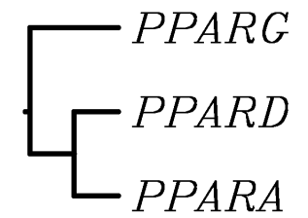

S. Table 10. Correlation between effect of LCFA on MacT and MDBK cells
Pearson correlation analysis for the effect of LCFA (16:0, 18:0, c9-18:1, t10-18:1, t10,c12-18:2, and EPA) on two bovine immortalized cell lines: MDBK (150 μM for 6 h; present experiment) and MacT (150 μM for 12h; ). A - correlation among expression of genes. B – correlation among LCFA. Light blue, yellow, and light red shade denote significance with a P<0.10; P<0.05; and P<0.01 respectively. Red borders denote the correlation between same parameters in the 2 experiments.
A |  |  |  |  | MACT
 |  |  |  |  | ACSL1 |  | CD36 |  | DGAT1 | FABP3 |  | FABP4 |  | LPIN1 | SCD |  | SREBF1 | SREBF2
MDBK |  | ACSL1 |  |  | 0.02 |  | 0.13 |  | 0.70 | 0.89 |  | 0.94 |  | 0.86 | 0.58 |  | 0.54 | 0.67
 |  | CD36 |  |  | 0.27 |  | 0.71 |  | 0.01 | 0.35 |  | 0.28 |  | 0.21 | -0.04 |  | -0.24 | 0.09
 |  | DGAT1 |  |  | -0.33 |  | -0.36 |  | 0.79 | 0.33 |  | 0.54 |  | 0.45 | 0.26 |  | 0.37 | 0.27
 |  | FABP3 |  |  | -0.43 |  | -0.46 |  | 0.38 | 0.76 |  | 0.60 |  | 0.85 | 0.86 |  | 0.88 | 0.87
 |  | FABP4 |  |  | 0.31 |  | 0.55 |  | -0.52 | 0.14 |  | -0.09 |  | -0.02 | -0.06 |  | -0.25 | 0.02
 |  | LPIN1 |  |  | 0.36 |  | 0.43 |  | -0.16 | 0.66 |  | 0.45 |  | 0.51 | 0.47 |  | 0.31 | 0.54
 |  | SCD |  |  | 0.15 |  | 0.21 |  | 0.42 | 0.94 |  | 0.84 |  | 0.84 | 0.77 |  | 0.68 | 0.82
 |  | SREBF1 |  |  | 0.04 |  | 0.04 |  | 0.51 | 0.92 |  | 0.86 |  | 0.86 | 0.81 |  | 0.78 | 0.85
 |  | SREBF2 |  |  | 0.12 |  | -0.02 |  | 0.45 | 0.93 |  | 0.87 |  | 0.87 | 0.79 |  | 0.77 | 0.83
B |  |  |  |  |  | MACT
 |  |  |  | 16:0 |  |  |  | 18:0 |  |  | c9-18:1 |  | EPA |  |  | t10-18:1 |  |  | t10c12CLA_
MDBK | 16:0 |  |  | -0.02 |  |  |  | 0.61 |  |  | 0.33 |  | 0.69 |  |  | 0.71 |  |  | 0.66
MDBK | 18:0 |  |  | -0.09 |  |  |  | 0.55 |  |  | 0.24 |  | 0.64 |  |  | 0.66 |  |  | 0.60
MDBK | c9-18:1 |  |  | 0.19 |  |  |  | 0.89 |  |  | 0.78 |  | 0.94 |  |  | 0.96 |  |  | 0.94
MDBK | EPA |  |  | 0.16 |  |  |  | 0.64 |  |  | 0.55 |  | 0.69 |  |  | 0.69 |  |  | 0.69
MDBK | t10-18:1 |  |  | 0.20 |  |  |  | 0.88 |  |  | 0.61 |  | 0.90 |  |  | 0.91 |  |  | 0.86
MDBK | t10c12CLA |  |  | 0.24 |  |  |  | 0.91 |  |  | 0.76 |  | 0.95 |  |  | 0.96 |  |  | 0.94

S. Figure 1. % relative abundance and Ct of measured genes
(A) Percentage relative abundance between transcripts measured were the values were obtained with the median ∆Ct corrected by the efficiency of amplification; (B) median Ct (cycle at a selected threshold) in qPCR analysis for each measure transcript.

A
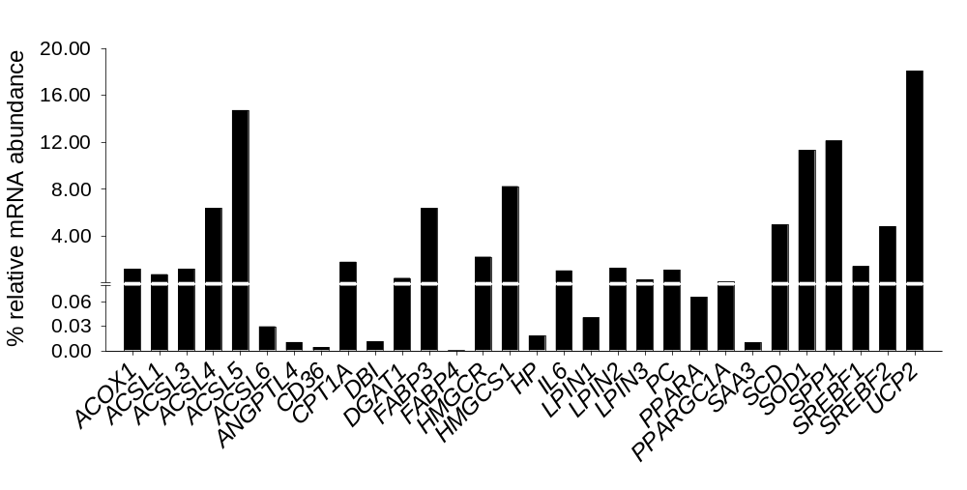
B
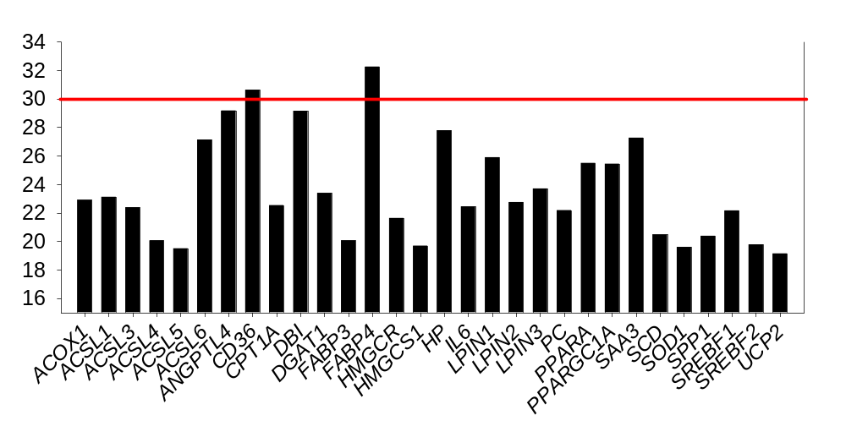

S. Figure 2. PPARα targets among measured genes as uncovered by IPA and previous literature
Networks generated by Ingenuity Pathway Analysis® (IPA) among all genes measured using IPA Knowledge Database (i.e. all known interactions) (last up-to-date November 2009). The genes are denoted by objects and arrows denote effect as described in the embossed legend. Genes have been grouped based on main functions. Edge labels denote Activation (A), effects on gene expression (E), protein-protein interactions (PP), protein-DNA interactions (PD), inhibition (I), RNA binding (RB), effect on translation (T), and effect on localization (LO). Red arrows indicate known direct effect of PPARα on gene expression based on IPA Knowledge Base. See S. Table 3 for explanation of gene symbol, functions, and sub-cellular localization.
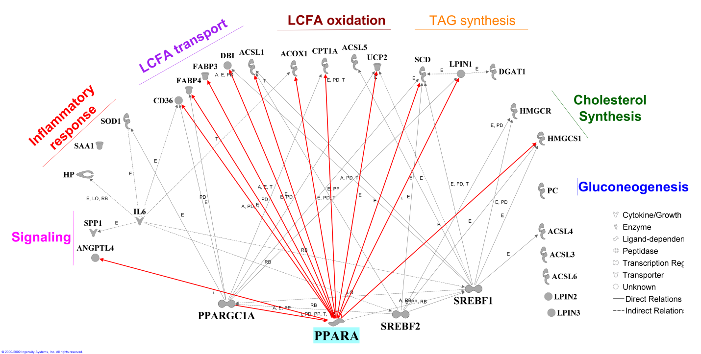

S. Figure 3. Functional PPRE analysis of bovine PPARα target genes
Functional PPRE analysis with reported position and estimated strength of binding for all three PPAR receptors in the 20,000 bp upstream of the transcription start site (TSS) and in the transcribed region (denoted by dotted line) of genes which expression was increased by WY treatment (i.e., PPARα targets in bovine) plus PPARA. The analysis was performed with the Research software . The * for FABP4 denotes the position (-8,305 from TSS) where a reported PPRE blast with the sequence extrapolated from Ensembl (see Additional file 2) using Align2seq in NCBI (supplemental information are reported in Additional file 2).
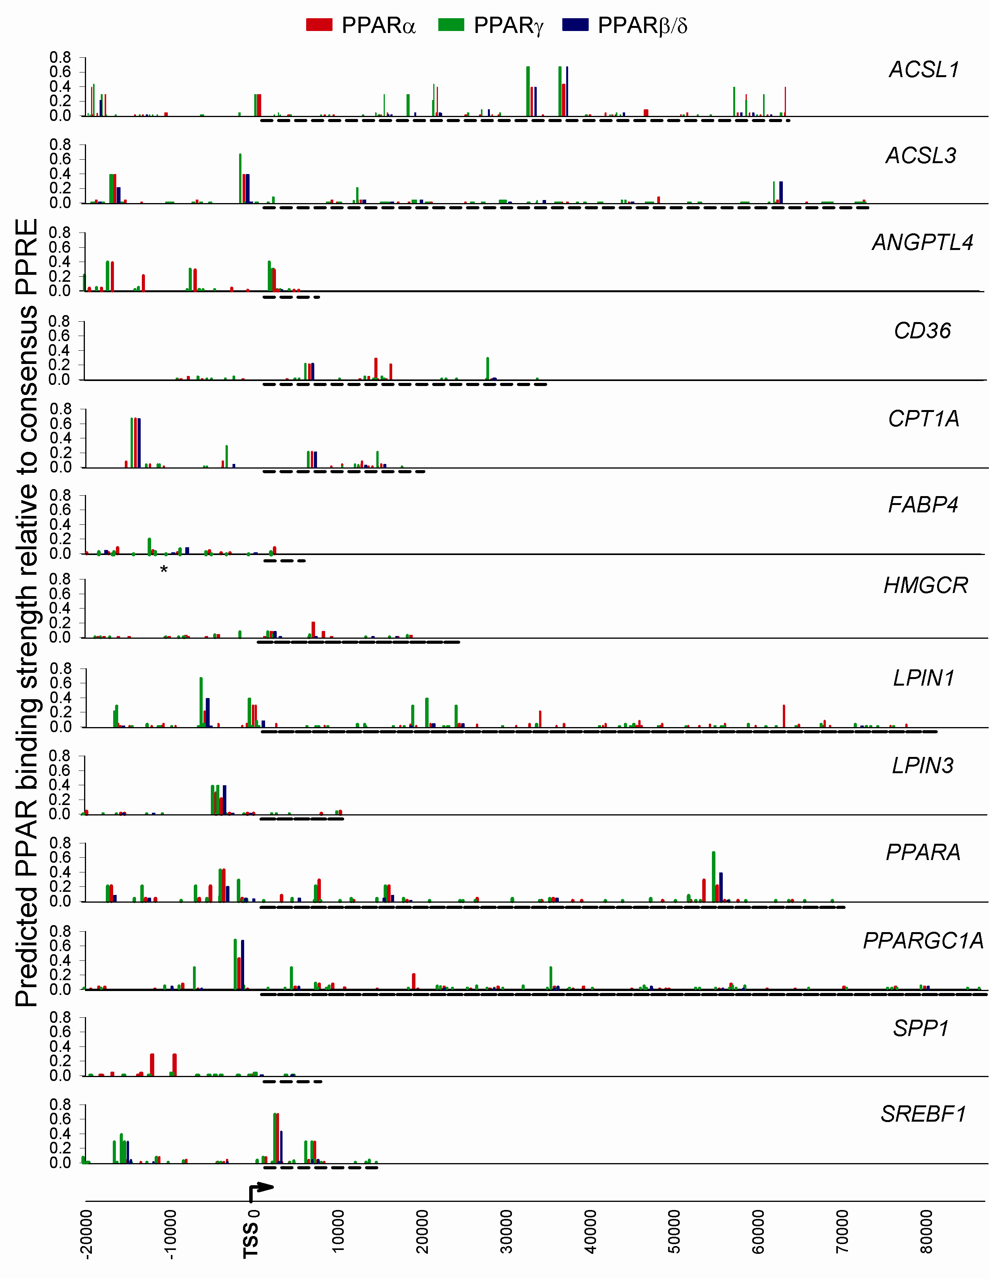

S. Figure 4. Functional PPRE analysis of non-bovine PPARα target genes
Functional PPAR response elements analysis with reported position and estimated strength of binding for all three PPAR receptors in the 20,000 bp up-stream of the transcription start site (TSS) and in the transcribed region (denoted by dotted line) of genes considered in the present experiment. The analysis was performed with the Research software .
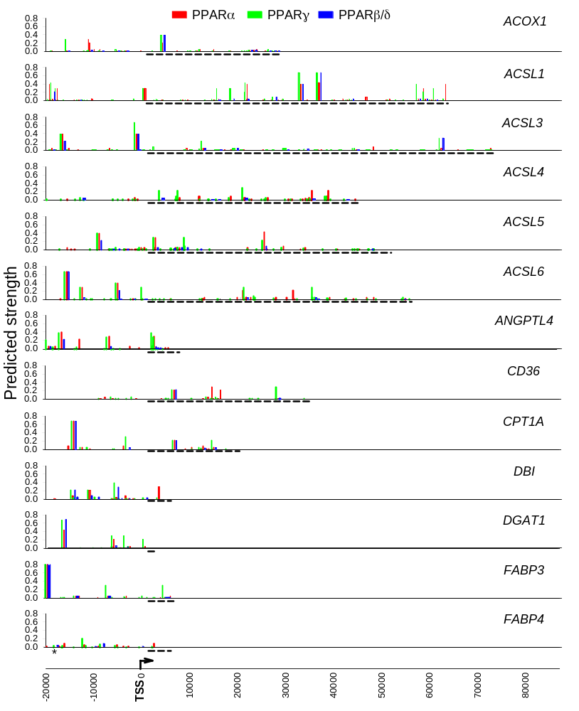
S. Figure 4. (cont.)
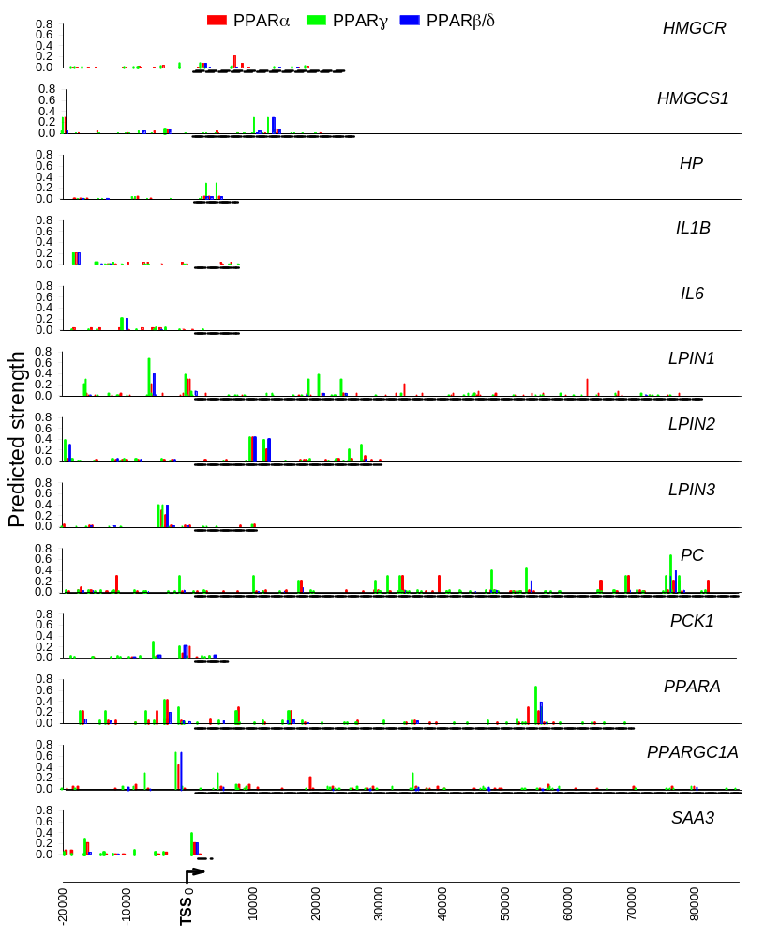
S. Figure 4. (cont)
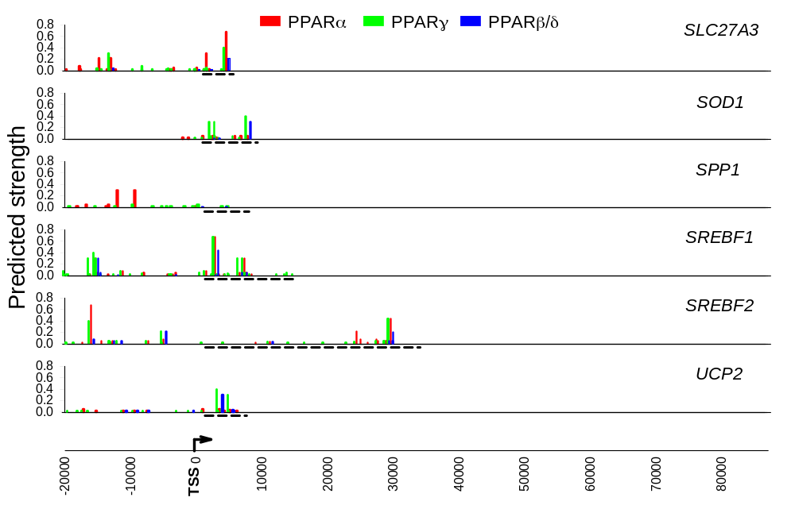

S. Figure 5. 3D structure of bovine LBD PPARα
(residue 202-470; UniProtKB/TrEMBL Q5EA13) analyzed with Swiss-Pdb Viewer (http://spdbv.vital-it.ch/) . Showed are: A. right view; B. bottom view; C. top view; D. left view. Label and side-chain colors denote: grey = ligand entry site; red = ligand-binding; green = putative dimerization PPAR-RXR interface; yellow = steroid receptor coactivator 1 interaction (see ) and S. Table 7 and 8 above).
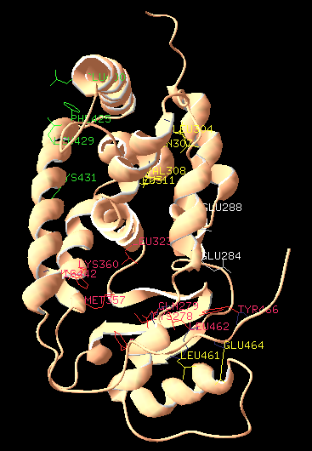
A
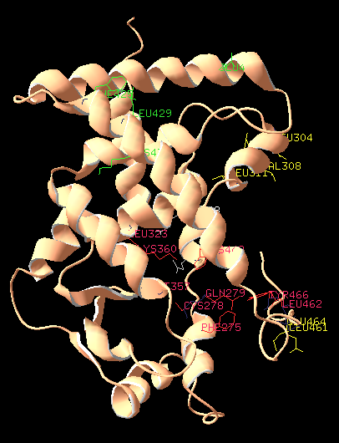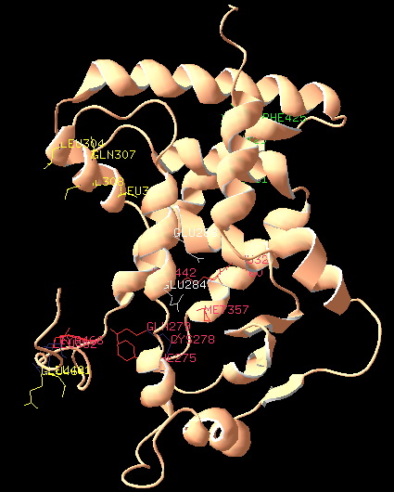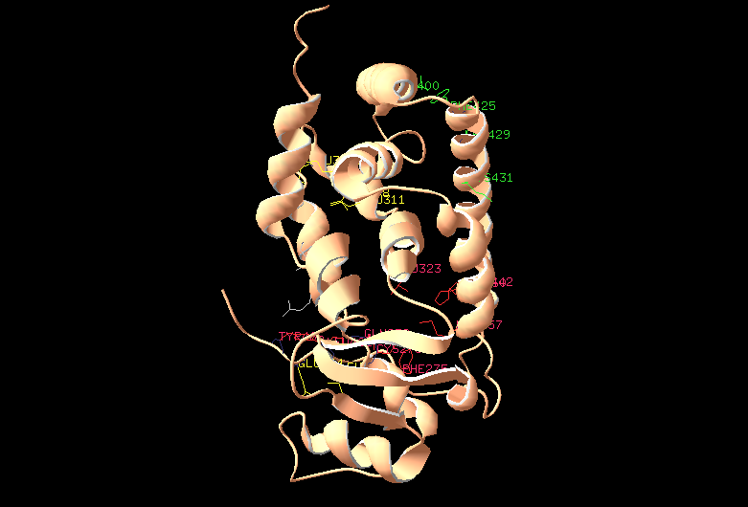
B
C
D

S. Figure 6. 3D linear structure of bovine and mouse PPARα LBD
Bovine (residue 202-470; UniProtKB/TrEMBL Q5EA13) and mouse (residue 202-468; UniProtKB/TrEMBL P23204) PPARα LBD were analyzed with Swiss-Pdb Viewer (http://spdbv.vital-it.ch/). Label and side-chain colors denote: grey/white = ligand entry site; red/purple = ligand-binding; green/light green = putative dimerization PPAR-RXR interface; yellow/dark yellow = steroid receptor coactivator 1 interaction (see ) and S. Table 7 and 8 above).

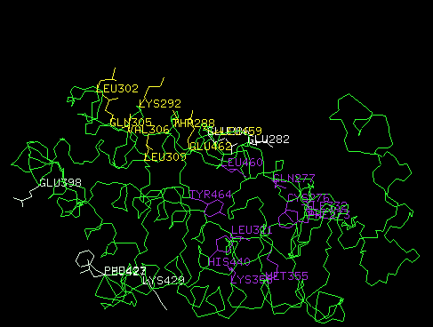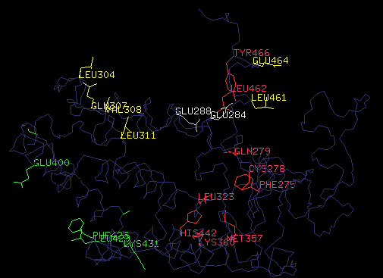
Mouse PPARα
Cow PPARα

S. Figure 7. Superimposed 3D structure of bovine and mouse PPARα LBD
Bovine (pink ribbon; residue 202-470; UniProtKB/TrEMBL Q5EA13) and mouse (green ribbon; residue 202-468; UniProtKB/TrEMBL P23204) PPARα LBD analyzed with Swiss-Pdb Viewer (http://spdbv.vital-it.ch/). Label and side-chain colors denote (cow/mouse): grey/white = ligand entry site; red/purple = ligand-binding; green/light green = putative dimerization PPAR-RXR interface; yellow/dark yellow = steroid receptor coactivator 1 interaction (see ) and S. Table 7 and 8 above).

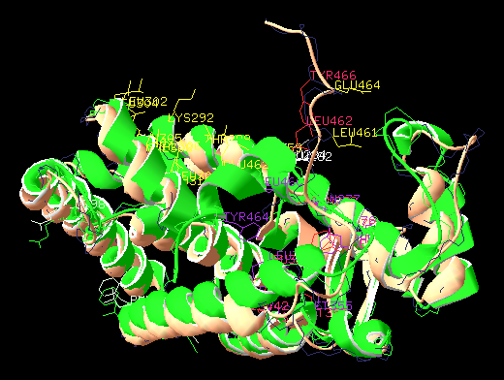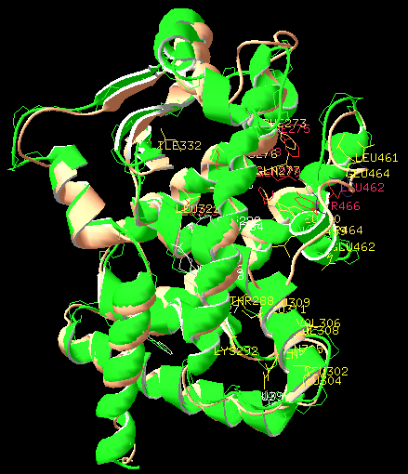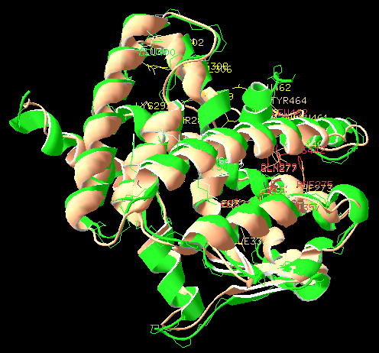
Ligand pocket view
Bottom view
Lef view

S. Figure 8. Superimposed 3D linear structure of bovine and mouse PPARα LBD
Bovine (blue line; residue 202-470; UniProtKB/TrEMBL Q5EA13) and mouse (green line; residue 202-468; UniProtKB/TrEMBL P23204) PPARα LBD analyzed with Swiss-Pdb Viewer (http://spdbv.vital-it.ch/). Label and side-chain colors denote (cow/mouse): grey/white = ligand entry site; red/purple = ligand-binding; green/light green = putative dimerization PPAR-RXR interface; yellow/dark yellow = steroid receptor coactivator 1 interaction (see ) and S. Table 7 and 8 above).
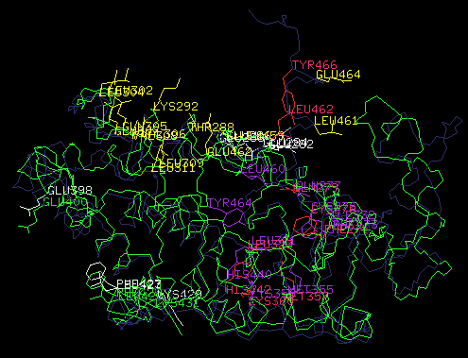

S. Figure 9. 3D surface structure of bovine and mouse PPARα LBD
Bovine (residue 202-470; UniProtKB/TrEMBL Q5EA13) and mouse (residue 202-468; UniProtKB/TrEMBL P23204) PPARα LBD were analyzed with Swiss-Pdb Viewer (http://spdbv.vital-it.ch/). Colors denote red = negative charge; white = neutral charge; blue = positive charge. The upper and lower panel include two positions is fully aligned between species.
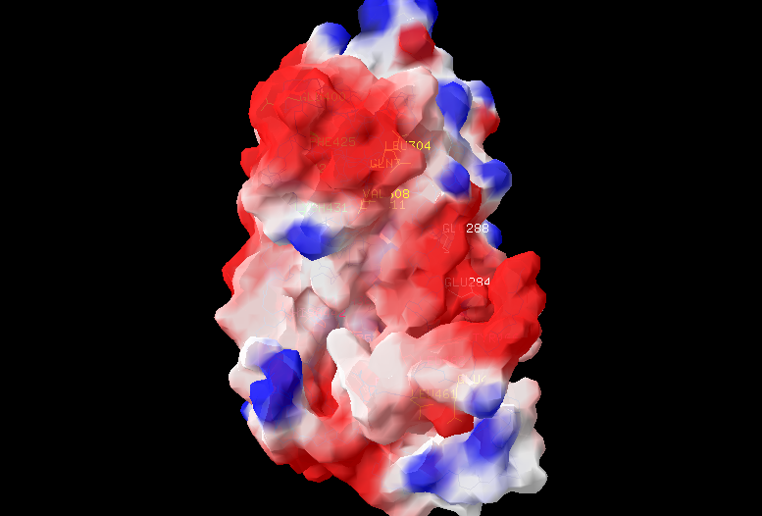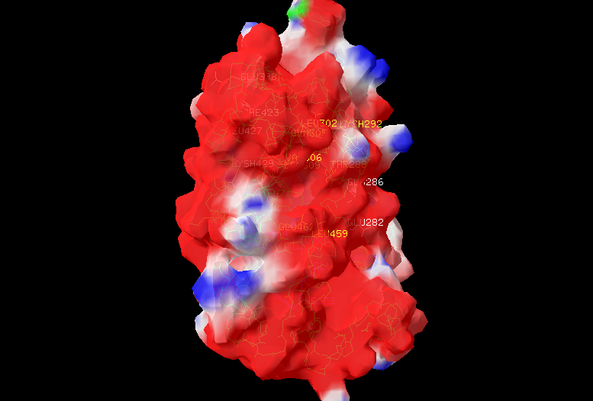
Bos taurus
Mus musculus
Ligand pocket
Ligand pocket
Ligand pocket
Ligand pocket
Ligand
entry site
Ligand
entry site
SRC1-binding site
SRC1-binding site
SRC1-binding site
SRC1-binding site
PPARA-RXR
interface
PPARA-RXR
interface
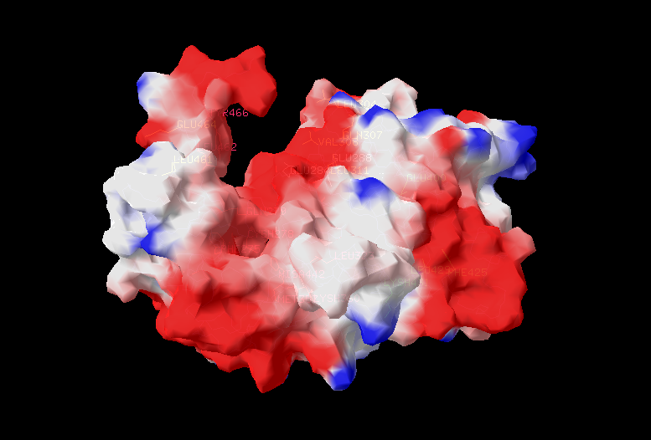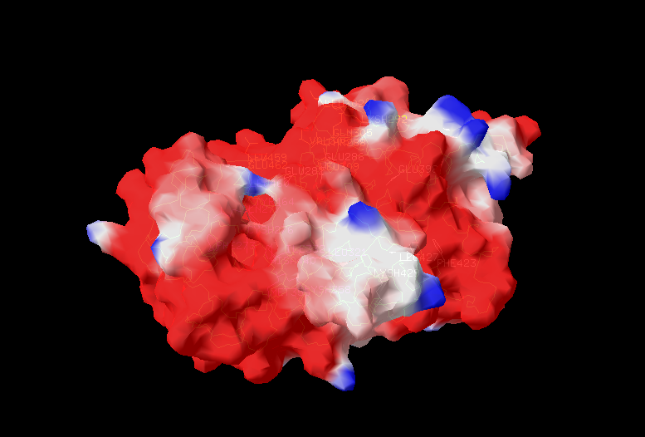
Bos taurus
Mus musculus
Ligand
entry site
Ligand
entry site

S. Figure 10. Effect of 20:0 on gene networks.
Networks generated by Ingenuity Pathway Analysis® (IPA) among all genes measured using IPA Knowledge Database (last up-to-date November 2009) and results from present experiment. The genes are denoted by objects and arrows denote effect [activation (A), effects on gene expression (E), protein-protein interactions (PP), protein-DNA interactions (PD), inhibition (I), RNA binding (RB), effect on translation (T), and effect on localization (LO)]. Genes have been grouped based on main functions. The red arrows highlight the genes which transcription was activated by 20:0 probably through PPARα. In green arrows are highlighted the PPARα target genes uncovered by using the IKB and/or by our data which expression was down-regulated by 20:0, suggesting a possible dual role for this LCFA, i.e., activate/deactivate PPARα. More likely, one or more putative transcription factor(s) are responding (induced or inhibited) to 20:0 and down-regulate several PPARα target genes (dark green arrows). The analysis of the gene network suggests that this LCFA increased fatty acid oxidation and production of signaling molecules, but decreased TAG synthesis. In addition, the network analysis suggested that 20:0 acts partly through activation of PPARα but likely activates/inhibits putative transcription regulator(s) which in turn decreases expression of several of the measured genes.
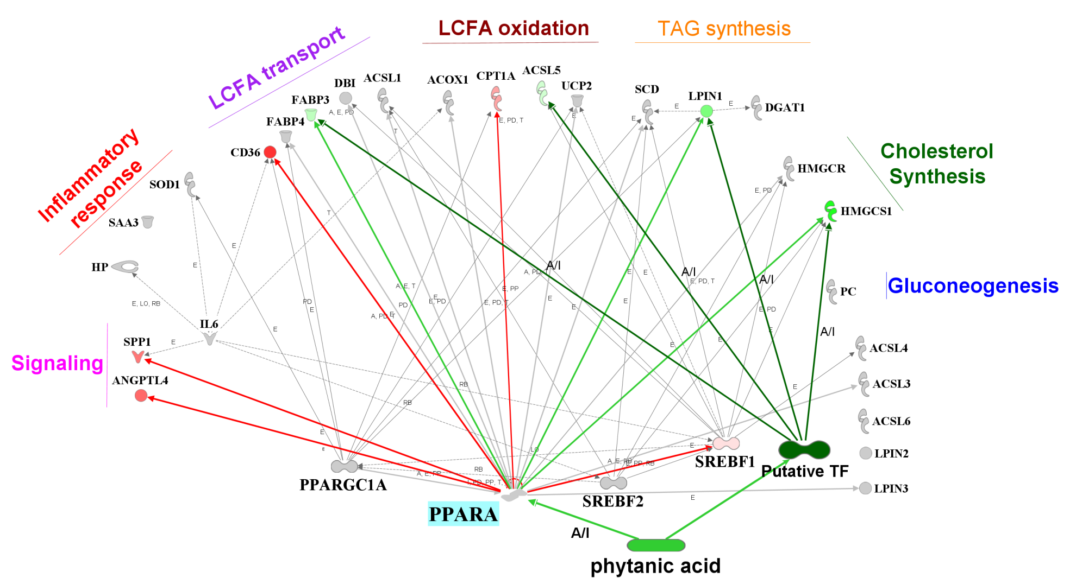

S. Figure 11. Effect of c9,t11CLA on gene networks
Networks generated by Ingenuity Pathway Analysis® (IPA) among all genes measured using IPA Knowledge Database (last up-to-date November 2009) and results from present experiment. The genes are denoted by objects and arrows denote effect [activation (A), effects on gene expression (E), protein-protein interactions (PP), protein-DNA interactions (PD), inhibition (I), RNA binding (RB), effect on translation (T), and effect on localization (LO)]. Genes have been grouped based on main functions. The red arrows highlight the 7 genes which transcription was activated by c9,t11CLA probably through PPARα. The dark yellow arrows and object highlight the effect on putative transcription factor(s) which is (are) responding (induced or inhibited) to c9,t11CLA which in turn up-regulates SAA3 and IL6. the network analysis it appeared that the effect of c9,t11CLA encompassed LCFA oxidation, TAG synthesis, signaling, and immune response and most of the effects were probably elicited through activation of PPARα. However, the induction of expression of IL6 and SAA3 suggested this LCFA could have acted through other putative transcription regulators
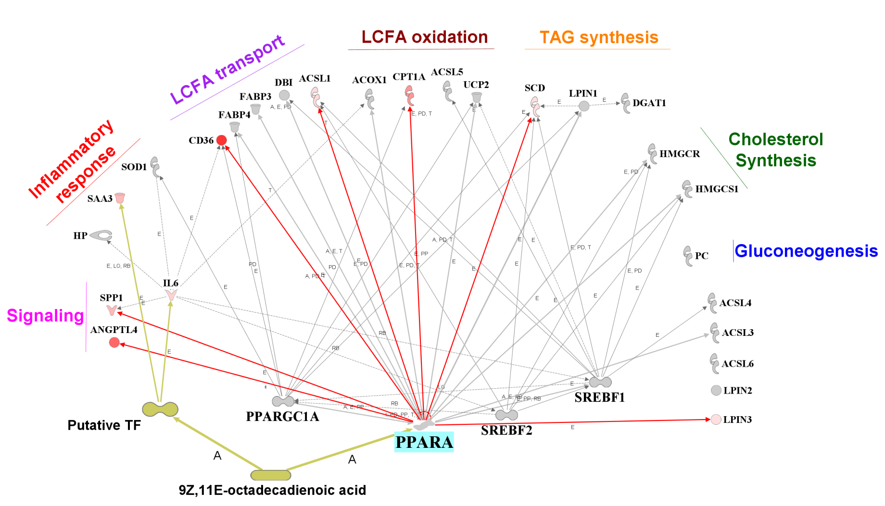

S. Figure 12. Effect of t10,c12CLA on gene networks
Networks generated by Ingenuity Pathway Analysis® (IPA) among all genes measured using IPA Knowledge Database (last up-to-date November 2009) and results from present experiment. The genes are denoted by objects and arrows denote effect [activation (A), effects on gene expression (E), protein-protein interactions (PP), protein-DNA interactions (PD), inhibition (I), RNA binding (RB), effect on translation (T), and effect on localization (LO)]. Genes have been grouped based on main functions. The red (up-regulated) and green (down-regulated) objects highlight the 7 genes which transcription was affected by t10,c12CLA. Partly of the effect appear to be through activation of PPARα (red arrow). The green arrows denote a potential negative effect of this LCFA on PPARα activation, but more likely another (or other) putative transcription factor(s) (TF) is/are able to bind the LCFA and decrease the transcription of the lipogenic genes (black arrows and object) or activating the post-transcriptional regulation (e.g., through increase expression of a specific miRNA). Gene networks analysis suggests that MDBK treated with t10,c12CLA increased production of signaling molecules and LCFA import into the cell (⇑CD36); however, most of the internalized LCFA were oxidized in the mitochondria (⇑CPT1A) and not necessarily used for TAG and/or cholesterol synthesis (⇓SREBF1, ⇓LPIN1, and ⇓HMGCR).
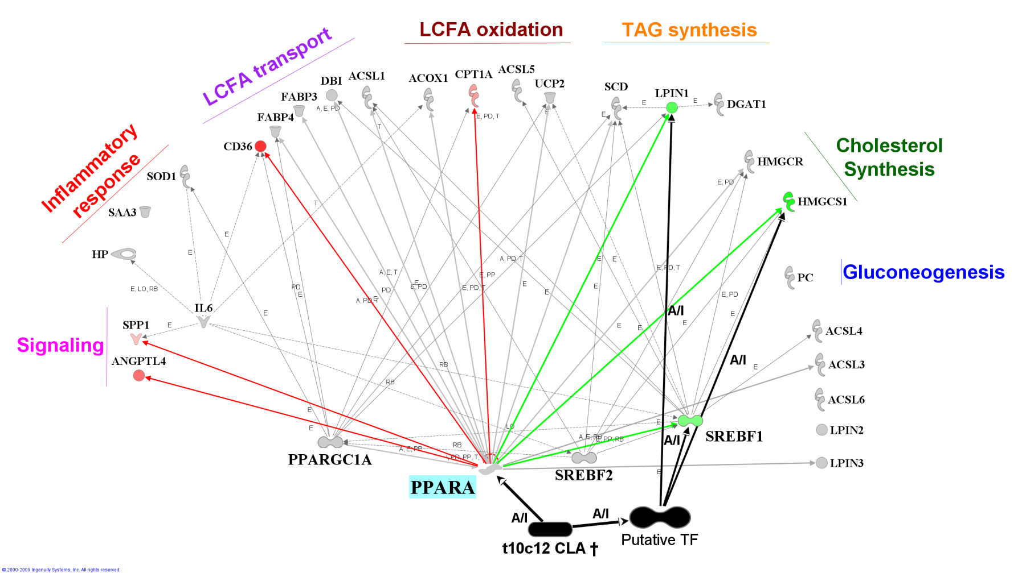

S. Figure 13. Effect of 18:2 on gene networks
Networks generated by Ingenuity Pathway Analysis® (IPA) among all genes measured using IPA Knowledge Database and results from present experiment. The genes are denoted by objects and arrows denote effect [activation (A), effects on gene expression (E), protein-protein interactions (PP), protein-DNA interactions (PD), inhibition (I), RNA binding (RB), effect on translation (T), and effect on localization (LO)]. Genes have been grouped based on main functions. The red (up-regulated) and green (down-regulated) objects denote the 8 genes which transcription was affected by 18:2. The 18:2 appears to increase expression of 5 genes through activation of PPARα (red arrow). Orange arrows and object highlight the effect of a putative transcription factor(s) which is (are) responding (induced or inhibited) to 18:2 which in turn down-regulate expression of lipogenic genes. Another possibility is that the LCFA activate transcription of a miRNA which in turn decrease the mRNA available for translation. The gene network analysis of the effect of 18:2 indicates a very similar biological effect as t10,c12CLA, with a likely higher increase in LCFA entry (⇑ACSL1).
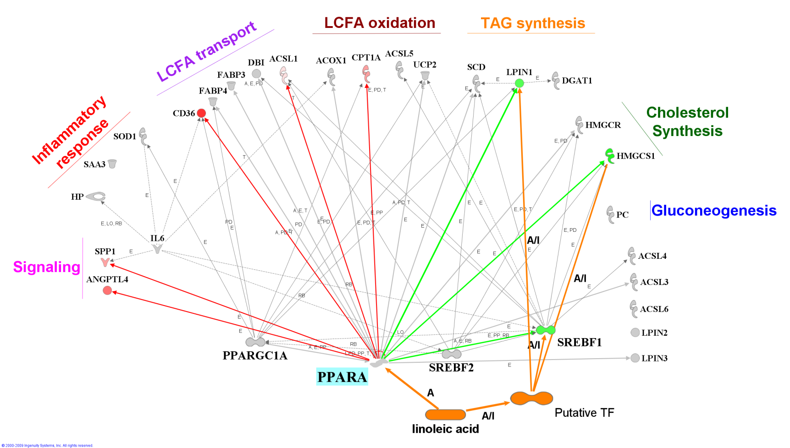

S. Figure 14. Effect of DHA on gene networks
Networks generated by Ingenuity Pathway Analysis® (IPA) among all genes measured using IPA Knowledge Databas and results from present experiment. The genes are denoted by objects and arrows denote effect [activation (A), effects on gene expression (E), protein-protein interactions (PP), protein-DNA interactions (PD), inhibition (I), RNA binding (RB), effect on translation (T), and effect on localization (LO)]. Genes have been grouped based on main functions. The red (up-regulated) and green (down-regulated) objects highlight the 7 genes which transcription was affected by DHA partly through positive activation of PPARα (red arrow). The down-regulation of SREBF1 indicates that the effect on another putative transcription factor probably override the activation of PPARα and resulted in a decrease of SREBF1 transcription (green arrow). Another plausible hypothesis is the increase in expression of a miRNA which decrease post-transcriptional mRNA. The gene network analysis suggests an overall increase of lipid metabolism without effect on immune-related functions. Most of the effects appeared to have been elicited through activation of PPARα, except for SREBF1, which suggested activation or inhibition by the LCFA of an unidentified transcription regulator(s) which in turn down-regulated expression of SREBF1. We can infer from the ⇓SREBF1 that exogenous DHA probably decreased de novo formation of LCFA.
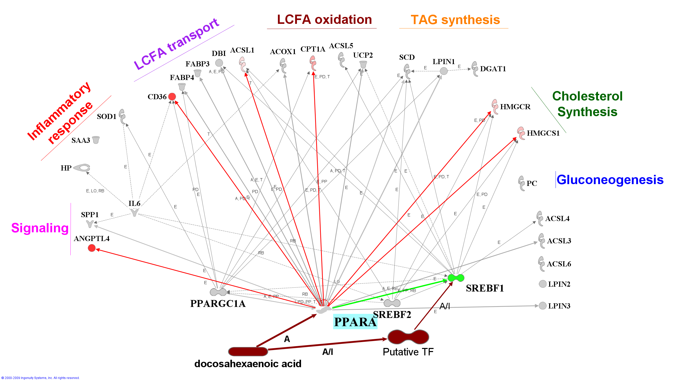

S. Figure 15. Effect of 18:3 on gene networks
Networks generated by Ingenuity Pathway Analysis® (IPA) among all genes measured using IPA Knowledge Database (IKB; i.e. all known interactions) (last up-to-date November 2009) and results from present experiment. The genes are denoted by objects and arrows denote effect [activation (A), effects on gene expression (E), protein-protein interactions (PP), protein-DNA interactions (PD), inhibition (I), RNA binding (RB), effect on translation (T), and effect on localization (LO)]. Genes have been grouped based on main functions. The red (up-regulated) and green (down-regulated) objects denote the 6 genes which transcription was affected by 18:3. Part of the effect of the LCFA was through PPARα (red arrow), but, very likely, the 18:3 binds and activates another (or other) transcription factor(s) (TF) which in turn decrease expression of ACSL3, ACSL5, and LPIN1 (light blue arrows and object). Another possibility is that the LCFA activate expression of a specific miRNA which in turn decrease available mRNA for translation. Overall view of the effect on the networks among genes measured indicates a likely activation of PPARα by this LCFA but also activation or inhibition of other transcription regulator(s) which in turn down-regulated expression of ACSL3, ACSL5, and LPIN1, with a likely overall decrease in TAG synthesis.
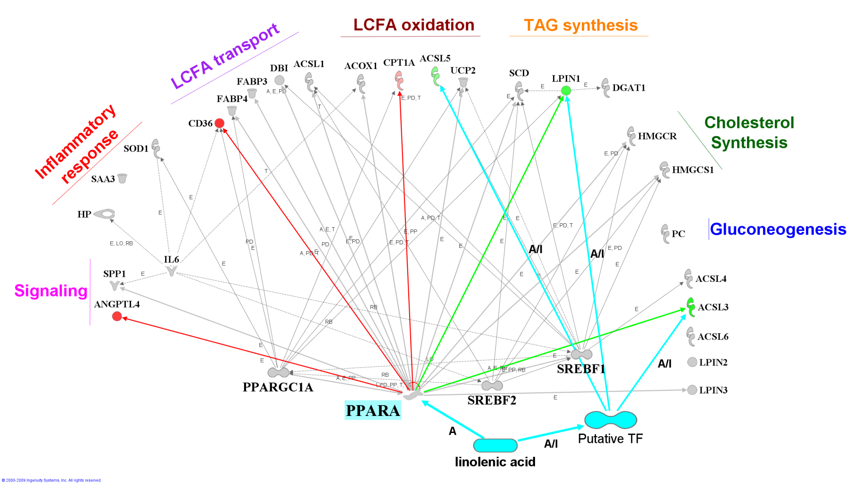

S. Figure 16. Effect of c9-18:1 on gene networks
Networks generated by Ingenuity Pathway Analysis® (IPA) among all genes measured using IPA Knowledge Database (IKB; i.e. all known interactions) (last up-to-date November 2009) and results from present experiment. The genes are denoted by objects and arrows denote effect [activation (A), effects on gene expression (E), protein-protein interactions (PP), protein-DNA interactions (PD), inhibition (I), RNA binding (RB), effect on translation (T), and effect on localization (LO)]. Genes have been grouped based on main functions. The red (up-regulated) and green (down-regulated) denote the 6 genes which transcription was affected by c9-18:1. Most of the effect on expression of genes by the LCFA was through PPARα (red arrow), but, very likely, the c9-18:1 binds and activates another transcription factor (TF) which in turn decrease expression of FABP3. The gene networks analysis suggests that treatment with c9-18:1 increased oxidation of LCFA and signaling through ANGPTL4 and SPP1.
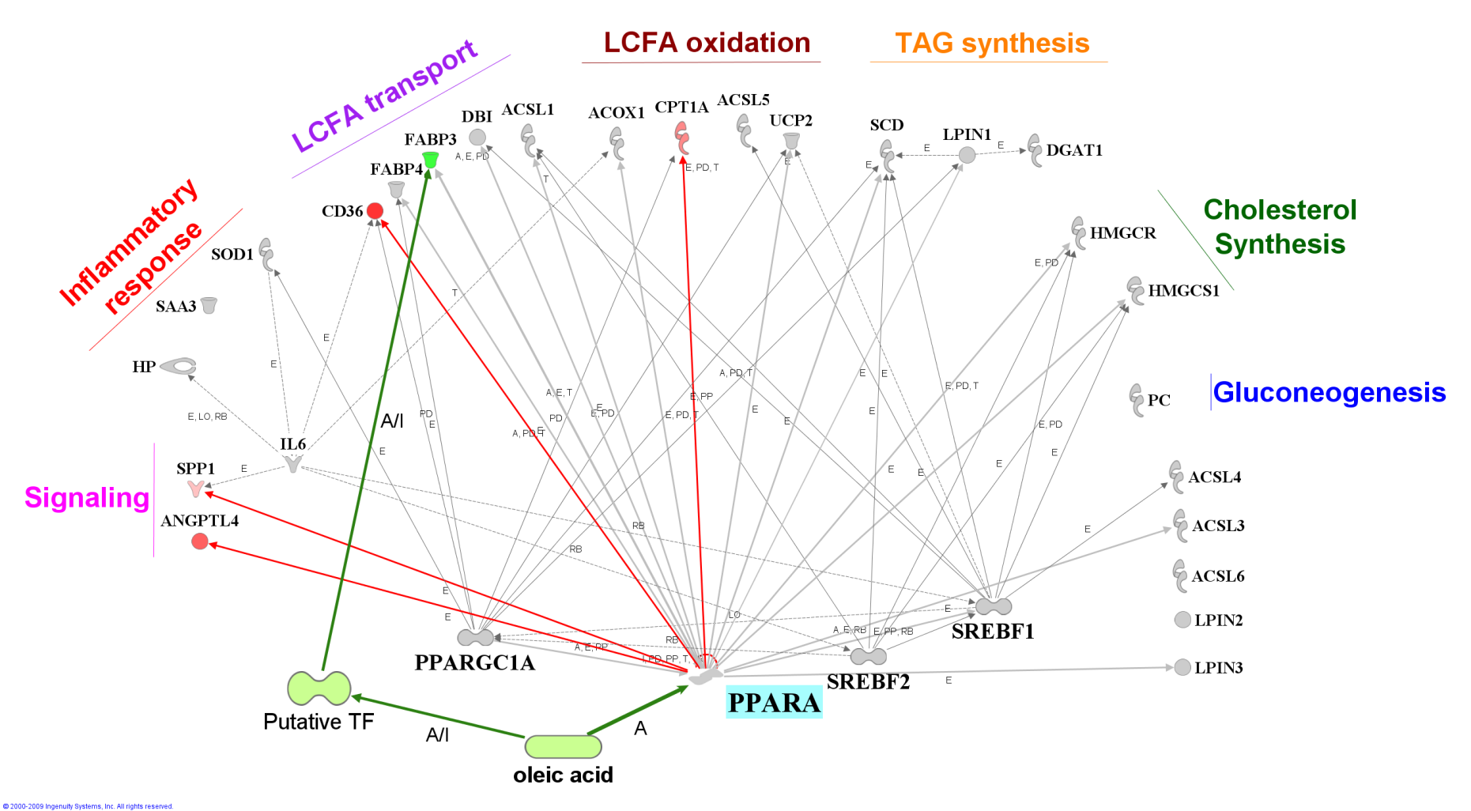

S. Figure 17. Effect of t10-18:1 on gene networks
Networks generated by Ingenuity Pathway Analysis® (IPA) among all genes measured using IPA Knowledge Database and results from present experiment. The genes are denoted by objects and arrows denote effect [activation (A), effects on gene expression (E), protein-protein interactions (PP), protein-DNA interactions (PD), inhibition (I), RNA binding (RB), effect on translation (T), and effect on localization (LO)]. Genes have been grouped based on main functions. The red objects and arrows denote the 4 genes which transcription was up-regulated by t10-18:1 probably through PPARα. The gene networks analysis suggests that treatment with t10-18:1 increased oxidation of LCFA and signaling through ANGPTL4.
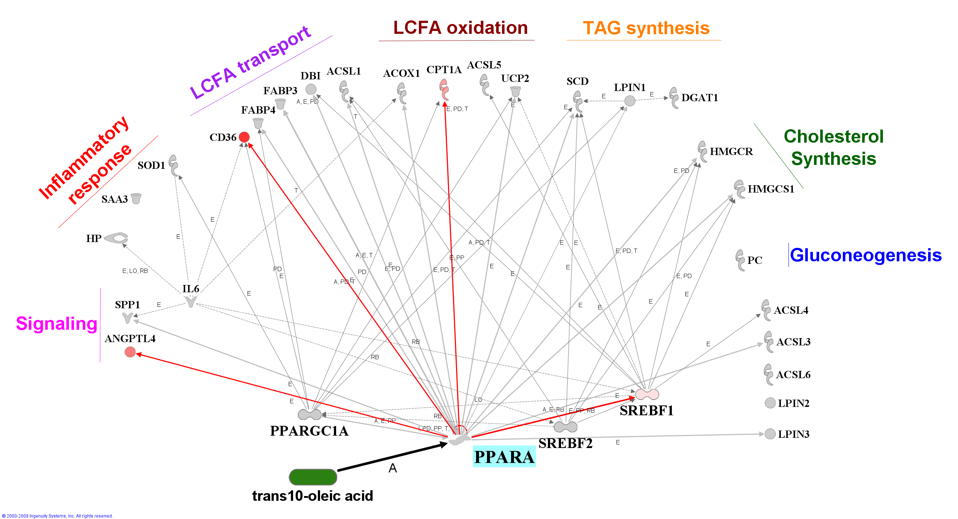

S. Figure 18. Effect of t11-18:1 on gene networks
Networks generated by Ingenuity Pathway Analysis® (IPA) among all genes measured using IPA Knowledge Database and results from present experiment. The genes are denoted by objects and arrows denote effect [activation (A), effects on gene expression (E), protein-protein interactions (PP), protein-DNA interactions (PD), inhibition (I), RNA binding (RB), effect on translation (T), and effect on localization (LO)]. Genes have been grouped based on main functions. The red objects and arrows denote the 5 genes which transcription was up-regulated by t11-18:1 probably through PPARα. The gene networks analysis suggests that treatment with t11-18:1 increased oxidation of LCFA, desaturation (⇑SCD), and signaling through ANGPTL4.
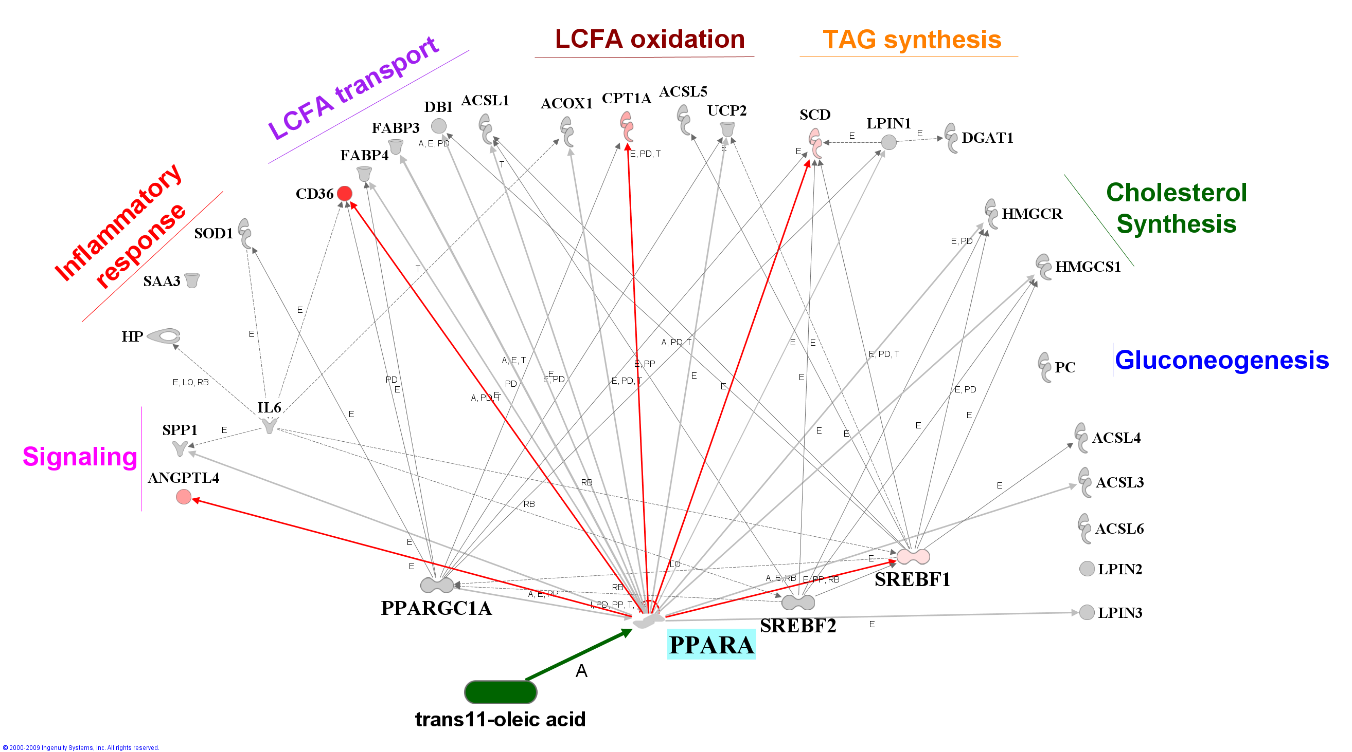

S. Figure 19. Hierarchical clustering of gene expression data without statistical analysis
Hierarchical clustering of gene expression data without considering statistical analysis for each treatment relative to the control (CTR) using Genesis software . Dendrogram allow visualization of clusters of similarity in expression pattern between treatments (links denoted by the lines at the top of the figure) and between genes (links denoted by the lines at the left side of the picture). Log2 fold-change in expression relative to CTR are denoted by shades of red (increase), yellow (no change), and green (decrease) according to the intensity bar at the top of the figure. White dots denote the largest responses (up or down) in mRNA expression relative to CTR for each gene.
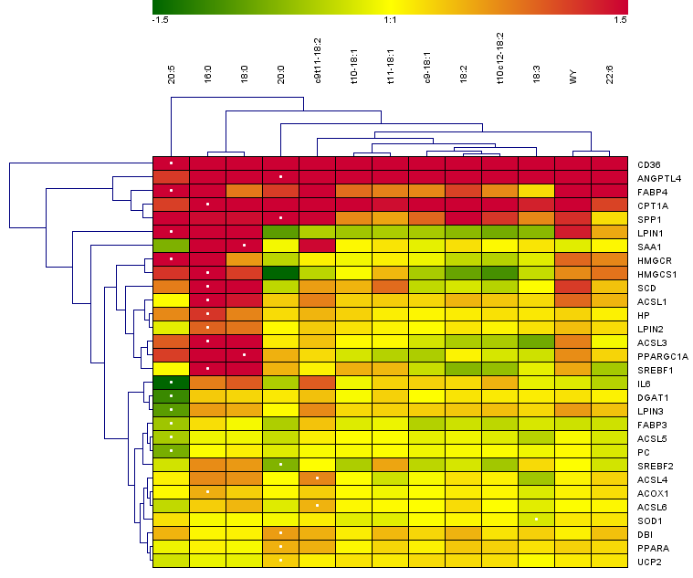

S. Figure 20. 3D surface structure of bovine PPARα, PPARγ, and PPARβ/δ
PPARα (res. 202-470; Q5EA13), PPARγ (res. 234-505; O18971) and PPARβ/δ (res. 171-441; A4IFL4) LBD were analyzed with Swiss-Pdb Viewer (http://spdbv.vital-it.ch/). A. Direct fit between the 3 bovine PPARs, with PPARα in red (labeled residues showed pertain to this PPAR subtype), PPARγ in green, and PPARβ/δ in blue; B-G. Comparison of the front ligand pocket in two diverse positions between the 3 PPARs. Red = negative charge; white = neutral charge; blue = positive charge. Arrow = ligand pocket
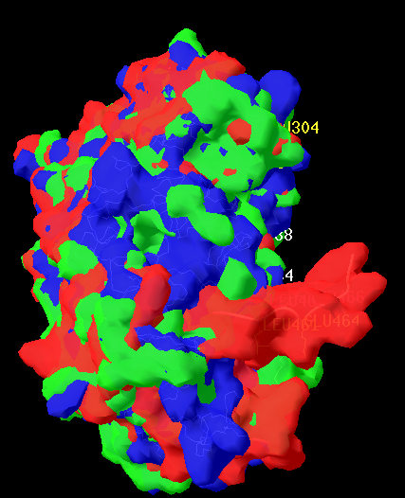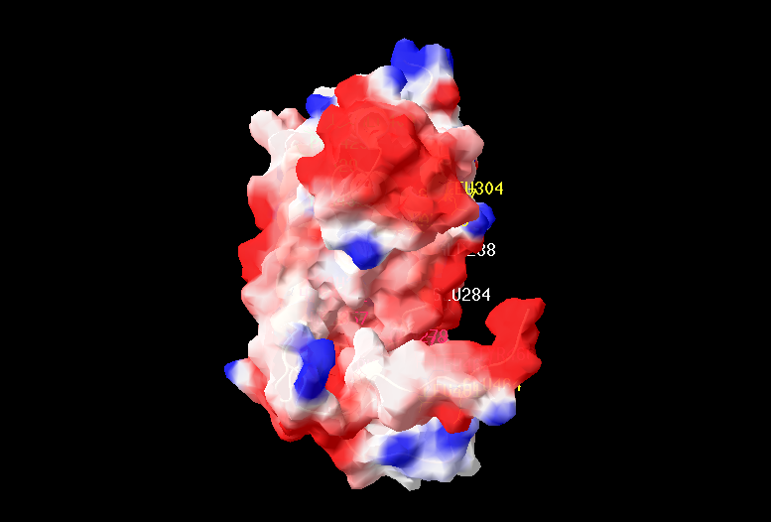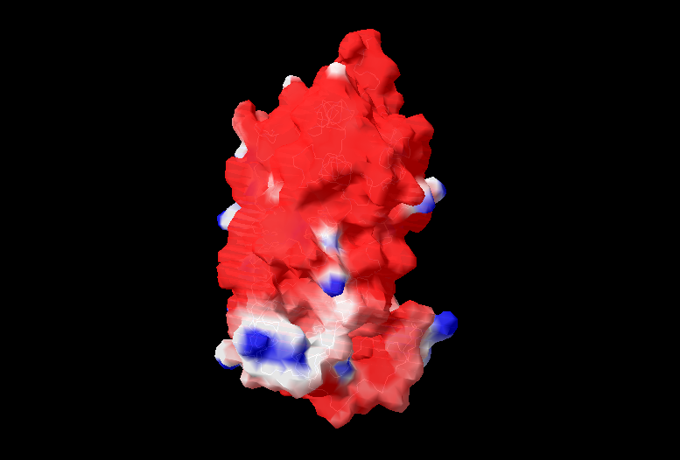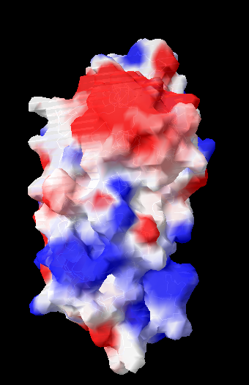
PPARα
PPARγ
PPARβ/δ
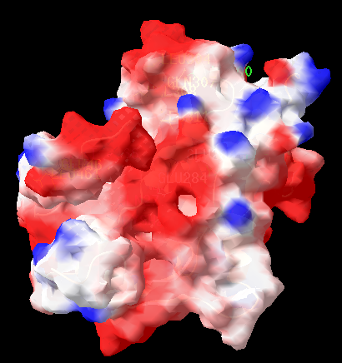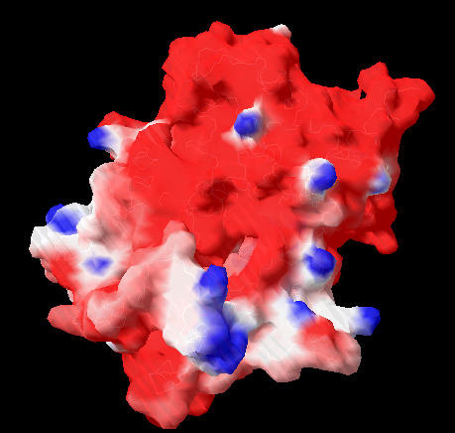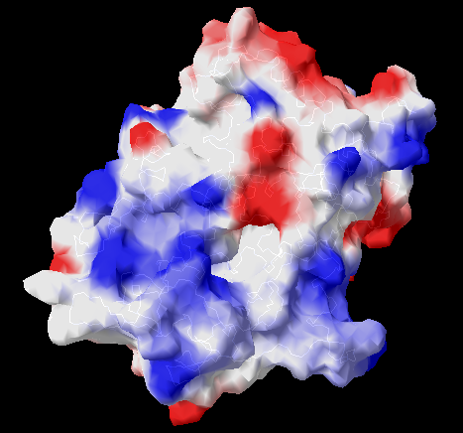
PPARα
PPARγ
PPARβ/δ

S. Figure 21. Temporal effect of 16:0 on expression of SPP1
Temporal expression of SPP1 in MDBK cultured for 24h with 150 μM palmitate in ethanol without albumin and with 2.5 mg/L of bovine insulin as reported in experiment to in .

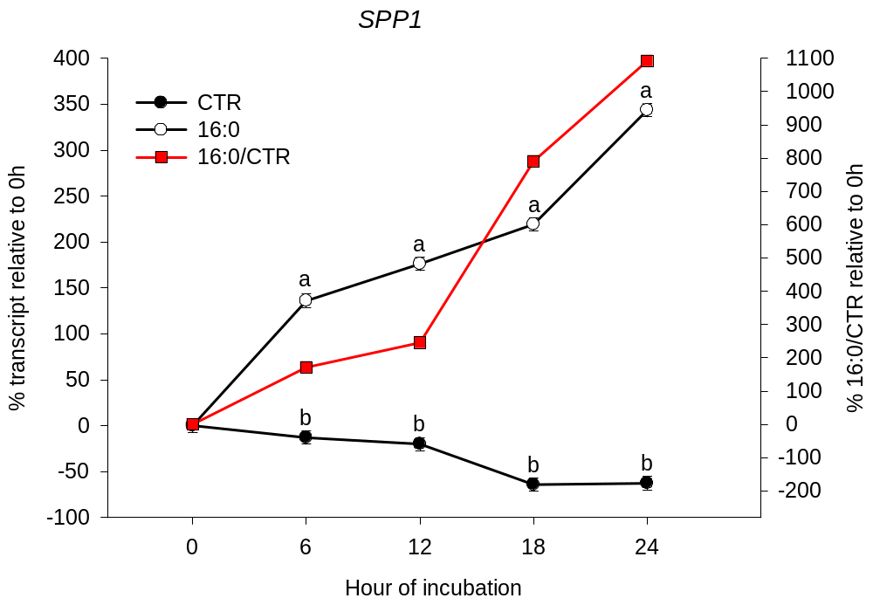
REFERENCES

