Supplementary material for Regional variations in the demographic response to the arrival of rice farming in prehistoric Japan
Enrico R. Crema^{1,2,*} [ORCID 0000-0001-6727-5138], Simon Carrignon² [ORCID 0000-0002-4416-1389], Shinya Shoda^{3,4} [ORCID 0000-0001-9525-3710] & Chris J. Stevens² [ORCID 0000-0002-2669-5715]

¹ Department of Archaeology, University of Cambridge, UK
² McDonald Institute for Archaeological Research, University of Cambridge, UK
³ Nara National Research Institute for Cultural Properties, Nara, Japan
⁴ BioArCh, University of York, UK
* Author for correspondence ✉ erc62@cam.ac.uk
Received: 21 July 2023; Revised: 29 November 2023; Accepted: 8 February 2024

1. Data

1.1 Radiocarbon Data
We extracted and filtered entries from the translated version of the radiocarbon database published by the National Museum of Japanese History (Kudo et al. 2018, Kudo et al. 2023). The original database contains over 44,000 ¹⁴C dates collated from archaeological site reports in Japan, and the recently published translated version includes a subset of ca 39,000 entries that have undergone a screening process that removed duplicates, possible errors, and inconsistencies.
For the purpose of this paper, we considered only samples from sites in the islands of Honshu, Kyushu and Shikoku with known geographic coordinates. The radiocarbon database provides site names, but these do not necessarily constitute a meaningful spatial unit, given site names from the same location can vary across site reports, and a unique site identifier is currently not available. We have thus arbitrarily assigned a unique site ID by clustering sites in close spatial proximity using the DBSCAN clustering algorithm (Ester et al. 1996; as implemented in the R-package 'dbscan', Hashler et al. 2019), using a distance threshold of 100 meters.
In order to consider only samples collected from known anthropogenic contexts, we joined the translated dataset to the full original database and we carried out a text pattern search on the field “サンプル採取地点等” (trans: “sampling location”). We redacted a list of 48 terms that included entries such as “住居” (trans: “house”), “炉” (trans: “hearth”), “墓” (trans: “burial”), and “水田” (trans: “paddy field”), and removed all ¹⁴C dates that did not have these keywords in the “サンプル採取地点等” field.
The final filtering process was based on the temporal window of analyses. For the summed probability distribution used in the main text Figure 2, we considered dates with a cumulative calibrated probability above 0.5 between 2950 BP and 1650 BP(n=3,716), approximately corresponding to the conventional time span for the Yayoi period. For the Bayesian estimates of growth rates (see section 3 below), we considered different temporal filters for each region, with a total of 1,892 dates for the short interval (500 years before/after the arrival of rice agriculture) and 3,132 dates for the longer interval (750 years before/after the arrival of rice agriculture).

1.2 Settlement Data
The 縄文・弥生集落データベース (trans: Jomon-Yayoi settlement database) published by the National Museum of Japanese History (2012) contains over 25,000 entries of settlement data from Jomon and Yayoi periods. The database contains for each entry an absolute time-span (start and end dates) based on the conversion of the archaeological period assigned by the excavator. It is worth noting that the time-span is a mixture of the occupational length and the uncertainty in the attribution of each site into a particular phase. Thus, a longer time-span can be either or both indicative of longer occupation and higher levels of chronological uncertainty. Sites with multiple occupational phases were entered separately, effectively capturing, to some extent, sites with known long occupational time span.
The database was downloaded and systematically cleaned by removing entries with inconsistencies and missing data . The final dataset includes 22,736 entries.

2. Settlement analyses
We visualised changes in the number of Yayoi settlements by using a composite Kernel Density Estimate (cKDE), loosely adapting similar algorithms used for depicting changes in the density of radiocarbon dates (Brown 2017; McLaughlin 2018). We randomly sampled a calendar date within the time-span of each site phase, assuming a uniform distribution and computed a kernel density estimate using a bandwidth of 50 years. This process was iteratively repeated 1,000 times and the resulting KDE combined together to define, for each calendar year, a 95% quantile interval.

3. Growth rate estimates from time-frequency of radiocarbon dates

3.1 Bayesian Intrinsic Conditional Autoregressive (ICAR) model
We used the time-frequency of radiocarbon dates as a proxy of demographic changes following the general principles of the so-called “dates as data” approach (Rick 1987). More specifically, we inferred annual growth rates before and after the estimated arrival of rice agriculture in each of the eight analytical regions defined by Crema et al. (2022).
Estimates of growth rates are often been based on direct regression analyses on the summed probability distribution of calibrated radiocarbon dates (SPD). Several recent studies (Carleton & Groucutt 2021; Crema 2022a) have demonstrated how such an approach does not account for sampling and measurement errors, nor the artificial peaks and troughs in SPDs caused by the calibration process. There are currently several statistical solutions (Carleton 2021; Crema & Shoda 2021; Timpson et al. 2021; Crema 2022a) that overcome these issues and can provide an unbiased estimate of the rate of changes in the density of radiocarbon dates. Here we employ and expand the Bayesian framework introduced by Crema and Shoda (2021) by taking into account the spatial correlation between regions via an intrinsic conditional autoregressive model (iCAR).
Because our objective is to compare the growth rates before and after the putative arrival of rice agriculture in a given region k, we model the distribution of radiocarbon dates using a discrete bounded double exponential growth model (see Figure S1):

𝛳_{i,k} ~ DoubleExponentialGrowth(a_{k}, b_{k}, r_{1,k}, r_{1,k}, r_{2,k} c_{k}) [1]

where 𝛳_{i,k} is the calendar age of sample i from region k, a_{k} and b_{k} are the start and end of the window of analyses in cal BP, r_{1,k} is the growth rate between a_{k} between and c_{k}, and r_{2,k} is the growth rate between c_{k} between and b_{k}. In practical terms, the bounded double exponential growth model is effectively a re-parametrised multinomial distribution with a probability assigned to each calendar year between a_{k} and b_{k}. Observed radiocarbon ages are then modelled as Gaussian distribution with a mean equal to the ¹⁴C age corresponding to 𝛳_{i,k} in the calibration curve and a standard deviation equal to the square root of the sum of the squares of the sample ¹⁴C age error and the corresponding error in the calibration curve.
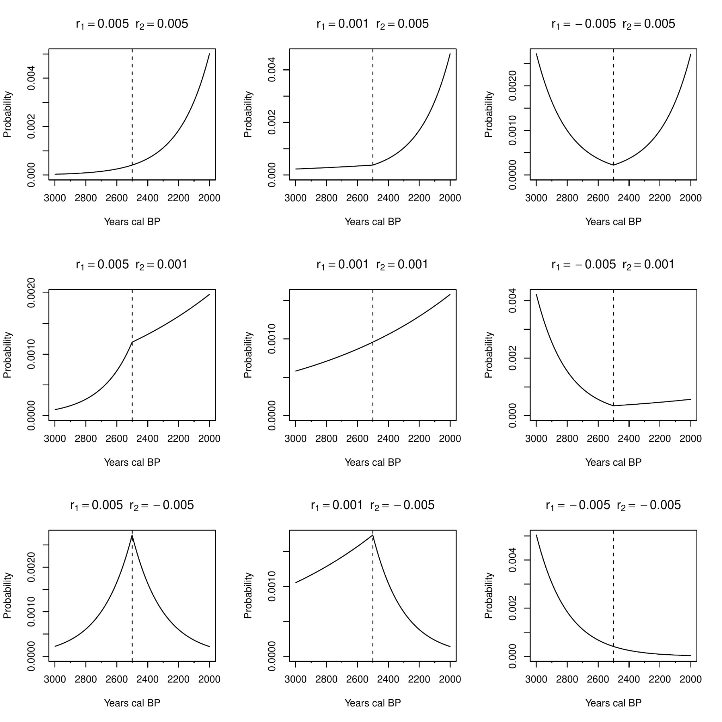
Figure S1. Double exponential growth model with r₁ ={0.005,0.001,-0.005}, r₂={0.005,0.001,-0.005}, a= 3000 BP, b= 2000BP, and c= 2500BP.

Crema and Shoda (2021) applied equation [1] by predefining the parameters a and b, and estimating the growth rates r₁ and r₂ and the changepoint c from the data. The estimate of c was then compared to the earliest dates associated with rice in the island of Kyushu to argue for an offset between the appearance of rice agriculture and a change in the population growth rate as inferred from the time-frequency of radiocarbon dates. Here we take a slightly different approach by predefining a_{k}, b_{k} and c_{k} and limiting our estimating to the growth parameters r_{1,k} and r_{2,k}. More specifically, for each region k we assign to c_{k} the mean posterior estimate of the arrival of rice agriculture in Crema et al. (2022) with a_{k} = c_{k} + 𝛥t and a_{k} = c_{k} - 𝛥t. This effectively ensures that r_{1,k} and r_{2,k} are, respectively, growth rates in region k 𝛥t years before and after the putative arrival time of rice agriculture.
To account for the potential autocorrelation in the growth rate between neighbouring regions we modelled r_{1,k} and r_{2,k} using the Intrinsic Conditional Autoregressive process (Besag 1974):

r1,k ~ Gaussian(1/wk+ 𝚺_{j∈N(k)}wkjr1,k, wk+𝜏1 ) [2]
r2,k ~ Gaussian(1/wk+ 𝚺_{j∈N(k)}wkjr2,k, wk+𝜏2 ) [3]

Where w_{kj} is the spatial weight between regions k and j (equal to 1 when adjacent, and 0 when not), N(k) is the neighbourhood of k, w_{k+} is the sum of all spatial weights within N(k), and 𝜏 is a precision parameter. In other words, equations [2] and [3] conditions the growth rates to be the weighted average between the neighbouring region with a precision parameter dependent on the size of the neighbourhood.

3.1 Implementation
We estimated our parameters of interests r_{1,k} and r_{2,k} using the NIMBLE probabilistic programming language (de Valpine et al. 2020) and the nimbleCarbon (Crema & Shoda 2021; Crema 2022b) package in R (R Core Team 2020). We fitted two versions of the model with 𝛥t set at 500 and 750 years. For both instances, we filtered relevant dates in each region by considering only samples with a cumulative calibrated probability distribution over 0.5 within a_{k} and b_{k}. To account for potential inter-site biases in sampling intensity, we randomly thinned a single date for any cluster of dates within 50 years using the binPrep() and thinDates() functions in the rcarbon R package (Crema & Bevan 2021). We considered only dates with terrestrial origin and employed the IntCal20 calibration curve (Reimer et al. 2020) for all analyses.
We ran four chains with a total of 250,000 iterations for each of the two models, with the first half dedicated to the burn-in, and with samples stored every five steps (i.e. with the thinning parameter set to 5). All parameters showed good mixing with the highest R-hat value (Gelman & Rubin 1992) below 1.008 (see Tables S1 & S2).

Table S1. Posterior estimates and MCMC diagnostics for the 500yrs ICAR model. Growth rate parameters (r) are converted into % annual growth rate.
Parameter | Mean Posterior | 95% HPDI | Rhat | ESS
r1,I | -0.091 | -0.283 ~ 0.103 | 1.0045 | 19283
r1,II | -0.089 | -0.238 ~ 0.064 | 1.0061 | 16041
r1,III | 0.121 | -0.006 ~ 0.262 | 1.0032 | 12250
r1,IV | 0.079 | -0.026 ~ 0.193 | 1.0013 | 19755
r1,V | 0.017 | -0.06 ~ 0.092 | 1.0011 | 14682
r1,VI | 0.052 | -0.068 ~ 0.188 | 1.0006 | 16561
r1,VII | -0.015 | -0.125 ~ 0.085 | 1.0007 | 10259
r1,VIII | 0.036 | -0.112 ~ 0.191 | 1.0034 | 27703
r2,I | 0.374 | 0.195 ~ 0.554 | 1.0025 | 28235
r2,II | 0.339 | 0.212 ~ 0.466 | 1.0083 | 20243
r2,III | 0.028 | -0.097 ~ 0.152 | 1.0051 | 19268
r2,IV | 0.109 | 0.002 ~ 0.219 | 1.001 | 28005
r2,V | 0.082 | 0.006 ~ 0.156 | 1.0012 | 24205
r2,VI | 0.244 | 0.125 ~ 0.356 | 1 | 18548
r2,VII | -0.003 | -0.115 ~ 0.111 | 1.0002 | 18493
r2,VIII | -0.018 | -0.185 ~ 0.147 | 1.0007 | 31334
𝜏₁ | 39.967 | 13.489 ~ 80 | 1.0073 | 7659
𝜏₂ | 24.698 | 13.446 ~ 36.257 | 1.001 | 19750

Table S2. Posterior estimates and MCMC diagnostics for the 750yrs ICAR model. Growth rate parameters (r) are converted into % annual growth rate.
Parameter | Mean Posterior | 95% HPDI | Rhat | ESS
r1,I | -0.091 | -0.048 ~ 0.19 | 1.0005 | 19955
r1,II | -0.089 | -0.051 ~ 0.109 | 1.0006 | 17261
r1,III | 0.121 | 0.013 ~ 0.163 | 1.0005 | 12778
r1,IV | 0.079 | -0.018 ~ 0.093 | 1.0001 | 33009
r1,V | 0.017 | -0.016 ~ 0.065 | 1.0002 | 24821
r1,VI | 0.052 | -0.024 ~ 0.092 | 1.0004 | 22679
r1,VII | -0.015 | -0.078 ~ 0.03 | 1.0011 | 14638
r1,VIII | 0.036 | -0.123 ~ 0.039 | 1.0008 | 15346
r2,I | 0.374 | 0.121 ~ 0.275 | 1.0008 | 16313
r2,II | 0.339 | 0.153 ~ 0.268 | 1.0011 | 12302
r2,III | 0.028 | 0.036 ~ 0.141 | 1.0003 | 12265
r2,IV | 0.109 | 0.069 ~ 0.157 | 1.0006 | 20476
r2,V | 0.082 | 0.071 ~ 0.135 | 1.0005 | 18314
r2,VI | 0.244 | 0.081 ~ 0.169 | 1.0015 | 11639
r2,VII | -0.003 | 0.071 ~ 0.154 | 1.0001 | 16813
r2,VIII | -0.018 | -0.021 ~ 0.138 | 1.0019 | 8436
𝜏₁ | 39.967 | 19.749 ~ 71.33 | 1.0019 | 12367
𝜏₂ | 24.698 | 19.743 ~ 167.286 | 1.0036 | 6044

4. Absolute population size estimate

4.1 Koyama 1978’s method
We estimated Yayoi absolute population sizes using a modified version of Shuzo Koyama’s method (Koyama 1978; Koyama & Sugito 1984) and an updated number of Yayoi and Haji (i.e. Kofun and Kodai period) archaeological sites.
For the Yayoi period, Koyama’s method is based on the following equation:

PYayoi,i = PHaji,Kanto / SHaji,Kanto ᐧ CYayoi/Haji ᐧ SYayoi,i [4]

where P_{Haji,Kanto} is the absolute population estimate for the Haji period in Kanto based on taxation records, S_{Haji,Kanto} is the total number of Haji sites in Kanto, S_{Yayoi,i} is the number of Yayoi archaeological sites in the region i, and C_{Yayoi/Haji} is the relative settlement size of a typical Yayoi compared to a Haji settlement, equivalent to ⅓ (Koyama 1978).
While never explicitly acknowledged in the original paper, equation [4] effectively overcomes the problem of sampling fraction, at least when the target region i is Kanto. This is because we can assume that the relative contribution of each observed archaeological site to the total population is actually given by the following:

(FHaji ᐧ PHaji,Kanto ) / SHaji,Kanto [5]

where F_{Haji} is the sampling fraction of Haji sites. This makes intuitive sense, if we found only half of the archaeological sites dated to the Haji period (F_{Haji} = 0.5), then the ratio population to site number ratio would be twice the amount. Estimates of sampling fraction are not available, but if we assume that this is equivalent between the Haji and the Yayoi period, we can establish the following relationship:

(F ᐧ PHaji,Kanto ) / SHaji,Kanto = (F ᐧ PYayoi,Kanto ) / SYayoi,Kanto ᐧ CYayoi/Haji [6]

which can be simplified to equation [1] above by removing F and re-arranging all terms.
While, in principle, the Haji period population-to-site ratio could have been applied for each region separately, Koyama uses the ratio of the Kanto region “due to problems of archaeological data quality outside the Kanto region” (Koyama 1978: 53). This effectively assumes that the sampling fraction of archaeological sites is the same across all regions.
The assumption of a spatially even sampling fraction can be indirectly tested by comparing the number of Haji period sites to the historical estimates of each region. If both the sampling fraction and the population-to-site ratio is geographically even, we should expect to see the two variables correlated.
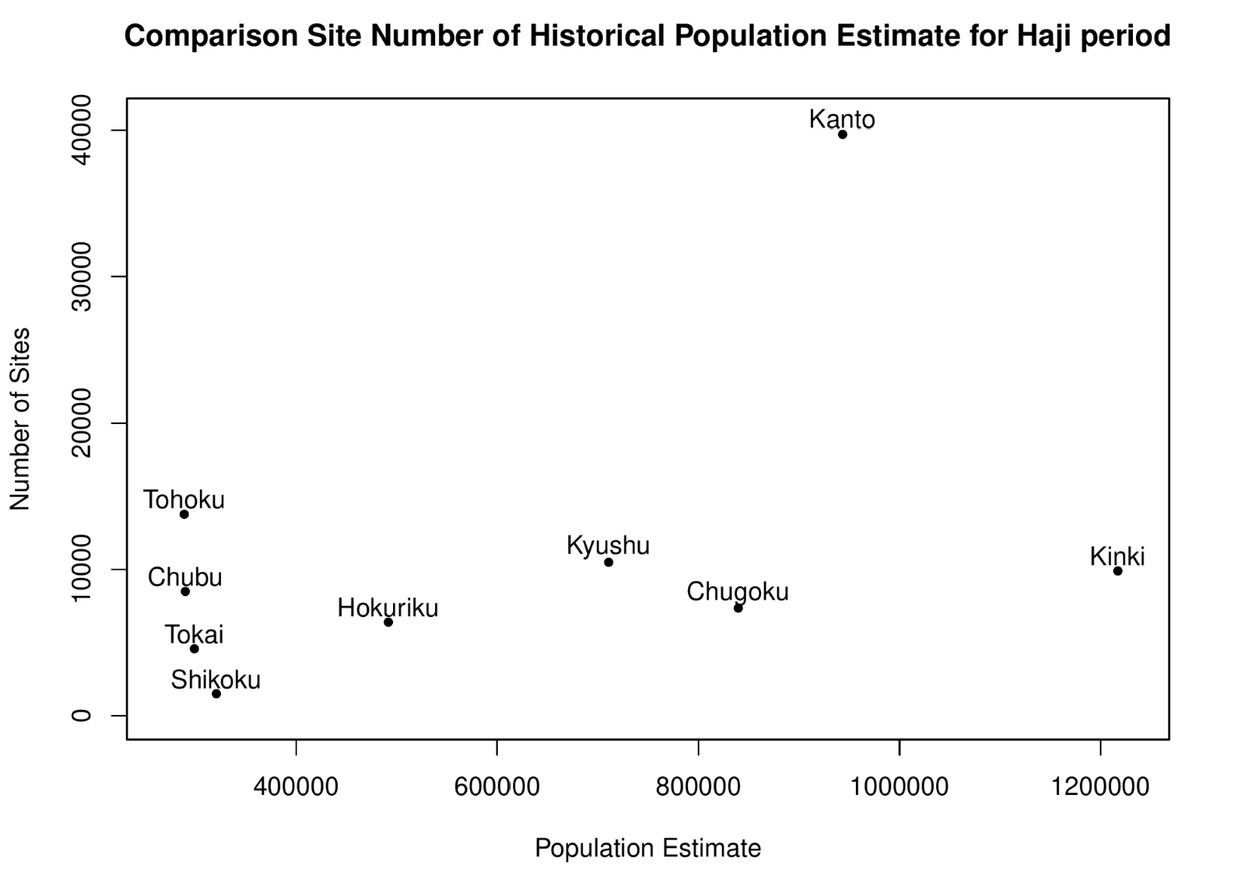
Figure S2. Historical population estimates are based on taxation records (Koyama 1978) and the number of Haji period archaeological sites in each region (Japanese Agency of Cultural Affairs 2016).

Figure S2 shows how the Kanto region is a clear outlier, most likely due to a substantially higher intensity of rescue excavations compared to other regions. As a result, using equation [4] would most likely lead to an underestimate of the population sizes in other regions.
A second issue on the applicability of equation [4] stems from the assumption of an equal duration between Haji and Yayoi periods. Koyama (1978) does estimate the duration of the Jomon and Yayoi periods (estimating 900 years for the latter) but does not include this in his equation. Crucially, the last 20 years saw a substantial revision of Yayoi absolute chronology, with a start date pushed back by more than 500 years (Shoda 2010) and a consensus of later start dates in Eastern Japan (de Boer et al. 2020).

4.2 Revised estimates
We made estimates of Yayoi population sizes using prefecture-level site counts published by the Japanese Agency of Cultural Affairs (2016), the regional historical population estimates based on taxation records reported in Koyama (1978), and the approximate start date in each prefecture based on dates reported by the Jomon-Yayoi settlement database of the National Museum of Japanese History (2012). Because historical population estimates at prefecture level were not available, we used the following equation to estimate the Yayoi period population size P_{Yayoi,i} of each prefecture i:

PYayoi,i = PHaji,j / SHaji,j ᐧ CYayoi/Haji ᐧ SYayoi,i ᐧ DHaji/Yayoi,i [7]

where S_{Yayoi,i} is the number of Yayoi sites in i, D_{Haji/Yayoi,i} is the ratio between the duration of Haji period (1,000 years) and the duration of Yayoi period at i, and P_{Haji,j} / S_{Haji,j} is the ratio between Haji period population estimates and Haji period archaeological sites in the region j, where i ∈ j. Prefecture-level estimates were then re-aggregated by the areal units defined in Crema et al.(2022) and divided by their surface area to obtain estimates of population density (Table 1, main article).
Figure S3 compares the original estimates from Koyama (more specifically, the values reported in Koyama & Sugito 1984 which corrects for minor calculations error in the original study) to three different estimates based on the new number of sites provided by the Japanese Agency of Cultural Affairs (2016). The first estimate (estimate 1 in Figure S3) utilises Koyama’s original formula (equation [4]) with updated site numbers, while the second, and third estimates employ our formula (equation [7]) without (estimate 2) and with (estimate 3) the term D_{Haji/Yayoi,i}. While for most regions the estimates are in the same order of magnitude, our figures are generally higher than those reported by Koyama’s original work, with the exception of Chubu and Tohoku regions. The largest discrepancies between our estimates and Koyama’s were observed in Kyushu, Shikoku, and Chugoku regions due primarily to the fact that we replaced
PHaji,Kanto / SHaji,Kanto with PHaji,j / SHaji,j , accounting for differences in sampling fraction.

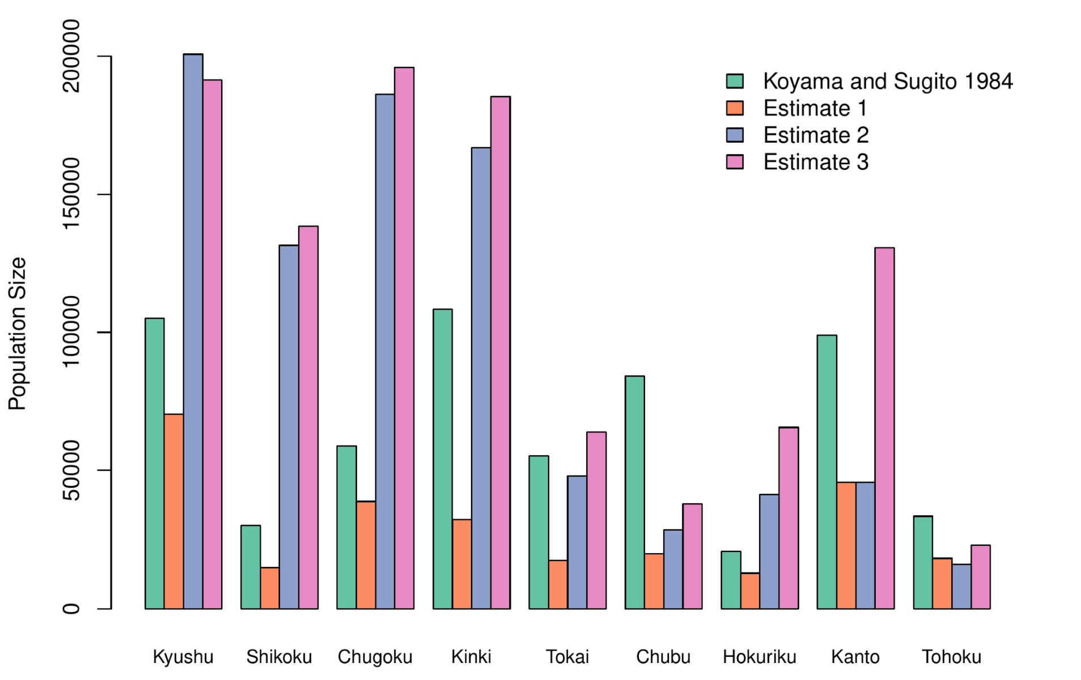
Figure S3. Different population estimates for the Yayoi period: 1) Koyama and Sugito 1984; 2) Equation [1] applied on new site counts for Yayoi and Haji periods (Estimate 1); 3) Modified version of equation [4] without the term D_{Haji/Yayoi,i} ; (Estimate 2); equation [4] (Estimate 3).

Estimates from Jomon sub-periods were not computed given the Japanese Agency of Cultural Affairs provide only counts for the largest periodisation.

5. Data Availability Statement
All data and R scripts required to reproduce the analyses can be found on a dedicated Github repository with a permanent snapshot archived on Zenodo.

References
Besag, J. 1974. Spatial interaction and the statistical analysis of lattice systems. Journal of the Royal Statistical Society 36: 192–225. https://doi.org/10.1111/j.2517-6161.1974.tb00999.x
Brown, W.A. 2017. The past and future of growth rate estimation in demographic temporal frequency analysis: biodemographic interpretability and the ascendance of dynamic growth models. Journal of Archaeological Science 80: 96–108. https://doi.org/10.1016/j.jas.2017.02.003
Carleton, W.C. 2021. Evaluating Bayesian Radiocarbon-dated Event Count (REC) models for the study of long-term human and environmental processes. Journal of Quaternary Science 36: 110–23. https://doi.org/10.1002/jqs.3256
Carleton, W.C. & H.S. Groucutt. 2021. Sum things are not what they seem: problems with point-wise interpretations and quantitative analyses of proxies based on aggregated radiocarbon dates. Holocene 31: 630–43. https://doi.org/10.1177/0959683620981700
Crema, E.R. 2022a. nimbleCarbon: models and utility functions for Bayesian analyses of radiocarbon dates with NIMBLE (v.0.2.0). Available at: https://github.com/ercrema/nimbleCarbon (accessed 31/5/2024).
– 2022b. Statistical inference of prehistoric demography from frequency distributions of radiocarbon dates: a review and a guide for the perplexed. Journal of Archaeological Method and Theory 29:1387–1418. https://doi.org/10.1007/s10816-022-09559-5
Crema, E.R. & A. Bevan. 2021. Inference from large sets of radiocarbon dates: software and methods. Radiocarbon 63: 23–39. https://doi.org/10.1017/RDC.2020.95
Crema, E.R. & S. Shoda. 2021. A Bayesian approach for fitting and comparing demographic growth models of radiocarbon dates: a case study on the Jomon-Yayoi transition in Kyushu (Japan). PLoS ONE 16: e0251695. https://doi.org/10.1371/journal.pone.0251695v
Crema, E.R., C.J. Stevens & S. Shoda. 2022. Bayesian analyses of direct radiocarbon dates reveal geographic variations in the rate of rice farming dispersal in prehistoric Japan. Science Advances 8: eadc9171. https://doi.org/10.1126/sciadv.adc9171
de Boer, E., M.A. Yang, A. Kawagoe & G.L. Barnes. (ed.) 2020. Japan considered from the hypothesis of farmer/language spread. Evolutionary Human Sciences 2.
https://doi.org/10.1017/ehs.2020.7
de Valpine, P. et al. 2020. NIMBLE: MCMC, Particle Filtering, and Programmable Hierarchical Modeling (version 0.10.1). Available at: https://doi.org/10.5281/zenodo.1211190 (accessed 31 May 2024).
Ester, M., H.-P. Kriegel, J. Sander & X. Xu. 1996. A density-based algorithm for discovering clusters in large spatial databases with noise, in Proceedings of the Second International Conference on Knowledge Discovery and Data Mining: 226–31. Portland (OR): AAAI.
Gelman, A. & D.B. Rubin. 1992. Inference from iterative simulation using multiple sequences.
Statistical Science: a review journal of the Institute of Mathematical Statistics 7: 457–72.
Japanese Agency of Cultural Affairs. 2016. Maizobunkazaikankei tokeishiryo -heisei 28 nendo-. Available at: https://www.bunka.go.jp/seisaku/bunkazai/shokai/pdf/h29_03_maizotokei.pdf (accessed 31/5/2024).
Hahsler, M., M. Piekenbrock & D. Doran. 2019. dbscan: Fast Density-Based Clustering with R. Journal of Statistical Software 91: 1-30. https://doi.org/10.18637/jss.v091.i01
Koyama, S. 1978. Jomon subsistence and population. Senri Ethnological Studies 2: 1–65.
Koyama, S. & S. Sugito. 1984. A study of Jomon population - computer simulation analysis. Bulletin of the National Museum of Ehtnology 9: 1–39.
Kudo, Y., M. Sakamoto & M. Hakozaki. 2018. Approach for creating database of the radiocarbon dates published on the archaeological research reports in Japan. Bulletin of the National Museum of Japanese History 212: 251–66.
Kudo, Y., M. Sakamoto, M. Hakozaki, C.J.Stevens & E.R.Crema, 2023. An Archaeological Radiocarbon Database of Japan. Journal of Open Archaeology Data 11:11p, https://doi.org/10.5334/joad.115
McLaughlin, T.R. 2018. On applications of space–time modelling with open-source 14C age calibration. Journal of Archaeological Method and Theory 26: 479–501.
https://doi.org/10.1007/s10816-018-9381-3
National Museum of Japanese History. 2012. Jomon - Yayoi Shuraku database. Available at: https://www.rekihaku.ac.jp/up-cgi/login.pl?p=param/jomo/db_param (accessed 2 January 2024).
R Core Team. 2020. R: a language and environment for statistical computing. Vienna, Austria: R Foundation for Statistical Computing. https://www.R-project.org/.
Reimer, P.J. et al. 2020. The IntCal20 Northern Hemisphere radiocarbon age calibration curve (0–55 cal kBP). Radiocarbon 62: 725–57. https://doi.org/10.1017/RDC.2020.41
Rick, J.W. 1987. Dates as data: an examination of the Peruvian preceramic radiocarbon record. American Antiquity 52: 55–73. https://doi.org/10.2307/281060
Shoda, S. 2010. Radiocarbon and archaeology in Japan and Korea: what has changed because of the Yayoi dating controversy. Radiocarbon 52: 421–27. https://doi.org/10.1017/S0033822200045471
Timpson, A., R. Barberena, M.G. Thomas, C. Méndez & K. Manning. 2021. Directly modelling population dynamics in the South American Arid Diagonal using 14C dates. Philosophical Transactions of the Royal Society of London. Series B, Biological Sciences 376: 20190723. https://doi.org/10.1098/rstb.2019.0723

https://www.rekihaku.ac.jp/up-cgi/login.pl?p=param/esrd/db_param
https://www.rekihaku.ac.jp/up-cgi/login.pl?p=param/esrd_en/db_param
https://github.com/ercrema/yayoi_demo
https://doi.org/10.5281/zenodo.11398533

