Supplementary Material
The goddess’ new clothes: the carving and polychromy of the Parthenon Sculptures
Giovanni Verri^{1,*}, Hero Granger-Taylor², Ian Jenkins³, Tracey Sweek³, Katarzyna Weglowska³ & William Thomas Wootton^{4,*}
¹ Art Institute of Chicago, Illinois, US
² Independent scholar, London, UK
³ British Museum, London, UK
⁴ King’s College, London, UK
* Authors for correspondence ✉ gverri@artic.edu; will.wootton@kcl.ac.uk
Received: 29 January 2022; Revised: 19 November 2022; Accepted: 24 November 2022

Table S1: Areas where evidence for carving and colour was revealed: East Pediment (EP); West Pediment (WP); East Frieze (EF)). Unless otherwise indicated, the identification of Egyptian blue was undertaken using VIL imaging and confirmed in select cases with Raman and SEM-EDX analysis. SEM-EDX and Raman analysis were performed on microscopic samples (<0.5mm diameter) collected from the surface of the sculpture, as indicated. The sample locations, marked by a white arrow, are in the corresponding figures as indicated in the table.
Figure | Location | Toolmarks | Blue | White | Purple | Degradation products
EP A (Helios) and B (Horses) | Sea | Claw chisel  Rasp  Polishing | Egyptian blue  - VIL
EP E (Demeter?) and F (Persephone?) | ‘Empty space’ below seat | Point chisel  Drill | Egyptian blue  - VIL
EP G (Hebe?) | ‘Empty space’ underneath dress | Point chisel | Egyptian blue  - VIL
EP K (Hestia?) | Decorative element on dress |  | Egyptian blue  - VIL
EP L and M (see Figure 7 for sampling location) | Decorative element on EP L’s dress and spread over rock by EP L’s feet | Claw chisel  Drill  Flat chisel and channelling tool  Rasp | Egyptian blue  - VIL  - Raman: 1085, 571, 430cm⁻¹  - SEM-EDX: Cu, Si, Ca, Na | Calcium phosphate (mixed with Egyptian blue)  - Raman: 963cm⁻¹  - SEM-EDX: Ca, P |  | Calcium oxalate  Superficial layer  - Raman: 1472, 910, 506, 495cm⁻¹  - SEM-EDX: Ca with Fe impurities
EP L (Dione?) and M (Aphrodite?) | Decorative element at the intersection between dress of EP M and spread | Claw chisel  Drill  Flat chisel and channelling tool  Rasp |  |  | Unknown compound likely including an anthraquinone  - FORS: c. 528, 570nm  - XRF: Ca, Fe
WP B (Kekrops?) | Snake skin | Point chisel  Claw chisel | Egyptian blue  - VIL
WP N (Iris?)  (see Figure 9 for sampling location) | Belt | Point chisel | Egyptian blue  - VIL  - Raman: 1085, 571, 430cm⁻¹  - SEM-EDX: Cu, Si, Ca, Na | Calcium sulphate (mixed with Egyptian blue)  - Raman: 412, 491, 1005, 1135cm⁻¹  - SEM-EDX: Ca, S
WP T (Kreusa?) | Decorative element on textile and  surface of rock |  | Egyptian blue  - VIL
EF Block V, Figure 32  (see Figure 10 for sampling location) | Dress |  | Egyptian blue  - VIL  - Raman: 1085, 571, 430cm⁻¹  - SEM-EDX: Cu, Si, Ca, Na | Calcium phosphate (mixed with Egyptian blue)  - Raman: 963cm⁻¹  - SEM-EDX: Ca, P

Supplementary figures
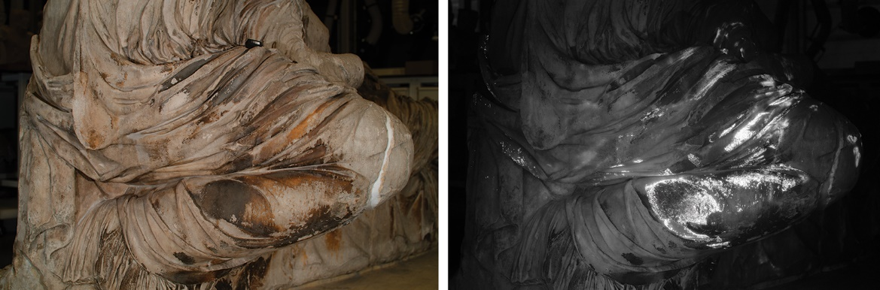
Figure S1. Figure EP L. Visible and VIL images of the side.

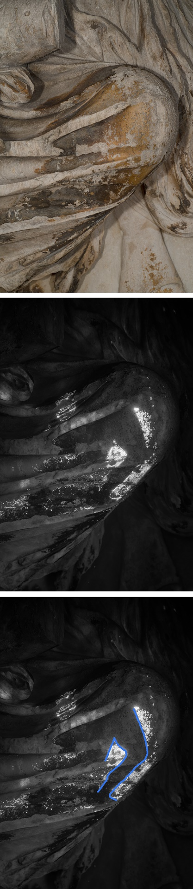
Figure S2. Figure EP L. Visible, VIL details and line drawing of the ‘leg’.

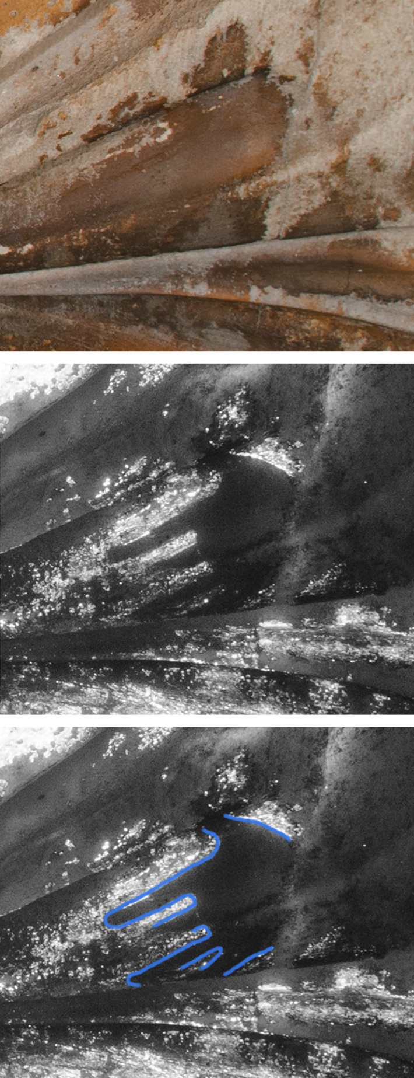
Figure S3. Figure EP L. Visible, VIL details and line drawing of the ‘hand’.
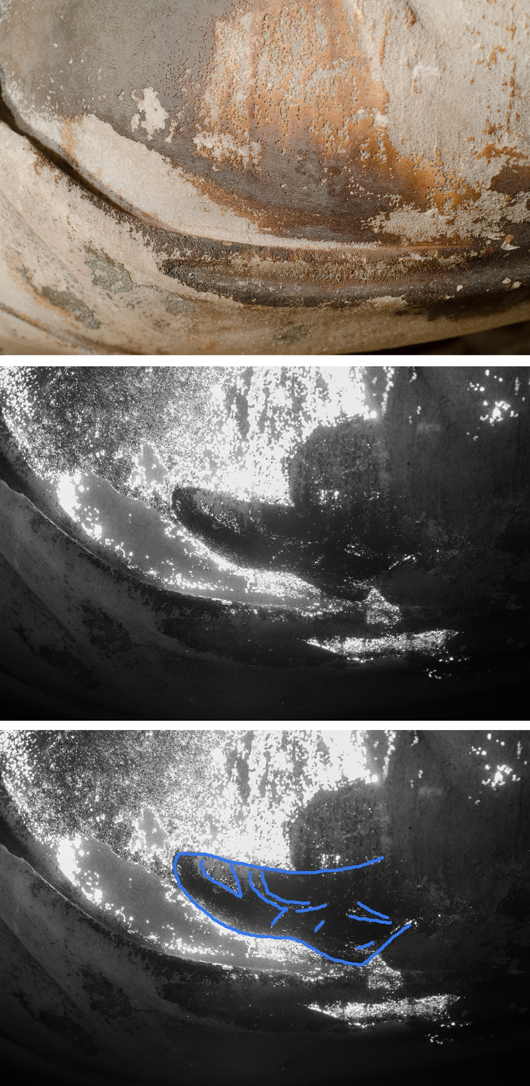
Figure S4. Figure EP L. Visible, VIL details and line drawing of the ‘foot’.

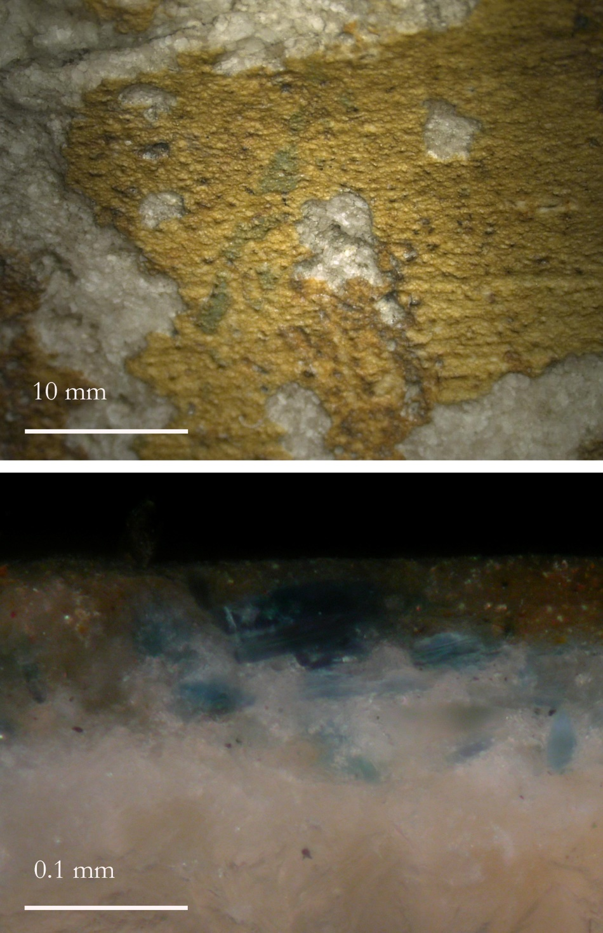
Figure S5. Figure EP L. (Left) Detail of EP L’s shin, showing fragmentary Egyptian blue under the orange calcium oxalate layer. The orange layer is likely the result of natural degradation processes. (Right) Cross-section from the location indicated in Figure 7, showing Egyptian blue particles in a calcium phosphate matrix. The blue paint layer is applied above a calcium phosphate layer and under the orange calcium oxalate layer.

