Ceramic Analysis for “Evidence for extensive social networks as risk-mitigation strategies on Southwest Madagascar”
Dylan S. Davis
9/16/2022

Introduction
This R Markdown document includes the code necessary to replicate the analysis in the associated manuscript. In what follows, code and its associated description will be provided along with the output of each component of the analysis.
The following code implements a network analysis of ceramic data from Southwest Madagascar following the protocol developed by Matt Peeples (2017). The original Script by Matt Peeples can be found at: http://www.mattpeeples.net/netstats.html
##Load libraries and necessary datasets
#Load required libraries library(statnet) #for network analysis library(tnet) #for network analysis library(rgdal) #for mapping GIS files library(here)
#set working directory setwd(here())
#Load data as properly formatted CSV files (See Peeples 2017 for formatting information)
# the name of each row (site name) should be the first column in the input ta ble
d_data1 <- read.table(file='Early_Period_Data.csv', sep=',', header=T, row.na mes=1)
d_data2 <- read.table(file='Middle_Period_Data.csv', sep=',', header=T, row.n ames=1)
d_data3 <- read.table(file='Late_Period_Data.csv', sep=',', header=T, row.nam es=1)

#Load shapefile of study area
AOI <- readOGR(dsn='Velondriake_AOI.shp')
## OGR data source with driver: ESRI Shapefile
## Source: "C:\Users\dylan\Documents\School_Work\Dissertation\Ceramic_Analysi s\Ceramic_Network_Data\Velondriake_AOI.shp", layer: "Velondriake_AOI"
## with 1 features
## It has 1 fields
##Implement functions for co-presence, Brainerd-Robinson (BR) coefficient, and chisquare distance metrics.
#Function to create a co-occurance dataset using presence/absence
co.p <- function(x, thresh = 0.1) {
# create matrix of proportions from ceramic data temp <- prop.table(as.matrix(x), 1)
# define anything with greater than or equal to 0.1 as present (1) temp[temp >= thresh] <- 1
# define all other cells as absent (0) temp[temp < 1] <- 0
# matrix algebraic calculation to find co-occurence (%*% indicates matrix
# multiplication) out <- temp %*% t(temp) return(out)
}

# run the function on the datasets d_data1P <- co.p(d_data1) #Decoration data d_data2P <- co.p(d_data2) #Manufacturing data d_data3P <- co.p(d_data3)

# Function for calculating Brainerd-Robinson (BR) coefficients # This creates a matrix of similarity values used in many SNAs sim.mat <- function(x) { # get names of sites names <- row.names(x)
x <- na.omit(x) # remove any rows with missing data x <- prop.table(as.matrix(x), 1) # convert to row proportions rd <- dim(x)[1]
# create an empty symmetric matrix of 0s results <- matrix(0, rd, rd)
# the following dreaded double for-loop goes through every cell in the # output data table and calculates the BR value as descried above for (s1 in 1:rd) { for (s2 in 1:rd) {
x1Temp <- as.numeric(x[s1, ]) x2Temp <- as.numeric(x[s2, ])
results[s1, s2] <- 2 - (sum(abs(x1Temp - x2Temp)))
} }
row.names(results) <- names # assign row names to output colnames(results) <- names # assign column names to output results <- results/2 # rescale results between 0 and 1 results <- round(results, 3) # round results return(results)
} # return the final output table

# Run the BR coefficient function on our sample data d_data1BR <- sim.mat(d_data1) #Decoration data d_data2BR <- sim.mat(d_data2) #Manufacturing data d_data3BR <- sim.mat(d_data3)

# Chi-square (X2) distance function chi.dist <- function(x) {
rowprof <- x/apply(x, 1, sum) # calculates the profile for every row avgprof <- apply(x, 2, sum)/sum(x) # calculates the average profile
# creates a distance object of $\chi^{2}$ distances chid <- dist(as.matrix(rowprof) %*% diag(1/sqrt(avgprof)))
# return the reults return(as.matrix(chid))
}
# Run the X2 function and then create the rescaled 0-1 version d_data1X <- chi.dist(d_data1) #Decoration data ## Warning in sqrt(avgprof): NaNs produced
d_data1X01 <- d_data1X/max(d_data1X)
d_data2X <- chi.dist(d_data2)#Manufacturing data ## Warning in sqrt(avgprof): NaNs produced
d_data2X01 <- d_data2X/max(d_data2X)
d_data3X <- chi.dist(d_data3) #Decoration data ## Warning in sqrt(avgprof): NaNs produced
d_data3X01 <- d_data3X/max(d_data3X)

###VISIUALIZING NETWORKS

# create network object from co-occurrence
Pnet_d1 <- network(d_data1P, directed = F)
Pnet_d2 <- network(d_data2P, directed = F)
Pnet_d3 <- network(d_data3P, directed = F)
# Now let's add names for our nodes based on the row names of our original # matrix
Pnet_d1 %v% "vertex.names" <- row.names(d_data1P)
Pnet_d2 %v% "vertex.names" <- row.names(d_data2P)
Pnet_d3 %v% "vertex.names" <- row.names(d_data3P)
# look at the results
Pnet_d1

## Network attributes:
## vertices = 48
## directed = FALSE
## hyper = FALSE
## loops = FALSE
## multiple = FALSE
## bipartite = FALSE
## total edges= 1119
## missing edges= 0
## non-missing edges= 1119
##
## Vertex attribute names:
## vertex.names
##
## Edge attribute names not shown
Pnet_d2
## Network attributes:
## vertices = 86
## directed = FALSE
## hyper = FALSE
## loops = FALSE
## multiple = FALSE
## bipartite = FALSE
## total edges= 3655
## missing edges= 0
## non-missing edges= 3655
##
## Vertex attribute names:
## vertex.names
##
## Edge attribute names not shown
Pnet_d3
## Network attributes:
## vertices = 146
## directed = FALSE
## hyper = FALSE
## loops = FALSE
## multiple = FALSE
## bipartite = FALSE
## total edges= 10559
## missing edges= 0
## non-missing edges= 10559
##
## Vertex attribute names:
## vertex.names
##
## Edge attribute names not shown
# plot network using default layout par(mfrow = c(2, 3)) par(mar=c(0.5,1,1,0.5))

plot(Pnet_d1, edge.col = "gray", edge.lwd = 0.10, vertex.cex = 0.75, main = " Co-Presence network, Early Period")
plot(Pnet_d2, edge.col = "gray", edge.lwd = 0.10, vertex.cex = 0.75, main = " Co-Presence network, Middle Period")
plot(Pnet_d3, edge.col = "gray", edge.lwd = 0.10, vertex.cex = 0.75, main = "
Co-Presence network, Late Period")
# plot network spatially using geographic coordinates
plot(Pnet_d1, edge.col = "gray", edge.lwd = 0.10, vertex.cex = 0.5, main = "S patial CP Network, Early Period",coord = d_data1[,10:11]) plot(AOI, add=T) #overlay network with coastline of study area
plot(Pnet_d2, edge.col = "gray", edge.lwd = 0.10, vertex.cex = 0.5, main = "S patial CP Network, Middle Period",coord = d_data2[,10:11]) plot(AOI, add=T) #overlay network with coastline of study area

plot(Pnet_d3, edge.col = "gray", edge.lwd = 0.10, vertex.cex = 0.5, main = "S patial CP Network, Late Period",coord = d_data3[,10:11])
plot(AOI, add=T) #overlay network with coastline of study area
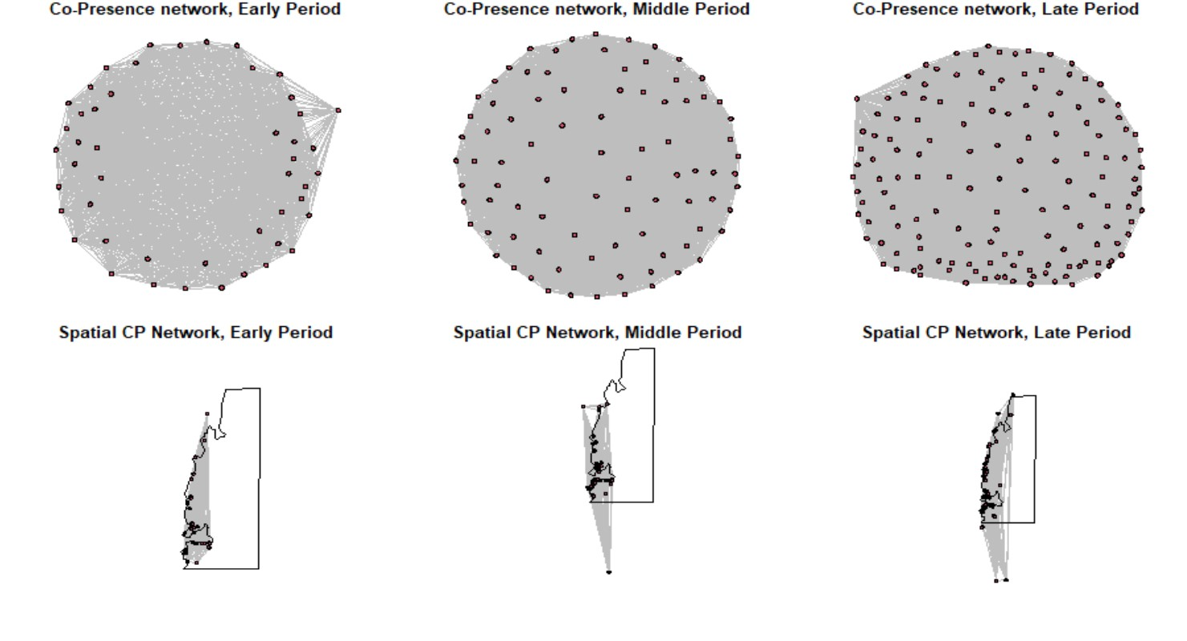
par(mfrow = c(1, 1)) # return to single plotting mode

# Define our binary network object from BR similarity
BRnet_d1 <- network(event2dichot(d_data1BR, method = "absolute", thresh = 0.6
),
directed = F)
BRnet_d2 <- network(event2dichot(d_data2BR, method = "absolute", thresh = 0.6

),
directed = F)
BRnet_d3 <- network(event2dichot(d_data3BR, method = "absolute", thresh = 0.6
),
directed = F)
# Add names for nodes based on the row names of the original matrix
BRnet_d1 %v% "vertex.names" <- row.names(d_data1BR)
BRnet_d2 %v% "vertex.names" <- row.names(d_data2BR)
BRnet_d3 %v% "vertex.names" <- row.names(d_data3BR)
# look at the results.
BRnet_d1
## Network attributes:
## vertices = 48
## directed = FALSE
## hyper = FALSE
## loops = FALSE
## multiple = FALSE
## bipartite = FALSE
## total edges= 351
## missing edges= 0
## non-missing edges= 351
##
## Vertex attribute names:
## vertex.names
##
## No edge attributes
BRnet_d2
## Network attributes:
## vertices = 86
## directed = FALSE
## hyper = FALSE
## loops = FALSE
## multiple = FALSE
## bipartite = FALSE
## total edges= 1743
## missing edges= 0
## non-missing edges= 1743
##
## Vertex attribute names:
## vertex.names
##
## Edge attribute names not shown
BRnet_d3
## Network attributes:
## vertices = 146
## directed = FALSE

## hyper = FALSE
## loops = FALSE
## multiple = FALSE
## bipartite = FALSE
## total edges= 4068
## missing edges= 0
## non-missing edges= 4068
##
## Vertex attribute names:
## vertex.names
##
## Edge attribute names not shown
# plot network using default layout par(mfrow = c(2, 3)) par(mar=c(0.5,1,1,0.5))

plot(BRnet_d1, edge.col = "gray", edge.lwd = 0.001, vertex.cex = 0.75, main =
"BR network, Early Period")
plot(BRnet_d2, edge.col = "gray", edge.lwd = 0.001, vertex.cex = 0.75, main =
"BR network, Middle Period")
plot(BRnet_d3, edge.col = "gray", edge.lwd = 0.001, vertex.cex = 0.75, main =
"BR network, Late Period")
# plot network spatially using geographic coordinates
plot(BRnet_d1, edge.col = "gray", edge.lwd = 0.001, vertex.cex = 0.5, main =
"Spatial BR Network",coord = d_data1[,10:11])
plot(AOI, add=T) #overlay network with coastline of study area
plot(BRnet_d2, edge.col = "gray", edge.lwd = 0.001, vertex.cex = 0.5, main =
"Spatial BR Network",coord = d_data2[,10:11])
plot(AOI, add=T) #overlay network with coastline of study area
plot(BRnet_d3, edge.col = "gray", edge.lwd = 0.001, vertex.cex = 0.5, main = "Spatial BR Network",coord = d_data3[,10:11])
plot(AOI, add=T) #overlay network with coastline of study area
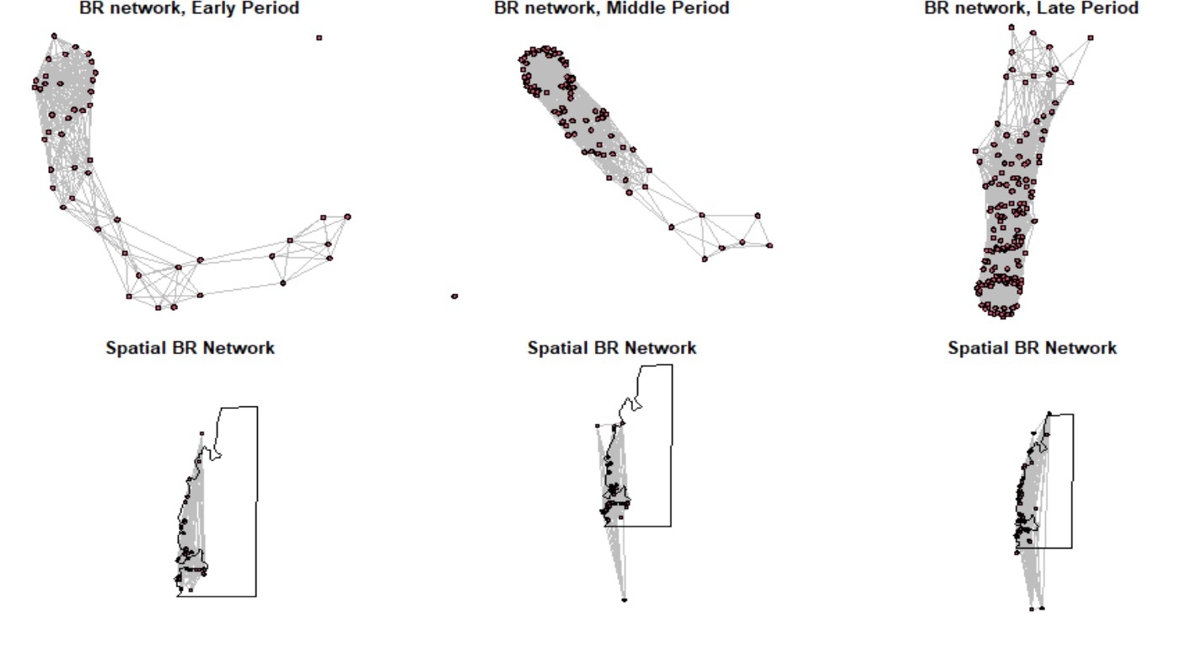
par(mfrow = c(1, 1)) # return to single plotting mode

# Plot X2 distance similarity index
# This uses the 1 minus dataX01 calculation to convert
# X2 distance to a similarity (following Peeples 2017)
Xnet_d1 <- network(event2dichot(1 - d_data1X01, method = "quantile", thresh =
0.8),
directed = F)
Xnet_d2 <- network(event2dichot(1 - d_data2X01, method = "quantile", thresh =
0.8),
directed = F)
Xnet_d3 <- network(event2dichot(1 - d_data3X01, method = "quantile", thresh =
0.8),
directed = F)

# Once again add vertex names
Xnet_d1 %v% "vertex.names" <- row.names(d_data1X01)
Xnet_d2 %v% "vertex.names" <- row.names(d_data2X01)
Xnet_d3 %v% "vertex.names" <- row.names(d_data3X01)
# look at the results
Xnet_d1
## Network attributes: ## vertices = 48
## directed = FALSE
## hyper = FALSE
## loops = FALSE
## multiple = FALSE
## bipartite = FALSE
## total edges= 206

## missing edges= 0
## non-missing edges= 206
##
## Vertex attribute names:
## vertex.names
##
## No edge attributes
Xnet_d2
## Network attributes:
## vertices = 86
## directed = FALSE
## hyper = FALSE
## loops = FALSE
## multiple = FALSE
## bipartite = FALSE
## total edges= 696
## missing edges= 0
## non-missing edges= 696
##
## Vertex attribute names:
## vertex.names
##
## No edge attributes
Xnet_d3
## Network attributes:
## vertices = 146
## directed = FALSE
## hyper = FALSE
## loops = FALSE
## multiple = FALSE
## bipartite = FALSE
## total edges= 2058
## missing edges= 0
## non-missing edges= 2058
##
## Vertex attribute names:
## vertex.names
##
## Edge attribute names not shown
# plot network using default layout par(mfrow = c(2, 3)) par(mar=c(0.5,1,1,0.5))

plot(Xnet_d1, edge.col = "gray", edge.lwd = 0.001, vertex.cex = 0.75, main =
"Chi-squared network \nEarly Period")
plot(Xnet_d2, edge.col = "gray", edge.lwd = 0.001, vertex.cex = 0.75, main =
"Chi-squared network \nMiddle Period")
plot(Xnet_d3, edge.col = "gray", edge.lwd = 0.001, vertex.cex = 0.75, main = "Chi-squared network \nLate Period")

# plot network using geographic coordinates
plot(Xnet_d1, edge.col = "gray", edge.lwd = 0.75, vertex.cex = 0.5, coord = d _data1[,

10:11])
plot(AOI, add=T) #overlay network with coastline of study area
plot(Xnet_d2, edge.col = "gray", edge.lwd = 0.75, vertex.cex = 0.5, coord = d _data2[,

10:11])
plot(AOI, add=T) #overlay network with coastline of study

plot(Xnet_d3, edge.col = "gray", edge.lwd = 0.75, vertex.cex = 0.5, coord = d _data3[,
10:11])
plot(AOI, add=T) #overlay network with coastline of study area
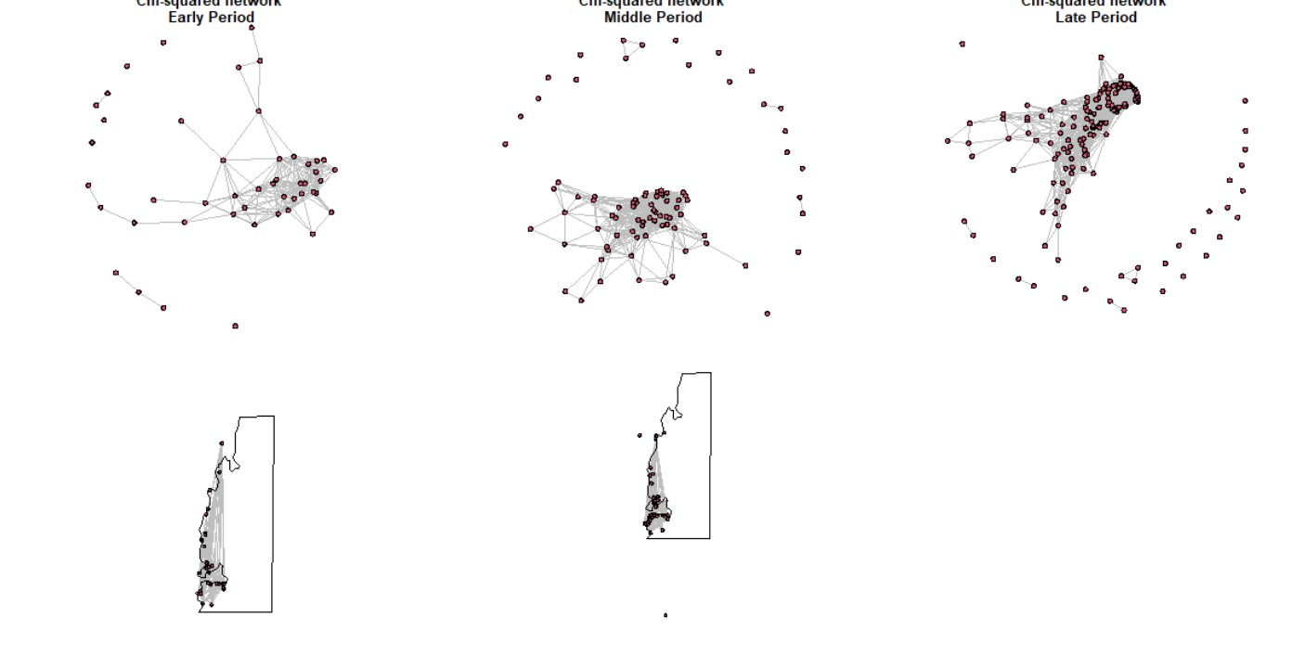
par(mfrow = c(1, 1))
#Peeples (2017) finds that weighted networks do not perform well with similarity or distance matrices, so we do not use them here.

CALCULATE RAW DATAVALUES OF NETWORK CONNECTIVITY
# Calculate centrality scores for binary networks net.stats <- function(y) {
# calculate degree centrality
dg <- as.matrix(sna::degree(y, gmode = "graph"))

# calculate and scale eigenvector centrality eg <- as.matrix(sna::evcent(y, use.eigen = TRUE)) eg <- sqrt((eg^2) * length(eg)) # calculate betweenness centrality
bw <- sna::betweenness(y, gmode = "graph") # combine centrality scores into matrix output <- cbind(dg, eg, bw)
rownames(output) <- rownames(as.matrix(y)) colnames(output) <- c("dg", "eg", "bw") return(output)
} # return results of this function

# net stats for binary co-presence network co.p.stats_d <- net.stats(Pnet_d1) co.p.stats_d2 <- net.stats(Pnet_d2) co.p.stats_d3 <- net.stats(Pnet_d3)
# net stats for binary BR similarity network
BR.stats_d <- net.stats(BRnet_d1)
BR.stats_d2 <- net.stats(BRnet_d2)
BR.stats_d3 <- net.stats(BRnet_d3)

# net stats for binary X^2 similarity network (1-distance)
X.stats_d <- net.stats(Xnet_d1)
X.stats_d2 <- net.stats(Xnet_d2)
X.stats_d3 <- net.stats(Xnet_d3) head(X.stats_d)
## dg eg bw
## G-11-20 1 2.480331e-05 0
## VATO Za003 0 3.076740e-15 0
## G-48-20 2 3.797514e-04 36
## LSS_52 3 1.534534e-02 36
## GI118 2 1.528389e-02 0
## GI128 1 1.002275e-03 0
#write.csv(X.stats_d3, "X2_1700_1900_Stats.csv")
##RUN GRAPH LEVEL CENTRALIZATION METRICS
detach(package:tnet, unload=TRUE) # unload tnet package (required for this an alysis)
#co-presence network
centralization(Pnet_d1,degree,normalize=T) #calculate binary degree centraliz ation
## centralization(Pnet_d1,degree,normalize=T) #calculate binary degree centra lization
## [1] 0.008325624

centralization(Pnet_d2,betweenness,normalize=T) #calculate binary betweenness centralization
## centralization(Pnet_d2,betweenness,normalize=T) #calculate binary betweenn ess centralization
## [1] 0

centralization(Pnet_d3,evcent,normalize=T) #calculate binary eigenvector cent ralization
## centralization(Pnet_d3,evcent,normalize=T) #calculate binary eigenvector c entralization ## [1] 0.0001854757

#BR network
centralization(BRnet_d1,degree,normalize=T) #calculate binary degree centrali zation
## centralization(BRnet_d1,degree,normalize=T) #calculate binary degree centr alization ## [1] 0.2303423
centralization(BRnet_d2,betweenness,normalize=T) #calculate binary betweennes s centralization
## centralization(BRnet_d2,betweenness,normalize=T) #calculate binary between ness centralization ## [1] 0.06405785
centralization(BRnet_d3,evcent,normalize=T) #calculate binary eigenvector cen tralization
## centralization(BRnet_d3,evcent,normalize=T) #calculate binary eigenvector centralization ## [1] 0.0561337 # Chi-Square Network
centralization(Xnet_d1,degree,normalize=T) #calculate binary degree centraliz ation
## centralization(Xnet_d1,degree,normalize=T) #calculate binary degree centra lization
## [1] 0.2978723
centralization(Xnet_d2,betweenness,normalize=T) #calculate binary betweenness centralization
## centralization(Xnet_d2,betweenness,normalize=T) #calculate binary betweenn ess centralization
## [1] 0.03032848

centralization(Xnet_d3,evcent,normalize=T) #calculate binary eigenvector cent ralization
## centralization(Xnet_d3,evcent,normalize=T) #calculate binary eigenvector c entralization ## [1] 0.103616
# The following function does the same calculation as above but is set up to
# work with the output of net.stats and net.stats.wt nsim <- 1000

samp.frac <- c("S90", "S80", "S70", "S60", "S50", "S40", "S30", "S20", "S10")

cv.resamp.bin <- function(x) {
# calculate all network stats for the original network stats.g <- net.stats(x) mat <- as.matrix(x)
dim.x <- dim(mat)[1] # count number of rows (nodes)
# define empty matrices for output dg.mat <- matrix(NA, nsim, 9) ev.mat <- matrix(NA, nsim, 9) bw.mat <- matrix(NA, nsim, 9)
# add column names based on sampling fraction colnames(dg.mat) <- samp.frac colnames(ev.mat) <- samp.frac colnames(bw.mat) <- samp.frac

# this double loop goes through each sampling fraction and each random
# replicate to cacluate centrality statistics and runs a Spearman's rho
# correlation between the resulting centrality values and the original
# sample for (j in 1:9) { for (i in 1:nsim) {
sub.samp <- sample(seq(1, dim.x), size = round(dim.x * ((10 - j)/10), 0), replace = F)
temp.stats <- net.stats(mat[sub.samp, sub.samp])
dg.mat[i, j] <- suppressWarnings(cor(temp.stats[, 1], stats.g[sub.samp, 1], metho d = "spearman"))
ev.mat[i, j] <- suppressWarnings(cor(temp.stats[, 2], stats.g[sub.samp, 2], metho d = "spearman"))
bw.mat[i, j] <- suppressWarnings(cor(temp.stats[, 3], stats.g[sub.samp, 3], metho d = "spearman"))
} }
out.list <- list() # create list for output and populate it
out.list[[1]] <- dg.mat out.list[[2]] <- ev.mat

out.list[[3]] <- bw.mat return(out.list)
} # return the resulting list
cop.rs_d <- cv.resamp.bin(Pnet_d1) cop.rs_d2 <- cv.resamp.bin(Pnet_d2) cop.rs_d3 <- cv.resamp.bin(Pnet_d3) BR.rs_d <- cv.resamp.bin(BRnet_d1)
BR.rs_d2 <- cv.resamp.bin(BRnet_d2)
BR.rs_d3 <- cv.resamp.bin(BRnet_d3)
X.rs_d <- cv.resamp.bin(Xnet_d1)
X.rs_d2 <- cv.resamp.bin(Xnet_d2)
X.rs_d3 <- cv.resamp.bin(Xnet_d3)

##PLOT DECORATIVE NETWORKS
par(mfrow = c(3, 3)) # set up for 3 by 3 plotting par(mar=c(1,1,3,1))
# plot boxplots by sampling fraction for each measure and each network type boxplot(cop.rs_d[[1]], ylim = c(0, 1), main = "co-presence - degree", xlab =
"sampling fraction", ylab = "Spearmans rho")
boxplot(cop.rs_d[[2]], ylim = c(0, 1), main = "co-presence - eigenvector", xl ab = "sampling fraction")
boxplot(cop.rs_d[[3]], ylim = c(0, 1), main = "co-presence - betweenness", xl ab = "sampling fraction")
boxplot(cop.rs_d2[[1]], ylim = c(0, 1), main = "co-presence - degree", xlab =
"sampling fraction", ylab = "Spearmans rho")
boxplot(cop.rs_d2[[2]], ylim = c(0, 1), main = "co-presence - eigenvector", x lab = "sampling fraction")
boxplot(cop.rs_d2[[3]], ylim = c(0, 1), main = "co-presence - betweenness", x lab = "sampling fraction")
boxplot(cop.rs_d3[[1]], ylim = c(0, 1), main = "co-presence - degree", xlab =
"sampling fraction", ylab = "Spearmans rho")
boxplot(cop.rs_d3[[2]], ylim = c(0, 1), main = "co-presence - eigenvector", x lab = "sampling fraction")
boxplot(cop.rs_d3[[3]], ylim = c(0, 1), main = "co-presence - betweenness", x
lab = "sampling fraction")
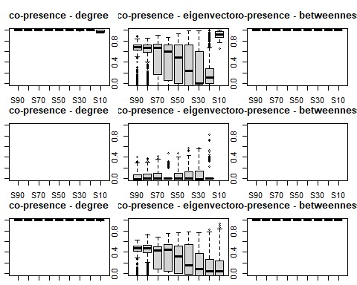
par(mfrow = c(3, 3)) # set up for 3 by 3 plotting par(mar=c(1,1,3,1))

boxplot(BR.rs_d[[1]], ylim = c(0, 1), main = "BR - degree", xlab = "sampling fraction",
ylab = "Spearmans rho")
boxplot(BR.rs_d[[2]], ylim = c(0, 1), main = "BR - eigenvector", xlab = "samp ling fraction")
boxplot(BR.rs_d[[3]], ylim = c(0, 1), main = "BR - betweenness", xlab = "samp ling fraction")
boxplot(BR.rs_d2[[1]], ylim = c(0, 1), main = "BR - degree", xlab = "sampling fraction",
ylab = "Spearmans rho")
boxplot(BR.rs_d2[[2]], ylim = c(0, 1), main = "BR - eigenvector", xlab = "sam pling fraction")
boxplot(BR.rs_d2[[3]], ylim = c(0, 1), main = "BR - betweenness", xlab = "sam pling fraction")
boxplot(BR.rs_d3[[1]], ylim = c(0, 1), main = "BR - degree", xlab = "sampling fraction",
ylab = "Spearmans rho")
boxplot(BR.rs_d3[[2]], ylim = c(0, 1), main = "BR - eigenvector", xlab = "sam pling fraction")
boxplot(BR.rs_d3[[3]], ylim = c(0, 1), main = "BR - betweenness", xlab = "sam
pling fraction")
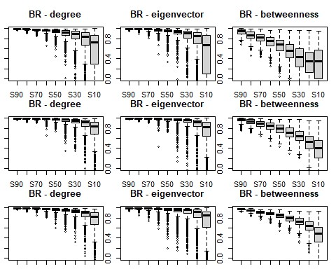
par(mfrow = c(3, 3)) # set up for 3 by 3 plotting par(mar=c(1,1,3,1))

boxplot(X.rs_d[[1]], ylim = c(0, 1), main = "Chi squared - degree", xlab = "s ampling fraction",
ylab = "Spearmans rho")
boxplot(X.rs_d[[2]], ylim = c(0, 1), main = "Chi squared - eigenvector", xlab
= "sampling fraction")
boxplot(X.rs_d[[3]], ylim = c(0, 1), main = "Chi squared - betweenness", xlab
= "sampling fraction")
boxplot(X.rs_d2[[1]], ylim = c(0, 1), main = "Chi squared - degree", xlab = "
sampling fraction",
ylab = "Spearmans rho")
boxplot(X.rs_d2[[2]], ylim = c(0, 1), main = "Chi squared - eigenvector", xla b = "sampling fraction")
boxplot(X.rs_d2[[3]], ylim = c(0, 1), main = "Chi squared - betweenness", xla b = "sampling fraction")
boxplot(X.rs_d3[[1]], ylim = c(0, 1), main = "Chi squared - degree", xlab = "
sampling fraction",
ylab = "Spearmans rho")
boxplot(X.rs_d3[[2]], ylim = c(0, 1), main = "Chi squared - eigenvector", xla b = "sampling fraction")
boxplot(X.rs_d3[[3]], ylim = c(0, 1), main = "Chi squared - betweenness", xla
b = "sampling fraction")
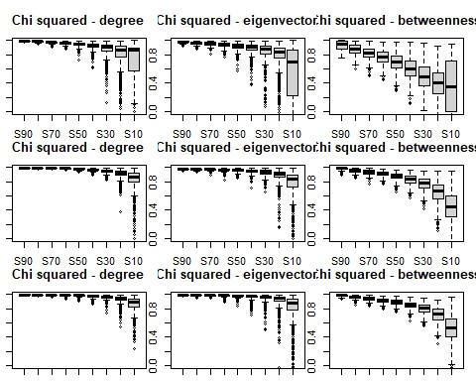
##Assess missing nodes within dataset
#NODE ASSESSMENT
nsim <- 1000 #set number of replicates

resamp.node <- function(x, samp.frac) { mat <- as.matrix(x) dim.x <- dim(mat)[1]
out.mat <- matrix(NA, dim.x, nsim) for (i in 1:nsim) {
sub.samp <- sample(seq(1, dim.x), size = round(dim.x * samp.frac, 0), replace = F)
# calculate centrality statistic for a given sub-sample and put in output
# matrix
temp.stats <- sna::degree(mat[sub.samp, sub.samp], gmode = "graph") out.mat[sub.samp, i] <- temp.stats
}
return(out.mat)
}
#ASSESSMENT OF DECORATIVE NETWORKS

# calculate the rank order of degree centrality in the CP network top.dg <- rank(-sna::degree(Pnet_d1), ties.method = "min") par(mfrow = c(2, 2))
P.resamp <- resamp.node(Pnet_d1, samp.frac = 0.8) #samp.frac is 80%
# calculate the rank order of the replicates and plot the top 4 as barplots # showing rank across all replicates
for (i in 1:4) {
barplot(table(apply(-P.resamp, 2, rank, ties.method = "random", na.last = " keep")[order(top.dg)[i],
]), main = paste("samp.frac=80%, rank = ", top.dg[order(top.dg)[i]])) }
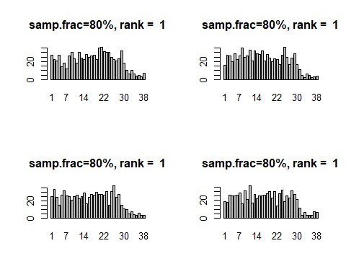
top.dg <- rank(-sna::degree(Pnet_d2), ties.method = "min") par(mfrow = c(2, 2))
P.resamp <- resamp.node(Pnet_d2, samp.frac = 0.8) #samp.frac is 80%
# calculate the rank order of the replicates and plot the top 4 as barplots
# showing rank across all replicates for (i in 1:4) {
barplot(table(apply(-P.resamp, 2, rank, ties.method = "random", na.last = " keep")[order(top.dg)[i],
]), main = paste("samp.frac=80%, rank = ", top.dg[order(top.dg)[i]])) }
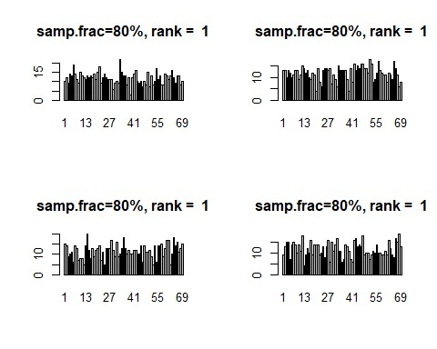
top.dg <- rank(-sna::degree(Pnet_d3), ties.method = "min") par(mfrow = c(2, 2))
P.resamp <- resamp.node(Pnet_d3, samp.frac = 0.8) #samp.frac is 80%
# calculate the rank order of the replicates and plot the top 4 as barplots # showing rank across all replicates

for (i in 1:4) {
barplot(table(apply(-P.resamp, 2, rank, ties.method = "random", na.last = " keep")[order(top.dg)[i],
]), main = paste("samp.frac=80%, rank = ", top.dg[order(top.dg)[i]])) }

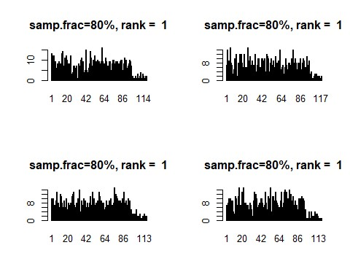
# calculate the rank order of degree centrality in the BR network top.dg <- rank(-sna::degree(BRnet_d1), ties.method = "min")
par(mfrow = c(2, 2))
BR.resamp <- resamp.node(BRnet_d1, samp.frac = 0.8) #samp.frac is 80%
# calculate the rank order of the replicates and plot the top 4 as barplots # showing rank across all replicates
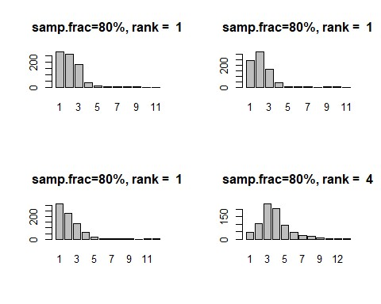
# calculate the rank order of degree centrality in the BR network top.dg <- rank(-sna::degree(BRnet_d2), ties.method = "min")
par(mfrow = c(2, 2))
BR.resamp <- resamp.node(BRnet_d2, samp.frac = 0.8) #samp.frac is 80%
# calculate the rank order of the replicates and plot the top 4 as barplots # showing rank across all replicates
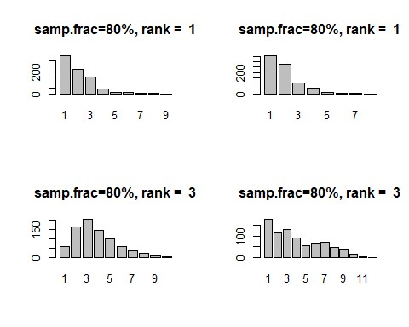
# calculate the rank order of degree centrality in the BR network top.dg <- rank(-sna::degree(BRnet_d3), ties.method = "min")
par(mfrow = c(2, 2))
BR.resamp <- resamp.node(BRnet_d3, samp.frac = 0.8) #samp.frac is 80%
# calculate the rank order of the replicates and plot the top 4 as barplots # showing rank across all replicates

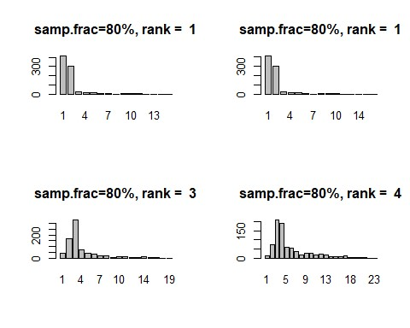
# calculate the rank order of degree centrality in the BR network top.dg <- rank(-sna::degree(Xnet_d1), ties.method = "min") par(mfrow = c(2, 2))
X.resamp <- resamp.node(Xnet_d1, samp.frac = 0.8) #samp.frac is 80%
# calculate the rank order of the replicates and plot the top 4 as barplots # showing rank across all replicates
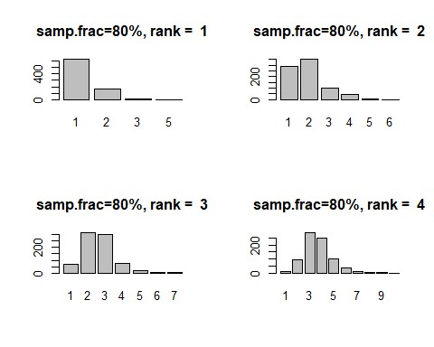
# calculate the rank order of degree centrality in the BR network top.dg <- rank(-sna::degree(Xnet_d2), ties.method = "min") par(mfrow = c(2, 2))
X.resamp <- resamp.node(Xnet_d2, samp.frac = 0.8) #samp.frac is 80%
# calculate the rank order of the replicates and plot the top 4 as barplots # showing rank across all replicates
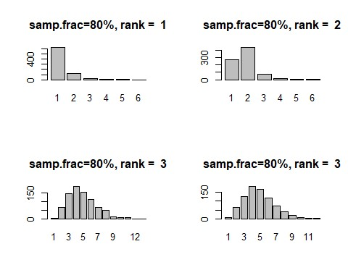
# calculate the rank order of degree centrality in the BR network top.dg <- rank(-sna::degree(Xnet_d3), ties.method = "min") par(mfrow = c(2, 2))
X.resamp <- resamp.node(Xnet_d3, samp.frac = 0.8) #samp.frac is 80%
# calculate the rank order of the replicates and plot the top 4 as barplots # showing rank across all replicates

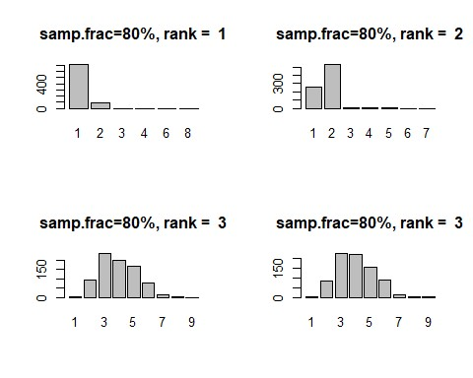
##Assess missing edges in dataset
# ASSESS MISSING EDGES
# set up to work with the output of net.stats nsim <- 1000
samp.frac <- c("S90", "S80", "S70", "S60", "S50", "S40", "S30", "S20", "S10")
cv.resamp.edge <- function(x) { stats.g <- net.stats(x) mat <- as.matrix(x) dim.x <- dim(mat)[1] dg.mat <- matrix(NA, nsim, 9) ev.mat <- matrix(NA, nsim, 9) bw.mat <- matrix(NA, nsim, 9) colnames(dg.mat) <- samp.frac colnames(ev.mat) <- samp.frac colnames(bw.mat) <- samp.frac

for (j in 1:9) { for (i in 1:nsim) {
sub.samp <- sample(seq(1, network.edgecount(x)), size = round(network.e dgecount(x) *
(j/10),
0), replace = F) temp.net <- x
net.reduced <- network::delete.edges(temp.net, sub.samp) temp.stats <- net.stats(net.reduced)

dg.mat[i, j] <- cor(temp.stats[, 1], stats.g[, 1], method = "spearman") ev.mat[i, j] <- cor(temp.stats[, 2], stats.g[, 2], method = "spearman") bw.mat[i, j] <- cor(temp.stats[, 3], stats.g[, 3], method = "spearman")
} }
out.list <- list() out.list[[1]] <- dg.mat out.list[[2]] <- ev.mat out.list[[3]] <- bw.mat return(out.list)
}

#ASSESS DECORATIVE NETWORKS

# run the script for our three binary networks
cop.edge.d <- cv.resamp.edge(Pnet_d1) BR.edge.d <- cv.resamp.edge(BRnet_d1)
X.edge.d <- cv.resamp.edge(Xnet_d1) cop.edge.d2 <- cv.resamp.edge(Pnet_d2)
BR.edge.d2 <- cv.resamp.edge(BRnet_d2)
X.edge.d2 <- cv.resamp.edge(Xnet_d2) cop.edge.d3 <- cv.resamp.edge(Pnet_d3) BR.edge.d3 <- cv.resamp.edge(BRnet_d3)
X.edge.d3 <- cv.resamp.edge(Xnet_d3)
par(mfrow = c(3, 3))
boxplot(cop.edge.d[[1]], ylim = c(0, 1), main = "Co-presence - degree", xlab
= "sampling fraction", ylab = "Spearmans rho")
boxplot(cop.edge.d[[2]], ylim = c(0, 1), main = "Co-presence - eigenvector", xlab = "sampling fraction")
boxplot(cop.edge.d[[3]], ylim = c(0, 1), main = "Co-presence - betweenness", xlab = "sampling fraction")
boxplot(BR.edge.d[[1]], ylim = c(0, 1), main = "BR - degree", xlab = "samplin g fraction",
ylab = "Spearmans rho")
boxplot(BR.edge.d[[2]], ylim = c(0, 1), main = "BR - eigenvector", xlab = "sa mpling fraction")
boxplot(BR.edge.d[[3]], ylim = c(0, 1), main = "BR - betweenness", xlab = "sa mpling fraction")
boxplot(X.edge.d[[1]], ylim = c(0, 1), main = "Chi squared - degree", xlab =
"sampling fraction", ylab = "Spearmans rho")
boxplot(X.edge.d[[2]], ylim = c(0, 1), main = "Chi squared - eigenvector", xl ab = "sampling fraction")
boxplot(X.edge.d[[3]], ylim = c(0, 1), main = "Chi squared - betweenness", xl ab = "sampling fraction")
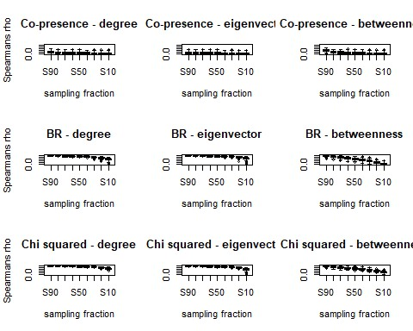
par(mfrow = c(3, 3))
boxplot(cop.edge.d2[[1]], ylim = c(0, 1), main = "Co-presence - degree", xlab
= "sampling fraction", ylab = "Spearmans rho")
boxplot(cop.edge.d2[[2]], ylim = c(0, 1), main = "Co-presence - eigenvector", xlab = "sampling fraction")
boxplot(cop.edge.d2[[3]], ylim = c(0, 1), main = "Co-presence - betweenness", xlab = "sampling fraction")
boxplot(BR.edge.d2[[1]], ylim = c(0, 1), main = "BR - degree", xlab = "sampli ng fraction",
ylab = "Spearmans rho")
boxplot(BR.edge.d2[[2]], ylim = c(0, 1), main = "BR - eigenvector", xlab = "s ampling fraction")
boxplot(BR.edge.d2[[3]], ylim = c(0, 1), main = "BR - betweenness", xlab = "s ampling fraction")
boxplot(X.edge.d2[[1]], ylim = c(0, 1), main = "Chi squared - degree", xlab =
"sampling fraction", ylab = "Spearmans rho")
boxplot(X.edge.d2[[2]], ylim = c(0, 1), main = "Chi squared - eigenvector", x lab = "sampling fraction")
boxplot(X.edge.d2[[3]], ylim = c(0, 1), main = "Chi squared - betweenness", x lab = "sampling fraction")
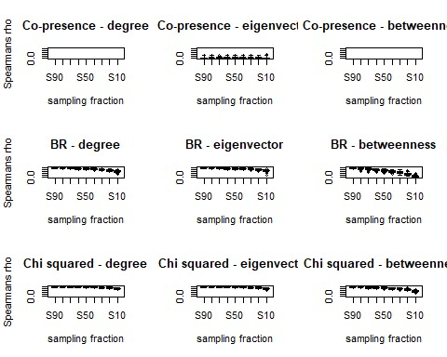
par(mfrow = c(3, 3))
boxplot(cop.edge.d3[[1]], ylim = c(0, 1), main = "Co-presence - degree", xlab
= "sampling fraction", ylab = "Spearmans rho")
boxplot(cop.edge.d3[[2]], ylim = c(0, 1), main = "Co-presence - eigenvector", xlab = "sampling fraction")
boxplot(cop.edge.d3[[3]], ylim = c(0, 1), main = "Co-presence - betweenness", xlab = "sampling fraction")
boxplot(BR.edge.d3[[1]], ylim = c(0, 1), main = "BR - degree", xlab = "sampli ng fraction",
ylab = "Spearmans rho")
boxplot(BR.edge.d3[[2]], ylim = c(0, 1), main = "BR - eigenvector", xlab = "s ampling fraction")
boxplot(BR.edge.d3[[3]], ylim = c(0, 1), main = "BR - betweenness", xlab = "s ampling fraction")
boxplot(X.edge.d3[[1]], ylim = c(0, 1), main = "Chi squared - degree", xlab =
"sampling fraction", ylab = "Spearmans rho")
boxplot(X.edge.d3[[2]], ylim = c(0, 1), main = "Chi squared - eigenvector", x lab = "sampling fraction")
boxplot(X.edge.d3[[3]], ylim = c(0, 1), main = "Chi squared - betweenness", x lab = "sampling fraction")
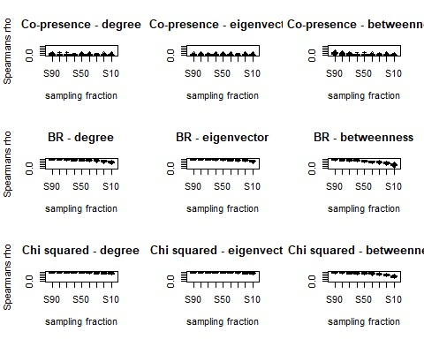
##Check for additional potential errors with missing data. This helps to validate our conclusions despite limited datasets
###CHECK FOR SAMPLING ERRORS AND BIASES IN DATASET
## This code was originally written by Peeples (2017) and uses ## simulations to check for sampling issues
nsim <- 100 # we use 100 simulations due to computational limitations. We did assess the data using larger numbers of simulations (200, 500, 1000) and it p rovided identical results, but also occasionally crashed the computer used fo r analysis.

net.prob <- function(x) { x <- as.matrix(x)
x[x < 0] <- 0 # define threshold for excluding edges net.list <- list() for (i in 1:nsim) { y <- x
for (j in 1:length(x)) {
y[j] <- rbinom(1, 1, prob = x[j])
}
net.list[[i]] <- network(y, directed = F)
}
return(net.list)
}

#ASSESS DECORATIVE NETWORKS
# Run the script on the BR similarity matrix
BRprob <- net.prob(d_data1BR)
# set up matrix and calculate eigenvector centrality for every replicate dg.mat <- matrix(NA, nrow(d_data1BR), nsim) for (i in 1:nsim) {
dg.mat[, i] <- sna::degree(BRprob[[i]])
}
# show boxplot of degree centrality sorted by the degree cent score in the
# original similarity matrix
boxplot(t(dg.mat[order(rowSums(d_data1BR)), ]), main = "Degree")
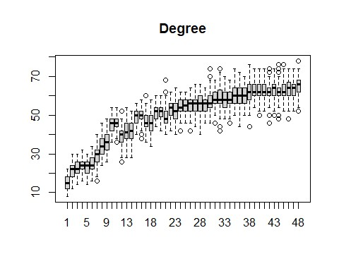
ev.mat <- matrix(NA, nrow(d_data1BR), nsim) for (i in 1:nsim) {
ev.mat[, i] <- sna::evcent(BRprob[[i]])
}
# show boxplot of eigenvector centrality sorted by the EV cent score in the
# original similarity matrix
boxplot(t(ev.mat[order(sna::evcent(d_data1BR)), ]), main = "Eigenvector")
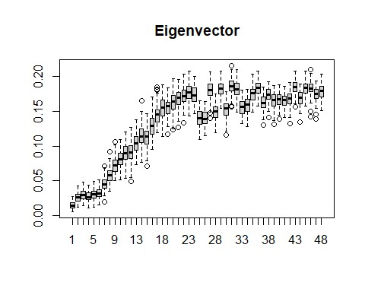
bw.mat <- matrix(NA, nrow(d_data1BR), nsim) for (i in 1:nsim) {
bw.mat[, i] <- sna::betweenness(BRprob[[i]])
}
# show boxplot of betweenness centrality sorted by the betweenness cent
# score in the original similarity matrix
boxplot(t(bw.mat[order(betweenness_w(d_data1BR)[, 2]), ]), main = "Betweennes s")
## Warning in as.tnet(net, type = "weighted one-mode tnet"): There were selfloops
## in the edgelist, these were removed
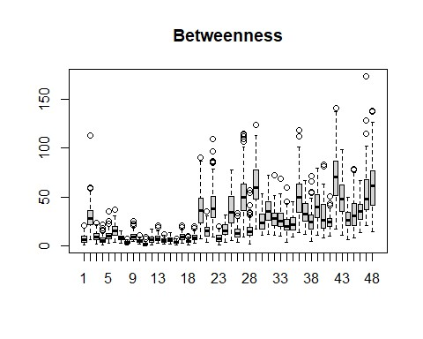
# Run the script on the BR similarity matrix
BRprob2 <- net.prob(d_data2BR)
# set up matrix and calculate eigenvector centrality for every replicate dg.mat <- matrix(NA, nrow(d_data2BR), nsim) for (i in 1:nsim) {
dg.mat[, i] <- sna::degree(BRprob2[[i]])
}
# show boxplot of degree centrality sorted by the degree cent score in the
# original similarity matrix
boxplot(t(dg.mat[order(rowSums(d_data2BR)), ]), main = "Degree")
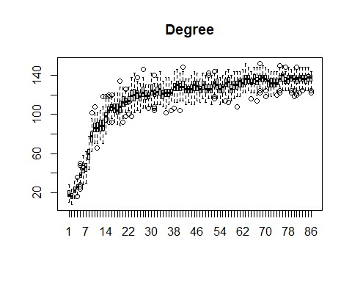
ev.mat <- matrix(NA, nrow(d_data2BR), nsim) for (i in 1:nsim) {
ev.mat[, i] <- sna::evcent(BRprob2[[i]])
}
# show boxplot of eigenvector centrality sorted by the EV cent score in the
# original similarity matrix
boxplot(t(ev.mat[order(sna::evcent(d_data2BR)), ]), main = "Eigenvector")
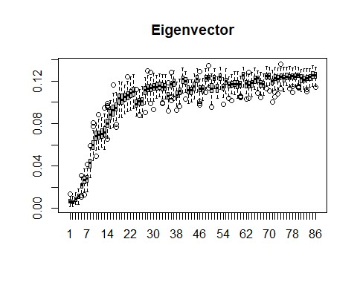
bw.mat <- matrix(NA, nrow(d_data2BR), nsim) for (i in 1:nsim) {
bw.mat[, i] <- sna::betweenness(BRprob2[[i]])
}
# show boxplot of betweenness centrality sorted by the betweenness cent
# score in the original similarity matrix
boxplot(t(bw.mat[order(betweenness_w(d_data2BR)[, 2]), ]), main = "Betweennes s")
## Warning in as.tnet(net, type = "weighted one-mode tnet"): There were selfloops
## in the edgelist, these were removed
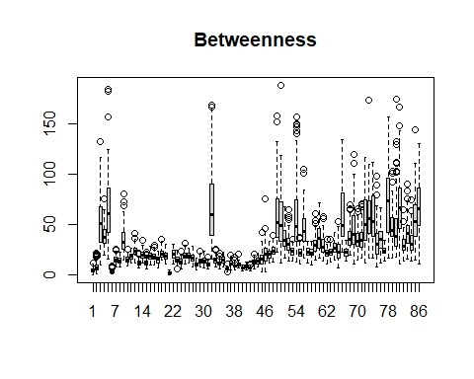
# Run the script on the BR similarity matrix
BRprob3 <- net.prob(d_data3BR)
# set up matrix and calculate eigenvector centrality for every replicate dg.mat <- matrix(NA, nrow(d_data3BR), nsim) for (i in 1:nsim) {
dg.mat[, i] <- sna::degree(BRprob3[[i]])
}
# show boxplot of degree centrality sorted by the degree cent score in the
# original similarity matrix
boxplot(t(dg.mat[order(rowSums(d_data3BR)), ]), main = "Degree")
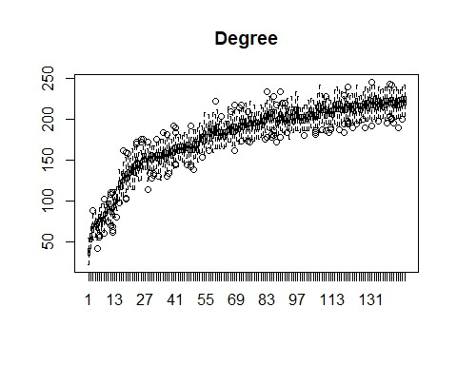
ev.mat <- matrix(NA, nrow(d_data3BR), nsim) for (i in 1:nsim) {
ev.mat[, i] <- sna::evcent(BRprob3[[i]])
}
# show boxplot of eigenvector centrality sorted by the EV cent score in the
# original similarity matrix
boxplot(t(ev.mat[order(sna::evcent(d_data3BR)), ]), main = "Eigenvector")
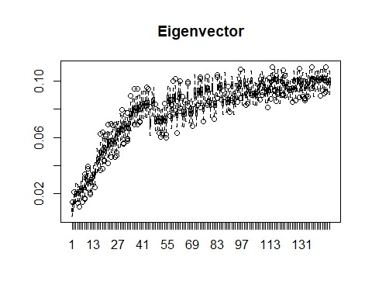
bw.mat <- matrix(NA, nrow(d_data3BR), nsim) for (i in 1:nsim) {
bw.mat[, i] <- sna::betweenness(BRprob3[[i]])
}
# show boxplot of betweenness centrality sorted by the betweenness cent
# score in the original similarity matrix
boxplot(t(bw.mat[order(betweenness_w(d_data3BR)[, 2]), ]), main = "Betweennes s")
## Warning in as.tnet(net, type = "weighted one-mode tnet"): There were selfloops
## in the edgelist, these were removed
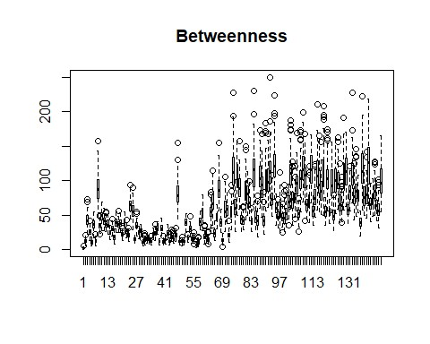
# Run the script on the X2 distance matrix
Xprob <- net.prob(d_data1X01)
# set up matrix and calculate eigenvector centrality for every replicate dg.mat <- matrix(NA, nrow(d_data1X01), nsim) for (i in 1:nsim) {
dg.mat[, i] <- sna::degree(Xprob[[i]])
}
# show boxplot of degree centrality sorted by the degree cent score in the
# original distance matrix
boxplot(t(dg.mat[order(rowSums(d_data1X01)), ]), main = "Degree")
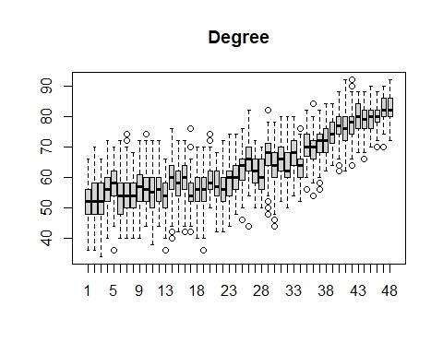
ev.mat <- matrix(NA, nrow(d_data1X01), nsim) for (i in 1:nsim) {
ev.mat[, i] <- sna::evcent(Xprob[[i]])
}
# show boxplot of eigenvector centrality sorted by the EV cent score in the
# original distance matrix
boxplot(t(ev.mat[order(sna::evcent(d_data1X01)), ]), main = "Eigenvector")
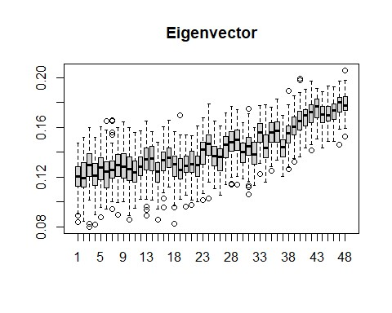
bw.mat <- matrix(NA, nrow(d_data1X01), nsim) for (i in 1:nsim) {
bw.mat[, i] <- sna::betweenness(Xprob[[i]])
}
# show boxplot of betweenness centrality sorted by the betweenness cent
# score in the original distance matrix
boxplot(t(bw.mat[order(betweenness_w(d_data1X01)[, 2]), ]), main = "Betweenne ss")
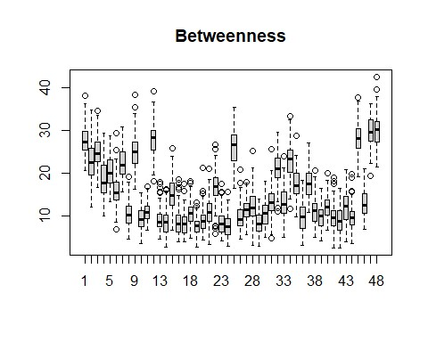
# Run the script on the X2 distance matrix
Xprob2 <- net.prob(d_data2X01)
# set up matrix and calculate eigenvector centrality for every replicate dg.mat <- matrix(NA, nrow(d_data2X01), nsim) for (i in 1:nsim) {
dg.mat[, i] <- sna::degree(Xprob2[[i]])
}
# show boxplot of degree centrality sorted by the degree cent score in the or iginal distance matrix
boxplot(t(dg.mat[order(rowSums(d_data2X01)), ]), main = "Degree")
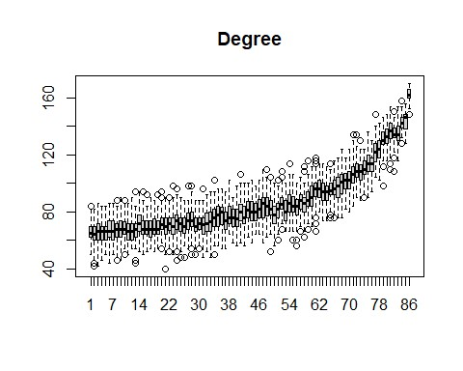
ev.mat <- matrix(NA, nrow(d_data2X01), nsim) for (i in 1:nsim) {
ev.mat[, i] <- sna::evcent(Xprob2[[i]])
}
# show boxplot of eigenvector centrality sorted by the EV cent score in the
# original distance matrix
boxplot(t(ev.mat[order(sna::evcent(d_data2X01)), ]), main = "Eigenvector")
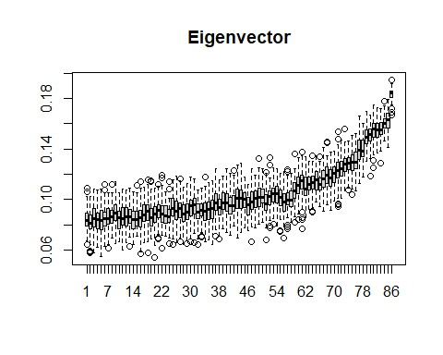
bw.mat <- matrix(NA, nrow(d_data2X01), nsim) for (i in 1:nsim) {
bw.mat[, i] <- sna::betweenness(Xprob2[[i]])
}
# show boxplot of betweenness centrality sorted by the betweenness cent
# score in the original distance matrix
boxplot(t(bw.mat[order(betweenness_w(d_data2X01)[, 2]), ]), main = "Betweenne ss")
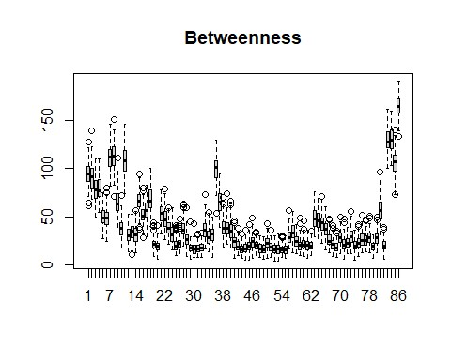
# Run the script on the X2 distance matrix
Xprob3 <- net.prob(d_data3X01)
# set up matrix and calculate eigenvector centrality for every replicate dg.mat <- matrix(NA, nrow(d_data3X01), nsim) for (i in 1:nsim) {
dg.mat[, i] <- sna::degree(Xprob3[[i]])
}
# show boxplot of degree centrality sorted by the degree cent score in the
# original distance matrix
boxplot(t(dg.mat[order(rowSums(d_data3X01)), ]), main = "Degree")
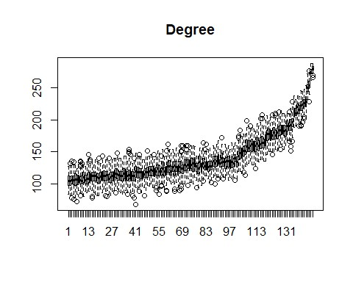
ev.mat <- matrix(NA, nrow(d_data3X01), nsim) for (i in 1:nsim) {
ev.mat[, i] <- sna::evcent(Xprob3[[i]])
}
# show boxplot of eigenvector centrality sorted by the EV cent score in the
# original distance matrix
boxplot(t(ev.mat[order(sna::evcent(d_data3X01)), ]), main = "Eigenvector")
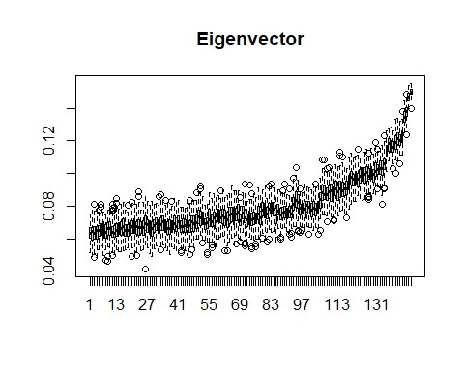
bw.mat <- matrix(NA, nrow(d_data3X01), nsim) for (i in 1:nsim) {
bw.mat[, i] <- sna::betweenness(Xprob3[[i]])
}
# show boxplot of betweenness centrality sorted by the betweenness cent
# score in the original distance matrix
boxplot(t(bw.mat[order(betweenness_w(d_data3X01)[, 2]), ]), main = "Betweenne ss")
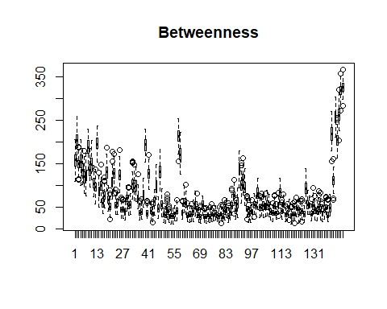

EVALUATE NETWORK DISTANCE CHANGES OVER TIME
library(igraph)
library(tidygraph)
#load each dataset as an igraph network object
early <- graph_from_data_frame(d_data1, directed = F)
middle <- graph_from_data_frame(d_data2, directed = F)
late <- graph_from_data_frame(d_data3, directed = F)
#Calculate the largest distance between nodes at each time period
diameter(early)
## [6]
diameter(middle)
## [4]
diameter(late)
## [4]

