Supplemental Material 1
Methods for: Ideal Distribution Models and the Tempo of Agricultural Development in a Windward Valley of Hawaiʻi
We constructed Bayesian models and tempo plots to evaluate the construction chronologies for traditional Hawaiian agricultural infrastructure in Punaluʻu Valley. This work adapted Morrison et al.’s (2022) Bayesian model for the colluvial slope complex (Sites 50-80-06-2927 and 7302) and integrated it with newly developed models to track changes in the irrigated terrace set (Site 50-80-06-2936). Additionally, we constructed the Bayesian model in such a way that we could query the relationships that infrastructural development in each environmental zone have with the date of Polynesian discovery of the archipelago, local environmental change, and the introduction of sweet potato.
Below, we describe the general structure of the Bayesian models and provide a further description of tempo plot construction and model stability. Data for these models were obtained from the excavation of 10 trenches through 14 terraces within the pondfield complex, with all trenches bisecting the stone facing of surface terraces. These trenches exposed stratified deposits with at least one buried pondfield soil, characterized by redoximorphic soil features and charcoal. As part of an earlier investigation, three small shovel test pits were excavated against the stone facings of terraces in order to obtain charcoal dating samples from beneath basal facing stones (Filimoehala et al. 2015). This builds upon work within the colluvial slope complex where 28 units (0.3 x 0.3 m to 1 x 1 m) were excavated over the course of three field seasons (Morrison et al. 2022). Excavation units abutted or sectioned surface features to document their construction and collect suitable dating samples. One shovel test pit was placed against the exterior fact of the northwest exterior wall of the heiau (Site 50-80-06-0296) within the colluvial slope complex. All radiocarbon dates from the irrigated facilities and colluvial slopes are provided in ST1.
Construction of Bayesian Model for Site 50-80-06-2936
Date estimates for the construction of architecture within Site 50-80-06-2936 (loʻi) were calculated using a set of sequences. These were built to be generally comparable to results presented in Morrison et al. (2022) to allow for chronological comparison between the different sites in Punaluʻu Valley. To construct models, all radiocarbon age were categorized as terminus post quem (TPQs) or terminus ante quem (TAQs) relative to architectural construction. A total of 12 events were of interest and 14 dates were associated with these events. Additionally, events of construction were also used as TPQs or TAQs when stratigraphic relationships between events could be observed. All events were built as separate sequences within a single model. Each sequence had a similar structure (after Dye 2016), though each sequence deviated slightly.
Date (Discovery “2022”) > Boundary (“Feature # Start”) > Phase (“Feature # TPQ”) > Boundary (“Feature # Construction) > Phase (“Feature # TAQ) > C_Date (AD 1950)
All sequences were constrained by a universal TPQ of Polynesian island discovery. This date is modelled after data in Athens et al. (2014) and was originally published using Oxcal commands by Dye (2016). One additional date has been added to this model, which is a U-Th dated piece of coral found within a religious structure and thought to date to the construction of that structure (Kirch et al. 2015; KOU CS-5a). Furthermore, one post-colonization date was removed (Beta-20852b) because of the size of its laboratory error range.
We tested three iterations of the Bayesian model using two different outlier structures, based on Christen (1994) and Dee and Bronk Ramsey (2014), as well as an iteration with no outlier commands. All three performed similarly and there is marked stability in the results of the three. Given the similarity of results, we chose to use the structure incorporating outlier models described by Christen (1994) as these provide posterior probabilities that individual dates are outliers. We are concerned with both issues of residuality for all ages and with potential inbuilt age for long-lived and medium-lived material. We assigned each date a prior outlier probability of 0.10.
Each sequence is described below with reference to specific TPQs and TAQs. Polynesian-introduced species are noted in the text. For other taxa identifications, see the table of radiocarbon dates below.
Trench 1 (see SF1): The construction dates for two architectural elements were estimated in this trench, a buried alignment and a surface retaining wall. One radiocarbon determination from Trench 1 (Beta-602309) and two radiocarbon determinations from Trench 2 (Beta-605045, -602308) constrain the construction of the buried alignment. The former dating sample was located directly beneath the buried alignment in a sandy clay loam (Layer V; alluvial) and is a TPQ. Beta-605045 was from an intact combustion feature at the interface between a sandy clay loam with common large clastics (Layer VI in Trench 2, Layer V in Trench 1) and a sandy clay to silty clay (Layer IIIb and IIIa; agricultural soil). As the buried alignment in Trench 1 derives from the sandy clay loam with large clastics, Beta-60545 acts as a TAQ for the construction of the alignment (see SF 2). Beta-602308 is from the silty clay (Layer IIIa) situated stratigraphically above the subsurface feature in Trench 2 and the determination derives from immediately below the surface retaining wall excavated by this trench (described below). The age estimate of the surface retaining wall in Trench 1 is constrained by the construction of the Trench 2 retaining wall as the former abuts the latter.

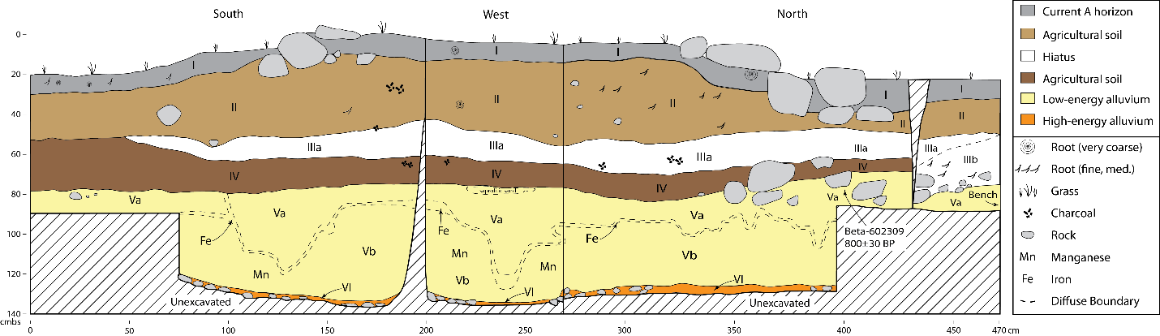
SF 1. Stratigraphic Profile of Trench 1
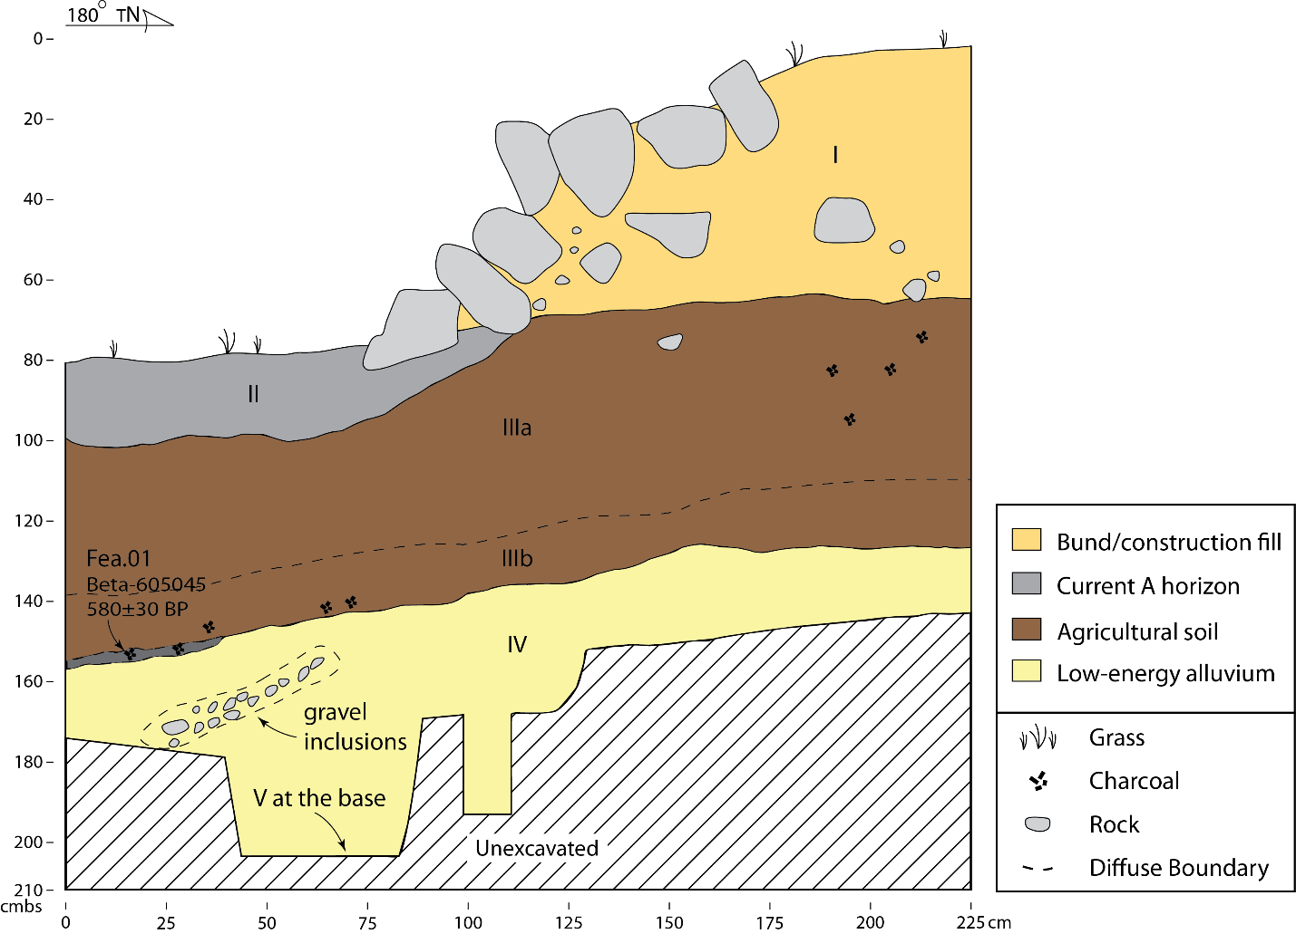
SF 2. Stratigraphic Profile of Trench 2. Beta-602308 is not shown because it was not taken from a location that was profiled.

Trench 2 (see SF 2): The construction date of one architectural element was estimated from this trench, the surface retaining wall. Two dating samples were recovered from stratigraphically inferior positions, both of which are described above (Beta-605045, -602308). Each of these determinations acts as a TPQ for the construction of this feature.
Trench 3 (see SF 3): The construction date for one architectural element was estimated from this trench, the surface retaining wall. Two determinations were obtained for the trench, and both of these provide TPQs for feature construction. Beta-605044 was recovered from a silty clay (Layer III) immediately below the basal stones of the retaining wall while Beta-605047 was recovered from the interface of a sandy loam (Layer VI; natural alluvium) and an overlying sandy clay matrix (Layer V; agricultural soil) that is stratigraphically inferior to the retaining wall.
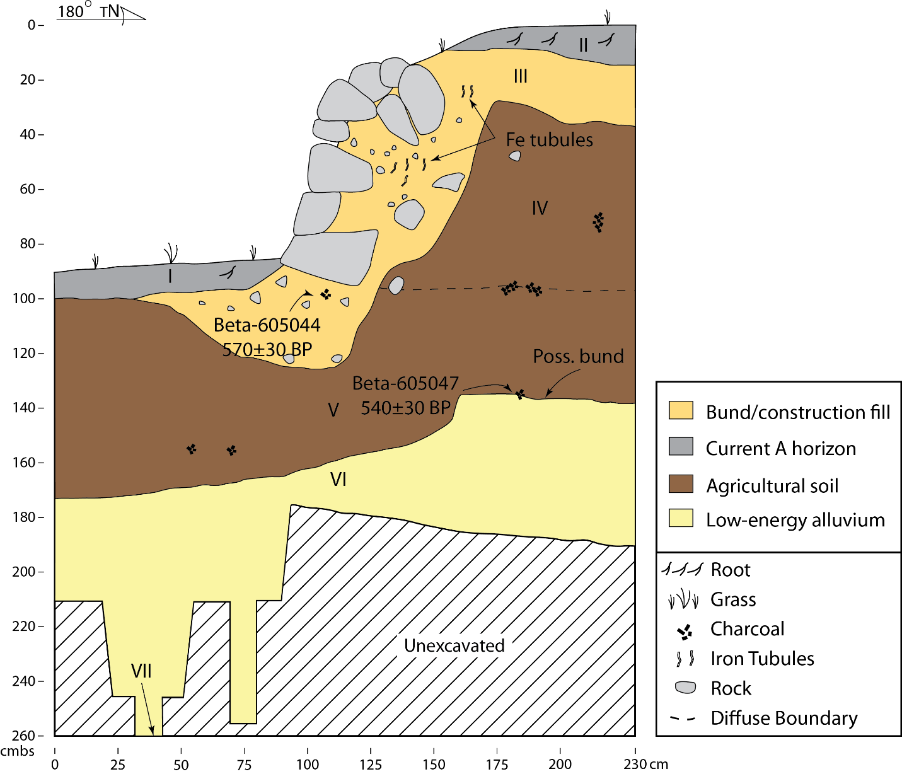
SF 3. Stratigraphic Profile of Trench 3.

Trench 4 (see SF 4): The construction date for the surface retaining wall was estimated in this trench using one radiocarbon determination (Beta-620794). The dating sample was taken from a silty clay (Layer III) immediately below the basal stones of the retaining wall and provides a TPQ for feature construction.
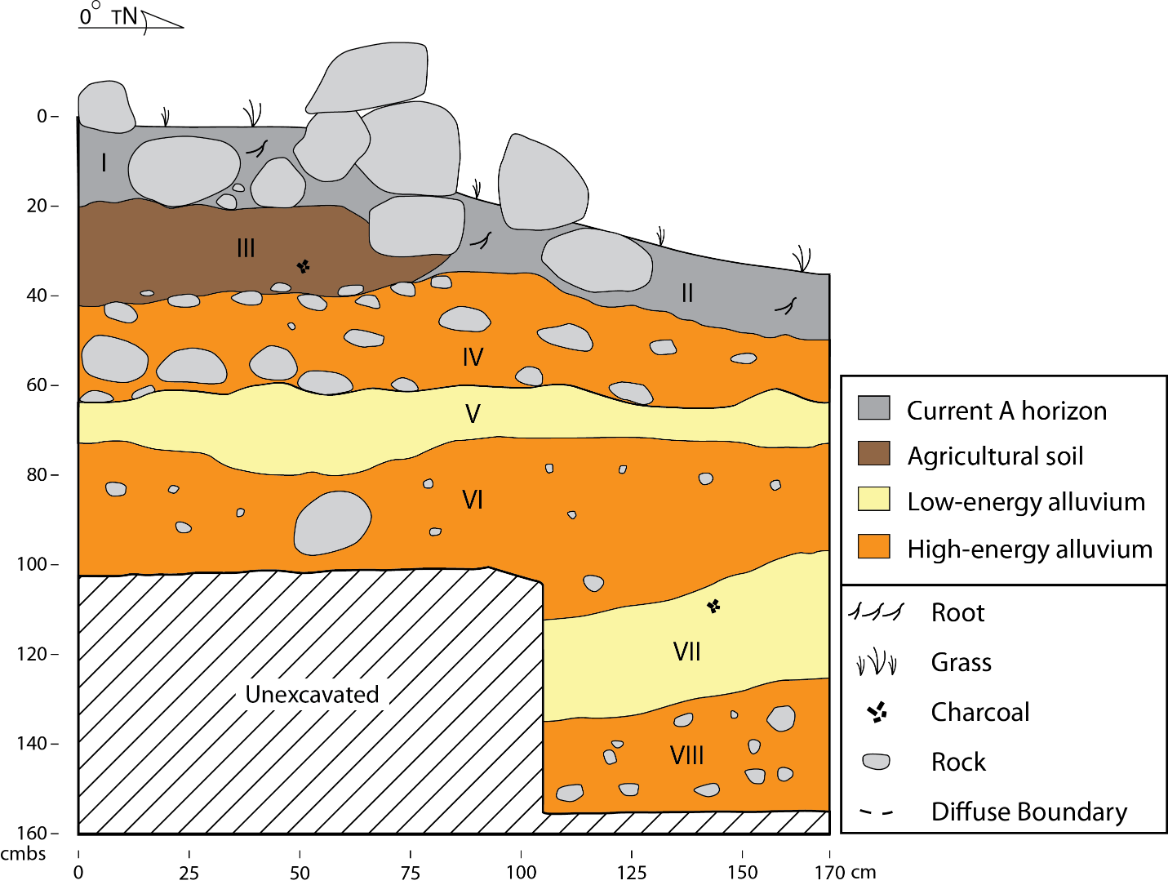
SF 4. Stratigraphic Profile of Trench 4. Beta-620794 is not shown because it was not taken from a location that was profiled.

Trench 6 (see SF 5): The construction date for a surface embankment was estimated in this trench using one radiocarbon determination (Beta-620795). The dating sample was taken from the top of a rocky sandy clay (Layer III, natural alluvium) near an interface with a silty clay (Layer II, agricultural soil). This determination provides a TPQ for the construction of the surface embankment.
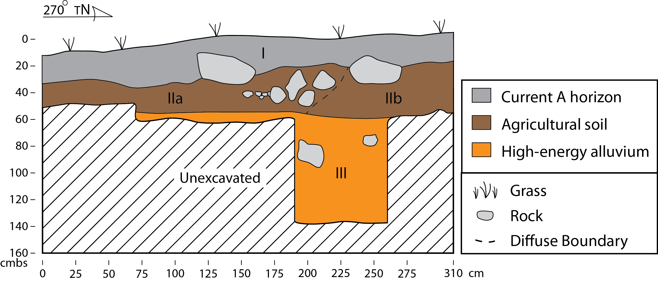
SF 5. Stratigraphic Profile of Trench 6. Beta-620795 is not shown because it was not taken from a location that was profiled.

Trench 7 (see SF 6): The construction dates for two architectural elements was estimated in this trench using three radiocarbon determinations. The lowest architectural element is a buried alignment/embankment situated within a rocky sandy clay loam (Layer VI, alluvial deposit). No charcoal was discovered below this alignment and the lone TPQ for this feature is the date of island discovery by Polynesians. As such, the highest posterior density (HPD) for this feature has a strong negative skew. Three radiocarbon determinations provide TAQs for the lower alignment. Beta-620796 was taken from a sandy clay (Layer IV, agricultural soil) above Layer VI. Beta-605046 was taken from an intact combustion feature at the interface between Layer IV and a later rocky sandy clay (Layer III, flood event). The last determination, Beta-602310, was taken from Layer III immediately beneath the basal stone of the surface retaining wall and stratigraphically above the intact feature. These three determinations serve as TPQs for the surface retaining wall and these dates are ordered stratigraphically in the model given their age-depth consistency.
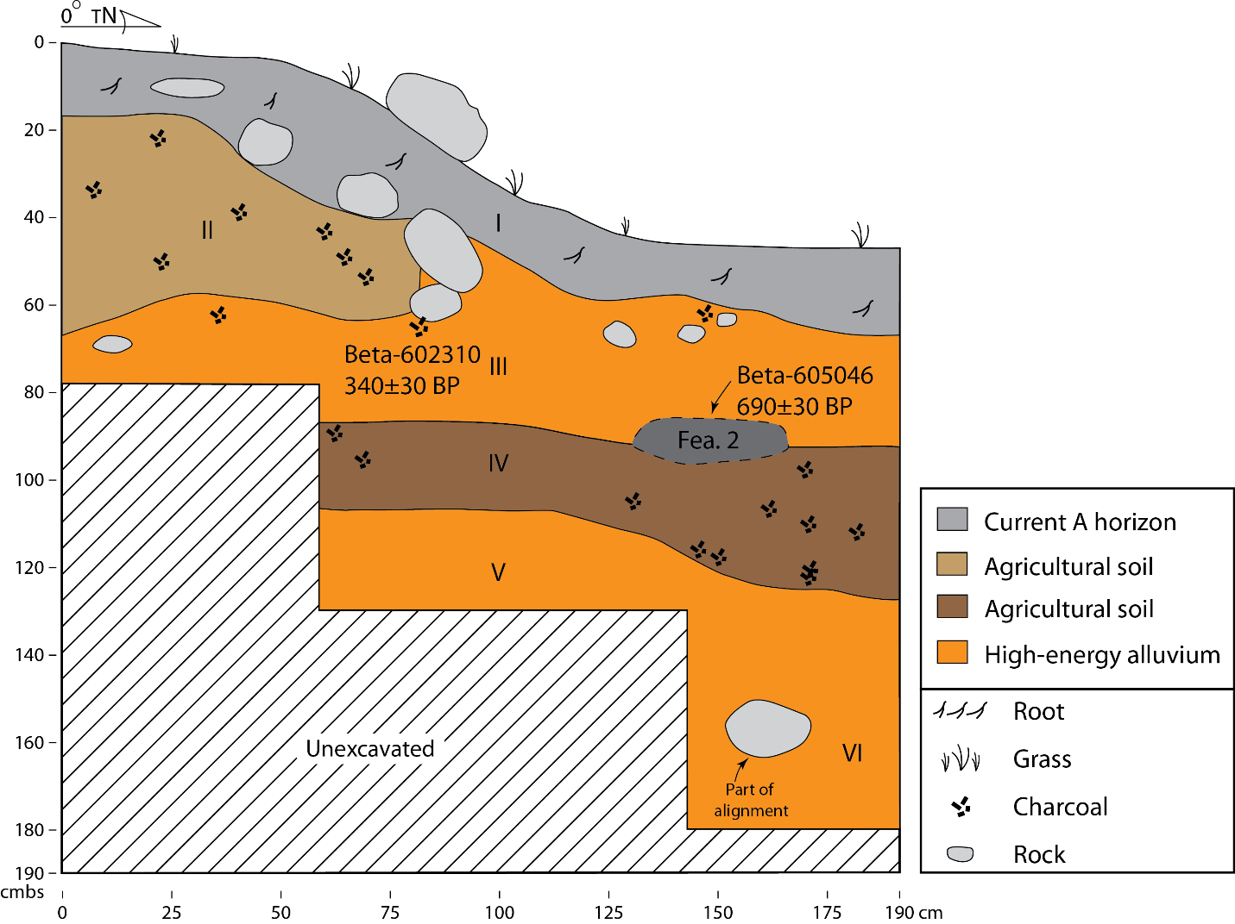
SF 6. Stratigraphic Profile of Trench 7. Beta-620796 is not shown because it was not taken from a location profiled.

Trench 8 and STP2 (see SF 7): The construction dates for two architectural elements, a buried retaining wall and subsequent surface retaining wall, were estimated. These two elements document two building phases for the terrace retaining wall. The date for the buried retaining wall (initial construction of the terrace edge) is based on one radiocarbon determination (Beta-602312) from Trench 8. That dating sample was taken from immediately beneath the basal stone of the buried feature and provides a TPQ for feature construction. The date for the surface retaining wall, which is essentially a veneer built along the buried retaining wall, is based on one radiocarbon determination (Beta-411588; see Filimoehala et al. 2015) from an adjacent test pit (STP2) excavated against the surface retaining wall (after methods in McElroy 2007). The single determination from STP2 provides a TPQ for the construction of the surface retaining wall and acts as a TAQ for the construction of the buried wall in Trench 8.
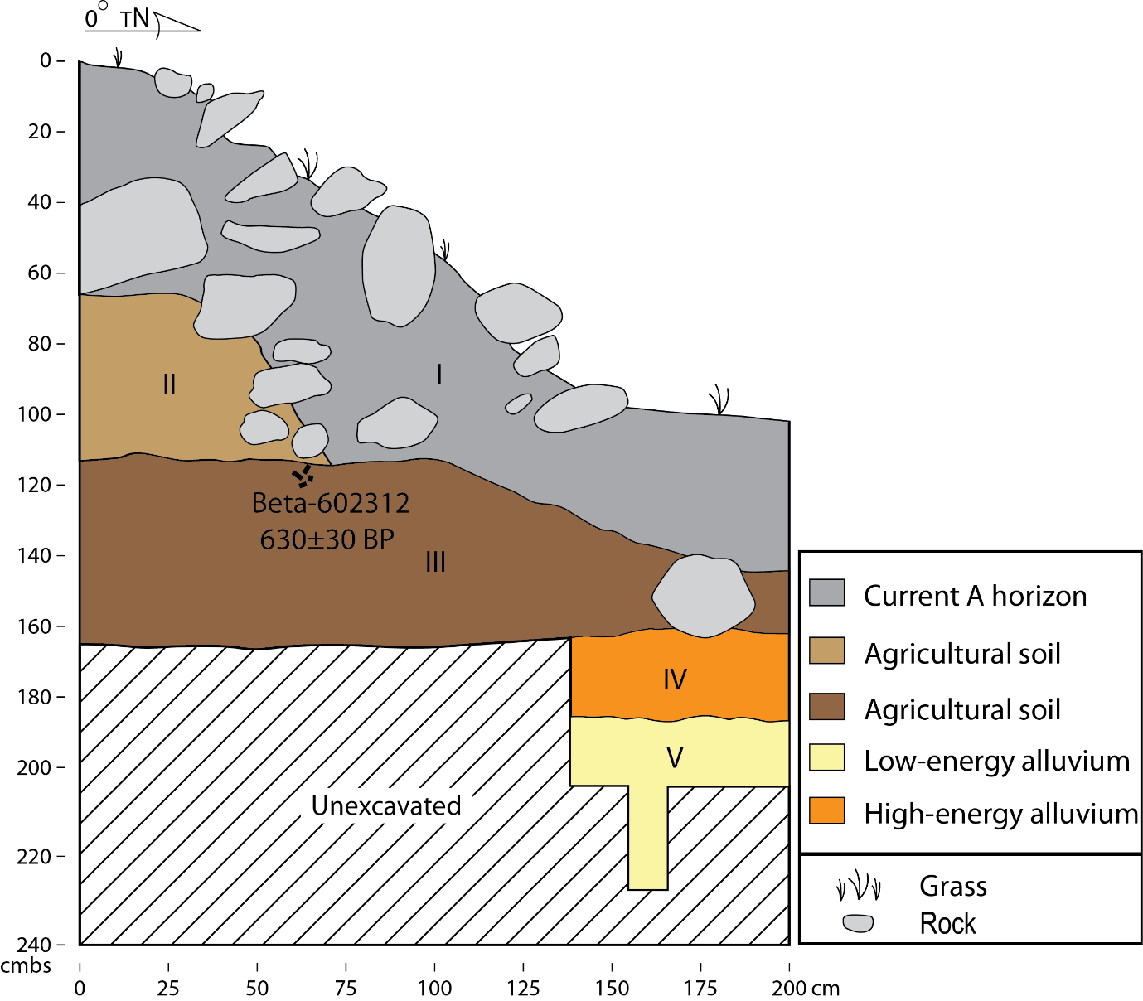
SF 7. Stratigraphic Profile of Trench 8.

Trench 9 (see SF 8): The construction dates of two architectural elements were estimated for this trench, a surface and buried retaining wall, using two determinations. Beta-602313 was taken from immediately beneath the basal stones of the buried retaining wall, at the interface between a rocky sandy clay loam (Layer V, alluvial deposit) and a silty clay (Layer IVa, agricultural embankment), while Beta-602311 was taken from immediately below the basal stones of the surface retaining wall in a silty clay (Layer III, agricultural embankment). The former date acts as a TPQ for the construction of the buried retaining wall. The latter date may act as a TAQ for the construction of the buried retaining wall, and both dates act as TPQs for the construction of the surface retaining wall. The date from immediately below the surface retaining wall is used as a TAQ in our Bayesian model given the age-depth consistency within the trench.
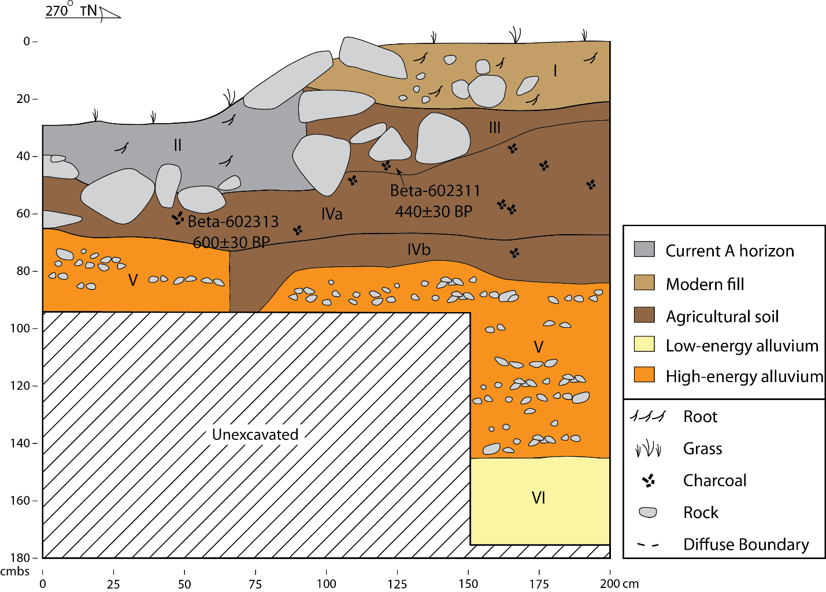
SF 8. Stratigraphic Profile of Trench 9.

Construction of Bayesian Model for Changing Depositional Environment
Excavations in the lo‘i uncovered a marked transition in the depositional environment from one characterized by the fluvial transport of large clastics and sandy sediments to one characterized by the fluvial and colluvial deposition of fine sediments. This transition was noted in all excavated units; evidence of agricultural activities, as is expected, was largely found in deposits of fine sediments but the early infrastructure was identified in deposits indicative of higher energy fluvial activity. Depositional change would affect the suitability of the environment for cultivation, with the environment becoming more suitable following the high-to-low energy change. Given the presence of radiocarbon determinations from both high- and low-energy depositional environments, we constructed a two-phase sequence in our Bayesian model to estimate the date of transition between depositional environments. The structure of the sequence assumes that such a change occurred across the site at roughly the same time. Radiocarbon determinations were grouped by the depositional environment within which they were found. Three were associated with high-energy fluvial deposits while eleven were associated with the deposition of fine sediments. The model structure is as follows:
Boundary (Begin Alluvium) > Phase (Alluvium) > Boundary (Depositional Change) > Phase (Agriculture)
Adaptation of Bayesian Model Presented in Morrison et al. (2022)
Estimates for the development of infrastructure along one colluvial slope in Punaluʻu have already been accomplished (Morrison et al. 2022). We incorporated the code from this prior work and adapted it to increase its comparability. The structure of the code was generally left as is, with the exception of replacing the .prior constraint with the universal TPQ employed in the lo‘i sequence. Furthermore, outlier models were applied to each date in the fashion we describe above. These revisions did not change the results described in Morrison et al. (2022) in any meaningful way.
Construction of Tempo Plots
Tempo plots were constructed using methods described in Morrison et al. (2022). The MCMC output generated in Oxcal by running the Bayesian model was exported as a .csv and used as the input to construct the tempo plot (see ST. 2). We used only events of feature construction to develop graphics in ArchaeoPhases.
The tempo_plot function of ArchaeoPhases was used in RStudio to produce the tempo plot. Tempo plots summarize the occurrence of archaeological events (Dye 2016). The slope of the tempo plot highlights the pace of change of some phenomenon. In this case, the slope of the tempo plot reflects the changing pace of loʻi construction. Default settings were used, which includes a 95% confidence interval. Three tempo plots were generated based on three different comparative events important to understanding habitat suitability. The first uses the date of island settlement by Polynesians, the second uses the change in depositional environment, and the third uses the introduction of sweet potato into the archipelago (Ladefoged et al. 2005). The first of these plots is presented in the main text while the other two are provided below (SF 9, 10).
The full R script is provided in an additional supplementary file.
Assessment of Model Performance, Model Stability, and Potential Outliers
We assess model performance with the OxCal indices, A_{model} and A_{overall}, generated during calibration of the no-outlier models, which we ran five times. These indices are meaningless when an outlier model is included in the calibration. Both indices are at or near the recommended threshold value of 60.0 during a run of the no-outlier model. During the final run of the five for the no-outlier model the A_{model} index was 61.7 and the A_{overall} index was 60.9. We interpret these results to mean that fit of data and model is acceptable, and that the calibrations are yielding reliable results.
The calibrations with the Christen (1994) outlier model and the no-outlier model each identify a potential outlier, Beta-45363. The date has a lower agreement than recommended, with an A value of 54.7 during calibration of the no-outlier model. This age determination is used to estimate Polynesian discovery and does not derive from Punalu‘u. The posterior outlier probabilities estimated during calibration with the Christen (1994) outlier model range from 0.06 to 0.35, with most values clustering between 0.06 and 0.21. The single potential outlier with a posterior outlier probability of 0.35 is Beta-411589, which was modeled and reported by Morrison et al. (2022). None of the age determinations from the Punalu‘u lo‘i were flagged as potential outliers during calibration. We interpret these results to indicate field procedures were sufficient to identify intrusive materials and that the materials submitted for radiocarbon dating from the lo‘i excavations are reliably associated with the contexts from which they derive.

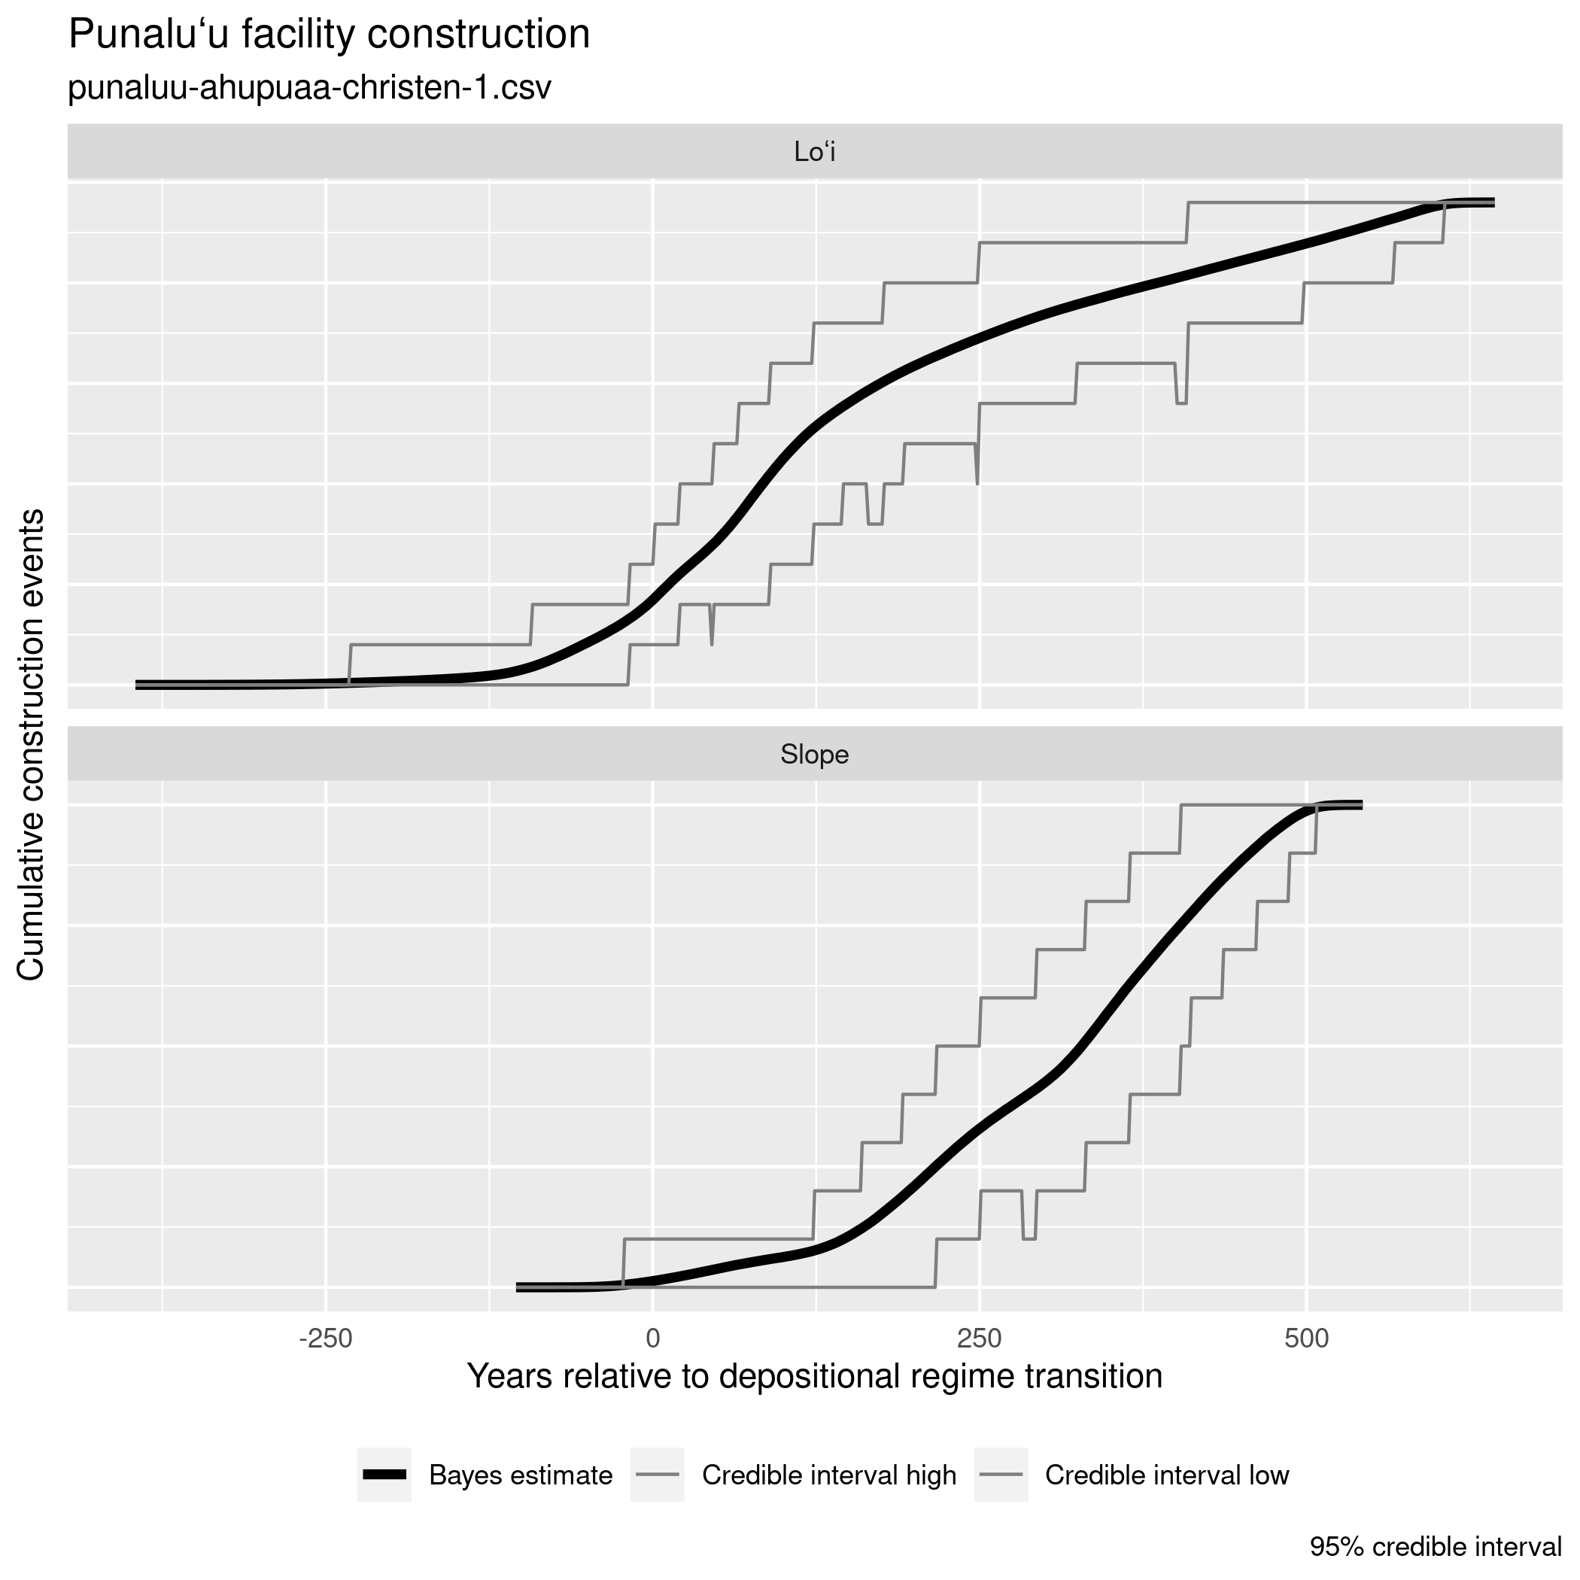
SF 9. The relationship between infrastructural construction and changing depositional environments along the alluvial terrace.

The stability of results over 5 independent calibrations of the outlier model was assessed with the estimate_range() function distributed with the ArchaeoPhases software package (ST 3). In every case, estimate means and medians vary 21 years or less, a value less than the laboratory standard deviation of any age determination in the calibration. As might be expected, variability is greater in the early and, especially, late tails of the estimates. The estimate for the upper 95% credible interval for the Trench 9 upper lo‘i wall construction is 70 years and for the Trench 3 retaining wall construction is 44 years. The third quantile of the estimate for the Trench 6 surface lo‘i construction is 46 years. These are the extreme variability values. All other statistics for estimates vary 30 years or less across calibrations. We interpret these results to mean that the calibration results are stable and reliable.

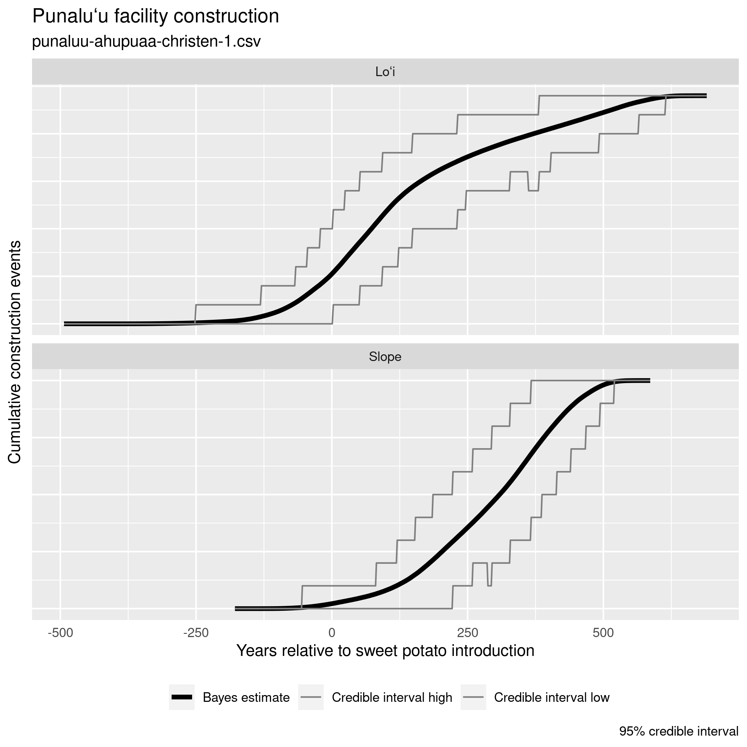
SF 10. The relationship between infrastructural construction and the introduction of sweet potato.

References
ATHENS, J.S., T.M. RIETH, & T.S. DYE. 2014. A paleoenvironmental and archaeological model-based age estimate for the colonization of Hawai‘i. American Antiquity 79: 144-155.
BRONK RAMSEY, C. 2009. Bayesian analysis of radiocarbon dates. Radiocarbon 51: 337–60
CHRISTEN, J.A. 1994. Summarizing a set of radiocarbon determinations: a robust approach. Applied Statistics 43: 489-503.
DEE, M.W., & C. BRONK RAMSEY. 2014. High-precision Bayesian modeling of samples susceptible to inbuilt age. Radiocarbon 56:83-94.
DYE, T.S. 2016. Long-term rhythms in the development of Hawaiian social stratification. Journal of Archaeological Science 71: 1-9.
FILIMOEHALA, C.W., M. J. TOMONARI-TUGGLE, T.M. RIETH, & D. FILIMOEHALA. 2015. Archaeological Inventory Survey of Punalu‘u Valley, Makaua, Punalu‘u, and Wai‘ono Ahupua‘a, Ko‘olaupoko Moku, O‘ahu; TMK (1) 5-3-001:041; (1) 5-3-003:001 (Portion); (1) 5-3-004:005, 007, 013, 018 (Portion), 019; (1) 5-3-007:023 (Portion); and (1) 5-3-011:001 (Portion). Prepared for Kamehameha Schools.
LADEFOGED, T.N., M.W. GRAVES, & J.H. COIL. 2005. The introduction of sweet potato in Polynesia: early remains from Hawaiʻi. Journal of the Polynesian Society 114: 359-373.
McELROY, W.K. & S. EMINGER. 2013. Revised Draft Archaeological Inventory Survey in Punalu‘u Ahupua‘a, Ko‘olauloa District, Island of O‘ahu. Prepared for Kamehameha Schools.
MORRISON, A. et al. 2022. Colluvial slope agriculture in context: An extensive agricultural landscape along the slopes of Punalu‘u Valley, O‘ahu Island, Hawai‘i. Journal of Island and Coastal Archaeology DOI: 10.1080/15564894.2021.1998936.
PHILIPPE A, M. VIBET, & T.S. DYE. 2017. ArchaeoPhases: post-processing of the Markov Chain simulated by ‘ChronoModel’, ‘Oxcal’ or ‘BCal’. R Package Version 1.
REIMER, P.J. et al. 2020. IntCal20 Northern Hemisphere radiocarbon age calibration curve (0-55 cal kBP). Radiocarbon 62: 725-757.
RIETH, T.M., S. QUINTUS, C.W. FILIMOEHALA, D. FILIMOEHALA, & T.S. DYE. 2021. Archaeological data recovery at Site 50-80-06-2936, Punalu’u Ahupua‘a, Ko‘olauloa Moku, O‘ahu. Report prepared for Kamehameha Schools, Wahi Kūpuna Program.

ST 2. Radiocarbon dates from Punaluʻu. All dates from the irrigated facility are reported for the first time here while those from the colluvial slopes were reported first in Morrison et al. (2022). Dates were calibrated in Oxcal 4.4 (Bronk Ramsey 2009) using the IntCal20 (Reimer et al. 2020)

Irrigated Facility
Beta Number | Trench | Location | Taxon | CRA (BP) | ¹³C/¹²C Ratio (‰) | Unmodelled Calibrated Age | Relationship to Infrastructure | Relationship to Depositional Change
602309 | 1 | Under Basal Stone of Buried Wall | cf. Nestegis sandwicensis | 800±30 | -25.1 | AD 1180-1189 (1.8%), 1210-1279 (93.7%) | TPQ of T1 Buried Wall | High Energy Alluvial
602308 | 2 | Under Basal Stones of Surface Wall | cf. Sideroxylon polynesicum | 540±30 | -28.5 | AD 1322-1356 (26%), 1391-1437 (69.5%) | TPQ of T2 Surface Wall and TAQ of T1 Buried Wall | Fine Sediments
605045 | 2 | Stratigraphically Above Buried Alignment | cf. Bidens sp. | 580±30 | -24.6 | AD 1305-1365 (64.6%), 1383-1419 (30.9%) | TAQ for T1 Buried wall. TPQ for T2 Wall | High Energy Alluvial
605047 | 3 | Under Basal Stones of Surface Wall | Aleurites moluccana endocarp | 540±30 | -25.5 | AD 1322-1356 (26%), 1391-1437 (69.5%) | TPQ for T3 | Fine Sediments
605044 | 3 | Under Basal Stones of Surface Wall | cf. Psychotria sp. | 570±30 | -25.7 | AD 1306-1364 (57.7%), 1385-1424 (37.7%) | TPQ for T3 | Fine Sediments
620794 | 4 | Under Basal Stones of Surface Wall | Indeterminate hardwood | 340±30 | -27.4 | AD 1474-1638 | TPQ for T4 Surface wall | Fine Sediments
620795 | 6 | Stratigraphically Below Surface Wall | Indeterminate hardwood | 560±30 | -27.6 | AD 1312-1362 (48.6%), 1387-1428 (46.9%) | TPQ for T6 Surface wall and buried wall | High Energy Alluvial
602310 | 7 | Under Basal Stones of Surface Wall | cf. Syzygium malaccense | 340±30 | -24 | AD 1474-1638 | TPQ of T7 Buried Wall | Fine Sediments
620796 | 7 | Stratigraphically Above Buried Alignment | cf. Scaevola sericea | 620±30 | -26.5 | AD 1296-1400 | TPQ for surface wall. Probable TAQ for buried wall | Fine Sediments
605046 | 7 | Stratigraphically Above Buried Alignment | cf. Nestegis sandwicensis | 690±30 | -29 | AD 1272-1317 (65.8%), 1360-1389 (29.6%) | TPQ for T7 Surface Wall, TAQ for earlier wall | Fine Sediments
602312 | 8 | Under Basal Stones of Buried Wall | cf. Sideroxylon polynesicum | 630±30 | -27.6 | AD 1293-1398 | TPQ of T8 Surface Wall | Fine Sediments
602311 | 9 | Under Basal Stones of Surface Wall | cf. Euphorbia sp. | 440±30 | -9.9 | AD 1419-1495 (94.2%), 1602-1610 (1.3%) | TPQ of T9 Surface Wall and TAQ of T9 Buried Wall | Fine Sediments
602313 | 9 | Under Basal Stones of Buried Wall | Indeterminate hardwood | 600±30 | -24.1 | AD 1301-1371 (71%), 1377-1408 (24.5%) | TPQ of T9 Buried Wall | Fine Sediments
411588 | STP2 | Under Basal Stones of Surface Wall | cf. Psychotria sp. | 150±30 | -24.1 | AD 1667-1783 (42.7%), 1796-1895 (33.9%), 1903- (18.9%) | STP TPQ | Fine Sediments
Colluvial Slopes
Beta Number | Feature | Location | Taxon | CRA (BP) | ¹³C/¹²C Ratio (‰) | Unmodelled Calibrated Age | Relationship to Infrastructure
514258 | 33 | Under Basal Stones of Surface Wall | Artocarpus altilis | 390±30 | -24.9 | AD 1442-1524 (67.1%), 1571-1631 (28.4%) | TPQ for the construction of terrace wall in Field 1; date for Poly. plant introduction and arboriculture in Punalu‘u
514259 | B-B | Under Basal Stones of Surface Wall | Nothocestrum sp. | 610±30 | -25.7 | AD 1299-1404 | TPQ for the construction of linear mound in Field 1
514256 | H-D (South) | Under Basal Stones of Surface Wall | Aleurites moluccana endocarp | 270±30 | -25.8 | AD 1510-1593 (43%), AD 1618-1669 (45.7%), AD 1781-1798 (6.7%) | TPQ for the construction of linear mound in Field 6; date for Poly. plant introduction and arboriculture in Punalu‘u
514257 | H-D (South) | Under Basal Stones of Surface Wall | Artocarpus altilis | 450±30 | -25.5 | AD 1412-1480 | TPQ for the construction of linear mound in Field 6; date for Poly. plant introduction and arboriculture in Punalu‘u
514260 | H-D (North) | Under Basal Stones of Surface Wall | Xylosma hawaiiense | 300±30 | -25.6 | AD1495-1602 (69.4%), AD 1610-1656 (26%) | TPQ for the construction of linear mound in Field 6
411591 | J | Under Basal Stones of Surface Wall | Psychotria sp. | 310±30 | -26.2 | AD 1490-1649 | TPQ for the construction of terrace feature
411590 | O | Under Basal Stones of Surface Wall | Psychotria sp. | 110±30 | -26.4 | AD 1682-1738 (25.7%), AD1754-1762 (1.1%), AD 1801-1938 (68.6%) | TPQ for the construction of terrace feature
411589 | Heiau | Under Basal Stones of Surface Wall | cf. Dodonaea viscosa | 210±30 | -27.4 | AD 1642-1690 (30.8%), 1728-1809 (53.6%), AD 1923- (11.1%) | TPQ for the construction of heiau
556931 | T | Under Basal Stones of Surface Wall | Wikstroemia sp. | 160±30 | -24.9 | AD 1663-1708 (16.8%), 1719-1786 (31.5%), 1792-1820 (10%), 1832-1893 (17.7%), 1906- (19.5%) | TPQ for the construction of linear mound abutting heiau
548833 | U | Under Basal Stones of Surface Wall | Aleurites moluccana endocarp | 330±30 | -25 | AD 1480-1640 | TPQ for construction of the terrace (Fea. U); direct date on a Poly. introduction
548834 | U | Under Basal Stones of Surface Wall | Acacia koa | 350±30 | -26.5 | AD 1461-1530 (39.7%), 1539-1636 (55.7%) | TPQ for construction of the terrace (Fea. U)
548835 | U | Under Basal Stones of Surface Wall | Cocos nucifera endocarp | 330±30 | -24.5 | AD 1480-1640 | TPQ for construction of the terrace (Fea. U); direct date on a Poly. introduction
548836 | U | Under Basal Stones of Surface Wall | Acacia koa | 320±30 | -26.1 | AD 1484-1644 | TPQ for construction of the terrace (Fea. U)
556928 | D | Under Basal Stones of Surface Wall | Aleurites moluccana endocarp | 350±30 | -25 | AD 1461-1530 (39.7%), 1539-1636 (55.7%) | TPQ for enclosure wall (Fea. D); direct date on Poly. introduction
548831 | D | Above Buried Paving | Artocarpus altilis | 340±30 | -25.6 | AD 1474-1638 | TAQ for buried pavement; direct date on a Poly. introduction
548832 | D | Above Buried Paving | Bidens sp. | 380±30 | -27.6 | AD 1447-1525 (59.1 %), 1588-1632 (36.3%) | TAQ for buried pavement
556930 | D | Below Buried Paving | Diospyros sandwicensis | 690±30 | -24.6 | AD 1272-1317 (65.8%), 1360-1389 (29.6%) | TPQ for buried pavement
548837 | D | Above Buried Paving | Indeterminate monocot | 260±30 | -10.8 | AD 1515-1591 (29.4 %), 1620-1674 (52.6%), 1767-1800 (13.5%) | TAQ for buried pavement
556929 | D | Below Buried Paving | Indeterminate charcoal | 970±30 | -25.3 | AD 1022-1159 | TPQ for buried pavement

ST2. Statistical summaries of the MCMC output generated by the Bayesian model.
 | Mean | Standard Deviation | Lower Credible Interval (95%) | Upper Credible Interval (95%)
Trench 7 Alluvial Loʻi Alignment | 1280 | 79 | 1105 | 1382
Trench 1 Lower Loʻi Wall Construction | 1288 | 26 | 1238 | 1334
Depositional Regime change | 1341 | 13 | 1315 | 1365
Trench 9 Lower Loʻi Wall Construction | 1415 | 33 | 1349 | 1469
Trench 2 Surface Loʻi Wall Construction | 1439 | 106 | 1314 | 1669
Trench 3 Loʻi Retaining Wall Construction | 1473 | 110 | 1331 | 1740
Trench 6 Surface Loʻi Wall Construction | 1490 | 177 | 1305 | 1887
Trench 9 Upper Loʻi Wall Construction | 1525 | 107 | 1407 | 1792
Trench 1 Surface Loʻi Wall Construction | 1511 | 154 | 1326 | 1858
Trench 8 Surface Loʻi Wall Construction | 1620 | 143 | 1367 | 1863
Trench 7 Surface Loʻi Wall Construction | 1617 | 113 | 1459 | 1869
Trench 4 Surface Loʻi Wall Construction | 1705 | 125 | 1519 | 1949
STP 2 Loʻi Retaining Wall Construction | 1850 | 72 | 1715 | 1951
Feature B-B Construction | 1448 | 105 | 1302 | 1675
Feature D Construction | 1527 | 32 | 1467 | 1587
N Heiau Wall Construction | 1653 | 66 | 1525 | 1764
Feature 33 Construction | 1663 | 107 | 1490 | 1848
Feature H-D South Construction | 1671 | 92 | 1534 | 1847
Feature J Construction | 1677 | 91 | 1538 | 1848
Feature H-D North Construction | 1680 | 89 | 1543 | 1848
Feature U Construction | 1688 | 72 | 1557 | 1815
Feature T Construction | 1751 | 42 | 1683 | 1819
Feature O Construction | 1780 | 46 | 1706 | 1848

ST 3. Variability in years of parameter estimates across five calibrations
 | mean | q1 | median | q3 | ci.inf | ci.sup
Ipomoea batatas | 0 | 0 | 1 | 0 | 1 | 0
Discovery (2022) | 3 | 6 | 5 | 3 | 6 | 1
Regime change | 1 | 1 | 1 | 0 | 2 | 1
Trench 1 Lower Lo‘i Wall Construction | 1 | 1 | 1 | 0 | 3 | 2
Trench 2 Surface Lo‘i Wall Construction | 14 | 6 | 12 | 22 | 2 | 33
Trench 1 Surface Lo‘i Wall Construction | 27 | 14 | 25 | 48 | 5 | 28
Trench 8 Early Lo‘i Wall Construction | 8 | 13 | 13 | 6 | 3 | 3
Trench 9 Lower Lo‘i Wall Construction | 1 | 2 | 0 | 1 | 1 | 3
Trench 9 Upper Lo‘i Wall Construction | 11 | 2 | 5 | 17 | 8 | 53
Trench 3 Lo'i Retaining Wall Construction | 6 | 1 | 2 | 7 | 7 | 27
Trench 7 Alluvial Lo‘i Alignment | 6 | 10 | 4 | 2 | 10 | 3
Trench 7 Surface Lo‘i Wall Construction | 9 | 5 | 8 | 16 | 4 | 20
STP 2 Lo'i Retaining Wall Construction | 3 | 4 | 4 | 2 | 3 | 0
Trench 4 Surface Lo‘i Wall Construction | 11 | 8 | 16 | 16 | 15 | 13
Trench 6 Surface Lo‘i Wall Construction | 11 | 3 | 10 | 27 | 2 | 11
Feature B-B Construction | 10 | 4 | 7 | 17 | 2 | 23
Feature 33 Construction | 11 | 16 | 15 | 12 | 7 | 1
Feature D Construction | 2 | 2 | 2 | 2 | 3 | 4
Feature H-D South Construction | 5 | 4 | 4 | 8 | 2 | 2
Feature H-D North Construction | 3 | 2 | 4 | 5 | 2 | 0
Feature J Construction | 2 | 2 | 2 | 2 | 1 | 0
N Heiau Wall Construction | 2 | 6 | 1 | 1 | 6 | 2
Feature U Construction | 3 | 7 | 2 | 2 | 8 | 3
Feature T Construction | 1 | 2 | 2 | 2 | 2 | 0
Feature O Construction | 0 | 1 | 1 | 0 | 1 | 0

