The epigraphic stela of Montoro (Córdoba): the earliest monumental script in Iberia?
Leonardo García Sanjuán^{1,*}, Marta Díaz-Guardamino², David W.Wheatley², Juan-Pablo Vita Barra³, José Antonio Lozano Rodríguez⁴, Miguel Ángel Rogerio-Candelera⁵, Ángel Justo Erbez⁶, Dominique Barker², Kris Strutt²&Manuel Casado Ariza¹

¹Departamento de Prehistoria y Arqueología, Universidad de Sevilla, Calle Doña María de Padilla s/n, 41004 Seville, Spain
²Department of Archaeology, Southampton University, University Road, Southampton SO17 1BJ, UK
³ Instituto de Lenguas y Culturas del Mediterráneo y Oriente Próximo, Consejo Superior de Investigaciones Científicas (CSIC), Calle Albasanz 26–28, 28037 Madrid, Spain
⁴Instituto Andaluz de Ciencias de la Tierra, CSIC-Universidad de Granada, Avenida de las Palmeras 4, 18100 Armilla, Granada, Spain
⁵Instituto de Recursos Naturales y Agrobiología, Consejo Superior de Investigaciones Científicas (CSIC), Avenida Reina Mercedes 10, 41012 Seville, Spain
⁶Instituto de Ciencia de Materiales, CSIC-Universidad de Sevilla, Calle Américo Vespucio 49, 41092 Seville, Spain
*Author for correspondence (Email: lgarcia@us.es)

A remarkable stela from Montoro, southern Spain, is unique in its morphology, epigraphic traits and landscape context.A programme of chemical characterisation, digital imaging, and geo-lithological and epigraphic analyseswas conducted to determine its age and significance, and the results were integrated with data fromarchaeological investigations of the surrounding area. This multi-faceted approach allowed the stela to be interpreted within the context of early interactions betweenliterate Mediterranean societies of the Late Bronze Age and Iron Age and non-literate Iberian societies. A key outcome of this research is a wider understanding of the complex patternsin the use and perception of early scripts.

Keywords: Spain, Montoro, Torre de Villaverde, Late Bronze Age, Iron Age, stela, epigraphy
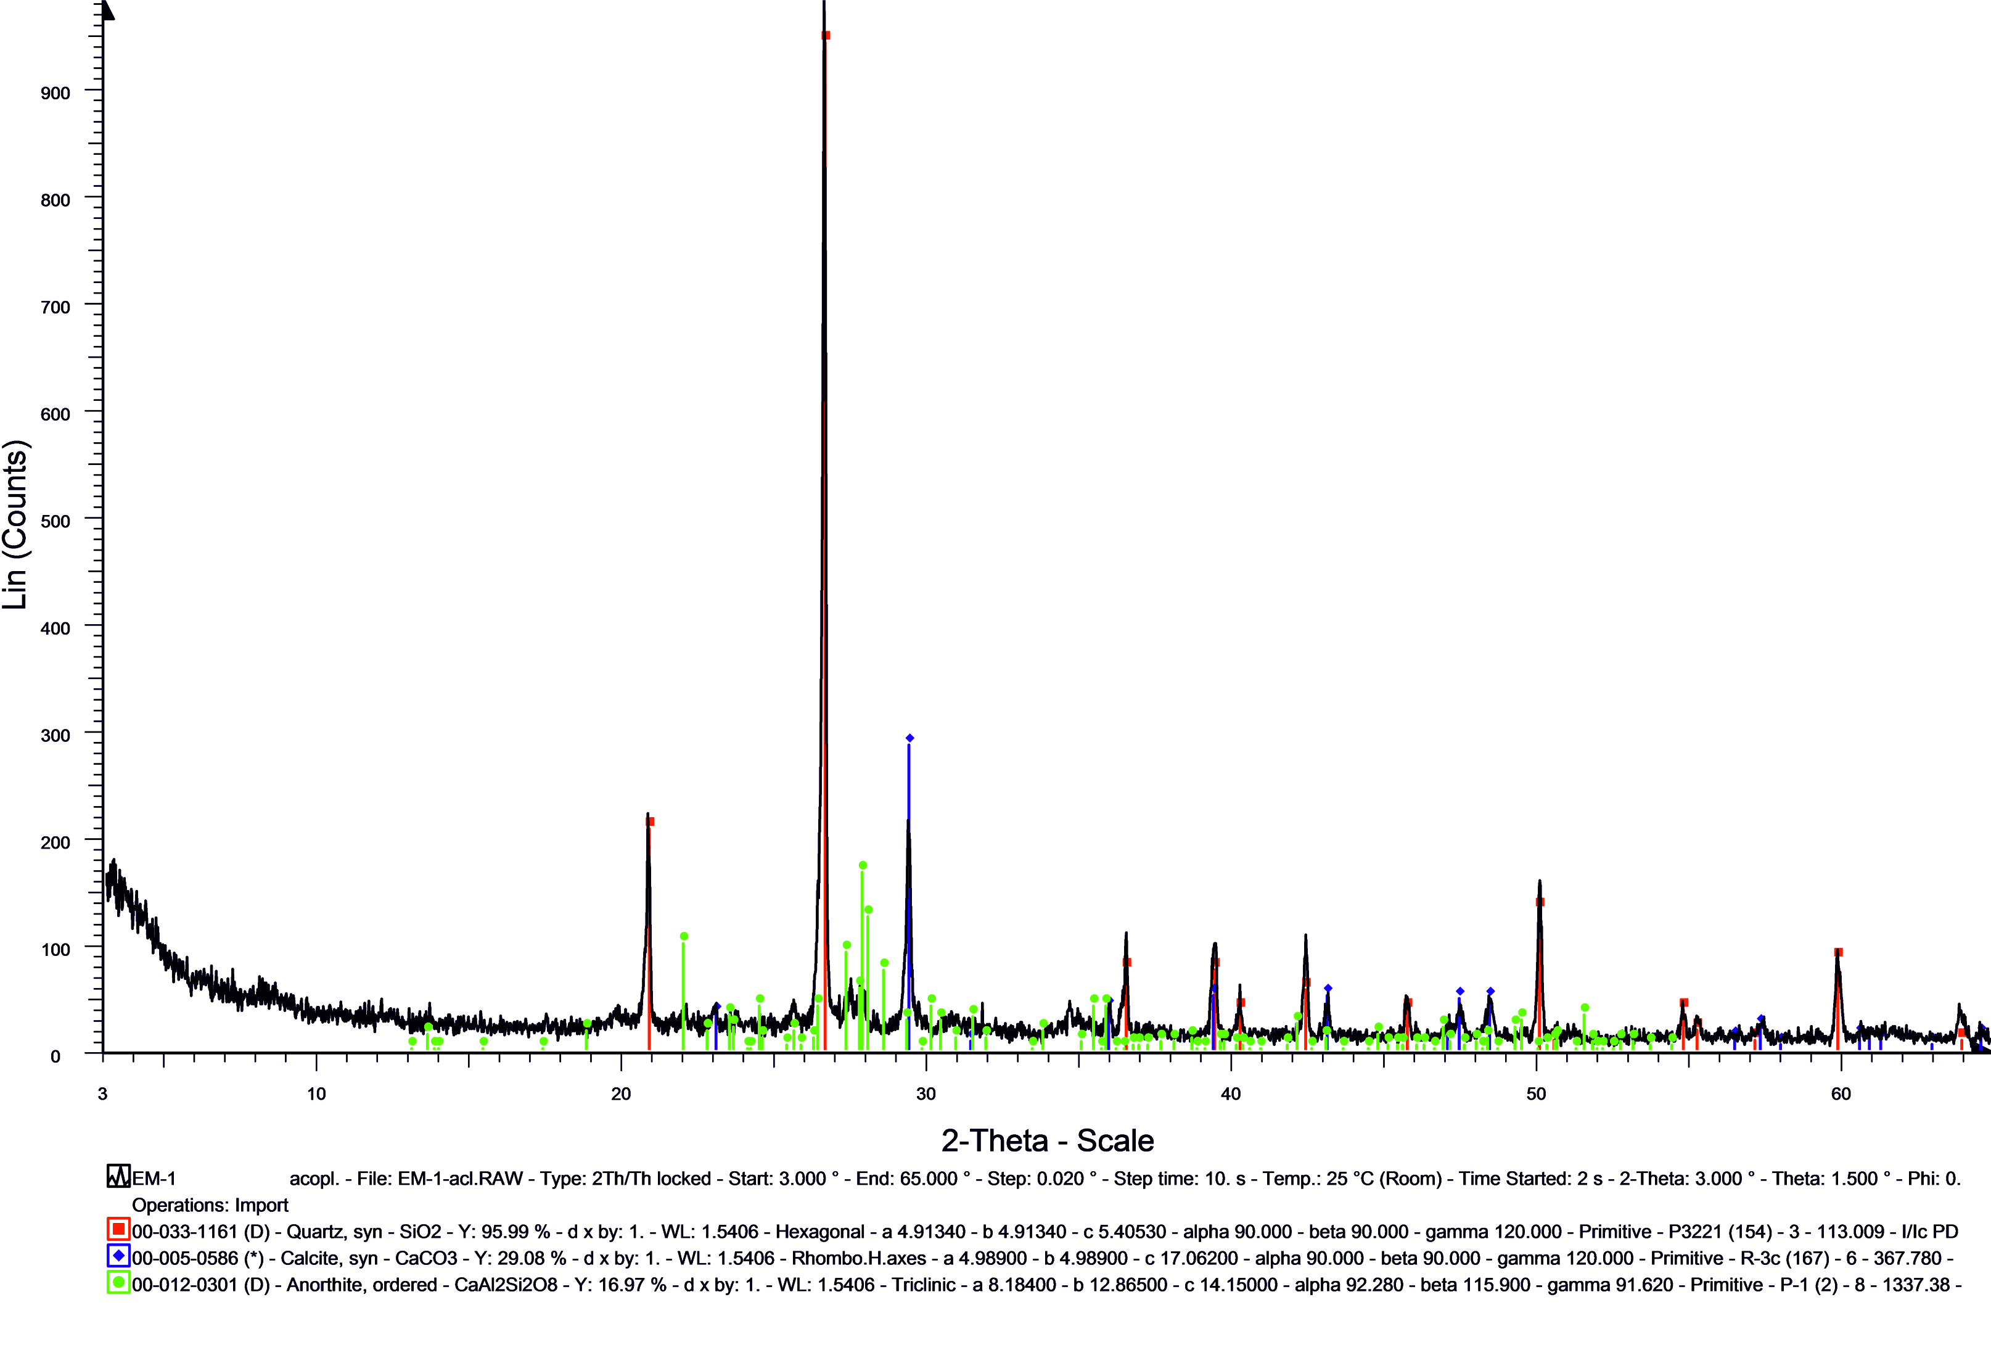
Figure S1. X-ray diffractogram of sample EM-1. Design: Ángel Justo Erbez.

