SUPPLEMENTARY MATERIAL

To be read in conjunction with

RETHINKING EARLY MEDIEVAL ‘PRODUCTIVE SITES’: WEALTH trade AND tradition AT little CARLTON, EAST LINDSEY

Hugh Willmott FSA and Duncan Wright FSA

with contributions from
Adam Daubney FSA, Paul Blinkhorn, Sophie Newman, Peter Townend and Graham Vickers.

published in volume 101 of the Antiquaries Journal

Hugh Willmott, Department of Archaeology, University of Sheffield, Minalloy House, Regent Street, Sheffield, South Yorkshire S35 7AA. Email: h.willmott@sheffield.ac.uk

Duncan W Wright, School of History, Classics and Archaeology, Faculty of Humanities and Social Sciences, Newcastle University, NE1 7RU. Email: duncan.wright@newcastle.ac.uk

Supplementary material

APPENDIX SM 1 The Skeletal Population and Pathologies
Table SM1. Summary of the Osteological Anlysis

APPENDIX SM 2 Earlier Finds from Little Carlton
Figure SM1 Amphora-Shaped Strapend and Penannular Brooch

APPENDIX SM 3 Summary of the Ceramics
Table SM2. Summary of the Ceramics

APPENDIX SM 4 BELLS AND BELL MANUFACTURE
Figure SM2 Fragments of Copper-Brazed Bells

APPENDIX SM 5 Calibrated radiocarbon dates

APPENDIX SM1

The Skeletal Population and Pathologies

Sophie Newman
Due to the poor preservation conditions, of the twenty-three burials selected for excavation, only sixteen were suitable for analysis as part of an articulated sample. Eight of these skeletons were adult, the other half juvenile (summarised in Table SM1). It has been possible to ascertain more accurate age estimations for a proportion of the juvenile individuals, as age estimation of non-adults (those less than seventeen years of age) is based on reasonably accurate developmental stages of the teeth and skeleton, whereas age estimation of adults relies primarily on the assessment of degenerative changes that may vary between individuals (Byers 2008, 202). The majority of the non-adults were classed as older juveniles (six to eleven years of age). None of the articulated skeletons were foetal, perinatal, or infant (i.e., less than one year of age); however, evidence for their presence within the burial population was seen in the disarticulated material.
For three-quarters of the adults, a more accurate age estimation than ‘adult’ (more than eighteen years of age) could not be achieved due to poor preservation. Of these six individuals, SK41 may have been aged between 25–45 years of age, as a very small fragment of the auricular surface of the pelvis suggested they were not of particularly advanced age, but no other ageing criteria were present to support this. SK64 may have been more than forty-six years of age (mature adult), but this was only based on dental wear which is particularly unreliable when used as a sole indicator of age as it can also be heavily influenced by differences in diet and the use of the teeth as a tool (Brothwell 1981). SK65 was also likely a mature adult as their mandible was edentulous, all teeth had been lost during life, but other factors that could have led to premature tooth loss during life cannot be discounted.
Of the two adult individuals where an age estimate could be made, SK28 was a mature adult (more than forty-six years of age) based on degeneration of the auricular surfaces and pubic symphysis of the pelvis (Lovejoy et al 1985; Brooks and Suchey 1990). SK46 was likely aged between twenty-five and thirty-five years, but as this estimate is based solely on dental wear and a very small fragment of the auricular surface of the pelvis, this age range has been extended to forty years of age.
For the adult individuals, an estimation of sex was attempted for those where preservation of the necessary skeletal elements allowed (the skull and pelvis, depending on preservation) using standard osteological methods for scoring sexually dimorphic traits (Mays and Cox 2000). This was possible for five of the eight adults at Little Carlton, where three individuals were likely to be males or possible males, and two were likely females or possible females. One individual was of indeterminate sex, meaning skeletal criteria were present for assessment but were neither convincingly male nor female in character, and the remaining two individuals could not be assessed for sex. Both adults that had been given an age estimation could also be attributed a sex estimate. SK46 (aged 25–45 years) was likely a female, and SK28 (more than forty-six years of age) was likely a male.
Several individuals displayed evidence for skeletal pathology and trauma. Cribra orbitalia, presenting as pitting of the orbital roof, was seen in SK31 (older juvenile), SK40 (adolescent), and SK64 (adult). Although the exact aetiology of this condition is contentious, it is generally believed that it arises during childhood in response to factors such as unhygienic environment and dietary deficiencies (Walker et al 2009; Oxenham and Cavill 2010). The permanent dentition of SK31 (older juvenile) also had evidence of dental enamel hypoplasia. These linear defects in the enamel of the teeth likely resulted from malnutrition or disease experienced during the growth period, resulting in the cessation of enamel formation during the period of ill health (Hillson 1996; King et al 2005). Signs of degenerative changes in the adults were also seen, which may have been caused by factors such as advancing age, everyday physical activity, or in response to repetitive heavy workloads (Roberts and Manchester 2010). The mature adult male SK28 and the adult, possible, male SK41 demonstrated degenerative disc disease and degenerative changes and osteoarthritis in their spines. SK41 also had degenerative changes in their right hip joint. The adult male had particularly severe osteoarthritic changes in both hips, as well as significant degenerative disc disease in the lower spine. It is likely that the changes seen in this individual would have had some impact on mobility. Evidence for trauma was also seen in the possible healed nasal fracture in mature adult male SK28, and a healed rib fracture in SK41 (adult, possible male). Both injuries may be indicators of interpersonal violence, but also could have occurred in response to accidental injury, such as falls, with rib fractures being especially common in archaeological populations (Roberts and Manchester 2010). Finally, dental disease appeared to be rife within the burial population, with conditions such as calculus (plaque) affecting four adults and three non-adults. Dental caries (cavities) were seen in two adults and one non-adult, and periodontal disease (gum disease) in four adults. Poor dental health had led to the loss of teeth during life for three adults, notably in SK65 who had lost all their lower teeth. Dental health is ultimately influenced by factors such as diet and oral hygiene (Hillson 1996; Roberts and Manchester 2010), therefore the high prevalence of these conditions in Little Carlton is suggestive of insufficient dental hygiene practices.
Table SM1 Summary of the Osteological Anlysis

SK | Age | Sex | Dental Pathology | Skeletal Pathology
1 | <17 years | - | - | -
20 | <17 years? | - | - | -
25 | 18+ years | U | - | -
28 | 45+ years | M | Calculus; caries; periodontal disease; possible abscess | Possible trauma to cranium, nasal fracture; degenerative disc disease in cervical and thoracic vertebrae; DJC in cervical and lumbar vertebrae; OA in lumbar vertebrae; possible DJC in hip
31 | 6-8 years | - | Calculus; DEH | Cribra orbitalia
35 | 18+ years | U | - | -
40 | 13-15 years | - | Calculus | Cribra orbitalia
41 | 25+ years | M? | - | Healed rib fracture; border shift; PNBF on endocranial surface of occipital and parietal bones; possible sinusitis in L frontal sinus; degenerative disc disease in cervical, thoracic, lumbar, and sacral vertebrae; DJC in lumbar vertebrae; OA in cervical, thoracic, lumbar, and sacral vertebrae; SN in thoracic vertebrae; DJC in R hip
46 | 25-40 years | F | Calculus; periodontal disease | Slight bowing of femora
54 | 10-12 years | - | - | -
55 | 25+ years | M | Caries; calculus; periodontal disease; AMTL | Severe OA in hips; possible healed PNBF on lower limbs; degenerative disc disease in cervical vertebrae; severe degenerative disc disease in thoracic vertebrae; DJC in thoracic vertebrae
56 | 7-9 years | - | Caries; calculus | -
57 | <17 years? | - | - | -
58 | 9 mths-1.5 years | - | - | Possible metabolic disease
64 | 20+ years | F? | Possible dental abscess; periodontal disease; calculus; AMTL | Cribra orbitalia
65 | 18+ years | I | Edentulous mandible | -

APPENDIX SM2

Earlier Finds from Little Carlton

Adam Daubney FSA
Iron Age to post-medieval objects are all represented in the sample, the majority of which were recovered through metal-detecting and surface collection. Although the assemblage ostensibly indicates long-term occupation in some form, the lack of chronological precision offered by individual components encourages a cautious interpretation. No prehistoric material has been found at Little Carlton beyond the scatter of flints associated with the burial mound in Area A, but a small and rather eclectic group of Roman finds is present. These comprised two early copper-alloy brooches, a silver finger ring of late first or second-century date, a worn sestertius, two House of Constantine nummi, a spoon bowl, and a silver snake bracelet. The Roman finds are somewhat enigmatic, especially given the lack of any activity of this date recognised through excavation. Indeed, the chronology represented by these artefacts is somewhat haphazard, representing all four centuries of the Roman period but in very small quantities, and it is possible that these finds were curated in the early medieval period, as was the case at Coddenham in Suffolk, where Roman metalwork was converted into base-metal clothes fasteners and belt-stiffeners.
Nonetheless, the discovery of an amphora-shaped strap-end dating between the fourth and early fifth centuries (fig SM1a) and a British penannular brooch of Fowler’s type G (fig SM1b), dating to the fifth or early sixth century, are suggestive of high-status activity in the vicinity of Little Carlton, if not on the actual ‘island’ itself, during the earliest medieval centuries.

Figure SM1 Amphora-Shaped Strapend and Penannular Brooch

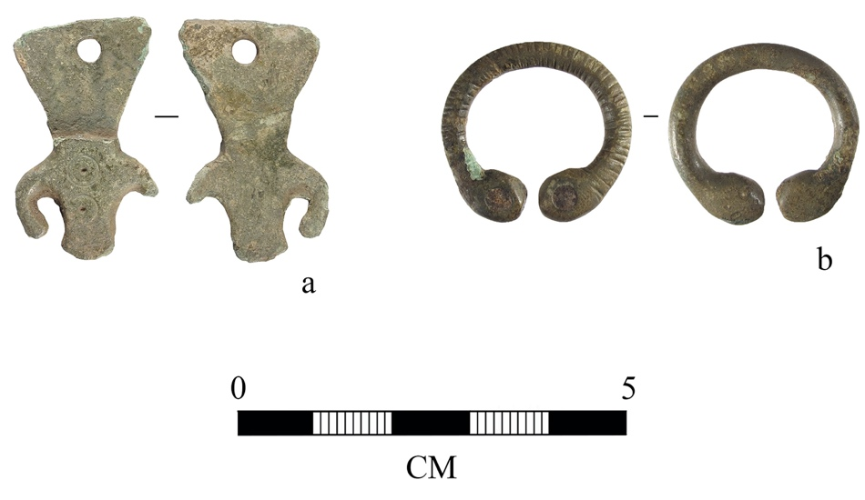
APPENDIX SM3
Summary of the Ceramics
Paul Blinkhorn
In addition to metalwork, a significant collection of ceramics was recovered through surface collection by the metal detectorist, as well as during excavation. Although the surface collection was not acquired via a systematic programme of fieldwalking, the assemblage is extensive, dating from the seventh to the eleventh centuries, and provides an indication of Little Carlton’s access to traded and imported goods. The excavated assemblage broadly mirrors that from the surface, except that no ninth- to eleventh-century wares were found. The entire early medieval pottery assemblage consists of 1,542 sherds with a total weight of 31,554kg (Table SM2).
The Maxey-type Ware assemblage recovered from the excavation is entirely typical of the tradition, comprising mostly jars with simple flattened or upright rims, with only one sherd of note being a very unusual small handle which is similar to an example from Lincoln (Young and Vince 2005, fig 34). The surface-collected Shelly Ware assemblage is largely abraded, with most of the sherds having had the calcareous component leached out. The range of rims indicates that vessels of both seventh to ninth centuries and later dates were present. Simple, hand-built vessels with upright rims and pierced lugs similar to those found on the Maxey-type Wares are present, for example, as are a few everted and lid-seated forms. Shelly wares similar to Lincoln Kiln-type Wares were also recovered, although the latter are a small element of the total (Young and Vince 2005, figs 34, 45–6). Ninth-century and later wares are relatively few in number, hinting at a decline in activity shortly after the introduction of such pottery, at some time after c AD 850.
The assemblage of Ipswich Ware from Little Carlton (947 sherds, 23.99kg) is the largest known from any site outside of East Anglia, other than the emporium at London. It is the largest from Lincolnshire, even exceeding the excavated assemblage at Flixborough which comprised 282 sherds (8.11kg) (Blinkhorn 2009), although it is more fragmented due to the higher percentage of ploughsoil recovery. All the other known assemblages from the county comprise less than ten sherds each, other than the site at Fishtoft, which yielded forty-nine (Blinkhorn 2012, 82; Cope-Faulkner and Allison, 2012).
The surface assemblage of Ipswich Ware consisted of small jars (53.5 per cent), large jars (21 per cent), pitchers (25.5 per cent), and a single Buttermarket bottle, whilst that from excavation comprised almost entirely jars, as well as a single jug rim. In East Anglia, small jars usually make up around 80–90 per cent of any assemblage, whereas pitchers and large jars occur more frequently at sites outside the region (Blinkhorn 2012). It is worthy of note that Little Carlton has produced one of the highest proportions of pitchers at any known site, and similar to that at Flixborough, although the proportion of large jars is not as high (Blinkhorn 2012, 32). It is possible, however, that some of the rims from this site identified as small jars may, in fact, be from pitchers, but lacking evidence of spouts or handles, as Ipswich Ware pitchers are usually relatively small, with a mean rim diameter of around 150mm (Blinkhorn 2012, 63).
The presence of imported Badorf Ware sherds is also significant dating to between the eighth and eleventh centuries, the majority of surface sherds of Badorf Ware appear to derive from pitchers or jars. Small quantities of relief-band amphorae with thick applied strips are also present, including a rim with rouletted decoration (Blackmore 2003, 241). The six sherds of Badorf Ware recovered from excavation appear to be from the same vessel, which is handled and probably a jug. Further continental imports are represented by three surface sherds of North French Blackware, probably all from a single vessel: a burnished pitcher typical of the tradition.
Continental imports were present at Flixborough, but otherwise such pottery is very rare from rural settlements in Lincolnshire. The few sites on which foreign ceramics have been found, such as Riby Crossroads, typically yield only one or two sherds (Steedman 1994). Nationally, the main inland distribution of Badorf Ware tends to be at sites identified as ecclesiastical in character, such as North Elmham, Norfolk, or settlements that have been otherwise identified as high status, such as Flixborough or Wicken Bonhunt, Essex (Wade-Martins 1980; Wade 1980). North French Blackware is well known from major ports of the period, but like Badorf Ware has occurred at only a limited number of locations in Lincolnshire (Steedman 1994). In summary, the presence at Little Carlton of continental imports, allied with the large quantity of Ipswich Ware, strongly suggests that this was a site of singular wealth and status between the seventh and ninth centuries.

Table SM2 Summary of the Ceramics
Type | Date | Surface Assemblage | Excavated Assemblage
Badorf-type wares | 8th-11th century | 9 sherds  136g | 6 sherds  96g
North French Blackwares | 7th-9th century | 3 sherds  43 | 1 sherd  37g
Ipwich wares | AD 720-850 | 887 sherds  21,772g | 60 sherds  2,213g
Sand and chaf tempered | 5th-9th century | 41 sherds  838g | 18 sherds  273g
Maxey-type wares | Late 7th-late 9th century | - | 284 sherds  2,954g
Late Saxon wares | mid 9th-11th century | 36 sherds  654g | -
Misc shelly wares | Late 7th-11th century | 197 sherds  2,538g | -

APPENDIX SM4
BELLS AND BELL MANUFACTURE
Hugh Willmott FSA and Adam Daubney FSA

A further significant aspect of the metal-detected finds assemblage at Little Carlton are the copper-brazed iron bells (fig SM2). One near-complete example is known, and shoulder fragments from a minimum of fifteen further incomplete examples have been found, in addition to fifty miscellaneous body fragments and a single large clapper. Dating of the bells is problematic, especially given that all fragments have so far been discovered in unstratified contexts. Parallels have been found on a variety of high-status centres in England, however, and also occur within graves dating between the sixth and the tenth centuries (Hinton 2000, 47; Tester et al 2014, 274; Oxford Historic Environment Record HER no. 5487). Copper-brazed iron handbells are well-known in Ireland, where their production on monastic sites has been dated between AD 600 and 900. Several examples are also known in Scotland (Bourke 1980; Stevens 2009; Bourke 1983, 464).
Whilst handbells are recognised to have performed liturgical functions in Ireland, in England they have tended to be interpreted as animal bells (E.g., Ottaway 1992, 558; Hinton 2000, 45). A recent revaluation of early medieval handbells from across England, however, has brought this assumption into question, and it is clear that the picture is far more complex. Whilst iron bells are found in southern England and the Midlands, they are invariably plain and possibly for prosaic use. Conversely, all finds of brazen bells occur in the more northerly counties of Cumbria, Yorkshire, and Lincolnshire, all areas that fell under the Northumbrian sphere of influence at some point in the early medieval period (Willmott and Daubney 2020).
One fragment of a bell from Little Carlton bears mineralised textile impressions (PAS LIN-D7BED6), which seems to represent the wrapping that was placed around the bell during the copper-fusing process. Ordinarily, such evidence would have been removed by the surface treatment that took place after casting to polish the bell, so its survival suggests it was never properly finished, and it is, in fact, a piece of manufacturing debris. This fragment strongly suggests on-site manufacturing at Little Carlton, and is hugely significant in an international context; despite the large corpus of handbell finds in Ireland, for example, direct evidence for their manufacture has only been found at two sites, at Clonfad in Westmeath and Ballinglanna in Cork, both of which were monastic sites (Stevens 2009, 94).

Figure SM2 Fragments of Copper-Brazed Bells
APPENDIX SM5
Calibrated radiocarbon dates

Wooden post (Beta Lab 504572)
Skeleton SK65 (Beta Lab 442776)

Wooden sleeper beam (Beta Lab 504573)

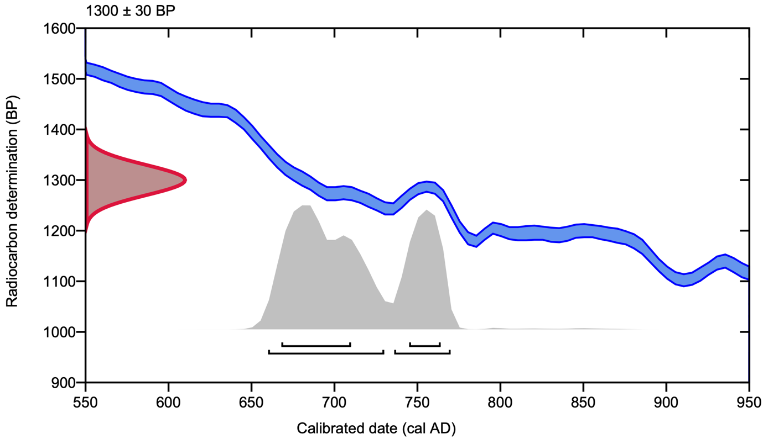

Bibliography
Blackmore, L 2003. ‘The pottery’, in G Malcolm and D Bowsher, Middle Saxon London. Excavations at the Royal Opera House 1989–99. MoLAS Monograph 15, 225–40, Museum of London Archaeology Service, London
Blinkhorn, P 2009. ‘Ipswich Ware’, in Evans, D and Loveluck, C, 2009. Life and Economy at Early Medieval Flixborough c. AD 600–1000. The Artefact Evidence. Excavations at Flixborough Vol II, –64, Oxbow Books, Oxford
Blinkhorn, P 2012. The Ipswich Ware Project: Ceramics, Trade and Society in Middle Saxon England, Medieval Pottery Research Group, London
Bourke, C 1980. ‘Early Irish hand-bells’, J Roy Soc Antiq Ireland 110, 52–66
Bourke, C 1983. 'The hand-bells of the early Scottish church', Proc Soc Antiq Scotland, 113, 464–8
Brooks, S T and Suchey, J M 1990. ‘Skeletal age determination based on the os pubis: a comparison of the Acsádi-Nemeskéri and Suchey-Brooks methods’, Human Evolution 5, 227–38
Brothwell, D R 1981. Digging Up Bones, 3rd ed, Cornell University, New York
Byers, S N 2008. Introduction to Forensic Anthropology, 3rd ed, Pearson Education, London
Cope-Faulkner, P and Allison, E P 2012. Clampgate Road, Fishtoft. Archaeology of a Middle Saxon Island Settlement in the Lincolnshire Fens. Lincolnshire Archaeology and Heritage Series Report 10, Heritage Trust of Lincolnshire, Sleaford
Green, C 2020. Britons and Anglo-Saxons: Lincolnshire AD 400–650 (2nd ed.). History of Lincolnshire Committee, Lincoln
Hillson, S 1996. Dental Anthropology, Cambridge University Press, Cambridge
Hinton, D 2000. A Smith in Lindsey: The Anglo-Saxon Grave at Tattershall Thorpe, Society for Medieval Archaeology Monograph Series 16, Society for Medieval Archaeology, London
King, T, Humphrey, L T and Hillson, S 2005. ‘Linear enamel hypoplasias as indicators of systemic physiological stress: evidence from two known age-at-death and sex populations from post-medieval London’, American J Physical Anthropol, 128, 547–59
Lovejoy, C O, Meindl, R S, Pryzbeck, T R and Mensforth, R P 1985. ‘Chronological metamorphosis of the auricular surface of the ilium: a new method for the determination of adult skeletal age at death’, American J Physical Anthropol, 68, 15–28
Mays, S and Cox, M 2000. ‘Sex determination in skeletal remains’, in M Cox and S Mays (eds) Human Osteology in Archaeology and Forensic Science, 117–30, Cambridge University Press, Cambridge
Ottaway, P 1992. Anglo-Scandinavian Ironwork from 16-22 Coppergate, Archaeology of York. The Small Finds 17/6, Council for British Archaeology, London

Oxenham, M F and Cavill, I 2010. ‘Porotic hyperostosis and cribra orbitalia: the erythropoietic response to iron-deficiency anaemia’, Anthrop Sci, 118(3), 199–200
Plunkett, S 2001. 'Some recent metalwork discoveries from the area of the Gipping Valley, and their local context', in P Binski and W Noel (eds) New Offerings, Ancient Treasures: Studies in Medieval Art for George Henderson, 61–87, Alan Sutton, Stroud
Roberts, C and Manchester, K 2010. The Archaeology of Disease. 3rd ed, History Press, Stroud
Steedman K 1994. ‘Excavation of a Saxon site at Riby Crossroads, Lincolnshire’, Archaeol J, 151, 212–306
Stevens, P 2009 ‘For whom the bell tolls: the monastic site at Clonford 3, Co. Westmeath, in Stanley, M, Danaher, E and Eogen, J (eds), Creative Minds: Production, Manufacturing and Invention in Ancient Ireland: Proceedings of the Public Seminar on Archaeological Discoveries on National Road Schemes Volume 7, 85–98, National Roads Authority, Dublin
Tester, A, Anderson, S, Riddler, I. and Carr, R 2014. Staunch Meadow, Brandon, Suffolk: a High Status Middle Saxon Settlement on the Fen Edge, East Anglian Archaeology Report 151, Suffolk County Council, Bury St. Edmunds
Wade, K 1980. ‘A settlement site at Bonhunt Farm, Wicken Bonhunt, Essex’, in D Buckley (ed), Archaeology in Essex to AD1500, 96–102, CBA Research Report 34, Council for British Archaeology, York
Wade-Martins, P 1980. ‘Excavations in North Elmham Park, 1967–72’, East Anglian Archaeol, 9, 413–78
Walker, P L, Bathurst, P R, Richman, R, Gjerdrum, T and Andrushko, V A 2009. ‘The causes of porotic hyperostosis and cribra orbitalia: a reappraisal of the iron-deficiency-anemia hypothesis’, American J Physical Anthropol, 139, 109–25
Willmott, H and Daubney, A 2020. ‘Of saints, sows or smiths? Copper-brazed iron and bells in Early Medieval England’. Archaeol J, 176, 63-83 DOI: 10.1080/00665983.2019.1567970
Young, J and Vince, A 2005. A Corpus of Anglo-Saxon and Medieval Pottery from Lincoln. Lincoln Archaeological Studies 7, Oxbow Books, Oxford

Plunkett 2001, 64, 77, 81; Fleming 2009, 419.
PAS ref. LIN-0C5BF1; PAS ref. LIN-35B2BE; e.g. Green 2020, 71.

