DEATH BY COMBAT AT THE DAWN OF THE BRONZE AGE? PROFILING THE DAGGER-ACCOMPANIED BURIAL FROM RACTON, WEST SUSSEX

Stuart Needham FSA, James Kenny, Garrard Cole, Jane Montgomery,
Mandy Jay, Mary Davis and Peter Marshall

Stuart Needham, Langton Fold, North Lane, South Harting, West Sussex GU31 5NW, UK.
Email: sbowman1@waitrose.com
James Kenny, Archaeology Officer, Chichester District Council, East Pallant House, 1 East Pallant,
Chichester, West Sussex PO19 1TY, UK. Email: jkenny@chichester.gov.uk
Garrard Cole, UCL Institute of Archaeology, 31–4 Gordon Square, London WC1H 0PY, UK.
Email: tcrngco@ucl.ac.uk
Janet Montgomery, Department of Archaeology, University of Durham, Durham DH1 3LE, UK.
Email: janet.montgomery@durham.ac.uk
Mandy Jay, Department of Archaeology, University of Durham, Durham DH1 3LE, UK.
Email: mandy.jay@durham.ac.uk
Mary Davis, 61 Talbot Street, Cardiff CF11 9BX. Email: mary.davis77@ntlworld.com
Peter Marshall, Chronologies, 25 Onslow Road, Sheffield S11 7AF, UK. Email: pete@chronologies.co.uk

SUPPLEMENTARY MATERIAL

APPENDIX SM1 FURTHER DETAILS ON THE OSTEOLOGICAL ANALYSIS
Garrard Cole
Table SM1. Dental formula
Table SM2. Alveolar resorption

APPENDIX SM2 METHODOLOGY AND INTERPRETATION OF ISOTOPE MEASUREMENTS OF HUMAN SKELETAL MATERIALS
Janet Montgomery & Mandy Jay

APPENDIX SM3 DESCRIPTION OF THE DAGGER AND RIVETS
Stuart Needham

APPENDIX SM4 FULL REPORT ON THE METAL ANALYSES
Mary Davis

APPENDIX SM5 DETAILED REVIEW OF RIVET-STUDDED HILTS
Stuart Needham
Fig SM1. Rivet set and associated items from a potentially early burial at Bush Barrow (Wilsford G5), Wiltshire
Fig SM2. Rivet set from a cist at Ballyenahan East, Co. Cork, Ireland (Fahy 1954)

APPENDIX SM6 BAYESIAN ANALYSIS OF RADIOCARBON DATES ASSOCIATED WITH THE RACTON BURIAL AND OTHER CONTEXTS WITH EARLIEST BRONZE IN BRITAIN AND IRELAND
Pete Marshall
Table SM3. Radiocarbon dates for contexts with earliest types of bronze object in Britain and Ireland
Table SM4. Series 2 daggers outlier analysis
Fig SM3. Probability distributions of dates for Series 2 daggers and three other early bronzes
Fig SM4. Probability distributions for daggers of Type 1C, ‘early’ Series 2 and ‘mainstream’ Series 2 treated as three independent groupings
Fig SM5. Probability distributions for daggers of Type 1C, ‘early’ Series 2 and ‘mainstream’ Series 2 treated as successive groups, based on archaeological evaluation
Fig SM6. Summary of the estimated dates of transitions derived from the model shown in figure SM5

APPENDIX SM7 SURFACE ANALYSIS OF THE MILSTON G51 DAGGER AND THE RIVET SET FROM BUSH BARROW (WILSFORD G5)
Garrard Cole & Stuart Needham
Table SM5. Detection limits for measured elements (uppermost of range quoted by manufacturer)
Table SM6. Results of surface analysis of the components of the Milston dagger
Table SM7. Results of surface analysis of the Bush Barrow rivet set and associated fragments

Appendix SM1
Further details on the osteological analysis
Garrard Cole

METHODS
The anthropological analysis was based on standardised methods. The individual was clearly adult, as the proximal epiphysis of the clavicle was fused so adult criteria for age, sex and stature were used. The age at death was estimated using morphological changes to the pubic symphysis and auricular surface of the pelvis. Tooth wear evidence was also utilised. The individual’s biological sex was assessed based on observations of pelvic and cranial morphology, along with measurements of selected sexually dimorphic skeletal elements. Stature estimation was based on the measurement of long bones in accordance with the methods and regression data of Trotter and Gleser.

NON-METRICAL TRAITS
The inferior margin of both sides of the mandible was distinctly curved convexly. This allows the mandible to be rocked back and forth when the mandible is placed on a flat surface. Given this affects both sides of the mandible, and an X-ray shows no sign of pathological change, this appears to be a developmental variation. Developmental variations are thought to have a weak genetic predisposition that varies across different population groups.
The right scapula has a suprascapular foramen rather than the more typical suprascapular notch. Squatting facets were observed on the lateral side of both left and right tibia.
The left and right patellae were noticeably different in shape and dimension. They both have the same height (49.1mm), but differ greatly in breadth (left 46.2mm versus right 56.1mm). There are two rounded shallow notches on the medial margin of the left specimen. This may reflect the presence of a tripartite left patella. This arises when the patella forms around multiple ossification centres (three, in this case) rather than one normally. The ossification of the patella is very variable: it may begin as early as 18 months or as late as five years. It tends to occur later in boys than in girls. During adolescence, additional ossification centres may appear, giving rise to multipartite patellae. These may arise from stress such as intense sporting activity.
The meric index (a measure of anterior–posterior flatness of the proximal femur) was 99.8 (eurymeric), averaged over left and right femur. The cnemic index (a measure of lateral flatness of the proximal tibia) was 75.7 (eurycnemic) for the right tibia. These morphological variations were first observed by both Busk and Broca in human remains from the caves near Gibraltar and in the Dordogne. The precise cause for the variation is unknown. The indices have been interpreted as an indicator of chronological development of hominins, evidence of varying mechanical strain on developing bones, an association with activity, especially squatting, nutritional deficiency and as a racial identifier in both nineteenth-century terms and in modern forensic cases. There appears to be no correlation between the two indices. The indices appear to vary within all chronological and regional groups, suggesting a weak genetic predisposition, as is the case with non-metric variants found in the skeleton. As these data refer to only one individual, they are simply reported here without further comment.
Cranial metrics could not be recorded.

PATHOLOGY
The vertebrae forming the spine exhibited typical degenerative changes associated with older individuals. The intervertebral joint facets of the thoracic vertebrae exhibited laminal spurs with some evidence for slight marginal lipping on the facets for the rib joints. The inferior margins of the lower intervertebral facets for the mid-thoracic vertebrae (fifth–ninth) showed evidence of marginal compression consistent with movement in the presence of reduced intervertebral disk thickness. The lumbar vertebrae all exhibited marginal osteophytes around the upper and lower margins of the vertebral bodies. The lumbar intervertebral facet joints all exhibited noticeable marginal lipping. Similar marginal changes were observed on the lower face of the twelfth thoracic vertebra, which articulates with the first lumbar vertebra, and the upper face of the first sacral segment, which articulates with the lowest lumbar vertebra.
Slight lipping was seen on most other joint surfaces, where present. The hands, feet and ankles were not affected, however. A large marginal osteophyte was observed on the lateral margin of the right patella. A smaller marginal osteophyte was noted on the superior margin of the left ilium, medial towards the lumbar vertebrae. Marginal osteophytes were noted on the ischial tuberosity and rim of the acetabulum on both sides of the pelvis.
Periosteal new bone was observed on the inferior surface of the left maxillary sinus.

Table SM1. Dental formula (key: X – lost post-mortem, a – buccal abscess, c – interstitial caries)
8 | X | X | 5 | 4 | 3 | 2 | X | X | 2 | 3 | 4 | 5 | ac | 7 | 8
8 | 7 | 6 | 5 | 4 | 3 | 2 | 1 | 1 | 2 | 3 | 4 | 5 | c | 7 | 8

The dental formula for the teeth present is given in Table SM 1. Evidence for the dental pathology was limited to two approximal carious lesions on the mesial surface of the first molar of the mandible and maxilla. The same maxillary molar had a small buccal abscess on the cheek side, possibly resulting from bacterial infection arising from the nearby carious lesion. There was no evidence for dental calculus. However, some of the teeth, particularly the labial teeth of the mandible, exhibited signs of chemical dissolution, so the possibility of this having removed the evidence of calculus cannot be excluded. The third molar on the left side was particularly affected; the tooth is a very loose fit in its socket. Alveolar resorption of the bone adjacent to teeth was observed in several locations, summarised in Table SM2.

Table SM2. Alveolar resorption
Element | Side | Site | Degree | Comment
Mandible | Left | M1–M2 | Slight | Lingual
Mandible | Left | M3 | Severe | All around the tooth
Mandible | Right | PM3–PM4 | Slight

Appendix SM2
Methodology and interpretation of isotope
measurements of human skeletal materials
Janet Montgomery &Mandy Jay

STRONTIUM AND OXYGEN ISOTOPE ANALYSIS OF TOOTH ENAMEL
Strontium and oxygen isotope analysis of archaeological humans and animals can provide evidence for their geographical origins. Chemical elements from ingested food and water are incorporated into teeth and bones and, because the isotope ratios of some elements vary geographically, these differences can be used to draw conclusions about whether individuals were of local or non-local origin. In doing this, there is usually a presumption that ancient people sourced the bulk of their diet locally. This report presents strontium and oxygen isotope data from tooth enamel, a skeletal tissue that is highly resistant to diagenetic alteration and which represents childhood diet. Strontium in this skeletal fraction is sourced primarily from ingested plants, so that the isotope ratio is controlled by the rocks and soils in which these plants grow and is usually indicative of the geology present in an individual’s home region. Oxygen is mainly from drinking water, sourced ultimately from rainwater, with isotope ratios varying geographically with latitude, altitude and distance from the sea. These data usually form an indicator of the climate prevailing in the home region.
Tooth enamel forms during childhood and the isotope ratios from strontium and oxygen incorporated during that period do not change during later life. The data obtained from these two chemical elements, therefore, reflect the geology and climate of the region where food and water were obtained during that childhood formation period. By comparing them with what might be expected for the region of burial, it is possible to say whether the childhood signal is consistent with the burial environment, in which case it may be probable that the individual lived throughout their lives in that location. If the signal does not match the burial environment, then it is likely that they moved away from their original home region during or after childhood.
There are several possible confounding factors that must be considered. If an individual moved away after childhood, lived away for many years and then returned to their original home location, this cannot be identified from the enamel signal. Also, if an individual moved between two locations where the geology and climate was very similar, this is unlikely to be identified from the data. The isotope ratios are derived from food and drink, so if this was not obtained from the home or burial region, as might be the case if food was being traded or transhumance was being practised, then this will also have an effect on the interpretation of the data.
Strontium isotope ratios are given as ⁸⁷Sr/⁸⁶Sr values and the oxygen isotope ratios are shown as δ¹⁸O values given in the unit ‰ (per mil). The oxygen isotope analyses undertaken for this report are from tooth enamel carbonate rather than phosphate.

CARBON AND NITROGEN ISOTOPE ANALYSIS OF COLLAGEN
Carbon and nitrogen stable isotope ratios in skeletal collagen are used to reconstruct dietary patterns. The amino acids that form bone and dentine collagen are mainly constructed from the carbon and nitrogen, which is found in the protein element of the consumer’s diet. The isotope ratios in collagen, therefore, bear a direct relationship to those in the protein in the foods that have been eaten, although there is some fractionation in the system (that is, one of the two isotopes being compared for each element is often taken up in preference to the other). Since the food chain leads back to plants at the base, the data can also be used to consider an individual’s connection with the local environment at a particular time and place by considering the effects of that environment on the diets of herbivores.
When discussing diet, the data can be used specifically to consider the amount of animal protein that has been consumed (trophic level), the level of aquatic resource consumption (particularly marine resources) and whether plants that use the C₄ photosynthetic pathway have been included in the food chain. δ¹⁵N values are elevated between trophic levels by approximately 3 to 5‰, whilst δ¹³C values may increase by around 1‰. High levels of marine resources lead to significant enrichments in both the ¹⁵N and ¹³C isotopes. C₃ and C₄ plants have different photosynthetic pathways and this results in δ¹³C values that are significantly different when they are traced through to the ultimate consumer, with C₄ plants producing δ¹³C values that are higher. C₃ plants are those that are usually found in temperate environments and are the main plant resources available in prehistoric Europe, whilst C₄ plants are more usually found in warmer environments and are not found in significant quantities in prehistoric Britain, although millet starts to show up isotopically in the food chain by the Middle Bronze Age on the Continent and these types of plant start to appear in the food chain from the Roman period onwards in Britain.
Plants are affected by local environmental conditions, such as climate, salinity and manuring practices. These conditions, therefore, affect the isotopic ratios that are seen in skeletal collagen throughout the food chain. For this reason, the consideration of absolute isotopic values for individuals can be problematic, with variation present both through time and space, according to local environments and subsistence practices. It is important, therefore, to have a ‘baseline’ for the environment when interpreting human data and this is usually obtained by analysing animal samples, particularly herbivores, from the same location and time period. Dietary patterns throughout the food chain can then be considered in relative terms. For this report, given there are no animal remains from the site, existing comparative data have been considered, both published and unpublished.
Unlike bone collagen, primary dentine collagen forms over a relatively short period of time during childhood and is not subsequently replaced, although small quantities of secondary and tertiary dentine can be laid down later on. Isotope ratios from dentine, therefore, reflect childhood diet and approximate to the period of enamel formation associated with analyses of that tooth fraction. The collagen data included in this report have been obtained from dentine.
Bone collagen is formed over a long period of time, with newly formed molecules replacing older ones throughout an individual’s life. The turnover period involved is much longer for adults than it is for infants or growing children. For mature adults, it is likely that a significant part of a cortical bone sample was formed during adolescence and the signal seen is certainly relevant to the averaged diet over many years. Whilst the sample from Racton Man came from dentine, it may be appropriate to consider analysing bone at a later date.

CARBON ISOTOPE ANALYSIS OF TOOTH ENAMEL CARBONATE
Carbon isotope ratios (δ¹³C values, given in units ‰) from enamel carbonate reflect carbon from whole diet rather than the carbon predominantly from the protein fraction of the diet that is reflected by collagen. There are known relationships between the δ¹³C values obtained from different skeletal fractions and with diet, and the combination of carbonate and collagen values can be used to improve interpretations of C₃, C₄ and marine dietary components.

ANALYTICAL METHODS
The enamel surface of the tooth was removed using a diamond dental burr and was then discarded. A sample of powdered enamel (~ 5–15mg) was produced for oxygen and carbon isotope analysis of the carbonate fractions. At the University of Bradford (Stable Light Isotope Facility, Archaeology Department), the sample was treated following a procedure modified after Sponheimer. To remove organic matter and exogenous carbonate, it was treated with 1.7% NaOCl solution for 30 minutes, rinsed with de-ionised water, treated with 0.1M acetic acid for ≤ 10 min, and then rinsed once more. After freeze-drying, the sample was weighed into a septa-capped vial and loaded into a Finnigan Gasbench II. Oxygen and carbon isotope ratios were measured in a Thermo Delta V Advantage mass spectrometer connected to the Gasbench II. The enamel value was measured in duplicate and normalised relative to internal and international standards. The value for the tooth listed in Table 3 (main paper) is a mean value presented relative to the international standard VSMOW and the analytical error, based on the reproducibility of the standards, was ± 0.2‰ (1sd) or better for δ¹⁸O_{carbonate} and ± 0.1 ‰ (1sd) δ¹³C_{carbonate}.
Following surface abrasion to a depth of >100μm, a chip of ~20mg of core enamel, free from adhering dentine, was removed from the tooth with a diamond-tipped rotary dental saw for strontium isotope analysis. The sample was sealed in a microtube and transferred to the class 100 HEPA-filtered laboratory at the NERC Isotopes Geosciences Laboratory (NIGL) in Keyworth. It was washed ultrasonically in water (Millipore Alpha Q, <1 ppb total heavy metal content) to remove adhering particulates. No chemical decontamination was carried out as, due to the high resistance of enamel to post-mortem contamination, changes in the bulk ⁸⁷Sr/⁸⁶Sr ratio of enamel samples following the use of such procedures has been negligible. Strontium concentrations and compositions were obtained by thermal-ionisation mass spectrometry (TIMS) using a Thermo Triton multi-collector mass spectrometer. ⁸⁷Sr/⁸⁶Sr was normalised to a NBS 987 value of 0.710250. The Sr contribution from within-run laboratory blanks was negligible. External reproducibility was estimated at ± 0.002% (2sd).
The δ¹³C and δ¹⁵N values from the dentine collagen were obtained in tandem with the radiocarbon date from the Scottish Universities Environmental Research Centre (SUERC). The laboratory code for the date was SUERC-55526 (GU35223). A modified version of the Longin method is used to extract the collagen component. A DremelTM multi-tool is used to clean sample surfaces prior to small fragments being demineralized in 1M HCl for approximately 24 hours. The samples are then rinsed with ultra-pure water to remove any remaining contaminants and heated to approximately 80°C in 100 ml of ultra-pure water to denature and solubilise the collagen. The denatured product is filtered using GF/A glass fibre filter paper, reduced to approximately 5ml by gentle heating, then freeze-dried. The samples are then analysed with a Thermo Scientific Delta V Advantage continuous-flow isotope ratio mass spectrometer (CF-IRMS) coupled via a Thermo Scientific Conflo IV to a Costech ECS 4010 elemental analyzer (EA) fitted with a pneumatic auto sampler. Bone collagen samples are weighed into tin capsules (~600μg) and combusted in the presence of oxygen in a single reactor containing tungstic oxide and copper wires at 1020°C to produce N₂ and CO₂. In-house gelatine standards are run in duplicate with every ten samples and those are calibrated to the International Atomic Energy Agency (IAEA) reference materials USGS40 (L-glutamic acid, δ¹³CV-PDB = – 26.39‰), USGS41 (L-glutamic acid, δ¹³CV-PDB = +37.63‰), IAEA-CH-6 (sucrose, δ¹³CV-PDB = –10.45‰), USGS25 (ammonium sulphate, δ¹⁵NAIR = −30.41‰), IAEA-N-1 (ammonium sulphate, δ¹⁵NAIR = +0.43‰) and IAEA-N-2 (ammonium sulphate, δ¹⁵NAIR = +20.41‰). The samples are run singly, without duplication. Results are reported as per mil (‰) relative to the internationally accepted standards VPDB and AIR, with 1σ precisions of ± 0.2‰ and ± 0.3‰ for δ¹³C and δ¹⁵N, respectively.

Appendix SM3
Description of the RACTON dagger and rivets
Stuart Needham

The metalwork associated with the Racton burial comprises a dagger blade with two rivets in situ and a third rivet hole broken across, plus twenty-four loose rivets, one of which is presumably from the broken hole (fig 17; main paper). Twenty millimetres of the blade tip has broken away, but is extant. It is not certain when this first broke, but the lower blade also has a bend of about 5° in profile and a very slight twist, which are almost certainly ancient damage for there is a hammer-struck dent immediately below a fine crack crossing the inner curve (face 2) some 40mm above the tip. A second crack across face 2 occurs at 64mm above the tip. Neither crack is visible on face 1 due to being covered with extremely fine conservation webbing. Although the blade is largely intact, its edges are almost continuously interrupted by minor notching, probably from corrosion chipping; this is worse in the mid- to lower blade, but even undamaged parts of the upper blade are not especially sharp, despite being very thin.
The part of the shoulder that has broken away was not retrieved by the finder or the subsequent archaeological excavation, but it should not necessarily be assumed that it was missing from the grave.
Face 1 exhibits fairly large areas of a smooth patina, mainly dark browny-green with limited areas yellowy-gold. Elsewhere, this is concealed by an intermittent layer of crumbly corrosion products. This textured corrosion skin is more extensive on face 2, where it is mid-green to rust-coloured and lies over a substrate of fir-green patina. A wide-omega hilt-line, which marks the bottom end of the former organic hilt, is preserved in the corroded surface of both faces. It is most consistent on face 1, where it is brought out not only by different textures above and below, but also by an intermittent fine ridge of corrosion products. These lines indicate that the hilt, or most of it, was in situ in the ground, but there is no sign of wood-grain or bone tissue structure on the face above. Likewise, there are no obvious traces of pseudomorphic structures deriving from a sheath such as are often found on daggers from burials.
The dagger blade, including a short tang, is 176mm long and would have been about 65mm wide at the shoulders (currently 55.5mm wide) (fig 18.4; main paper). The blade is flat in cross-section with a maximum thickness of 2.2mm. It is triangular in shape converging towards an acute tip; weakly defined edge bevels survive alongside both edges; they are about 1.5mm thick and 4mm to 5mm broad for most of the blade tapering out towards the top. Where edge bevels are free of the corrosion skin, notably the left upper edge of face 1, diagonal grinding marks are discernible; they are very fine-grained and aligned nearer the longitudinal axis than the transverse one. These are certainly ancient, whereas some equally fine striations showing in the brightest patch of underlying metal in the blade face (also face 1) are suspected to be the result of modern cleaning. Such striations were not observed on other corrosion-free areas of the main blade.
The tang is strongly trapezoidal: 23mm long, 27mm across at the base and 9mm wide at the apex, at which point it is 0.8mm thick. There are neat but narrow chamfers along its edges that would have been created in post-cast finishing of the tang prior to hilting, probably by fine grinding. This feature is more developed on the left side of either face and a groove runs into the shoulder by a millimetre or two. Despite the large number of rivets present in the grave, the blade was secured to the hilt by only three. A single rivet hole perforates the top of the tang and two others perforate either shoulder. All three exhibit tiny countersinks up to 1mm wide on both faces. The shoulders are pronounced with near-horizontal upper edges.
The rivets are fairly consistent in morphology and shank diameter (3.4mm–3.9mm) with minor variations noted in Table 4 (main paper). The rod they were made from was generally round in section, but there are often longitudinal facets, presumably from the forging process. Lengths vary from 7.2mm to 8.9mm, and this variation can be interpreted as relating to the individual position of a rivet through a hilt whose faces were not flat or parallel to one another. Head diameters were also quite variable (4.3mm–5.8mm), partly due to unpredictability of expansion during clenching and partly due to corrosion nibbling. Head expansion was nonetheless rather limited, the resulting lips being under a millimetre in any direction, and the caps are mostly very gently domed.

Appendix SM4
Full report on the metal analyses
Mary Davis

The dagger blade and rivets were analysed using a Bruker AXS Tracer III-SD portable X-ray fluorescence spectrometer equipped with a rhodium tube and silicon drift detector targeted on unabraded surfaces. This can only provide qualitative results owing to the likelihood of distortions (surface enrichment or depletion; surface geometry and source to sample distance) to the true levels of some elements relative to others. For this reason, the actual readings obtained are not published as they would give a false sense of accuracy. Nevertheless, useful results can be obtained on both the alloy composition and the presence of impurities at trace levels.
The blade was analysed in three areas, all on face 1: (1) left side of mid-blade, (2) near the focal point of the omega hilt-line, and (3) right side, just above the fracture closest to the tip. Each of the rivets was analysed at a single spot. The results will be described according to the significant elements found or sought.
Tin was consistently recorded at levels, suggesting a regular tin-bronze. The actual readings varied, some being quite high, probably due to tin enrichment at the surface. Within the limitations of the technique, there was no apparent difference between blade and rivets. After the copper and tin, arsenic gave the highest levels and can be described as a major impurity. As for the tin, it is likely that most or all of the measurements recorded enhanced levels and allowance has been made for this. The rivets gave a fairly coherent range of readings and it is likely that they contain in the region of 1.5%–2.5% of arsenic, while the blade contained less, probably less than 1.0%. This difference is believed to be a true reflection of the arsenic levels in the rivets and blade respectively.
Antimony, bismuth and zinc can be treated together since they were all detected at low levels in virtually all of the measurements for both blade and rivets. Given the limitations of the technique, it is estimated that these elements are present at around 0.1% or a little more. Slight traces of silver were detected in twelve of the twenty-six rivets, and nickel was only detected in three of those twelve. These two elements were undetected in remaining rivets and the blade and are probably present at most at very low levels, much less than 0.01%.
All the metal components involved in the Racton dagger are of a regular tin-bronze (for example, tin at 10 ± 3%). This distinguishes the composition from that of one of the close parallels from Ferry Fryston, which contained only 3% tin. The impurity suite is also relatively consistent for all components, especially the set of rivets. The one difference seen in the blade that can be considered a reliable indication of the actual composition is the lower arsenic content; it is possible this may result from the melting and working history of the metal in that component, rather than indicating metal from a different source or circulation pool. Arsenic is the only major impurity and the relatively low level of antimony plus the extremely low level of silver rule out this having the classic signature of Irish Ross Island metal (A-metal), in which both are present typically at between 0.1% and 1.0%. Similarly, it cannot be identified as ‘Bell Beaker metal’ (BB-metal) because, although that can have very low levels of antimony and silver, even the low-nickel variant has nickel ranging from about 0.05% to 0.5%. The Racton impurity suite may be described as ‘arsenic-only’, that is, arsenic is the only principal impurity.

Appendix SM5
Detailed review of rivet-studded hilts
Stuart Needham

Large sets of rivets are now known in association with dagger blades at seven sites in Britain. This appendix will also discuss a rivet set from Ireland, although this had no associated blade and differs from the British examples in some key respects.
The best evidence for rivet arrangement still comes from two of the earliest finds, those from Silk Hill, Milston, Wiltshire, and Garton Slack 107, East Yorkshire. The hilt furnishings of the latter, moreover, provide the best empirical evidence for the overall shape of the hilt and its length. Mortimer’s account of his findings in November 1867 is worth citing in part:

About 7 inches from the right side of the skull were the remains of a very beautiful bronze knife-dagger…. The pommel of the handle is of bone… and has been secured to its place with two rivets. From traces of the handle remaining on the blade, it seems to have consisted of two pieces of horn held together by forty-two rivets of bronze, varying in length from ¼ to ⅜ of an inch, and a 1/16 of an inch in thickness, and two curved strips of bronze 2 ⅞ inches long, 3/16 of an inch wide, and 1/16 of an inch in thickness. When found these rivets were in four rows just as the decayed handle had left them. The blade… has been secured to the handle by the end rivet of each row.

It appears, therefore, that the rivets had not been disturbed since the decay of the organic handle. The two strips of bronze are still unique, these being interpreted as insets along the sides of the handle. On the assumption that these strips were not much shorter than the handle’s sides, they give a length of about 100mm for the whole hilt from pommel top to lowest point of the hilt-line; this is a reasonable length to accommodate a human hand. Mortimer’s reconstruction drawing is a little schematic; for example, it does not show the hilt overlapping the blade and fixing rivets, and it is evidently not entirely accurate since only forty rivets are shown, plus one more sticking out of one hole in the pommel. Only thirty-nine rivets have survived, three of them in situ in the hilt-plate (of which the fourth could be one of the loose rivets). Nevertheless, it seems possible that Mortimer’s total of forty-two actually included the pommel fixings, described as ‘rivets’, but not specified to be bronze. The illustration given here (fig 27.3; main paper) follows the current museum restoration, which has symmetrical numbers of rivets in the corresponding columns, rather than Mortimer’s illustration, which does not.
The other well-preserved and relatively well-recorded example was that excavated some sixty years earlier (28 July 1804) by William Cunnington at Milston, Wiltshire; his manuscript account is cited in the main paper. The reconstruction he had made has three columns of rivets (also seen in his sketch) running through the handle to meet an arc of nine at the base. The visual effect of rivet-studding, impressive in itself, was further enhanced by two intervening columns of circular motifs engraved into the surface of the wooden hilt, while there was also a dotted outline around the whole hilt-face and a double-dot line down the hilt sides. The columns of circular motifs apparently lined up with the two rivets immediately flanking the central one on the butt, while the outer columns of rivets terminated at the next ones outwards. If the general layout presented in the reconstruction is faithful, it shows how the vertical column arrangement of the handle was linked seamlessly to the multiple-rivet arc curving round the butt (fig 27.5; main paper).
Some caution needs to be raised about the accuracy Cunnington claims for the reconstructed hilt. His drawing survives in a sketchbook now in Devizes Museum and, while the outline of the blade looks good, he appears to have got confused over the number of rivets and their arrangement. Rather than the total of thirty rivets he describes in his text, the sketch shows a total of thirty-seven (both totals excluding the two pegs through the pommel). This can perhaps be explained if, having recognised that only three of the arc around the butt attached the blade, he then in abstract (the original hilt having fragmented) assigned the remaining twenty-seven rivets to the handle, forgetting that six more were already accounted for around the butt. One point in favour of the actual reconstruction is the fact that it incorporates thirty rivets in total, which matches Cunnington’s written description.
A further question concerns the detailed design of the dot rows outlining the wooden hilt. Cunnington’s sketch only shows a single line of dots except at the top where it meets the pommel, whereas the reconstruction has a double-row all round except along the arc of the hilt-line. The latter arrangement seems best to correspond with Cunnington’s phrase ‘ornamented with double indentations etc’. Secondly, the columns of motifs in between the three rivet columns are depicted as faintly pencilled ovals by Cunnington – nine in one column, eleven in the other. There is no sign in the sketch of these being dot-circles with a central dot, so it cannot be known whether this was an embellishment of a simpler motif on the part of the joiner. It must be said that rivets, ‘engraved’ circles and, indeed, the whole hilt drawing appear to be very loosely sketched, so little confidence can be attached to Cunnington having rendered the detail faithfully, not least because we cannot know how degraded the surface of the wood actually was or to what extent he was extrapolating from small fragments. The dot outlining of the hilt has parallels elsewhere in lines of fine holes, probably for wire studs, along the hilt-lines of three hilt remnants, two being on slightly later daggers from Wilford G5 and Winterbourne Stoke G5, both Wiltshire, and the third occurring on the more contemporary dagger from Rameldry, Fife.
The arrangement of rivets on the Leicester hilt appears to have been similar to Milston since the blade has an arc of nine in-situ rivets and the associated pommel tang holds three columns of rivets. The unattached rivets between pommel and blade have not survived, but the presence of two indents in the butt line close to the shoulders may suggest that the handle rivets flowed differently into the butt. In figure 27.6 (main paper), it has been conjectured that the outer columns on the handle splayed out to form a second line of rivets backing those to either side of the butt. The notch at the apex of the butt could have accommodated the last rivet of the central column.
The most informative of subsequent discoveries is that from Ferry Fryston, excavated in 2003. Although the context was well excavated and the dagger and its hilt furnishings block-lifted for laboratory excavation, the hilt of the dagger had fragmented and been somewhat disarranged early in its time in the ground. It is not possible to ascertain whether this happened at the time of burial or a little later, for example, when the coffin lid collapsed. Despite this problem, there can be a high level of confidence that all rivets were recovered and it was possible to identify groups in the excavated plan that are probably meaningful in relation to their original positions on the hilt. Overall, it was deduced that there would have been three columns of rivets, the two outer ones splaying towards the butt in order to flow into the shoulder rivets (fig 27.1; main paper). One of the implications of the Ferry Fryston reconstruction is that rivets do not necessarily line up across all three columns; alignment in approximate rows seems to have been the case at Milston and Garton Slack, but is almost impossible to achieve with the number of rivets available at Ferry Fryston.

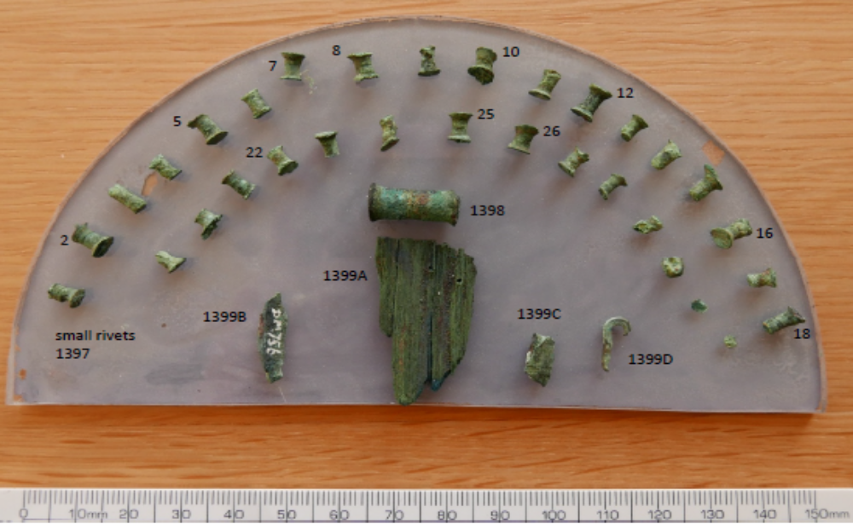
Fig SM1. Rivet set and associated items from a potentially early burial at Bush Barrow, Wiltshire (Wilsford G5). Note that the large rivet at the centre is thought not to belong with the group (see Appendix SM7). Photograph: Stuart Needham
The arrangements at the other three sites is highly conjectural due to inadequate recording or, at Bush Barrow (fig SM1), more likely due to prior disturbance. The blade, apparently represented now only by a single small fragment, may already have been in fragments by the time Cunnington excavated it and he records no pattern in the disposition of the associated rivets. The writer has previously suggested that these remains derive from a rivet-studded dagger that would have been rather earlier in date than the main burial nearby, and could have been disturbed or re-deposited in the course of that later interment.
Thomas Bateman’s account of the example he found at Net Lowe Hill in June 1845 is rather scant. The dagger lay close to the right arm of a skeleton, ‘the decorations of its handle consisting of thirty rivets, and two pins of brass’. He goes on to cite the earlier excavated parallel from Milston. Bateman’s ‘pins’ are long-shanked studs that have only recently been paralleled at Ferry Fryston (above) and were almost certainly studs inserted vertically to secure the pommel, as others had previously deduced. Piggott placed them on the outside of three columns of rivets whereas Gerloff inserted them in between three columns – a rather more likely arrangement, especially given the subsequent evidence from Ferry Fryston. Only four rivets, two towards each shoulder, remain in situ in the hilt-plate, but the implication must be that more surrounded or impinged on the butt – three fit comfortably in the space available to give a total arc of seven (fig 27.4; main paper). While it would be possible to bring three columns down the handle to meet directly the three central butt rivets conjectured, the present writer prefers to see doubled rows splaying out to either shoulder, as inferred for the Leicester example. As proved to be the case at Ferry Fryston, a symmetrical arrangement of the thirty extant rivets requires that they did not line up across all three columns (fig 27.1; main paper); there must, however, be the possibility that not all the rivets were recovered at Net Lowe.

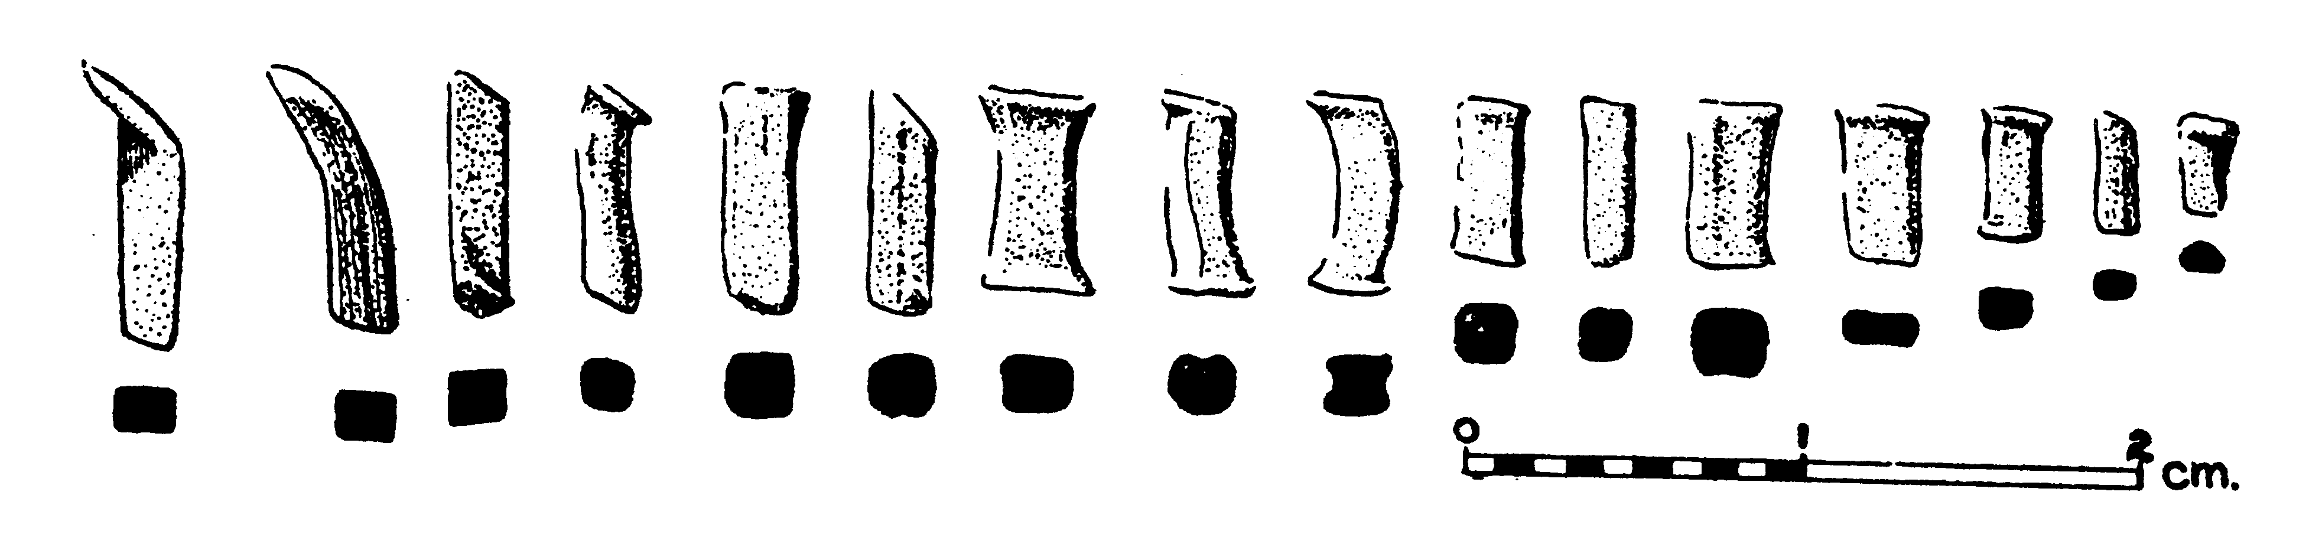

Fig SM2. Rivet set from a cist at Ballyenahan East, Co. Cork, after Fahy 1954; these may not be from a dagger hilt.

The final rivet set to be mentioned comes from Ballyenahan East, Co Cork, but no blade was present in the burial cist and it is possible, therefore, that the rivets furnished another kind of object. The rivets differ in a number of respects from the British examples. Firstly, they appear to be rather more variable in form and some have very oblique ‘heads’ at one end (fig SM2). Secondly, they have square-to-rectangular shank sections, except for the two smallest, which are shown with sub-oval sections. Thirdly, the length spectrum is considerably greater than on any of the British hilts, ranging from around 8mm up to 21.5mm. In fact, the length spectrum can be broken down into five groups, each of three or four rivets: 8mm–10.3mm (3); about 12.5mm (4); about 15mm (3); about 17mm (3); 18.5mm–21.5mm (3). It is noteworthy that the shortest and the longest groups are the least consistent in length and either one might be explained as pommel fixings rather than for hilt studding. Even so, the remaining length variability (8mm–17mm, or 12.5mm–21.5mm) is large and would imply a hilt that thickened significantly from one end to the other. It is unlikely that the longest six formed a spine down the centre of a hilt since it is these that tend to have one or two oblique heads. The lack of any associated grave goods leaves the precise chronology of this grave uncertain.
Since any in-situ formation had been lost at Racton due to the metal-detectorist’s disturbance, the original format of the rivets again has to be a matter of conjecture. There is the added problem that we cannot be totally confident all rivets were recovered; it is salutary that, despite painstaking retrieval under archaeological conditions, the broken part of the dagger blade’s shoulder was not recovered. Nevertheless, the features and disposition of the rivets attached to the blade, plus information drawn from the parallels, allow some reasonable deductions to be made. Important for reconstructing the Ferry Fryston arrangement were the minimum and maximum ‘inter-flange lengths’ of the rivets – that is, the distances between the flanges (or lips) formed by head expansion – for these helped indicate which were likely to be sited near the middle of the hilt and which towards the sides. This dimension, however, may not be so useful for the Racton rivets because very few rivets have heads lying in slightly converging planes. Moreover, several have rhombic long profiles overall, which may imply they penetrated the hilt assembly skew to perpendicular. Nevertheless, the inter-flange lengths remain important for indicating how thick the hilt actually was at any given point.
It is natural to envisage three columns of rivets springing from the rivets through the hilt-plate, and this matches the best reconstruction of all the parallels except Garton Slack, but this still leaves the detailed lay-out to be considered. Of the two rivets in situ, that through the shoulder (Table 4, no 3; main paper) is the shortest of all twenty-six at 7.2mm. One of the three loose rivets recovered by the finder is equally short (no. 5, 7.3mm) and can be taken to be from the broken shoulder. The rivet through the tang (no. 4) is about a millimetre longer (8.4mm) and shows that the hilt thinned a little from the centre of the omega hilt-line towards its outer edges. It is not obvious from their lengths that the other two loose rivets recovered by the finder (nos 6 & 7) necessarily came from close to the butt of the blade. These combined with the twenty-one rivets recovered in the archaeological investigation have lengths ranging from 7.7mm to 8.9mm. Some of the variation is probably due to the hilt having a slightly oval section throughout so that marginal rivets were shorter than the corresponding medial rivets, but most is probably due to changes in thickness along the length of the hilt. The simplest reconstruction would see a medial line increasing steadily from 8.4mm at the blade to 8.9mm at the pommel (fig 28; main paper). Two marginal lines springing from the shoulder rivets can then be populated by rivets that are systematically a little shorter than their medial counterpart, again gradually increasing in length pommel-wards.
The reconstructions for both Ferry Fryston and Garton Slack have two rivets flanking either side of the tang, and something similar seems likely at Racton. If there had only been one rivet per side, this would leave twenty-one rivets for the hilt above the tang – these could form seven rows in three columns (fig 28a; main paper). However, this gives a rather unsatisfactory marked change of spacing between the grip and the shoulders of the hilt; this can only be resolved by introducing more rivets around the butt. With two rivets flanking either side of the tang, then the remaining twenty rivets could have been disposed in staggered formation – in which case, one would be missing (fig 28b; main article). If aligned instead in rows, then again, a change in spacing results. Three rivets either side of the tang not only allow for reasonably even spacing throughout, but also require no additional rivets to those recovered (fig 28c; main paper). While it is feasible to bring the grip rivets all into six rows by introducing one more rivet, staggered formations on the grip do seem to have been the case at Ferry Fryston and perhaps Net Lowe. The Racton reconstruction with three tang-flanking rivets develops a more evenly spaced rivet arc around the butt such as is seen at Milston and Leicester, and perhaps also Garton Slack and Net Lowe (fig 27; main paper). Either this or the two tang-flanking rivets format is plausible when seen against the transformations taking place in dagger design at this time. Indeed, ultimately, it appears that this was the key design dilemma for the rivet-studded style – how to conjoin harmoniously the near vertical columns down the grip with a smooth arc of evenly spaced rivets around the butt.

Appendix SM6
Bayesian analysis of radiocarbon dates associated with the Racton burial and other contexts with earliest bronze in Britain and Ireland
Pete Marshall

The radiocarbon dates from contexts containing the earliest Bronze artefacts in Britain and Ireland clearly fall into a coherent group concentrated in the last quarter of the third millennium cal BC (Table SM3). Simple visual inspection of the calibrated radiocarbon dates does not allow us to assess the date of the earliest Bronze artefacts, since the calibration process does not allow for the fact that this group of radiocarbon dates are related – most are associated with flat bronze daggers belonging to Type 1C Ferry Fryston and Series 2 (various types); one was associated with a bronze hoard, one with a small axe-chisel, and one with a bronze halberd. Bayesian statistical modelling is required to account for this dependence, which has been undertaken using OxCal v.4.2 and the internationally agreed calibration curve for the northern hemisphere, IntCal13. The date ranges from these models are given in italics to distinguish them from simple, calibrated radiocarbon dates.
The analysis aimed to answer the following specific questions:

QUESTION 1: Combine Racton and Ferry Fryston (Type 1C Ferry Fryston daggers), both as a ‘phase’ and as effectively contemporary events.
Figure 31 (see main paper) shows two different ways of trying, with two dates, to determine the currency/date of the Ferry Fryston type. Firstly, they are taken to represent a single phase of activity and this gives revised estimates for both examples:
KIA-25326 (Ferry Fryston) = 2275–2255 cal BC (3% probability) or 2210–2035 cal BC (92% probability) and probably 2205–2125 cal BC (60% probability) or 2085–2060 cal BC (8% probability).
SUERC-55526 (Racton) = 2405–2375 cal BC (2% probability) or 2350–2135 cal BC (93% probability) and probably 2295–2195 cal BC (68% probability).
The alternative model assumes that the close similarities between the two daggers means they were very closely contemporary. The estimate for Combine Racton and Ferry Fryston is 2285–2135 cal BC (95% probability) and probably 2275–2260 cal BC (9% probability) or 2210–2140 cal BC (59% probability).

QUESTION 2: Consider the date range for all Series 2 daggers (all types) as a group, independent of any internal seriation or assumption of being successive to Type 1C.
The first task is to identify any outliers. The two main approaches for dealing with outliers in radiocarbon dating are to eliminate them manually from the analysis or to use a more objective statistical approach. The approach employed here was to use outlier analysis (OxCal – ‘General’ model, P=5%) – the model was first run with outlier analysis to see which radiocarbon dates are likely to be outliers and then re-run without outlier analysis (but with the results identified as outliers excluded). The results of the outlier analysis are given in Table SM4 and those dates (SUERC-26188, OxA-3814, and OxA-6713) excluded from subsequent model are identified in figs SM3, SM4 and SM5 by a ‘?’ after the laboratory sample reference.
The model for all the Series 2 daggers is shown in fig SM3 and once again assumes that the dated samples represent a single phase of activity. The estimated start date for Series 2 daggers is 2180–2035 cal BC (95% probability) and probably 2145–2065 cal BC (68% probability). The estimated end date is 2030–1905 cal BC (95% probability) and probably 2010–1945 cal BC (68% probability).

Table SM3. Radiocarbon dates for contexts with earliest types of bronze object in Britain and Ireland
SITE | OBJECT TYPE(S)  & CONTEXT | SAMPLE MATERIAL | BP RADIOCARBON DATE | LABORATORY REFERENCE | PREVIOUS LISTING OR SOURCE
Racton, West Sussex | Type 1C dagger; burial | Human tooth dentine | 3826 ± 33 | SUERC-55526 | This paper
Ferry Fryston, North Yorkshire | Type 1C dagger; burial | Human bone | 3732 ± 27 | KIA-25326 | Needham 2012, appendix 1.1 (CD)
Radley Barrow Hills 3, Oxfordshire | Type 2C dagger; burial | Human bone | 3785 ± 90 | OxA-4355 | Needham 2012, table 1
Rameldry Farm, Fife | Type 2C dagger; burial | Human bone | 3725 ± 40 | GU-9574 | Needham 2012, table 1
Amesbury G85, Wiltshire | Type 2D dagger; burial (no. 2) | Human bone | 3870 ± 35 | SUERC-26188 (GU-19937) | Needham 2012, table 1
Gravelly Guy, Oxfordshire | Type 2F1 dagger; burial | Human bone | 3709 ± 35 | UB-3122 | Needham 2012, table 1
SITE | OBJECT TYPE(S) & CONTEXT | SAMPLE MATERIAL | BP RADIOCARBON DATE | LABORATORY REFERENCE | PREVIOUS LISTING OR SOURCE
Wilsford G54, Wiltshire | Type 2F1 dagger; burial (skeleton 7) – not certainly | Human bone | 3855 ± 30 | SUERC-31859 | Mike Parker Pearson, pers comm
Gask Hill, Collessie, Fife | Type 2F2 dagger; burial | Burnt human bone  Hide from sheath | 3695 ± 45  3690 ± 80 | GrA-19054  OxA-4510 | Needham 2012, table 1
Garrowby Wold 32, East Yorkshire | Type 2B dagger; burial (no. 4) | Human bone | 3729 ± 29 | OxA-V-2199-33 | Needham 2012, table 1
Foxley Farm, Eynsham, Oxfordshire | Type 2B dagger; burial (no. 15) | Human bone | 3650 ± 30 | SUERC-26193 | Needham 2012, table 1
Manor Farm, Borwick, Lancashire | Type 2B dagger; Class 3A axe; burial (SF 55) | Animal bone  Human bone | 3450 ± 70  3270 ± 80 | HAR-5661  HAR-5628 | Needham 2012, table 1
Lockerbie Academy, Dumfries & Galloway | Type 2A dagger; burial (F33) | Animal hide from sheath | 3645 ± 35 | SUERC-19817 | Needham 2012, table 1
Seafield West, Inverness, Highland | Probably Type 2A dagger (corroded); burial | Hide and wood from sheath (both samples) | 3600 ± 30 (weighted mean of two) | GrA-27037/27039 | Needham 2012, table 1
Allerwash Farm, Newbrough, Northumberland | Type 2E/2A dagger; burial (partial and re-arranged) | Human bone | 3713 + 28 BP | OxA-26254 | Chris Fowler, pers comm
Forteviot, Perth & Kinross | Type 2E dagger; burial | Bark (birch)  Charcoal (Betula)  Wood (cf Salix)  Seeds (cf Filipendula ulmaria)  Flower (cf Filipendula ulmaria) | 3675 ± 30  3690 ± 30  3705 ± 30  3590 ± 30  3740 ± 35 | SUERC-26112  SUERC-29196  SUERC-29200  SUERC-29198  SUERC 29199 | Noble and Brophy 2011, 794 table 1
Bught Park, Inverness, Highland | Type 2E dagger; burial | Human bone | 3695 ± 31 | OxA-V-2247-48 | Needham 2012, table 1
Corkey, Co Antrim | Cf Type 2E knife; burial | Human bone | 3680 ± 50 | GrA-5409 | Needham 2012, table 1
Gristhorpe Cliff, North Yorkshire | Type 2F3 knife or dagger; burial | Human tooth dentine | 3671 ± 32 | OxA-16844 | Needham 2012, table 1
SITE | OBJECT TYPE(S) & CONTEXT | SAMPLE MATERIAL | BP RADIOCARBON DATE | LABORATORY REFERENCE | PREVIOUS LISTING OR SOURCE
Shuttlestone Plantation, Parwich Moor, Derbyshire | Type 2F3 dagger, class 4B axe; burial | Human bone | 3680 ± 30 | SUERC-26172 (GU-19924) | Needham 2012, table 1
Candleston Castle, Merthyr Mawr, West Glamorgan | Type 2F3 dagger; burial | Burnt human bone | 3630 ± 35  3605 ± 35 | GrA-27615  GrA-27614 | Needham 2012, table 1
Vessey Pasture Farm, Aldro 116, East Yorkshire | Series 2 dagger (unclassified to type); burial (no. 2) | Human bone | 3679 ± 32 | OxA-V-2199-43 | Needham 2012, table 1
Migdale, Highland | Hoard with Type Migdale axe, bar armlets, tubular beads and other ornaments | Wooden bead core | 3655 ± 75 | OxA-4659 | Needham et al 1997, 61 table 1
Worlingham, Suffolk | Axe-chisel (Class 3) from pit group | Charcoal & charred hazelnut shells | 3775 ± 60 BP | AA-444404 (GU-9491) | Colin Pendleton, pers comm
Lough Ree, Ireland | Halberd of Type Corlurgan; lake find | Wooden haft fragments (probably oak) | 3780 ± 29 BP | UBA-23195 | Bell 2014

Table SM4. Series 2 daggers outlier analysis – SUERC-26188, OxA-3814, and OxA-6713 are clearly identified as being potential ‘outliers’ (the prior probability for each date being an outlier was set as 5%)

 | OK | OUTLIER
SUERC-26188 | 79 | 21
OxA-4355 | 96 | 4
OxA-V-2199-33 | 97 | 3
GU-9574 | 97 | 3
UB-3122 | 97 | 3
Gask Hill | 97 | 3
OxA-V-2247-48 | 97 | 3
GrA-5409 | 97 | 3
SUERC-26172 | 97 | 3
OxA-V-2199-43 | 97 | 3
OxA-16844 | 97 | 3
SUERC-19817 | 97 | 3
Candleston Castle | 97 | 3
OxA-V-2247-46 | 96 | 4
GrA-19990 | 96 | 4
GrA-14775 | 96 | 4
Seafield West | 96 | 4
OxA-3814 | 92 | 8
OxA-6173 | 84 | 16

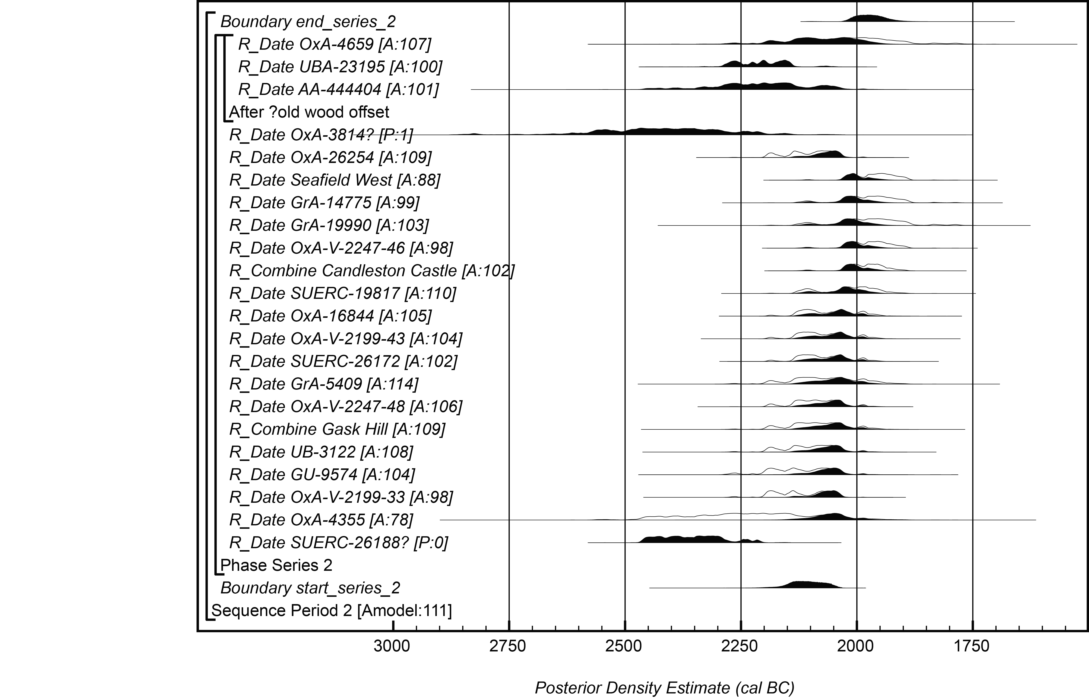
Fig SM3. Probability distributions for dates for Series 2 daggers and three other early bronzes. Graph: Peter Marshall, using OxCal v.4.2.

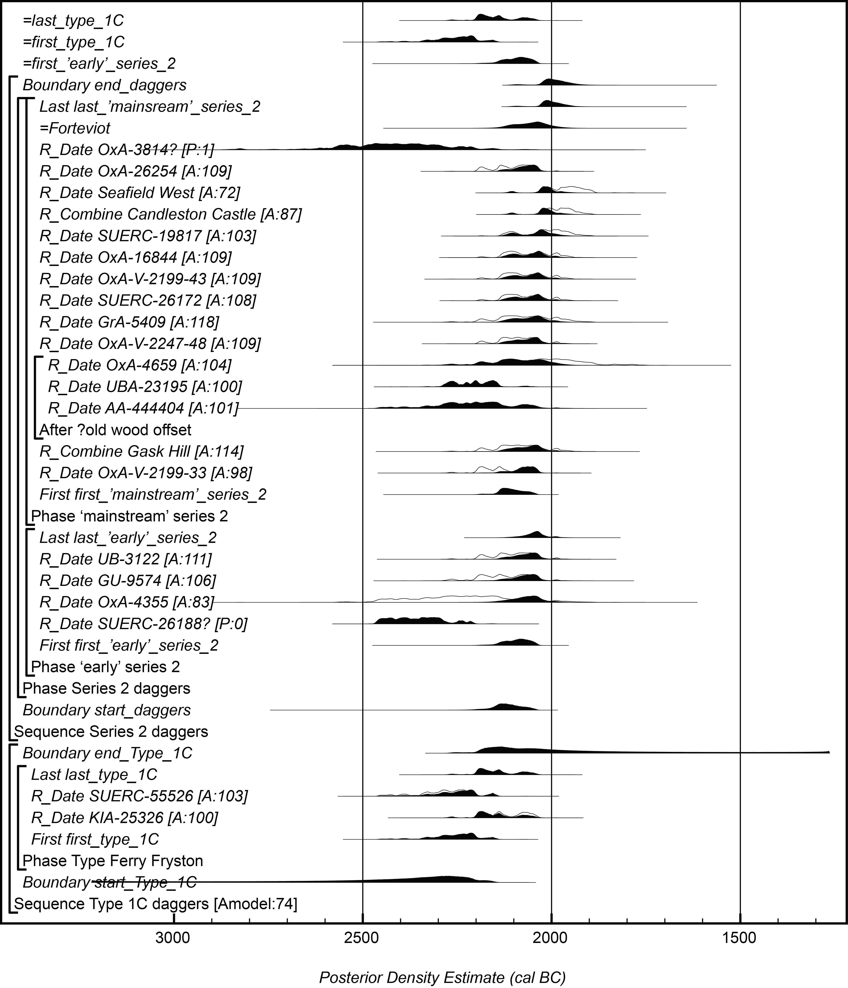
Fig SM4. Probability distributions for daggers of Type 1C, ‘early’ Series 2 and ‘mainstream’ Series 2 treated as three independent groupings. The overall format is identical to fig SM3. Graph: Peter Marshall, using OxCal v.4.2.

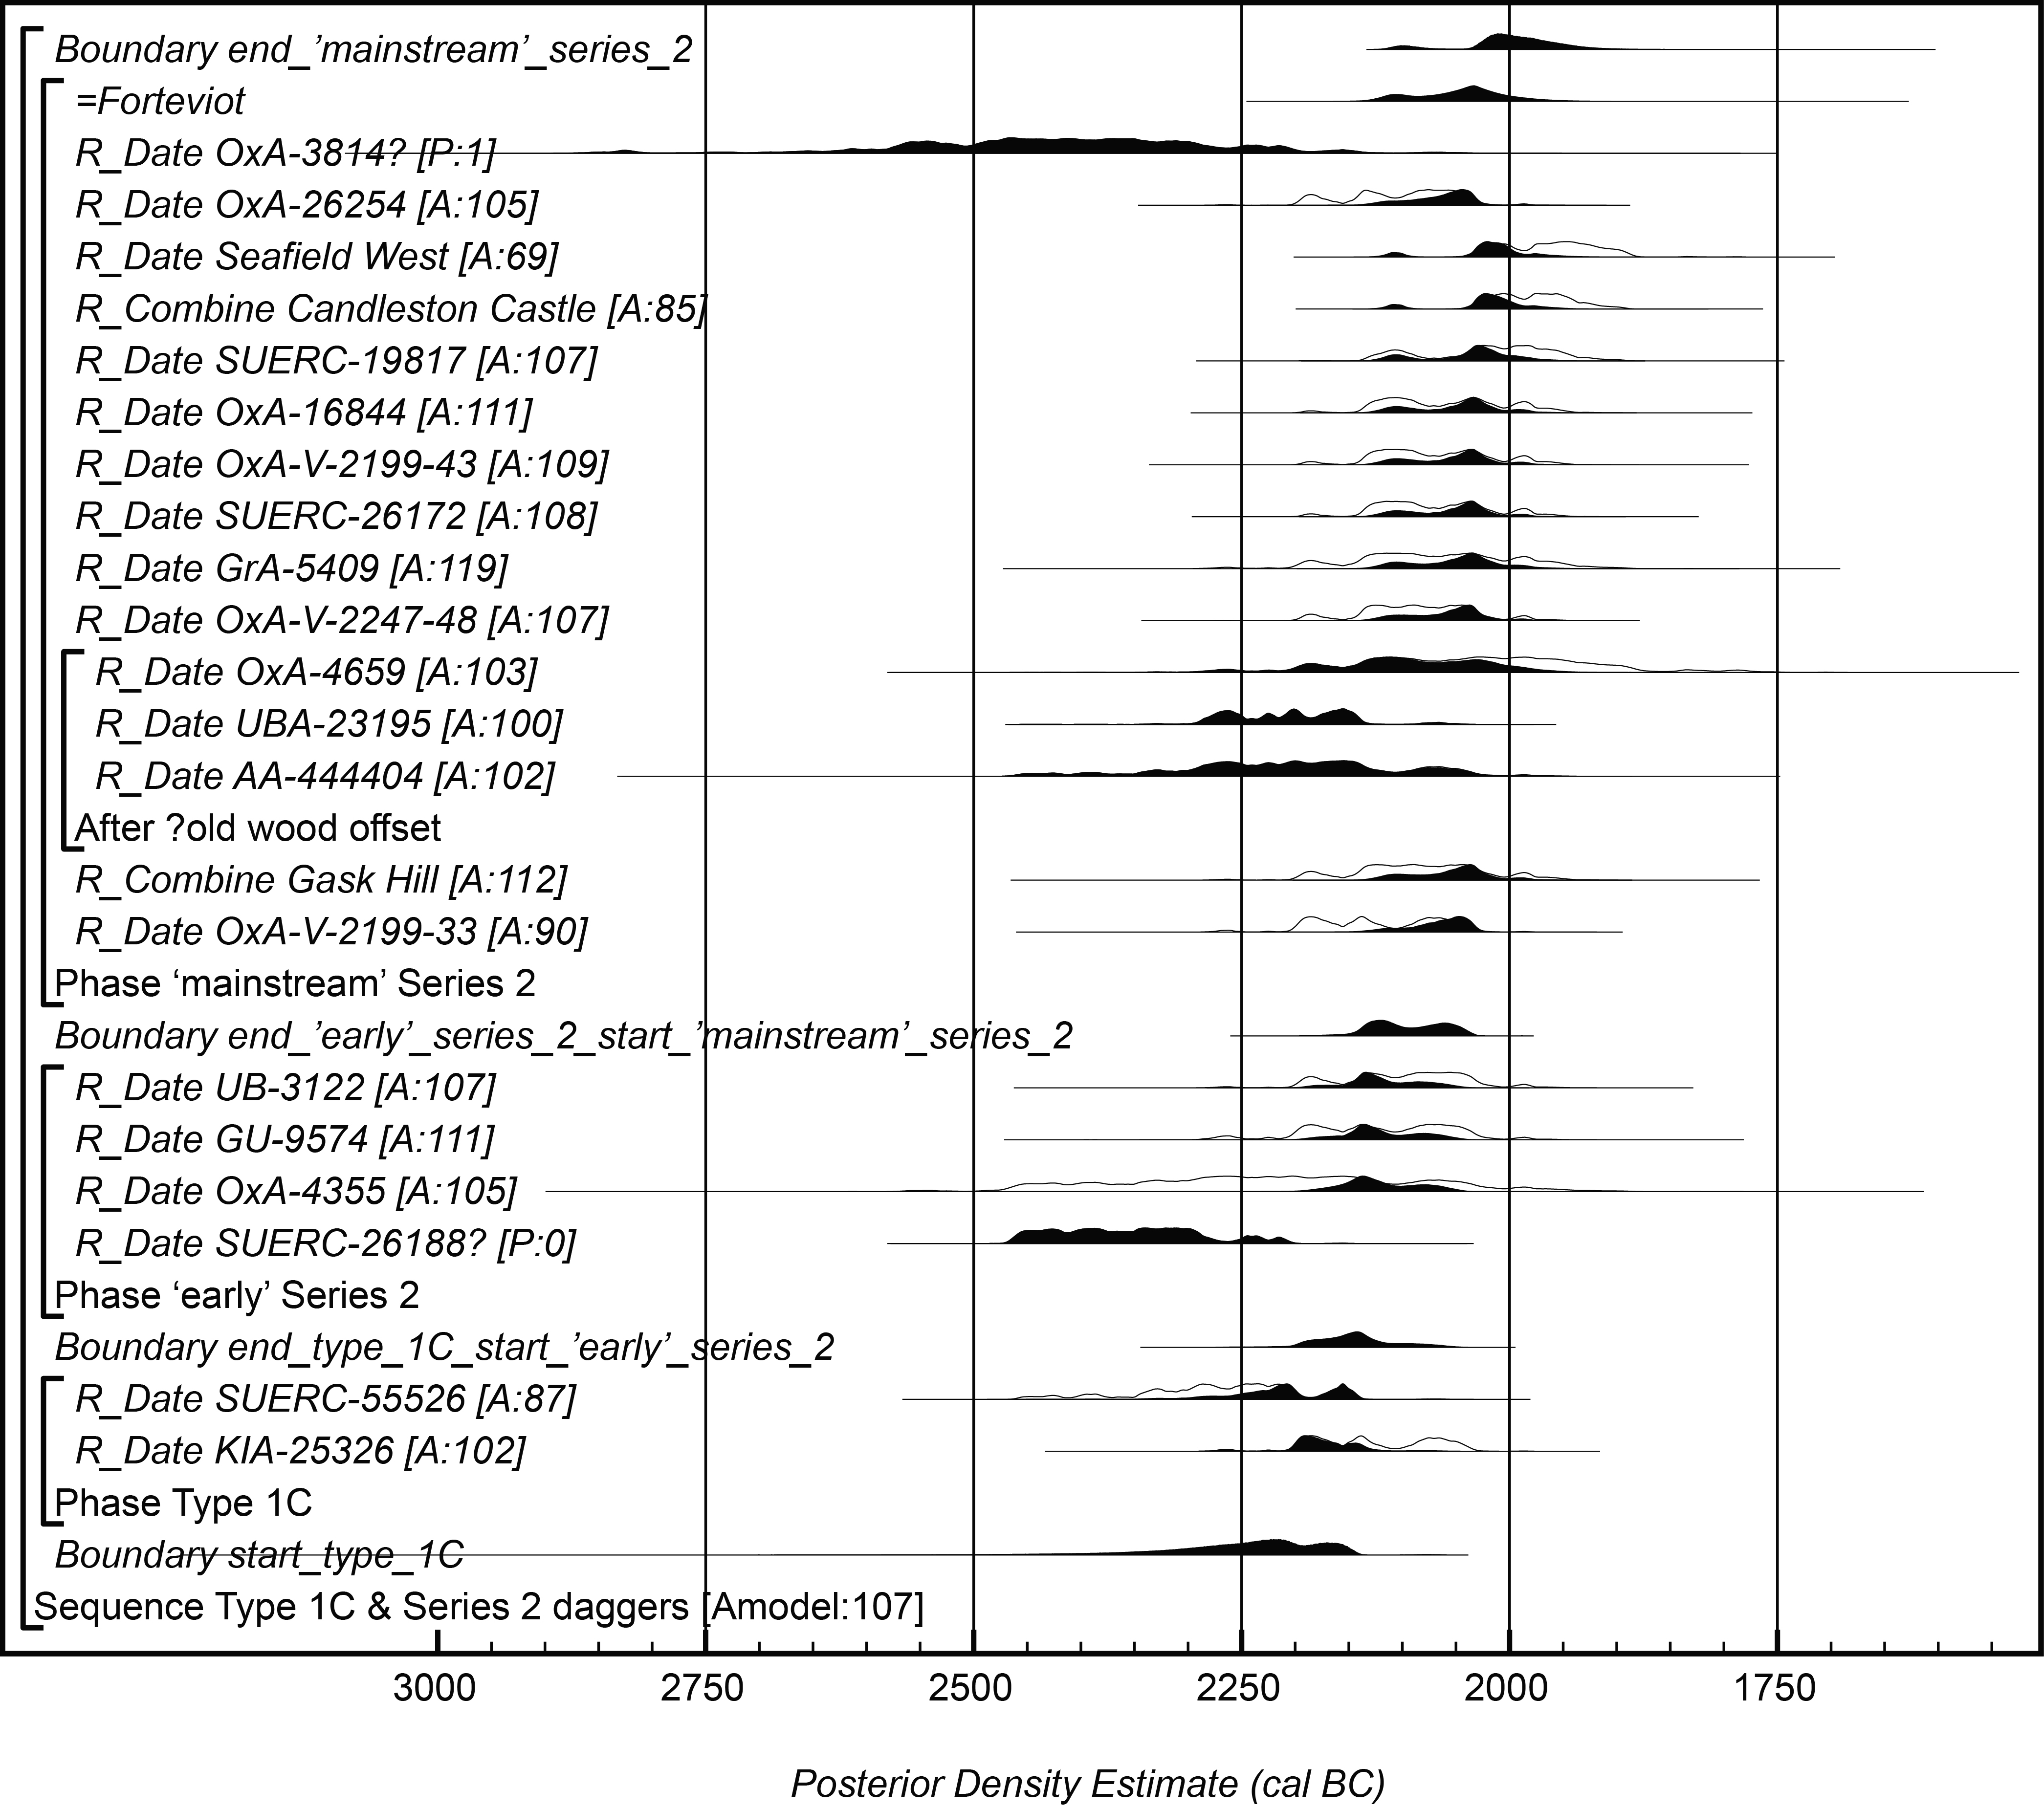

Fig SM5. Probability distributions for daggers of Type 1C, ‘early’ Series 2 and ‘mainstream’ Series 2 treated as successive groups, based on archaeological evaluation. The overall format is identical to fig SM3. Graph:
Peter Marshall, using OxCal v.4.2.

QUESTION 3: Does the available radiocarbon data support the deductions based on typology and associations that a sequence can be recognised from Type 1C to certain ‘early’ Series 2 types to ‘mainstream’ Series 2 types?
Figure SM4 treats these three groupings as phases independent of one another. Type 1C is shown clearly to be earlier than Series 2, including those postulated to be early. The succession from ‘early’ to ‘mainstream’ daggers within Series 2 is not supported by this model, but neither is it negated. On the assumption that the archaeological deductions for a sequence are good, this can be modelled differently, as in fig SM5, where it is found that the sequence 1C – early 2 – mainstream 2 has good agreement with the radiocarbon dates (Amodel:108). This allows the dates of transition to be estimated (fig SM6) as follows: end Type 1C and start early Series 2 = 2205–2055 cal BC (95% probability) and probably 2190–2120 cal BC (68% probability); end early Series 2 and start mainstream Series 2 = 2150–2035 cal BC (95% probability) and probably 2140–2100 cal BC (38% probability) or 2080–2045 cal BC (30% probability).

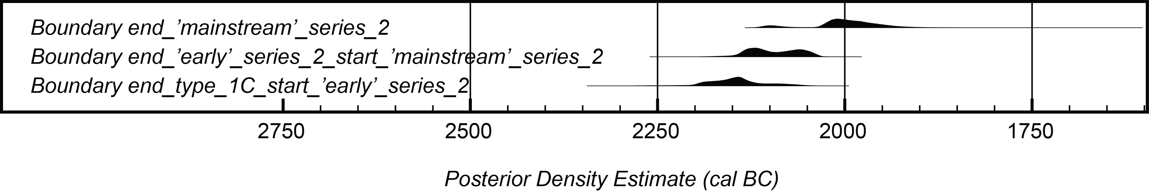

Fig SM6. Summary of the estimated dates of transitions derived from the model shown in fig SM5. Graph:
Peter Marshall, using OxCal v.4.2.

Appendix SM7
Surface analysis of the Milston G51 dagger and the rivet set from Bush Barrow (Wilsford G5)
Garrard Cole & Stuart Needham

As research on the Racton dagger and its parallels proceeded, it became obvious that it would be desirable to ascertain the composition of the Milston dagger blade and its associated rivets (hitherto assumed to be bronze on the basis of typology) and, furthermore, to confirm the composition of the Bush Barrow rivet set. Previously, only one of the latter rivets had been analysed and shown to be copper rather than bronze. Since the key question in relation to the chronological position of rivet-studded daggers was whether they were of unalloyed copper or alloyed bronze, it was decided to seek permission only for qualitative analysis of unabraded surfaces using X-ray fluorescence. Permission was readily granted by the Trustees of The Wiltshire Heritage Museum, Devizes, and kindly facilitated by Patrick Quinn at the Institute of Archaeology, University College London.

ANALYTICAL TECHNIQUE AND LIMITATIONS
The analysis was carried out using an Olympus Innov-X Delta™ Handheld XRF Analyzer. The machine has a 3mm target aperture, an anode voltage of 40kV and a maximum beam current of 200μA. The measurement system is based on a Silicon Drift Detector coupled to a floating point digital signal processor. It has a built-in barometer for automatic altitude correction. It was operated in ‘Alloy Plus’ mode with an extended element set ‘enabled’. The instrument uses Fundamental Parameter Analysis for element identification. The objects analysed were not prepared in any way. The gun was held as close to the surface as possible without actually touching, this being achieved by using supports of appropriate height just to the side of the object. The gun faceplate was oriented to be parallel to the general object surface. The instrument was allowed to warm up and stabilise for about 30 minutes prior to taking measurements. The internal calibration check (using a 316 Stainless Steel Alloy target) was performed before the first measurement and periodically through the measurement sequence. After the measurement sequence had been completed, the instrument calibration was checked using a set of commercial precision copper-alloy standards. The set of five known standards were identified as ‘European Commission BCR-691 A’ to ‘European Commission BCR-691 E’. The standards are described as Quaternary Bronze, Brass, Arsenic-Copper, Lead Bronze and Tin Bronze, respectively. The standards have polished surfaces to minimise surface geometry errors.
The handheld XRF instrument measures the surface and shallow sub-surface elemental composition of the object under test. The penetration depth depends on the density of the material, the higher the density the shallower the penetration depth. In all cases the penetration depth is very shallow and may not be greater than the corrosion layer.
The instrument operates as an Energy Dispersive XRF system. Elements are identified by characteristic X-ray emission energies. The intensity of the detected peak is proportional to the amount of that element present in the test sample. High energy X-ray photons knock electrons out of the innermost K, L or M orbits around a nucleus, converting the atom into an unstable charged ion. An electron from an outer shell moves to fill the gap; in doing so, it emits a fixed amount of energy as a secondary X-ray photon, a process known as fluorescence. The energy depends on the difference between the initial and final energy levels. The resultant energy patterns are characteristic of a given element. The hand-held portable XRF system relies on extensive computer processing of the raw detected signal, along with knowledge of the detector characteristics and calibration libraries for elemental data.
The equipment relies on internal calibration data specific to each instrument. The calibration algorithm does not rely on the use of standards and is known as the Fundamental Parameters method of quantification. There are a number of potential pitfalls associated with XRF analysis. One, interference, arises when a spectral peak of one element of interest overlaps a peak of another element. This overlap may be partial or complete. If the instrument is calibrated for both elements, then the effect of the interference is to raise the limit of detection of the interfered element and poorer precision. This may occur with lead and arsenic with a one-way interference from lead to arsenic, so arsenic has a degraded limit of detection and precision in the presence of lead. Other interferences may occur between adjacent elements ordered by atomic number. High levels of an element of atomic number Z may result in falsely higher levels of element Z-1 or Z+1 being reported, if present. For example, high levels of Fe (> 10%, Z=26) may cause elevated levels of Mn (Z=25) or Co (Z=27). One other form of interference arises when the L-shell energy line of one element overlaps the K-shell line of another. This is seen most commonly with lead and arsenic because the L-alpha line of lead almost coincides with the K-alpha line of arsenic.
Potential instrument limitations such as stability and precision are handled by careful and robust instrument design.
The main sample-specific problems relate to the lack of sample preparation implicit in the use of non-destructive measurements (this being the prime advantage of portable XRF systems) and the difficulty in accurately quantifying low-Z elements. Low-Z are detected with low efficiency, resulting in higher limits of detection and lower accuracy when compared to higher Z elements measured by the same instrument. One other major problem particularly for non-inert metals arises from the variable modification of surface composition as metallic objects degrade after deposition. These changes may be reflected in either relative enhancement or relative depletion of various elements forming the particular alloy. For example, Sn may have a relative surface enhancement compared to Cu as it is less mobile in typical environments. Trace Pb may also be affected in the same way. Taphonomic changes may result in enhanced levels of Fe, Mn and Zn due to their presence in the local environment. Zinc is particularly problematical as it is subject to spurious signals in both EDXRF and WDXRF; trace levels of Zn should consequently be interpreted with caution.
The instrument measures the average elemental composition over an area defined by the instrument sampling window – 3mm for the instrument in question. Several areas of blade were selected for measurement along with the end face of a number of rivets. To minimise errors arising from surface composition variation, the areas of blade free of patina were selected. In the case of the rivets, the instrument measurement centre was aligned over the centre of the rivet face.
The manufacturer produces tables of the limit of detection for each element. These are presented as a lower level and an upper level. The lower level is the best-case, level three sigma above statistical noise level in an interference-free environment. The upper level reflects levels achievable in a more realistic environment. The upper limit is, therefore, the appropriate level for typical archaeological applications and is given in Table SM5.
Given the limitations of the portable XRF instrument analysing unabraded surfaces, the data was assessed in a qualitative mode using a six-level grading scheme. The levels used are: 0 – not detected; 1 – detected and up to 0.04%; 2 – between 0.04% and 0.1%; 3 – between 0.1% and 1.0%; 4 – between 1.0% and 10%; 5 – above 10% (Tables SM6 and SM7). This avoids the use of potentially misleading numeric values, which may imply greater accuracy than is justified. The fact that a given element is quoted as being present in a range, such as ‘3’, does not guarantee it was at a level between 0.1% and 1.0% in the original composition, but it may give a reasonable estimate of the order of magnitude relative to other measurements made using the same technique.

Table SM5. Detection limits for measured elements (uppermost of range quoted by manufacturer)*
Element | Ti | Cr | Ni | Cu | Zn | As | Se | Ag | Cd | Sn | Sb | Ba | Hg | Pb
Atomic no | 22 | 24 | 28 | 29 | 30 | 33 | 34 | 47 | 48 | 50 | 51 | 56 | 80 | 82
Limit (ppm) | 4 | 10 | 20 | 7 | 4 | 4 | 3 | 8 | 8 | 15 | 15 | 20 | 4 | 4
*Note: these limits take no account of inaccuracies introduced by corrosion distortions or the X-ray beam hitting more than one object

Table SM6. Results of surface analysis of the components of the Milston dagger*
OBJECT PART | Cu | Sn | Pb | Zn | As | Sb | Ag | Ni | Co | Bi | Fe | Mn
blade (#6) | 5 | 5 | 3 | 3 | 4 | 3 | 3 | 0 | 0 | 0 | 0 | 0
blade (#8) | 5 | 5 | 2 | 3 | 4 | 3 | 3 | 0 | 0 | 0 | 2 | 0
blade (#9) | 5 | 5 | 1 | 0 | 3 | 3 | 3 | 0 | 0 | 0 | 2 | 0
blade (#10) | 5 | 5 | 2 | 2 | 4 | 3 | 3 | 0 | 0 | 0 | 2 | 0
blade (#11) | 5 | 5 | 3 | 3 | 4 | 3 | 3 | 0 | 0 | 0 | 3 | 0
rivet 5 (#5) | 5 | 5 | 3 | 0 | 4 | 0 | 4 | 0 | 0 | 0 | 3 | 0
rivet 2 (#13) | 5 | 5 | 3 | 0 | 4 | 0 | 0 | 1 | 0 | 0 | 3 | 0
rivet 3 (#14) | 5 | 5 | 3 | 0 | 4 | 3 | 0 | 0 | 0 | 0 | 3 | 0
rivet 4 (#16) | 5 | 5 | 3 | 0 | 4 | 0 | 0 | 0 | 0 | 0 | 3 | 0
rivet 7 (#17) | 5 | 5 | 3 | 3 | 4 | 0 | 0 | 0 | 0 | 0 | 3 | 0
rivet 8 (#18) | 5 | 5 | 3 | 0 | 4 | 0 | 0 | 0 | 0 | 0 | 3 | 0
rivet 9 (#19) | 5 | 5 | 3 | 3 | 4 | 0 | 0 | 0 | 0 | 2 | 3 | 0
rivet 11 (#20) | 5 | 5 | 3 | 0 | 4 | 0 | 0 | 1 | 0 | 0 | 3 | 0
rivet 20 (#21) | 5 | 5 | 3 | 0 | 4 | 0 | 0 | 0 | 0 | 0 | 3 | 0
rivet 17 (#22) | 5 | 5 | 3 | 0 | 3 | 0 | 0 | 0 | 0 | 0 | 3 | 0
butt rivet 29 (#24) | 5 | 5 | 3 | 3 | 4 | 3 | 3 | 0 | 0 | 2 | 3 | 0
butt rivet 27 (#25) | 5 | 5 | 3 | 3 | 4 | 3 | 3 | 0 | 0 | 0 | 3 | 0
butt rivet 23 (#26) | 5 | 5 | 3 | 3 | 4 | 0 | 3 | 2 | 0 | 0 | 3 | 0
butt rivet 22 (#27) | 5 | 5 | 3 | 3 | 4 | 3 | 3 | 0 | 0 | 2 | 3 | 0
wooden hilt (#28) | 5 | 5 | 4 | 3 | 0 | 0 | 0 | 0 | 0 | 3 | 4 | 0
wooden hilt (#29) | 5 | 4 | 4 | 3 | 0 | 0 | 0 | 0 | 0 | 0 | 4 | 0
wooden hilt (#30) | 5 | 5 | 4 | 3 | 0 | 0 | 4 | 0 | 0 | 3 | 4 | 0
pommel rivet 32 (#31) | 5 | 0 | 4 | 4 | 0 | 0 | 0 | 0 | 0 | 0 | 3 | 2
pommel rivet 33 (#32) | 5 | 0 | 4 | 4 | 0 | 0 | 0 | 0 | 0 | 0 | 3 | 0

*Note: Only selected elements recorded are shown here; actual readings are simplified to large ranges because of the likely distortions to element percentages discussed above

Key: 0 – not detected (see text for detection limits)
1 – detected and below 0.04%
2 – between 0.04% and 0.1%
3 – between 0.1% and 1.0%
4 – between 1.0% and 10%
5 – above 10%

Table SM7. Results of surface analysis of the Bush Barrow rivet set and associated fragments*
OBJECT PART | Cu | Sn | Pb | Zn | As | Sb | Ag | Ni | Co | Bi | Fe | Mn
rivet 2 (#36) | 5 | 0 | 3 | 3 | 0 | 0 | 0 | 0 | 0 | 0 | 2 | 0
rivet 5 (#37) | 5 | 0 | 3 | 4 | 0 | 0 | 0 | 0 | 0 | 0 | 2 | 0
rivet 8 (#38) | 5 | 0 | 3 | 4 | 0 | 0 | 0 | 0 | 0 | 0 | 2 | 0
rivet 10 (#39) | 5 | 0 | 3 | 4 | 0 | 0 | 0 | 0 | 0 | 0 | 2 | 0
rivet 12 (#40) | 5 | 0 | 3 | 3 | 0 | 0 | 0 | 1 | 0 | 0 | 1 | 0
rivet 16 (#41) | 5 | 3 | 3 | 4 | 0 | 0 | 0 | 1 | 0 | 0 | 3 | 0
rivet 18 (#42) | 5 | 0 | 3 | 4 | 0 | 0 | 0 | 0 | 0 | 0 | 0 | 0
rivet 22 (#43) | 5 | 0 | 3 | 4 | 0 | 0 | 0 | 0 | 0 | 0 | 0 | 0
rivet 25 (#44) | 5 | 3 | 3 | 3 | 0 | 0 | 0 | 0 | 0 | 0 | 2 | 0
rivet 26 (#45) | 5 | 0 | 3 | 4 | 0 | 0 | 0 | 0 | 0 | 0 | 3 | 0
rivet 7 (#48) | 5 | 0 | 3 | 3 | 0 | 0 | 0 | 0 | 0 | 0 | 0 | 0
blade? fragment 1399B (#49) | 5 | 5 | 1 | 3 | 3 | 0 | 0 | 2 | 0 | 0 | 2 | 0
blade fragment 1399C (#50) | 5 | 4 | 3 | 3 | 0 | 0 | 0 | 0 | 0 | 0 | 2 | 0
hooked wire 1399D (#51) | 5 | 4 | 5 | 4 | 0 | 0 | 0 | 0 | 0 | 0 | 2 | 0
wood fragment 1399A (#52) | 5 | 0 | 1 | 2 | 1 | 0 | 0 | 0 | 0 | 0 | 3 | 0
large rivet 1398 (#53) | 5 | 4 | 3 | 0 | 3 | 3 | 0 | 3 | 0 | 0 | 2 | 0
Perspex mount (#54) | 0 | 0 | 3 | 5 | 0 | 0 | 0 | 0 | 0 | 3 | 0 | 0

*Note: Only selected elements recorded are shown here; actual readings are simplified to large ranges because of the likely distortions to element percentages discussed above

Key: 0 – not detected (see text for detection limits)
1 – detected and below 0.04%
2 – between 0.04% and 0.1%
3 – between 0.1% and 1.0%
4 – between 1.0% and 10%
5 – above 10%

RESULTS

Milston G51 dagger (Table SM6 and fig 22 (main paper))
Five measurements were obtained on different parts of the blade and fourteen of the twenty-nine extant rivets were analysed, as were the two ‘pegs’ fixing the pommel. The analyses of the rivets are likely to be ‘contaminated’ by the surrounding hilt because the beam from the analytical instrument was wider than, or as wide as, the rivet heads and it was impossible to centre it on the head exactly. Although the surround is of wood, it has evidently been coated or stained with a substance that contains traces of several metals (Table SM6, #28, #29 & #30). Of three readings on the wood (taken as far away as possible from any rivets), iron, copper, tin, lead, zinc, titanium, cadmium, palladium and various other rare elements were present in all; bismuth was present in two; silver in one. Fortunately, three significant impurities for Early Bronze Age copper – arsenic, antimony and nickel – were not detected. All metal components proved to be of bronze except for the two ‘pegs’ through the pommel, which were of leaded brass.
Two types of surface were analysed on the blade of the dagger, both avoiding a fine-textured corrosion skin, which covers much of both faces. Readings #6, #8 and #11 were on smooth, shiny patinated surfaces; readings 9 and 10 were instead on small patches, where the textured corrosion skin had flaked to reveal a dull copper-coloured surface. The patinated surfaces gave readings for tin above 20%, almost certainly due to enrichment, whereas the flaked surfaces gave between 12% and 15%, which is likely to be closer to the actual percentage present.
The rivets are numbered 1–30, from top left to bottom right looking at the face for which the missing rivet (10) is to the left-hand side; nos 1–21 furnish the grip; 22–30 form the arc around the blade’s butt. Fourteen rivets were analysed and these too gave probably artificially high readings for tin, ranging between 13% and 32%, partly due to surface enrichment, but possibly also due to the presence of tin in the coating of the wooden hilt restoration, which may have contributed background noise to many of the readings. Likewise, lead readings of between 0.12% and 0.56% in the rivets are likely to derive from lead in the background material; lead levels in the blade are much lower, the readings giving between 0.03% and 0.12%. Zinc, too, is present in the wooden hilt/coating, but only at low levels and, given that traces of zinc up to about 0.2% were shown to be present in four of five analyses of the blade, it is possible that some of the zinc (0.17%–0.35%) shown in six of the analysed rivets is genuinely a part of the bronze composition. If zinc is genuinely present (note the spurious effects it can be subject to, mentioned above), its levels are all low enough to be considered as impurities deriving from the copper source.
The ‘principal impurities’ (that is, those that have been found to be most useful for characterising copper used in the Bronze Age) are arsenic, antimony, silver and nickel. Nickel was undetected in the blade and only recorded at low levels (beneath 0.05%) in three rivets. In contrast, arsenic was recorded in reasonable quantity at all analysed points. On the blade, a distinction similar to that observed for tin is seen, with three probably enhanced readings on the patinated surface (1.7%–2.7%) and two lower readings on the flaked surface (0.5%–1.2%), which we believe to be closer to the true value. Arsenic readings for the rivets vary widely between 0.7% and 2.7% and are likely in general to be over-estimates. Nevertheless, arsenic is a significant and consistently present impurity. The presence of silver and antimony is more complicated and follows a very similar pattern. All of the blade analyses and three of the four rivets analysed in the butt-arc show both antimony and silver at moderate impurity levels (readings of 0.4%–1.0%). Meanwhile, the ten analysed rivets in the hilt grip are almost entirely consistent in having neither element detected – one, however, has silver detected (rivet 5) and no antimony, another has the opposite (rivet 3). The third exception to the general pattern is that no antimony was detected in one of the butt-arc rivets (rivet 23).
Overall, therefore, the following summary compositions may be suggested:

Blade: probably a ‘standard’ tin bronze (that is, tin levels similar to those well established for the British Early Bronze Age); an impurity suite in which arsenic, antimony and silver are all significant impurities, and with zinc, lead and iron at lower levels; nickel is, significantly, undetected. Overall, this looks highly comparable to the classic impurity suite for ‘A-metal’, believed to come ultimately from Ross Island in Co Kerry, Ireland. Quantitative analysis, discarding corrosion layers, would be needed to confirm this.

Butt-arc rivets (four analysed): in both alloy and impurity suite, this is likely to have been very similar to the metal in the blade, with the only differences – enhanced lead, zinc and iron – probably being due to slight contamination from the coating of the surrounding wood. Rivet 23 is less certainly of the same composition since it lacked measurable antimony and had instead a small amount of nickel.

Hilt-grip rivets (ten analysed): eight are clearly differentiated from both the blade and the butt-arc rivets. While arsenic is again a significant impurity, silver and antimony are undetected (above about 8ppm and 15ppm respectively, Table SM6). Other differences are that eight of ten readings revealed no zinc, while lead levels are almost all higher (0.27%–0.56%, one exception) than for the butt-arc rivets (0.18%–0.23%). Taken together, these various differences must reflect use of a copper with a different composition. Rivets 3 and 5 are anomalous in showing antimony and silver respectively, but not both.

Pommel rivets: No tin was detected, whereas both zinc and lead were measured at between 2% and 4%, the great bulk being copper. These rivets are therefore of a slightly leaded, low-zinc brass and can be interpreted as components introduced for the early nineteenth century restoration.

Bush Barrow (Table SM7; fig SM1)
The Bush Barrow rivet set (ID 1397), along with five more fragments (ID 1398, 1399A–D), are all glued to a Perspex mount (fig SM1); numbering of all follows that recently published. The same problem with potential background contamination applies as is described above for the Milston rivets; the larger objects – the piece of wood (1399A) and the large rivet (1398) – are those most likely to be free from this effect. The mount was analysed away from the objects and revealed a range of metal traces, largest of which were palladium, zinc and cadmium. Of the smaller traces, lead and bismuth are the only elements normally sought to characterise early copper/alloys and these are not critical for interpretation (Table SM7, #54).
The eleven rivets analysed are the more substantial ones that would better fill the X-ray beam area. In only two was any tin detected (rivets 16 & 25) and the levels were well below 1% and hence likely to be an impurity or accidental inclusion. Since zinc and lead are at low levels and both are potentially enhanced by background contributions (especially zinc), a good number of the rivets are now established to be of unalloyed copper, thus confirming the single previous analysis mentioned above. Apart from a little iron, which ranges from undetected up to 0.16%, other significant elements are conspicuous by their virtual absence above respective detection limits; just two rivets revealed a trace of nickel below 0.03% (rivets 12 & 16). In particular, arsenic, antimony and silver were consistently not found. This pattern of low-impurity and unalloyed copper partly corresponds with Case’s more accurate chemical analysis (unknown which rivet), which showed tin at 0.08%–0.10%, arsenic at 0.006%–0.007%, zinc at 0.002%–0.003% and lead at 0.03%–0.04%. However, nickel and silver were both measured at 0.10%–0.15%, a level that should easily have been detected by the present instrument. The rivets analysed by us can, therefore, be seen to represent a copper low in natural impurities, which was used in unalloyed form.
The large rivet (ID 1398) has an entirely different composition previously established by Humphrey Case. It is of alloyed bronze, with significant impurities of arsenic, antimony, silver, nickel and lead with a little bismuth and zinc. While our surface analysis is similar, we got a lower reading for tin (7.5% compared to 12.5%) and no detected silver (compared to Case’s 0.20%–0.25%).
The wood fragment (ID 1399A) is verdigris-stained and analysis showed that, amongst the elements sought by the instrument, the overwhelming majority was of copper (over 99.5%). Tin was undetected.
The metal fragment thought possibly to be from a dagger or knife blade (ID 1399C) revealed high enough tin to suggest a standard bronze. Lead was measured at close to 1%, but excluding zinc which might all be due to the background the only other impurity was a small amount of iron (c. 0.1%). Arsenic, antimony, silver and nickel were all at levels below respective detection limits, so although this fragment contrasts with the small rivets in being alloyed, the similarity in impurity suite could support the assumption that this is part of the same dagger.
Another fragment on the mount (ID 1399B) was previously thought by one of the writers (SN) to be metal-impregnated wood, but the presence of tin, arsenic and nickel not found in the wood piece suggests it is actually metal. The tin is at a level implying a standard bronze and arsenic is close to 1%. The nickel content is much lower and with silver and antimony being undetected this might indicate an ‘arsenic-only’ impurity suite or a ‘Bell-Beaker’ composition with low nickel. Regardless, there are enough differences from ID 1399C to suggest this is not part of the same object.
The final fragment is a small hook of wire, possibly part of an ornament (ID 1399D). Analysis revealed a bulk of copper with some tin, the latter possibly rather low for a standard bronze. More unexpectedly, it showed a large amount of lead (over 15%), which cannot have come from the mount and indicates a leaded bronze (or the presence of a lead blob not noticed). Zinc was registered at a significant level, but no more so than in some of the rivets, so was probably picked up from the Perspex. While it is possible that the high lead indicates metal of a later period, it is intriguing that yet again the critical impurities of arsenic, antimony, silver and nickel are all below detection limits. This could suggest a link with the rivet set and blade fragment 1399C and it is worth mentioning that pure lead was used for a string of Early Bronze Age beads found at Westwater Reservoir in the Scottish Borders.
It should not be assumed that all the fragments mounted on the Perspex are intimately related, although there is the presumption that they are a residue of small pieces from Cunnington’s Bush Barrow excavation. In summary, it appears that three components – the small-rivet set, a probable blade fragment and the hooked wire – may be linked by employing relatively low-impurity copper, yet their alloy states are quite different. The rivets are unalloyed, the blade fragment likely a standard tin-bronze and the hooked wire a leaded low-tin bronze. The large rivet is probably of later Early Bronze Age date and may not correctly belong to the site assemblage (a point made before) and the final metal fragment seems to come from yet another object but is too small to interpret.

BIBLIOGRAPHY

Annable, F K and Simpson, D D A 1964. Guide Catalogue of the Neolithic and Bronze Age Collections in Devizes Museum, Wiltshire Archaeological and Natural History Society, Devizes
Bateman, T 1848. Vestiges of the Antiquities of Derbyshire, Smith, London
Bayliss, A et al 2007. ‘Bradshaw and Bayes: towards a timetable for the Neolithic’, Cambridge Journal of Archaeology, 17, supplement, 1–28
Bell, D 2014. ‘A radiocarbon date for an Irish Bronze Age halberd’, PAST, no 76, 15–6
Bentley, R A 2006. ‘Strontium isotopes from the earth to the archaeological skeleton: a review’, J Archaeol Method & Theory, 13 (3), 135–87
Berrizbeitia, E L 1989. ‘Sex determination with the head of the radius’, J Forensic Sciences, 34, 1206–13
Berry, A C 1975. ‘Factors affecting the incidence of non-metrical skeletal variants’, J Anatomy, 120, 519–35
Brooks, S T and Suchey, J M 1990. ‘Skeletal age determination based on the os pubis: a comparison of the Acsádi-Nemeskéri and Suchey-Brooks methods’, Human Evolution, 5, 227–38
Broca, P 1868. ‘On the Crania and Bones of Les Eyzies, Dordogne’, Transactions of the International Congress of Prehistoric Archaeology, 5, 168–75
Bronk Ramsey, C 1995. ‘Radiocarbon calibration and analysis of stratigraphy: the OxCal program’, Radiocarbon, 37, 425–30
Bronk Ramsey, C 1998. ‘Probability and dating’, Radiocarbon, 40, 461–74
Bronk Ramsey, C 2000. ‘Comment on 'The Use of Bayesian Statistics for 14C dates of chronologically ordered samples: a critical analysis', Radiocarbon, 42, 199–202
Bronk Ramsey, C 2001. ‘Development of the radiocarbon calibration program OxCal’, Radiocarbon, 43, 355–63
Bronk Ramsey, C 2009a. ‘Bayesian analysis of radiocarbon dates’, Radiocarbon, 51, 337–60
Bronk Ramsey, C 2009b. ‘Dealing with outliers and offsets in radiocarbon dating’, Radiocarbon, 51, 1023–45
Brothwell, D R 1981. Digging up Bones: the excavation, treatment and study of human skeletal remains, British Museum, London & Oxford University Press, Oxford
Brown, F et al 2007. The Archaeology of the A1 (M) Darrington to Dishforth DBFO Road Scheme, Lancaster Imprints (Oxford Archaeology North) 12, Lancaster
Buck, C E, Litton, C D and Smith, A F M 1992. ‘Calibration of radiocarbon results pertaining to related archaeological events’, J Arch Sci, 19, 497–512
Buikstra, J E and Ubelaker, D H 1994. Standards for Data Collection from Human Skeletal Remains, Arkansas Archaeological Society, Fayetteville, Arkansas
Busk, G 1868. ‘On the caves of Gibraltar in which human remains and works of art have been found’, Transactions of the International Congress of Prehistoric Archaeology, 5, 106–67
Buxton, L H D 1938. ‘Platymeria and platycnemia’, J Anatomy, 73, 31–6
Cameron, J 1934. The Skeleton of British Neolithic Man, Williams & Norgate, London
Christen, J A 1994. ‘Summarizing a set of radiocarbon determinations: a robust approach’, Applied Statistics, 43, 489–512
Cowie, T 2003. ‘The dagger: introduction and description’, pp 96–8 in L Baker, J A Sheridan and T G Cowie, ‘An Early Bronze Age ‘dagger grave’ from Rameldry Farm, near Kingskettle, Fife’, Proc Soc Antiq Scot, 133, 85–123
Dittrick, J and Suchey, J M 1986. ‘Sex determination of prehistoric central California skeletal remains using discriminant analysis of the femur and humerus’, Am J Phys Anthropol, 70, 3–9
Evans, J A, Chenery, C A and Montgomery, J 2012. ‘A summary of strontium and oxygen isotope variation in archaeological tooth enamel excavated from Britain’, J Anal Atom Spectrom, 27, 754–64
Fahy, E M 1954. ‘Bronze Age cemetery at Ballyenahan North, Co. Cork’, J Cork Hist Archaeol Soc, 59, 42–9
Gerloff, S 1975. The Early Bronze Age Daggers in Great Britain, and a reconsideration of the Wessex Culture, Prähistorische Bronzefunde, VI/2, Munich
Gill, G W 2001. ‘Racial variation in the proximal and distal femur: heritability and forensic utility’, J Forensic Sciences, 46, 791–9
Goodale, N et al 2012, ‘pXRF: A Study of Inter-Instrument Performance’, Journal of Archaeological Science, 39, 875–83
Hedges, R E M et al 2007. ‘Collagen turnover in the adult femoral mid-shaft: modeled from anthropogenic radiocarbon tracer measurements’, Am J Phys Anthropol, 133, 808–16
Hoare, R C 1812. The Ancient History of South Wiltshire, William Miller, London
Hunt, A M W and Speakman, R J 2015. ‘Portable XRF Analysis of Archaeological Sediments and Ceramics’, Journal of Archaeological Science, 53, 626–38.
Hunter, F and Davis, M 1994. ‘Early Bronze Age lead – a unique necklace from southeast Scotland’, Antiquity, 68, 824–30
Innov-X 2010. Delta™ Family: Handheld XRF Analyzers user Manual, Innov-X Systems Inc.
Jones, J 2007. ‘Freeze-lifting, conservation, and analysis of grave goods from burial 2245’, in F Brown et al 2007, appendix 9 (CD, pp 589–94)
Kellner, C M and Schoeninger, M J 2007. ‘A simple carbon isotope model for reconstructing prehistoric human diet’, Am J Phys Anthropol, 133, 1112–27
Lee-Thorp, J A 2008. ‘On isotopes and old bones’, Archaeometry, 50, 925–50
Libby, W F et al 1964. ‘Replacement rates for human tissue from atmospheric radiocarbon’, Science, 146, 1170–3
Longin, R 1971. ‘New method of collagen extraction for radiocarbon dating’, Nature, 230, 241–2
Lovejoy, C O et al 1985. ‘Chronological metamorphosis of the auricular surface of the ilium: a new method for the determination of adult skeletal age at death’, Am J Phys Anthropol, 68, 15–28
Miles, A E W 1962. ‘Assessment of the ages of a population of Anglo-Saxons from their dentition’, Proc Roy Soc Medicine, 55, 881–6
Montgomery, J 2002. ‘Lead and strontium isotope compositions of human dental tissues as an indicator of ancient exposure and population dynamics’, unpublished PhD thesis, University of Bradford
Montgomery, J 2010. ‘Passports from the past: investigating human dispersals using strontium isotope analysis of tooth enamel’, Ann Hum Biol, 37 (3), 325–46
Mortimer, J R 1905. Forty Years’ Researches in British and Saxon Burial Mounds of East Yorkshire, Brown & Sons, London
Needham, S P 2002. ‘Analytical implications for Beaker metallurgy in North-west Europe’, in M Bartelheim, E Pernicka and R Krause (eds), Die Anfänge der Metallurgie in der Alten Welt, 99–133, Forschungen zur Archäometrie und Altertumswissenschaf 1, Freiberg
Needham, S 2007. ‘The dagger blade and hilt furnishings from Site D (Ferry Fryston), burial 2245’, in F Brown et al 2007, 279–89
Needham, S 2012. ‘Case and place for the British Chalcolithic’, in M J Allen, J Gardiner and A Sheridan (eds) 2012, 1–26
Needham, S 2015. ‘Items of personal adornment II: gold and the regalia from Bush Barrow’, in A Woodward and J Hunter, Ritual in Early Bronze Age Grave Goods: an examination of ritual and dress equipment from Beaker age and Early Bronze Age graves in Britain, 209–60, Oxbow, Oxford
Needham, S P et al 1997. ‘An independent chronology for British Bronze Age metalwork: the results of the Oxford Radiocarbon Accelerator’, Archaeol J, 154, 55–107
Needham, S, Lawson, A J, and Woodward, A 2010. ‘‘A Noble Group of Barrows’: Bush Barrow and the Normanton Down Early Bronze Age cemetery two centuries on’, Antiq J, 90, 1–39
Noble, G and Brophy, K 2011. ‘Ritual and remembrance at a prehistoric ceremonial complex in central Scotland: excavations at Forteviot, Perth and Kinross’, Antiquity, 85, 787–804
Piggott, S 1963. ‘Abercromby and after: The Beaker cultures of Britain re-examined’, in I L Foster and L Alcock (eds), Culture and Environment: essays in honour of Sir Cyril Fox, 53–91, Routledge, London
Reimer, P J et al 2013. ‘IntCal13 and Marine13 radiocarbon age calibration curves 0–50,000 years cal BP’, Radiocarbon, 55, 1869–87
Scheuer, L and Black, S 2004. The Juvenile Skeleton, Academic Press, London
Sealy, J, 2001. ‘Body tissue chemistry and palaeodiet’, in D R Brothwell and A M Pollard (eds), Handbook of Archaeological Sciences, 269–79, John Wiley & Sons, Chichester
Sponheimer, M 1999. ‘Isotopic ecology of the Makapansgat Limeworks fauna’, unpublished PhD thesis, Rutgers University
Stenhouse, M J and Baxter, M S 1979. ‘The uptake of bomb ¹⁴C in humans’, in R Berger and H E Suess (eds), Radiocarbon Dating: proceedings of the ninth international conference Los Angeles and La Jolla, 1976, 324–41, University of California Press, Berkeley
Tafuri, M A, Craig, O E and Canci, A 2009. ‘Stable isotope evidence for the consumption of millet and other plants in Bronze Age Italy’, Am J Phys Anthropol, 139, 146–53
Townsley, W 1946. ‘Platymeria’, J Pathology Bacteriology. 58, 85–8
Trotter, M and Gleser, G C 1952. ‘Estimation of stature from long bones of American whites and Negroes’, Am J Phys Anthropol, 10, 463–514
Trotter, M and Gleser, G C 1958. ‘A re-evaluation of estimation based on measurements of stature taken during life and of long bones after death’, Am J Phys Anthropol, 16, 79–123
WEA 1980. ‘Recommendations for age and sex diagnoses of skeletons’, J Human Evolution, 9, 517–49
Wild, E M et al 2000. ‘¹⁴C dating with the bomb peak: an application to forensic medicine’, Nucl Instrum Meth B, 172, 944–50

WEA 1980
Brothwell 1981
Brooks and Suchey 1990
Lovejoy et al 1985
Miles 1962
Buikstra and Ubelaker 1994
Dittrick and Suchey 1986; Berrizbeitia 1989
Trotter and Gleser 1952; 1958
Scheuer and Black 2004
Busk 1868; Broca 1868
Brothwell 1981
Townsley 1946
Cameron 1934
Buxton 1938
Gill 2001
Berry 1975
Suggested sources for more detailed information about the analytical techniques and the interpretation of strontium and oxygen isotope ratio data are Bentley 2006; Montgomery 2010; Evans et al. 2012
For example, Sealy 2001 and Lee-Thorp 2008 for basic summaries
For example, Tafuri et al 2009
Libby et al 1964; Stenhouse and Baxter 1979; Wild et al 2000
Hedges et al 2007
Kellner & Schoeninger 2007
Sponheimer 1999
Following the procedure of Montgomery 2002
Longin 1971
Hook, in Needham 2007
Needham 2002, fig 4 (left)
Needham 2002, fig 7
Needham 2002, fig 5 (left)
Mortimer 1905, 231
Mortimer 1905, plate 79 fig 590
Hoare 1812, 195 n., pl 23; Wiltshire Heritage Museum, Devizes, Cunnington Letters Book IX, 16–18
Annable and Simpson 1964, end plates
Cowie 2003, illus 8
Jones 2007, 589 fig 240
Needham 2007, 285–7
Needham 2015, 253; also Appendix SM7 here
Needham et al 2010, 19
Bateman 1848, 68–9
Piggott 1963, 85 fig 19.6; Gerloff, 1975, pl.5 no. 59
Fahy 1954; note that there was a dagger blade in another cist on the site
Needham 2007
Buck et al 1992; Bronk Ramsey 2000; Bayliss et al 2007
Bronk Ramsey 1995; 1998; 2001; 2009a
Reimer et al 2013
Buck et al 1992
Bronk Ramsey 2009b; Christen 1994
Bronk Ramsey 2009b
Buck et al 1992
An analysis initiated long ago by Humphrey Case, now published (Needham 2015, 251)
Innov-X 2010
Hunt & Speakman 2015
Goodale et al 2012
Orfanou & Rehren 2015
Needham 2015, 249-54
Published in Needham 2015, 253
Hunter & Davis 1994

