Supplementary Materials (SM) for “Taking Stock of Solidarity Between PoC”

SM.1. Pre-Registration of Meta-Analysis and IRB Approvals for Original Studies
SM.2. Treatment Wordings
SM.3. Question Wordings
SM.4. Full Details on Inputs and Outputs of Mini Meta-Analysis
SM.5. Results are Robust to Inclusion of Ps Who Failed Manipulation Checks

SM.1. Pre-Registration of Meta-Analysis (link: https://aspredicted.org/7ge6b.pdf)

Have any data been collected for this study already?
It's complicated. We have already collected some data but explain in Question 8 why readers may consider this a valid pre-registration nevertheless.

What's the main question being asked or hypothesis being tested in this study?
Our meta-analyses will focus on members of racially minoritized ingroups. We stipulate 4 confirmatory hypotheses. First, we hypothesize that, in the aggregate, a sense that one's ingroup is discriminated against similarly to another outgroup increases solidarity with people of color (PoC) (H1). In turn, a heightened level of solidarity with PoC will motivate individuals to express greater support for policies that implicate other minoritized outgroups (H2). Furthermore, we hypothesize that, in the aggregate, this entire pathway is significantly different than zero (H3) (as indicated by the substantive and statistical significance of the treatment-to-moderator and moderator-to-outcome paths) and moderately robust to confounding in the downstream path (H4). We set a threshold of rho (ρ) ~.30 or better to evaluate the robustness test in (H4).

We also pre-register 4 exploratory hypotheses. First, we assess whether our proposed mediation network is reliably different for Latinos vs. non-Latinos (H5). Moreover, we examine whether there is a reliable numerical difference in the mediation pattern for studies analyzing the inferiority dimension versus the foreign dimension in the U.S. racial hierarchy (H6). Further, we examine whether there are reliable differences by timing of a study (H7). We also investigate whether the mediation pattern reported for these studies varies significantly by whether a study has been published or under review (H8). Finally, we evaluate whether the observed effects vary significantly by whether a study is pre-registered or not (H9).

Describe the key dependent variable(s) specifying how they will be measured.
Our mediator, solidarity with people of color (PoC), is measured with two statements answered on scales from 1-strongly disagree to 7-strongly agree. The statements are "I feel solidarity with people of color, which include African Americans, Asian Americans, and Latinos." and "The problems of Blacks, Latinos, Asian Americans, and other minorities are too different for them to be allies or partners."

Our focal outcomes consist of policy proposals in domains that are strongly associated with a particular racial outgroup. The racial outgroups are: African Americans, Asian Americans, and Latinos. These proposals were also evaluated on a similar 7-point scale. Specifically, the policy proposals, by racial groups are:

Latinos:

-Increasing the number of border patrol agents at the U.S.-Mexico border (reverse-worded).

-Renewing temporary relief from deportation for undocumented Latino immigrants brought to the U.S. as children.

-Granting a pathway to citizenship for undocumented Latino immigrants.
-Provide a pathway to citizenship for undocumented immigrants

-Exclude the children of unauthorized immigrants from government benefits and services (reverse-worded)

African Americans:
-Introducing harsher penalties for hate crimes committed against Black individuals.

-Limiting the protest activities of #BlackLivesMatter and other movements like it (reverse-worded)

Asian Americans:
- Increasing the number of H1-B visas, which allow U.S. companies to hire people from foreign countries to work in highly skilled occupations, such as engineering, computer programming, and high-technology.

-Expanding the number of visas available to legal immigrants wishing to enter the United States.
We will code all variables so that higher values indicate greater support for each policy.

How many and which conditions will participants be assigned to?
In all experiments under analysis, there is a control condition where individuals read about a giant tortoise named Lonesome George. Depending on the study, there are 1-2 treatments. One treatment describes how another outgroup (e.g., Latinos) is similarly discriminated against one's ingroup (e.g., Black people) on the basis of their alleged inferiority. The other treatment describes how another outgroup (e.g., Latinos) is similarly discriminated against one's ingroup (e.g., Asian people) on the basis of their alleged foreigness.

Specify exactly which analyses you will conduct to examine the main question/hypothesis.
In our analyses, we will combine all measured variables into simple additive indexes that range continuously from 0-1. This will facilitate the task of standardizing our coefficients across studies.

We will estimate all mediation models in two ways: 1) in the traditional Baron and Kenny (1986) approach that uses a system of equations; and 2) in the causal inference framework outlined by Imai and Yamamoto (2013). The latter approach lends itself to yielding sensitivity coefficients (ρ), which we plan to meta-analyze as well. We plan to analyze ACMEs by assessing the size, direction, and significance of the "treatment to mediator" and "mediator to outcomes" paths.

Finally, our analyses for the exploratory hypotheses stipulated above will consist of moderated-mediation models where a dummy indicator will be used for all potential moderators outlined above: 1) population (Latino vs. non-Latinos); 2) dimension in hierarchy (inferiority vs. foreign); 3) timing of study (2021 vs. 2022); 4) publication status of experiment (unpublished vs. under review vs. under revise and resubmit); and 5) pre-registration status (pre-registered or not).

Describe exactly how outliers will be defined and handled, and your precise rule(s) for excluding observations.
Each experiment in the sample contained manipulation checks. We exclude from analyses all participants that failed these checks.

How many observations will be collected or what will determine sample size? No need to justify decision, but be precise about exactly how the number will be determined.
The total sample size consists of N=4,279 individual participants of color.

- Anything else you would like to pre-register? (e.g., secondary analyses, variables collected for exploratory purposes, unusual analyses planned?) This pre-registration is a meta-analysis of existing experiments that address the mediating role of solidarity with people of color (PoC) in producing unified political opinions among African Americans, Asian Americans, Latinos, and other non-Whites in the U.S. As a result, data for this meta-analysis have been gathered already. We are assembling and standardizing these data to conduct this meta-analysis.

The IRB approvals for the meta-analyzed studies are:

-IRB-21-001166 (PoC Solidarity Among Middle Eastern People)
-IRB-21-002042 (What Causes Solidarity Among People of Color? Blacks-Latinos)
-IRB-21-000810 (Solidarity among PoC)

SM.2. Treatment Wordings

Control article in Studies 1-5

News Brief: A Tortoise at Risk
-Associated Press

He’s about 70 to 80 years old, and he’s been alone for the last 30 years. His name is Lonesome George, and scientists believe he is the last of his subspecies, Geochelone elephantopus abingdoni, a giant tortoise found only on the Galápagos island of Pinta. As giant tortoises live about 150 to 200 years, George could still be considered relatively young. Found in 1971, George is now living at the Charles Darwin Research Station on Santa Cruz with other giant tortoises in the station’s captive breeding program. Researchers keep George with two female giant tortoises in hopes that he will pass on some of this genes even if this would be a hybrid offspring. So far they’ve had no luck. “It is hard to say if he is even interested in trying,” said Erica Buck of the Charles Darwin Foundation.
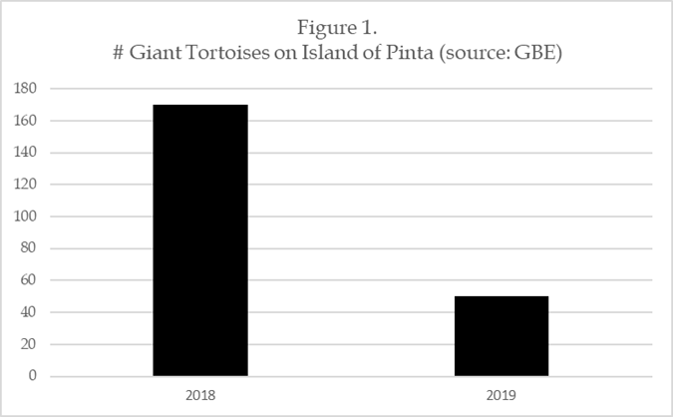
In the 19th century, whalers and sealers hunted giant tortoises for their meat and oil, taking advantage of the fact that they could be kept in the holds of the ship for up to a year without food or water. Females were usually taken first because they were smaller and easier to find in the lowland areas during the egg-laying season. Last winter, an independent group of scientists performed a DNA test on George. The scientists determined that George’s closest relatives are found on islands far from his home island of Pinta, whereas tortoises on closer islands are more distantly related.

Foreigner Treatment in Studies 1-3

This treatment focuses on the alleged foreigness of Latinos and was assigned to Asian participants in Study 1 and MENAs in Study 3. In Study 2, Latinos received the same treatment, but focused on the alleged foreigness of Asian Americans. The ingroup referenced in paragraph 2 of this treatment (highlighted in red) was matched to the race/ethnicity of the study participant.

News Brief: Never Fully American, Always a Suspected Foreigner: 2021 Continues Highlighting Latinos’ Decades-Long Exclusion in the U.S.
- Associated Press
For many Latino individuals, the year 2021 began with a roar, as hate crimes and other public expressions of prejudice toward them surged in cities and towns throughout the United States. Many of these incidents were caught on video, providing yet another vivid reminder that, no matter how long a Latino individual has been in the United States or how much they contribute to this nation’s culture and economy, they are still viewed as un-American to various degrees, similar to many Asian people. This increase has been in the making for some time. Figure 1 shows an increase in reported hate crimes against Latino individuals from 2018 to 2019. This spike is likely under-estimated, since too many victims of hate crimes are too afraid to come forward and report an incident.
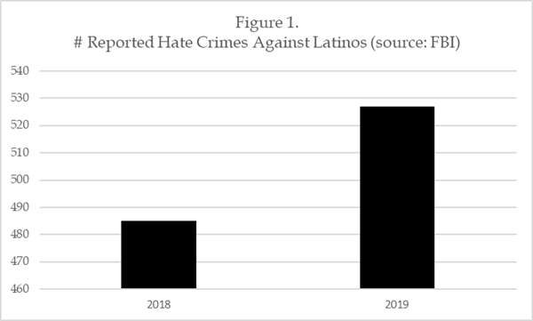
As a recent victim of one of these hate crimes toward Latinos stated (on condition of anonymity): “It’s so scary—and frustrating—that you can give so much of yourself to this country, and yet still be treated like a foreigner, even if you and your family have been here for generations.” These words ring true among many Asian individuals throughout the U.S., including those who recently arrived and those who have been here for decades. One lesson of this latest wave of anti-Latino prejudice is that despite the social, political, and economic diversity of the Latino population in the U.S., too many Americans continue seeing them as “outsiders,” never to be fully included.

Inferiority Treatment in Studies 4-5

This treatment focuses on the alleged inferiority of Latinos and was assigned to Black participants in Study 4. Latinos in Study 5 received the same treatment, but focused on the alleged inferiority of African Americans. The ingroup referenced in paragraph 2 of this treatment (highlighted in red) was matched to the race/ethnicity of the study participant.

Despite Their Presence in the United States for Decades, Many Latinos are Still Treated as Second Class Citizens, As Evidenced by Hate Crimes Data
-Associated Press
For many Latino individuals, the year 2021 began with a roar, as hate crimes and other public expressions of prejudice toward them surged in cities and towns throughout the United States. Many of these incidents were caught on video, providing yet another vivid reminder that, no matter how long a Latino individual has been in the United States or how much they contribute to this nation's culture and economy, they are still viewed as second-class individuals, similar to many Black people. This increase has been in the making for some time. Figure 1 shows an increase in reported hate crimes against Latino individuals from 2019 to 2020. This spike is likely underestimated, since many victims of hate crimes are too afraid to come forward and report an incident.
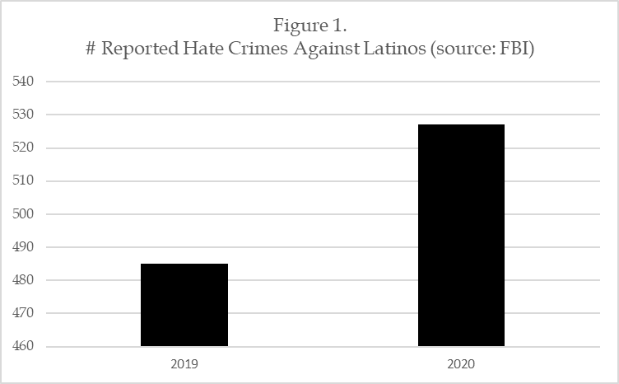
As a recent victim of one of these hate crimes toward Latinos stated (on condition of anonymity): "It's so scary—and frustrating—that you can give so much of yourself to this country, and yet still be treated as less than equal, even if you and your family have been here for generations." These words ring true among many African American individuals throughout the U.S., many of whom experience a similar sense of exclusion. One lesson of this latest wave of anti-Latino prejudice is that despite the social, political, and economic diversity of the Latino population in the U.S., society continues to see them as "less than" other groups, never to be fully included in the larger nation.

SM.3. Question Wordings

Solidarity between people of color

-I feel solidarity with people of color, which include African Americans, Asian Americans, and Latinos.

-The problems of Blacks, Latinos, and Asian Americans and other minorities are too different for them to be allies or partners.

1) Strongly disagree
2) Somewhat disagree
3) Neither disagree nor agree
4) Somewhat agree
5) Strongly agree

-You will now be asked to report your opinions about various policy proposals. Please use the response options provided to indicate how much you disagree or agree with each statement.
Undocumented immigration (Pro-Latino) – Study1

-Increase the number of border patrol agents at the U.S.-Mexico border.

-Provide a pathway to citizenship for undocumented immigrants.

1) Strongly disagree
2) Somewhat disagree
3) Neither disagree nor agree
4) Somewhat agree
5) Strongly agree

Legal immigration (Pro-Asian) – Study 2

-Increasing the number of H1-B visas, which allow U.S. companies to hire people from foreign countries to work in highly skilled occupations, such as engineering, computer programming, and high-technology.

-Expanding the number of visas available to legal immigrants wishing to enter the United States.

1) Strongly disagree
2) Somewhat disagree
3) Neither disagree nor agree
4) Somewhat agree
5) Strongly agree

Undocumented immigration (Pro-Latino) – Study 3

-Increase the number of border patrol agents at the U.S.-Mexico border.
-Provide a pathway to citizenship for undocumented immigrants.
-Exclude the children of unauthorized immigrants from government benefits and services.
1) Strongly disagree
2) Somewhat disagree
3) Neither disagree nor agree
4) Somewhat agree
5) Strongly agree

Undocumented immigration (Pro-Latino) – Study 4

-Increase the number of border patrol agents at the U.S.-Mexico border.

-Provide a pathway to citizenship for undocumented immigrants.

-Granting a pathway to citizenship for undocumented Latino immigrants.
1) Strongly disagree
2) Somewhat disagree
3) Neither disagree nor agree
4) Somewhat agree
5) Strongly agree

Policies toward African Americans (Pro-Black) – Study 5

-Introducing harsher penalties for hate crimes committed against Black individuals.
-Limiting the protest activities of #BlackLivesMatter and other movements like it
1) Strongly disagree
2) Somewhat disagree
3) Neither disagree nor agree
4) Somewhat agree
5) Strongly agree

SM.4. Full Details on Inputs and Outputs of Mini Meta-Analysis

The meta-analyzed quantities reported in tables 2-5 in the manuscript were produced via an automated template provided by Jin Goh et al. (2016), which can be publicly downloaded via the Open Science Framework (https://osf.io/6tfh5/files/osfstorage). This template requires two quantities from each study that is meta-analyzed: 1) the relevant effect size(s); and 2) the attendant sample size for each effect size. For item 2, the sample sizes will depend on whether one is meta-analyzing a treatment effect (sample size by condition) or an association between variables (pooled sample).

Goh et al.’s (2016) template automates a fixed effects analysis, which produces a weighted mean effect size (ES) that gives greater weight to larger studies. In simpler terms, this template estimates the average ES across a set of studies, weighted by larger sample size. This template does not provide fit statistics for the estimation, in part, because fit statistics are less diagnostic here, where the goal is to evaluate whether, in the aggregate, there are any substantively meaningful and reliable trends in the pooled data. Critically, however, the template does provide confidence intervals and p-values for each meta-analyzed ES, which we now report in tables SM.4.1-SM.4.4 below. These tables also contain the raw input needed to reproduce our results via Goh et al.’s (2016) automated template.

Table SM.4.1 Direct Treatment Effects on Downstream Outcomes
Note: d values reflect standard deviation units. Bolded entry is meta-analyzed value with standard error in parentheses.
Study  (Sample – treatment) | Estimate  (d value) | N  (Control) | N  (Treatment)
Study 1 (Asians – foreigner treatment) | .119 | 302 | 248
Study 2 (Latinos – foreigner treatment) | .012 | 305 | 241
Study 3 (MENAs – foreigner treatment) | .362 | 238 | 186
Study 4 (Blacks – inferiority treatment) | .106 | 393 | 409
Study 5 (Latinos – inferiority treatment) | .209 | 409 | 409
Meta-analyzed (d) | .153  (.036)
95% Confidence Interval (CI) | [.082, .223]

Table SM.4.2. Treatment Effects on Solidarity with PoC
Note: d values reflect standard deviation units. Bolded entry is meta-analyzed value with standard error in parentheses.
Study  (Population – treatment) | Estimate  (d value) | N  (Control) | N  (Treatment)
Study 1 (Asians – foreigner treatment) | .218 | 305 | 252
Study 2 (Latinos – foreigner treatment) | .217 | 304 | 238
Study 3 (MENAs – foreigner treatment) | .242 | 239 | 185
Study 4 (Blacks – inferiority treatment) | .129 | 394 | 410
Study 5 (Latinos – inferiority treatment) | .131 | 409 | 409
Meta-analyzed (d) | .175  (.036)
95% Confidence Interval (CI) | [.105, .246]

Table SM.4.3. Solidarity’s Influence on Downstream Outcomes
Note: Bolded entry is meta-analyzed association between our mediator and outcome in each study, with standard error in parentheses. d values reflect standard deviation units.
Study  (Population – treatment) | Estimate r | N  (pooled)
Study 1 (Asians – foreigner treatment) | .334 | 547
Study 2 (Latinos – foreigner treatment) | .389 | 546
Study 3 (MENAs – foreigner treatment) | .414 | 417
Study 4 (Blacks – inferiority treatment) | .236 | 802
Study 5 (Latinos – inferiority treatment) | .462 | 818
Meta-analyzed (r) | .366  (.018)
95% Confidence Interval (CI) | [.335, .396]
r converted to d value | .790

Table SM.4.4. Sensitivity Analysis

Study  (Population – treatment) | Estimate (standardized) | N  (Pooled)
Study 1 (Asians – foreigner treatment) | .294 | 547
Study 2 (Latinos – foreigner treatment) | .274 | 540
Study 3 (MENAs – foreigner treatment) | .391 | 417
Study 4 (Blacks – inferiority treatment) | .260 | 802
Study 5 (Latinos – inferiority treatment) | .433 | 818
Meta-analysis (ρ) | .333  (.018)
95% Confidence Interval (CI) | [.302, .364]

SM.5. Results are Robust to Inclusion of Participants Who Failed Manipulation Check

The 3 tables below report the original/revised estimates of our meta-analyses. The revised estimates include all respondents who did not pass our manipulation check. In two out three instances, our estimates are slightly attenuated, which is unsurprising given that participants who fail a manipulation check generally introduce more noise into an analysis. However, the main conclusion here is that our revised analysis yields meta-analyzed estimates of substantively similar size and precision as the original ones we report in the manuscript.

SM.5.1. Direct Treatment Effects on Downstream Outcomes
Note: Bolded entries indicate estimate is reliable at the 1% level or better.
Study  (Sample – treatment) | Estimate (standardized) | Sample  Size
Study 1 (Asians – foreigner treatment) | Original/Revised  .119/.053 | Original/Revised  550/601
Study 2 (Latinos – foreigner treatment) | .012/-.024 | 546/603
Study 3 (MENAs – foreigner treatment) | .362/.308 | 424/446
Study 4 (Blacks – inferiority treatment) | .106/092 | 802/818
Study 5 (Latinos – inferiority treatment) | .209/.204 | 818/835
Meta-analyzed (d) | .153 (.036)/.121(.035) | 3,140/3,303

SM.5.2. Treatment Effects on Solidarity with PoC
Note: Bolded entries indicate estimate is reliable at the 1% level or better.
Study  (Population – treatment) | Estimate (standardized) | Sample  Size
Study 1 (Asians – foreigner treatment) | Original/Revised  .218/.158 | Original/Revised  557/609
Study 2 (Latinos – foreigner treatment) | .217/.138 | 542/600
Study 3 (MENAs – foreigner treatment) | .242/.204 | 424/446
Study 4 (Blacks – inferiority treatment) | .129/.125 | 804/820
Study 5 (Latinos – inferiority treatment) | .131/.122 | 818/835
Meta-analyzed (d) | .175 (.036)/.143 (.035) | 3,145/3,310

SM.5.3. Influence of Solidarity on Downstream Outcomes
Note: Bolded entries indicate estimate is reliable at the 1% level or better.
Study  (Population – treatment) | Estimate (standardized) | Sample  Size
 | Original/Revised | Original/Revised
Study 1 (Asians – foreigner treatment) | .334/.347 | 547/598
Study 2 (Latinos – foreigner treatment) | .389/.400 | 546/603
Study 3 (MENAs – foreigner treatment) | .414/.417 | 417/438
Study 4 (Blacks – inferiority treatment) | .236/.241 | 802/818
Study 5 (Latinos – inferiority treatment) | .462/.462 | 818/835
Meta-analysis (r) | .366 (.018)/.372 (.017) | 3,142/3,292

