Supplemental Materials:

Table A1: Location of Offices of Immigrant Affairs
County/City | State | County/City | State
Anchorage | AL | Minneapolis | MN
Chula Vista | CA | Charlotte | NC
Los Angeles | CA | Greensboro | NC
Oakley | CA | High Point | NC
Redwood City | CA | Lincoln County | NE
San Diego | CA | Jersey City | NJ
San Jose | CA | Albuquerque | NM
Contra Costa | CA | Buffalo | NY
San Mateo | CA | New York City | NY
Santa Clara County | CA | Bowling Green | OH
San Francisco | CA | Columbus | OH
Aurora | CO | Dayton | OH
Denver | CO | Toledo | OH
Gunnison | CO | Franklin County | OH
Summit County | CO | Tulsa | OK
Miami-Dade County | FL | Beaverton | OR
Orlando | FL | Portland | OR
Athens-Clarke | GA | Erie | PA
Clarkston | GA | Lancaster | PA
Atlanta | GA | Philadelphia | PA
Iowa City | IA | Pittsburgh | PA
North Liberty | IA | Nashville | TN
Boise | ID | Austin | TX
Chicago | IL | Dallas | TX
Bowling Green | KY | San Antonio | TX
Lexington | KY | Houston | TX
Louisville | KY | Salt Lake City | UT
Boston | MA | Salt Lake County | UT
Cambridge | MA | Allegheny County | VA
Baltimore | MD | Charlottesville | VA
Salisbury | MD | Harrisonburg | VA
Montgomery County | MD | Roanoke | VA
Anne Arundel | MD | Tacoma | WA
Portland | ME | King County | WA
Detroit | MI | Seattle | WA
Kent County | MI
Oakland | MI
Global Michigan | MI
Table A2: Demographic Characteristics of Survey Sample and ACS 2019
 | ACS 2019 |  | Survey Sample
Variable | N | Percent | N | Percent
Gender | 2598263 |  | 2107
Women | 1339171 | 51.5% | 1079 | 51.2%
Male | 1259092 | 48.5% | 1028 | 48.8%
Age | 2598263 |  | 2107
18 - 29 | 462250 | 17.8% | 442 | 21%
30 - 41 | 465384 | 17.9% | 545 | 25.9%
42 - 54 | 510097 | 19.6% | 446 | 21.2%
55 or more | 1160532 | 44.7% | 674 | 32%
Ethnoracial Background | 2598263 |  | 2107
Asian | 152408 | 5.9% | 100 | 4.7%
Black | 245956 | 9.5% | 250 | 11.9%
Hispanic | 329280 | 12.7% | 171 | 8.1%
Native American | 20398 | 0.8% | 24 | 1.1%
White | 1850221 | 71.2% | 1541 | 73.1%
Region | 2598263 |  | 2107
Midwest | 550975 | 21.2% | 404 | 19.2%
Northeast | 463249 | 17.8% | 442 | 21%
South | 976600 | 37.6% | 792 | 37.6%
West | 607439 | 23.4% | 469 | 22.3%
Education | 2598263 |  | 2107
Less than HS | 236337 | 9.1% | 69 | 3.3%
HS | 709372 | 27.3% | 613 | 29.1%
Some college | 569300 | 21.9% | 549 | 26.1%
AA | 217604 | 8.4% | 284 | 13.5%
BA | 507039 | 19.5% | 410 | 19.5%
Postgraduate | 320606 | 12.3% | 180 | 8.5%
other | 0 | 0% | 2 | 0.1%
Income | 2598263 |  | 2107
20k or less | 296477 | 11.4% | 565 | 26.8%
20 - 59k | 710534 | 27.3% | 929 | 44.1%
60 - 99k | 567142 | 21.8% | 354 | 16.8%
100k or more | 877454 | 33.8% | 216 | 10.3%
NA | 146656 | 5.6% | 43 | 2%

Table A3: Partisan and Political Summary
 | Survey Sample
Variable | N | Percent
Party ID | 2064
Democrat | 806 | 39.1%
Independent | 638 | 30.9%
Republican | 620 | 30%
Political ID | 2060
Liberal | 654 | 31.7%
Moderate | 813 | 39.5%
Conservative | 593 | 28.8%

Table A4. Balance Table Survey Experiment #1
 | Cooperation Immigration Enforcement |  | Immigration Office
Variable | N | Mean | N | Mean
Gender | 1041 |  | 1036
Male | 510 | 49% | 505 | 48.7%
Women | 531 | 51% | 531 | 51.3%
Age | 1041 |  | 1036
18 - 29 | 214 | 20.6% | 222 | 21.4%
30 - 41 | 264 | 25.4% | 273 | 26.4%
42 - 54 | 220 | 21.1% | 220 | 21.2%
55 or more | 343 | 32.9% | 321 | 31%
Ethnoracial Background | 1041 |  | 1036
Asian | 52 | 5% | 46 | 4.4%
Black | 128 | 12.3% | 119 | 11.5%
Hispanic | 80 | 7.7% | 88 | 8.5%
Native | 12 | 1.2% | 10 | 1%
Other | 10 | 1% | 10 | 1%
White | 759 | 72.9% | 763 | 73.6%
Region | 1041 |  | 1036
Midwest | 198 | 19% | 201 | 19.4%
Northeast | 214 | 20.6% | 224 | 21.6%
South | 389 | 37.4% | 392 | 37.8%
West | 240 | 23.1% | 219 | 21.1%
Education | 1041 |  | 1036
Less than HS | 30 | 2.9% | 39 | 3.8%
HS | 286 | 27.5% | 315 | 30.4%
Some college | 290 | 27.9% | 248 | 23.9%
AA | 132 | 12.7% | 150 | 14.5%
BA | 211 | 20.3% | 195 | 18.8%
Postgraduate | 91 | 8.7% | 88 | 8.5%
other | 1 | 0.1% | 1 | 0.1%
Income | 1041 |  | 1036
20k or less | 264 | 25.4% | 290 | 28%
20 - 59k | 468 | 45% | 449 | 43.3%
60 - 99k | 179 | 17.2% | 172 | 16.6%
100k or more | 108 | 10.4% | 105 | 10.1%
NA | 22 | 2.1% | 20 | 1.9%
Pol ID | 1034 |  | 1026
Liberal | 329 | 31.8% | 325 | 31.7%
Moderate | 413 | 39.9% | 400 | 39%
Conservative | 292 | 28.2% | 301 | 29.3%
Party ID | 1035 |  | 1029
Democrat | 401 | 38.7% | 405 | 39.4%
Independent | 320 | 30.9% | 318 | 30.9%
Republican | 314 | 30.3% | 306 | 29.7%
Table A5: Balance Table Survey Experiment #2
 | Control |  | Access Open to All |  | Documented Only
Variable | N | Mean | N | Mean | N | Mean
Gender | 686 |  | 685 |  | 686
Male | 332 | 48.4% | 340 | 49.6% | 337 | 49.1%
Women | 354 | 51.6% | 345 | 50.4% | 349 | 50.9%
Age | 686 |  | 685 |  | 686
18 - 29 | 125 | 18.2% | 148 | 21.6% | 156 | 22.7%
30 - 41 | 173 | 25.2% | 167 | 24.4% | 191 | 27.8%
42 - 54 | 166 | 24.2% | 141 | 20.6% | 131 | 19.1%
55 or more | 222 | 32.4% | 229 | 33.4% | 208 | 30.3%
Ethnoracial Background | 686 |  | 685 |  | 686
Asian | 33 | 4.8% | 33 | 4.8% | 32 | 4.7%
Black | 79 | 11.5% | 74 | 10.8% | 89 | 13%
Hispanic | 53 | 7.7% | 57 | 8.3% | 57 | 8.3%
Native | 5 | 0.7% | 7 | 1% | 10 | 1.5%
Other | 8 | 1.2% | 8 | 1.2% | 4 | 0.6%
White | 508 | 74.1% | 506 | 73.9% | 494 | 72%
Region | 686 |  | 685 |  | 686
Midwest | 138 | 20.1% | 126 | 18.4% | 129 | 18.8%
Northeast | 146 | 21.3% | 150 | 21.9% | 139 | 20.3%
South | 238 | 34.7% | 276 | 40.3% | 261 | 38%
West | 164 | 23.9% | 133 | 19.4% | 157 | 22.9%
Education | 686 |  | 685 |  | 686
Less than HS | 21 | 3.1% | 24 | 3.5% | 21 | 3.1%
HS | 192 | 28% | 190 | 27.7% | 210 | 30.6%
Some college | 177 | 25.8% | 190 | 27.7% | 166 | 24.2%
AA | 92 | 13.4% | 93 | 13.6% | 97 | 14.1%
BA | 138 | 20.1% | 135 | 19.7% | 130 | 19%
Postgraduate | 64 | 9.3% | 53 | 7.7% | 62 | 9%
other | 2 | 0.3% | 0 | 0% | 0 | 0%
Income | 686 |  | 685 |  | 686
20k or less | 183 | 26.7% | 183 | 26.7% | 178 | 25.9%
20 - 59k | 306 | 44.6% | 305 | 44.5% | 299 | 43.6%
60 - 99k | 116 | 16.9% | 124 | 18.1% | 110 | 16%
100k or more | 69 | 10.1% | 60 | 8.8% | 83 | 12.1%
NA | 12 | 1.7% | 13 | 1.9% | 16 | 2.3%
Pol ID | 686 |  | 683 |  | 685
Liberal | 218 | 31.8% | 227 | 33.2% | 207 | 30.2%
Moderate | 271 | 39.5% | 267 | 39.1% | 273 | 39.9%
Conservative | 197 | 28.7% | 189 | 27.7% | 205 | 29.9%
Party ID | 686 |  | 685 |  | 686
Democrat | 266 | 38.8% | 276 | 40.3% | 263 | 38.3%
Independent | 217 | 31.6% | 199 | 29.1% | 218 | 31.8%
Republican | 203 | 29.6% | 210 | 30.7% | 205 | 29.9%
About Lucid
Lucid is a well-known and frequently used by academics and researchers. Lucid uses an online opt-in model to collect nationally representative samples of survey respondents. Respondents come from a large set of online vendors and Lucid habitually monitors the sample to ensure data quality. We relied on Lucid Theorem focused on shorter surveys aimed at collecting nationally representative samples.

Questions pre-treatment
We gathered the following information from all respondents pre-treatment: Age, Education, Ethnoracial Background, State, Favorability of different groups (Democrats, Republicans, Undocumented Immigrants, Documented Immigrants), Policy Preferences (welfare, same-sex marriage, abortion)

Lucid provided the following information about each respondent:
Age, Gender, Income, ZIP, Region

Treatment and outcome questions
Survey Experiment #1
Respondents were presented with the following prompt:

Let me tell you about a middle-class city in the American Midwest.

The city has great schools, a growing economy, and affordable housing. In response to a growing immigrant population, local leaders recently passed a city ordinance [that creates an office of immigrant affairs that helps immigrants integrate into the community / to cooperate with federal immigration enforcement to identify and detain immigrants for deportation].

Outcome question and responses:
Given only the information above, how favorable or unfavorable do you view this city?
5-item Likert scale ranging from (1) very favorable – (0) very unfavorable

Survey Experiment #2
Suppose your city was considering creating an ‘office of immigrant affairs.’ This office would be in charge of teaching classes to help immigrants learn English, connecting immigrants to local public services, and help integrate immigrants into the local community [BLANK / providing aid to immigrants regardless of legal status / providing aid only to immigrants that are in the country lawfully]

Outcome question and responses:
To what extent would you support or oppose the creation of an office of immigrant affairs in your city?
5-item Likert scale ranging from (1) strongly support – (0) strongly oppose
Regression results in survey experiment 1

Table A6: Impact of Presence of OIA on Favorability Towards the City by Partisanship and Experimental Group
 |  | Outcome variable: | Favorability of City
 | Pooled | Democrats | Independents | Republicans
(Intercept) | 0.601*** | 0.524*** | 0.567*** | 0.729***
 | (0.010) | (0.017) | (0.016) | (0.015)
Immigration Office | 0.121*** | 0.290*** | 0.125*** | -0.093***
 | (0.013) | (0.020) | (0.022) | (0.022)
Num.Obs. | 2077 | 806 | 638 | 620
R2 | 0.042 | 0.204 | 0.050 | 0.029
R2 Adj. | 0.042 | 0.203 | 0.049 | 0.027
Std. Errors | Robust | Robust | Robust | Robust
*p < 0.1, ** p < 0.05, *** p < 0.01
Note: The intercept represents attitudes towards cooperation with immigration enforcement. OLS regressions results include robust standard errors.

Table A7: Impact of Presence of OIA on Favorability Towards the City by Partisanship and Experimental Group Controlling for Covariates
 |  | Outcome variable: | Favorability of City
 | Pooled | Democrats | Independents | Republicans
(Intercept) | 0.610*** | 0.601*** | 0.523*** | 0.742***
 | (0.025) | (0.040) | (0.045) | (0.041)
OIA | 0.121*** | 0.289*** | 0.122*** | -0.091***
 | (0.013) | (0.020) | (0.022) | (0.022)
Num.Obs. | 2077 | 806 | 638 | 620
R2 | 0.064 | 0.242 | 0.085 | 0.078
R2 Adj. | 0.053 | 0.220 | 0.050 | 0.042
Std. Errors | Robust | Robust | Robust | Robust
*p < 0.1, ** p < 0.05, *** p < 0.01
Note: The intercept represents attitudes toward cooperation with immigration enforcement. OLS regression results include robust standard errors and control for age, gender, income, education, region, and ethnoracial background. Complete model results (including controls) are available in APSR Dataverse (SM2 file).

Table A8: Impact of Presence of OIA on Favorability Towards the City by Political Ideology
 |  | Outcome variable: | Favorability of City
 | Pooled | Liberals | Moderates | Conservatives
(Intercept) | 0.601*** | 0.498*** | 0.580*** | 0.744***
 | (0.010) | (0.020) | (0.013) | (0.015)
OIA | 0.121*** | 0.327*** | 0.104*** | -0.079***
 | (0.013) | (0.023) | (0.018) | (0.023)
Num.Obs. | 2077 | 654 | 813 | 593
R2 | 0.042 | 0.236 | 0.039 | 0.020
R2 Adj. | 0.042 | 0.234 | 0.038 | 0.018
Std. Errors | Robust | Robust | Robust | Robust
* p < 0.1, ** p < 0.05, *** p < 0.01
Note: The intercept represents attitudes toward cooperation with immigration enforcement. OLS results include robust standard errors.
Table A9: Impact of Presence of OIA on Favorability Towards the City by Political Ideology, Controlling for Covariates
 |  | Outcome variable: | Favorability of City
 | Pooled | Liberals | Moderates | Conservatives
(Intercept) | 0.610*** | 0.540*** | 0.553*** | 0.765***
 | (0.025) | (0.046) | (0.036) | (0.042)
OIA | 0.121*** | 0.322*** | 0.104*** | -0.077***
 | (0.013) | (0.023) | (0.018) | (0.023)
Num.Obs. | 2077 | 654 | 813 | 593
R2 | 0.064 | 0.282 | 0.072 | 0.075
R2 Adj. | 0.053 | 0.257 | 0.045 | 0.038
Std. Errors | Robust | Robust | Robust | Robust
p < 0.1, ** p < 0.05, *** p < 0.01
Note: The intercept represents attitudes toward cooperation with immigration enforcement. OLS results include robust standard errors and control for age, gender, income, education, region, and ethnoracial background. Complete model results (including controls) are available in APSR Dataverse (SM2 file).

To investigate the attitudes towards OIAs, we ran a set of regressions where we set the treatment as a dummy variable, where 1 is OIA and 0 reflects immigration enforcement cooperation.

Figure A1: Treatment Effects in Pooled Sample and by Partisanship. 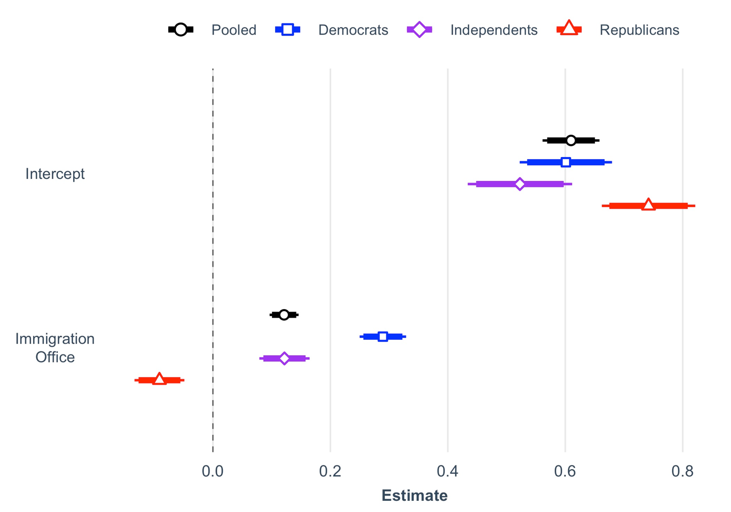
Note: Regression results across partisanship including robust standard errors and controlled for age, gender, education, income, region and ethnoracial background. Inside bars reflect 90% confidence intervals, outside bars reflect 95% confidence intervals. The intercept reflects attitudes towards immigration enforcement cooperation and serves as the reference category. The coefficients on OIA reflect changes in attitudes compared to the reference category per its specified group. See Table A7 for full regression results.
Figure A2: Treatment Effects in Pooled Sample and by Political Ideology 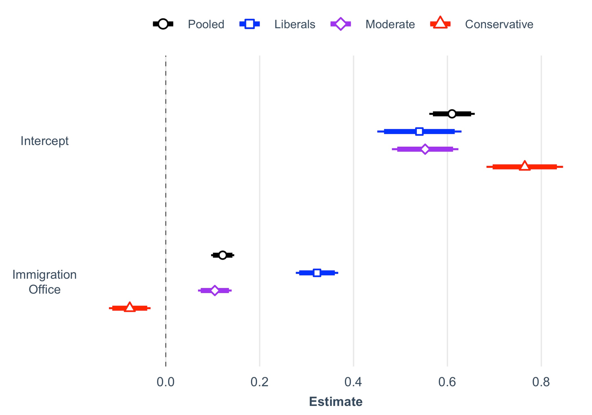
Note: Regression results across political ideology including robust standard errors and controlled for age, gender, education, income, region and ethnoracial background. Inside bars reflect 90% confidence intervals, outside bars reflect 95% confidence intervals. The intercept reflects attitudes towards immigration enforcement cooperation and serves as the reference category. The coefficients on OIA reflect changes in attitudes compared to the reference category per its specified group. See Table A9 for full regression results.
Table A10: Impact of Presence of OIA on Favorability towards the City by Ethnoracial Background and Experimental Treatment Group
 | Outcome variable: | Favorability of City
 | Unadjusted | Adjusted
(Intercept) | 0.576*** | 0.580***
 | (0.019) | (0.030)
OIA | 0.171*** | 0.169***
 | (0.024) | (0.024)
White | 0.033 | 0.039*
 | (0.022) | (0.022)
OIA × White | -0.068** | -0.065**
 | (0.028) | (0.028)
Num.Obs. | 2077 | 2077
R2 | 0.045 | 0.064
R2 Adj. | 0.043 | 0.055
Std. Errors | Robust | Robust
* p < 0.1, ** p < 0.05, *** p < 0.01
Note: The intercept represents attitudes toward cooperation with immigration enforcement among non-White respondents. The adjusted results control for age, gender, income, education, and region. All OLS regression results include robust standard errors. Complete model results (including controls) are available in APSR Dataverse.
Table A11: Impact of Presence of OIA on Favorability Towards the City by Partisanship, Ethnoracial, and Experimental Group
 | Outcome variable: | Favorability of City
 | Non-White | White
(Intercept) | 0.548*** | 0.509***
 | (0.028) | (0.022)
OIA | 0.220*** | 0.332***
 | (0.034) | (0.025)
Independents | 0.005 | 0.064**
 | (0.040) | (0.029)
Republicans | 0.176*** | 0.221***
 | (0.052) | (0.027)
OIA × Independents | -0.057 | -0.222***
 | (0.052) | (0.036)
OIA × Republicans | -0.202*** | -0.437***
 | (0.067) | (0.034)
Num.Obs. | 551 | 1513
R2 | 0.113 | 0.133
R2 Adj. | 0.105 | 0.130
Std. Errors | Robust | Robust
* p < 0.1, ** p < 0.05, *** p < 0.01
Note: The intercept represents attitudes toward cooperation with immigration enforcement among Democrats. OLS regression results include robust standard errors.

Table A12: Impact of Presence of OIA on Favorability Towards the City by Partisanship, Ethnoracial, and Experimental Group, Controlling for Covariates.
 | Outcome variable: | Favorability of City
 | Non-White | White
(Intercept) | 0.577*** | 0.513***
 | (0.053) | (0.033)
OIA | 0.219*** | 0.333***
 | (0.034) | (0.025)
Independents | 0.008 | 0.070**
 | (0.040) | (0.029)
Republicans | 0.182*** | 0.225***
 | (0.055) | (0.027)
OIA × Independents | -0.078 | -0.220***
 | (0.052) | (0.036)
OIA × Republicans | -0.198*** | -0.439***
 | (0.071) | (0.034)
Num.Obs. | 551 | 1513
R2 | 0.152 | 0.153
R2 Adj. | 0.117 | 0.140
Std. Errors | Robust | Robust
* p < 0.1, ** p < 0.05, *** p < 0.01
Note: The intercept represents attitudes toward cooperation with immigration enforcement among Democrats. OLS regression results include robust standard errors and control for age, gender, income, education, and region. Complete model results (including controls) are available in APSR Dataverse (SM2 file).
Regression Results in Survey Experiment 2

Table A13: Impact of Access Restrictions on Mean Support for Establishing an OIA by Partisanship and Experimental Group
 |  | Outcome variable: | Support towards OIA
 | Pooled | Democrats | Independents | Republicans
(Intercept) | 0.716*** | 0.805*** | 0.692*** | 0.624***
 | (0.010) | (0.014) | (0.018) | (0.020)
Access Open to All | -0.026* | 0.005 | -0.005 | -0.090***
 | (0.016) | (0.021) | (0.027) | (0.031)
Documented Only | 0.019 | 0.000 | -0.002 | 0.067**
 | (0.015) | (0.020) | (0.026) | (0.029)
Num.Obs. | 2057 | 805 | 634 | 618
R2 | 0.004 | 0.000 | 0.000 | 0.042
R2 Adj. | 0.003 | -0.002 | -0.003 | 0.039
Std. Errors | Robust | Robust | Robust | Robust
p < 0.1, ** p < 0.05, *** p < 0.01
Note: The intercept represents attitudes in the control. OLS regression results include robust standard errors.

Table A14: Impact of Access Restrictions on Mean Support for Establishing an OIA by Partisanship and Experimental Group, Controlling for Covariates
 |  | Outcome variable: | Support towards OIA
 | Pooled | Democrats | Independents | Republicans
(Intercept) | 0.688*** | 0.798*** | 0.671*** | 0.663***
 | (0.024) | (0.032) | (0.044) | (0.049)
Access Open to All | -0.024 | 0.002 | -0.006 | -0.080**
 | (0.016) | (0.021) | (0.027) | (0.031)
Documented Only | 0.019 | -0.004 | -0.002 | 0.070**
 | (0.015) | (0.020) | (0.027) | (0.030)
Num.Obs. | 2057 | 805 | 634 | 618
R2 | 0.031 | 0.049 | 0.027 | 0.093
R2 Adj. | 0.020 | 0.021 | -0.011 | 0.057
Std. Errors | Robust | Robust | Robust | Robust
p < 0.1, ** p < 0.05, *** p < 0.01
Note: The intercept represents attitudes in the control. OLS regression results include robust standard errors and control for age, gender income, education, region, and ethnoracial background. Complete model results (including controls) are available in APSR Dataverse (SM2 file).

Table A15: Impact of Access Restrictions on Mean Support for Establishing an OIA by Ethnoracial Background and Partisanship
 | Outcome variable: | Support towards OIA
 | Non-White | White
(Intercept) | 0.787*** | 0.818***
 | (0.021) | (0.019)
Access Open to All | -0.045 | 0.030
 | (0.035) | (0.026)
Documented Only | 0.021 | -0.014
 | (0.032) | (0.026)
Independents | -0.069 | -0.133***
 | (0.042) | (0.029)
Republicans | -0.124* | -0.198***
 | (0.065) | (0.029)
Access Open to All × Independents | 0.031 | -0.035
 | (0.060) | (0.041)
Documented Only × Independents | -0.052 | 0.021
 | (0.060) | (0.041)
Access Open to All × Republicans | 0.087 | -0.134***
 | (0.102) | (0.041)
Documented Only × Republicans | 0.106 | 0.073*
 | (0.083) | (0.041)
Num.Obs. | 549 | 1508
R2 | 0.031 | 0.121
R2 Adj. | 0.017 | 0.116
Std. Errors | Robust | Robust
* p < 0.1, ** p < 0.05, *** p < 0.01
Note: The intercept represents attitudes among Democrats in the control condition. OLS regression results include robust standard errors.

Table A16: Impact of Access Restrictions on Mean Support for Establishing an OIA by Ethnoracial Background and Partisanship, Controlling for Covariates
 | Outcome variable: | Support towards OIA
 | Non-White | White
(Intercept) | 0.728*** | 0.815***
 | (0.045) | (0.031)
Access Open to All | -0.055 | 0.029
 | (0.036) | (0.026)
Documented Only | 0.012 | -0.019
 | (0.033) | (0.026)
Independents | -0.069 | -0.126***
 | (0.042) | (0.029)
Republicans | -0.151** | -0.192***
 | (0.065) | (0.029)
Access Open to All × Independents | 0.041 | -0.032
 | (0.061) | (0.041)
Documented Only × Independents | -0.050 | 0.027
 | (0.060) | (0.041)
Access Open to All × Republicans | 0.108 | -0.131***
 | (0.104) | (0.041)
Documented Only × Republicans | 0.139 | 0.079*
 | (0.086) | (0.041)
Num.Obs. | 549 | 1508
R2 | 0.060 | 0.135
R2 Adj. | 0.015 | 0.121
Std. Errors | Robust | Robust
* p < 0.1, ** p < 0.05, *** p < 0.01
Note: The intercept represents attitudes among Democrats in the control condition. OLS regression results include robust standard errors and control for age, gender, income, education, and region. Complete model results (including controls) are available in APSR Dataverse (SM2 file).

Figure A3: Treatment Effects in Pooled Sample and by Partisanship
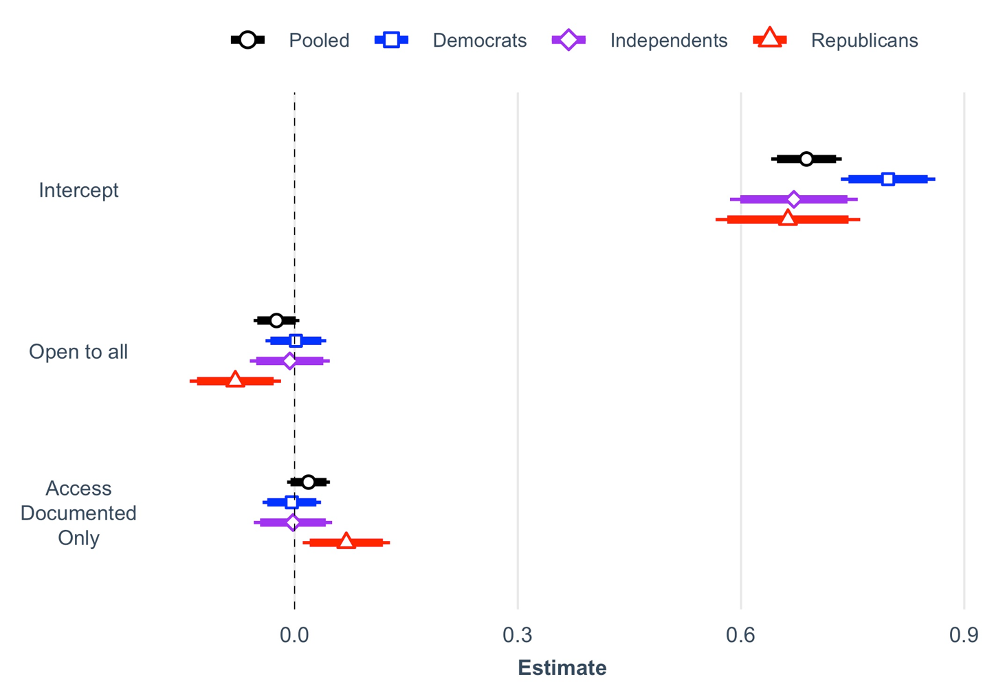
Note: Regression results across partisanship including robust standard errors and controlled for age, gender, education, income, region and ethnoracial background. Inside bars reflect 90% confidence intervals, outside bars reflect 95% confidence intervals. The intercept reflects attitudes towards the city in the control and serves as the reference category. The coefficients in the treatments reflect changes in attitudes compared to the reference control group. See Table A14 for full regression results.

Figure A4: Treatment Effects in Pooled Sample and by Political Ideology 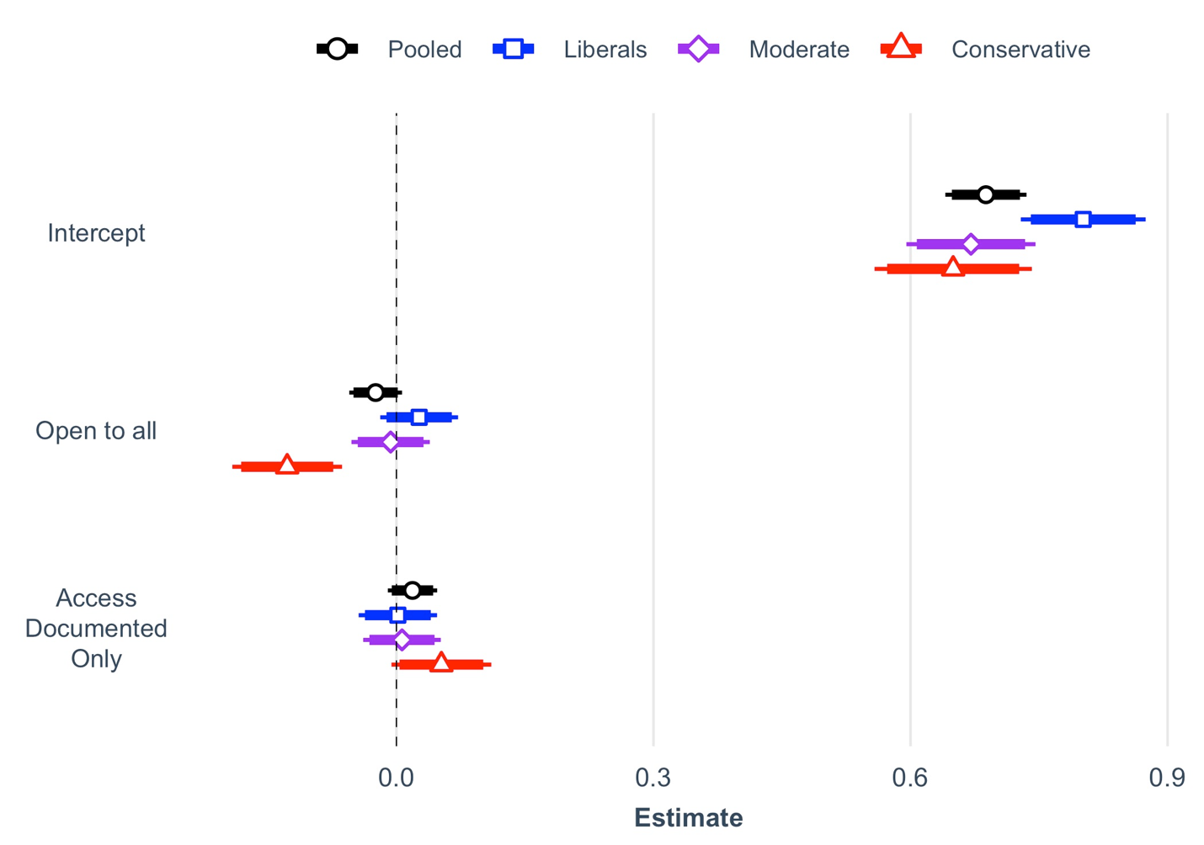
Note: Regression results across political ideology including robust standard errors and controlled for age, gender, education, income, region and ethnoracial background. Inside bars reflect 90% confidence intervals, outside bars reflect 95% confidence intervals. The intercept reflects attitudes towards the city in the control and serves as the reference category. The coefficients in the treatments reflect changes in attitudes compared to the reference control group. For full results in tabular format, see APSR Dataverse (SM2 file).

Favorability or welfare support

Support for OIAs can also be influenced by favorability towards the recipients and support for welfare programs. To measure favorability to undocumented immigrants we asked respondents to ‘how favorable or unfavorable do you view the following group: undocumented immigrants’ using a 5-item Likert scale ranging from (1) very favorable to (0) very unfavorable. To assess support for welfare programs we asked respondents a standard question of welfare attitudes ‘federal spending on welfare programs be (1) increased, decreased, kept the same or (0) cut entirely?’ The results are presented below.

Figure A5: Results for Survey Experiment #1 by Welfare Attitudes and Favorability Toward Undocumented Immigrants 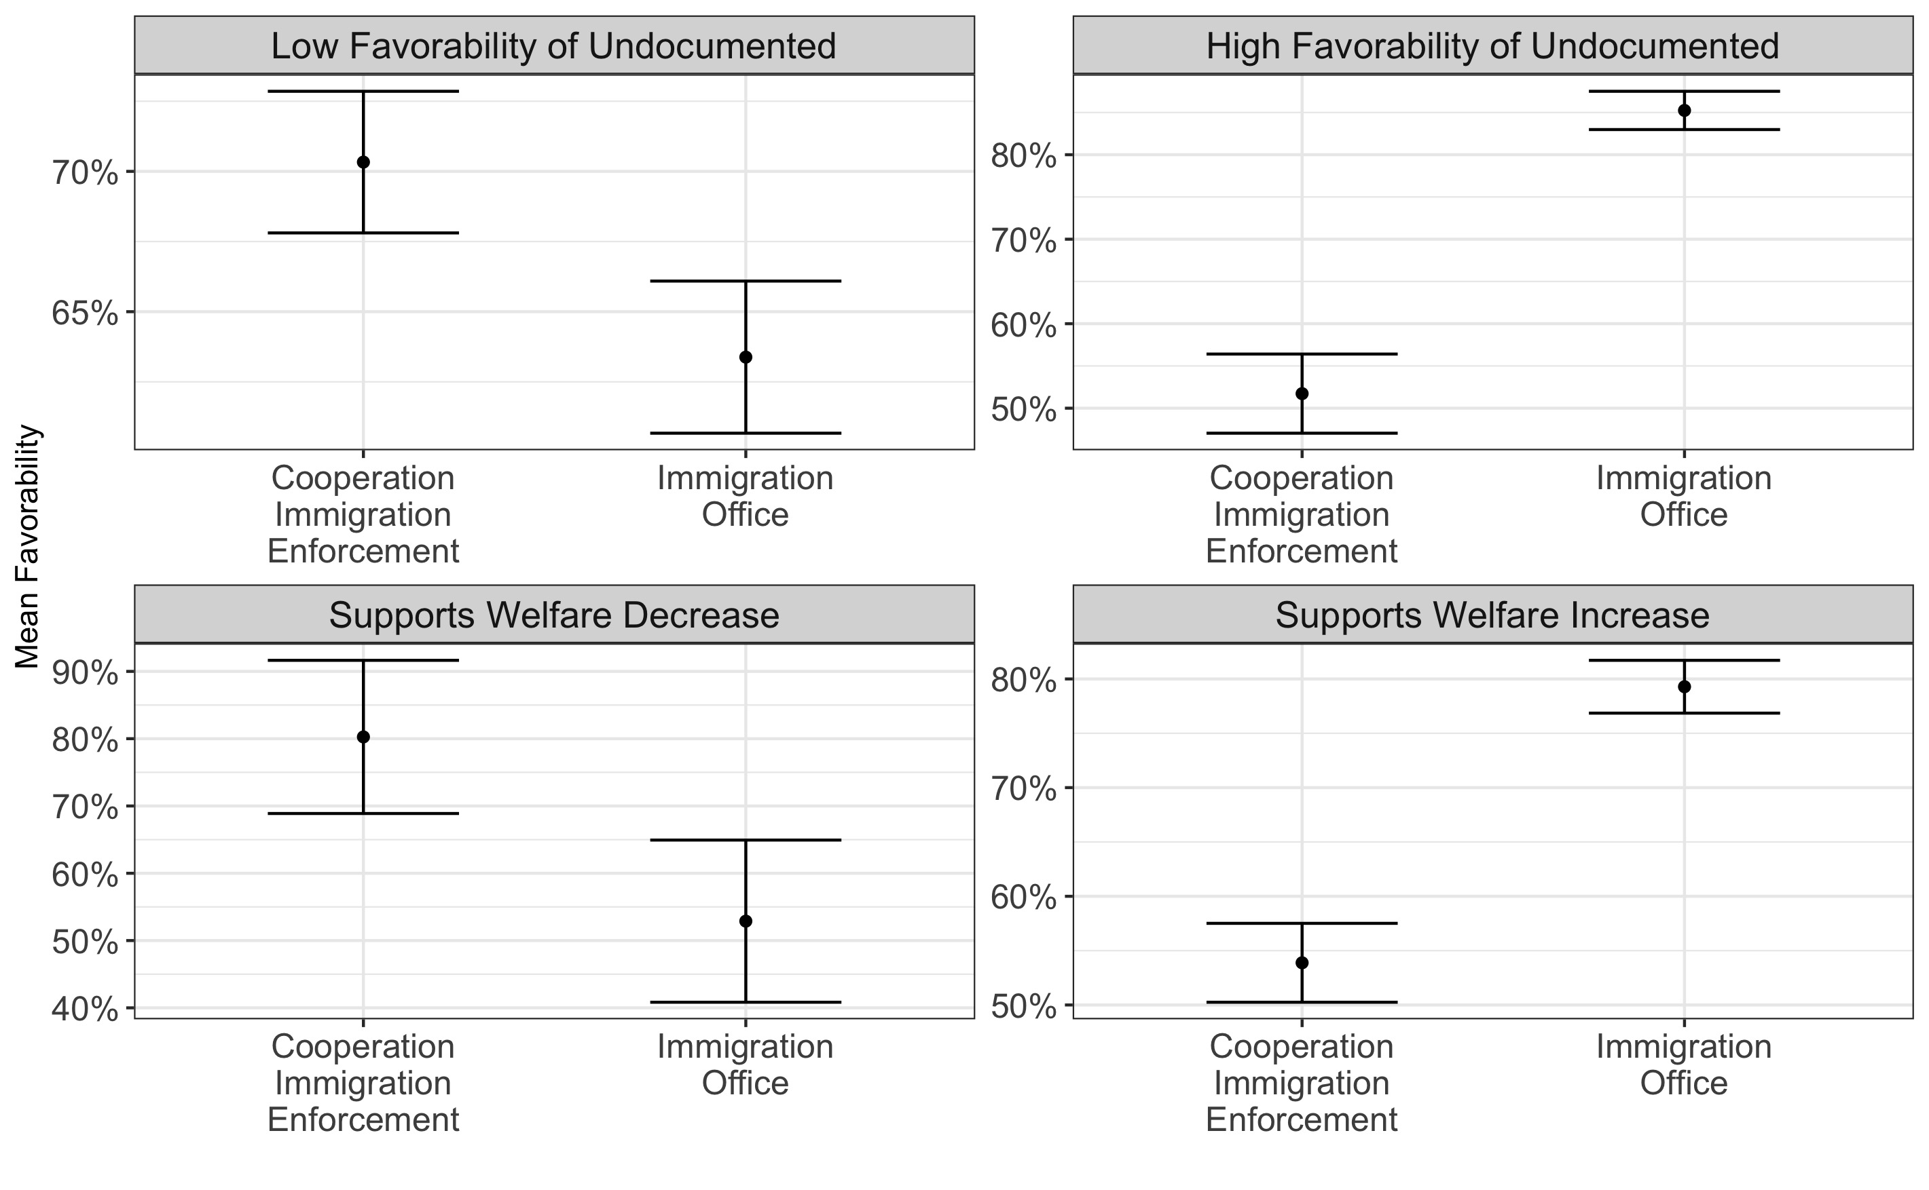
Note: Results for survey experiment #1 across favorability toward undocumented immigrants and welfare attitudes. Bars reflect 95% confidence intervals. Top row shows results among respondents who showed low (top left) or high (top right) favorability views toward undocumented immigrants. Bottom row shows results among respondents who prefer a decrease (bottom left) or increase (bottom right) welfare spending. For full results in tabular format, see APSR Dataverse (SM2 file).

Figure A6: Results for Survey Experiment #2 by Welfare Attitudes and Favorability Toward Undocumented Immigrants 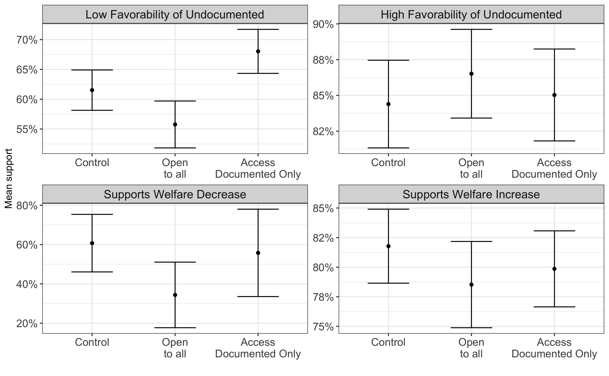
Note: Results for survey experiment #2 across favorability toward undocumented immigrants and welfare attitudes. Bars reflect 95% confidence intervals. Top row shows results among respondents who showed low (top left) or high (top right) favorability views toward undocumented immigrants. Bottom row shows results among respondents who prefer a decrease (bottom left) or increase (bottom right) welfare spending. For full results in tabular format, see APSR Dataverse (SM2 file).

Pre-registration details and deviations – Hypotheses
We made wording changes to our pre-registered hypotheses to clarify our main points and reduce redundancy. We made some changes prior to submission to improve the logical flow of the manuscript. We made other changes in response to reviewers’ and editors’ suggestions during the peer-review process. Critically, the changes do not change the substance of our hypotheses. Rather, they make it easier for readers to understand expectations for the data and how the results support or reject them. See APSR Dataverse for full PAP.

Table A17: Changes to hypotheses from pre-registered report and final manuscript
Event | Change | Reason
Prior to submission | H1 and H3 are switched in order | Reflect the order of the experiments and paper
Prior to submission | H1a and H2a are switched in order | Reflect the order of the manuscript
Prior to submission | H3a and H1a are switched in order | Reflect the order of the manuscript
Prior to submission | Combined H3b and H3c; new H2c | Reduce redundancy
During peer review | Combined H1 and H2; new H1 | Reduce redundancy
During peer review | Combined H1a and H2a; new H1a | Reduce redundancy
During peer review | Combined H1b and H2b; new H1b | Reduce redundancy
During peer review | Combined H1c and H2c; new H1c | Reduce redundancy
During Peer review | Moved H2 (old H3) to the end of the hypotheses | Improve the flow of the manuscript

Pre-registration details and deviations – Supplementary Analyses
The pre-registration also outlined two more analyses. In survey experiment #1, we proposed exploring to what extent respondents would recommend the city to a friend. In the second survey experiment, we proposed analyzing respondents' perceived impact of establishing an OIA on a city's economic and social impact. We also initially proposed exploring open-ended answers with the goal of characterizing respondents’ beliefs. However, we did not end up using these data in our analysis.

We exclude these results from the main text two reasons. First, the results largely reflect the patterns we presented in the main text – albeit in different magnitudes. Therefore, the narrative we present in the main text encompassed the findings from these analyses. Second, we were limited by word count. We believe the paper in its current format – Letter – strikes a balance showing noteworthy results, a straightforward narrative, and a call for increased scholarship on the impact of local immigration policies. Therefore, adding these analyses would have significantly altered the structure of the paper, but we did not believe it would have created a better manuscript.

Regression Results – Survey Experiment #1 – Recommending the City to a Friend
Immediately after outlining their favorability towards a city cooperating with immigration enforcement or creating an OIA, we asked respondents to what extent they would recommend or discourage a friend from relocating to this city. We coded the dependent variable using a five item Likert scale ranging from (1) ‘strongly recommend’ to (0) ‘strongly discourage.’

Table A18: Impact of the Presence of an OIA on Recommending the City to a Friend in Pooled Sample by Partisanship
 |  | Outcome variable: | Recommending City to a Friend
 | Pooled | Democrats | Independents | Republicans
(Intercept) | 0.592*** | 0.580*** | 0.556*** | 0.642***
 | (0.009) | (0.014) | (0.015) | (0.015)
OIA | 0.063*** | 0.145*** | 0.060*** | -0.040*
 | (0.011) | (0.018) | (0.019) | (0.021)
Num.Obs. | 2069 | 806 | 638 | 620
R2 | 0.015 | 0.073 | 0.015 | 0.006
R2 Adj. | 0.014 | 0.072 | 0.014 | 0.005
Std. Errors | Robust | Robust | Robust | Robust
*p < 0.1, ** p < 0.05, *** p < 0.01
Note: The intercept represents the impact of cooperation with immigration enforcement on recommending the city to a friend. OLS regression results include robust standard errors.

Table A19: Impact of the Presence of an OIA on Recommending the City to a Friend in Pooled Sample by Partisanship, Controlling for Covariates
 |  | Outcome variable: | Recommending City to a Friend
 | Pooled | Democrats | Independents | Republicans
(Intercept) | 0.588*** | 0.584*** | 0.501*** | 0.719***
 | (0.022) | (0.036) | (0.041) | (0.040)
OIA | 0.062*** | 0.145*** | 0.059*** | -0.045**
 | (0.011) | (0.018) | (0.019) | (0.020)
Num.Obs. | 2069 | 806 | 638 | 620
R2 | 0.046 | 0.122 | 0.051 | 0.096
R2 Adj. | 0.035 | 0.097 | 0.015 | 0.061
Std. Errors | Robust | Robust | Robust | Robust
*p < 0.1, ** p < 0.05, *** p < 0.01
Note: The intercept represents the impact of cooperation with immigration enforcement on recommending the city to a friend. OLS regression results include robust standard errors and adjusted for age, gender, income, education, region, and ethnoracial background. Complete model results (including controls) are available in APSR Dataverse (SM2 file).

Regression Results – Survey Experiment #2 – Impact of OIA on Local Economy
After providing their favorability rating towards the city in survey experiment #2, we asked respondents to what extent they would agree or disagree with the following statement: ‘the creation of an OIA would benefit the local economy.’ We measured responses using a five-item Likert scale ranging from (1) ‘strongly agree’ to (0) ‘strongly disagree.’

Table A20: Perceived Economic Impact of Establishing an OIA by Access Restrictions and Partisanship
 |  | Outcome variable: | Perception of establishing an OIA as having a positive impact on local economy
 | Pooled | Democrats | Independents | Republicans
(Intercept) | 0.696*** | 0.781*** | 0.671*** | 0.611***
 | (0.010) | (0.014) | (0.018) | (0.021)
Access Open to All | 0.004 | 0.037* | 0.015 | -0.054*
 | (0.015) | (0.020) | (0.027) | (0.030)
Documented Only | 0.005 | 0.012 | -0.020 | 0.027
 | (0.015) | (0.021) | (0.026) | (0.030)
Num.Obs. | 2056 | 805 | 633 | 618
R2 | 0.000 | 0.004 | 0.003 | 0.012
R2 Adj. | -0.001 | 0.002 | 0.000 | 0.009
Std. Errors | Robust | Robust | Robust | Robust
p < 0.1, ** p < 0.05, *** p < 0.01
Note: The intercept represents attitudes in the control. OLS regression results include robust standard errors.

Table A21: Perceived Economic Impact of Establishing an OIA by Access Restrictions and Partisanship, Controlling for Covariates
 |  | Outcome variable: | Perception of establishing an OIA as having a positive impact on local economy
 | Pooled | Democrats | Independents | Republicans
(Intercept) | 0.684*** | 0.799*** | 0.638*** | 0.679***
 | (0.025) | (0.033) | (0.044) | (0.051)
Access Open to All | 0.006 | 0.031 | 0.014 | -0.037
 | (0.015) | (0.020) | (0.027) | (0.030)
Documented Only | 0.004 | 0.007 | -0.021 | 0.037
 | (0.015) | (0.020) | (0.026) | (0.030)
Num.Obs. | 2056 | 805 | 633 | 618
R2 | 0.030 | 0.076 | 0.035 | 0.073
R2 Adj. | 0.019 | 0.049 | -0.003 | 0.036
Std. Errors | Robust | Robust | Robust | Robust
p < 0.1, ** p < 0.05, *** p < 0.01
Note: The intercept represents attitudes in the control. OLS regression results include robust standard errors and control for age, gender income, education, region, and ethnoracial background. Complete model results (including controls) are available in APSR Dataverse (SM2 file).

Regression Results – Survey Experiment #2 – Impact of OIA on Quality of Local Area
We asked respondents to what extent they agreed or disagreed with the following statement: ‘the creation of an OIA would improve the quality of life in my city.’ We measured responses using a five-item Likert scale ranging from (1) ‘strongly agree’ to (0) ‘strongly disagree.’

Table A22: Perceived Social Impact of Establishing an OIA by Access Restrictions and Partisanship
 |  | Outcome variable: | Perception of establishing an OIA as having a positive impact on quality of local area
 | Pooled | Democrats | Independents | Republicans
(Intercept) | 0.663*** | 0.757*** | 0.624*** | 0.580***
 | (0.011) | (0.015) | (0.018) | (0.021)
Access Open to All | -0.004 | 0.015 | 0.014 | -0.050*
 | (0.016) | (0.021) | (0.027) | (0.030)
Documented Only | 0.015 | 0.021 | -0.004 | 0.031
 | (0.015) | (0.021) | (0.026) | (0.030)
Num.Obs. | 2051 | 802 | 631 | 618
R2 | 0.001 | 0.001 | 0.001 | 0.012
R2 Adj. | 0.000 | -0.001 | -0.002 | 0.009
Std. Errors | Robust | Robust | Robust | Robust
p < 0.1, ** p < 0.05, *** p < 0.01
Note: The intercept represents attitudes in the control.

Table A23: Perceived Social Impact of Establishing an OIA by Access Restrictions and Partisanship, Controlling for Covariates
 |  | Outcome variable: | Perception of establishing an OIA as having a positive impact on quality of local area
 | Pooled | Democrats | Independents | Republicans
(Intercept) | 0.649*** | 0.748*** | 0.601*** | 0.662***
 | (0.025) | (0.035) | (0.043) | (0.049)
Access Open to All | -0.001 | 0.012 | 0.014 | -0.034
 | (0.015) | (0.021) | (0.027) | (0.029)
Documented Only | 0.013 | 0.017 | -0.008 | 0.034
 | (0.015) | (0.021) | (0.026) | (0.029)
Num.Obs. | 2051 | 802 | 631 | 618
R2 | 0.048 | 0.059 | 0.039 | 0.113
R2 Adj. | 0.037 | 0.032 | 0.001 | 0.077
Std. Errors | Robust | Robust | Robust | Robust
p < 0.1, ** p < 0.05, *** p < 0.01
Note: The intercept represents attitudes in the control. Results include robust standard errors. OLS regression results include robust standard errors and control for age, gender income, education, region, and ethnoracial background. Complete model results (including controls) are available in APSR Dataverse (SM2 file).

Research Ethics Statement
The authors' Institutional Review Board approved the survey questionnaire and research design (IRB - 62402). The survey data were collected through the Lucid Theorem platform, which provided each participant with a standard compensation for completing the survey experiment. All participants were asked to read and agree to an informed consent sheet outlining the questionnaire's risks and benefits. Respondents that disagreed with the informed consent did not participate. The sample did not specifically target any vulnerable groups. All participants were debriefed at the end of the questionnaire.

