Appendix

Divided We Unite:
The Nature of Partyism and the Role of Coalition Partnership in Europe

A Information about the Survey 2
A.1 Ethical Considerations 2
A.2 Summary Statistics 3
B Experimental Design 3
C Construction of Key Variables and Descriptive Statistics 5
D Full Model Results 9
E Additional Analyses 14
E.1 Societal divides 14
E.2 Feeling Thermometer 15
F Robustness 17
F.1 Controlling for Ideological Proximity 17
F.2 The Role of Partisan-Ideological Alignment 18
F.3 Alternative Measure of Country-Level Polarization 20
F.4 The Role of Economic Inequality 21
F.5 The Role of Immigration 22
G Survey Questions 24
References 25

A Information about the Survey

A.1 Ethical Considerations

The study was reviewed and approved by the ethics committee of the University of Mannheim (EC Mannheim 67/2022) and the data were collected in full compliance with the European General Data Protection Regulation. Participation in the survey was completely voluntary and participants were incentivized by monetary compensation (such as gift cards and reward points) whose values range from 1.9 EUR to 3.4 EUR, considering prices, recruitment strategies and costs of each country, for their 15-minute participation.

Before respondents started answering survey questions, they were informed that the survey is part of a scientific project. Through the informed consent document, we provided the information about the researcher (name, affiliation, and contact information), the general purpose of the research, how long on average the survey lasts, and assurance of anonymity of responses and security of the data storage. We also stated that their participation is completely voluntary and that they could withdraw from the survey any time they want. The surveys proceeded only after getting the consent of potential participants. At the end of the survey, we also debriefed them by stating that the content used in the experiments may not be based on facts. The authors affirm, to their best knowledge, that this study adheres to the APSA’s Principles and Guidance on Human Subjects Research.

A.2 Summary Statistics

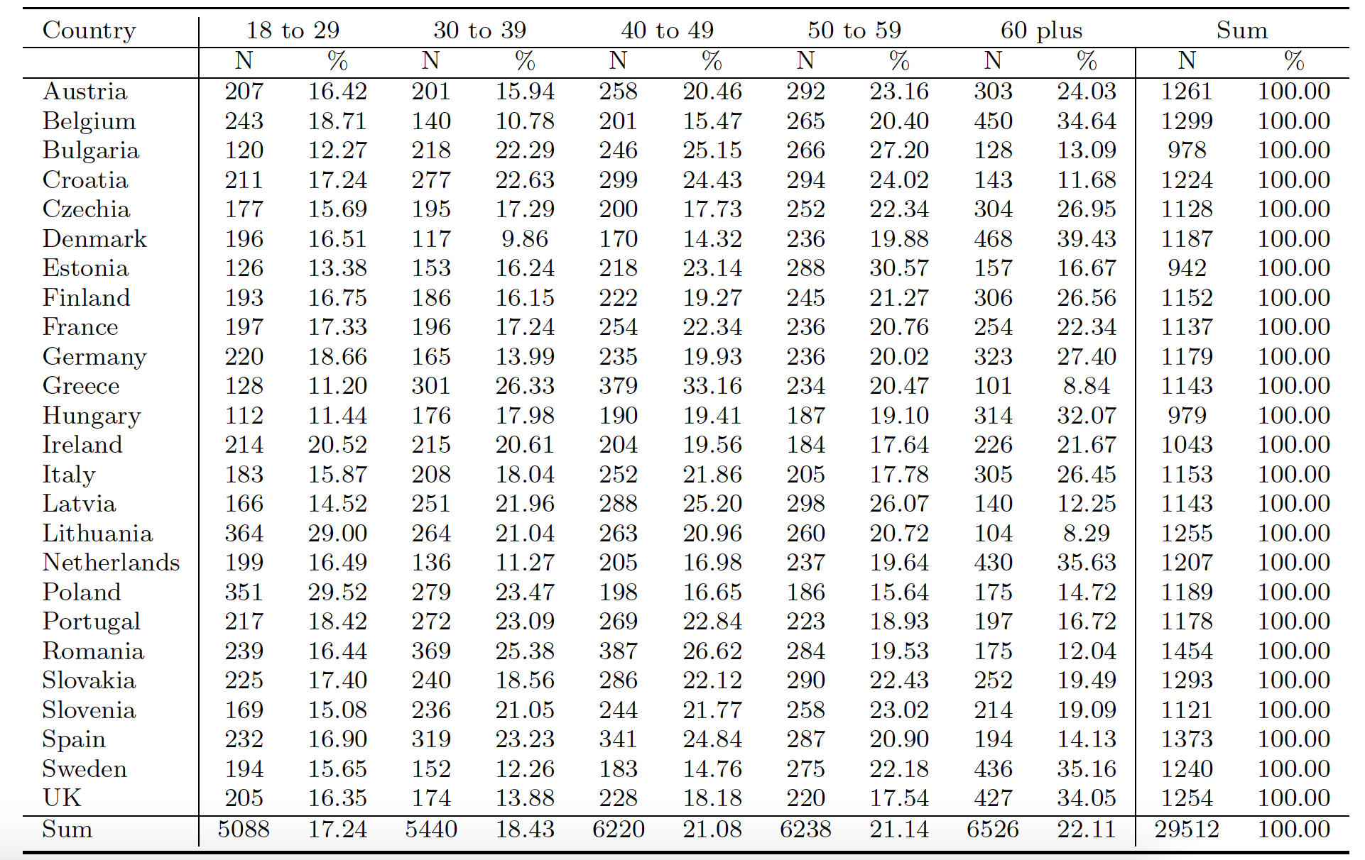
TABLE A1: Sample Breakdown by Age

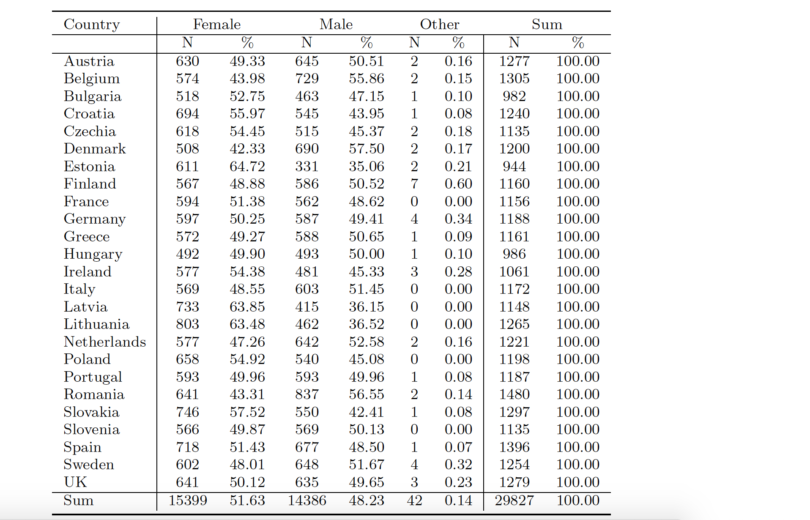
TABLE A2: Sample Breakdown by Gender

B Experimental Design

Before the dictator game, we presented the respondents with the following background information and instruction.

This game is played by pairs of individuals. Each pair is made up of a Player 1 and a Player 2. Each player will have some information about the other player, but you will not be told who the other players are during or after the experiment.
The game is conducted as follows: A sum of 10 tokens will be provisionally allocated to Player 1 at the start of each round. Player 1 will then decide how much of the 10 tokens to offer to player 2. Player 1 could give some, all, or none of the 10 tokens. Player 1 keeps all tokens not given to player 2. Player 2 gets to keep all the tokens Player 1 offers.

You will play this game three times with three different people.

Respondents then received a tabular overview over Player 2:

FIGURE B1: Player 2 Profile Example
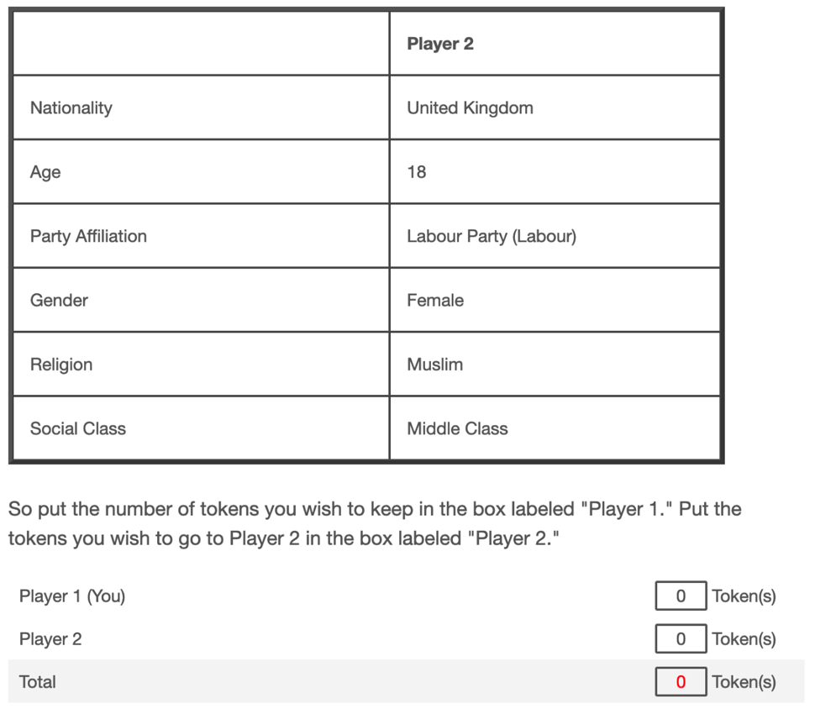

Before the trust game, we presented the following background information and instruction.

This game is played by pairs of individuals. Each pair is made up of a Player 1 and a Player 2. Each player will have some information about the other player, but you will not be told who the other players are during or after the experiment.
Each player will receive 10 tokens. Player 1 then has the opportunity to give a portion of his or her 10 tokens to Player 2. Player 1 could give some, all, or none of the 10 tokens. Whatever amount Player 1 decides to give to Player 2 will be tripled before it is passed on to Player 2. Player 2 then has the option of returning any portion of this tripled amount to Player 1.
Then, the game is over.
Player 1 receives whatever he or she keeps from their original 10 tokens, plus anything returned to him or her by Player 2. Player 2 receives their original 10 tokens, plus whatever he or she keeps after returning any portion of the tripled amount to Player 1.
You will play this game three times, with three different people.
The more tokens you obtain, the more successful you will be.

We will now run through 3 examples to show you how the game might be played.
Example 1
Imagine that Player 1 gives 4 tokens to Player 2. We triple this amount, so Player 2 gets 12 tokens (3 times 4 tokens equals 12 tokens). At this point, Player 1 has 6 tokens. Then Player 2 has to decide whether to give any portion of this tripled amount (12 tokens) back to Player 1, and if so, how much.
Suppose Player 2 decides to return 3 tokens to Player 1. At the end of the game Player 1 will have 9 tokens and Player 2 will have his or her original 10 tokens, plus 9 tokens (the amount Player 2 keeps for himself or herself).
Example 2
Imagine that Player 1 gives 3 tokens to Player 2. We triple this amount, so Player 2 gets 9 tokens (3 times 3 tokens equals 9 tokens). At this point, Player 1 has 7 tokens. Then Player 2 has to decide whether to give any portion of this tripled amount (9 tokens) back to Player 1, and if so, how much.
Suppose Player 2 decides to return 0 tokens to Player 1. At the end of the game Player 1 will have 7 tokens and Player 2 will have his or her original 10 tokens, plus 9 tokens (the amount Player 2 keeps for himself or herself).
Example 3
Imagine that Player 1 gives 10 tokens to Player 2. We triple this amount, so Player 2 gets 30 tokens (3 times 10 tokens equals 30 tokens). At this point, Player 1 has 0 tokens. Then Player 2 has to decide whether to give any portion of this tripled amount (30 tokens) back to Player 1, and if so, how much.
Suppose Player 2 decides to return 3 tokens to Player 1. At the end of the game Player 1 will have 3 tokens and Player 2 will have his or her original 10 tokens, plus 27 tokens (the amount Player 2 keeps for himself or herself).

Again, respondents received information on Player 2 in tabular form (see Figure B1 above).

C Construction of Key Variables and Descriptive Statistics

Randomized profiles are coded according to whether they represent the respondent’s in- or out-group, using information that respondent provided before:

Gender: male (female) respondents are coded to perceive a female (male) Player 2 as out-group. Respondents who indicate gender “Other” cannot be coded easily and are “dummied out” with a separate indicator.

Age: we code respondents according to their belonging to five age groups: 18-29, 30-39, 40-49, 50-59, 60 plus. The age of Player 2 was randomly selected to be 18, 30, 42, 53, or 65 years old. We code in-group when respondents are matched with a Player 2 from the same age bracket, and otherwise out-group.

Class: Respondents indicate their subjective belonging to a social class on a hierarchical scale, covering “The working class of society,” “The lower middle class of society,” “The middle class of society,” “The upper middle class of society” and “The higher class of society.” We collapse the three middle categories into “Middle Class,” creating a three-fold distinction that parallels the set from which we select Player 2’s class, “Lower Class,” “Middle Class” or “Upper Class.” A Player 2 from the same social class is coded as in-group, from a different social class as out-group.

Religion: Respondents could select from a detailed battery of religious beliefs. The religion of Player 2 was randomly selected from a set including “Catholic,” “Protestant,” “Muslim,” and “No Religion.” A Player 2 with the same belief as a Catholic, Protestant or Muslim respondent are coded as in-group. A Player 2 with beliefs different from the respondent are coded as out-group, for example Catholic respondents matched with a Protestant or Muslim Player 2, or one with “No religion.” Respondents that are neither Catholic, Protestant nor Muslim are indicated with a separate dummy (“Other religion”). Similarly, atheist or agnostic respondents, or respondents who “don’t know” are indicated with a separate indicator (“Non-believer”).

Nationality: For each of the 25 countries in which we fielded the survey, we only allow nationals of that country to participate. Nationality of Player 2 is randomly selected to be co-national (e.g., “Ireland” for respondents in Ireland), EU-national or non-EU national.

Partisanship: Respondents indicate their partisanship by answering a question which party they feel close to. Depending on the answer, we randomly generate the partisanship of Player 2. Randomization was adjusted such that in expectation, there is a 50% chance for Player 2 to have the same partisanship (co-partisan), and 50% chance to be identify with another party from the top 8 parties in the country at that time (out-partisan), based on recent electoral results, polling numbers, and relevance to the research question (Eurosceptic parties).

Table C1 summarizes descriptive information on key variables of the survey experiment.

TABLE C1: Descriptive Overview over Variables from the Survey Experiment
Variable |  | N | %
Tokens for Player 2 (DV) | Mean = 3.39, SD = 2.40 | 178,936 | 100
Gender | In Group | 89,121 | 49.8
 | Out Group | 89,563 | 50.1
 | Respondent: Other gender | 252 | 0.1
 | Sum | 178,936 | 100
Age | In-Group | 35,291 | 19.7
 | Out-Group | 143,645 | 80.3
 | Sum | 178,936 | 100
Class | In-Group | 57,551 | 32.2
 | Out-Group | 113,945 | 63.7
 | Respondent: Don’t know | 7,440 | 4.2
 | Sum | 178,936 | 100
Religion | In-Group | 19,807 | 11.1
 | Out-Group | 59,595 | 33.3
 | Respondent: Other religion | 35,406 | 19.8
 | Respondent: Non-believer | 64,128 | 38.8
 | Sum | 178,936 | 100
Nationality | In-Group | 121,927 | 68.1
 | Out-Group | 57,009 | 31.9
 | Sum | 178,936 | 100
Partisanship | In-Group | 30,835 | 17.2
 | Out-Group | 66,766 | 37.3
 | Control-Group (No information provided) | 24,326 | 13.6
 | Respondent: Non-partisan | 57,009 | 31.9
 | Sum | 178,936 | 100
Note: Level of analysis is respondent-round level

Next, we describe the construction of one key independent variable in the multi-level model: To estimate the effect of coalition partnership (and coalition experience) on the allocation of tokens, we constructed different versions of this measure. When Player 2 shares the respondent’s partisan affiliation (co-partisan), we employ measures that identify whether the respondent’s party is member of (or has experience of) a coalition government. When Player 2 has a party affiliation different from the respondent’s (out-partisan), we employ measures that identify whether the respondent’s party is a coalition partner of (or has coalition experience with) that specific out-party.
The distribution of coalition experience is presented in Table C2. It shows the distribution of years that parties spend in coalition governments. The distribution of observations has a clear skew, due to the fact that most parties in our dataset never formed a (coalition) government. For the distribution of years spent with a particular coalition partner, the skew is even more pronounced. This reflects the fact that parties govern with changing coalition partners and some party dyads never formed a coalition government (e.g., the left-wing Podemos and the right-wing Vox in Spain).

TABLE C2: Coalition Partnership of Political Parties
 | Years in Coalition Government |  | Years with Coalition Partner
Years | Number of Parties |  | Number of Party-Dyads†
0-2 | 233 | 67.7% | 99 | 32.2%
3-5 | 46 | 13.4% | 110 | 35.8%
6-8 | 21 | 6.1% | 59 | 19.2%
9-11 | 22 | 6.4% | 32 | 10.4%
>=12 | 22 | 6.5% | 7 | 2.2%
Sum | 344 | 100% | 307 | 100%
† Note: There are 2490 party-dyads that never formed a coalition government.

Figure C1 allows for a closer inspection of these distributions, plotting the top 25 in terms of parties spending time in coalition government and party-dyads with most time governing together, respectively. The Austrian ÖVP, the Belgian O-VLD and the Estonian ER are among the parties with most coalition experience since 2000. In terms of coalition partners, the Belgian O-VLD and the Mouvement Reformateur spent most time with each other in a government coalition, followed by the O-VLD together with the Parti Socialiste. Note that the order of parties in each dyad is arbitrary. Each dyad is counted only once.

FIGURE C1: Distribution of Coalition Experience since 2000 (Top 25)
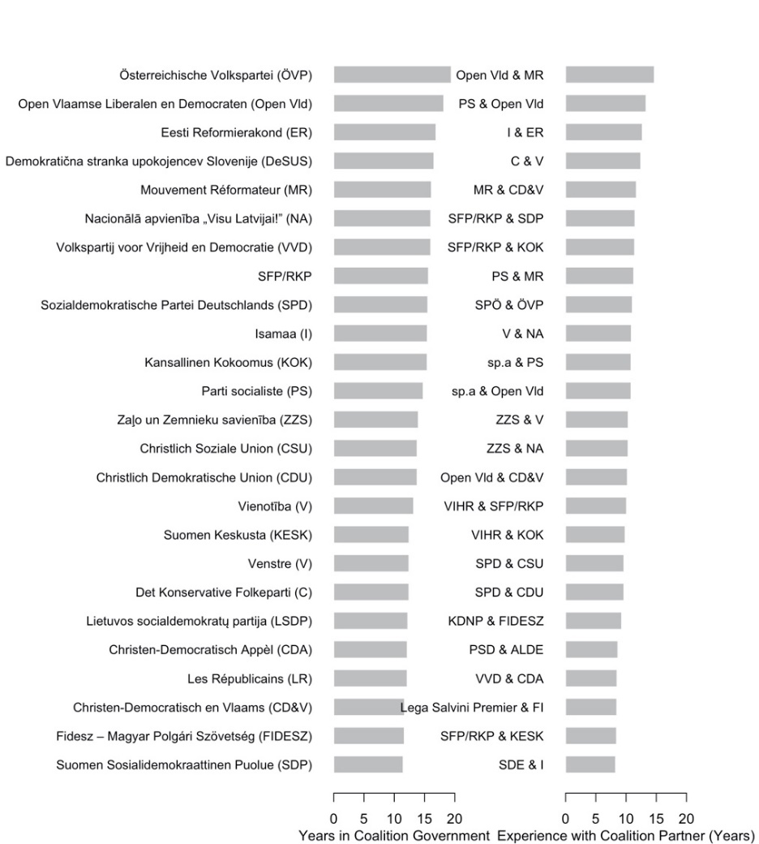
Finally, Table C3 offers an overview over dependent and independent variables in the multilevel model.

TABLE C3: Descriptive Information for Dependent and Independent Variables
 | Min | Mean | Max | N
Tokens for Player 2 | 0 | 3.52 | 10 | 77,456
Co-Partisan | 0 | 0.40 | 1 | 77,456
Out-Partisan | 0 | 0.40 | 1 | 77,456
Coalition Partner (Co-Partisan) | 0 | 0.24 | 1 | 77,456
Coalition Partner (Out-Partisan) | 0 | 0.03 | 1 | 77,456
Coalition Experience (Co-Partisan, in Years) | 0 | 4.29 | 19.43 | 77,456
Experience with Coalition Partner (Out-Partisan, in Years) | 0 | 0.35 | 14.67 | 77,456
Average District Magnitude (logged) | 0 | 2.12 | 5.01 | 77,456
Effective Number of Parties | 2.39 | 4.73 | 9.70 | 77,456
Elite Polarization (Dalton 2008) | 2.45 | 5.21 | 15.74 | 77,456
Elite Polarization (Maoz & Somer-Topcu 2009) | 0.22 | 0.37 | 0.53 | 77,456
Controls:
Female | 0 | 0.47 | 1 | 77,456
Age | 18 | 47.16 | 88 | 76,546
Education | 0 | 21.36 | 30 | 74,357
Left-Right Distance (Current) | 0 | 9.01 | 84.71 | 64,048
Left-Right Distance (since 2000) | 0 | 8.58 | 70.18 | 64,623
Left-Right Partisan-Ideological Alignment | -10 | 2.26 | 10 | 45,718
Population size (in Million) | 1.30 | 21.97 | 83.10 | 77,456
GDP per capita (in thousand Euros) | 8.78 | 30.10 | 72.26 | 77,456
Gini coefficient | 24.2 | 31.14 | 40.40 | 77,456

D Full Model Results

Table D1 shows the full model table underlying Figure 2 in the main manuscript.

Table D1: Effects of Identity Attributes on Allocations to Player 2 (Results of HLMs)
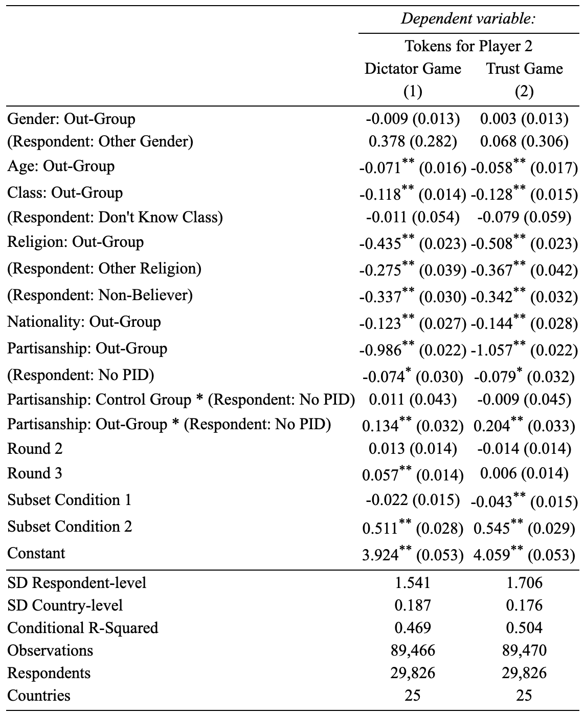
Notes: SD indicates the estimate of the standard deviation of the random intercept. ⁺ p < 0.1, * p < 0.05, ** p < 0.01

We seek to utilize the whole sample and make generalizable inferences about the relative importance of social divides based on gender, age, class or religion. Roughly two thirds of our respondents report to be partisan (18,937 respondents), while one third reports to be non-partisan (10,890 respondents). Compared to other social divides, the partisan divide is relevant only for partisans. We therefore separate partisan from non-partisan respondents through an interaction effect (e.g., Partisanship: Out-Group * (Respondent: No PID)). The main effect of Partisanship: Out-Group can be interpreted as the effect of affective polarization among partisans, which is the quantity of interest.

Our models include controls to address the scenarios of interest and the implausible cases. Subset Condition 1 is a dummy variable that indicates a subset of decision-making games in which respondents receive information about Player 2’s group attributes that are the topic of this study. The results reported here were part of a larger data collection effort designed to address political divides in Europe and in a subset of decision-making games where we display Player 2 as an EU national, we randomly display additional information about Player 2 (EU identity), which is explored in a separate study. Subset Condition 2 is another dummy indicator for whether partisanship information is shown. As explained in the manuscript, partisanship could only be shown when Player 2 is a co-national. To take into account that respondents play three rounds of decision-making games, we include a respondent-level random intercept and fixed effects for each round.

Table D2 shows the model table underlying Figure 4 in the manuscript. Note that the focus here is on co-national profiles where information about the partisanship of Player 2 may either be shown or not. Subset Condition 2 therefore is dropped.

Table D2: In-Group Favoritism and Out-Group Derogation (Results of HLMs)
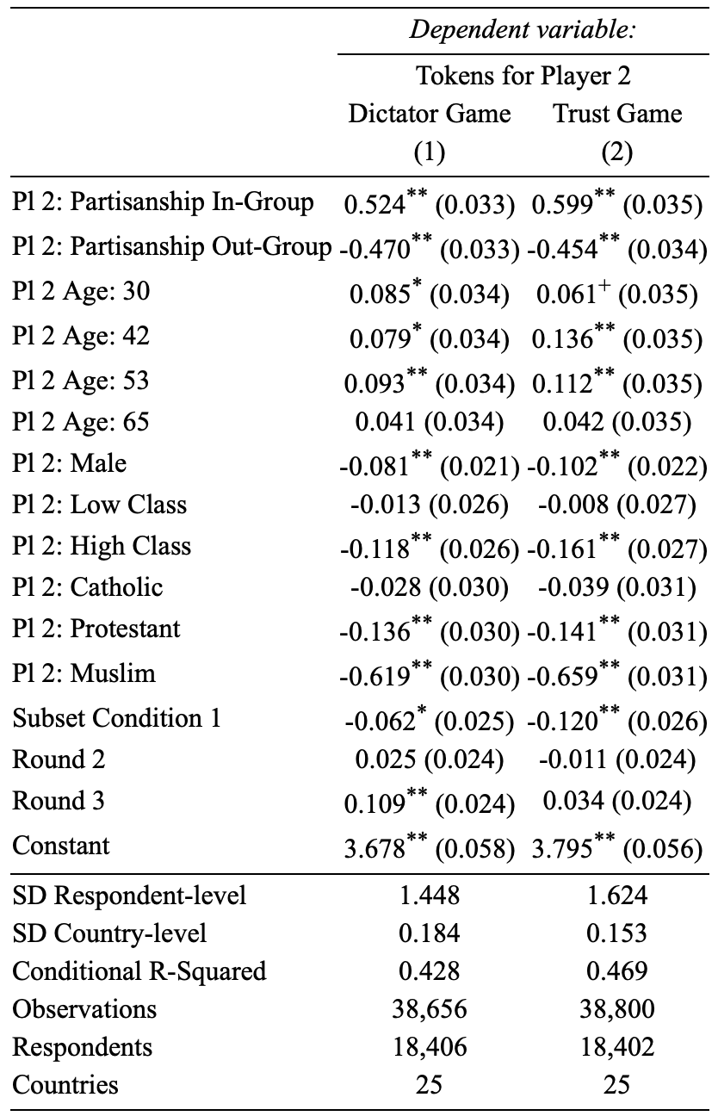
Notes: SD indicates the estimate of the standard deviation of the random intercept. ⁺ p < 0.1, * p < 0.05, ** p < 0.01

TABLE D3: In-Group Favoritism and Out-Group Derogation Across Countries
 | Dictator Game |  |  | Trust Game
 | Difference in tokens  (Compared to Control Group) |  | |Out-group| – |In-group| | Difference in tokens  (Compared to Control Group) |  | |Out-group| – |In-group|
Country | In-Group | Out-Group |  | In-Group | Out-Group
Austria | 0.28  (-0.06, 0.63) | -0.78  (-1.13, -0.39) | 0.49  (-0.16, 1.15) | 0.41  (0.05, 0.77) | -0.66  (-1.03, -0.29) | 0.25  (-0.43, 0.92)
Belgium | 0.59  (0.29, 0.89) | -0.63  (-0.92, -0.35) | 0.04  (-0.51, 0.58) | 0.70  (0.40, 1.01) | -0.51  (-0.79, -0.23) | -0.19  (-0.71, 0.37)
Bulgaria | 0.41  (0.01, 0.84) | -0.29  (-0.66, 0.08) | -0.12  (-0.81, 0.61) | 0.73  (0.30, 1.17) | -0.31  (-0.73, 0.11) | -0.42  (-1.23, 0.37)
Croatia | 0.15  (-0.21, 0.51) | -0.91  (-1.26, -0.56) | 0.76  (0.11, 1.42) | 0.58  (0.24, 0.94) | -0.63  (-0.97, -0.30) | 0.05  (-0.57, 0.69)
Czechia | 0.59  (0.27, 0.91) | -0.76  (-1.06, -0.42) | 0.17  (-0.44, 0.74) | 0.81  (0.46, 1.16) | -0.44  (-0.81, -0.10) | -0.37  (-1.00, 0.29)
Denmark | 0.55  (0.28, 0.82) | -0.28  (-0.56, 0.01) | -0.27  (-0.78, 0.27) | 0.52  (0.24, 0.80) | -0.52  (-0.77, -0.25) | 0.00  (-0.51, 0.52)
Estonia | 0.44  (0.07, 0.82) | -0.36  (-0.70, -0.01) | -0.08  (-0.75, 0.62) | 0.53  (0.15, 0.92) | -0.26  (-0.64, 0.12) | -0.27  (-0.98, 0.43)
Finland | 0.55  (0.25, 0.86) | -0.32  (-0.61, -0.01) | -0.23  (-0.81, 0.32) | 0.72  (0.37, 1.09) | -0.26  (-0.60, 0.09) | -0.47  (-1.13, 0.18)
France | 0.88  (0.52, 1.25) | -0.28  (-0.64, 0.07) | -0.60  (-1.27, 0.06) | 1.17  (0.81, 1.51) | -0.22  (-0.57, 0.16) | -0.95  (-1.61,-0.32)
Germany | 0.28  (-0.04, 0.63) | -0.47  (-0.81, -0.15) | 0.19  (-0.46, 0.80) | 0.44  (0.08, 0.78) | -0.48  (-0.82, -0.14) | 0.04  (-0.59, 0.67)
Greece | 0.29  (0.01, 0.58) | -0.60  (-0.90, -0.31) | 0.31  (-0.23, 0.83) | 0.55  (0.29, 0.83) | -0.62  (-0.88, -0.36) | 0.07  (-0.42, 0.53)
Hungary | 0.73  (0.39, 1.06) | -0.75  (-1.09, -0.41) | 0.02  (-0.62, 0.64) | 0.77  (0.42, 1.13) | -0.63  (-1.03, -0.26) | -0.14  (-0.79, 0.56)
Ireland | 0.28  (-0.08, 0.66) | -0.34  (-0.69, -0.01) | 0.06  (-0.58, 0.77) | 0.53  (0.15, 0.90) | -0.23  (-0.59, 0.14) | -0.30  (-0.97, 0.38)
Italy | 0.67  (0.38, 0.97) | -0.35  (-0.63, -0.07) | -0.31  (-0.85, 0.22) | 0.70  (0.37, 0.99) | -0.39  (-0.71, -0.09) | -0.31  (-0.87, 0.28)
Latvia | 0.54  (0.11, 0.97) | -0.37  (-0.77, 0.03) | -0.17  (-0.95, 0.61) | 1.08  (0.66, 1.52) | -0.21  (-0.65, 0.23) | -0.87  (-1.66, -0.06)
Lithuania | 0.40  (0.03, 0.78) | -0.57  (-0.94, -0.21) | 0.18  (-0.50, 0.86) | 0.59  (0.21, 0.98) | -0.30  (-0.69, 0.08) | -0.28  (-1.00, 0.38)
Netherlands | 0.85  (0.56, 1.14) | -0.27  (-0.57, 0.06) | -0.58  (-1.15, -0.02) | 0.86  (0.52, 1.19) | -0.40  (-0.70, -0.08) | -0.46  (-1.04, 0.12)
Poland | 0.70  (0.40, 0.99) | -0.25  (-0.55, 0.04) | -0.45  (-0.98, 0.10) | 0.51  (0.22, 0.84) | -0.49  (-0.78, -0.21) | -0.02  (-0.55, 0.52)
Portugal | 0.49  (0.21, 0.77) | -0.17  (-0.47, 0.11) | -0.33  (-0.83, 0.22) | -0.02  (-0.30, 0.27) | -0.58  (-0.86, -0.31) | 0.59  (0.07, 1.09)
Romania | 0.63  (0.32, 0.95) | -0.38  (-0.69, -0.07) | -0.25  (-0.82, 0.32) | 0.68  (0.37, 1.01) | -0.42  (-0.72, -0.13) | -0.26  (-0.83, 0.31)
Slovakia | 0.72  (0.40, 1.04) | -0.42  (-0.72, -0.11) | -0.30  (-0.87, 0.30) | 1.01  (0.65, 1.38) | -0.19  (-0.54, 0.16) | -0.83  (-1.46, -0.18)
Slovenia | 0.40  (0.07, 0.73) | -0.58  (-0.92, -0.24) | 0.19  (-0.42, 0.81) | 0.28  (-0.07, 0.61) | -0.52  (-0.87, -0.17) | 0.24  (-0.37, 0.88)
Spain | 0.54  (0.26, 0.82) | -0.64  (-0.93, -0.37) | 0.10  (-0.40, 0.62) | 0.23  (-0.06, 0.53) | -0.56  (-0.85, -0.27) | 0.33  (-0.21, 0.84)
Sweden | 0.46  (0.18, 0.73) | -0.21  (-0.49, 0.06) | -0.25  (-0.76, 0.28) | 0.41  (0.11, 0.70) | -0.48  (-0.77, -0.16) | 0.07  (-0.50, 0.59)
United  Kingdom | 0.47  (0.14, 0.80) | -0.60  (-0.93, -0.26) | 0.13  (-0.49, 0.75) | 0.67  (0.32, 1.02) | -0.43  (-0.77, -0.07) | -0.24  (-0.88, 0.44)
Note: 95% confidence intervals are shown in parentheses.

Tables D4 and D5 show the full models that we presented in abbreviated form in the manuscript (Tables 1 and 2).
Table D4: Current Coalition Partnership (Full Results of HLMs)
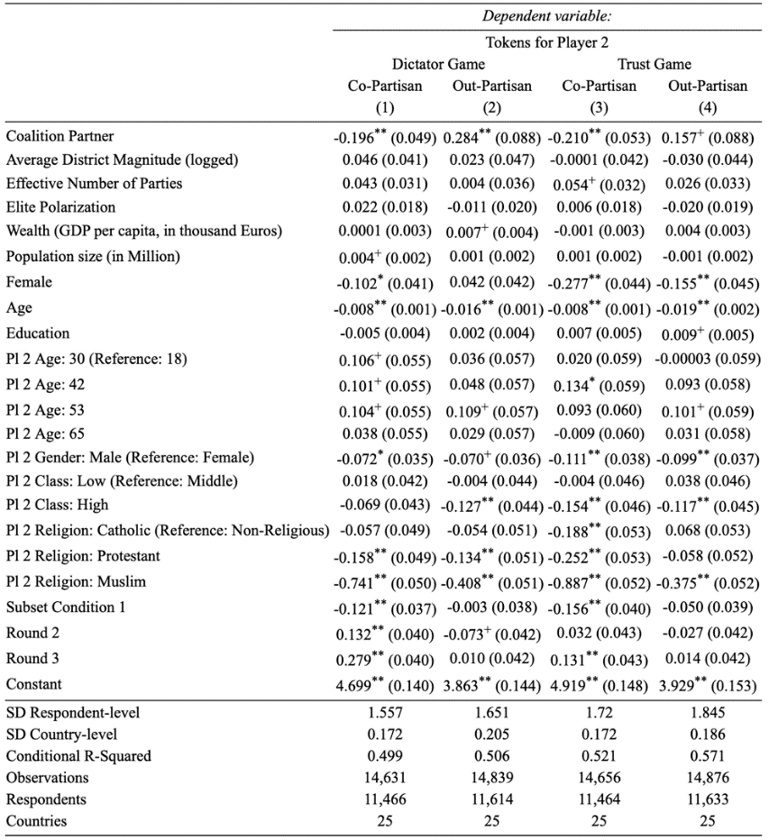
Notes: SD indicates the estimate of the standard deviation of the random intercept.
⁺ p < 0.1, * p < 0.05, ** p < 0.01

Table D5: Coalition Experience (Full Results of HLMs)
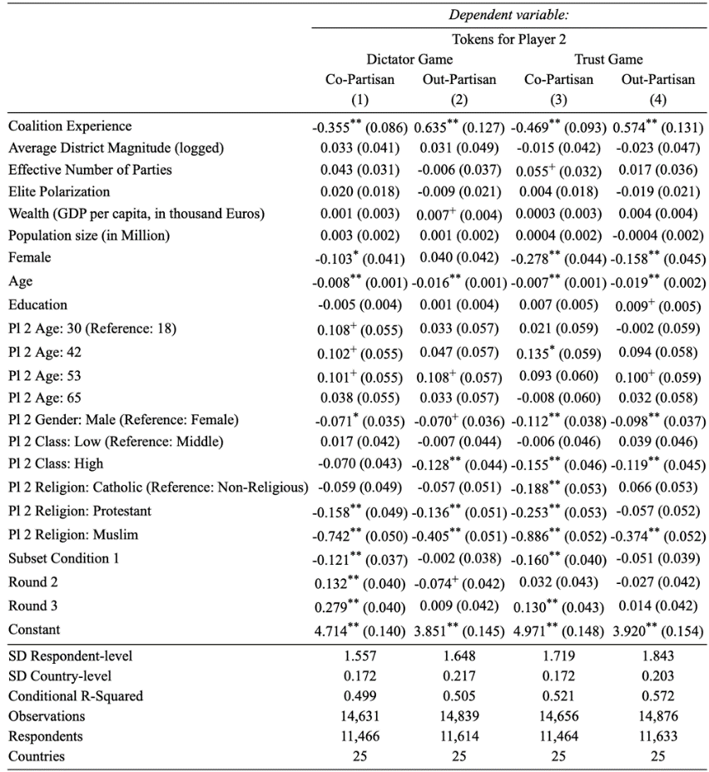
Notes: SD indicates the estimate of the standard deviation of the random intercept.
⁺ p < 0.1, * p < 0.05, ** p < 0.01

E Additional Analyses

E.1 Societal divides

To evaluate the substantive strength of partisan divide, we also compare the magnitude of the average partisan divide relative to some of particularly salient divides such as the Christian-Muslim divide and the upper-lower class divide. For this purpose, we present Table E.1 and Figure E.1 below. Indeed, particularly salient divides such as the Christian-Muslim divide and the upper-lower class divide are greater than the average effects of the broader categories (religion and class), as indicated by increased estimates of the corresponding coefficients. However, the key finding is that the partisan divide continues to be greater than these salient social divides, leading to larger discrimination in the allocation of tokens.

TABLE E.1: Partisan Divide versus Class/Religious Divide
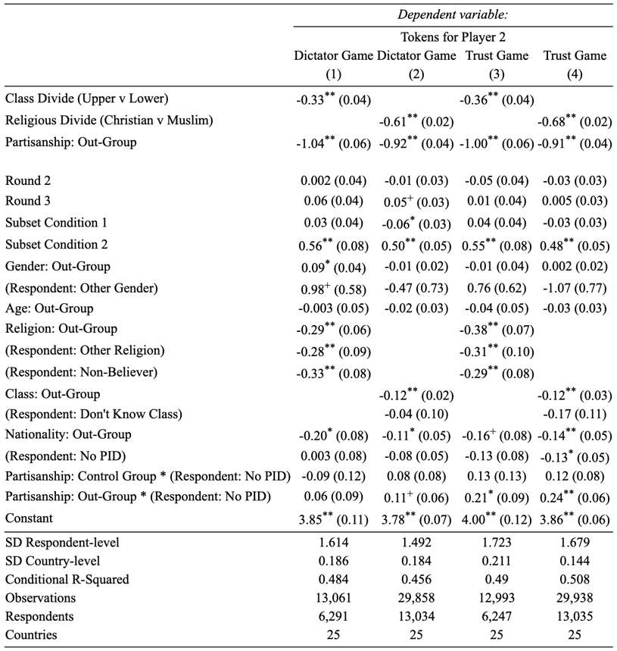
Notes: SD indicates the estimate of the standard deviation of the random intercept.
⁺ p < 0.1, * p < 0.05, ** p < 0.01

FIGURE E.1: Partisan Divide versus Class/Religious Divide
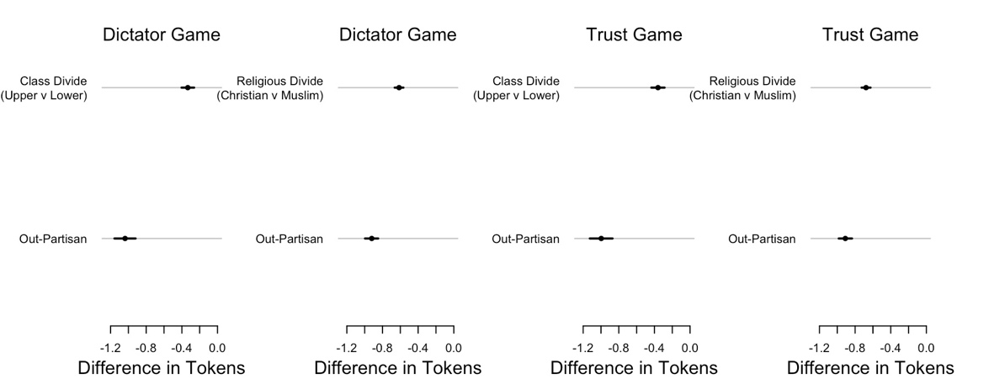
Notes: Visualization of the allocation of tokens towards the out-group, showing model predictions (dots) together with their 95% confidence intervals (lines).

E.2 Feeling Thermometer

Analyzing feeling thermometer scores, we find consistent (stronger indeed) evidence to support our original findings. Table E.2.1 and Figure E.2 below show the findings for the pooled 25 countries. While out-parties receive a feeling thermometer score of 33.8 degrees on average, co-parties receive a score of 84.4 degrees on average. Using the baseline of 50 degrees representing a neutral feeling as a reference point, this implies higher levels of in-group favoritism (84.4 degrees – 50 degrees = 34.4 degrees) than out-group derogation (50 degrees – 33.8 degrees = 16.2 degrees). In other words, respondents’ feeling about the average out-party is much closer to neutrality than their feeling towards the in-party. Table E.2.2 provides the breakdown by countries, showing that these results are consistent across Europe. In summary, using feeling thermometer provides further evidence that affective polarization in Europe is not driven by out-group derogation. Indeed, in-group favoritism is more consequential on average than out-group derogation.

Table E.2.1: Hierarchical Linear Model – Feeling Thermometer
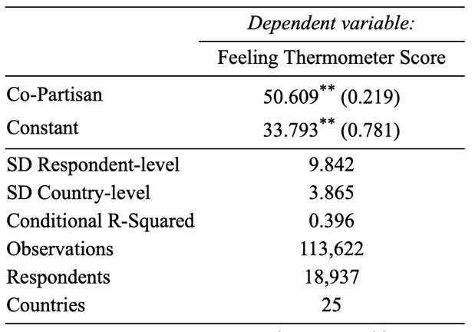
Notes: SD indicates the estimate of the standard deviation of the random intercept.
⁺ p < 0.1, * p < 0.05, ** p < 0.01

FIGURE E.2: In-Group Favoritism and Out-Group Derogation in the Feeling Thermometer
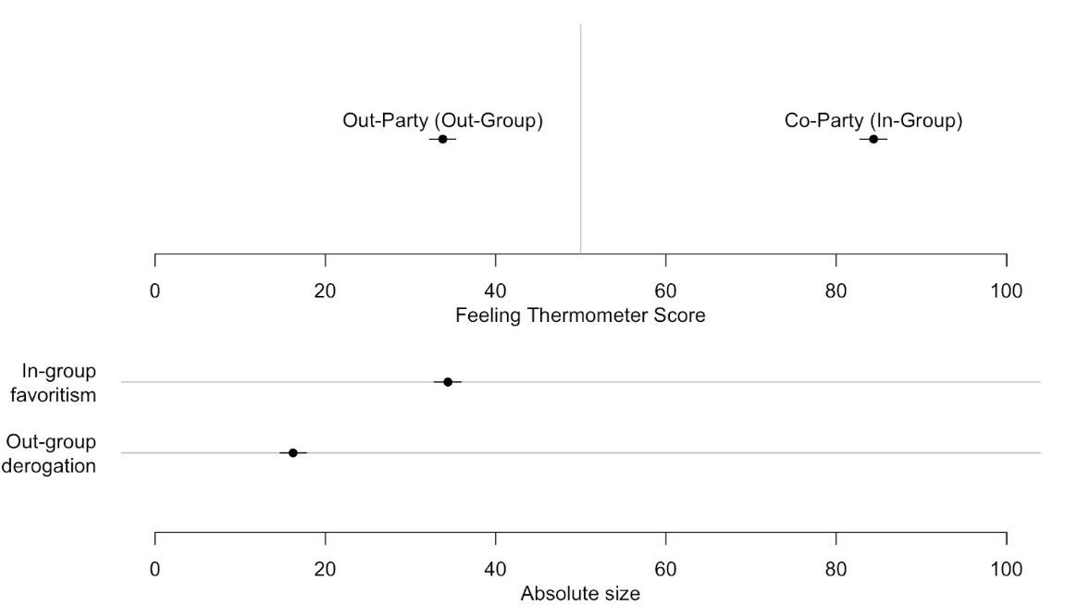
Notes: Visualization of feeling thermometer scores for co-party and out-parties, showing predicted scores (dots) together with their 95% confidence intervals (lines). Point estimates and confidence intervals obtained by redrawing model coefficients 10.000 times based on model in Table E.2.1.

Table E.2.2: Hierarchical Linear Model – Feeling Thermometer Estimates, by Country

Country | Out-Party Score | In-Party Score | Out-Group  Derogation  (50 – Out-Party Score) | In-Group  Favoritism  (In-Party Score – 50) | |Out-group| – |In-group|
Austria | 32.8  (31.7, 33.9) | 85.4  (83.3, 87.5) | 17.2  (16.1, 18.3) | 35.4  (33.3, 37.5) | -18.2  (-20.7, -15.6)
Belgium | 37.6  (36.6, 38.7) | 84.6  (82.5, 86.7) | 12.4  (11.3, 13.4) | 34.6  (32.5, 36.7) | -22.3  (-24.8, -19.7)
Bulgaria | 27.5  (26.0, 28.9) | 84.4  (81.7, 86.9) | 22.5  (21.1, 24) | 34.4  (31.7, 36.9) | -11.8  (-15.1, -8.4)
Croatia | 25.8  (24.7, 27) | 80.5  (78.2, 82.8) | 24.2  (23, 25.3) | 30.5  (28.2, 32.8) | -6.4  (-9.2, -3.5)
Czechia | 35.0  (34.0, 35.9) | 87.3  (85.3, 89.3) | 15.0  (14.1, 16.0) | 37.3  (35.3, 39.3) | -22.3  (-24.6, -20)
Denmark | 39.7  (38.8, 40.5) | 85.7  (83.9, 87.5) | 10.3  (9.5, 11.2) | 35.7  (33.9, 37.5) | -25.4  (-27.5, -23.3)
Estonia | 37.3  (36.3, 38.3) | 85.3  (83.1, 87.5) | 12.7  (11.7, 13.7) | 35.3  (33.1, 37.5) | -22.6  (-25, -20.1)
Finland | 36.7  (35.7, 37.7) | 85.8  (83.8, 87.7) | 13.3  (12.3, 14.3) | 35.8  (33.8, 37.7) | -22.5  (-24.8, -20.1)
France | 31.7  (30.6, 32.8) | 82.6  (80.5, 84.7) | 18.3  (17.2, 19.4) | 32.6  (30.5, 34.7) | -14.4  (-16.9, -11.7)
Germany | 33.0  (31.9, 34.1) | 84.2  (82.1, 86.3) | 17.0  (15.9, 18.1) | 34.2  (32.1, 36.3) | -17.2  (-19.8, -14.6)
Greece | 23.0  (22.0, 24.0) | 82.6  (80.6, 84.5) | 27.0  (26.0, 28.0) | 32.6  (30.6, 34.5) | -5.6  (-7.9, -3.1)
Hungary | 32.0  (30.8, 33.1) | 87.6  (85, 90.1) | 18.0  (16.9, 19.2) | 37.6  (35.0, 40.1) | -19.5  (-22.4, -16.5)
Ireland | 40.4  (39.0, 41.8) | 79.9  (77.5, 82.3) | 9.6  (8.2, 11.0) | 29.9  (27.5, 32.3) | -20.3  (-23.4, -17.1)
Italy | 33.4  (32.4, 34.4) | 84.3  (82.4, 86.2) | 16.6  (15.6, 17.6) | 34.3  (32.4, 36.2) | -17.7  (-20.0, -15.3)
Latvia | 33.3  (31.9, 34.6) | 83.7  (80.8, 86.6) | 16.7  (15.4, 18.1) | 33.7  (30.8, 36.6) | -17  (-20.4, -13.5)
Lithuania | 32.2  (30.9, 33.4) | 81.9  (79.5, 84.2) | 17.8  (16.6, 19.1) | 31.9  (29.5, 34.2) | -14.1  (-17.0, -11.1)
Netherlands | 38.4  (37.4, 39.4) | 83.0  (80.8, 85.2) | 11.6  (10.6, 12.6) | 33.0  (30.8, 35.2) | -21.4  (-24.0, -18.8)
Poland | 37.8  (36.8, 38.8) | 85.2  (83.4, 87.1) | 12.2  (11.2, 13.2) | 35.2  (33.4, 37.1) | -23.1  (-25.4, -20.7)
Portugal | 41.6  (40.6, 42.6) | 83.0  (81.0, 84.9) | 8.4  (7.4, 9.4) | 33.0  (31.0, 34.9) | -24.6  (-27.0, -22.1)
Romania | 30.3  (29.3, 31.3) | 86.3  (84.2, 88.4) | 19.7  (18.7, 20.7) | 36.3  (34.2, 38.4) | -16.6  (-19.1, -14.1)
Slovakia | 33.8  (32.8, 35.0) | 86.7  (84.4, 88.9) | 16.2  (15.0, 17.2) | 36.7  (34.4, 38.9) | -20.5  (-23.2, -17.8)
Slovenia | 34.9  (33.8, 36.0) | 87.6  (85.4, 89.7) | 15.1  (14.0, 16.2) | 37.6  (35.4, 39.7) | -22.5  (-25.1, -19.9)
Spain | 32.6  (31.9, 33.4) | 84.5  (82.7, 86.4) | 17.4  (16.6, 18.1) | 34.6  (32.7, 36.4) | -17.2  (-19.2, -15.2)
Sweden | 33.1  (32.2, 33.9) | 87.7  (85.7, 89.5) | 16.9  (16.1, 17.8) | 37.7  (35.7, 39.5) | -20.7  (-22.8, -18.6)
United  Kingdom | 31.3  (30.2, 32.4) | 79.5  (77.5, 81.5) | 18.7  (17.6, 19.8) | 29.5  (27.5, 31.5) | -10.9  (-13.4, -8.3)
Notes: 95% confidence intervals are shown in parentheses.

F Robustness

F.1 Controlling for Ideological Proximity

To control for a possible confounder of coalition partnership, we include ideological proximity between the respondent’s party and the party of Player 2. We use party positions on the left-right dimension from the Comparative Manifesto Project (Volkens et al 2021). Table F.1 presents the findings. Columns (1) through (4) use the indicator of current Coalition Partnership. In the dictator game, we find that Coalition Partnership still significantly increases the allocation of tokens for out-partisans. In the trust game, the effect just fails to be significant at conventional levels.

Next, we repeat the same for Coalition Experience since 2000. Consistent with the timeframe, we also calculate ideological proximity by taking the difference between average party positions over that period. Columns (5) through (8) in Table F.1 shows that after controlling for ideological proximity, Coalition Experience has a significant effect, both in dictator and trust game.

TABLE F.1: Current Coalition Partnership and Coalition Experience since 2000 (Results of HLMs)
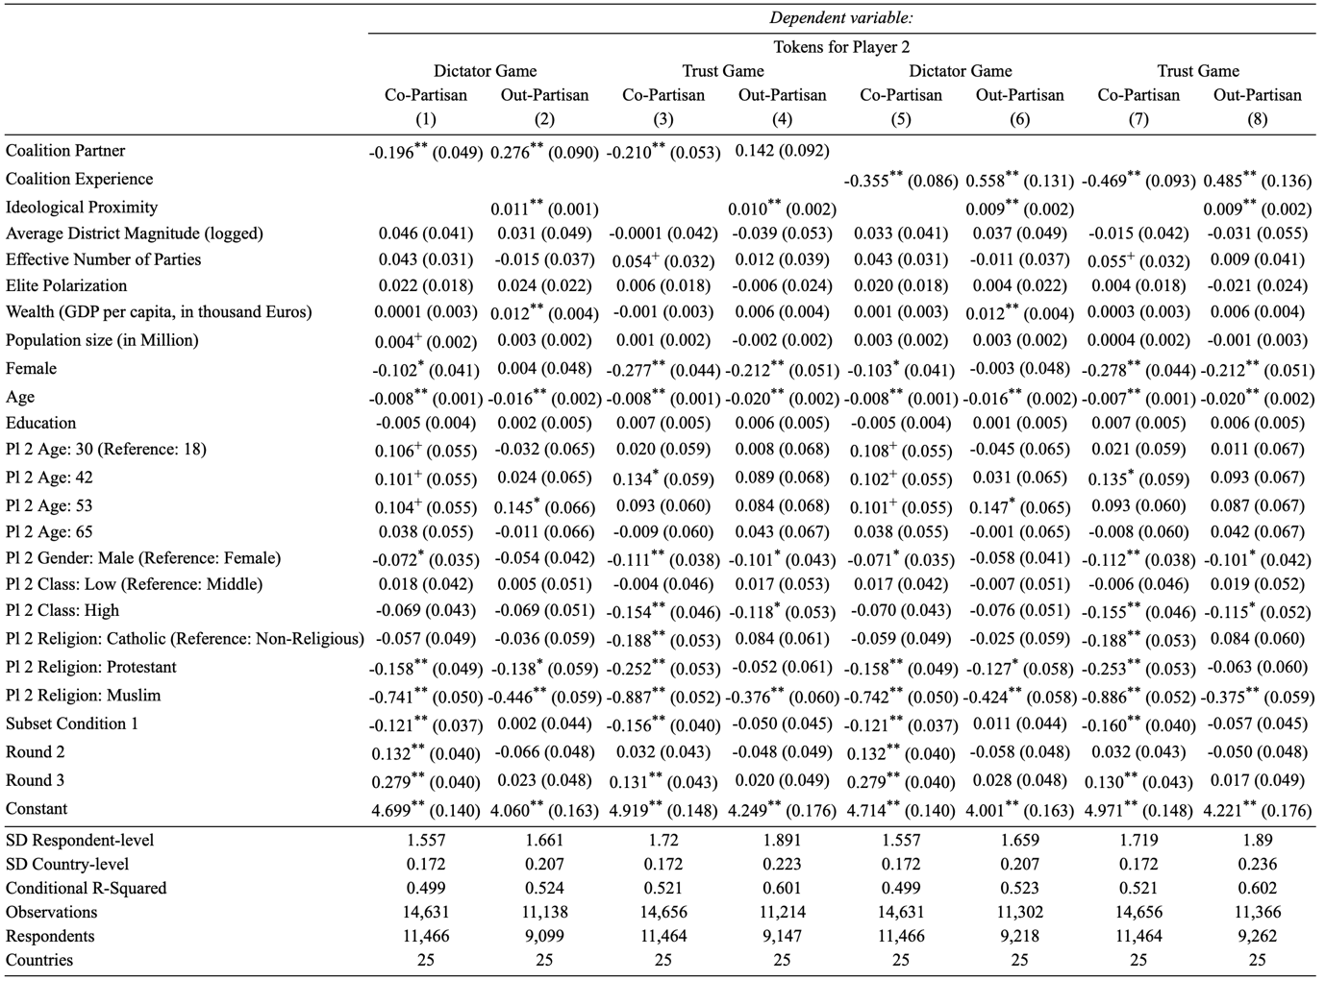
Notes: SD indicates the estimate of the standard deviation of the random intercept. ⁺ p < 0.1, * p < 0.05, ** p < 0.01

FIGURE F.1: Effect of Coalition Partnership on In-Group Favoritism and Out-Group Derogation
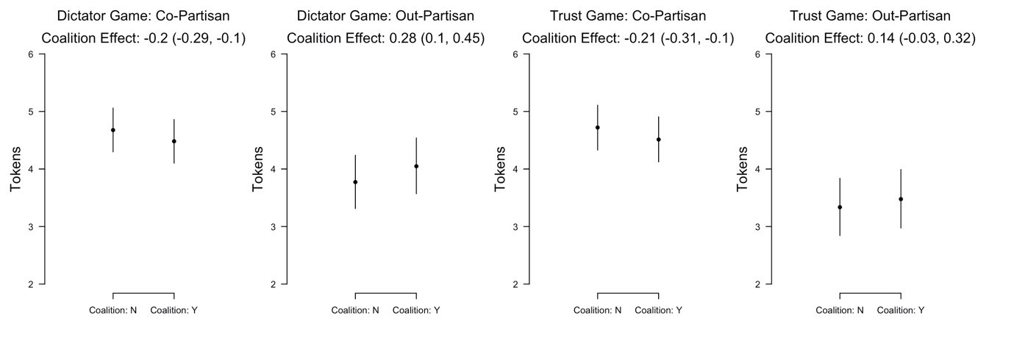
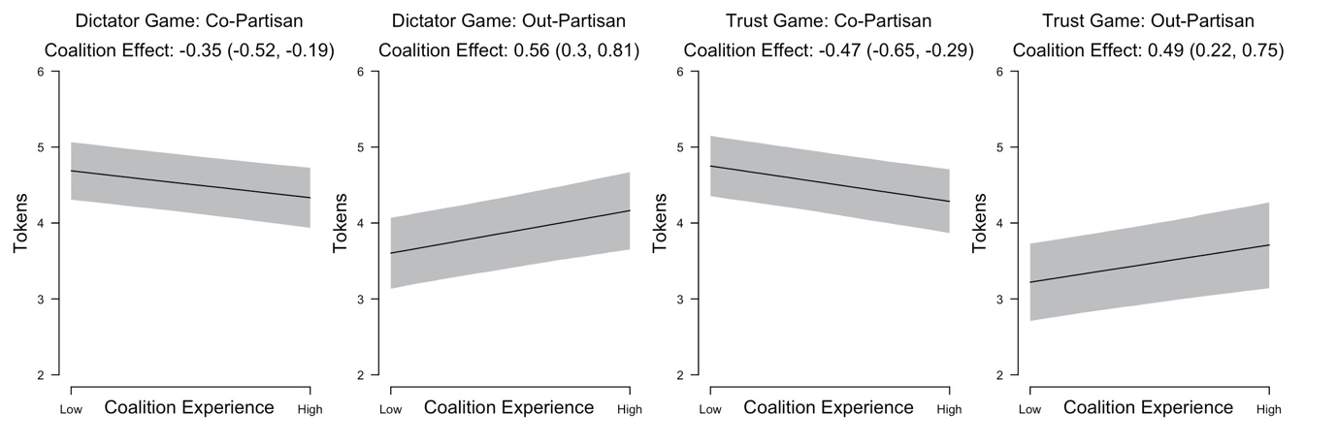
Notes: Visualization of coalition partnership (upper row) and coalition experience (bottom row) effects. showing predicted allocation of tokens together with their 95% confidence intervals. Predictions for a fixed profile (30 year old, female, middle class, no religion, 1st round), with respondent- and country-characteristics held at median values. Predictions based on Table F.1, Columns (1) – (4) (upper row) and Columns (5) – (8) (lower row).

F.2 The Role of Partisan-Ideological Alignment

In order to control for the effect of partisan-ideological sorting as a potential driver of affective polarization, we use the self-placement of our survey respondents on an 11-point left-right scale, as well as their perceptions of party positions on that same scale. Our Partisan-Ideological Alignment score subtracts the respondent’s ideological distance to the in-party (ranging from 0 to 10) from his or her average ideological distance to out-parties (ranging from 0 to 10). This measure produces a scale that ranges from –10 to +10. -10 indicates that distance to his or her own party is much larger than the average distance to the other parties, which represents weak alignment or sorting. +10 indicates that the average distance to the other parties is much larger than distance to the own party, which reflects strong alignment. Values close to zero indicate intermediate levels of alignment. Table F.2, as well as the corresponding figure, show that after controlling for partisan-ideological alignment, Coalition Partnership and Experience continue to be significant.

TABLE F.2: Current Coalition Partnership and Coalition Experience since 2000 (Results of HLMs)
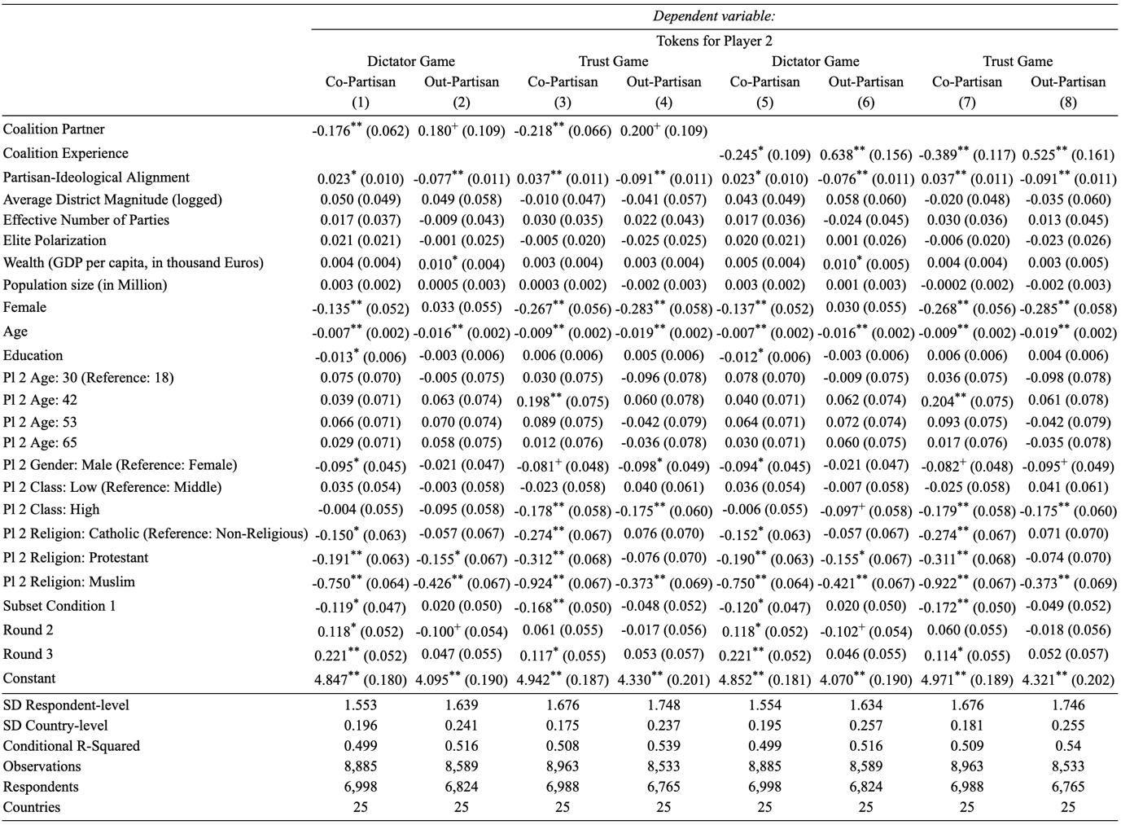
Notes: SD indicates the estimate of the standard deviation of the random intercept. ⁺ p < 0.1, * p < 0.05, ** p < 0.01

FIGURE F.2: Effect of Coalition Partnership on In-Group Favoritism and Out-Group Derogation
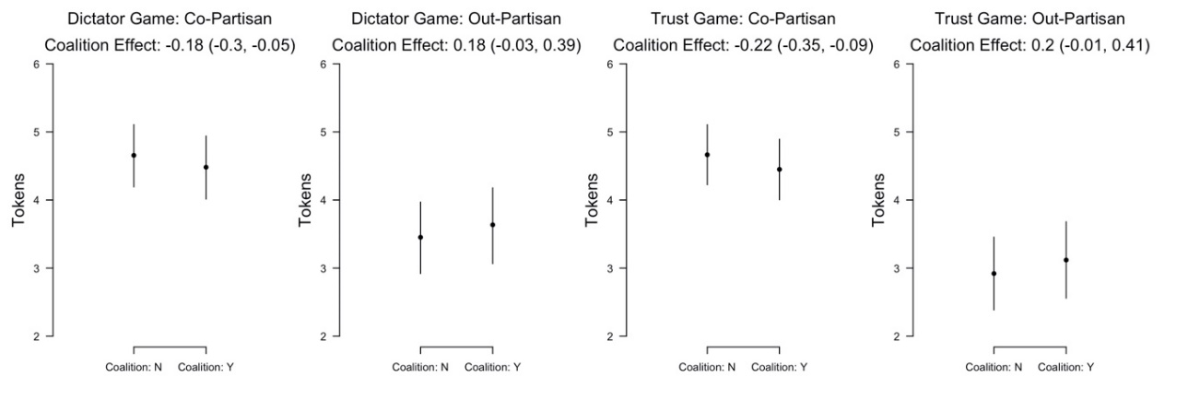
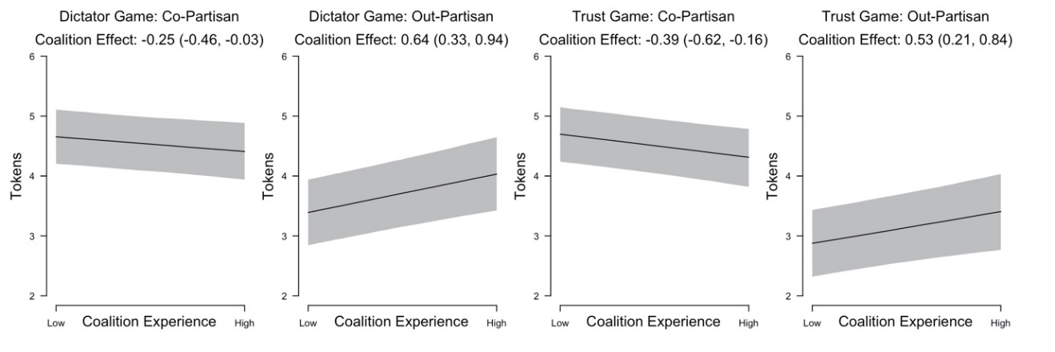
Notes: Visualization of coalition partnership (upper row) and coalition experience (bottom row) effects. showing predicted allocation of tokens together with their 95% confidence intervals. Predictions for a fixed profile (30 year old, female, middle class, no religion, 1st round), with respondent- and country-characteristics held at median values. Predictions based on Table F.2, Columns (1) – (4) (upper row) and Columns (5) – (8) (lower row).

F.3 Alternative Measure of Country-Level Polarization

We employ an alternative measure for country-level polarization in the party system, the measure proposed by Maoz and Somer-Topcu (2010). Our main findings with regards to the effect of Coalition Partnership and Coalition Experience remain unchanged (Table F.3 and Figure F.3).

TABLE F.3: Current Coalition Partnership (Results of HLMs)
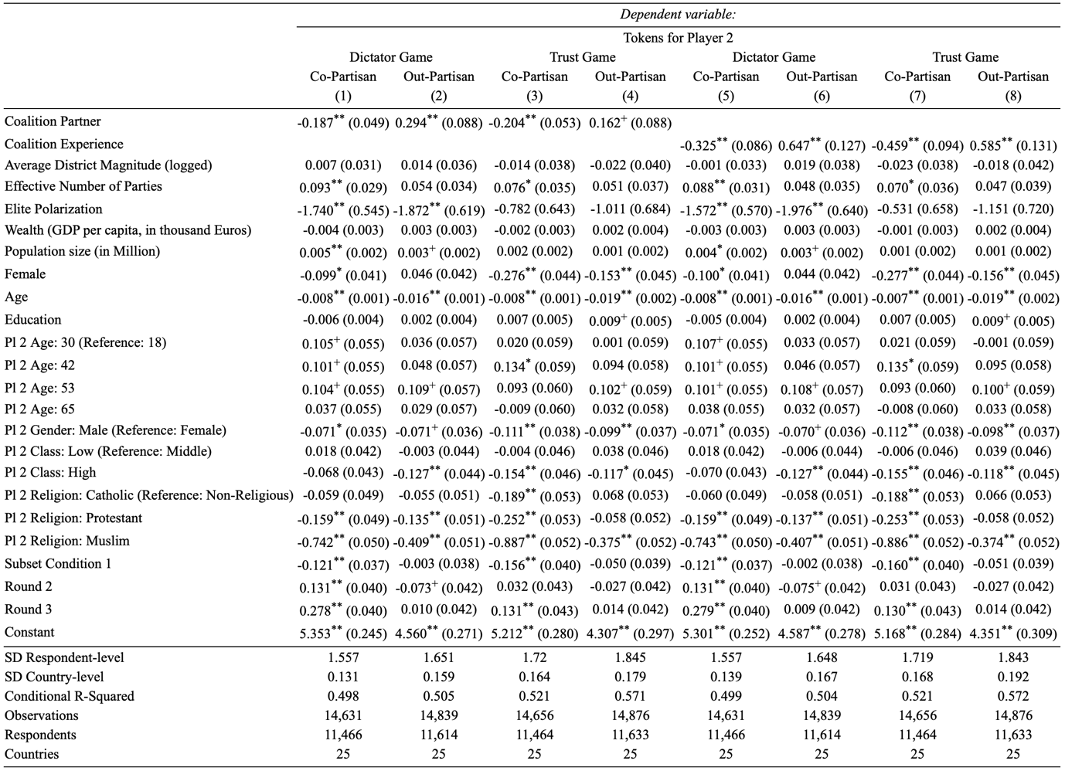
Notes: SD indicates the estimate of the standard deviation of the random intercept. ⁺ p < 0.1, * p < 0.05, ** p < 0.01

FIGURE F.3: Effect of Coalition Partnership on In-Group Favoritism and Out-Group Derogation
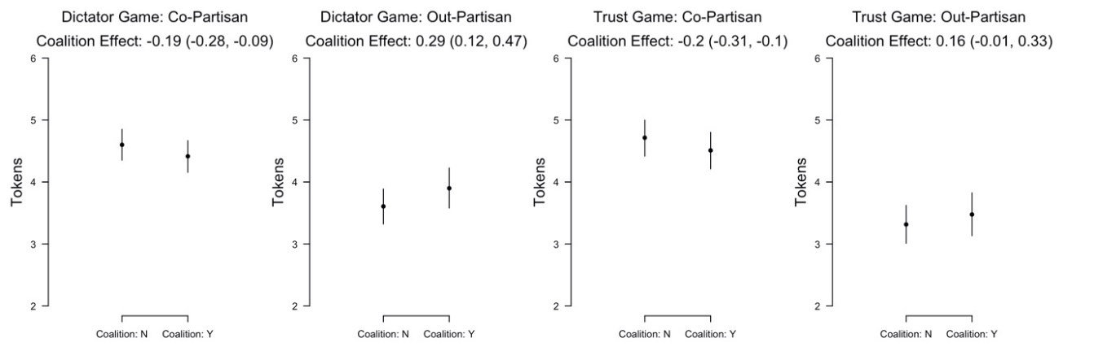
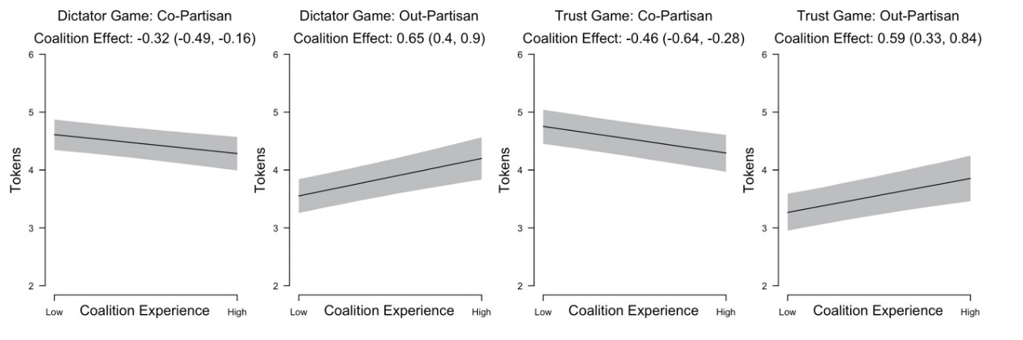
Notes: Visualization of coalition partnership (upper row) and coalition experience (bottom row) effects. showing predicted allocation of tokens together with their 95% confidence intervals. Predictions for a fixed (30 year old, female, middle class, no religion, 1st round), with respondent- and country-characteristics held at median values. Predictions based on Table F.3, Columns (1) – (4) (upper row) and Columns (5) – (8) (lower row).

F.4 The Role of Economic Inequality

Furthermore, we control for a measure of economic inequality as a potential cause of affective polarization, using data from the World Bank. Again, our main findings with regards to the effect of Coalition Partnership and Coalition Experience remain unchanged (Table F.4 and Figure F.4).

TABLE F.4: Current Coalition Partnership and Coalition Experience since 2000 (Results of HLMs)
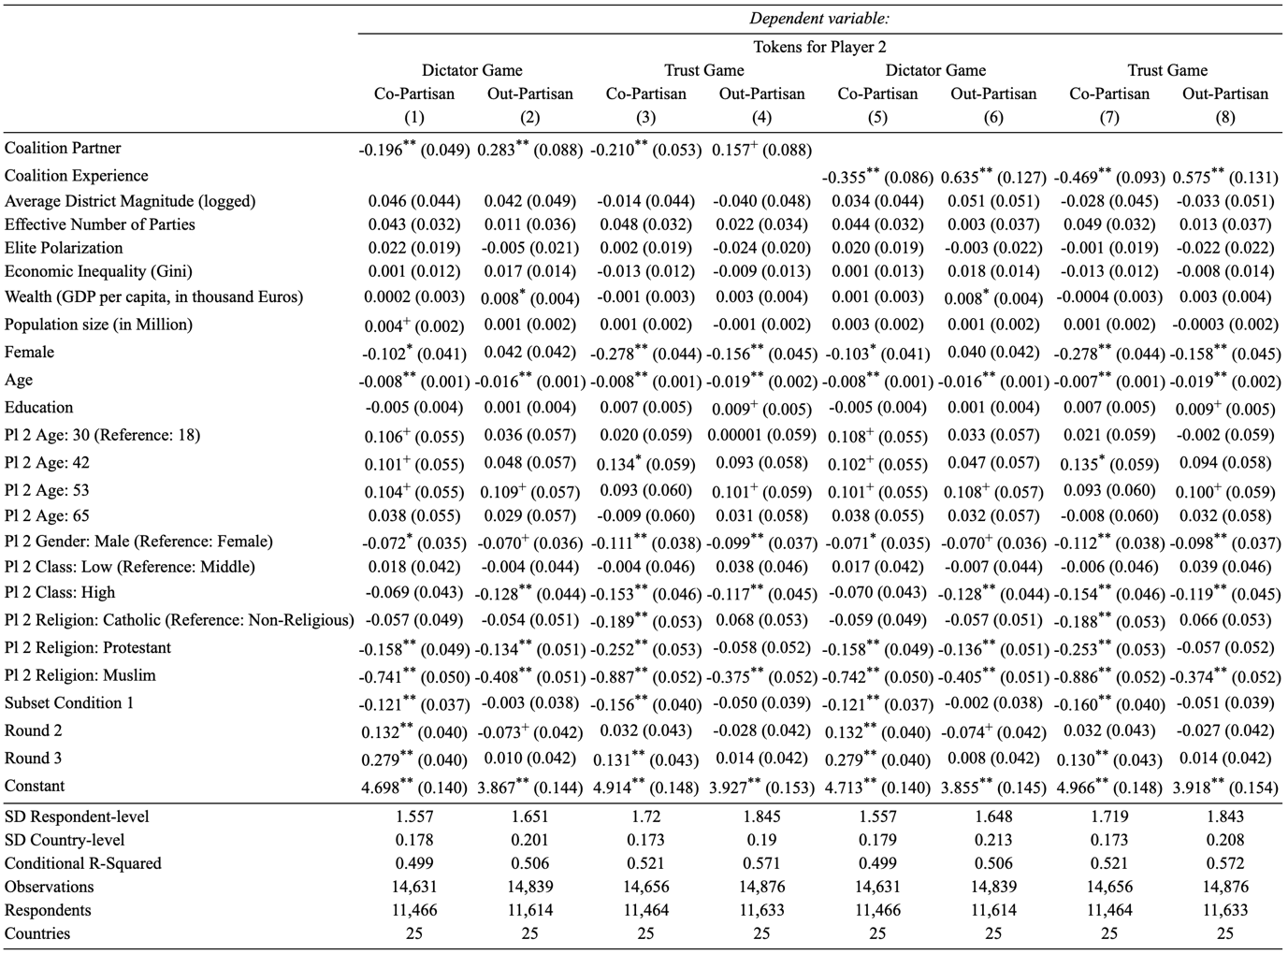
Notes: SD indicates the estimate of the standard deviation of the random intercept. ⁺ p < 0.1, * p < 0.05, ** p < 0.01

FIGURE F.4: Effect of Coalition Partnership on In-Group Favoritism and Out-Group Derogation
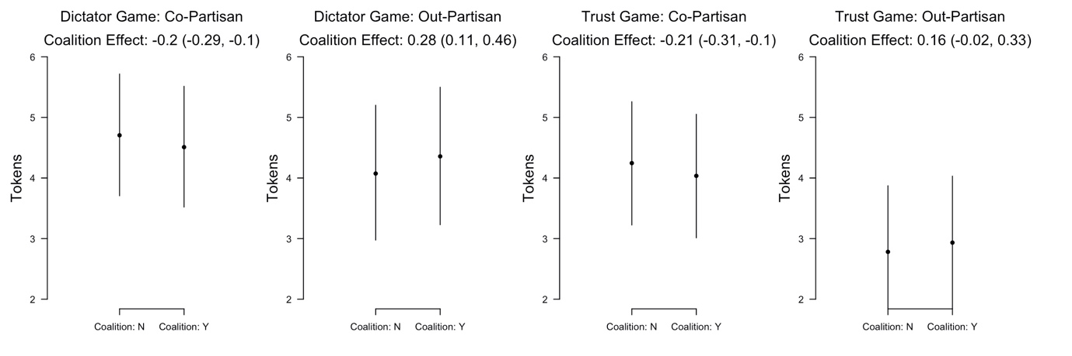
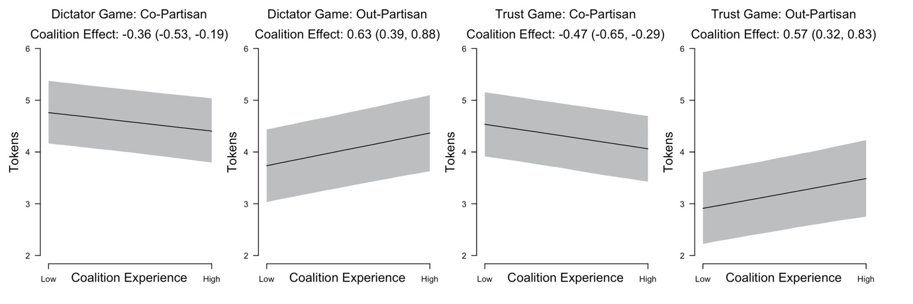
Notes: Visualization of coalition partnership (upper row) and coalition experience (bottom row) effects. showing predicted allocation of tokens together with their 95% confidence intervals. Predictions for a fixed (30 year old, female, middle class, no religion, 1st round), with respondent- and country-characteristics held at median values. Predictions based on Table F.4, Columns (1) – (4) (upper row) and Columns (5) – (8) (lower row).

F.5 The Role of Immigration

Furthermore, we control for the inflow of immigration, using country-level statistics from Eurostat for the year 2018, the year before our survey was fielded. The findings are consistent with our main analysis (Table F.5). Current Coalition Partnership reduces in-group favoritism and out-group derogation in both dictator and trust games (Columns (1) through (4)). Coalition experience since 2000 has similar effects (Columns (5) through (8)).

TABLE F.5: Current Coalition Partnership and Coalition Experience since 2000 (Results of HLMs)
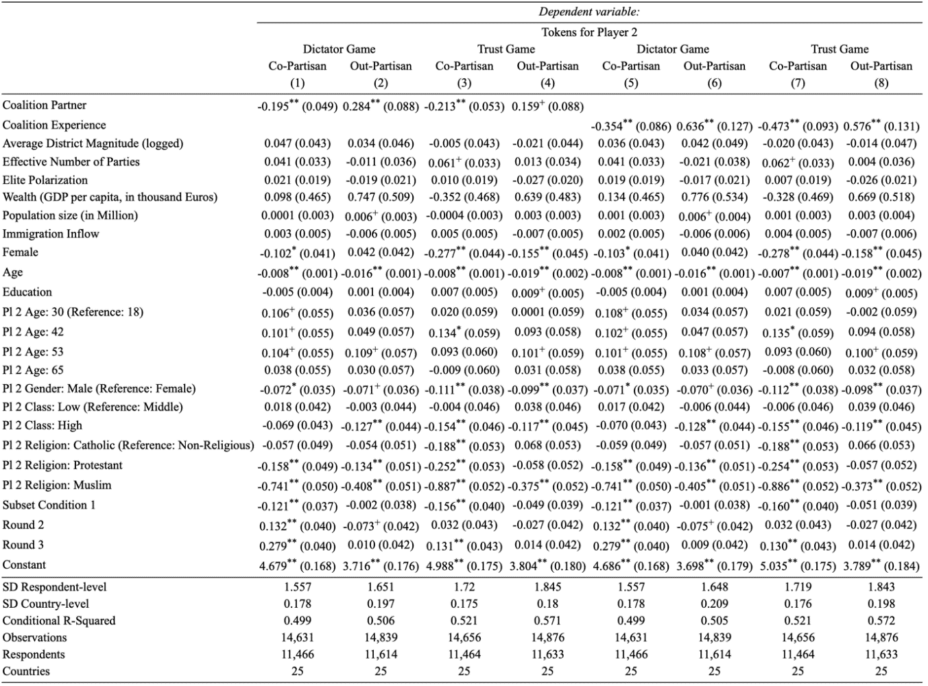
Notes: SD indicates the estimate of the standard deviation of the random intercept. ⁺ p < 0.1, * p < 0.05, ** p < 0.01

FIGURE F.5: Effect of Coalition Partnership on In-Group Favoritism and Out-Group Derogation
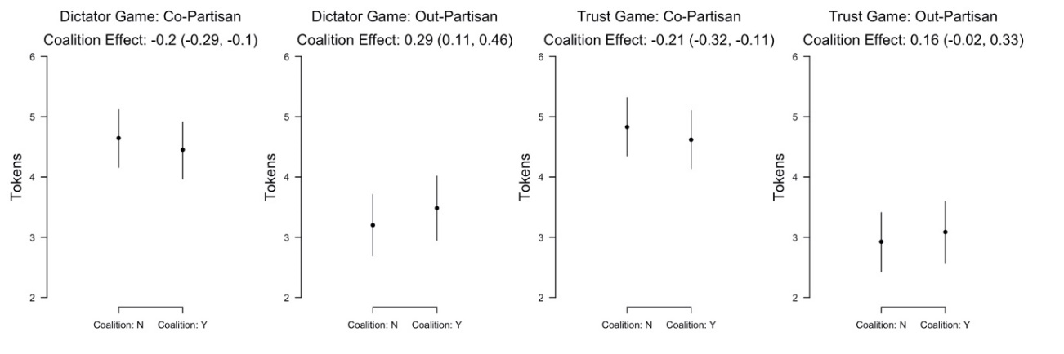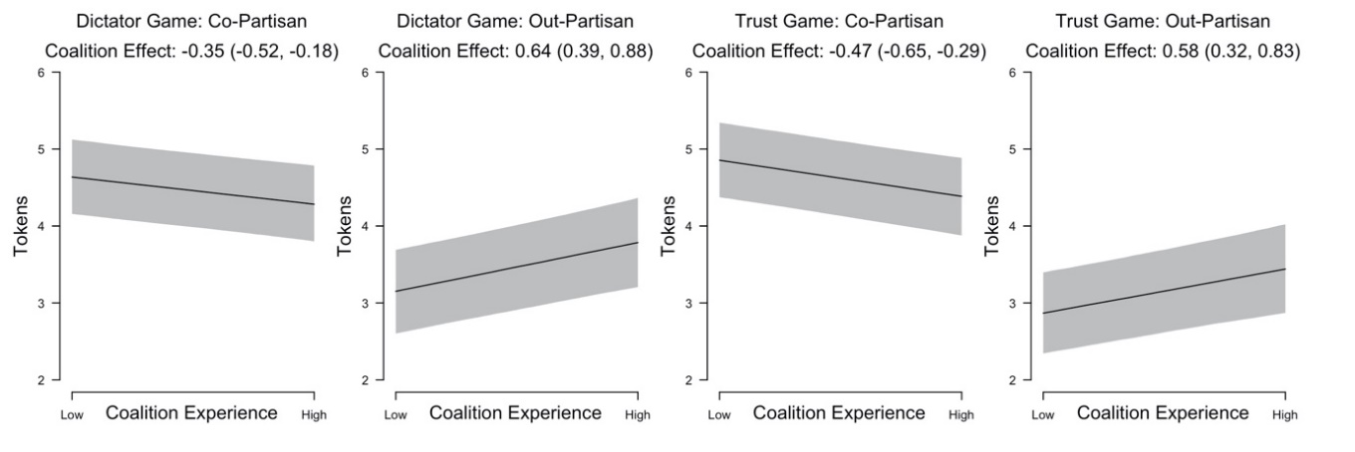
Notes: Visualization of coalition partnership (upper row) and coalition experience (bottom row) effects. showing predicted allocation of tokens together with their 95% confidence intervals. Predictions for a fixed profile (30 year old, female, middle class, no religion, 1st round), with respondent- and country-characteristics held at median values. Predictions based on Table F.5, Columns (1) – (4) (upper row) and Columns (5) – (8) (lower row).

G Survey Questions

Party Identification: Do you consider yourself to be close to any particular political party? If so, which party do you feel close to?
- [Party names], Other (fill the blank)
- No, I do not feel close to any political party

Left-right self-placement: In politics, people often talk about “left” and “right.” When you use this scale from 1 to 11, where would you locate yourself, where 1 means “left” and 11 means “right?”
- Left (1), (2), (3), …, Right (11)
- Don’t know

Left-right party placement: And where would you place the following parties on this scale? Which number from 1 to 11, where '1' means "left" and '11' means "right" best describes each of the following parties?
- Left (1), (2), (3), …, Right (11)
- Don’t know the party
- Don’t know where to place the party

Gender: Please indicate your gender.
- Male
- Female
- Other

Age: How old are you?
[List to select age from]

Nationality: What is your nationality?
[Answer options include choice among European nationalities plus an open answer box for “Other countries”]

Religion: Do you consider yourself to be…?
- Catholic (1), Orthodox (2), Protestant (3), Other Christian (4), Jewish (5), Muslim (6), Sikh (7), Buddhist (8), Hindu (9), Atheist (10), Non believer or Agnostic (11), Other (12)
- Don't know

Class: Do you see yourself and your household belonging to...?
- The working class of society (1), The lower middle class of society (2), The middle class of society (3), The upper middle class of society (4), The higher class of society (5)
- Don't know

References

Dalton, Russell J. 2008. “The quantity and the quality of party systems: Party system polarization, its measurement, and its consequences.” Comparative Political Studies 41(7): 899-920.
Maoz, Zeev, and Zeynep Somer-Topcu. 2010. “Political polarization and cabinet stability in multiparty systems: A social networks analysis of European parliaments, 1945–98.” British Journal of Political Science 40(4): 805-833.
Mason, Lilliana. 2015. “‘I disrespectfully agree’”: The differential effects of partisan sorting on social and issue polarization." American Journal of Political Science 59(1): 128-145.
Volkens, Andrea, Tobias Burst, Werner Krause, Pola Lehmann, Theres Matthieß, Sven Regel, Bernhard Weßels, Lisa Zehnter. 2021: The Manifesto Data Collection. Manifesto Project (MRG/CMP/MARPOR). Version 2021a. Berlin: Wissenschaftszentrum Berlin für Sozialforschung (WZB). https://doi.org/10.25522/manifesto.mpds.2021a.

