PRESIDENTIAL INVESTMENT IN THE ADMINISTRATIVE STATE
Supplemental Appendices

Table of Contents
- Nominations Data

- Models of Time to Nomination

- Survey on the Future of Government Service (2020)

  - Survey Basics
  - Discussion of Survey Non-response and Model Estimation

- Tobit Models of Survey Data

- Alternate Specifications: Survey Data

- Further Robustness Checks: Partisan Asymmetry and Endogeneity

- Appendix References

Appendix A: Nominations Data
The nominations data come from a U.S. Government publication called Policy and Supporting Positions (i.e., the Plum Book), a regular Congressional Research Service publication called Presidential Appointee Positions Requiring Senate Confirmation and Committees Handling Nominations, and the congressional website congress.gov. The United States House of Representatives and the Senate have alternated publishing the Plum Book every election year since 1960. The Plum Book lists all of the key policy positions in the executive establishment, both those filled by political appointees and those filled by career professionals. It also includes key staff positions of a policy or confidential nature that support these key policy-making positions. From this document, we extracted all positions requiring nomination by the president and confirmation by the Senate (i.e., PAS positions). We focus specifically on Plum Book data from 2000, 2008, 2016, and 2020. We supplement the Plum Book with the other sources because it omits some Senate-confirmed positions. In total, about 18% of all PAS positions are omitted from the Plum Book after the positions described below are removed.
Starting from the master list derived from the three sources, we removed several classes of positions from the data. These include judicial positions on the Superior Court of the District of Columbia, positions in agencies managed by Congress or the Judicial Branch, positions in the Plum Book listed as requiring Senate confirmation that no longer require Senate confirmation, duplicates, and positions included in the Plum Book that no longer existed by Inauguration Day. We also excluded positions that are filled automatically when persons receive another Senate-confirmed position. For example, the Secretary of the Treasury assumes a role on the Financial Stability Oversight Council automatically upon confirmation as Secretary of the Treasury.
To connect executive nominations to specific positions, we used data from congress.gov during the four years of the president’s term. Specifically, we downloaded all formal nominations to civilian positions from the two congresses seated during this period. This means we collected all nominations from January 20th until January 20th four years later. We matched nominations to the list of vacant positions, noting that a nomination had been made and the number of days since Inauguration Day. For each position, we include only the first nomination to a position.

Appendix B. Alternative Models of Time to Nomination
Table B1. Models of Days to Nomination: Bush, Obama, Trump, and Biden Administrations (Complete Models from Table 2)
 | Dependent Variable
 | Hazard Rate of Nomination
 | (1) |  | (2) |  | (3) |  | (4)
 | B | SE | B | SE | B | SE | B | SE
Hypothesized Relationships
Policy Position (0,1) | 0.63 | 0.14* | 0.46 | 0.14* | 0.42 | 0.18* | 0.35 | 0.17*
Management Position (0,1) | -0.25 | 0.12* | -0.43 | 0.11* | -0.39 | 0.19* | -0.52 | 0.19*
Priority (0,1) | 0.26 | 0.12* | 0.06 | 0.11 | 0.24 | 0.23 | 0.28 | 0.26
Agency Ideology (0.00,3.87) | -0.05 | 0.03 | -0.08 | 0.02* | -0.10 | 0.07 | 0.12 | 0.06*
Priority*Agency Ideology | -0.04 | 0.06 | -0.01 | 0.04 | -0.04 | 0.09 | -0.03 | 0.10
Agency Skills (-1.99,1.82) |  |  |  |  | -0.05 | 0.09 | -0.23 | 0.09*
Agency Level Controls
EOP (0,1) | -0.43 | 0.08* |  |  | -0.78 | 0.19*
Commission (0,1) | -0.52 | 0.11* |  |  | -0.60 | 0.24*
Agency Giving Grants (0,1) | -0.07 | 0.13 | -0.26 | 0.10* | -0.25 | 0.09⁺ | -0.29 | 0.13*
Position Level Controls
Pay Level (0-5) | 0.30 | 0.03* | 0.33 | 0.03* | 0.40 | 0.07* | 0.50 | 0.08*
Part Time (0,1) | -0.55 | 0.25* | -0.59 | 0.20* | -0.19 | 0.38 | -0.47 | 0.42
Ambassador (0,1) | 0.03 | 0.08 | 0.38 | 0.08* | 0.40 | 0.38 | 0.41 | 0.26
Inspector General (0,1) | -1.56 | 0.19* | -1.65 | 0.19* | -1.52 | 0.28* | -1.51 | 0.29*
US Attorney (0,1) | 0.10 | 0.09 | 0.24 | 0.04* | 0.53 | 0.23* | 1.03 | 0.20*
US Marshall (0,1) | -0.55 | 0.09* | -0.54 | 0.04* | -1.73 | 0.25* | -1.39 | 0.22*
Administration Controls
Bush (0,1) | 0.51 | 0.18* | 0.55 | 0.19*
Obama (0,1) | 0.21 | 0.13 | 0.19 | 0.15
Trump (0,1) | -0.16 | 0.13 | -0.20 | 0.14 | -0.25 | 0.13* | -0.35 | 0.14*
Estimator | Cox |  | Cox |  | Cox |  | Cox
Department Level Stratified | No |  | Yes |  | No |  | No
Committee Stratified | No |  | Yes |  | Yes |  | Yes
N | 3,871 |  | 3,871 |  | 1,759 |  | 1,759
R² | 0.27 |  | 0.19 |  | 0.27 |  | 0.23
Note: *significant at the 0.05 level; +significant at the 0.10 level in two-tailed tests. All estimates use type HC0 standard errors clustered at the department level.

Table B2. Estimated Days to First Nomination: Bush, Obama, Trump, and Biden Administrations
 | Dependent Variable
 | Days to First Nomination
 | (1) |  | (2) |  | (3) |  | (4)
 | B | SE | B | SE | B | SE | B | SE
Hypothesized Relationships
Policy Position (0,1) | -146.77 | 24.86* | -141.92 | 26.10* | -114.76 | 35.58* | -148.84 | 37.65*
Management Position (0,1) | 63.26 | 33.29⁺ | 59.78 | 36.36 | 75.80 | 46.20 | 52.95 | 46.92
Priority (0,1) | -34.75 | 38.31 | -56.94 | 38.02 | -46.05 | 50.42 | -76.70 | 47.71
Agency Ideology (0.00,3.87) | 29.81 | 8.74* | 26.38 | 8.48* | 38.55 | 12.49* | 35.01 | 12.30*
Priority*Agency Ideology | -1.75 | 16.61 | 5.59 | 15.84 | -5.02 | 19.86 | -6.42 | 18.92
Agency Skills (-1.99,1.82) |  |  |  |  | 9.42 | 23.71 | 15.68 | 24.62
Agency Level Controls
EOP (0,1) | 101.86 | 49.81* |  |  | 183.25 | 82.53*
Commission (0,1) | 198.99 | 32.81* |  |  | 249.42 | 56.63*
Agency Giving Grants (0,1) | -22.80 | 20.99 | 9.14 | 23.71 | 29.43 | 31.38 | 37.47 | 32.96
Position Level Controls
Pay Level (0-5) | -74.97 | 8.16* | -76.42 | 8.39* | -92.17 | 13.93* | -103.33 | 14.26*
Part Time (0,1) | 323.67 | 44.62* | 387.76 | 42.84* | 256.03 | 80.66* | 384.74 | 81.92*
Ambassador (0,1) | 0.47 | 27.42 | -113.08 | 38,91* | -150.98 | 53.50* | -103.86 | 55.79*
Inspector General (0,1) | 639.94 | 66.37* | 669.03 | 65.75* | 572.94 | 88.73* | 551.47 | 86.96*
US Attorney (0,1) | -39.28 | 30.43 | -65.24 | 43.77 | -169.52 | 79.54* | -266.33 | 80.46*
US Marshall (0,1) | 252.84 | 32.93* | 225.39 | 45.49* | 448.07 | 94.29* | 348.24 | 95.63*
Administration Controls
Bush (0,1) | -89.00 | 18.15* | -91.76 | 18.35*
Obama (0,1) | 5.58 | 17.42 | 6.30 | 17.19
Trump (0,1) | 161.48 | 19.45* | 165.63 | 19.25* | 153.33 | 22.26* | 158.93 | 21.99*
Constant | 407.55 | 32.61* | 596.79 | 219.29* | 438.08 | 81.65* | 194.61 | 98.85*
Estimator | Tobit |  | Tobit |  | Tobit |  | Tobit
Position-Type Controls | Yes |  | Yes |  | Yes |  | Yes
Department Fixed Effects | No |  | Yes |  | No |  | No
Committee Fixed Effects | No |  | Yes |  | Yes |  | Yes
N | 3871 |  | 3871 |  | 1759 |  | 1759
Pseudo R² | 0.13 |  | 0.14 |  | 0.64 |  | 0.64
Note: *significant at the 0.05 level; +significant at the 0.10 level in two-tailed tests. All estimates use type HC1 standard errors clustered at the department level. Position-type controls include indicators for ambassadors, U.S. marshals, and U.S. attorneys. Goodness-of-fit for tobit models reported as McFadden's Pseudo-R2 (McFadden 1974).

Appendix C. Survey on the Future of Government Service, 2020
Survey Basics
Sampling Procedure: The goal of the procedure was to secure a sample that was a census of Presidential Appointees with Senate Confirmation (PAS), presidential appointees without Senate confirmation (PA; excluding the immediate White House), Schedule C appointees (SC), members of the Senior Executive Service (both career and non-career; CA, NA), and members of the Senior Foreign Service (SFS). Senior federal employees included in the survey who do not hold a position listed above were identified by title. Specifically, the sample includes a census of employees whose titles are variants of Administrator, Commissioner, Secretary (e.g., Under Secretary, Deputy Secretary, Assistant Secretary), Chief or General Counsel, Chief of Staff, Chief Officers (e.g. Chief Executive Officer, Chief Financial Officer), Controller, President, Director (e.g., Deputy Director). The agencies included in the sample comprise the 15 executive departments, 7 agencies in the Executive Office of the President, and 68 independent agencies.
Heterogeneity in title usage across agencies makes it difficult to identify a set of titles that reliably identifies senior employees in every agency. Moreover, variants of Chief, Manager, and Supervisor are common among senior employees in subagencies, meaning that the titles used to construct the census sample may not produce a large enough sample to yield a sufficient number of responses to make reliable subagency-level inferences. Therefore, for EOP agencies, subagencies, and independent agencies that had at least 100 employees in the sample frame (i.e., enough potential respondents to yield a reliable agency-level estimate give our expected response rate), survey principals executed the following sampling procedure:

For each agency with at least 100 people in the sample frame and the titles Administrator, Director, Chief, Manager, and Supervisor (in that order),
- Calculate the number of additional respondents needed to reach a sample size of 100 for the agency
- Select people in the sample frame not already selected by the census procedures
- From step b, identify all individual whose title includes “Administrator”
- If adding all individuals from step c would cause the sample size to exceed 100, take a simple random sample from the set of individuals such that the sample size for that agency will be 100 and proceed to the next agency
- Otherwise, add all individuals from step c to the sample and repeat step c for the next title
- If all titles have been searched and the sample size remains below 100, proceed to the next agency
In total, this procedure yielded a sample of 23,824 individuals of whom 2,984 were not part of the census sample. Names and addresses were submitted to a vendor for mail service processing. There were 22,819 records (out of 23,824) that had a mailing address or building location in the directory. About 96% of these addresses were found to be valid delivery points in the USPS delivery sequence file. Through additional editing and research, nearly all of the remaining 4% were validated. The file was also inspected for duplicate names and email addresses. Because the survey is administered online, we then eliminated individuals with no email address resulting in a final sample of 17,792 individuals.
Survey Execution: The Princeton Survey Research Center (PSRC) fielded the 15-20 minute survey in the summer and fall of 2020 (June 12, 2020 to December 31, 2020). In 2020, most federal executives were working from home because of the 2020 global pandemic. This made letters and postcards infeasible since most respondents would not receive their work mail at home. The pandemic also made telephone calls difficult since most executives were working from home rather than the office. PSRC still tried to reach executives through calls to work numbers. Most of the 2020 survey involved electronic communications.
Response and Participation Rates: The participation rate was 11% (1,779 full or partial completes out of 16,232). Out of 1,779 respondents, there were 125 appointees (7%; 125/1,605) and 1,654 career professionals (11%; 1,654/14,627). These rates are comparable to most public opinion surveys (Marken 2018; response rates for Gallup telephone surveys average around 7 percent).
Confidentiality and Replication: The sensitive nature of the data limits the public release of replication files for the survey analyses. The combination of variables, such as workplace, pay level, and ideology, makes it possible to identify specific individuals who took or did not take the survey. Therefore, standard principles of human subject research limit the disclosure of this data.
Survey Weights: All analysis includes survey weights to ensure that the answers provided by the sample of respondents are reliable and mirror those of the target population. The results reported are weighted to reduce non-response and noncoverage bias. We created post-stratification weights using iterative proportional fitting, more commonly called raking. The sample drawn from the Federal Government database was used to create population marginals because the sample is primarily a census sample, meaning the sample is our best estimate of the population.
The characteristics used for weighting are:
- Whether a respondent worked in the DC area (defined as the District of Columbia, Maryland, and Virginia).
- Position type defined as political appointee (i.e., Presidential Appointments with Senate Confirmation, Presidential Appointments without Senate Confirmation, Schedule C Appointments, Non-Career Senior Executive Service positions), career member of the Senior Executive Service, member of the Senior Foreign Service, and career civil servant.
- Workplace location in the executive branch defined as the Executive Office of the President, each executive department (separately), and independent agencies (as a whole).
The composite design effect for a sample of size n with each case having weight w_{i} is:
$$deff=\frac{n\sum_{i=1}^{n}{w_{i}^{2}}}{(\sum_{i=1}^{n}{w_{i})^{2}}}$$
(1)
We set $\hat{p}=0.5$ and calculated the weighted margin of error as:
$$±(\sqrt{deff}×1.96\sqrt{\frac{\hat{p}(1-\hat{p})}{n}}$$
(2)
The Impact of Non-response on Models Using 2020 SFGS Survey Data
An increasing difficulty in public opinion surveys is declining response rates. In the waves of the Survey on the Future of Government Service, the participation rate declined from 33 percent in 2007 to 24 percent in 2014. This is not a problem for inference (i.e., bias in estimates) if the sample that responds to the survey is representative of the population we are trying to sample. In most surveys, however, the sample differs in important ways from the population.
The most common way of dealing with survey non-response bias is to weigh survey responses to adjust for differences between the sample and population. That is what we have done here (see description above). All analysis includes survey weights to ensure that the answers provided by the sample of respondents are reliable and mirror those of the target population. The results reported are weighted to reduce non-response and noncoverage bias.
Non-response Correlated with Dependent Variable: There are two key problems that could emerge in survey non-response if non-response is correlated with values of the dependent variable. First, it is possible that federal executives that are afraid of retribution from the Trump Administration are less likely to respond to the survey. If this is the case, we have to ascertain how the federal executives that trust the Trump Administration differ from those that do not. It is likely that the “trusters” are more likely to be supportive of the Trump Administration than the “non-trusters.” If this is the case, the president’s supporters could be overrepresented in the sample relative to the population. If so, the sample is more likely to report that the White House is investing in agencies (our dependent variable). In the figures below we illustrate how this kind of sample-selection bias would lead us to underestimate the true effect of agency priority, ideology, and workforce skill on presidential investment. The figure imagines a bivariate relationship between perceptions of White House support and the key independent variables. There is a sample regression line fitted between the points (solid line). The dotted horizontal line imagines what dots we could observe if the respondents least likely to report White House investment (i.e., those that do not trust the administration) were cut out of the sample. The flatter line is the new regression line drawn with the remaining data that we can observe. So, a sample that omits those fearful of the Trump Administration’s retribution would lead us to underestimate the effects of our key independent variables.
Figure C1: Hypothetical Correlation of Perceptions of White House Support and Priority if “Non-Trusters” Do Not Respond
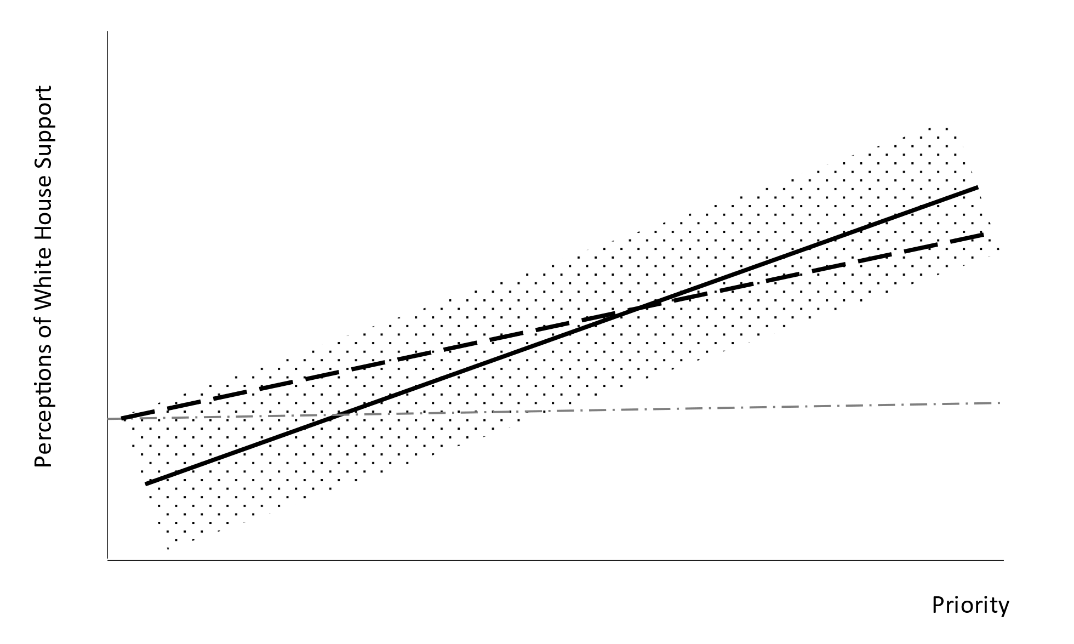
Figure C2: Hypothetical Correlation of Perceptions of White House Support and Ideological Alignment if “Non-Trusters” Do Not Respond
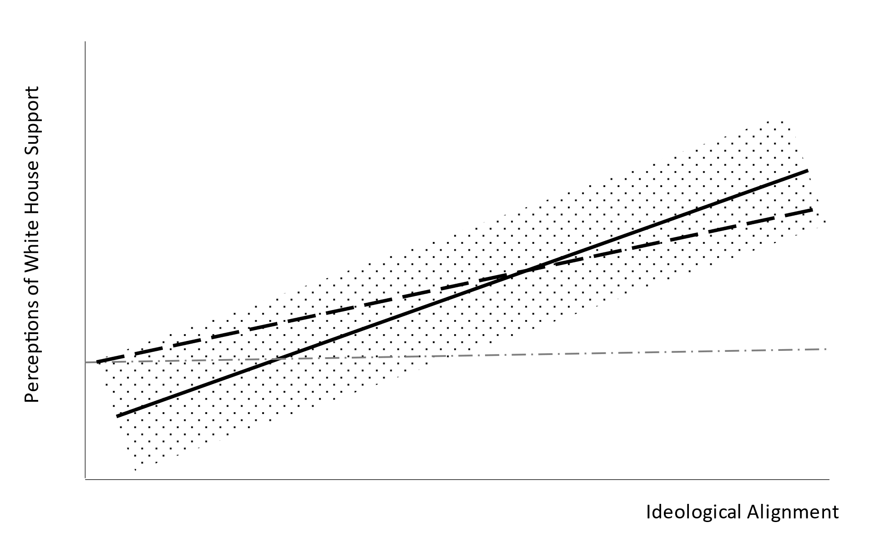
Figure C3: Hypothetical Correlation of Perceptions of White House Support and Workforce Skill if “Non-Trusters” Do Not Respond
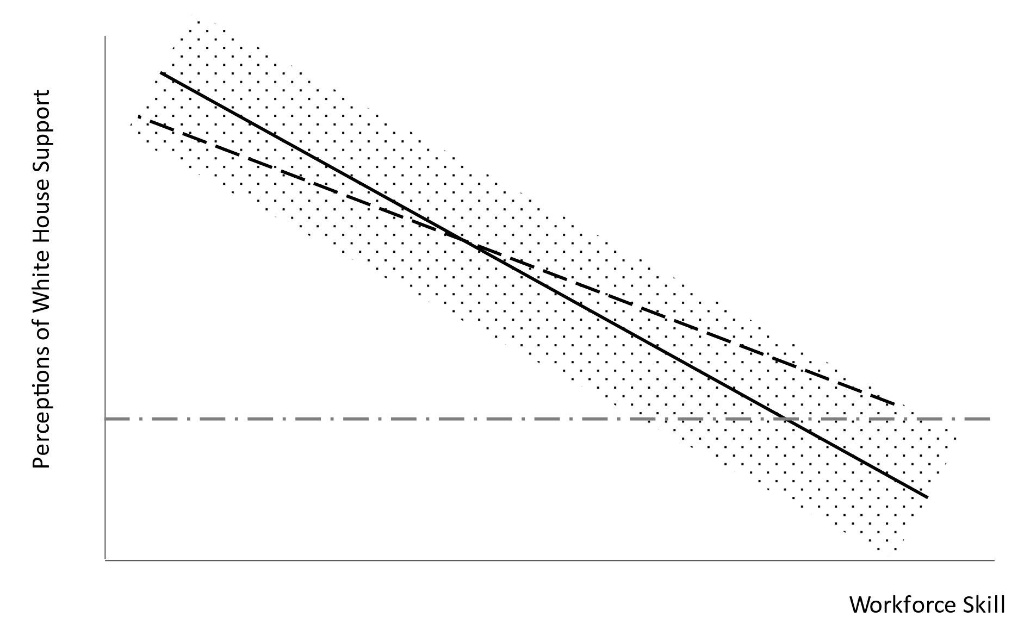
Second, it is possible that those respondents supportive of the president are less likely to respond. Perhaps supporters of the president are less trusting of surveys or elites. In this context, the sample of respondents would differ from the true population in that those most likely to believe the White House is supportive are removed from the sample. The figure below illustrates what the key relationships would look like if we systematically omit Trump supporters from the sample. The figure includes hypothetical values of the independent variables on the X-axis and the dependent variable on the Y-axis. The rectangle reflects data points and the solid line reflects the regression line that fits the data. If we cut off the top part of the distribution (i.e., those most likely to report support from the White House), this, again, leads us to underestimate the relationship between the key independent variables and presidential support. So, some aspects of sample selection would make it more difficult for us to find a relationship.
Figure C4: Hypothetical Correlation of Perceptions of White House Support and Priority if “Non-Trusters” Respond
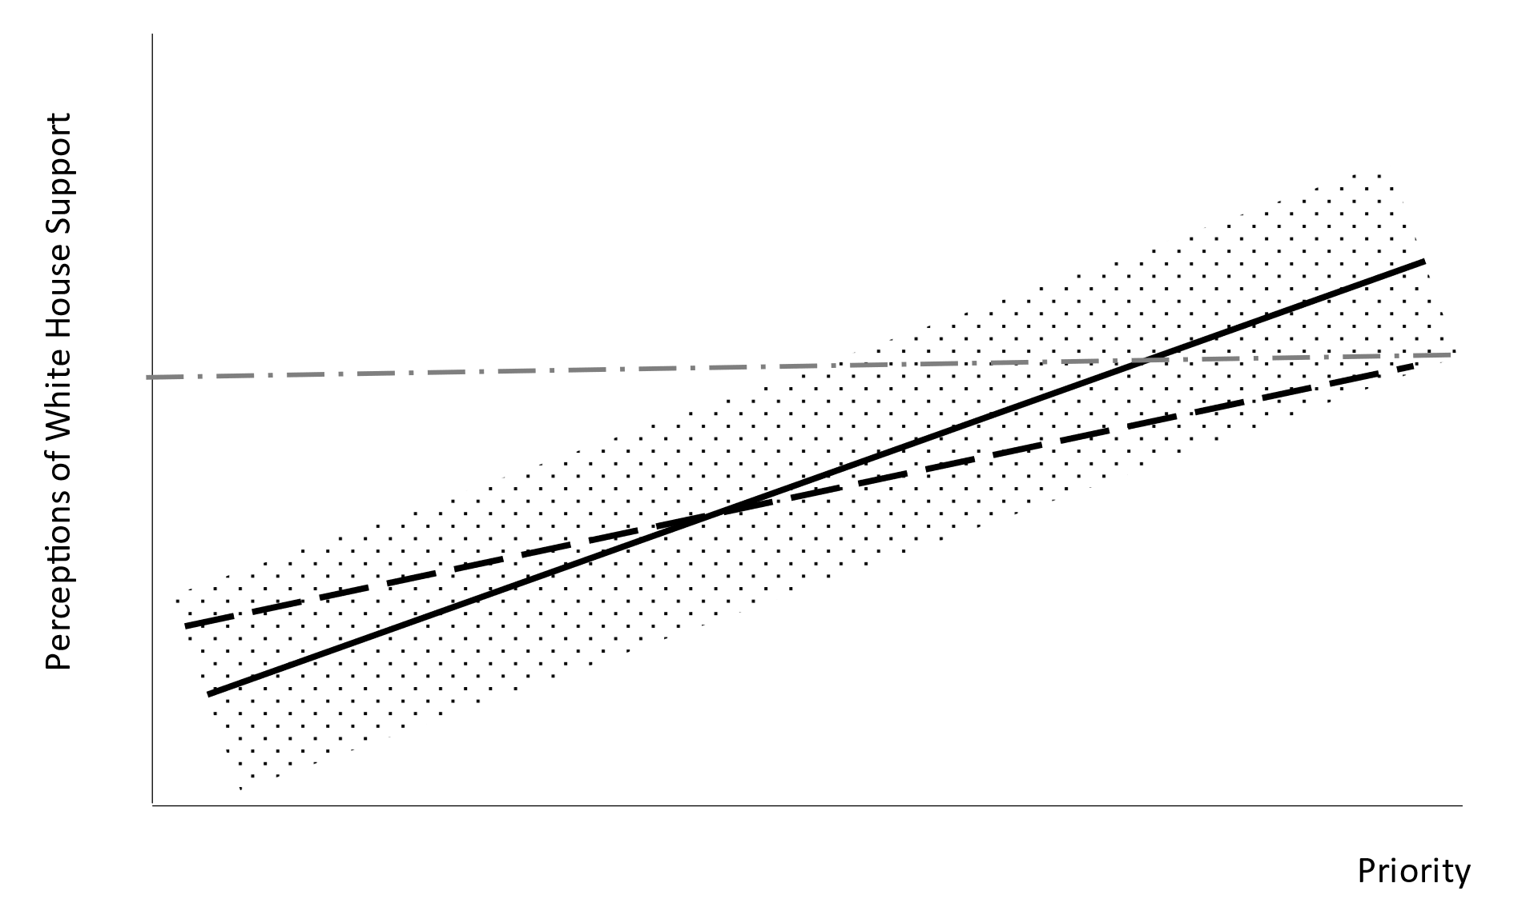
Correlated with Independent Variables: A More Serious Potential Problem: Whether sample selection is a more serious problem for inference depends upon whether this difference between the sample and the population (i.e., Trump support overrepresented) is correlated with key variables of interest (e.g., agency priority, ideology, workforce skill). For example, it is possible that respondents working in agencies on the president’s agenda are more likely to respond than respondents working in agencies off the president’s agenda. In the figure below we illustrate how this could be a problem and lead us to overestimate the effect of a key independent variable and presidential support. We again include hypothetical values of the independent variables on the X-axis and the dependent variable on the Y-axis. The rectangle reflects data points and the solid line reflects the regression line that fits the data. This time, we add a vertical line that divides the extent to which respondents from an agency off the agenda respond. As the new regression line (dotted) drawn on the remaining observable data shows, this could lead us to overestimate the effect of priority on the amount of presidential support.

Figure C5: Hypothetical Correlation of Perceptions of White House Support and Priority if Sampling Correlates with Independent Variables
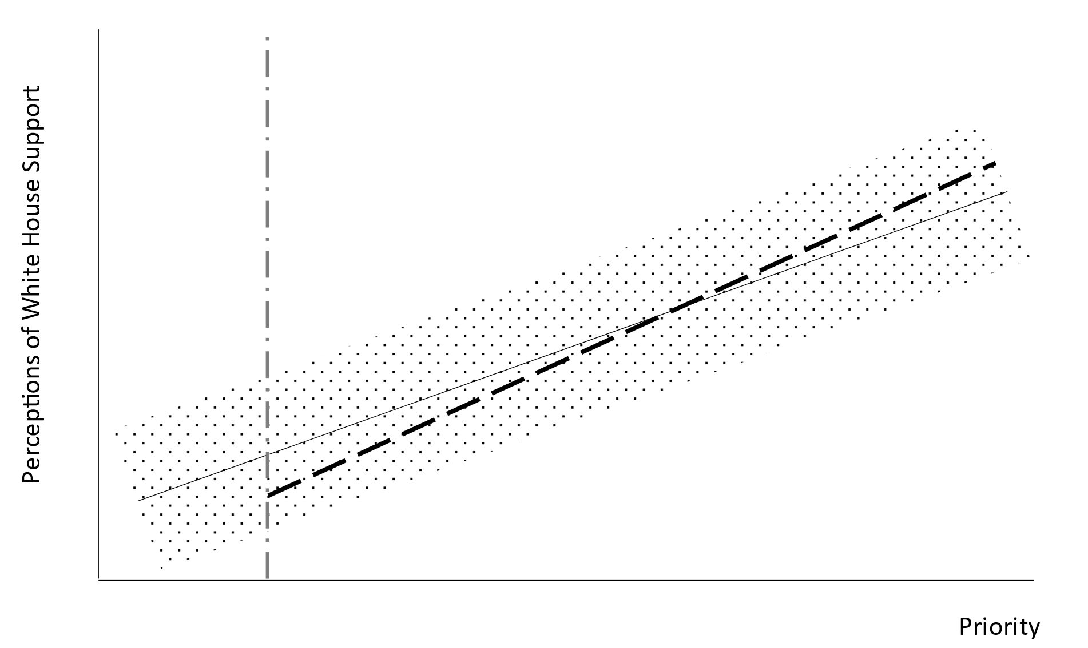
At this stage, some concerns for non-response cut in different directions. Some differences between the sample and population will lead us to underestimate key relationships and others will lead us to overestimate those same relationships. We now turn to evaluating patterns of response and the adequacy of our weighting strategy.
A Potential Solution? Our Sample and Weights: We focus on the problem of overestimating key relationships. We do this, first, by evaluating whether response rates differ across agencies when we divide agencies based on values of the key independent variables. We find that federal executives working in priority agencies were 3.4 percentage points more likely to respond to the survey. We found that executives in agencies with skills 1 standard deviation above the mean were 1.4 percentage points more likely to respond to the survey. We also found that federal executives in agencies 1 standard deviation more conservative were 0.09 percentage points less likely to respond to the survey. So, there are some differences between the sample and the population related to key independent variables. This could lead us to estimate biased coefficients that appear to support our claims.
These different agency characteristics—presidential priority, ideology, and workforce skill—are agency-level characteristics. In generating our sample weights we adjusted for response rates in the EOP (1), each cabinet department (15), and independent agencies (1), in addition to appointment type (e.g., political appointee, senior executive service, etc.), and location in Washington, DC. This means that survey respondents were given weights based on where they work, and by doing so, the weights partly adjust the sample for priority, ideology, and workforce skill and make the sample more representative of the population. If we have a sample that is adjusted to reflect priority/non-priority agencies, liberal/moderate/conservative agencies, and high/low workforce skill agencies in proportion to the population, this mitigates the non-response bias. To confirm that weights correct for the correlation between response rate and the independent variables, we regressed survey weights on the key independent variables. The results suggest that respondents in priority agencies and high-skill agencies are down-weighted and respondents in conservative agencies are upweighted. So, the survey weights help adjust for differences between the sample and population.
Table C1. Model of Sample Weights on Key Independent Variables Explaining Presidential Support for Agency Capacity
 | Dependent Variable
 | Sample Weight
 | (1)
 | B | SE
Presidential Priority (0,1) | -0.17 | 0.15
Agency Ideology (L-C) | 0.37 | 0.08*
Agency Skills (Low to High) | -0.21 | 0.09*
Constant | 9.34 | 0.08*
Estimator | OLS
Unit of Analysis | Individual
N | 1,536
F-Test (3 df) | 9.53*
Note: *significant at the 0.05 level; +significant at the 0.10 level in two-tailed tests.

Appendix D. Tobit Models of Survey Data

Table D1. Tobit Models of Federal Executive Responses to Question, “How much effort do the following groups [White House] spend to ensure that [your agency] has what it needs to carry out its mission?”, 2020
 | Dependent Variable
 | Individual-Level Response
 | (1) |  | (2)
 | B | SE | B | SE
Hypothesized Relationships
Presidential Priority (0,1) | 0.08 | 0.17 | 0.24 | 0.12⁺
Agency Ideology (L-C) | 0.31 | 0.10* | 0.47 | 0.11*
Presidential Priority*Agency Ideology | 0.20 | 0.15 | 0.28 | 0.13*
Agency Skills (Low to High) | 0.03 | 0.08 | 0.07 | 0.08
Agency Level Controls
Executive Office of the President (0,1) | 0.46 | 0.25⁺ | 0.53 | 0.33
Executive Department
Office of the Secretary (0,1) | -0.21 | 0.22 | -0.42 | 0.30
Distinct Bureau (0,1) | -0.51 | 0.16* | -0.79 | 0.18*
Independent Commission (0,1) | -0.42 | 0.26 | -0.43 | 0.31
Agency Giving Grants (0,1) | 0.33 | 0.15* | 0.30 | 0.15⁺
Individual Level Controls
Appointee (0,1) | 0.86 | 0.23* | 0.87 | 0.22*
Party ID (D, I, R) | 0.38 | 0.07* | 0.35 | 0.07*
Scope of Responsibility (0 to 7) | 0.05 | 0.03⁺ | 0.05 | 0.03⁺
Years of Government Experience | 0.01 | 0.01 | 0.01 | 0.01
Constant | 0.99 | 0.20* | 1.05 | 0.24*
Estimator | Tobit |  | Tobit
Unit of Analysis | Individual |  | Individual
Department Level Fixed Effects | No |  | Yes
Sampling Weights | Yes |  | Yes
Wald Test for Interaction (1 df) | 1.94 |  | 4.72*
N | 866 |  | 866
Number of Groups | 143 |  | 143
F-Test (13, 28 df) | 7.92* |  | 12.31*
Note: *significant at the 0.05 level; +significant at the 0.10 level in two-tailed tests. Response categories: None (0), Little (1), Some (2), A good bit (3), A great deal (4). All models estimated with robust fixed effects adjusted for clustering on agency. Source: 2020 Survey on the Future of Government Service.

Appendix E. Alternative Specifications: Survey Data

Table E1. Model of Federal Executive Responses to Question, “How much effort do the following groups [White House] spend to ensure that [your agency] has what it needs to carry out its mission?”, 2020 (Complete Model (2) from Table 3)

 | Dependent Variable
 | Individual-Level Response
 | (1)
 | B | SE
Hypothesized Relationships
Presidential Priority (0,1) | 0.38 | 0.20⁺
Agency Ideology (L-C) | 0.70 | 0.17*
Presidential Priority*Agency Ideology | 0.38 | 0.20⁺
Agency Skills (Low to High) | 0.13 | 0.14
Agency Level Controls
Executive Office of the President (0,1) | 0.86 | 0.51⁺
Office of the Secretary (0,1) | -0.64 | 0.49
Distinct Bureau (0,1) | -1.21 | 0.28*
Independent Commission (0,1) | -0.71 | 0.50
Agency Giving Grants (0,1) | 0.39 | 0.25
Individual Level Controls
Appointee (0,1) | 1.44 | 0.36*
Party ID (D, I, R) | 0.58 | 0.11*
Scope of Responsibility (0 to 7) | 0.09 | 0.05⁺
Years of Government Experience | 0.01 | 0.01
Department Fixed Effects
USDA | 0.59 | 0.50
COM | 0.38 | 0.43
DOD | -1.03 | 0.71
DOE | 0.91 | 0.43*
DOED | -0.06 | 0.69
HHS | 0.86 | 0.44*
DHS | 0.21 | 0.52
HUD | 0.07 | 0.39
DOJ | -0.58 | 0.43
DOL | 0.54 | 0.49
STAT | 0.09 | 0.47
INT | 0.02 | 0.47
TREAS | -1.19 | 0.42*
DOT | -0.02 | 0.44
VA | 1.35 | 0.49*
Cut Points
Cutpoint 1 | -1.16 | 0.38*
Cutpoint 2 | 0.82 | 0.39*
Cutpoint 3 | 2.34 | 0.42*
Cutpoint 4 | 3.48 | 0.41*
Estimator | Logit
Unit of Analysis | Individual
Department Level Fixed Effects | Yes
Sampling Weights | Yes
Wald Test for Interaction (1 df) | 3.52⁺
N | 866
Number of Groups | 143
Wald Test, F-Test (13, 28, 14 df) | 245.12*
Note: *significant at the 0.05 level; +significant at the 0.10 level in two-tailed tests. Dependent variable is individual responses to question: "How much effort do the following groups [White House] spend to ensure that [your agency] has what it needs to carry out its mission?" Response categories: None (0), Little (1), Some (2), A good bit (3), A great deal (4). All models estimated with robust fixed effects adjusted for clustering on agency. Source: 2020 Survey on the Future of Government Service.

Table E2. Alternate Models: Careerists only, Executive Agencies only, Hierarchical
 | Dependent Variable
 | Individual-Level Response
 | Careerist  Responses |  | Executive Agency Responses |  | Hierarchical Model
 | B | SE | B | SE | B | SE
Hypothesized Relationships
Presidential Priority (0,1) | 0.34 | 0.21 | 0.41 | 0.20* | 0.48 | 0.17*
Agency Ideology (L-C) | 0.70 | 0.17* | 0.84 | 0.18* | 0.48 | 0.16*
Presidential Priority*Agency Ideology | 0.44 | 0.19* | 0.33 | 0.21 | 0.54 | 0.20*
Agency Skills (Low to High) | 0.17 | 0.14 | 0.25 | 0.13⁺ | 0.04 | 0.13
Agency Level Controls
Executive Office of the President (0,1) | 0.47 | 0.62 | 0.73 | 0.49
Executive Department
Office of the Secretary (0,1) | -0.22 | 0.50 | -0.63 | 0.49 | -0.32 | 0.26
Distinct Bureau (0,1) | -1.08 | 0.29* | -1.24 | 0.27* | -0.46 | 0.20*
Independent Commission (0,1) | -0.72 | 0.49 |  |  | -0.05 | 0.43
Agency Giving Grants (0,1) | 0.34 | 0.26 | 0.41 | 0.23⁺ | 0.53 | 0.15*
Individual Level Controls
Appointee (0,1) |  |  | 1.52 | 0.36* | 0.99 | 0.36*
Party ID (D, I, R) | 0.51 | 0.11* | 0.58 | 0.12* | 0.28 | 0.13*
Scope of Responsibility (0 to 7) | 0.09 | 0.05⁺ | 0.10 | 0.05* | 0.05 | 0.06
Years of Government Experience | 0.02 | 0.01⁺ | 0.01 | 0.01 | 0.01 | 0.01
Constant |  |  |  |  | 1.03 | 0.42*
Estimator | Logit |  | Logit |  | Logit
Unit of Analysis | Individual |  | Individual |  | Individual
Department Level Fixed Effects | Yes |  | Yes |  | No
Random Intercepts for Department | No |  | No |  | Yes
Sampling Weights | Yes |  | Yes |  | No
Wald Test for Interaction (1 df) | 5.28* |  | 2.57 |  | 7.60*
N | 821 |  | 801 |  | 905
Number of Groups | 143 |  | 125 |  | 48
Wald Test (13, 28, 13 df) | 216.53* |  | 240.37* |  | 76.97*
Note: *significant at the 0.05 level; +significant at the 0.10 level in two-tailed tests. Dependent variable is individual responses to question: "How much effort do the following groups [White House] spend to ensure that [your agency] has what it needs to carry out its mission?" Response categories: None (0), Little (1), Some (2), A good bit (3), A great deal (4). All models estimated with robust fixed effects adjusted for clustering on agency. Cutpoint estimates omitted. The ICC for hierarchical model is 0.00. Source: 2020 Survey on the Future of Government Service.
Appendix F. Further Robustness Checks: Partisan Asymmetry and Endogeneity

Evaluating Whether Republican Presidents Treat Rulemaking Agencies Differently than Democratic Presidents

One question that emerges when investigating presidential investment in the administrative state is whether there is a partisan asymmetry in capacity building, namely that Republican or conservative presidents benefit when the administrative state has less capacity. This implies that Republican presidents have greater incentives to neglect capacity building. One way of evaluating this possibility is to look at differences across the four presidents to see whether Republican presidents are slower to nominate persons. There is no consistent pattern in nominations, but this could be because the pace of nominations and confirmations has been decreasing over time due to factors unrelated to capacity building.
A second way of evaluating whether there is an asymmetry between Republican presidents and Democratic presidents is to see how they treat rulemaking agencies, the agencies scholars most associate with the expanding administrative state. For both the nominations data and the survey data we collected information on which agencies had promulgated major rules in the year before the new president was inaugurated. This data comes from the Unified Agenda. We classify a rule as a “major rule” if it is covered by 5 U.S.C. § 801. These rules have an estimated annual effect on the economy of $100 million or more and, therefore, are representative of agencies that engage in largescale, economically-impactful regulation. We then reestimated models to see both whether the main conclusions of the paper changed and whether Republican and Democratic presidents treated major rulemaking agencies differently.
We thought carefully about how to code whether an agency produced major rules. We wanted to make sure the variable was pre-treatment. We also wanted to make sure it was not influenced by extreme values due to idiosyncratic legislative enactments (e.g., HHS after Obamacare or CFPB after Dodd-Frank). In some models, we include an indicator for whether an agency produced a major rule in the year before the president took office. In other models, we included counts of the major rules promulgated in the year prior to the president’s inauguration.
Nominations Data: Bush, Obama, Trump, and Biden Administration: In Tables F1 and F2 we include estimates of models controlling for agencies engaged in promulgating major rules, either via an indicator variable (Table F1) or a count of the number of major rules promulgated (Table F2). We also include an interaction term to account for the fact that the coefficient estimate on rulemaking agencies may vary by the partisanship of the administration. As the models indicate, the coefficient estimate on the main effect for rulemaking agencies is positive, suggesting that presidents nominate persons to manage these agencies more quickly than other agencies. The interaction terms for the presidents suggest that the size of the rulemaking coefficient is slightly smaller for Obama and larger for Trump. Substantively, this means that, if anything, Trump was quicker to put nominees into rulemaking agencies, even controlling for his priorities and the ideology of agencies. In total, there is very little evidence in these data to suggest that Republicans are slower overall to send nominees to the Senate as a way of hurting the administrative state. The results in Tables F1 and F2 are broadly consistent with those in the main text.

Table F1. Cox Models of Days to Nomination, 2000-2022 w/Controls for Major Rulemaking Agencies (Indicator for Agencies Promulgating Major Rules)
 | Dependent Variable
 | Hazard Rate of Nomination
 | (1) |  | (2) |  | (3) |  | (4)
 | B | SE | B | SE | B | SE | B | SE
Hypothesized Relationships
Policy Position (0,1) | 0.58 | 0.17* | 0.46 | 0.18* | 0.38 | 0.19* | 0.31 | 0.18⁺
Management Position (0,1) | -0.35 | 0.18* | -0.49 | 0.16* | -0.42 | 0.18* | -0.53 | 0.19*
Priority (0,1) | 0.35 | 0.16* | 0.22 | 0.17 | 0.22 | 0.24 | 0.29 | 0.26
Agency Ideology (0.00,3.87) | -0.04 | 0.04 | -0.07 | 0.03* | -0.11 | 0.07* | -0.13 | 0.06*
Priority*Agency Ideology | -0.07 | 0.06 | -0.01 | 0.05 | -0.04 | 0.09 | -0.03 | 0.10
Agency Skills (-1.99,1.82) |  |  |  |  | -0.04 | 0.09 | -0.22 | 0.10*
Agency Level Controls
EOP (0,1) | -0.32 | 0.09* |  |  | -0.68 | 0.20*
Commission (0,1) | -0.47 | 0.13* |  |  | -0.59 | 0.24*
Agency Giving Grants (0,1) | -0.16 | 0.14 | -0.34 | 0.11* | -0.23 | 0.15 | -0.26 | 0.14⁺
Rulemaking Agency (0,1) | 0.50 | 0.25* | 0.15 | 0.20 | 0.36 | 0.24 | 0.24 | 0.24
Obama*Rulemaking Agency | -0.41 | 0.36 | -0.26 | 0.35
Trump*Rulemaking Agency | -0.29 | 0.26 | -0.06 | 0.26 | -0.09 | 0.27 | 0.11 | 0.27
Position Level Controls
Pay Level (0-5) | 0.40 | 0.06* | 0.47 | 0.06* | 0.41 | 0.07* | 0.50 | 0.08*
Part Time (0,1) | -0.27 | 0.29 | -0.18 | 0.26 | -0.18 | 0.39 | -0.49 | 0.43
Ambassador (0,1) | 0.29 | 0.13* | 0.62 | 0.23* | 0.41 | 0.39 | 0.40 | 0.25
Inspector General (0,1) | -1.58 | 0.24* | -1.60 | 0.24* | -1.55 | 0.28* | -1.54 | 0.29*
US Attorney (0,1) | 0.39 | 0.15 | 0.81 | 0.14* | 0.55 | 0.23* | 1.02 | 0.19*
US Marshall (0,1) | -0.42 | 0.15* | -0.13 | 0.14* | -1.71 | 0.25* | -1.41 | 0.22*
Administration Controls
Obama (0,1) | 0.25 | 0.15⁺ | 0.20 | 0.16
Trump (0,1) | -0.14 | 0.17 | -0.19 | 0.17 | -0.26 | 0.14* | -0.39 | 0.16*
Estimator | Cox |  | Cox |  | Cox |  | Cox
Department Level Stratified | No |  | Yes |  | No |  | Yes
Committee Stratified | No |  | Yes |  | Yes |  | Yes
N | 2,936 |  | 2,936 |  | 1,759 |  | 1,759
R² | 0.28 |  | 0.20 |  | 0.27 |  | 0.23
Note: *significant at the 0.05 level; +significant at the 0.10 level in two-tailed tests. All estimates use type HC0 standard errors clustered at the department level.

Table F2. Cox Models of Days to Nomination, 2000-2022 w/Controls for Major Rulemaking Agencies (Count of Major Rules)
 | Dependent Variable
 | Hazard Rate of Nomination
 | (1) |  | (2) |  | (3) |  | (4)
 | B | SE | B | SE | B | SE | B | SE
Hypothesized Relationships
Policy Position (0,1) | 0.60 | 0.17* | 0.47 | 0.18* | 0.40 | 0.19* | 0.33 | 0.18⁺
Management Position (0,1) | -0.35 | 0.18⁺ | -0.49 | 0.16* | -0.41 | 0.19* | -0.52 | 0.19*
Priority (0,1) | 0.37 | 0.16* | 0.22 | 0.17 | 0.24 | 0.24 | 0.28 | 0.26
Agency Ideology (0.00,3.87) | -0.05 | 0.04 | -0.08 | 0.03* | -0.13 | 0.07⁺ | -0.14 | 0.06*
Priority*Agency Ideology | -0.07 | 0.06 | -0.01 | 0.05 | -0.03 | 0.09 | -0.02 | 0.10
Agency Skills (-1.99,1.82) |  |  |  |  | -0.04 | 0.08 | -0.23 | 0.09*
Agency Level Controls
EOP (0,1) | -0.35 | 0.09* |  |  | -0.71 | 0.19*
Commission (0,1) | -0.47 | 0.14* |  |  | -0.57 | 0.26*
Agency Giving Grants (0,1) | -0.16 | 0.14 | -0.33 | 0.11* | -0.24 | 0.15⁺ | -0.27 | 0.12*
Rulemaking Count | -0.02 | 0.09 | -0.02 | 0.09 | -0.05 | 0.09 | -0.03 | 0.10
Obama*Rulemaking Count | 0.12 | 0.30 | -0.04 | 0.30
Trump*Rulemaking Count | 0.10 | 0.10 | 0.06 | 0.11 | 0.17 | 0.10⁺ | 0.13 | 0.10
Position Level Controls
Pay Level (0-5) | 0.39 | 0.06* | 0.47 | 0.06* | 0.41 | 0.07* | 0.50 | 0.08*
Part Time (0,1) | -0.27 | 0.30 | -0.17 | 0.26 | -0.17 | 0.40 | -0.47 | 0.43
Ambassador (0,1) | 0.26 | 0.14⁺ | 0.62 | 0.24* | 0.40 | 0.38 | 0.41 | 0.26
Inspector General (0,1) | -1.57 | 0.24* | -1.60 | 0.24* | -1.54 | 0.28* | -1.52 | 0.29*
US Attorney (0,1) | 0.36 | 0.15* | 0.81 | 0.14* | 0.56 | 0.23* | 1.04 | 0.20*
US Marshall (0,1) | -0.45 | 0.15* | -0.13 | 0.14 | -1.73 | 0.24* | -1.42 | 0.22*
Administration Controls
Obama (0,1) | 0.20 | 0.14 | 0.18 | 0.16
Trump (0,1) | -0.20 | 0.16 | -0.22 | 0.17 | -0.31 | 0.14* | -0.41 | 0.15*
Estimator | Cox |  | Cox |  | Cox |  | Cox
Department Level Stratified | No |  | Yes |  | No |  | Yes
Committee Stratified | No |  | Yes |  | Yes |  | Yes
N | 2,936 |  | 2,936 |  | 1,759 |  | 1,759
R² | 0.29 |  | 0.20 |  | 0.27 |  | 0.23
Note: *significant at the 0.05 level; +significant at the 0.10 level in two-tailed tests. All estimates use type HC0 standard errors clustered at the department level.

2020 Survey on the Future of Government Service: We conducted a similar analysis for the models using the survey data. The model estimates are included in Table F3 and do not include interactions since the data is only for one administration (i.e., the Trump Administration). In models estimated with indicators for whether an agency promulgated a major rule, the coefficients are close to 0 and imprecise. In models that include counts of the number of major rules, the coefficients are positive, indicating that respondents in rulemaking agencies report more investment by President Trump. These agencies include agencies such as the Centers for Medicare and Medicaid Services, Department of Veterans Affairs, Internal Revenue Service, and Office of Postsecondary Education (DOED). So, there is very little evidence in these models that Republicans invest less in rulemaking agencies, those arguably at the heart of the administrative state.

Table F3. Ordered Logit Models of Federal Executive Responses to Question, “How much effort do the following groups
[White House] spend to ensure that [your agency] has what it needs to carry out its mission?”, 2020. Models with Controls for
Major Rulemaking Agencies
 | Dependent Variable
 | Individual-Level Response
 | (1) |  | (2) |  | (3) |  | (4)
 | B | SE | B | SE | B | SE | B | SE
Hypothesized Relationships
Presidential Priority (0,1) | 0.16 | 0.25 | 0.38 | 0.21⁺ | 0.12 | 0.25 | 0.34 | 0.20⁺
Agency Ideology (L-C) | 0.46 | 0.15* | 0.70 | 0.17* | 0.49 | 0.15* | 0.68 | 0.17*
Priority*Agency Ideology | 0.26 | 0.22 | 0.37 | 0.21⁺ | 0.31 | 0.23 | 0.45 | 0.21*
Agency Skills (Low to High) | 0.06 | 0.12 | 0.12 | 0.14 | 0.10 | 0.12 | 0.19 | 0.13
Agency Level Controls
EOP (0,1) | 0.64 | 0.34⁺ | 0.84 | 0.53 | 0.70 | 0.34* | 0.94 | 0.50⁺
Office of the Secretary (0,1) | -0.26 | 0.35 | -0.62 | 0.48 | -0.25 | 0.36 | -0.56 | 0.49
Distinct Bureau (0,1) | -0.71 | 0.25* | -1.20 | 0.29* | -0.74 | 0.25* | -1.21 | 0.28*
Commission (0,1) | -0.66 | 0.41 | -0.70 | 0.49 | -0.68 | 0.42 | -0.70 | 0.51
Agency Giving Grants (0,1) | 0.44 | 0.23⁺ | 0.39 | 0.25 | 0.40 | 0.22⁺ | 0.36 | 0.25
Rulemaking Agency (0,1) | -0.10 | 0.22 | -0.04 | 0.23
Rulemaking Count |  |  |  |  | 0.04 | 0.01* | 0.05 | 0.01*
Individual Level Controls
Appointee (0,1) | 1.34 | 0.35* | 1.43 | 0.35* | 1.39 | 0.35* | 1.46 | 0.36*
Party ID (D, I, R) | 0.59 | 0.11* | 0.58 | 0.11* | 0.59 | 0.11* | 0.59 | 0.11*
Scope of Responsibility (0 to 7) | 0.08 | 0.04⁺ | 0.09 | 0.05⁺ | 0.08 | 0.04⁺ | 0.09 | 0.05⁺
Years of Government Experience | 0.01 | 0.01 | 0.01 | 0.01 | 0.01 | 0.01 | 0.01 | 0.01
Estimator | Logit |  | Logit |  | Logit |  | Logit
Unit of Analysis | Individual |  | Individual |  | Individual |  | Individual
Department Level Fixed Effects | No |  | Yes |  | No |  | Yes
Sampling Weights | Yes |  | Yes |  | Yes |  | Yes
Wald Test for Interaction (1 df) | 1.39 |  | 3.00⁺ |  | 1.95 |  | 4.79*
N | 866 |  | 866 |  | 866 |  | 866
Number of Groups | 143 |  | 143 |  | 143 |  | 143
X²-Test (14, 29 df) | 92.05* |  | 246.24* |  | 115.68* |  | 301.18
Note: *significant at the 0.05 level; +significant at the 0.10 level in two-tailed tests. Response categories: None (0), Little (1), Some (2), A good bit (3), A great deal (4). Cutpoint estimates omitted. All models estimated with robust fixed effects adjusted for clustering on agency. Source: 2020 Survey on the Future of Government Service.

Endogeneity: Is Presidential Priority Endogenous?
We examined whether presidential priority is post-treatment since presidential priorities could be a function of the ideology of the agency or its capacity. To do this we first looked at correlations between the pre-treatment variables (agency ideology, workforce skill) and then conducted simple mediation analyses. The base correlations between the treatment variables (agency ideology, workforce skill) and the potential mediator (presidential priority agency) are close to 0 and, not surprisingly, the mediation analysis reflects this. In both the nominations analysis and the survey analysis the average causal mediation effect (ACME) is estimated to be only a tiny proportion of the total treatment effect.
Nominations Analysis: For the nominations analysis, the correlation between whether the position is within an agency that implements a presidential priority and agency ideology is -0.004. The correlation between whether the position is within an agency that implements a presidential priority and workforce skills is 0.01. It is unlikely that priority is a mediator for either agency ideology or workforce skill. Nevertheless, we conduct a simple mediation analysis to confirm this suspicion, estimating probits for the mediator function and linear regressions for the days to nomination (Imai et al. 2011). When we conduct a mediation analysis, the average causal mediation effect is estimated to be 0.05 out of 32.44 and -0.47 out of -4.18 of the total effect of the treatment, respectively, for agency ideology and workforce skills in fully specified models.

Table F4. Summary Statistics from Causal Mediation Analysis: 2000-2022 Nominations Data
Ideology | Estimate | 95% CI (Lower) | 95% CI (Upper)
ACME | 0.05 | -1.43 | 1.71
ADE | 32.39 | 13.36 | 52.44
Total E | 32.44 | 13.49 | 52.00
Prop. Mediated | 0.000 | -0.06 | 0.07
Workforce Skills
ACME | -0.47 | -12.36 | 8.83
ADE | -3.70 | -49.01 | 45.01
Total E | -4.18 | -49.53 | 45.35
Prop. Mediated | 0.02 | -1.92 | 1.71
N=3,928 and 1,812, respectively.
2020 Survey Analysis: In the survey analysis, the correlation between whether a respondent works in an agency that implements a presidential priority and agency ideology is 0.01. The correlation between whether a respondent works in an agency that implements a presidential priority and the estimated workforce skill of the agency is -0.01. So, it is unlikely that priority is a mediator for either agency ideology or workforce skill. This is confirmed by simple mediation analysis. When we conduct mediation analysis where the mediator is estimated with a probit and the dependent variable with linear regression, the average causal mediation effect is estimated to be 0.001 of the total effect of 0.345 and 0.004 out of a total effect of 0.017, respectively, for agency ideology and workforce skills in fully specified models.
Table F5. Summary Statistics from Causal Mediation Analysis: 2020 Survey Data
Ideology | Estimate | 95% CI (Lower) | 95% CI (Upper)
ACME | 0.001 | -0.006 | 0.009
ADE | 0.343 | 0.264 | 0.427
Total E | 0.345 | 0.428 | 0.429
Prop. Mediated | 0.004 | 0.003 | 0.005
Workforce Skills
ACME | 0.004 | -0.016 | 0.022
ADE | 0.013 | -0.079 | 0.110
Total E | 0.017 | -0.075 | 0.112
Prop. Mediated | 0.053 | -1.159 | 1.069
N=905.
Appendix G. Appendix References
Congressional Research Service. 2021. Presidential Appointee Positions Requiring Senate Confirmation and Committees Handling Nominations. CRS Report RL30959, December 28, 2021 https://sgp.fas.org/crs/misc/RL30959.pdf.
Davis, Christopher M., and Michael Greene. 2017. Presidential Appointee Positions Requiring Senate Confirmation and Committees Handling Nominations. CRS Report RL30959, May 3. https://fas.org/sgp/crs/misc/RL30959.pdf.
Hicks, Raymond, and Dustin Tingley. 2011. “Causal Mediation Analysis.” The Stata Journal :11(4): 605-19.
Hogue, Henry B. 2003. Presidential Appointee Positions Requiring Senate Confirmation and Committees Handling Nominations. CRS Report RL30959, October 27. https://www.everycrsreport.com/files/20031027_RL30959_dfd4157bf54c3547fc8a715c2b4854e44f75bf4f.pdf.
Hogue, Henry B., Maureen Bearden, and Terrence L. Lisbeth. 2008. Presidential Appointee Positions Requiring Senate Confirmation and Committees Handling Nominations. CRS Report RL30959, March 18. https://www.everycrsreport.com/files/ 20080318_RL30959_ e8d2689f3bc242b49ac39eaf01db4de564fba6a9.pdf.
Imai, Kosuke, Luke Keele, Dustin Tingley, and Teppei Yamamoto. 2011. “Unpacking the Black Box of Causality: Learning about Causal Mechanisms from Experimental and Observational Studies.” American Political Science Review 105(4):765-89.
Marken, Stephanie. 2018. “Still Listening: The State of Telephone Surveys,” Gallup Methodology Blog, January 11. https://news.gallup.com/opinion/methodology/225143/listening-state-telephone-surveys.aspx.
McFadden, Daniel 1974. “Conditional Logit Analysis of Qualitative Choice Behavior.” In P. Zarembka, ed. Frontiers in Econometrics, New York, NY: Academic Press: 104-42.
Richardson, Mark D. 2019. “Politicization and Expertise: Exit, Effort, and Investment.” Journal of Politics 81(3): 878–91.
Richardson, Mark D. N.d. “SFGS 2020 Methods: Sample Construction, Weighting, and Agency List,” Manuscript on file with author.
Tingley, Dustin, Teppei Yamamoto, Kentaro Hirose, Luke Keele, Kosuke Imai. 2014. “mediation: R package for Causal Mediation Analysis.” Journal of Statistical Software 59(5):1-38.

The CRS first published this report in 2003 and updated it regularly through 2021 (Hogue 2003, Hogue et al. 2008, Davis and Greene 2017, Congressional Research Service 2021). This document provides a useful supplement to the Plum Book since the Plum Book includes some errors and omits many minor boards and commissions.
When using official Senate data on nominations we found a few additional positions omitted from the Plum Book and CRS reports. Some of these positions were positions created after the publication of the Plum Book and the CRS report. Others were semi-discretionary positions in the State Department. Finally, neither document included the Marine Mammal Commission and each missed a few other positions. For a full discussion of the nominations for which no positions were listed in either the Plum Books or CRS reports see the nominations data appendix.
Congressional agencies include the Architect of the Capitol, the General Accounting Office, the General Accountability Office, the Government Printing Office, the Government Publishing Office, and the Library of Congress. The only Judicial Branch agency in the Plum Book is the U.S. Sentencing Commission.
Occasionally, Congress will remove the confirmation requirement for certain PAS positions. For example, Congress enacted the Presidential Appointment Efficiency and Streamlining Act in 2012. This law removed the confirmation requirement from more than 150 positions. Positions no longer requiring Senate confirmation in 2016 that were still listed as PAS in 2016 included the following positions: John F. Kennedy Center for the Performing Arts (36); National Museum and Library Services Board (14); National Council on Disability (5); Director, Selective Service System (1); Assistant Secretary for Administration, USDA (1); Assistant Secretary for Public Affairs, HUD (1); Assistant Secretary for Administration and Management, DOL (1); Assistant Secretary for Budget and Programs/CFO, DOT (1); Alternate Federal Co-Chairman, Appalachian Regional Commission (1); Administrator, United States Fire Administration, FEMA/DHS (1); Office of Navajo and Hopi Indian Relocation, Commissioner (1).
All of the Plum Books include some minor errors. For example, the 2016 Plum Book includes the following duplicates: Director, Institute of Museum and Library Services; Chief Financial Officer, Department of Labor; Inspector General, Small Business Administration; and Inspector General, Social Security Administration.
Since the Plum Book is published during the election year, some legislative changes occur after data has been collected.
For the Biden Administration, we collected data through July 8, 2022.
This section comes more or less directly from the document “SFGS 2020 Methods: Sample Construction, Weighting, and Agency List,” on file with the author. Mark D. Richardson wrote this document describing the 2020 survey methodology.
For further details see Richardson (2019).
We refer to the participation rate since many respondents started but did not complete the whole survey.
We use the mediation package in R (Tingley et al. 2014) to implement the mediation analysis described in Imai et al. (2011).

