Online Supplementary Material for “Greed, Envy, and Admiration: The Distinct Nature of Public Opinion about Redistribution from the Rich”

S1.0. Sample Characteristics and Recruitment 0
S1.1. Sample 1 0
S1.2. Sample 2 1
S1.3. Sample 3 1
S1.4. Sample 4 2
S2.0. Measurement details 2
S3.0. Correlation matrices 16
S4.0. Robustness tests 18
S.4.1. Testing if Hypothesis 1 is robust if standardized measures of effort and prosociality are used 18
S4.2. Testing if the results are robust when using alternative measures 20
S4.3. Testing if Hypothesis 1 is robust if control variables are included in the experiment 30

S1.0. Sample Characteristics and Recruitment
This research did not use deception or interfere with any political processes. It also did not involve any harm or discomfort to the respondents. Therefore, approval of an ethics committee was not required at the authors’ home institutions. All the surveys complied with the APSA Principles for Human Subjects Research. Respondents participated voluntarily, were informed about the nature of the study and they were made aware that their answers would be used in anonymized versions for research purposes.

S1.1. Sample 1
Sample 1 was collected December 2016 as an online web survey by the YouGov survey agency.
YouGov states that they: “incentivize panelists with points that can be redeemed for cash and gift cards. These rewards are deliberately pitched on the conservative side versus other players in the market to mitigate the risk of attracting professional survey takers” (YouGov, 2020). To draw a nationally representative sample, quota sampling was used to match population on gender, age (18–76), education and region. Among the sample, 48.8 percent were male and the average age was 46. Thirty-eight (38) percent of the respondents would vote for one of the left-leaning parties, that is, The Social Democrats, The Social Liberal Party, The Socialist People’s Party, The Red Green Alliance, or The Alternative. Twenty-four (24) percent fall in one of the categories: Other candidate or party outside the list, Would cast a blank vote, Would not vote, and Don’t know. Thirty-eight (38) percent would vote for one of the right-leaning parties, that is, Venstre, Denmark’s Liberal Party; Conservative People’s Party; The Christian Democrats; Liberal Alliance; Danish People’s Party; or The New Right. The most frequently reported annual household income was 300.000 DKK–399.999 DKK ≈ $48,000–$64,000, n = 2393.

S1.2. Sample 2
Sample 2 was collected in the United States as an online web survey by the YouGov survey agency in November–December 2017. YouGov states that they: “incentivize panelists with points that can be redeemed for cash and gift cards. These rewards are deliberately pitched on the conservative side versus other players in the market to mitigate the risk of attracting professional survey takers” (YouGov, 2020). To draw a nationally representative sample quota, sampling was used to match population on gender, age, education, and region. Among that sample, 47.2 percent were male, and the average age was 45. Thirty-one (31) percent of the respondents were Democrats, and 21 percent of the respondents were Republicans. 48 percent of the respondents fell in one of the categories: Independent, No preference, Other party, or Don’t know. The most frequently reported annual household income was $30,000–$39,999, n = 1672.

S1.3. Sample 3
Sample 3 was collected in the United States in June 2019. Respondents were recruited on Amazon Mechanical Turk’s on-line labor market. The survey introduction text stated clearly that all answers would be treated with complete confidence and might be used in anonymized versions for research purposes. The vignette experiment did not use deception, as respondents had to form opinions about a short fictitious story that they were asked to imagine. Respondents were debriefed afterwards with a text stating that other respondents had read other versions of the fictitious story. Respondents had the opportunity to write questions, concerns, or comments, directly in the survey or via email to the researchers. Respondents were compensated $0.35 for completing the very brief survey. The median completion time was 128 seconds resulting in a pay of $9.84 per hour. This compensation was higher than the federal minimum wage at the time ($7.25 per hour). Among the sample, 52.2 percent were male and the average age was 39. Forty-four (44) percent of the respondents were Democrats and 23 percent of the respondents were Republicans. Thirty-four (34) percent of the respondents fell in one of the categories: Independent, No preference, Other party, or Don’t know. The most frequently reported annual household income was $30,000–$39,999, n=1420.

S1.4. Sample 4
Sample 4 was collected as part of the International Social Survey Program in Denmark in 2019 from October to December. Data was collected by Statistics Denmark using simple random sampling. Respondents received either a physical letter or an email with a link to the survey as well as information about consent, anonymity and the ISSP more broadly. Among the sample, 48.5 percent were male, and the average age was 52 years old. Fifthy-two (52) percent indicated that they voted for one of the left-leaning parties in the last election, that is, The Social Democrats, The Social Liberal Party, The Socialist People’s Party, The Red Green Alliance, or The Alternative. Twelve (12) percent fall in one of the categories Other and Do not wish to answer. Thirty-seven (37) percent voted for one of the right-leaning parties, that is, Venstre, Denmark’s Liberal Party; Conservative People’s Party, Liberal Alliance, Danish People’s Party, The New Right, Klaus Riskær Pedersen or Hard Line. Respondents reported on average an annual household income of 342,605 DDK ≈ $54,441, n=1113.

S2.0. Measurement details
Opposition to taxing the rich
In Sample 1, opposition to taxing the rich was measured by asking respondents about the so-called top tax. The top tax is imposed on 10 percent of the Danish taxpayers, that is, citizens who earn more than 467,300 DKK annually (75,685 USD). They pay 15 percent of their exceeding income in top tax after deduction of a labor market contribution tax (The Danish Ministry of Taxation, http://www.skm.dk/english). Specifically, the following question was used to measure opposition to taxing the rich: “We would like to ask you about your view on different taxes and levies. Please indicate if each of the following taxes/levies should be raised or cut.” The item used from the battery was: “The top tax.” The scale ranged from 0–10 where 0 represents “Should be cut substantially,” 5 represents “Should neither be cut nor raised,” and 10 represents “Should be raised substantially.” In Sample 2, respondents were asked: “Do you think that the following taxes should be cut, kept about the same, or raised?” Answers were obtained on a 7-point scale about “Taxes on the wealthy” with end points ”Cut a lot” to ”Raised a lot.” In Sample 3, respondents were asked about the following statements: “The village should raise taxes on people like Thomas,” “The village should demand that people like Thomas contribute more of their money to the village,” and “The village should take more money from people like Thomas to reduce inequality.” Answers were obtained on a 7-point Likert scale ranging from “Strongly agree” to “Strongly disagree.” In Sample 4, respondents were asked to indicate agreement with the following statement: “The rich should be taxed more than they are today.” Answers were obtained on a 7-point Likert scale ranging from “Strongly agree” to ”Strongly disagree.” In all samples, opposition to taxing the rich was recoded to vary between 0 and 1. Higher values indicate stronger opposition to taxing the rich.
Support for social welfare
In Sample 1, support for social welfare was measured with the following question: “We would like to ask you about different kinds of public expenditures. Please indicate whether the government should spend more or less money on each.” The item used was “social welfare.” The scale ranged from 0–10 where 0 represents “Should spend less money,” 5 represents “Neither more nor less money,” and 10 represents “Should spend more money.” In Sample 2, respondents were asked “Do you think federal spending on the following services should be increased, decreased, or kept about the same?” The item was “social welfare.” Answers were obtained on as 7-point scale ranging from “Decreased a lot” to “Increased a lot.” In Sample 3, respondents were asked on a 7-point Likert scale: “The village should spend money on social assistance to people like Thomas;” “The village should do more to help people like Thomas;” “The village should give more money to people like Thomas to reduce inequality.” Answers ranged from “Strongly disagree” to “Strongly agree.” In Sample 4, respondents were asked on a 7-point Likert scale ranging from “Strongly disagree” to “Strongly agree” whether they agree with the following statement: “The activation requirements for receiving social welfare should be tightened.”
Perceptions of effort
In Sample 1 and Sample 4, perceptions of rich and poor people’s efforts were measured with the following question: “Please place each of the following groups on a scale from 1–7, where 1 means that most people in the group tend to be lazy and where 7 means that most people in the group are hardworking.” The items were “Rich” and “Poor.” In Sample 2, respondents were asked using a trait battery: “On a scale from 1–7, how well does each word describe poor people? And “On a scale from 1–7, how well does each word describe rich people?” Endpoints were: “Not at all well” and “Extremely well.” The used traits were “hardworking” and “lazy.” In Sample 3, effort was experimental manipulations. Full wording is presented in the main manuscript.
Perceptions of prosociality
In Sample 1, respondents were asked to place the rich and the poor on a scale from 1 to 7 using the following question. “Please place every group on a scale from 1–7, where 1 means that you dislike the group very much and where 7 means that you like the group very much. In Sample 2, respondents were asked using a trait battery: “On a scale from 1–7, how well does each word describe poor people? And “On a scale from 1–7, how well does each word describe rich people? The used traits were “Greedy” and “Generous.” In Sample 3, prosociality was experimentally manipulated. Full wording is presented in the main manuscript. In Sample 4, the following question was used: “Please place each of the following groups on a scale from 1–7, where 1 means that most people in the group tend to be greedy and where 7 means that almost all of the people in the group are generous.” The items were “Rich” and “Poor.”
Emotions
In Sample 2, the following questions were used: “To what extent do you experience the following emotions when you hear or read about rich people? and “To what extent do you experience the following emotions when you hear or read about poor people?” Answers on envy, admiration, and compassion were obtained on a 7-point scale with endpoints “Not at all” to “Very strongly.” In Sample 3, respondents were asked, “To what extent do you experience the following emotions when you think about a person like Thomas?” Answers on envy, admiration, and compassion were obtained on a 7-point scale with endpoints “Not at all” to “Very strongly.” In Sample 4, respondents were asked, “To what extent do you experience the following emotions when you think about rich people” and “To what extent do you experience the following emotions when you think about poor people.” Answers on envy, admiration and compassion were obtained on a 7-point scale with endpoints “Not at all” to “To an extreme extent.” All emotions were coded to range from 0 to 1. Higher values indicate stronger emotion. There were no measures of emotions in Sample 1.
Education
In Sample 1, education was measured on a 8-point scale with end points “Primary school” and “Advanced degree (e.g. PhD)”. In Sample 2, education had four values with endpoints “No HS, High school graduate, Missing” and “Post-grad”. In Sample 4, education had five values with endpoints: “Primary school or unspecified” and “Long higher education” In all three samples, education was recoded to vary between 0 and 1. Higher values indicate higher education.
Income
In Sample 1, income was measured using the following question: “What is your annual household income before taxes?” Answers were obtained on a 11-point scale (with end points “Less than 100,000 DKK [about $15,776] and “1,000,000 DKK or more” [about $157,759]). In Sample 2 and Sample 3, income was obtained on a 12-point scale (with end points “Less than $10,000” to “More than $150,000”) using the question: “Thinking back over the last year, what was your family's annual income?” In Sample 4, income was measured by asking respondents to write their monthly income before taxes in an open field. The income scales were coded to range from 0 to 1 in Samples 1–3, with higher values indicating higher income.
Race/ ethnicity
In Sample 2, race/ ethnicity was coded as a dichotomous variable with white respondents=1, and respondents from racial and ethnic minorities=0. In Sample 4, ethnicity was coded as a dichotomous variable with respondents born in Denmark=1 and respondents not born in Denmark=0. Sample 1 and Sample 3 did not include a measure of race/ethnicity.
Party
In Sample 1 and Sample 4, party was coded as: 0=“Left-leaning party,” 1=“Other/Independent,” and 2=“Right-leaning party.” The following parties were coded as 0: The Social Democrats, The Social Liberal Party, The Socialist People’s Party, The Red Green Alliance, and The Alternative. 2 include the following parties: Venstre, Denmark’s Liberal Party; Conservative People’s Party; Liberal Alliance; Danish People’s Party; and The New Right. Klaus Riskær Pedersen and Hard Line were new parties in 2019 that were added to 2=“Right-leaning parties in Sample 4. In Sample 1, “Other/Independent” includes the following categories: “Other candidate or party outside the list,” “I would cast a blank vote,” “I would not vote,” and “Don’t know.” In Sample 4 “Other/Independent” includes the following categories: “Other” and “Prefer not to answer.”
In Sample 2 and Sample 3, party was coded as: 0=“Democrat,” 1=“Other/Independent,” and 2=“Republican.” 1 included the following categories: “Independent,” “No preference,” “Other party,” and “Don’t know.”

Table A1. Summary statistics for key variables with question wording
 | n | Mean  (0-1) | SD.
Sample 1
Effort rich: “Please place each of the following groups on a scale from 1–7, where 1 means that most people in the group tend to be lazy and where 7 means that most people in the group are hardworking.” Item: “Rich people” | 2,168 | 0.691 | 0.242
Prosocial rich: “Please place every group on a scale from 1–7, where 1 means that you dislike the group very much and where 7 means that you like the group very much.”  Item: “Rich people” | 2,147 | 0.585 | 0.237
Tax rich: We would like to ask you about your view on different taxes and levies. Please indicate if each of the following taxes/levies should be raised or cut”. Item: “The top tax”. Points: 1. “Should be cut substantially”; 5. “Should neither be cut nor raised”; 10. “Should be raised substantially” (Reverse coded) | 2,354 | 0.472 | 0.247
Effort poor: “Please place each of the following groups on a scale from 1–7, where 1 means that most people in the group tend to be lazy and where 7 means that most people in the group are hardworking.”  Item: “Poor people” | 2,134 | 0.570 | 0.251
Prosocial poor: “Please place every group on a scale from 1–7, where 1 means that you dislike the group very much and where 7 means that you like the group very much.” Item: “Poor people” | 2,151 | 0.620 | 0.212
Social welfare: “We would like to ask you about different kinds of public expenditures. Please indicate whether the government should spend more or less money on each.” Item: “Social welfare”. Points: 1. “Should spend less money”; 5. “Neither more nor less money”; 10. “Should spend more money.” | 2,353 | 0.520 | 0.228
Sample 2
Effort rich: “How well does each word describe rich people?”. Items: “Hardworking”; “Lazy” Endpoints: 1. “Not at all well” 7. “Extremely well”. | 1,545 | 0.582 | 0.233
Prosocial rich: “How well does each word describe rich people? Items: “Greedy”; “Generous”. Endpoints: 1. “Not at all well”; 7.“Extremely well”. | 1,545 | 0.408 | 0.238
Tax rich: “Do you think that the following taxes should be cut, kept about the same, or raised?” Item used: “Taxes on the wealthy”. Endpoints: 1. ”Cut a lot”; 7. ”Raised a lot”. (Reverse coded) | 1,461 | 0.321 | 0.297
Emotions rich: “To what extent do you experience the following emotions when you hear or read about rich people?”
Item: “Envy”. Endpoints: 1. “Not at all”; 7. “Very Strongly”. | 1,544 | 0.315 | 0.291
Item: “Admiration”. Endpoints: 1. “Not at all”; 7. “Very Strongly”. | 1,544 | 0.353 | 0.294
Item: “Compassion”. Endpoints: 1. “Not at all” 7. “Very Strongly”. | 1,544 | 0.242 | 0.273
Effort poor: “On a scale from 1–7, how well does each word describe poor people?”. Items: “Hardworking”; “Lazy”. Endpoints: 1. “Not at all well” 7. “Extremely well”. | 1,544 | 0.633 | 0.223
Prosocial Poor: “On a scale from 1–7, how well does each word describe poor people? Items: “Greedy”; “Generous”. Endpoints: 1. “Not at all well”; 7. “Extremely well”. | 1,544 | 0.639 | 0.199
Social welfare: “Do you think federal spending on the following services should be increased, decreased, or kept about the same?” Item: “Social welfare. Endpoints: 1. “Decreased a lot”; 7. “Increased a lot”. | 1,442 | 0.526 | 0.323
Emotions poor: “To what extent do you experience the following emotions when you hear or read about poor people?”
Item: “Envy”. Endpoints: 1. “Not at all”; 7. “Very Strongly”. | 1,538 | 0.138 | 0.255
Item: “Admiration”. Endpoints: 1. “Not at all”; 7. “Very Strongly”. | 1,538 | 0.316 | 0.309
Item: “Compassion”. Endpoints: 1. “Not at all” 7. “Very Strongly”. | 1,538 | 0.562 | 0.297
Sample 3
Tax rich: “The village should raise taxes on people like Thomas”. Endpoints: 1. “Strongly disagree”; 7. “Strongly agree”. (Reverse coded) | 719 | 0.457 | 0.331
Demand from rich: “The village should demand that people like Thomas contribute more of their money to the village”. Endpoints: 1. “Strongly disagree”; 7. “Strongly agree”. (Reverse coded) | 719 | 0.592 | 0.325
Rich inequality: “The village should take more money from people like Thomas to reduce inequality”. Endpoints: 1. “Strongly disagree”; 7. “Strongly agree”. (Reverse coded) | 719 | 0.548 | 0.335
“To what extent do you experience the following emotions when
you think about a person like Thomas?”
Item: “Envy”. Endpoints: 1. “Not at all”; 7. “Very Strongly”. | 1,411 | 0.215 | 0.285
Item: “Admiration”. Endpoints: 1. “Not at all”; 7. “Very Strongly”. | 1,411 | 0.387 | 0.348
Item: “Compassion”. Endpoints: 1. “Not at all”; 7. “Very Strongly”. | 1,411 | 0.429 | 0.336
Social welfare: “The village should spend money on social assistance to people like Thomas”. Endpoints: 1. “Strongly disagree”; 7. “Strongly agree”. | 692 | 0.565 | 0.327
Help poor: “The village should do more to help people like Thomas”. Endpoints: 1. “Strongly disagree”; 7. “Strongly agree”. | 692 | 0.613 | 0.325
Poor inequality: “The village should give more money to people like Thomas to reduce inequality”. Endpoints: 1. “Strongly disagree”; 7. “Strongly agree”. | 692 | 0.516 | 0.334
Sample 4
Effort rich: “Please place each of the following groups on a scale from 1–7, where 1 means that most people in the group tend to be lazy and where 7 means that most people in the group are hardworking.” Item: “Rich people” | 1,066 | 0.682 | 0.220
Prosociality rich: “Please place each of the following groups on a scale from 1–7, where 1 means that most people in the group tend to be greedy and where 7 means that most people in the group are generous”. Item: “Rich people” | 1,064 | 0.369 | 0.229
Tax rich: “The rich should be taxed more than they are today.” Endpoints: 1. “Strongly agree”; 7. ”Strongly disagree.” (Reversed) | 1,054 | 0.471 | 0.349
Emotions rich: To what extent do you experience the following emotions when you think about rich people”
Item: “Envy”. Endpoints: 1. “Not at all”; 7. “To an extreme extent” | 1,066 | 0.255 | 0.240
Item: “Admiration”. Endpoints: 1. “Not at all”; “To an extreme extent” | 1,060 | 0.360 | 0.252
Item: “Compassion”. Endpoints: 1. “Not at all” 7. “Very Strongly” | 1,060 | 0.164 | 0.217
Effort poor: “Please place each of the following groups on a scale from 1–7, where 1 means that most people in the group tend to be lazy and where 7 means that most people in the group are hardworking.” Item: “Poor people” | 1,063 | 0.545 | 0.239
Prosociality poor: “Please place each of the following groups on a scale from 1–7, where 1 means that most people in the group tend to be greedy and where 7 means that most people in the group are generous”. Item: “Poor people” | 1,067 | 0.574 | 0.214
Social welfare: “The activation requirements for receiving social welfare should be tightened.” Endpoints: 1. “Strongly agree”; 7.”Strongly disagree”. (Reverse coded) | 1,066 | 0.534 | 0.343
Emotions poor: “To what extent do you experience the following
emotions when you think about poor people.”
Item: “Envy”. Endpoints: 1. “Not at all”; 7. “To an extreme extent” | 1,059 | 0.088 | 0.186
Item: “Admiration”. Endpoints: 1. “Not at all”; “To an extreme extent” | 1,055 | 0.273 | 0.266
Item: “Compassion”. Endpoints: 1. “Not at all” 7. “To an extreme  extent” | 1,059 | 0.554 | 0.220

Figure A1. Distributions of key variables in Sample 1.
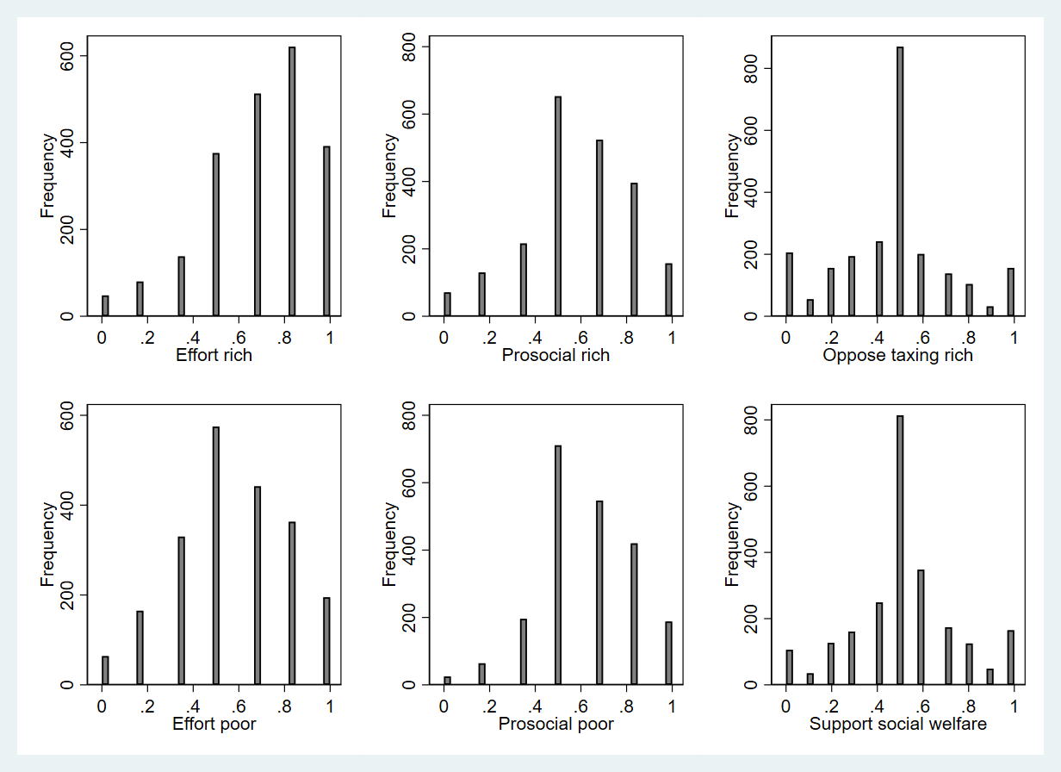
Figure A2.1. Distributions of key variables in Sample 2.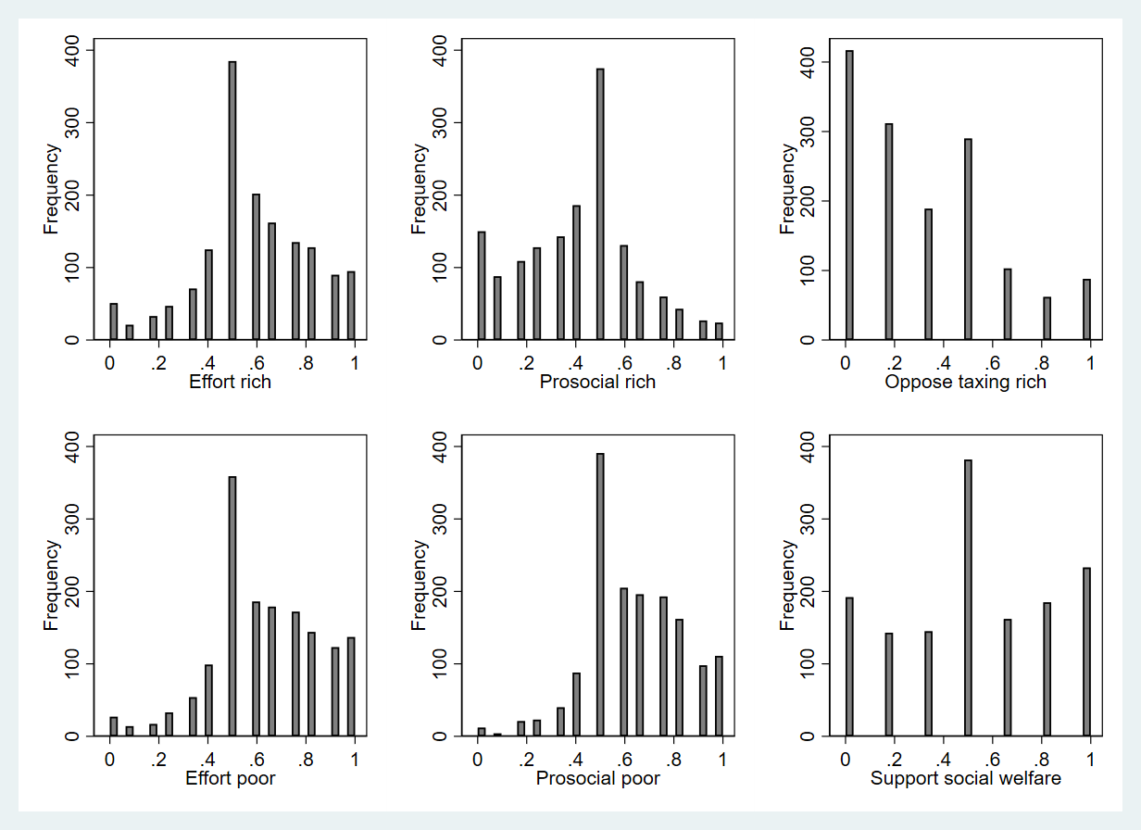

Figure A2.2. Distributions of key variables in Sample 2
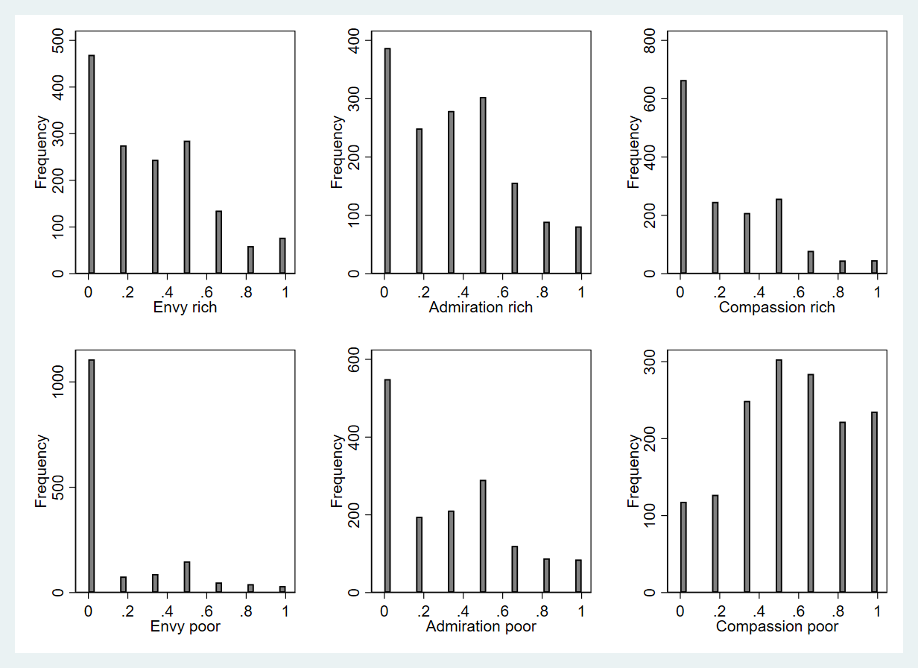

Figure A3. Distributions of key variables in Sample 3
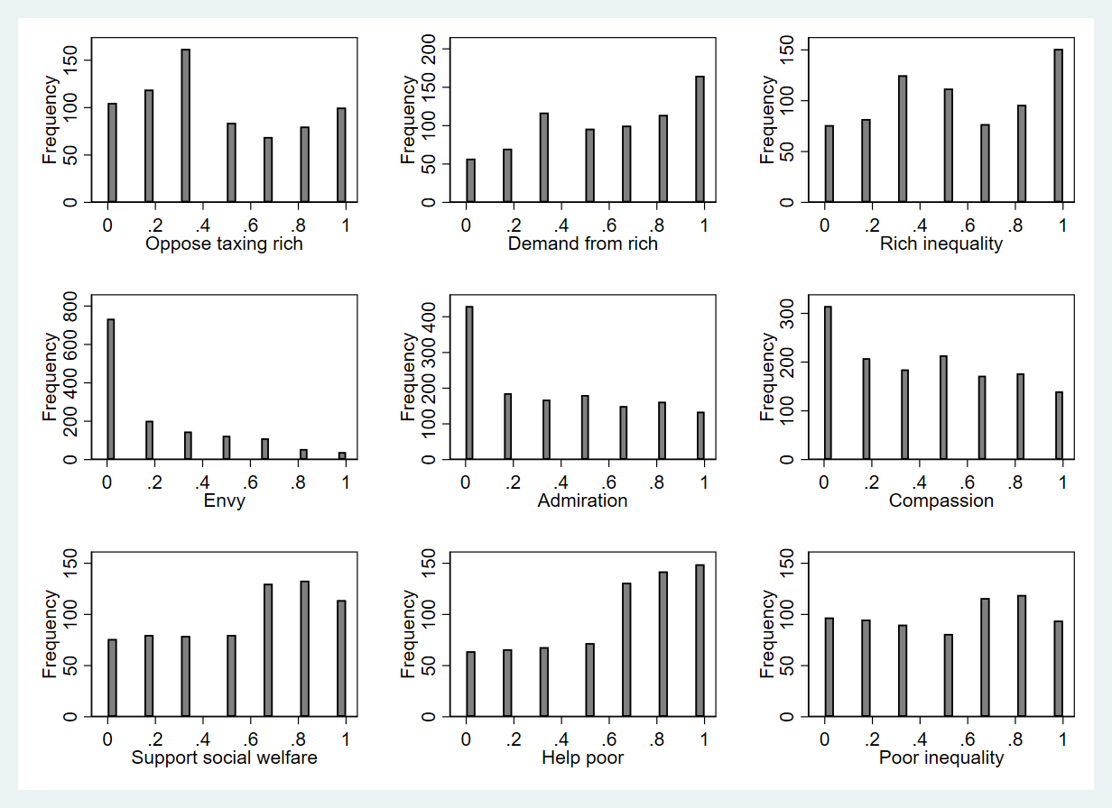
Figure A4.1. Distributions of key variables in Sample 4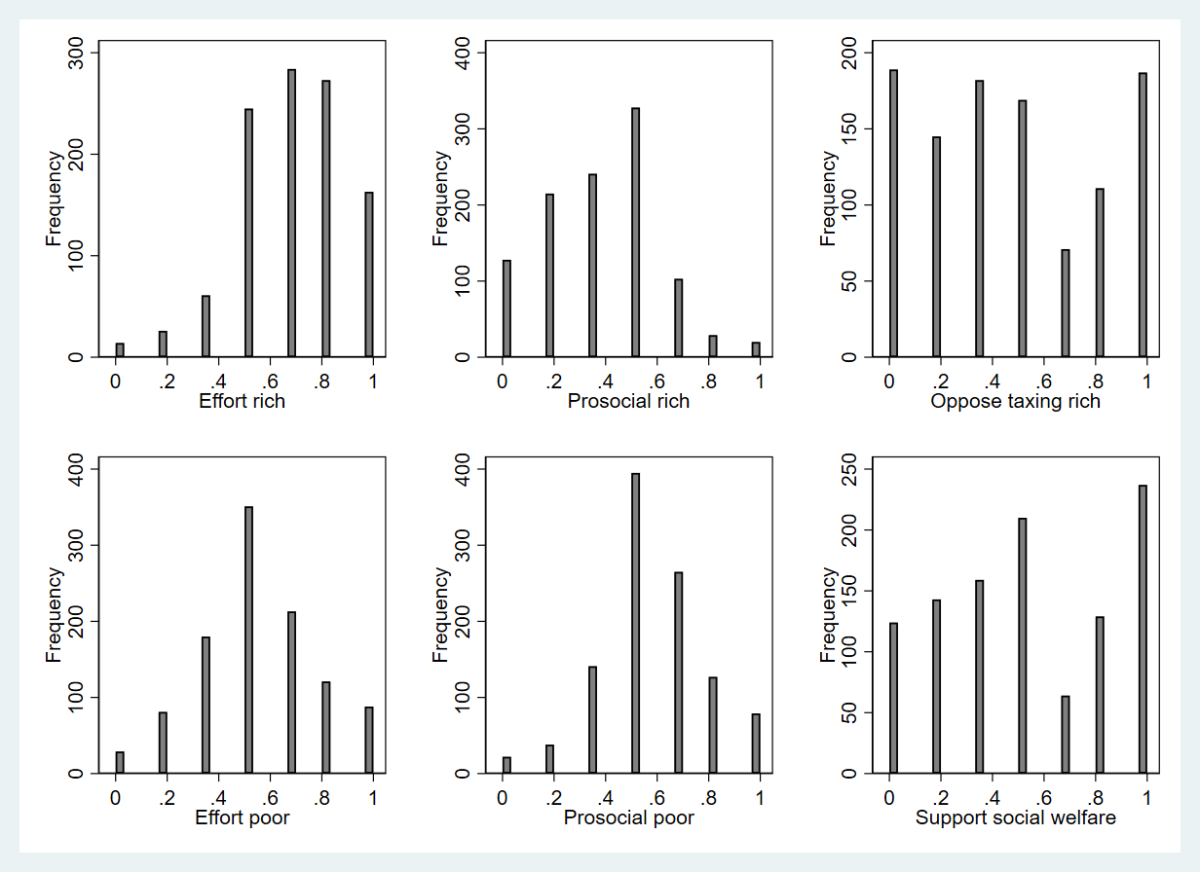

Figure A4.2. Distributions of key variables in Sample 4
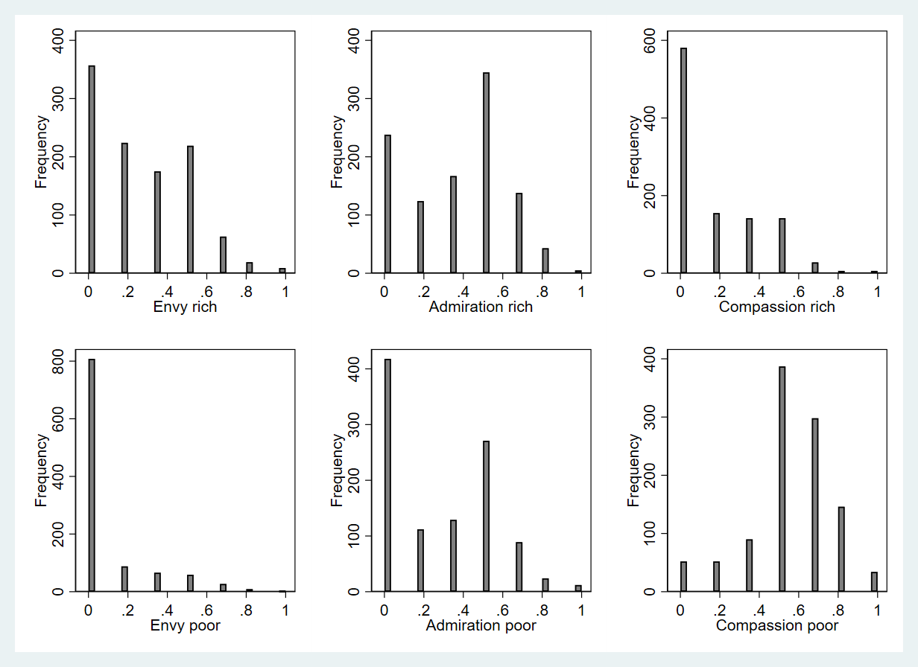

S3.0. Correlation matrices

Table A2. Bivariate correlations between independent variables in Sample 1 (Pearson’s correlations).
 | Effort rich | Effort poor | Prosocial rich | Prosocial poor
Effort rich | 1.000
Effort poor | 0.031 | 1.000
Prosocial rich | 0.524 | 0.043 | 1.000
Prosocial poor | 0.055 | 0.586 | 0.214 | 1.000

Table A3. Bivariate correlations between independent variables in Sample 2 (Pearson’s correlations).
 | Effort rich | Effort poor | Proso-cial rich | Proso-cial poor | Envy rich | Envy poor | Admi-ration rich | Admi-ration poor | Comp-assion rich | Comp-assion poor
Effort rich | 1.000
Effort poor | -0.200 | 1.000
Prosocial rich | 0.556 | -0.211 | 1.000
Prosocial poor | -0.173 | 0.677 | -0.218 | 1.000
Envy rich | -0.043 | -0.047 | -0.034 | -0.058 | 1.000
Envy poor | -0.128 | -0.101 | 0.054 | -0.134 | 0.300 | 1.000
Admiration rich | 0.383 | -0.186 | 0.412 | -0.146 | 0.388 | 0.292 | 1.000
Admiration poor | -0.184 | 0.374 | -0.072 | 0.333 | 0.192 | 0.398 | 0.154 | 1.000
Compassion rich | 0.169 | -0.095 | 0.357 | -0.093 | 0.270 | 0.468 | 0.570 | 0.326 | 1.000
Compassion poor | -0.085 | 0.496 | -0.134 | 0.462 | 0.130 | 0.046 | 0.075 | 0.494 | 0.139 | 1.000

Table A4. Bivariate correlations between emo-
tions in Sample 3 (Pearson’s correlations).
 | Envy | Admiration | Compassion
Envy | 1.000
Admiration | 0.317 | 1.000
Compassion | 0.072 | 0.635 | 1.000

Table A5. Bivariate correlations between independent variables in Sample 4 (Pearson’s correlations).
 | Effort rich | Effort poor | Pro-social rich | Pro-social poor | Envy rich | Envy poor | Admi-ration rich | Admi-ration poor | Comp-assion rich | Comp-assion poor
Effort rich | 1.000
Effort poor | 0.011 | 1.000
Prosocial rich | 0.226 | -0.082 | 1.000
Prosocial poor | -0.026 | 0.375 | -0.197 | 1.000
Envy rich | -0.101 | -0.126 | -0.100 | 0.024 | 1.000
Envy poor | -0.049 | -0.016 | -0.018 | 0.011 | 0.159 | 1.000
Admiration rich | 0.214 | -0.185 | 0.144 | -0.093 | 0.367 | 0.089 | 1.000
Admiration poor | -0.062 | 0.268 | -0.018 | 0.223 | 0.102 | 0.337 | 0.125 | 1.000
Compassion rich | 0.053 | 0.009 | 0.126 | 0.099 | 0.200 | 0.435 | 0.278 | 0.300 | 1.000
Compassion poor | -0.056 | 0.263 | -0.120 | 0.273 | 0.108 | -0.016 | 0.094 | 0.369 | 0.136 | 1.000

S4.0. Robustness tests

S.4.1. Testing if Hypothesis 1 is robust if standardized measures of effort and prosociality are used
In the main text, we test Hypothesis 1 using unstandardized measures of effort and prosociality perceptions. It is possible that perceived prosociality of the rich is more strongly associated with opposition to taxing them than perceptions of their effort because the distributions of these variables are different. To rule out this possibility, Table A6 contains regression analyses where perceived effort and prosociality of the rich have been standardized to have a standard deviations of 1. The results in Table A6 replicate the findings in the main text: (Test of effort rich – prosocial rich = 0; Sample 1: F=4.81; p=0.029; Sample 2: F=15.74; p<0.001; Sample 4: F=8.69; p=0.003).

Table A6. Perceived effort and prosociality of the rich as predictors of opposition to taxing the
rich
 | Model 1  Sample 1  DK | Model 2  Sample 2  US | Model 3  Sample 4  DK
Effort rich | 0.022***  (0.006) | 0.035***  (0.009) | 0.025*  (0.011)
Prosocial rich | 0.046***  (0.006) | 0.096***  (0.009) | 0.075***  (0.011)
Age | -0.002***  (0.000) | -0.001*  (0.000) | -0.004***  (0.001)
Gender | 0.027*  (0.011) | 0.073***  (0.014) | 0.010  (0.021)
Income | 0.103***  (0.020) | -0.011  (0.027) | 0.000  (0.000)
Education | 0.038⁺  (0.020) | -0.002  (0.025) | 0.020  (0.032)
Party (Left)

Independents/ no party | 0.080***  (0.015) | 0.130***  (0.017) | 0.152***  (0.036)
Right | 0.178***  (0.012) | 0.200***  (0.021) | 0.258***  (0.023)
Race/ Ethnicity |  | -0.028⁺  (0.016) | 0.022  (0.062)
Intercept | 0.383***  (0.021) | 0.245***  (0.028) | 0.532***  (0.071)
N | 1689 | 1244 | 886
Adjusted R² | 0.230 | 0.280 | 0.224
Note. Entries are unstandardized OLS regression coefficients with standard errors in parentheses. Perceived effort and prosociality of the rich have been standardized to have a standard deviations of 1. All variables except age and perceived effort and prosociality of the rich vary between 0 and 1. For Race/Ethnicity 0=minority and 1=majority i.e. in the US 1=“white” and in Denmark 1=“Born in Denmark”. In the US, Party (Left)=Democrat and Party (Right)=Republican. In Denmark, Party (Left)=left-leaning parties and Party (Right)=right-leaning parties. ⁺ p < 0.10, * p < 0.05, ** p < 0.01, *** p < 0.001.

S4.2. Testing if the results are robust when using alternative measures
The surveys in Sample 1, Sample 2 and Sample 4 contain questions that can be used as alternative measures to test the hypotheses. In this section, I test the extent to which the results are robust if I use these instead. First, Sample 1 included another questions that are related to opposition to taxing the rich. Specifically, respondents were asked, “Do you think that each of the following groups pay too much or too little in income taxes?”. Answers on “The upper class” were obtained on a 5-point scale that was recoded to range from 0-1 with higher values indicating that they pay too much in income taxes. As the results in Table A7 Model 1 show, the results replicate using this measures, as the hypothesized pattern emerges. The association with perception of rich people’s prosociality is stronger than the association with perception of rich people’s effort. The difference is statistically significant (test of effort rich – prosocial rich = 0; F=10.88; p=0.001).

Table A7. Robustness test with alternative dependent variable in Sample 1. Perceived effort
and prosociality of the rich as predictors of opposition to taxing the rich
Model 1
Agreement that the upper class pays too much in income taxes
Effort rich | 0.117***  (0.029)
Prosocial rich | 0.287***  (0.030)
Age | -0.005***  (0.000)
Gender | 0.036**  (0.013)
Income | 0.058*  (0.023)
Education | 0.104***  (0.023)
Party (Left)
Independents/ no party | 0.085***  (0.017)
Right | 0.203***  (0.014)
Intercept | 0.142***  (0.028)
N | 1689
Adjusted R² | 0.301
Note. Entries are unstandardized OLS regression coefficients with standard errors in parentheses. All variables except age vary between 0 and 1. ⁺ p < 0.10, * p < 0.05, ** p < 0.01, *** p < 0.001.

Sample 2 included two questions that are related to opposition to taxing the rich. Specifically, the questions were: “Do you think that the following taxes should be cut, kept about the same, or raised?” Answers on “Taxes on large corporations” were obtained on a 7-point scale that was recoded to range from 0-1 with higher values indicating support for cutting taxes. Respondents were also asked, Do you think that each of the following social groups pay too much or too little in income taxes? Answers on “The upper class” were obtained on a 7-point scale that was recoded to indicate agreement that they pay too much in income taxes on a 0-1 scale. As the results in Table A8 Model 1 and Model 3 show the predicted patterns emerge when we use these measures. Perception of rich people’s prosociality is more strongly associated with support for cutting taxes on large corporations, although the difference is not statistically significant (test of effort rich – prosocial rich = 0; F=2.49; p=0.115). When it concerns the view that the upper class pays too much in income taxes, the difference is statistically significant (test of effort rich – prosocial rich = 0; F=4.93; p=0.027). The results are also robust with respect to the associations with emotions Hypothesis 2 and Hypothesis 3, as shown in Model 2 and Model 4.

Table A8. Robustness test with alternative dependent variable in Sample 2. Perceptions of the
rich and emotions toward the rich as predictors of opposition to taxing the rich
 | Model 1  Support cutting taxes on large corporations | Model 2  Support cutting taxes on large corporations | Model 3  The upper class pays too much in income taxes | Model 4  The upper class pays too much in income taxes
Effort rich | 0.207***  (0.041) |  | 0.244***  (0.040)
Prosocial rich | 0.317***  (0.039) |  | 0.397***  (0.039)
Envy |  | -0.145***  (0.030) |  | -0.121***  (0.030)
Administration |  | 0.232***  (0.035) |  | 0.333***  (0.036)
Compassion |  | 0.055  (0.036) |  | 0.056  (0.036)
Age | 0.001  (0.001) | 0.001⁺  (0.001) | -0.000  (0.001) | 0.000  (0.001)
Gender | 0.105***  (0.015) | 0.096***  (0.016) | 0.056***  (0.015) | 0.045**  (0.016)
Income | 0.028  (0.029) | 0.054⁺  (0.030) | 0.036  (0.029) | 0.069*  (0.030)
Education | 0.025  (0.026) | 0.031  (0.028) | -0.027  (0.026) | -0.017  (0.028)
Race/Ethnicity | 0.027  (0.017) | 0.041*  (0.018) | -0.025  (0.017) | -0.003  (0.018)
Party (Democrat)

Independents/ no party | 0.140***  (0.018) | 0.148***  (0.019) | 0.122***  (0.018) | 0.131***  (0.019)
Republican | 0.198***  (0.022) | 0.218***  (0.023) | 0.181***  (0.022) | 0.197***  (0.023)
Intercept | -0.140***  (0.033) | 0.018  (0.035) | -0.089**  (0.033) | 0.058⁺  (0.035)
n | 1242 | 1242 | 1235 | 1235
adj. R² | 0.261 | 0.197 | 0.279 | 0.200
Note. Entries are unstandardized OLS regression coefficients with standard errors in parentheses. All variables except age vary between 0 and 1. ⁺ p < 0.10, * p < 0.05, ** p < 0.01, *** p < 0.001.

In Sample 4, respondents were asked, “Do you think that people with high incomes should pay a larger, the same share, or a smaller share of their income in taxes compared to those who have lower incomes? Answers were obtained on a 5-point scale ranging from “Much smaller share” to “Much larger share.” The variable is recoded to range from 0-1 with higher values indicating smaller share. Table A9 shows that the findings are robust as perception of rich people’s prosociality is more strongly associated with this alternative measure than perception of rich people’s effort. Although the difference is only marginally significant (test of effort rich – prosocial rich = 0; F=2.97; p=0.085). Turning to the column on the right in Table A9, envy is negatively associated and admiration is positively associated with this alternative measure. Thus, the results are also robust with respect to Hypothesis 2 and Hypothesis 3.

Table A9. Robustness test with alternative dependent variable in Sample 4. Perceptions of the
rich and emotions toward the rich as predictors of opposition to taxing the rich
 | Model 1  Prefer that people with higher incomes pay a smaller share of their incomes in taxes than people with lower incomes. | Model 2  Prefer that people with higher incomes pay a smaller share of their incomes in taxes than people with lower incomes.
Effort rich | 0.065*  (0.026)
Prosocial rich | 0.132***  (0.025)
Envy |  | -0.115***  (0.027)
Admiration |  | 0.120***  (0.025)
Compassion |  | 0.052⁺  (0.027)
Age | -0.001*  (0.000) | -0.001**  (0.000)
Gender | 0.004  (0.011) | 0.001  (0.011)
Income | -0.000  (0.000) | -0.000  (0.000)
Education | -0.030⁺  (0.017) | -0.016  (0.017)
Race/Ethnicity | 0.026  (0.032) | 0.021  (0.032)
Party (Left)

Independents/ no party | 0.086***  (0.019) | 0.075***  (0.019)
Right | 0.116***  (0.012) | 0.114***  (0.012)
Intercept | 0.202***  (0.040) | 0.290***  (0.040)
N | 877 | 878
adj. R² | 0.174 | 0.169
Note. Entries are unstandardized OLS regression coefficients with standard errors in parentheses. All variables except age and income vary between 0 and 1. ⁺ p < 0.10, * p < 0.05, ** p < 0.01, *** p < 0.001.

The results from Sample 2 in the main text are based on measures of perceptions of the rich and poor that were obtained using a trait battery on which respondents had to indicate whether certain words describe the rich and the poor well on a scale from “Not at all well” to “Extremely well.” The traits were: hardworking, lazy, generous, and greedy. In the main text, effort was constructed by using the lazy item and subtracting it from the hardworking item to provide one measure, as these traits are logical opposites. Likewise, prosociality was constructed by subtracting the greedy item from the generous item. In contrast to the ANES effort measure, these measures do not force respondents to pick a value on one dimension. A possible limitation with respect to this measurement approach is that respondents can indicate both that they think a person is hardworking and lazy at the same time. Thus, Table A10 provides a test of whether the results are robust if we analyze these trait items separately. As the results in Model 1 show, the results are robust, as opposition to taxing the rich is more strongly associated with characteristics on the effort dimension than characteristics on the prosociality dimension (test of (Reversed lazy + hardworking) - (Reversed greedy + generous) = 0; F=8.53; p=0.004). Moreover, support for social welfare is more strongly associated with perceptions of poor people’s effort than perceptions of poor people’s prosociality in Model 2. (test of (Reversed lazy + hardworking) - (Reversed greedy + generous) = 0; F=13.77; p<0.001).

Table A10. Robustness test where the perceptions of rich and poor people’s effort and
prosociality are based on indicators instead of indexes. Perceptions of the rich and
perceptions of the poor as predictors of redistributive attitudes (Sample 2).
 | Model 1  Opposition to taxing the rich | Model 2  Support for social welfare
Rich lazy (reverse coded) | 0.028  (0.030)
Rich hardworking | 0.144***  (0.035)
Rich greedy (reverse coded) | 0.257***  (0.027)
Rich generous | 0.110**  (0.035)
Poor lazy (reverse coded) |  | 0.184***  (0.039)
Poor hardworking |  | 0.254***  (0.037)
Poor greedy (reverse coded) |  | 0.001  (0.037)
Poor generous |  | 0.096**  (0.036)
Age | -0.001*  (0.000) | -0.001  (0.001)
Gender | 0.076***  (0.014) | 0.005  (0.016)
Income | -0.011  (0.027) | -0.053⁺  (0.029)
Education | 0.001  (0.025) | 0.038  (0.027)
Race/ Ethnicity | -0.026  (0.016) | 0.016  (0.018)
Party (Democrat)

Independents/ no party | 0.127***  (0.017) | -0.155***  (0.018)
Republican | 0.193***  (0.021) | -0.249***  (0.023)
Intercept | 0.005  (0.031) | 0.362***  (0.043)
N | 1244 | 1230
adj. R² | 0.284 | 0.288
Note. Entries are unstandardized OLS regression coefficients with standard errors in parentheses. All variables except age vary between 0 and 1. ⁺ p < 0.10, * p < 0.05, ** p < 0.01, *** p < 0.001.

In Sample 2, there were also independent measures of perceived effort and prosociality that were
similar to the ones used in Sample 1. That is, the standard ANES measure of perceived
effort asking respondents on a 7-point scale about whether the rich (and poor) are hardworking or
lazy as well as the indirect measure of perceived prosociality, where respondents were
asked on a 7-point scale about whether they “dislike” or “like” the rich (and poor). There was also
an additional indirect measure of prosociality, warmth, where respondents placed the rich (and the
poor) on 7-point scales from warm to cold. These two indirect measures of prosociality (likeability
and warmth) form reliable scales: (Alpha rich =0.72; Alpha poor= 0,74). The reason why I used
the trait battery (greed, generosity, hardworking, and lazy) in the main analyses of Sample 2 was
because they directly tap into the theoretical construct. Nevertheless, if we use these alternative
measures instead, Hypothesis 1 is still supported as shown in Table A11 (Model 1). The difference
is marginally significant (test of effort rich – prosocial rich = 0; F=3.08; p=0.079). In Model 2, the
results are robust, as support for social welfare is more strongly associated with perceptions of the
poor’s effort than perceptions of their prosociality (test of effort poor – prosocial poor = 0;
p=0.007). However, if we solely measure prosociality as likeability as in Sample 1 (See Model 3),
Hypothesis 1 is not supported (test of effort rich – prosocial rich = 0; F=0.75; p=0.387). The results
regarding support for social welfare remains supported in Model 4 (test of effort poor – prosocial
poor = 0; p=0.001). Also, the results in Table A11 still show an effort asymmetry, as
perceptions of poor people’s efforts remain more strongly associated with redistributive attitudes
than do perceptions of rich people’s efforts.

Table A11. Robustness test with alternative measures of the independent variables.
Perceptions of the rich and perceptions of the poor as predictors of redistributive attitudes.
(Sample 2).
 | Model 1  Opposition to taxing the rich | Model 2  Support for social welfare | Model 3  Opposition to taxing the rich | Model 4  Support for social welfare
Effort rich | 0.157***  (0.030) |  | 0.206***  (0.028)
Prosocial rich  (Likeability-warmth measure) | 0.262***  (0.037)
Prosocial rich  (Likeability measure) |  |  | 0.161***  (0.031)
Effort poor |  | 0.336***  (0.035) |  | 0.341***  (0.032)
Prosocial poor (Likeability-warmth measure) |  | 0.140**  (0.046)
Prosocial poor (Likeability measure) |  |  |  | 0.134***  (0.038)
Age | -0.001  (0.000) | -0.001⁺  (0.001) | -0.001  (0.000) | -0.001⁺  (0.001)
Gender | 0.059***  (0.015) | 0.017  (0.016) | 0.064***  (0.015) | 0.016  (0.016)
Income | -0.011  (0.027) | -0.056⁺  (0.029) | -0.010  (0.027) | -0.056⁺  (0.029)
Education | -0.007  (0.025) | 0.033  (0.026) | -0.005  (0.025) | 0.034  (0.026)
Race/Ethnicity | -0.026  (0.017) | 0.009  (0.017) | -0.029⁺  (0.017) | 0.009  (0.017)
Party (Democrat)

Independents/ no party | 0.126***  (0.017) | -0.162***  (0.018) | 0.129***  (0.017) | -0.162***  (0.018)
Republican | 0.202***  (0.021) | -0.260***  (0.023) | 0.207***  (0.021) | -0.260***  (0.023)
Intercept | 0.044  (0.030) | 0.392***  (0.041) | 0.049  (0.031) | 0.393***  (0.040)
N | 1244 | 1230 | 1244 | 1230
adj. R² | 0.247 | 0.290 | 0.233 | 0.292
Note. Entries are unstandardized OLS regression coefficients with standard errors in parentheses. All variables except age vary between 0 and 1. ⁺ p < 0.10, * p < 0.05, ** p < 0.01, *** p < 0.001.

S4.3. Testing if Hypothesis 1 is robust if control variables are included in the experiment
Table A12 includes control variables of the experimental test of Hypothesis 1. The results provide even stronger support for the hypothesis than the ones presented in the main manuscript. (Test of effort rich – prosocial rich = 0; Model 1: F=6.16; p=0.013; Model 2: F=5.02; p=0.025; Model 3: F=1.24; p=0.267).

Table A12. The effects of effort of the rich and prosociality of the rich on opposition to taxing the rich. (Sample 3).
 | Model 1  Agree with: | Model 2  Agree with: | Model 3  Agree with:
 | The village should spend money on social assistance to people like Thomas | The village should do more to help people like Thomas | The village should give more money to people like Thomas to reduce inequality
Effort | 0.074**  (0.023) | 0.042⁺  (0.023) | 0.050*  (0.023)
Prosociality | 0.151***  (0.023) | 0.113***  (0.023) | 0.086***  (0.023)
Age | 0.002⁺  (0.001) | 0.003**  (0.001) | 0.003**  (0.001)
Gender | -0.006  (0.023) | -0.025  (0.023) | -0.024  (0.024)
Income | 0.217***  (0.043) | 0.213***  (0.044) | 0.262***  (0.045)
Education | -0.018*  (0.009) | -0.029**  (0.009) | -0.022*  (0.009)
Party (Democrat)

Independents/ no party | 0.160***  (0.026) | 0.141***  (0.027) | 0.164***  (0.027)
Republican | 0.261***  (0.030) | 0.162***  (0.030) | 0.214***  (0.031)
Intercept | 0.166**  (0.061) | 0.381***  (0.062) | 0.271***  (0.063)
N | 704 | 704 | 704
adj. R² | 0.196 | 0.128 | 0.152
Note. Entries are unstandardized OLS regression coefficients with standard errors in parentheses. All variables except age vary between 0 and 1. ⁺ p < 0.10, * p < 0.05, ** p < 0.01, *** p < 0.001.

