Supplementary Material

1) SM.1. Item Wordings and Descriptive Statistics for Study 1 (2012 ANES) and Additional Analysis of 2016 ANES

2) SM.2. Racial Resentment Mediates the Impact of American ID on Latino Support for Black-Centered Policies – Full Results for Study 1 (2012 ANES) & Additional Analysis of 2016 ANES

3) SM.3. Liberal Ideology Does Not Moderate the Impact of American ID on Levels of Racial Resentment – Study 1 (2012 ANES) & Additional Analysis of 2016 ANES

4) SM.4. Correlates of American ID and Ideology Among Latinos (2012 and 2016 ANES)

5) SM.5. Wording of Treatment, Balance Checks, and Raw Treatment Effects for Studies 2-3 (Prolific Experiments)

6) SM.6. Wording of Treatment, Balance Checks, Raw Treatment Effects, and Pre-Registration for Study 4 (Dynata Experiment)

7) SM.7. Wording for Racial Resentment and Outcomes in Study 4 (Dynata Experiment)

8) SM.8. Correlates of Traditional versus Latino-specific Racial Resentment Scale: Comparison of Study 3 and Study 4

SM.1. Item Wordings and Descriptive Statistics for Study 1 (2012 ANES) and Additional Analysis of 2016 ANES

Study 1 (2012 ANES)

Dependent variables

*scaled

*Do you favor, oppose, or neither favor nor oppose allowing universities to increase the number of black students studying at their schools by considering race along with other factors?

1) Favor a great deal
2) Favor moderately
3) Favor a little
4) Neither favor nor oppose
5) Oppose a little
6) Oppose moderately
7) Oppose a great deal

*Do you favor, oppose, or neither favor nor oppose allowing companies to increase the number of black workers by considering race along with other factors when choosing employees?

1) Favor a great deal
2) Favor moderately
3) Favor a little
4) Neither favor nor oppose
5) Oppose a little
6) Oppose moderately
7) Oppose a great deal

Should the government in Washington see to it that black people get fair treatment in jobs or is this not the federal government’s business?

1) Feel strongly that government should see to fair treatment
2) Feel not strongly that government should see to fair treatment
4) Feel not strongly that fair treatment is not government’s business
5) Feel strongly that fair treatment is not government’s business

Where would you place YOURSELF on this scale or haven’t you thought much about this?

1) Government should help blacks
2)
3)
4)
5)
6)
7) Blacks should help themselves

Mediator

*Irish, Italians, Jewish and many other minorities overcame prejudice and worked their way up. Blacks should do the same without any special favors.

1) Agree strongly
2) Agree somewhat
3) Neither agree nor disagree
4) Disagree somewhat
5) Disagree strongly

*Generations of slavery and discrimination have created conditions that make it difficult for blacks to work their way out of the lower class.

1) Agree strongly
2) Agree somewhat
3) Neither agree nor disagree
4) Disagree somewhat
5) Disagree strongly

*Over the past few years, blacks have gotten less than they deserve.

1) Agree strongly
2) Agree somewhat
3) Neither agree nor disagree
4) Disagree somewhat
5) Disagree strongly

*It’s really a matter of some people not trying hard enough; if blacks would only try harder they could be just as well off as whites.

1) Agree strongly
2) Agree somewhat
3) Neither agree nor disagree
4) Disagree somewhat
5) Disagree strongly

Independent variable

How important is being American to your identity?

1) Extremely important
2) Very important
3) Moderately important
4) A little important
5) Not important at all

Covariates

How important is being Hispanic to your identity?

1) Extremely important
2) Very important
3) Moderately important
4) A little important
5) Not important at all

In what state, country, or territory were you born?

1) A U.S. State or D.C.
2) Puerto Rico
3) Another U.S. territory
4) Another country

Generally speaking, do you usually think of yourself as a Democrat, a Republican, an Independent, or what? [with follow up prompts]

1) Strong Democrat
2) Not very strong Democrat
3) Independent-Democrat
4) Independent
5) Independent-Republican
6) Not very strong Republican
7) Strong Republican

Where would you place YOURSELF on this scale, or haven’t you thought much about this?

1) Extremely liberal
2) Liberal
3) Slightly liberal
4) Moderate; middle of the road
5) Slightly conservative
6) Conservative
7) Extremely conservative

Respondent’s level of highest education group

1) Less than a high school credential
2) High school credential
3) Some post-high school, no bachelor’s degree
4) Bachelor’s degree
5) Graduate degree

How often do you pay attention to what’s going on in government and politics?

1) Always
2) Most of the time
3) About half the time
4) Some of the time
5) Never

So far as you and your family are concerned, how worried are you about your current financial situation?

1) Extremely worried
2) Very worried
3) Moderately worried
4) A little worried
5) Not at all worried

Reported family income

1) Under $5, 000
2) $5,000 - $9,999
3) $10,000 – $12,499
4) $12,500 - $14,999
5) $15,000 - $17,499
6) $17,500 - $19,999
7) $20,000 - $22,499
8) $22,500 - $24,999
9) $25,000 - $27,499
10) $27,500 - $29,999
11) $30,000 - $34,999
12) $35,000 - $39,999
13) $40,000 - $44,999
14) $45,000 - $49,999
15) $50,000 - $54,999
16) $55,000 - $59,999
17) $60,000 - $64,999
18) $65,000 - $69,999
19) $70,000 - $74,999
20) $75,000 - $79,999
21) $80,000 - $89,999
22) $90,000 - $99,999
23) $100,000 - $109,999
24) $110,000 - $124,999
25) $125,000 - $149,999
26) $150,000 - $174,999
27) $175,000 - $249,999
28) $250,000 or more
-9) Refused
-8) Don’t know

Gender of respondent

1) Male
2) Female

Age of respondent

1) 18 years of age
.
.
.
2) 90 years of age

Additional Analysis of 2016 ANES

Dependent variables

What about your opinion – are you for or against preferential hiring and promotion of blacks?

1) Strongly for preferential hiring
2) Not strongly for preferential hiring
4) Not strongly against preferential hiring
5) Strongly against preferential hiring

Where would you place YOURSELF on this scale or haven’t you thought much about this?

1) Government should help blacks
2)
3)
4)
5)
6)
7) Blacks should help themselves

Mediator

Same as in Study 1

Independent variable

Same as in Study 1

Covariates

Same as in Study 1

Descriptive Statistics for Study 1 (2012 ANES)

 | Mean | Std. Dev.
Support affirmative action  (scaled) | .409 | .275
Support fair treatment of Blacks | .500 | .447
Support federal aid to Blacks | .423 | .316
Racial resentment | .631 | .227
American identity | .783 | .264
Liberal ideology | .511 | .236
Political interest | .536 | .281
Latino identity | .674 | .305
College education (proportion) | .191 | .393
Financial worry | .489 | .318
Income | .376 | .284
Age (years) | 43.75 | 16.55
Female (proportion) | .514 | .500
Note: All variables on a 0-1 scale, unless otherwise noted.

Descriptive Statistics for Additional Analysis of 2016 ANES

 | Mean | Std. Dev.
Support affirmative action  (scaled) | .350 | .403
Support fair treatment of Blacks | N/A | N/A
Support federal aid to Blacks | .531 | .331
Racial resentment | .531 | .252
American identity | .747 | .267
Liberal ideology | .500 | .204
Political interest | .590 | .280
Latino identity | .669 | .335
College education (proportion) | .222 | .416
Financial worry | .524 | .309
Income | .456 | .289
Age (years) | 42.81 | 16.88
Female (proportion) | .48 | .500
Note: All variables on a 0-1 scale, unless otherwise noted.

SM.2. Racial Resentment Mediates the Impact of American ID on Latino Support for Black-Centered Policies – Full Results for Study 1 (2012 ANES)
Note: Entries are OLS coefficients with standard errors in parentheses. All variables range continuously from 0 to 1. *p<.05, two-tailed.
 | Impact on Mediator | Impact on Outcomes
 | Racial resentment | Support  affirmative action | Support Blacks’ fair treatment | Support federal aid to Blacks
American identity | .182*  (.032) | -.058  (.038) | -.044  (.064) | .051  (.045)
Racial resentment | --- | -.407*  (.044) | -.730**  (.074) | -.563**  (.049)
Latino identity | -.059*  (.028) | .125*  (.033) | .160*  (.057) | .078*  (.038)
U.S.-born | -.021  (.017) | -.074*  (.020) | -.087*  (.034) | -.084*  (.023)
Party ID (Democrat) | -.112*  (.028) | .092*  (.033) | .082  (.055) | .118*  (.037)
Ideol. (Liberal) | -.113*  (.039) | .073*  (.046) | .004  (.076) | .148*  (.052)
College education | -.064*  (.021) | -.010  (.025) | .008  (.042) | -.016  (.027)
Political interest | -.066*  (.030) | .017  (.036) | .014  (.060) | -.006  (.041)
Financial worry | .049  (.026) | .010  (.031) | -.056  (.052) | .012  (.035)
Income | .039  (.031) | -.059  (.036) | -.163*  (.062) | -.119*  (.041)
Female | .018  (.016) | -.021  (.019) | -.002  (.032) | -.024  (.021)
Age | -.001  (.001) | .001  (.001) | -.000  (.001) | -.001  (.001)
Constant | .586*  (.052) | .643*  (.066) | .956*  (.111) | .854*  (.076)
N | 717 | 711 | 651 | 609

Racial Resentment Mediates the Impact of American ID on Asian and Latino Support for Black-Centered Policies – Full Results for Additional Analysis of 2016 ANES
Note: Entries are OLS coefficients with standard errors in parentheses. All variables range continuously from 0 to 1. *p<.05, two-tailed.
 | Impact on Mediator |  | Impact on Outcomes
 | Racial resentment |  | Oppose affirm. action |  | Oppose federal aid to Blacks
American identity |  | .142*  (.051) |  | -.065  (.085) |  | .051  (.073)
Racial resentment |  | --- |  | -.582*  (.093) |  | -.437*  (.077)
Latino ID |  | -.061  (.042) |  | .048  (.069) |  | .028  (.060)
U.S.-born |  | -.054  (.029) |  | -.007  (.049) |  | -.112*  (.041)
Party ID (Dem.) |  | -.192*  (.048) |  | .119  (.081) |  | .088  (.067)
Ideology (Cons.) |  | .241*  (.072) |  | .115  (.121) |  | -.124  (.099)
College education |  | -.129*  (.032) |  | .023  (.055) |  | -.003  (.046)
Political interest |  | -.070  (.046) |  | -.149*  (.077) |  | -.022  (.065)
Financial worry |  | .012  (.043) |  | -.014  (.070) |  | .129*  (.061)
Income |  | .037  (.046) |  | -.173*  (.076) |  | -.146*  (.064)
Female |  | -.006  (.025) |  | .047  (.041) |  | .076*  (.035)
Age |  | .001  (.001) |  | .000  (.001) |  | -.002  (.001)
Constant |  | .513*  (.081) |  | .690*  (.142) |  | .857*  (.123)
N |  | 327 |  | 322 |  | 265

SM.3. Liberal Ideology Does Not Moderate the Impact of American ID on Levels of Racial Resentment – Study 1 (2012 ANES)
Note: Entries are OLS coefficients with standard errors in parentheses.
All variables range continuously from 0 to 1. **p<.05, two-tailed.
Racial resentment
(Mediator)
American identity | .047*  (.018)
Liberal | -.104  (.133)
American identity x Liberal | -.002  (.032)
Latino identity | -.015*  (.007)
U.S.-born | -.021  (.017)
Party identity (Democrat) | -.112*  (.028)
College education | -.064*  (.022)
Political interest | -.066*  (.031)
Financial worry | .049  (.026)
Income | .039  (.030)
Female | .018  (.016)
Age | -.001  (.001)
Constant | .663*  (.084)
N | 717

Liberal Ideology Does Not Moderate the Impact of American ID on Levels of Racial Resentment – Additional Analysis of 2016 ANES
Note: Entries are OLS coefficients with standard errors in parentheses.
All variables range continuously from 0 to 1. **p<.05, two-tailed.
Racial resentment
(Mediator)
American identity | .180  (.157)
Liberal | -.187  (.216)
American identity x Liberal | -.069  (.256)
Latino identity | -.060  (.039)
U.S.-born | -.053  (.029)
Party identity (Democrat) | -.192*  (.042)
College education | -.129*  (.034)
Political interest | -.072  (.046)
Financial worry | .011  (.044)
Income | .037  (.046)
Female | -.006  (.025)
Age | .001  (.001)
Constant | .726*  (.144)
N | 328

SM.4. Correlates of American Identity and Liberal Ideology Among Latinos

American Identity

 | 2012 ANES | 2012 ANES | 2016 ANES
Ideology | -.158***  (.042) | -.226**  (.073) | -.276***  (.075)
Skin Tone | --- | -.109  (.114) | -.007  (.101)
Latino Identity | .229***  (.037) | .187**  (.062) | .261***  (.062)
Language (English) | -.185***  (.049) | -.177*  (.074) | .028  (.084)
Nativity | -.009  (.022) | -.032  (.036) | .012  (.036)
Income | .099**  (.037) | .084  (.063) | .070  (0.058)
College education | -.028  (.023) | -.080*  (.040) | 0.007  (0.007)
Constant | .777***  (.051) | .904***  (.094) | 0.579***  (0.106)
N | 733 | 267 | 252
Note: Entries are OLS coefficients with standard errors in parentheses. All variables range continuously from 0 to 1. *p<.05, two-tailed.

Ideology (Liberal)

 | 2012 ANES | 2012 ANES | 2016 ANES | 2016 ANES
Racial resentment | -.193***  (.041) | -.085  (0.0632) | -.333***  (.045) | -.330***  (.044)
Skin Tone | --- | -.110  (.084) | --- | .081  (.079)
American Identity | -.092**  (.035) | -.162**  (.062) | -.125*  (.050) | -.125*  (.050)
Latino Identity | .099**  (.033) | .068  (.058) | .127***  (.038) | .130***  (.038)
Language | -.006  (.046) | -.053  (.080) | -.086  (.071) | -.090  (.071)
Nativity | .028  (.022) | -.002  (.039) | .039  (.033) | .037  (.033)
Mexican | -.020  (.019) | .003  (.035) | -.041  (.027) | -.043  (.027)
Income | -.0006  (.033) | .112  (.062) | -.0300  (.046) | .025  (.047)
College education | .033  (.022) | -.047  (.037) | -.003  (.006) | -.003  (.006)
Constant | .632***  (.050) | .701***  (.099) | .755***  (.094) | .731***  (.096)
N | 724 | 259 | 251 | 250

Note: Entries are OLS coefficients with standard errors in parentheses. All variables range continuously from 0 to 1. *p<.05, two-tailed.

SM.5. Wording of Treatment, Balance Checks, and Raw Treatment Effects in Studies 2-3 (Prolific Experiments)

New Census Data Reveal Latinos are Becoming an Important Part of U.S. Society
Early returns from the latest U.S. census are painting a nuanced portrait of Latinos in the United States. These new data suggest that Latinos are becoming more complete members of American society. Although Latinos have been fixtures of U.S. entertainment (e.g., actress Eva Longoria) and cuisine (e.g., tacos) for some time, their presence is now spilling into new domains. For example, more Latinos are gaining greater fluency in English, which is allowing larger numbers of them to complete high school and move onto college and beyond (Fig. 1). With more university diplomas in hand, many Latinos are actively taking on visible roles in politics and private industry, thus changing the face of America and what it means to be American (Fig. 2). These trends make it difficult to characterize Latinos as a minority that is separate and apart from other Americans. Instead, these data suggest Latinos are becoming fuller members of American society.
Figure 1. Figure 2.

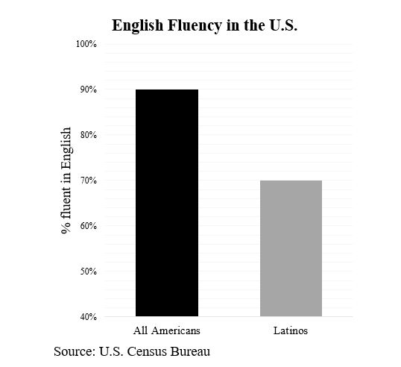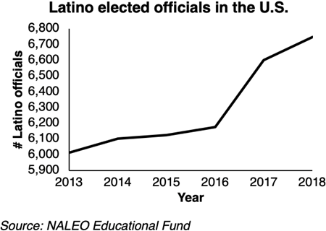

Study 2 (Prolific)– Balance Check (N=248)

The table below indicates balance on all observed pre-treatment covariates, chance variations aside.

 | Control | Treatment | Difference  Significant?
Liberal ideology | 3.58 | 3.61 | p<.889 via t-test
College education | .404 | .441 | p<.568 via χ-test
U.S.-born | .959 | .929 | p<.316 via χ-test
Male | .488 | .583 | p<.135 via χ-test
Age (years) | 29 | 28 | p<.161 via t-test
N | 121 | 127

The table below displays the raw treatment effects for Study 2 (Prolific)

Raw Treatment Effects (Study 2, Prolific)

 | Racial resentment  (mediator) | Support for pro-Black policies (outcome)
Becoming American  (treatment) | .008  (.034) | .002  (.026)
N=248

The table below indicates balance on all observed pre-treatment covariates, chance variations aside.

Study 3 (Prolific) – Balance Check (N=330)

 | Control | Treatment | Difference  Significant?
Liberal ideology | .688 | .699 | p<.713 via t-test
College education | .382 | .370 | p<.820 via χ-test
U.S.-born | .933 | .927 | p<.829 via χ-test
Male | .515 | .490 | p<.660 via χ-test
Age (years) | 36 | 38 | p<.115 via t-test
N | 165 | 165

Study 3 (Prolific) Raw Treatment Effects

 | Racial resentment  (mediator) | Support for pro-Black policies (outcome)
Becoming American  (treatment) | -.005  (.027) | .020  (.023)
N=330

SM.6. Wording of Treatment, Balance Checks, Raw Treatment Effects, and Pre-Reigstration for Study 4 (Dynata Experiment)

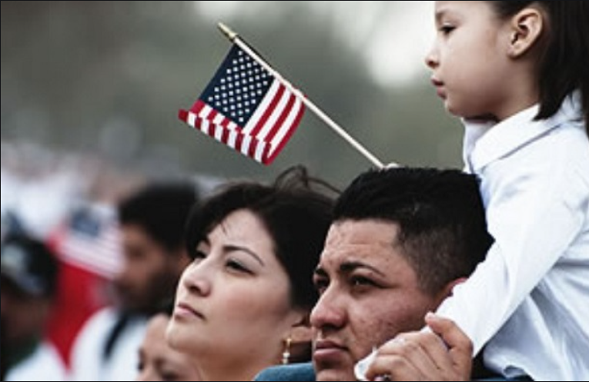

News Brief: Latest Census Shows Latinos Losing Foothold in U.S. Society; Status as Newest Americans More Uncertain Now, Similar to Blacks
-Associated Press
Americans are generally defined by hard work and constant hope for a better future. Not long ago, many Latinos were poised to gain more complete membership as Americans. Yes, Latinos generally earn lower wages, possess fewer years of education, and accumulate less wealth in their lifetimes than most Americans. But until recently, many Latinos were making strides, as evidenced by upticks in their homeownership rates and trends in consumer spending (e.g., car purchases).
Yet early returns from the latest Census suggest these gains are quickly fading, putting Latinos in an insecure and unstable position as Americans. In fact, Latinos are at risk of losing their foothold in American society and becoming a permanent ethnic minority. For example, many Latinos remain stuck in low-wage jobs with few prospects for improvement in the future, even among those born in the United States. Too many Latinos also do not possess medical insurance, which undermines their long-term health. Finally, many Latino students fail to finish college on a strong note, which limits their ability to enter many professions with confidence. These trends clearly suggest Latinos are becoming more isolated in social, economic, and political terms, similar to many African Americans who are marginalized.

Study 4 (Dynata)– Balance Check

The table below indicates balance on all observed pre-treatment covariates, chance variations aside.

 | Control | Treatment 1 | Treatment 2 | Difference significant?
Liberal ideology | .483 | .472 | .487 | p<.706 via χ-test
College education | .407 | .420 | .378 | p<.451 via χ-test
U.S.-born | .234 | .199 | .158 | p<.024 via χ-test
Male | .441 | .477 | .494 | p<.311 via χ-test
Age (years) | 42 | 41 | 41 | p<.711 via χ-test

The table below displays the raw treatment effects in Study 4.

Study 4 (Dynata)

 | Racial resentment  (mediator) | Support for pro-Black policies (outcome)
Becoming less American, like Blacks (treatment 1) | .004  (.017) | .017  (.017)
Becoming less American (treatment 2) | -.009  (.017) | .031  (.018)
N=1,170

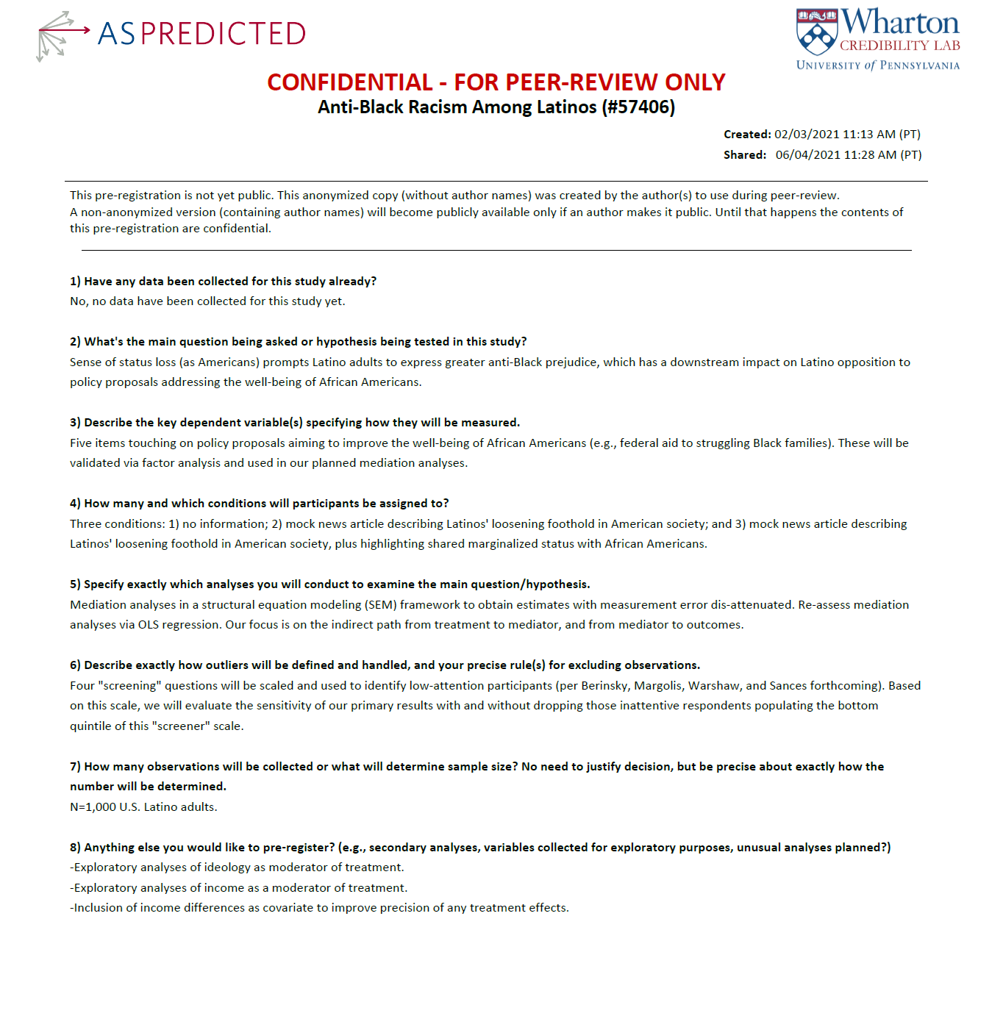

SM.7. Wording for Racial Resentment and Outcomes in Study 4 (Dynata)

Racial resentment

It's really a matter of some people not trying hard enough; if Blacks would only try harder they could be just as well off as Latinos.

1) Strongly disagree
2) Disagree
3) Somewhat disagree
4) Neither agree nor disagree
5) Somewhat agree
6) Agree
7) Strongly agree

Mexicans, Salvadorans, Puerto Ricans, Cubans, and other Latinos have worked their way up to earn what they have. Blacks should do the same without any special favors.

1) Strongly disagree
2) Disagree
3) Somewhat disagree
4) Neither agree nor disagree
5) Somewhat agree
6) Agree
7) Strongly agree

Over the past few years, Blacks have gotten less than they deserve.

1) Strongly disagree
2) Disagree
3) Somewhat disagree
4) Neither agree nor disagree
5) Somewhat agree
6) Agree
7) Strongly agree

Generations of slavery and discrimination have created conditions that make it difficult for Blacks to work their way out of the lower class.

1) Strongly disagree
2) Disagree
3) Somewhat disagree
4) Neither agree nor disagree
5) Somewhat agree
6) Agree
7) Strongly agree

Outcomes

Authorizing federal aid to help struggling Black families

1) Strongly disagree
2) Disagree
3) Somewhat disagree
4) Neither agree nor disagree
5) Somewhat agree
6) Agree
7) Strongly agree

Ensuring that more Black candidates are elected to Congress to represent Blacks and other people of color.

1) Strongly disagree
2) Disagree
3) Somewhat disagree
4) Neither agree nor disagree
5) Somewhat agree
6) Agree
7) Strongly agree

Requiring universities to admit more Black students to their schools by taking their racial background into account.

1) Strongly disagree
2) Disagree
3) Somewhat disagree
4) Neither agree nor disagree
5) Somewhat agree
6) Agree
7) Strongly agree

Providing harsher penalties for acts of police brutality against Black individuals.

1) Strongly disagree
2) Disagree
3) Somewhat disagree
4) Neither agree nor disagree
5) Somewhat agree
6) Agree
7) Strongly agree

Encouraging private businesses to increase the number of Black employees by considering race along with other factors when hiring workers.

1) Strongly disagree
2) Disagree
3) Somewhat disagree
4) Neither agree nor disagree
5) Somewhat agree
6) Agree
7) Strongly agree

SM.8. Correlates of Traditional vs. Latino-specific Racial Resentment Scale in Study 4

In the analysis below, the traditional racial resentment scale is from Study 3 (Prolific experiment), while the Latino-specific version of the racial resentment scale is from Study 4 (Dynata experiment).
Note: The traditional racial resentment scale is from Study 3. The Latino-specific racial resentment scale is from Study 4. Entries are OLS coefficients with standard errors in parentheses.
*p<.05, ^p<.10, two-tailed.
 | Racial Resentment  (Traditional) | Racial Resentment  (Latino-specific)
Ideology (Liberal) | -.639*  (.042) | -.337*  (.024)
College education | -.005  (.021) | -.045*  (.013)
U.S.-born | -.001  (.040) | -.028^  (.016)
Male | .037^  (.021) | .049*  (.013)
Age | -.000  (.001) | .003*  (.000)
Mean/Std. Dev. (scale) | .280/.245 | .461/.242
N | 330 | 1,189

