Appendix
Table A1: Language in the Control and Treatment Conditions of the Survey Experiment

Control | Treatment
As of May 21, 2020, there have been more than 1.5 million cases of coronavirus (COVID-19) in the United States. Over 93,000 Americans have died as a result of the coronavirus (COVID-19), but some places have been hit harder than others. In New York, which has the country's highest numbers of confirmed cases and deaths, over 22,000 people have died. In Michigan, over 5,000 people have died from the virus. In Louisiana, 2,485 people have died from the virus. Finally, in Illinois, 4,525 people have died from the coronavirus. | As of May 21, 2020, there have been more than 1.5 million cases of coronavirus (COVID-19) in the United States. Over 93,000 Americans have died as a result of the coronavirus (COVID-19), but some places have been hit harder than others, with Blacks/African Americans having disproportionate death rates. In New York, which has the country's highest numbers of confirmed cases and deaths, over 22,000 people have died, but Blacks/African Americans are three times as likely to die as Whites. In Michigan, over 5,000 people have died from the virus, but Blacks/African Americans are five times as likely as Whites to die from the virus. In Louisiana, where 2,485 people have died from the virus, Blacks/African Americans account for 60% of the coronavirus deaths, while they are only 33% of the population. Finally, in Illinois, 4,525 people have died from the coronavirus. Blacks/African Americans account for 42% of the coronavirus deaths in Illinois, although they are only 15% of the population. Collectively, Blacks/African Americans represent 12.9% of the population nationwide but have suffered 25.1% of deaths.

Table A2: The Influence of Racial Disparities Treatment and Negative Stereotype Endorsement on COVID-19 Opinion (Pilot Study)

 | Fining Risky Behavior | Reopen the State Protestors Should Stay Home | Non-Essential Businesses Should be Shut Down
Racial Disparities Information | 0.08  (0.25) | 0.14  (0.35) | 0.21  (0.28)
Negative Stereotype Endorsement | 0.16  (0.33) | -0.47  (0.41) | -0.08  (0.36)
Racial Disparities Information X Negative Stereotype Endorsement | -0.84*  (0.50) | -1.11*  (0.58) | -1.19**  (0.52)
Constant | 0.20  (0.18) | 1.65***  (0.24) | -0.86***  (0.19)
N | 347 | 346 | 347
Log Likelihood | -237.11 | -164.36 | -210.12
Notes: *p<.1, **p<.05, ***p<.01. Entries are logit coefficients. Standard errors in parentheses

Table A3: The Influence of Racial Disparities Treatment and Negative Stereotype Endorsement on COVID-19 Opinion (Controlling for Total Cases Per County until 05-26-2020)

 | Facemasks are Important |  | Individual Rights and Freedom Threatened | Visit Parks Without Any Restrictions | Black People Follow Social Distancing Guidelines
Racial Disparities Information |  | 0.17  (0.19) | -0.41*  (0.22) | -0.13  (0.23) | -0.58***  (0.22)
Negative Stereotype Endorsement |  | 0.03  (0.29) | 0.07  (0.31) | -0.56  (0.40) | -0.08  (0.32)
Racial Disparities Information X Negative Stereotype Endorsement |  | -1.26***  (0.43) | 1.03**  (0.44) | 1.13**  (0.52) | 1.72***  (0.45)
Total County-Level Covid Cases  Constant  N |  | 0.20**  (0.09)  -0.21  (0.26)  576 | -0.17*  (0.09)  -0.42  (0.28)  572 | -0.23**  (0.10)  -0.62**  (0.30)  574 | -0.10  (0.10)  -0.59**  (0.28)  572
Log Likelihood |  | -364.59 | -319.20 | -272.98 | -308.71
Notes: *p<.1, **p<.05, ***p<.01 Entries are logit coefficients. Standard errors in parentheses. As a result of a data-use agreement with the National Opinion Research Center, I had to remove the zip code information from the dataset, which means that analyses in this table cannot be replicated (the count-level covid cases rely on the zip code information).

Table A4: The Influence of Racial Disparities Treatment and Negative Stereotype Endorsement on COVID-19 Opinion
(Controlling for the Percentage of African Americans Living in the Respondents’ Zip Code)

 | Facemasks are Not Important | Individual Rights and Freedom Threatened | Visit Parks Without Any Restrictions | Black People Rarely Follow Social Distancing Guidelines
Racial Disparities Information | -0.14  (0.27) | -0.50  (0.32) | -0.16  (0.32) | -0.42  (0.28)
Negative Stereotype Endorsement | 0.22  (0.51) | -0.15  (0.53) | -0.95  (0.76) | 0.46  (0.54)
Racial Disparities Information X Negative Stereotype Endorsement | 1.28*  (0.68) | 1.58**  (0.71) | 1.45  (0.92) | 1.72***  (0.45)
Percent Black | 0.01  (0.01) | -0.02  (0.02) | 0.00  (0.01) | 0.02  (0.01)
Constant  N | -0.42  (0.22)  588 | -0.65  (0.25)  585 | -1.16***  (0.26)  587 | -0.59**  (0.22)  584
Log Likelihood | -391.15 | -338.02 | -304.66 | -362.99
Notes: *p<.1, **p<.05, ***p<.01. Entries are logit coefficients. Standard errors in parentheses. As the result of a data-use agreement with the National Opinion Research Center, I had to remove the zip code information from the dataset, which means that analyses in this table cannot be replicated (the percent Black is calculated by relying on zip code information).

Table A5: The Influence of Racial Disparities Treatment and Negative Stereotype Endorsement on COVID-19 Opinion (Controlling for State Mention)

 | Facemasks are Not Important | Individual Rights and Freedom Threatened | Visit Parks Without Any Restrictions | Black People Rarely Follow Social Distancing Guidelines
Racial Disparities Information | -0.15  (0.19) | -0.51**  (0.22) | -0.16  (0.23) | -0.41**  (0.20)
Negative Stereotype Endorsement | 0.32  (0.38) | -0.16  (0.42) | -0.91*  (0.55) | 0.63  (0.44)
Racial Disparities Information X Negative Stereotype Endorsement | -0.81***  (0.27) | -0.35  (0.29) | -0.61*  (0.34) | -0.92***  (0.25)
State Mention | 1.32**  (0.54) | 1.68***  (0.55) | 1.32**  (0.67) | 1.31**  (0.66)
Constant  N | -0.28*  (0.14)  590 | -0.75***  (0.15)  587 | -1.08***  (0.17)  589 | 0.83***  (0.15)  586
Log Likelihood | -367.19 | -324.76 | -278.69 | -339.85
Notes: *p<.1, **p<.05, ***p<.01. Entries are logit coefficients. Standard errors in parentheses.

Table A6: The Influence of Racial Disparities Treatment and Negative Stereotype Endorsement on COVID-19 Opinion (Non-dichotomized Dependent Variables)

 | Facemasks are Not Important | Individual Rights and Freedom Threatened | Visit Parks Without Any Restrictions | Black People Rarely Follow Social Distancing Guidelines
Racial Disparities Information | -0.02  (0.03) | -0.06*  (0.03) | -0.01  (0.02) | -0.05***  (0.02)
Negative Stereotype Endorsement | 0.01  (0.06) | -0.03  (0.06) | -0.05  (0.05) | 0.03  (0.04)
Racial Disparities Information X Negative Stereotype Endorsement | 0.20***  (0.08) | 0.28***  (0.09) | 0.10  (0.06) | 0.19***  (0.06)
Constant  N | 0.32***  (0.02)  590 | 0.43***  (0.02)  587 | 0.60***  (0.02)  589 | 0.49***  (0.02)  586
R² | 0.03 | 0.03 | 0.01 | 0.06
Notes: *p<.1, **p<.05, ***p<.01. Entries are OLS coefficients. Standard errors in parentheses.

Table A7: Description of Variables

Variable | Question Wording | Coding
P_EXP | N/A | 1=Experimental Group A (Control)  2=Experimental Group (Racial Disparities Information Treatment)
hardworkWhites | Next, imagine a seven-point scale on which the characteristics of the people in a group can be rated. A score of “1” means that you think almost all of the people in that group tend to be LAZY. A score of “7” means that you think most people in the group are HARDWORKING. A score of “4” means that you think most people in the group are not closer to one end or the other, and of course, you may choose any number in between.  Please use the scale below to show how you would describe Whites as a group? | 0- HARDWORKING  .16666667  .3333333  .5  .6666667  .8333333  1-LAZY
hardworkBlacks | Next, imagine a seven-point scale on which the characteristics of the people in a group can be rated. A score of “1” means that you think almost all of the people in that group tend to be LAZY. A score of “7” means that you think most people in the group are HARDWORKING. A score of “4” means that you think most people in the group are not closer to one end or the other, and of course, you may choose any number in between.  Please use the scale below to show how you would describe Blacks/African Americans as a group? | 0- HARDWORKING  .16666667  .3333333  .5  .6666667  .8333333  1-LAZY
lazystereotype | N/A | hardworkWhites minus hardworkBlacks
lazystereotype2 | N/A | 0 = rates Black people more hardworking than Whites or rates both groups equally hardworking/lazy  1 =rates Whites more hardworking than Black people
intelligentWhites | Next, imagine a seven-point scale on which the characteristics of the people in a group can be rated. A score of “1” means that you think almost all of the people in that group tend to be UNINTELLIGENT. A score of “7” means that you think most people in the group are INTELLIGENT. A score of “4” means that you think most people in the group are not closer to one end or the other, and of course, you may choose any number in between.  Please use the scale below to show how you would describe Whites as a group? | 0-Intelligent  .16666667  .3333333  .5  .6666667  .8333333  1-Unintelligent
intelligentBlacks | Next, imagine a seven-point scale on which the characteristics of the people in a group can be rated. A score of “1” means that you think almost all of the people in that group tend to be UNINTELLIGENT. A score of “7” means that you think most people in the group are INTELLIGENT. A score of “4” means that you think most people in the group are not closer to one end or the other, and of course, you may choose any number in between.  Please use the scale below to show how you would describe Blacks as a group? | 0-Intelligent  .16666667  .3333333  .5  .6666667  .8333333  1-Unintelligent
unintelligentstereotype | N/A | intelligentWhites minus intelligentBlacks
unintelligentstereotype2 | N/A | 0 = rates Black people more intelligent than Whites or rates both groups equally hardworking/lazy  1 =rates Whites more intelligent than Black people
Negative stereotype endorsement | N/A | (unintelligentstereotype 2 + lazystereotype2 )/2  1=endorses negative stereotype of Black people as less hardworking or less intelligent than Whites  0= does not endorse stereotype of Whites as more hardworking or intelligent than Black People
facemasks | How important is it for people to wear a mask when coming close to people outside of their home (because of the coronavirus outbreak)? | 0=Extremely Important  .25=Very Important  .5=Somewhat Important  .75=Not Very Important  1=Not At All Important
facemasks_dichotomous | How important is it for people to wear a mask when coming close to people outside of their home (because of the coronavirus outbreak)? | 0=Extremely Important, Very Important, Somewhat Important  1= Not Very Important, Not At All Important
individualrights | State and local directives that ask people to "shelter in place" or to be "safer at home" are a threat to individual rights and freedom. | 0=Strongly Disagree  .25= Disagree  .5=Neither Agree Nor Disagree  .75=Agree  1=Strongly Agree
individualrights_dichotomous | State and local directives that ask people to "shelter in place" or to be "safer at home" are a threat to individual rights and freedom. | 0- Strongly Disagree, Disagree, Neither Agree Nor Disagree  1= Agree, Strongly Agree
visitparks | During the coronavirus outbreak, please indicate whether each of the following should be allowed without any restrictions, allowed but with restrictions on crowd size or physical distancing, or not allowed at all in the United States:  Visiting parks, beaches, or other outdoor spaces | 0=Not allowed at all  .5=Allowed with restrictions  1=Allowed without any restrictions
visitparks_dichotomous | During the coronavirus outbreak, please indicate whether each of the following should be allowed without any restrictions, allowed but with restrictions on crowd size or physical distancing, or not allowed at all in the United States:  Visiting parks, beaches, or other outdoor spaces | 0=Not allowed at all, Allowed with restrictions  1-Allowed without any restrictions
Follow_Blacks | How often do you think the following groups follow social distancing guidelines?  Blacks/African Americans | 0=Always  .25=Most of the time  .5=Half of the time  .75=Some of the time  1-Most of the time
Follow_Blacks_dichotomous | How often do you think the following groups follow social distancing guidelines?  Blacks/African Americans | 0=Always, Most of the time  1= Never, Some of the time, About half of the time
South | N/A | 0=Northeast, Midwest, West  1=South
pid7 | N/A | 0= Strong Democrat  .1666667= Moderate Democrat"  .3333333 =Lean Democrat"  .5= Don't Lean/Independent/None  .666667=Lean Republican  .833333=Moderate Republican"  1=Strong Republican
gender | N/A | 0=Male  1= Female
ideo5 | N/A | 0=Extremely Liberal  .1666667=Liberal  .3333333=Slightly Liberal  .5=Moderate  .666667=Slightly Conservative  .833333=Conservative  1=Extremely Conservative
INCOME | N/A | 1= Less than $5000  2=$5000-$9,999  3=$10,000-$14,999  4=$15,000-$19,999  5=$20,000-$24,999  6=$25,000-$29,999  7=$30,000-$34,999  8=$35,000-$39,999  9=$40,000-$49,999  10=$50,000-$59,999
11=$60,000-$74,999
12=$75,000-$84,999
13=$85,000-$99,999
14=$100,000-$124,999
15=$125,000-$149,999
16=$150,000-$174,999
17=$175,000-$199,999
18=$200,000 or more
newExperimentalConditions (pilot study) | N/A | 0= Control  1= Treatment
financiallypunished_dichotomous (pilot) | Risky behaviors, which might enable the further spread of the coronavirus, should be financially punished | 0=Disagree  1=Agree
shutdown_dichotomous (pilot) | Until widespread testing becomes available, all non-essential businesses should be closed. | 0=Disagree  1=Agree
stayathome_dichotomous (pilot) | People who are participating in protests and rallies to pressure their governors to reopen the states should follow the rules and stay at home. | 0=Disagree  1=Agree
newlazy_stereo (pilot) | N/A | 1=endorses negative stereotype of Black people as less hardworking than Whites  0= does not endorse stereotype of Whites as more hardworking than Black People

Figure A1: Difference in Average Treatment Effects: Prejudiced vs. Unprejudiced Whites

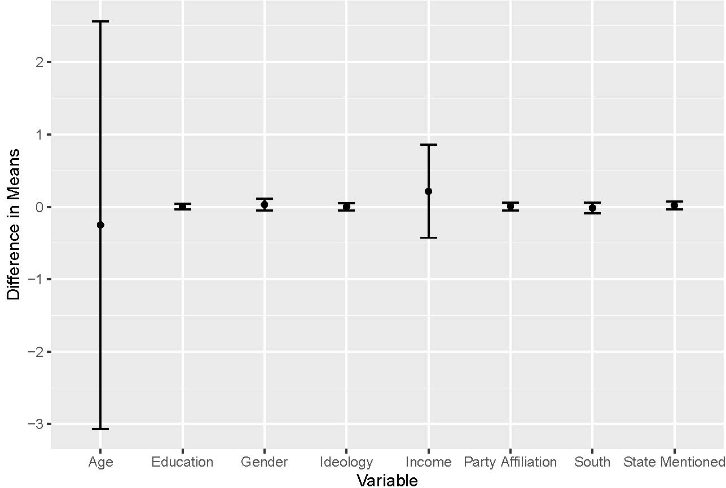

Figure A2: Distribution of Opinion on Individual Rights (0=Strongly Disagree, .25= Disagree, .5=Neither Agree Nor Disagree, .75=Agree, 1=Strongly Agree)

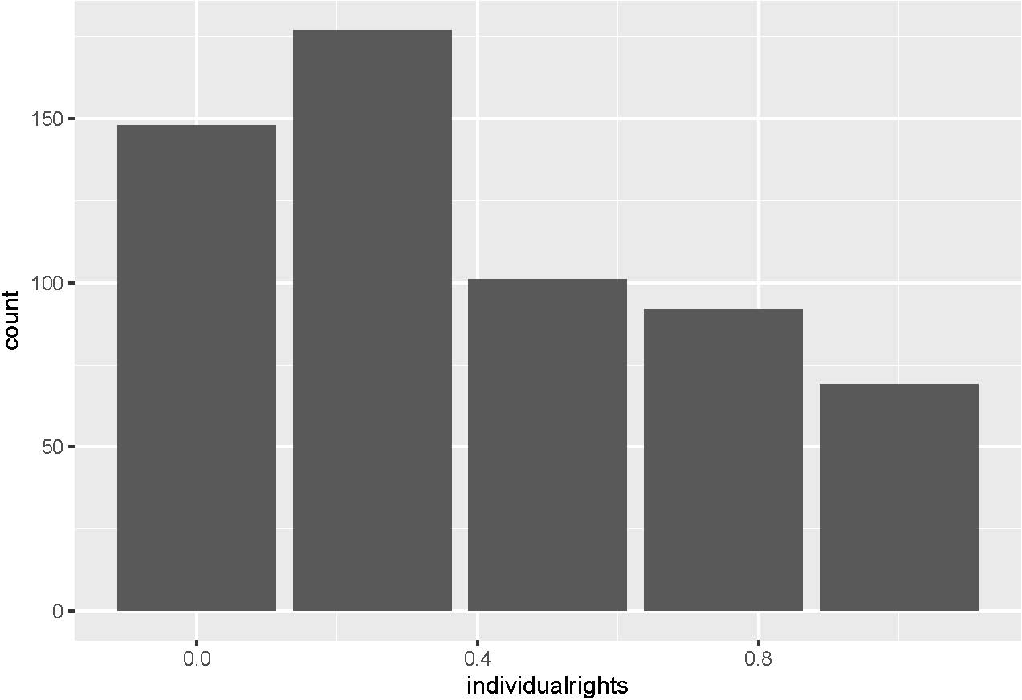

Figure A3: Distribution of Opinion on Facemasks (0=Extremely Important, .25=Very Important, .5=Somewhat Important, .75=Not Very Important, 1=Not At All Important)
,
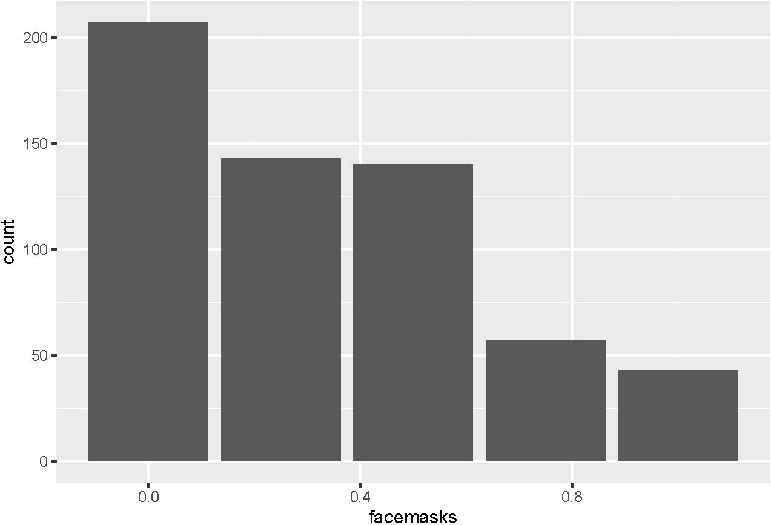

Figure A4: Distribution of Opinion on Visiting Parks (0=Not allowed at all .5=Allowed with restrictions, 1=Allowed without any restrictions)

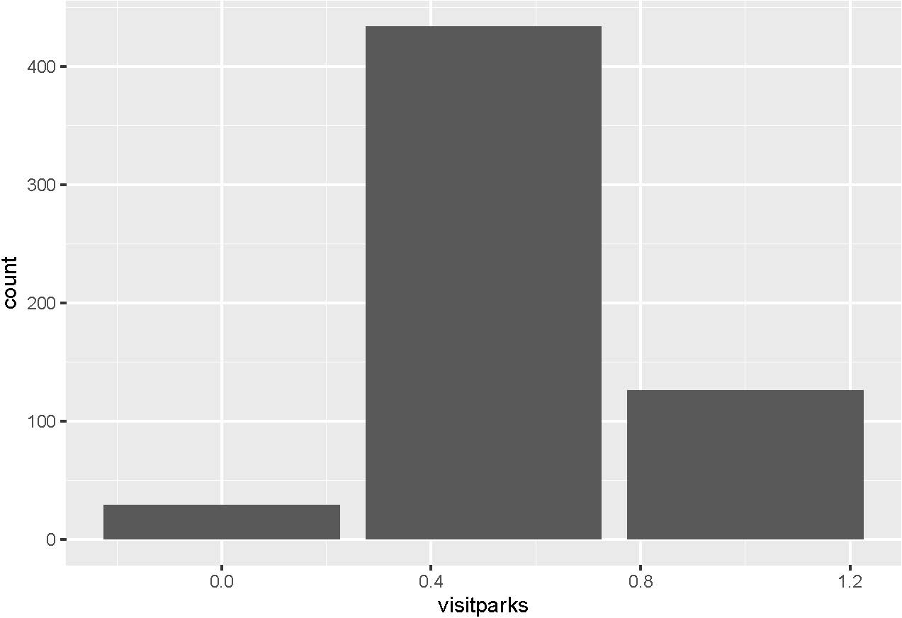

Figure A5: Distribution of the Perception that Black People Follow Social Distancing Guidelines (0=Always, .25=Most of the time, .5=Half of the time, .75=Some of the time, 1= All of the Time)

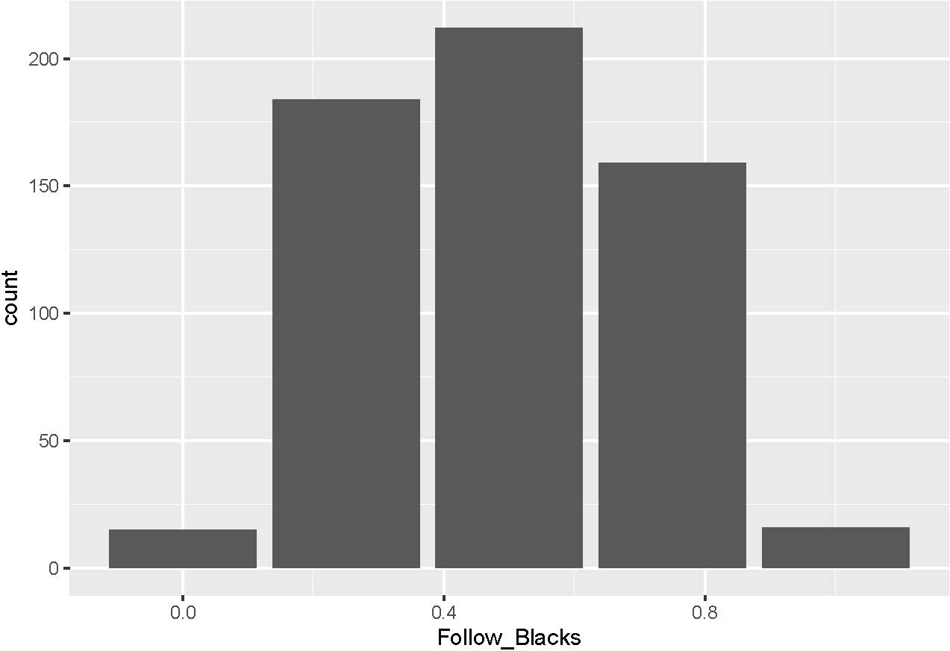

Research Ethics

Recruitment
Recruitment for my study was conducted by AmeriSpeak. Ameripeak provides a representative panel of civilian, non-institutional adults (age 18 and over) living in the United States. Recruitment is a two-stage process: initial recruitment using less expensive methods and then nonresponse follow-up using personal interviewers. For the initial recruitment, sample units are invited to join AmeriSpeak online by visiting the panel website (www.amerispeak.org) or by telephone. (inbound/outbound supported). Study invitations are communicated via a 6” x 9” prenotification postcard, a USPS recruitment package in a 9” x 12” envelope (containing a cover letter, a study brochure, and a non-contingent incentive), one follow-up postcard, and also followup by NORC’s telephone research center for matched sample units.

The second-stage nonresponse follow-up targets a stratified random subsample of the nonresponders from the initial recruitment. Stratification is based on consumer vendor data and stratification variables from the initial recruitment stage in order to increase sample representation of young adults, non-Hispanic African Americans, and Hispanics. Units sampled for the nonresponse follow-up are sent, by FedEx, a new recruitment package with an enhanced incentive offer. NORC field interviewers then make personal, face-to-face visits to the respondents’ homes to encourage participation. NORC field interviewers administer the recruitment survey in person using computer-assisted personal interviewing or else encourage the respondents to register at www.amerispeak.org or call the toll-free AmeriSpeak telephone number to register.
Consent
Consent was obtained via the National Opinion Research Center; the center that sponsors the AmeriSpeak Panel. Members of the AmeriSpeak Panel consent to participate in research that has no more than a minimal risk to the subject, which is criteria that my study met.
AmeriSpeak's recruitment procedures for protecting the rights of human research subjects have been reviewed and approved by NORC's Institutional Review Board (IRB). NORC obtains and documents informed consent and agreement to the study's Privacy Policy and Terms and Conditions during the registration process. After registration is completed, AmeriSpeak panel members first complete an introduction survey of about 15 minutes by web or by telephone asking questions about the household's composition and the person's background and interests. The introduction survey provides an initial profile of the panelist and the household. Upon completion of the registration process and introduction survey, therespondent is an active AmeriSpeak panel member eligible for client studies and additional profile surveys.

Compensation
Prior to fielding the survey, I estimated that the survey would take approximately 10 minutes to complete. AmeriSpeak panel members receive modest incentives, in the form of "AmeriPoints," for participation in surveys. For the majority of surveys a respondent will earn between 2,000 and 10,000 AmeriPoints (1,000 points = $1) for completing a survey. Subjects in my study received 2,000 points or the equivalent of $2. This amount was determined based on the federal minimum of $7.25 per hour. If the respondents were being paid minimum wage, they would have received about 1,200 points or $1.20. I opted to pay significantly more than the minimum wage at $2 for a survey that took on average 9.75 minutes to complete.

A panel member receives points for a survey once they complete the survey. A respondent can take breaks during a survey and return where they left off. In addition they may skip survey questions that they do not wish to answer. Once a panel member has accumulated 10,000 points they can redeem for cash (in the form of a check), debit cards, gift cards, or merchandise. Online members redeem points through the AmeriSpeak web-portal

IRB Approval
The study received IRB Approval on May 13, 2020 from my university. The study also received approval from NORC IRB

Deception
The study did not entail any deception. Respondents read about COVID-19 infection and mortality rates, which were accurate at the time of the study. Infection and mortality numbers have increased since the study was fielded in May 2020.

Confidentiality
The data were de-identified. All results are reported in the aggregate, so it is virtually impossible to identify any individual subject's responses.

Harm and Impact
The risks to the subjects were very minimal. They read statistics about coronavirus, which is a topic that is constantly in the news. The information was no different than something they would encounter watching television news or by reading a news publication.

Pre-Analysis Plan:
Backlash Effect? White Americans’ Reaction to Racial Disparities in COVID-19 Outcomes

This is a pre-analysis plan for a study that examines how information about the disproportionate impact of the coronavirus on Black communities influences White Americans’ reactions to the crisis. To answer this question, I will conduct a survey experiment, varying whether participants receive information about the racial disparities of COVID-19 outcomes. I will analyze the impact of this information on respondents’ reactions to efforts to curb the coronavirus. This plan was written during data collection but prior to any analysis.

Introduction

Initially, the coronavirus was perceived to be a “great equalizer,” infecting and killing Americans of all racial groups. However, as the crisis unfolds, it is becoming evident that rather than “equalizing,” the coronavirus has exposed racial disparities in health outcomes. In areas where the data are available by race, the evidence indicates that Blacks are disproportionately affected by the coronavirus—both in the sheer number of cases and in the number of deaths from the virus.

I propose that we can learn more about whether White Americans may be more resistant to efforts to curb the virus and more supportive of protests to reopen states when the crisis is framed as disproportionately harming African Americans. As the coronavirus pandemic unfolds, it is important to learn whether White Americans’ evaluations of a seemingly race-neutral public health crisis are altered when they are reminded of the disproportionate impact of the crisis on their Black counterparts.

I am drawing on previous research that found racial stimuli can be associated with a negative response, such that White respondents were more supportive of capital punishment when informed that it disproportionately affected African Americans (Peffley and Hurwitz 2007). This effect has been widely cited in political science (Knoll, Redlawsk, and Sanborn 2010; Weber and Thornton 2012) and has also influenced research in criminal justice (Unnever and Cullen 2009; Pickett et al. 2012; Ramirez 2013), law (Lopez 2010; Unah 2009; Glaser, Karin, and Kahn 2015), and sociology (Savelsberg and King 2011) Scholars, however, have not tested for a backlash effect, with respect to the public’s evaluations of public health crises. Moreover, recent research has called into question whether this effect still exists in the area of capital punishment (Butler et al. 2018).

Testing for the existence of a backlash effect is important because it has implications for how public health crises are framed, as well as the solutions for crises that are deemed viable. Thus, this study makes a contribution to our understanding of intragroup differences in public opinion and a contribution to our understanding of how the public reacts to public health crises.

I fielded a pilot study on the survey platform, Prolific on, April 20, 2020 on a sample of 343 White Americans. Republicans constitute 52 percent of the sample (including leaners), whereas 48 percent of the sample identifies as Democrats (including leaners). The sample is more educated than the general population, with about 57 percent reporting that they have a Bachelor’s degree or higher. Women accounted for 57 percent of the sample, and 34 percent of the sample live in the South.

In the pilot, I found that respondents who were exposed to information about the disproportionate impact of coronavirus on African Americans were approximately 20 percentage points less likely to think that the United States should take measures aimed at slowing the spread of coronavirus, relative to the respondents in the control condition (p < 0.05).

When asked whether people who are participating in protests and rallies to pressure their governors to reopen their states should follow the rules and stay at home, respondents who were exposed to the treatment were about 20 percentage points less likely to agree with the statement (p<.05).

Finally, when respondents were asked whether they thought that people who engaged in risky behavior that could further spread the virus should be fined, White Americans in the treatment condition were less likely to support fines for risky behavior, relative to White Americans in the treatment. In sum, reporting racial health disparities in COVID-19 helped to racialize the virus, such that racially prejudiced Whites became more resistant to efforts to curb the virus.
Experimental Design

Given what I found in the pilot study, I propose fielding a one-wave survey experiment on a nationally representative sample of 575 Whites. The condition and treatment will be blocked by party identification so that there are roughly equal numbers of Republicans and Democrats in each condition. Subjects will be asked questions about their racial attitudes, including the racial resentment scale, the negative stereotype battery, and attributions for racial disparities in health outcomes (individual versus structural), followed by distractor questions. Subjects will then be randomly assigned to one of two conditions (control and treatment). In the treatment, subjects will be given information about how Black communities have been disproportionately affected by the coronavirus. In the control, subjects will not be provided with any information about the racial disparities associated with the coronavirus.

After receiving the language in either the treatment condition or the control condition, subjects will answer a series of questions about their support for the reopening of the country, their support for protests regarding reopening the economy, their evaluations of political elites who may have made vocal calls to either “reopen” the country or to keep shelter in place orders in tact until more widespread testing becomes available.

On the following pages, I have included the text and mockup of the treatments, to give an idea of what the respondents will see.

Treatment

As of May 21, 2020, there have been more than 1.5 million cases of coronavirus (COVID-19) in the United States. Over 93,000 Americans have died as a result of the coronavirus (COVID-19), but some places have been hit harder than others, with Blacks/African Americans having disproportionate death rates. In New York, which has the country’s highest numbers of confirmed cases and deaths, over 22,000 people have died, but Blacks/African Americans are three times as likely to die as Whites. In Michigan, over 5,000 people have died from the virus, but Blacks/African Americans are five times as likely as Whites to die from the virus. In Louisiana, where 2,485 people have died from the virus, Blacks/African Americans account for 60% of the coronavirus deaths, while they are only 33% of the population. Finally, in Illinois, 4,525 people have died from the coronavirus. Blacks/African Americans account for 42% of the coronavirus deaths in Illinois, although they are only 15% of the population. Collectively, Blacks/African Americans represent 12.9% of the population nationwide but have suffered 25.1% of deaths.
Control
As of May 21, 2020, there have been more than 1.5 million cases of coronavirus (COVID-19) in the United States. Over 93,000 Americans have died as a result of the coronavirus (COVID-19), but some places have been hit harder than others. In New York, which has the country’s highest numbers of confirmed cases and deaths, over 22,000 people have died. In Michigan, over 5,000 people have died from the virus. In Louisiana, 2,485 people have died from the virus. Finally, in Illinois, 4,525 people have died from the coronavirus.

Hypotheses
I expect that high levels of negative racial attitudes toward African Americans (i.e., racial resentment, negative stereotype endorsement about Blacks) will moderate the effect of the treatment, such that people with high levels of negative attitudes toward African Americans will exhibit a “backlash” to the treatment. In other words, when exposed to the treatment that the coronavirus is disproportionately affecting African Americans, people with negative attitudes toward Blacks will become more resistant to efforts to curb the virus, and more supportive of efforts to protest shelter in place orders. I also have the same expectations for people who attribute racial disparities in health to African Americans making Blacks making “poor health choices, such as eating unhealthy food and not exercising.” Specifically, I hypothesize that White Americans with anti-Black attitudes and those White Americans who attribute racial disparities in health to individual behavior (as opposed to structural factors), will be more likely to disagree with the following statements:

The United States should take measures aimed at slowing the spread of the coronavirus while more widespread testing becomes available, even if that means many businesses will have to stay closed.

It is important that people stay home rather than participating in protests and rallies to pressure their governors to reopen their states.

I also hypothesize that White Americans with anti-Black attitudes and who attribute racial health disparities to individual behavior will be more likely to agree with the following statements:

State and local directives that ask people to "shelter in place" or to be "safer at home" are a threat to individual rights and freedom
The United States will take too long in loosening restrictions and the economic impact will be worse with more jobs being lost

Moderators:
The moderators will be measured and coded as follows. First, we will code them so higher
values represent more racially resentful or conservative predispositions. We will divide these into bins defined by a substantively meaningful range of values, while ensuring that each bin is
sufficiently powered. For racial predispositions, we will use two or three bins, depending on their
distributions. For ideology and party, we will use three bins. We will include each bin as a dummy variable, omitting one category as a baseline.

1. Racial resentment (Kinder and Sanders 1996): A combined index of the following four
closed-ended, five-point measures, rescaled from 0 to 1, binned and dummied out.
Question wording from American National Election Study.
a. “The Irish, Italian, Jews, and many other minorities overcame prejudice and
worked their way up. Blacks should do the same without any special favors.
Do you agree strongly, agree, neither agree or disagree, disagree, or disagree strongly?” (We will code this as: strongly disagree = 0, disagree = 0.25, neither agree or disagree = 0.5, agree =
0.75, strongly agree = 1)
b. “Generations of slavery and discrimination have created conditions that make
it difficult for blacks to work their way out of the lower class. Do you agree strongly, agree, neither agree or disagree, disagree, or disagree strongly?” (We will code this as: strongly disagree = 0, disagree = 0.25, neither agree or disagree = 0.5, agree = 0.75, strongly agree = 1)
c. “Over the past few years, blacks have gotten less than they deserve. Do you agree strongly, agree, neither agree or disagree, disagree, or disagree strongly?” (We will code this as: strongly disagree = 0, disagree = 0.25, neither agree or disagree = 0.5, agree = 0.75, strongly agree = 1)
d. “It's really a matter of some people not trying hard enough; if Blacks would only try harder they could be just as well off as whites. Do you agree strongly, agree, neither agree or disagree, disagree, or disagree strongly?” (We will code this as: strongly disagree = 0, disagree = 0.25, neither agree or disagree = 0.5, agree = 0.75, strongly agree = 1
2. Negative Stereotype Endorsement
Imagine a seven-point scale on which the characteristics of the people in a group can be rated. A score of “1” means that you think almost all of the people in that group tend to be LAZY/UNINTELLIGENT. A score of “7” means that you think most people in the group are HARDWORKING/INTELLIGENT. A score of “4” means that you think most people in the group are not closer to one end or the other, and of course, you may choose any number in between.
The difference between the rating of Blacks and Whites is taken on both dimensions (intelligence and hard work) and then averaged.

3. Attributions for Health Disparities
On average, Blacks/African Americans have worse health outcomes than White Americans.

On a scale of 1 through 7, indicate how much each of the following factors contributes to these racial differences in health outcomes. A score of “1” means that you think the explanation is “Not at All” a factor, while a score of “7” means that you think the explanation contributes “A Great Deal” to racial differences in health outcomes.

Genetic differences between Blacks/African Americans and Whites.
Blacks/African Americans have less access than Whites to health insurance, high quality healthcare and healthy food.
Blacks/African Americans make more unhealthy choices than Whites, such as eating unhealthy food and not exercising.
Blacks/African Americans face more discrimination than Whites, which can be linked to poor health outcomes.

Pre-treatment covariates:
Age (numeric)
Region (0 = non-south, 1 = south; as a robustness check, non-south will be further divided by
region, for example, Northeast, Midwest, West, if there is sufficient statistical power)

Education (a set of dummy variables: Less than high school (omitted baseline), High school
graduate, Some college, College graduate, Post-graduate)

Gender (0 = male, 1 = female)

Income (a set of dummy variables: Less than $25,000 (omitted baseline), $25,000 to $34,000,
$35,000 to $49,0000, $50,000 to $74,999, $75,000 to $99,999, $100,000 to $149,999, $150,000
or more, and Refused or Don’t Know)

Partisanship (see Moderators, above)

Ideology (see Moderators, above)

At the time that the study was fielded, national data about racial disparities in COVID-19 were not publicly available. I relied on these specific states, because COVID-19 deaths and case rates by race were publicly available for these states.
Given the results from my pilot data, it is also my expectation that partisanship will moderate the effect of the treatment or that the treatment effects will be concentrated among Republican respondents.

