Appendix

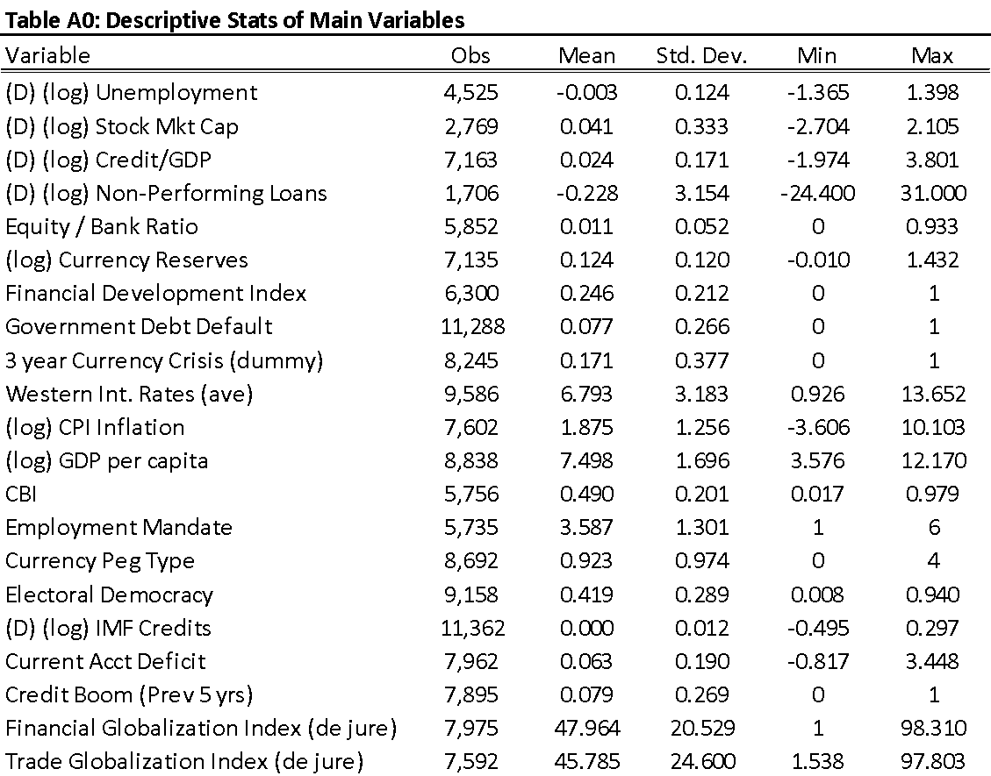

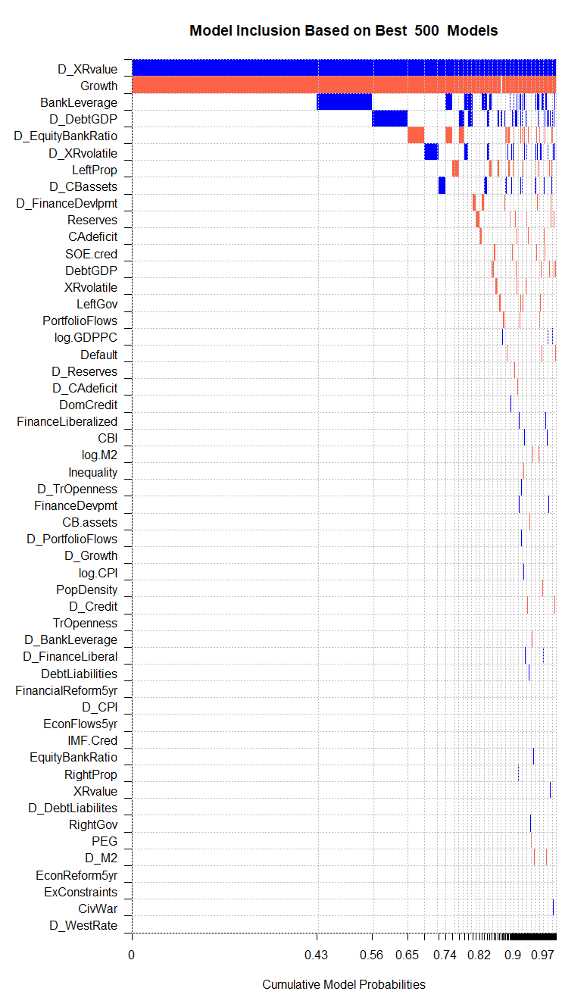

**Figure A1 – BMA Model Results**



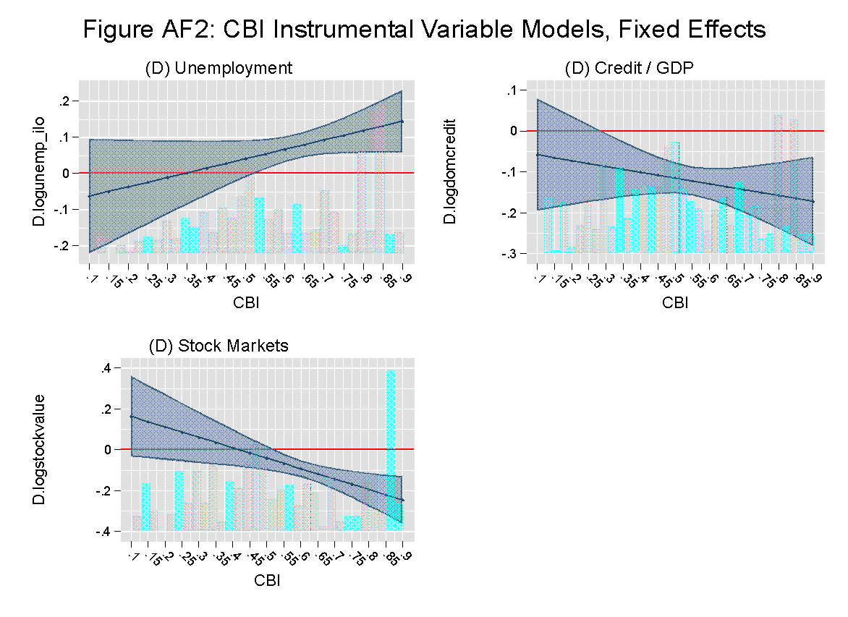

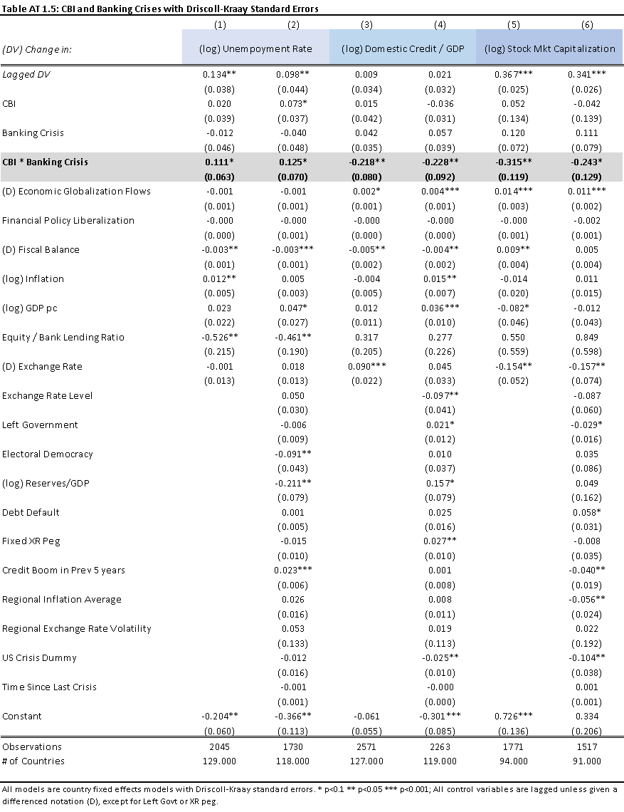

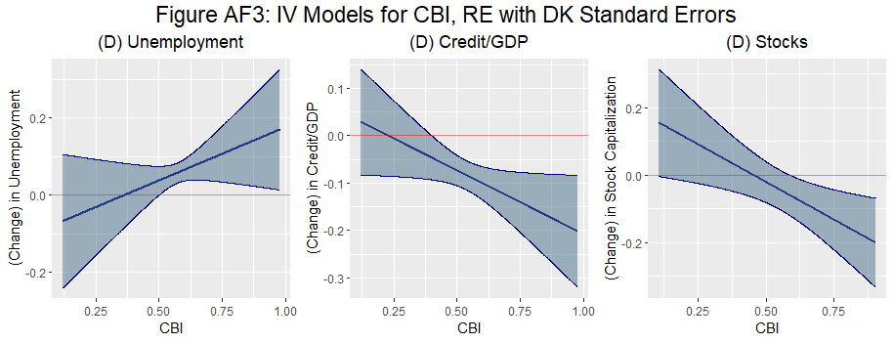

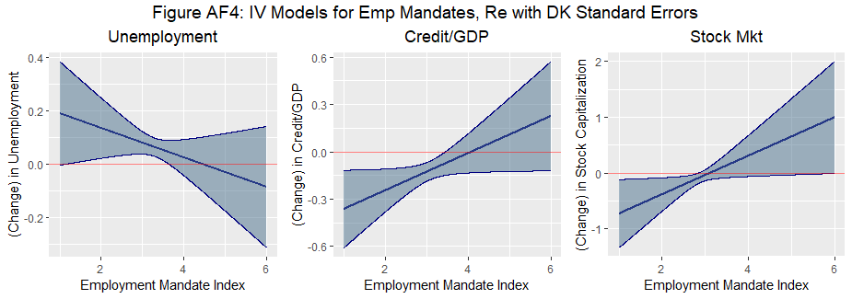

The above marginal effects are taken from the next two output tables, AT2 and AT3, which are alternate operationalizations of the IV approach. Here I also use the same IV strategy as applied to CBI but also apply it to the employment mandate models. Conventional Fixed effects approachs with this IV method yielded the same inferential results, but the instruments were not sufficiently strong for the employment mandate models (unlike with CBI). This is not surprising, given how much less variation there is for employment mandate changes and the inefficiency of fixed effects. Thus, these models were estimated via random effects, for which instrument strength tests are dramatically improved and are at or exceed F tests of 20. Confidence intervals are 90% confidence intervals.

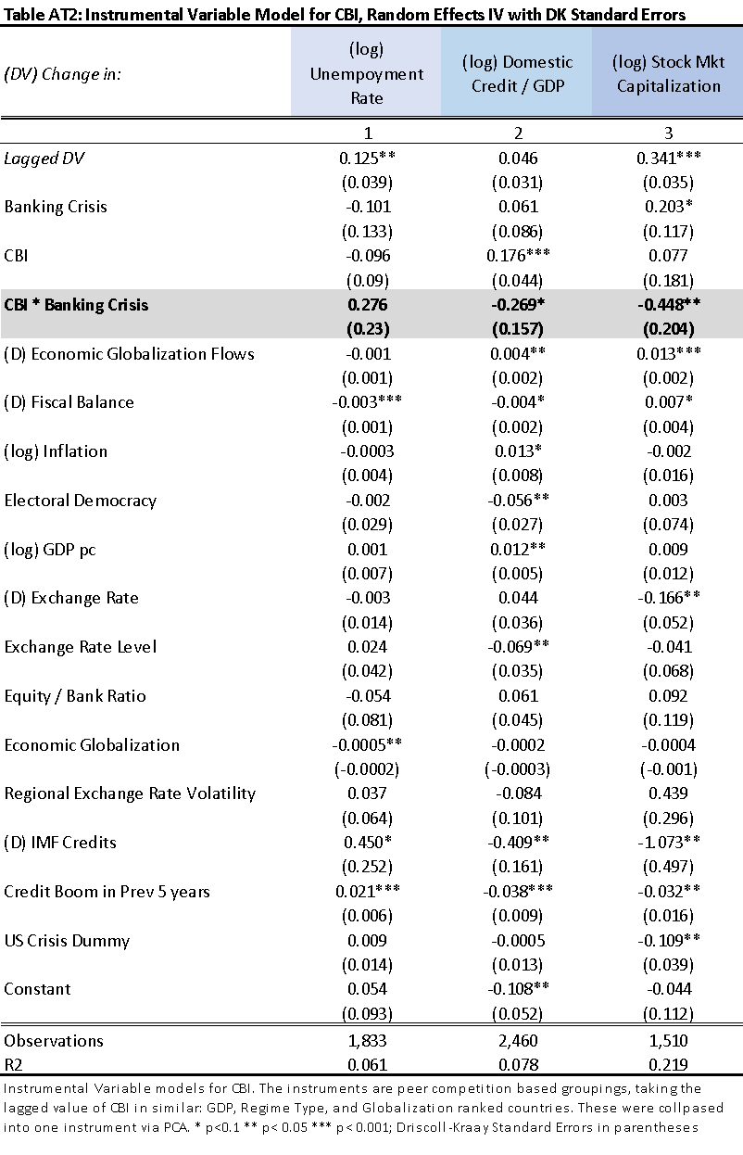

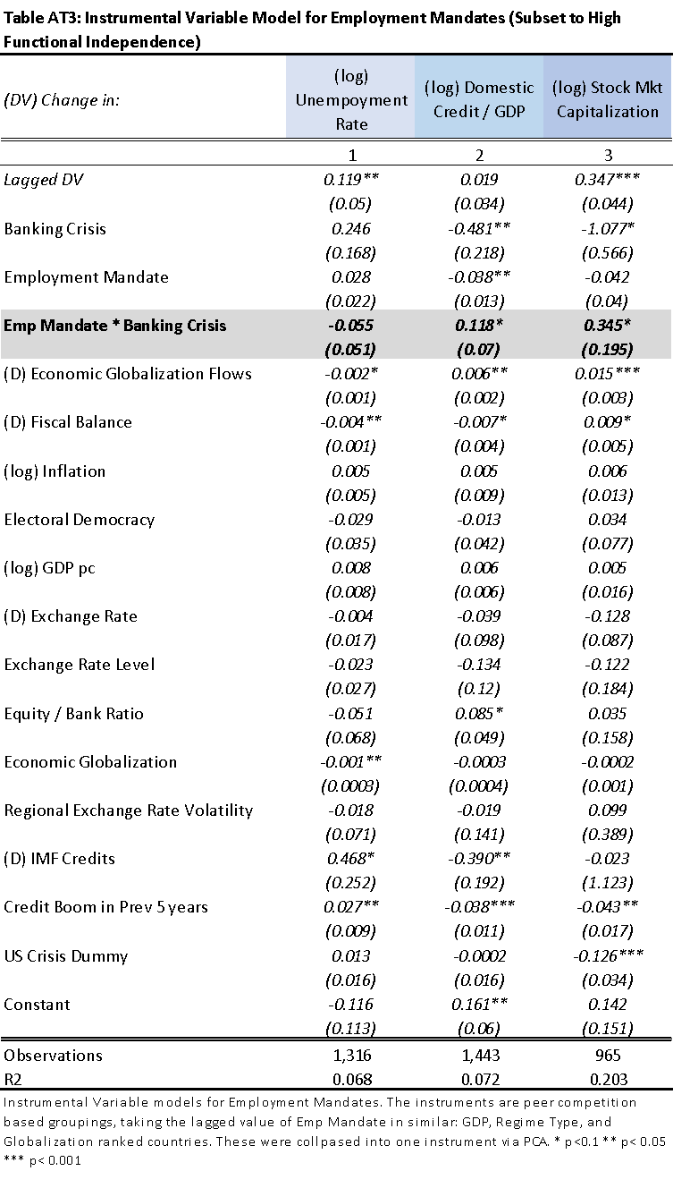



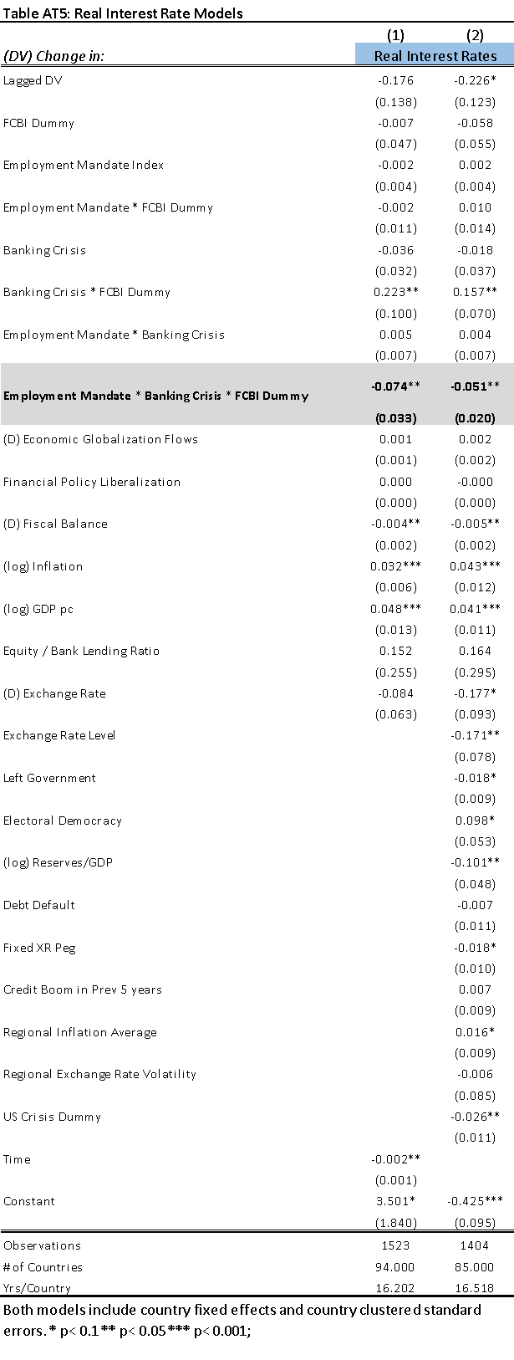

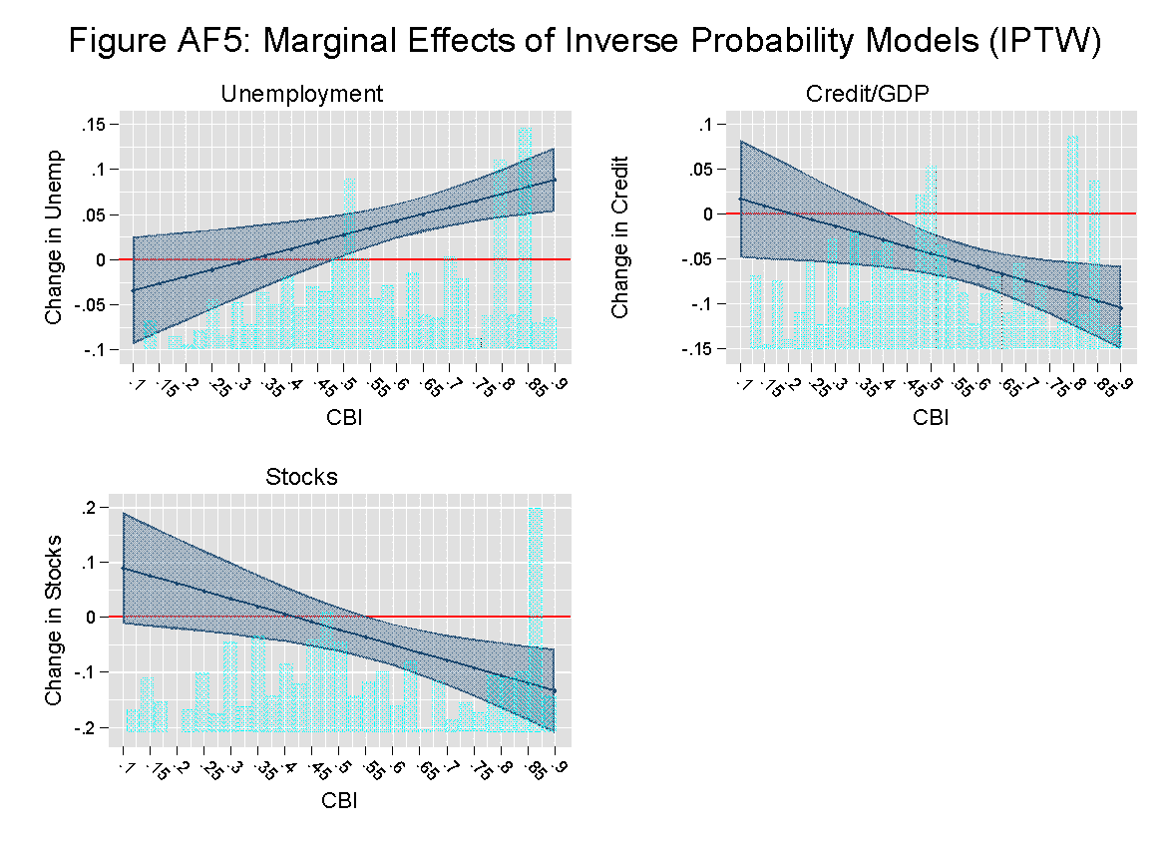



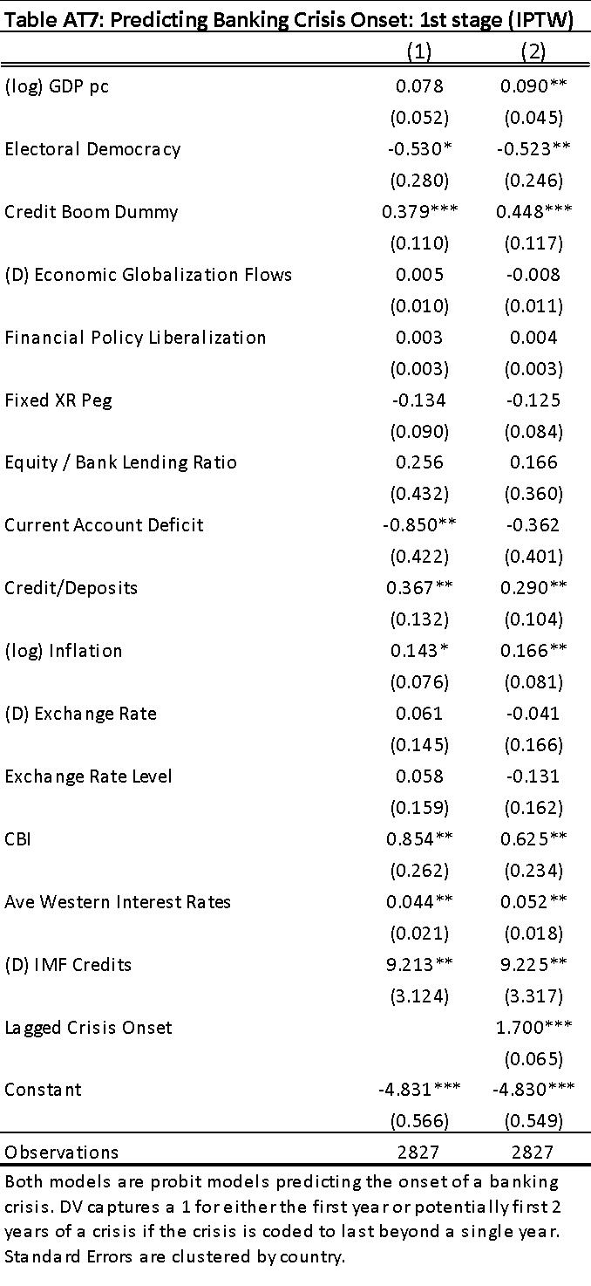

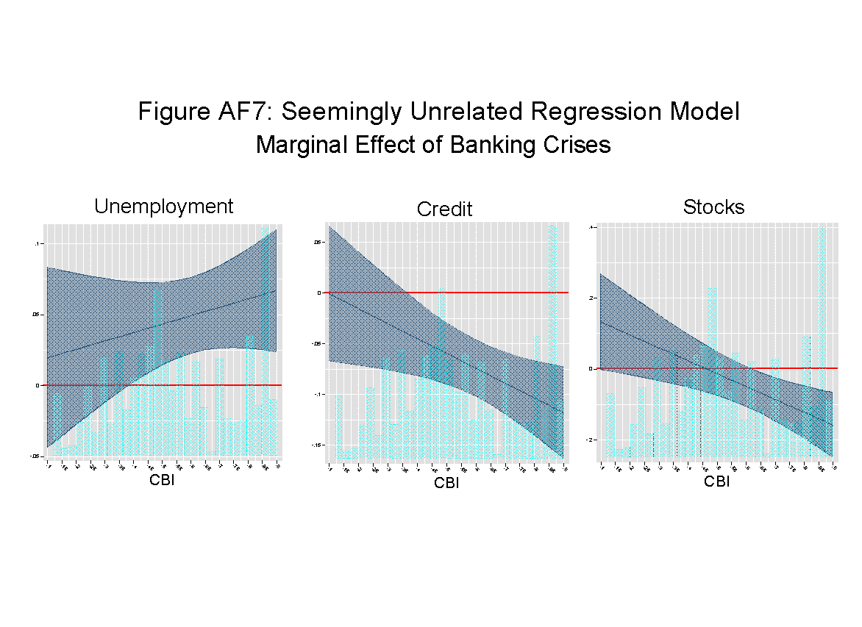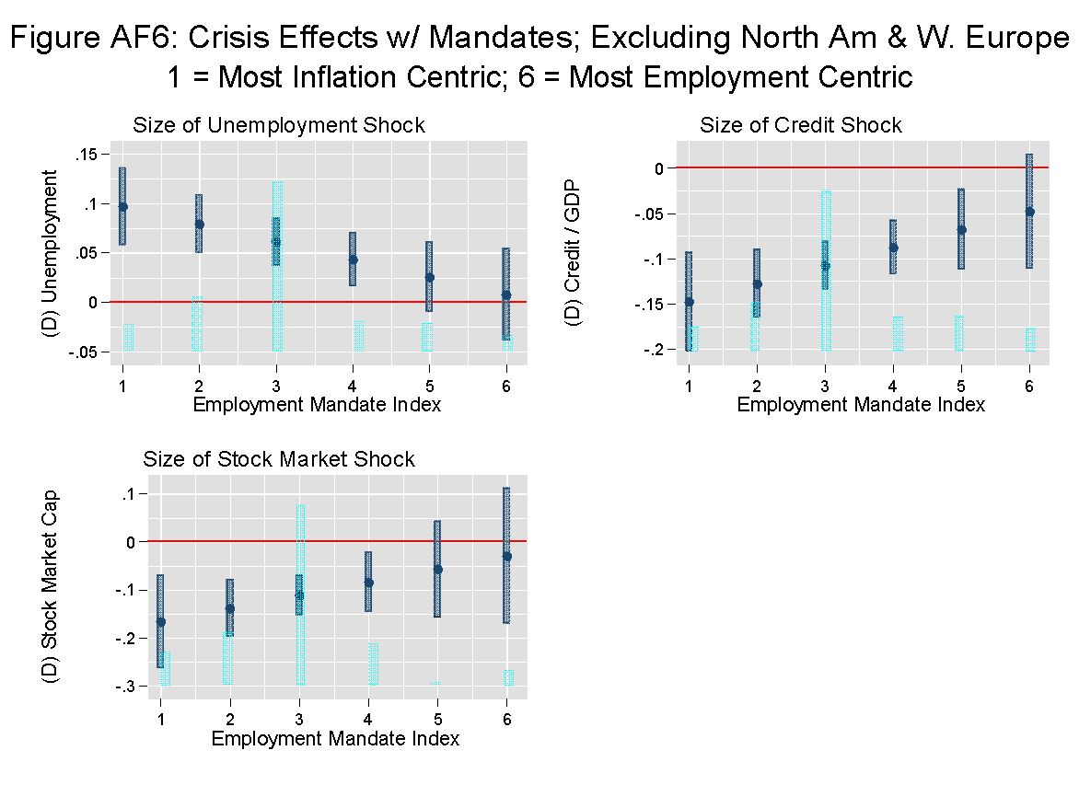

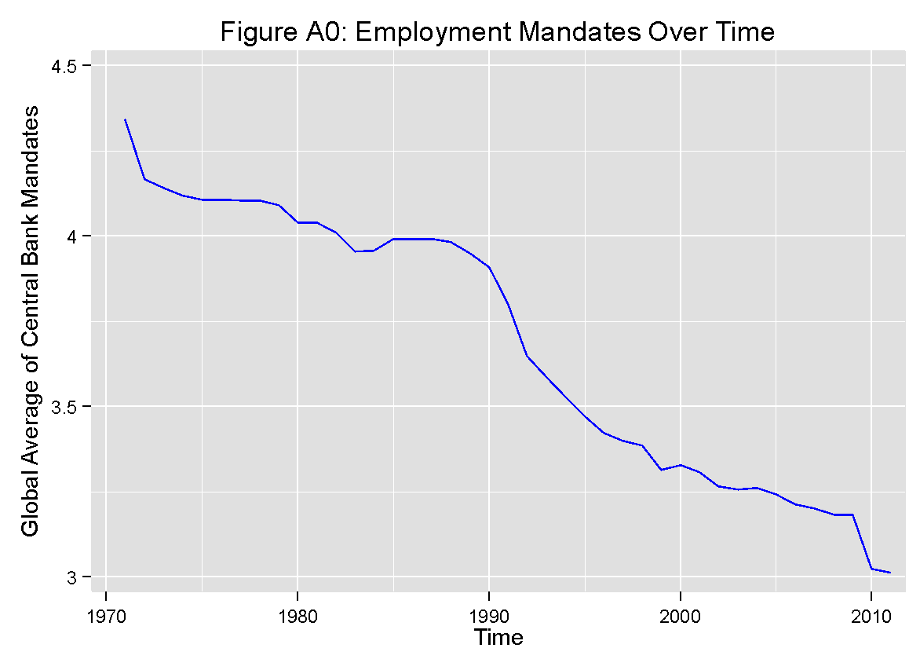

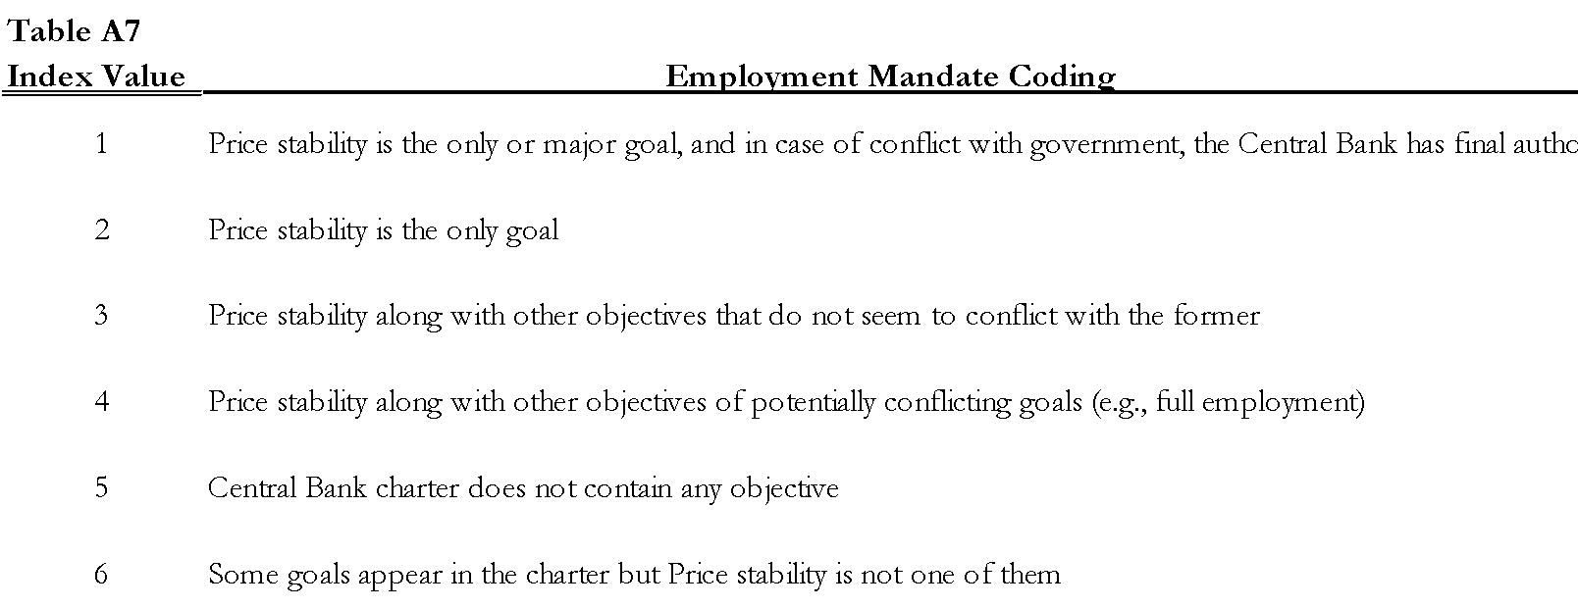

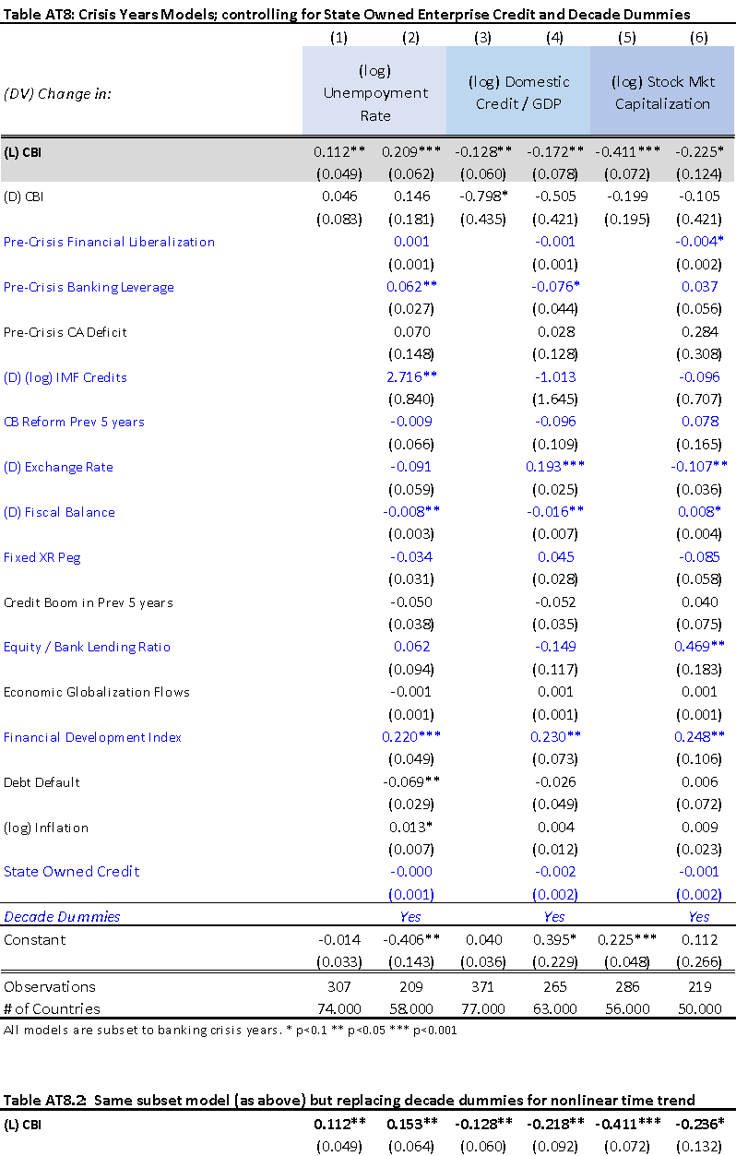

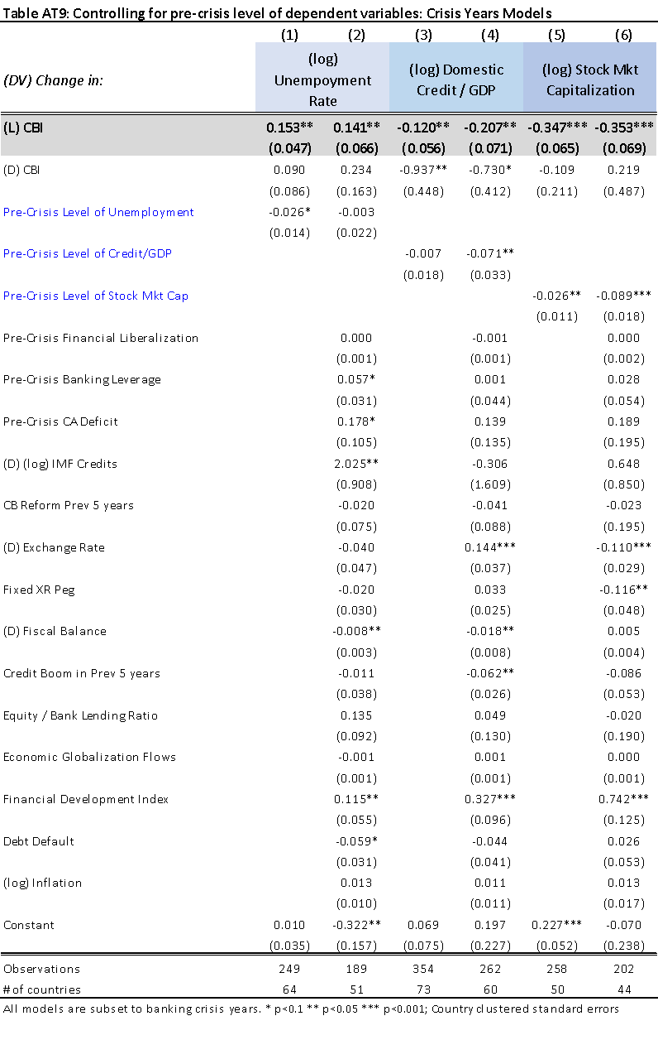Table AT9 provides evidence that the significant negative shocks associated with CBI is not simply driven by a high pre-crisis level of the DV. The eliminates the possibility that a high pre-crisis lending or stock market boom simply preceded a significant crash. The CBI results hold.





Above in table AT11 is an assessment for whether CBI also predicts the magnitude and nature of the size of the governments fiscal response. The model is subset to banking crisis years as a random effects estimation, but the results did not change with regional fixed effects. Also, an additional model interacting CBI here with the time trend was estimated, but was insignificant.



Table AT12 attempts to resolve issues of data quality, accuracy, and potential correlations with CBI and the outcomes associated with the main results. This table reports weighted regressions based and various measures known to highly correlate with data quality – HRV Economic Transparency, the World Bank’s “statistical capacity” continuous measure, and the level of polyarchy (VDEM) democracy. For the “Stats Cap” measure, to maximize sample size, I first regress the WB measure on (log) gdp-pc, polyarchy democracy, and HRV transparency. I then obtained the fitted values, and used this “Stats Cap” as the weighting measure in models 2, 5, and 8.



Figure AF8 is the marginal effect of an alternate policy indicator than real interest rates. Here the short-term treasury bill rates are used, which is common the monetary transmission literature in developing countries. It is highly controlled by central banks even in poor developing countries, and it highly corroborates the real interest rate results.







