Contents
Appendix C: Pride parade vignette 1
Appendix D: Additional analyses 3
Non-stratified results 3
Placebo treatment 5
Country-specific estimates 6
Flexible interaction models of outcome treatment with nationalism and authoritarianism scales 10
Authoritarianism and Nationalism by Party Preference 13
Interactions with voting intent for right-wing populist parties 15
Correlation matrices 17
Appendix E. Regression tables 18

Appendix C: Pride parade vignette

In our original pre-registered experiment, 1500 respondents in Poland were assigned to a vignette involving a gay pride parade. As we discuss in the pre-registration document, LGBT rights are a primary issue in right-populist mobilization in Poland. Gay pride parades have often been met with restrictions from local officials, especially in Eastern Europe but European courts have ruled that such bans violate freedom of assembly. The specific vignette we designed followed the same format as our other vignettes, where national officials take some action restricting rights, local courts decide in favor or against the officials and a European court upholds or overturns the local court decision:
Suppose that the mayor of a Polish town has banned a gay pride parade, which is a public event that celebrates lesbian, gay, bisexual, transgender, and queer acceptance, achievements, and rights. The pride parade’s organizers have appealed the decision to ban the parade at a Polish court. The Polish court has found that the authorities [CAN/CAN NOT] ban the parade. A European court then [AGREED WITH/DISAGREED WITH] the Polish court. The final decision is that the gay pride parade [CAN TAKE PLACE/CAN NOT TAKE PLACE].

Unfortunately, a translation issue in implementation made our results for this experiment unusable. During the fielding of the survey, the “parade can take place” final sentence appeared in vignettes where the authorities “could” ban the parade (and vice-versa). As a result, the wording of the vignette was contradictory with respect to the ultimate outcome – the final sentence contradicted the combination of rulings. We present the estimated effects for the outcome and deference treatments here for completeness and transparency. However, we emphasize that the confusing nature of the vignette with respect to the outcome makes these estimates substantively meaningless.

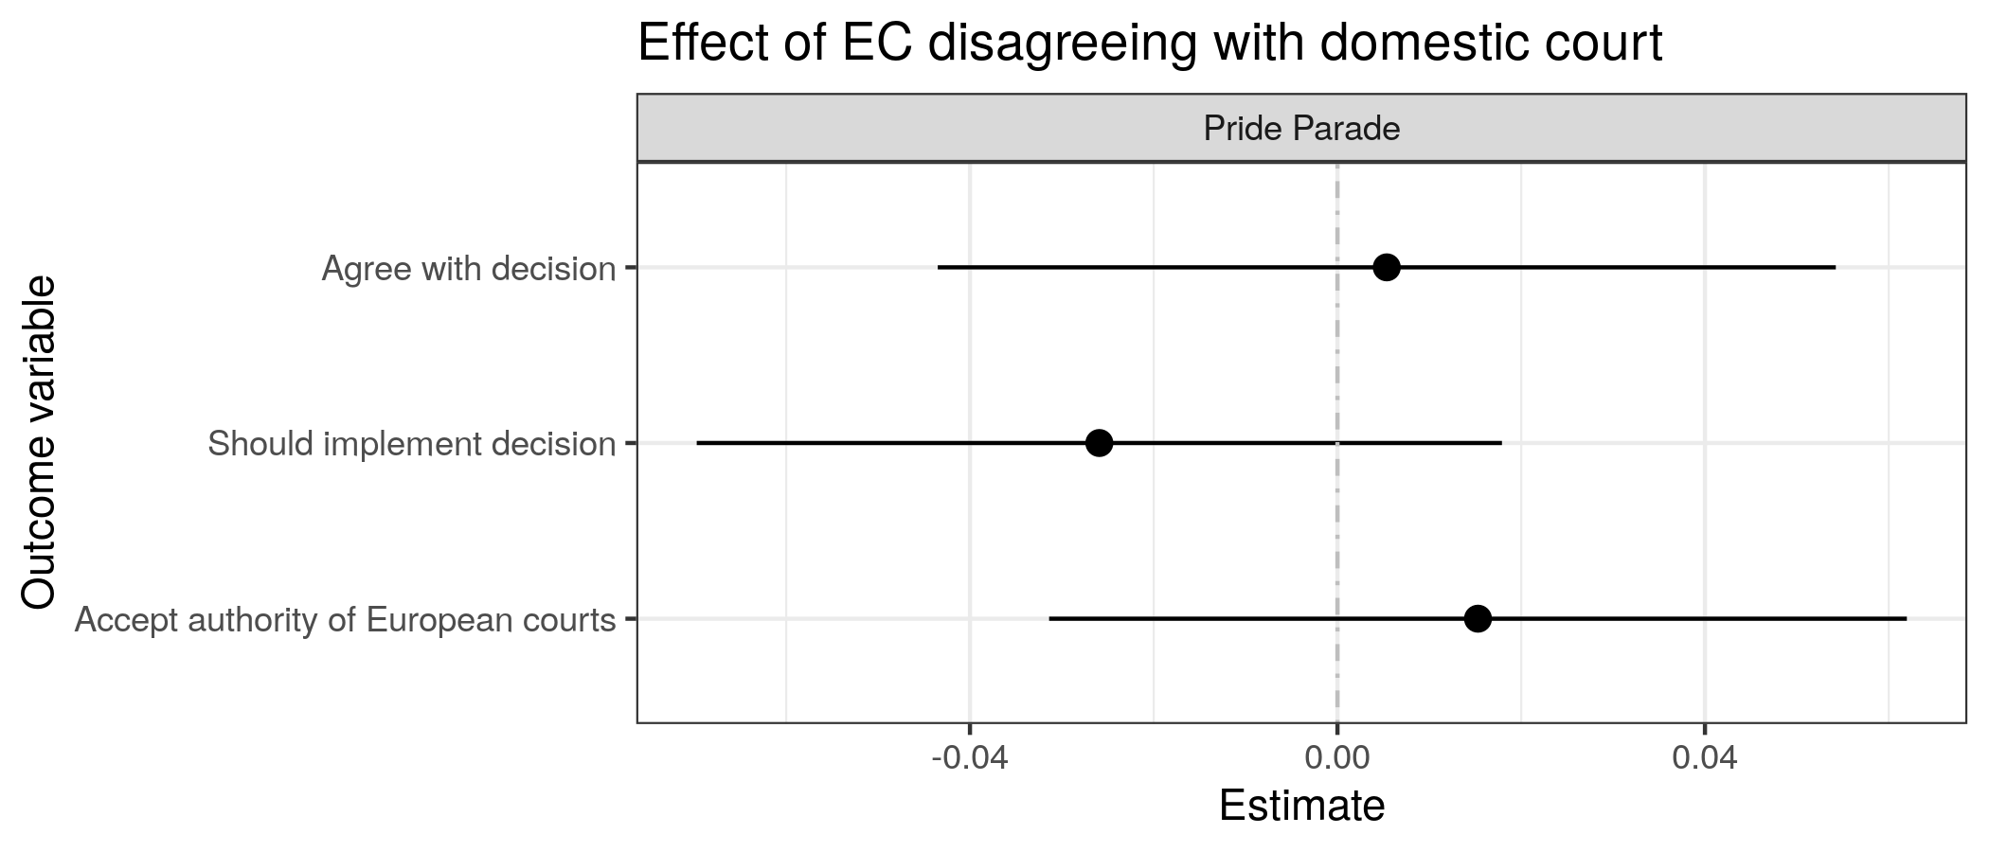
Figure C1: Average treatment effect of European court disagreeing with a domestic court. Lines denote 95% confidence intervals – Pride Parade vignette
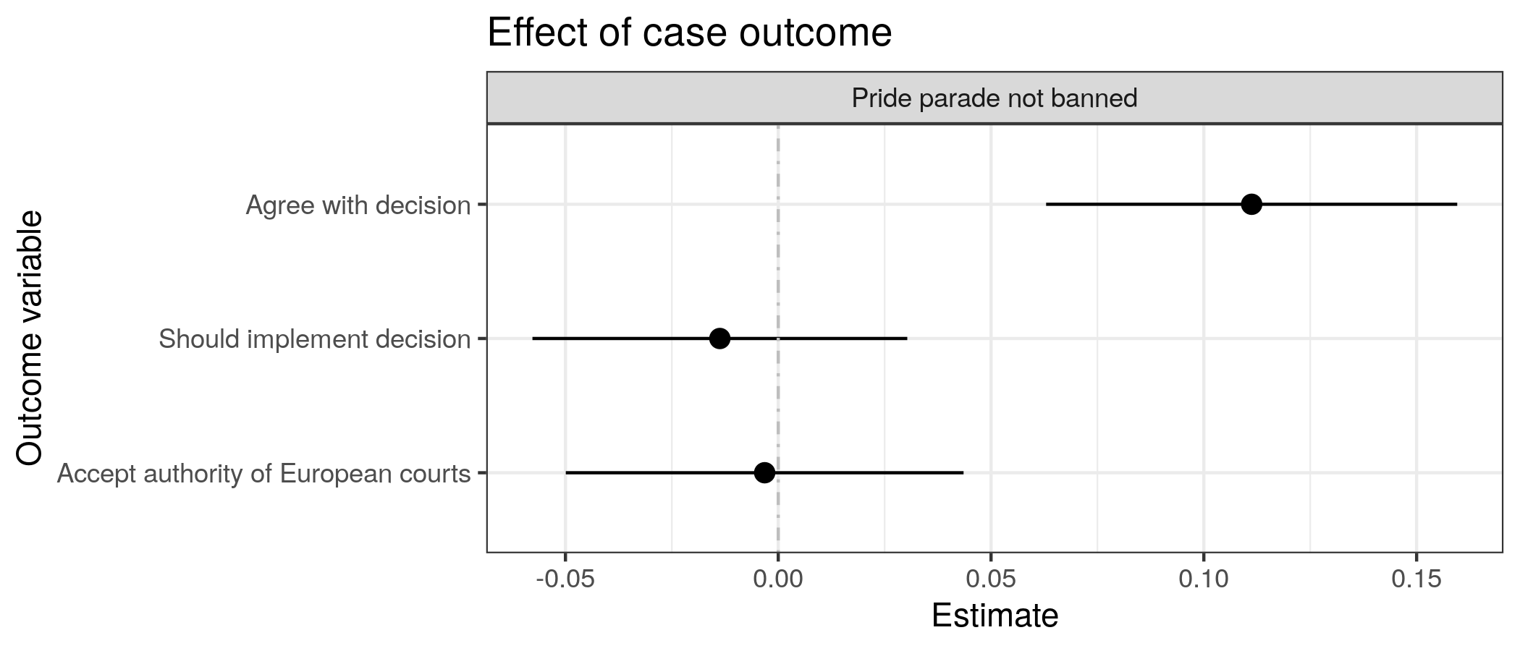
Figure C2: Average treatment effect of case outcome. Lines denote 95% confidence intervals. – Pride Parade vignette

Appendix D: Additional analyses

Non-stratified results
This section replicates the main effect estimates for the outcome and deference treatments (H1 and H2) without post-stratification. Results are nearly identical to the stratified estimates.
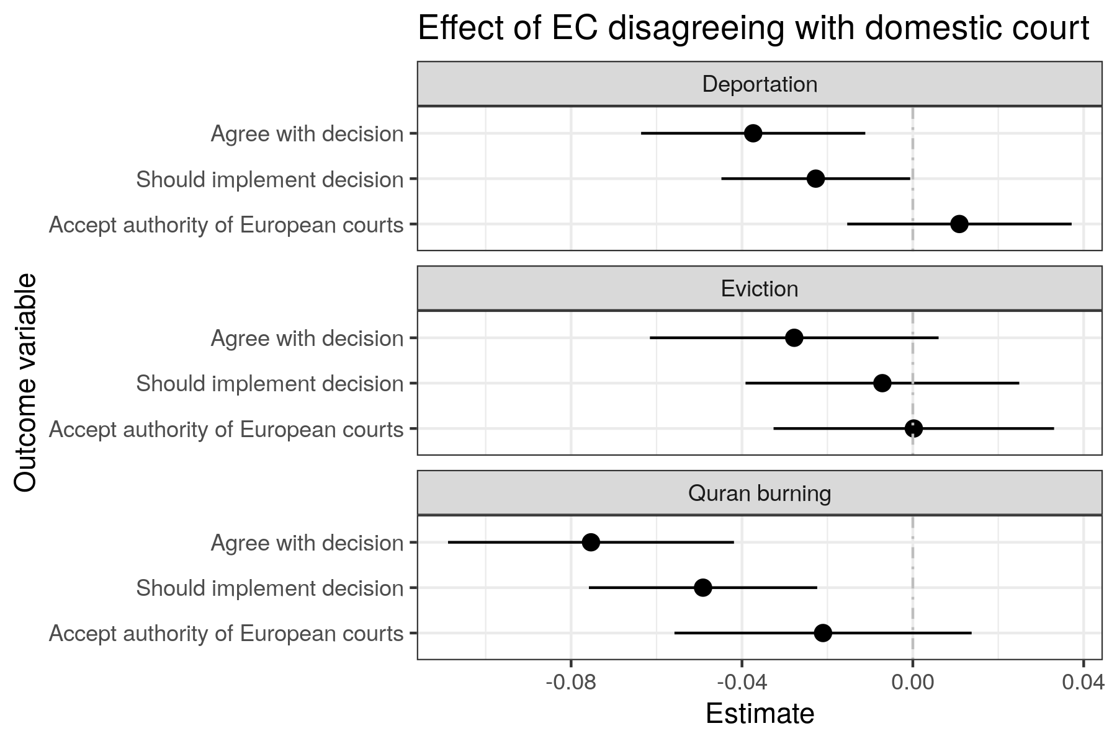
Figure D1: Average treatment effect of European court disagreeing with a domestic court - No post-stratification
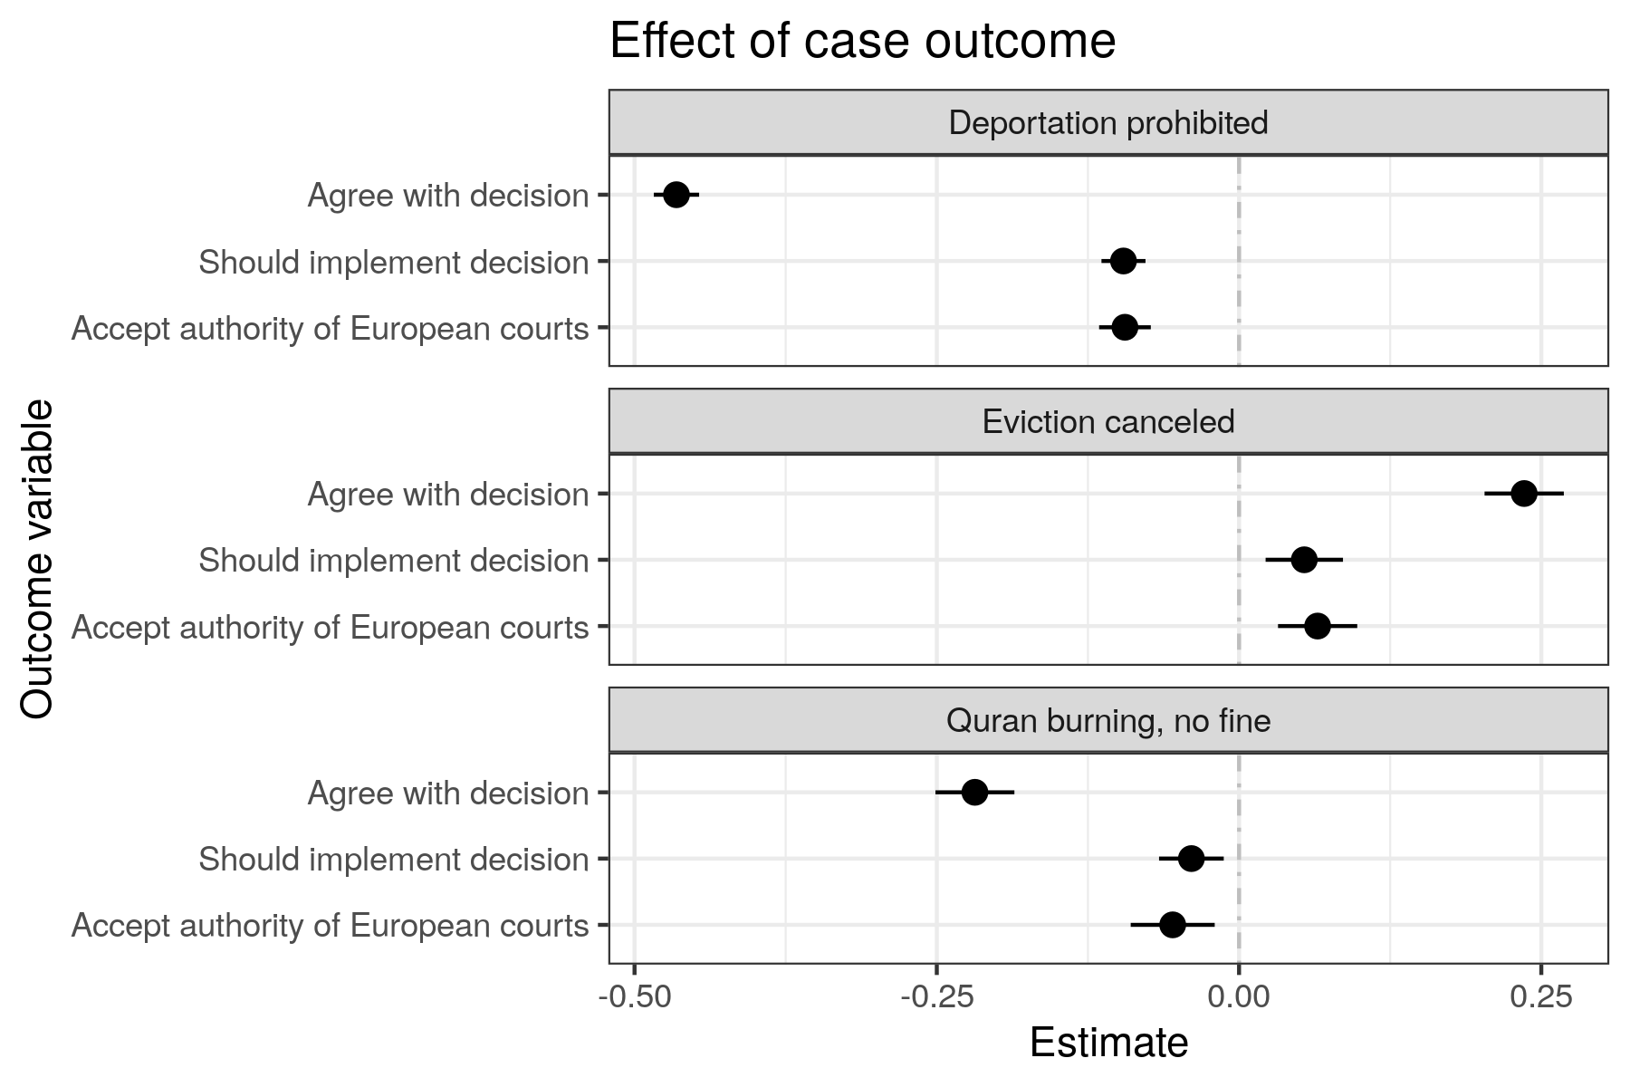
Figure D2: Average treatment effect of case outcome. Lines denote 95% confidence intervals. – No post-stratification
Continuous outcome variable
Each outcome question answered by respondents took the form of a six-level scale from strongly disagree to strongly agree. In the main text and pre-registration we analyzed a coarsened version of this outcome – a binary indicator for whether the respondent selected any of the three “agree” levels (slightly agree, agree, strongly agree). Here, we conduct the same analyses from the main paper using our post-stratified difference-in-means estimator on the full 6-level agreement scale converted to a numeric value (1-6). Results are substantively identical to those using the binary outcome.
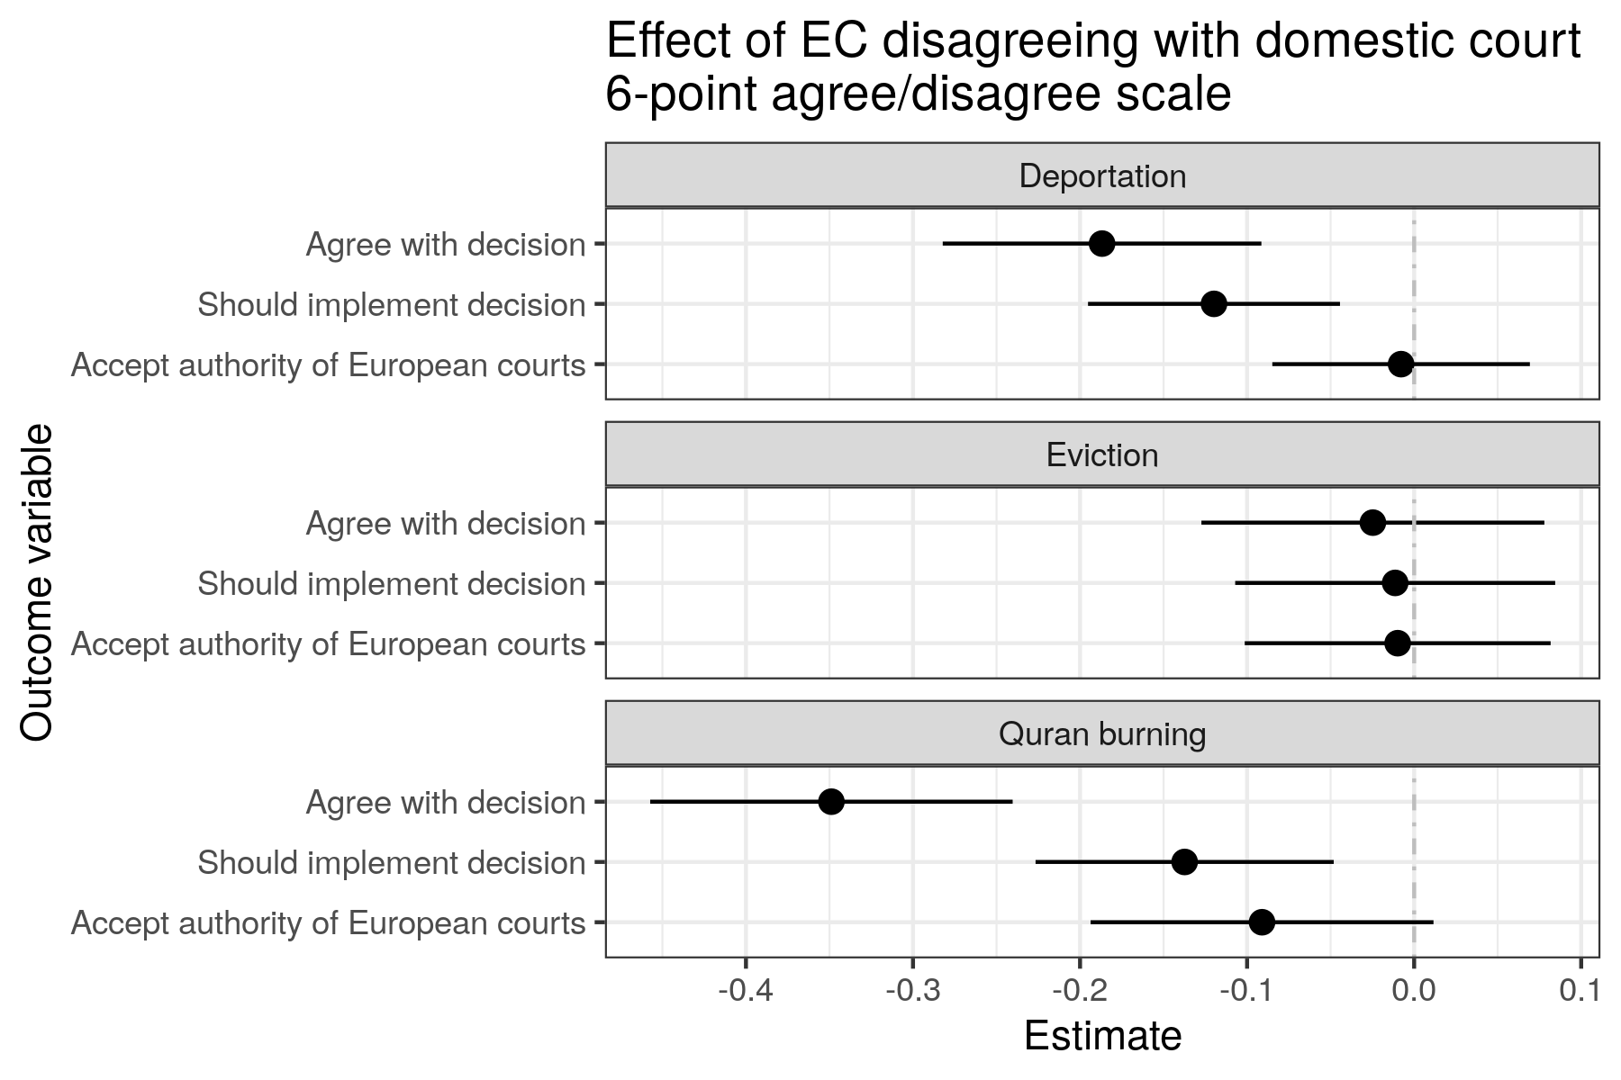
Figure D3: Average treatment effect of European court disagreeing with a domestic court – 6-point continuous outcome variable.

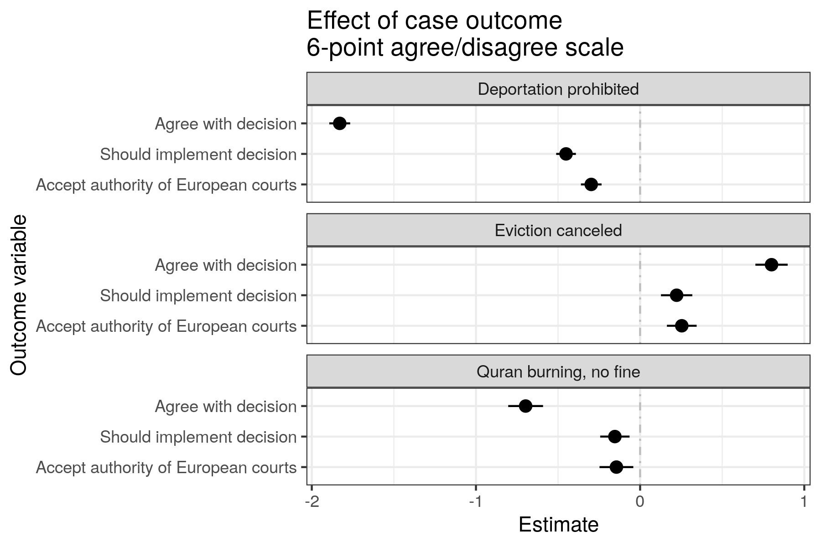
Figure D4: Average treatment effect of case outcome. Lines denote 95% confidence intervals. – 6-point continuous outcome variable.

Placebo treatment
In the deportation vignette, we assigned some respondents to a “placebo” condition to assess whether just the mention of a European court affected respondent’ behavior. We find no significant difference in the outcome effect in the “no court” condition compared to the outcome effect from the main four treatment conditions. We also find that the “no court” condition behaves similarly to the “EC overturns” condition when looking at the deference treatment effects (relative to “EC upholds”).
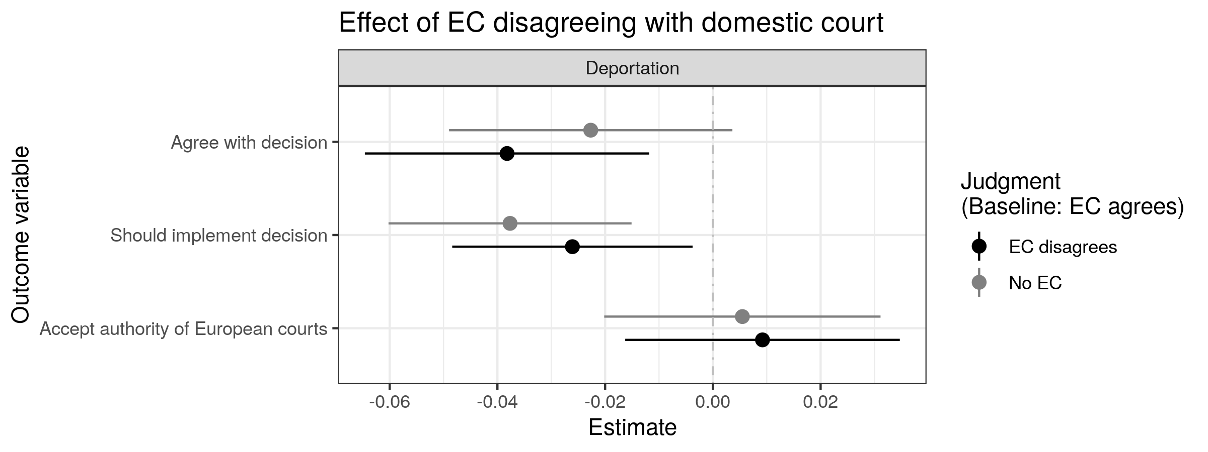
Figure D5: Average treatment effect of European court disagreeing with a domestic court – comparison with alternate “placebo” condition

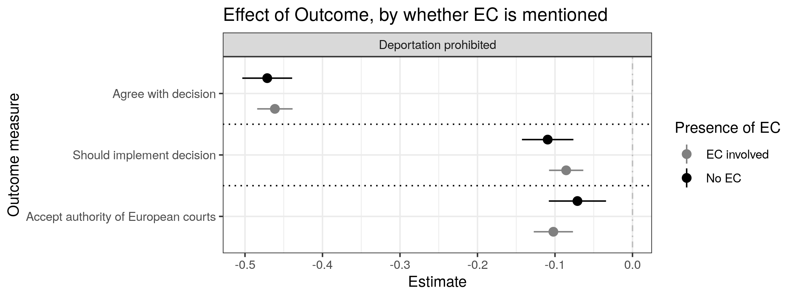
Figure D6: Average treatment effect of case outcome. Lines denote 95% confidence intervals. – Interaction with placebo “no court” condition

Country-specific estimates
Below we report country-specific analyses that were reported in the main text of the paper.
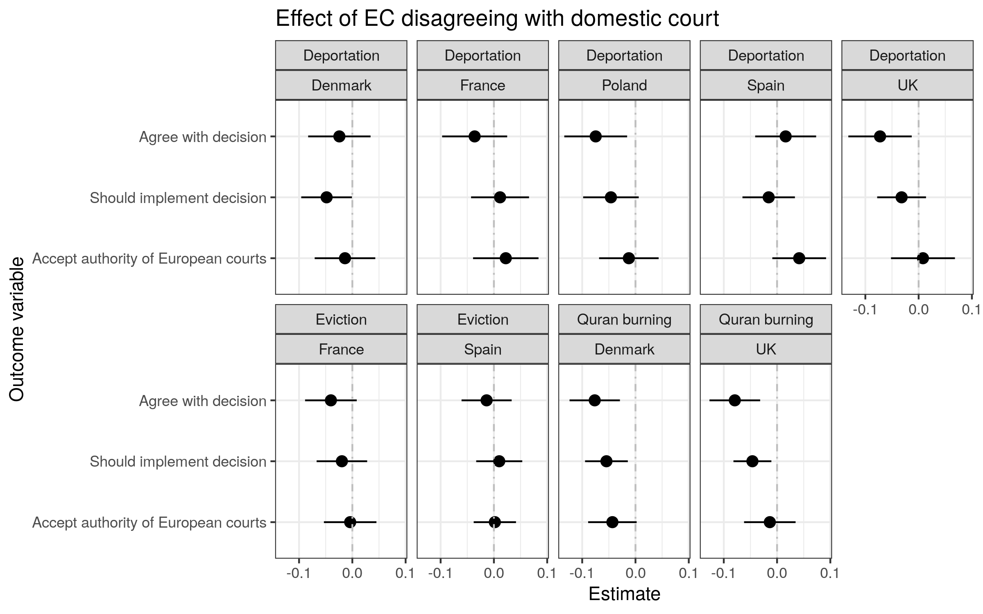
Figure D7: Effect of EC disagreement by country and vignette
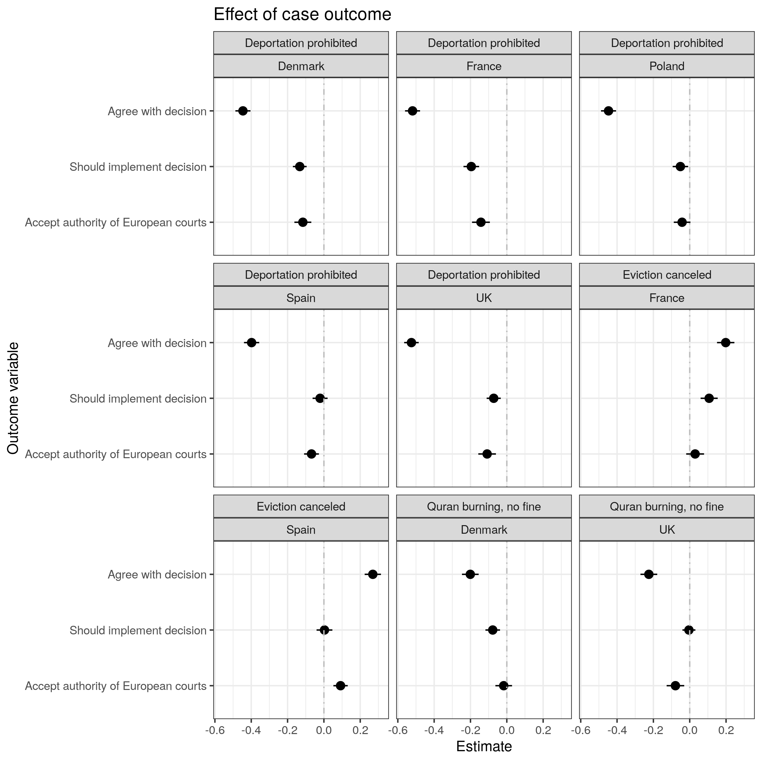
Figure D8: Effect of Case Outcome by Country

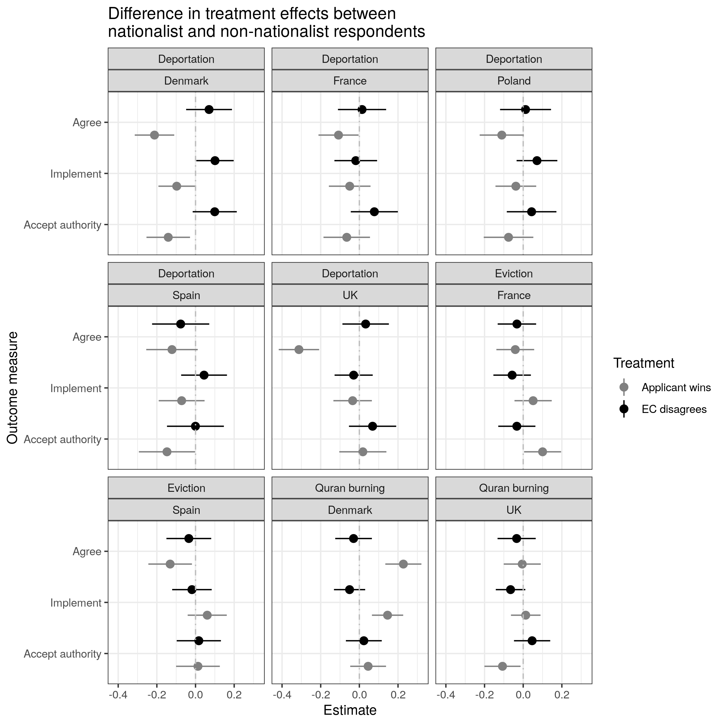
Figure D9: Treatment effects by nationalism by country and vignette

Flexible interaction models of outcome treatment with nationalism and authoritarianism scales
In the paper we mention interaction models using the authoritarianism scale and the nationalism scale for the outcome treatment for each vignette on the implementation outcome. These models are estimated using the binning procedure described in: Hainmueller, Jens, Jonathan Mummolo, and Yiqing Xu. "How much should we trust estimates from multiplicative interaction models? Simple tools to improve empirical practice." Political Analysis 27.2 (2019): 163-192.
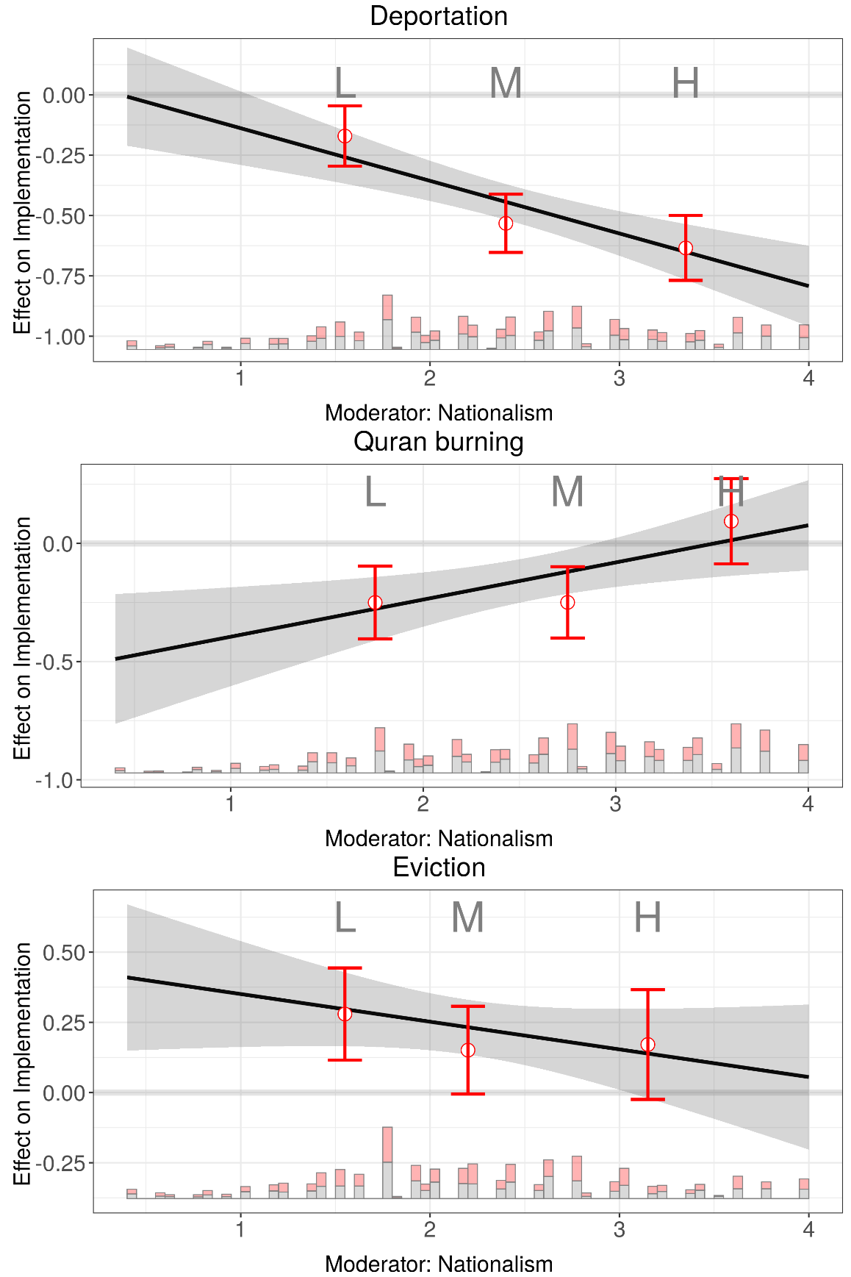
Figure D10: Effect of outcome treatment on support for implementation (6-point continuous scale) by nationalism – linear and flexible interaction models

Figure D11: Effect of outcome treatment on support for implementation (6-point continuous scale) by authoritarianism – linear and flexible interaction models

Authoritarianism and Nationalism by Party Preference
Note: all values are mean and 95% confidence intervals on 0-1 authoritarianism scale and 0-1 nationalism scale by vote intention if elections were held today.
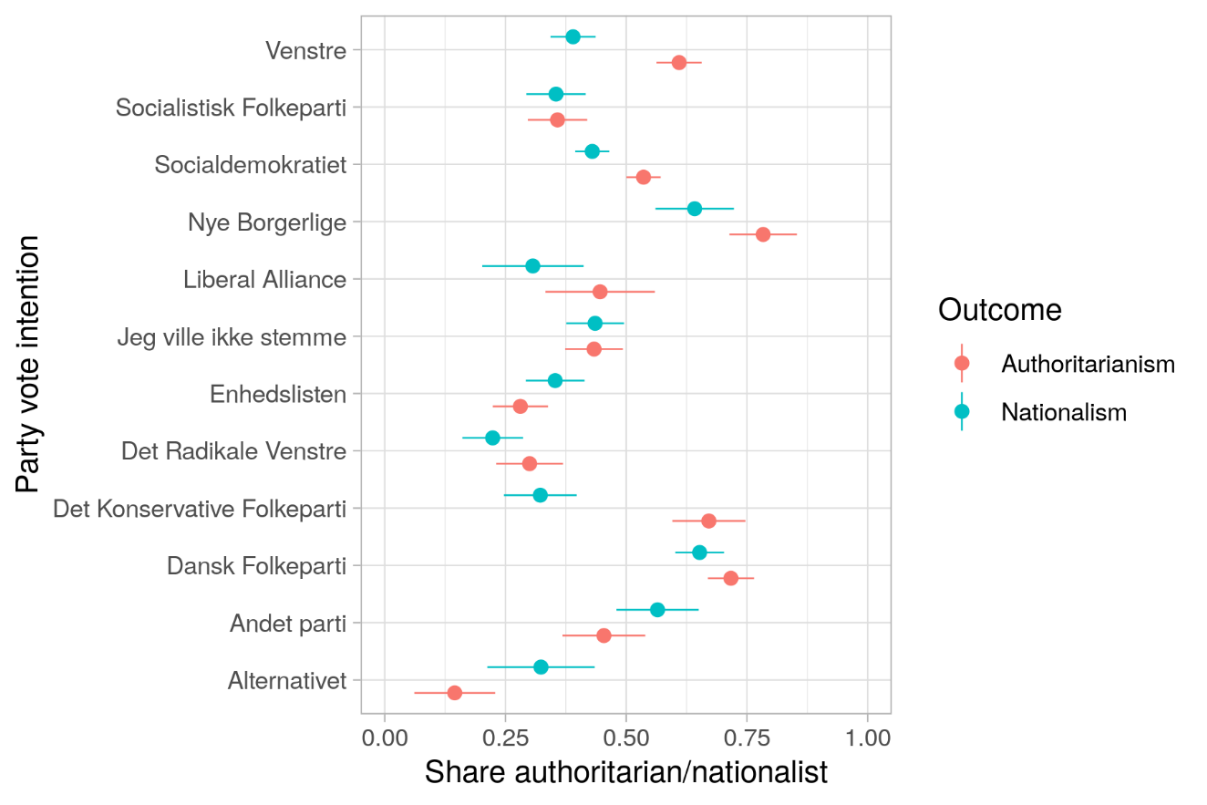
Figure D12: Authoritarianism and nationalism shares by party vote intention - Denmark
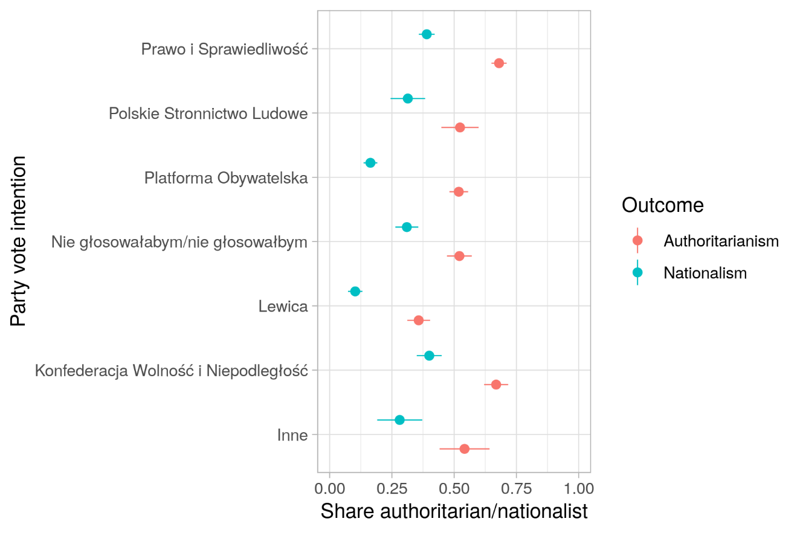
Figure D13: Authoritarianism and nationalism shares by party vote intention - Poland
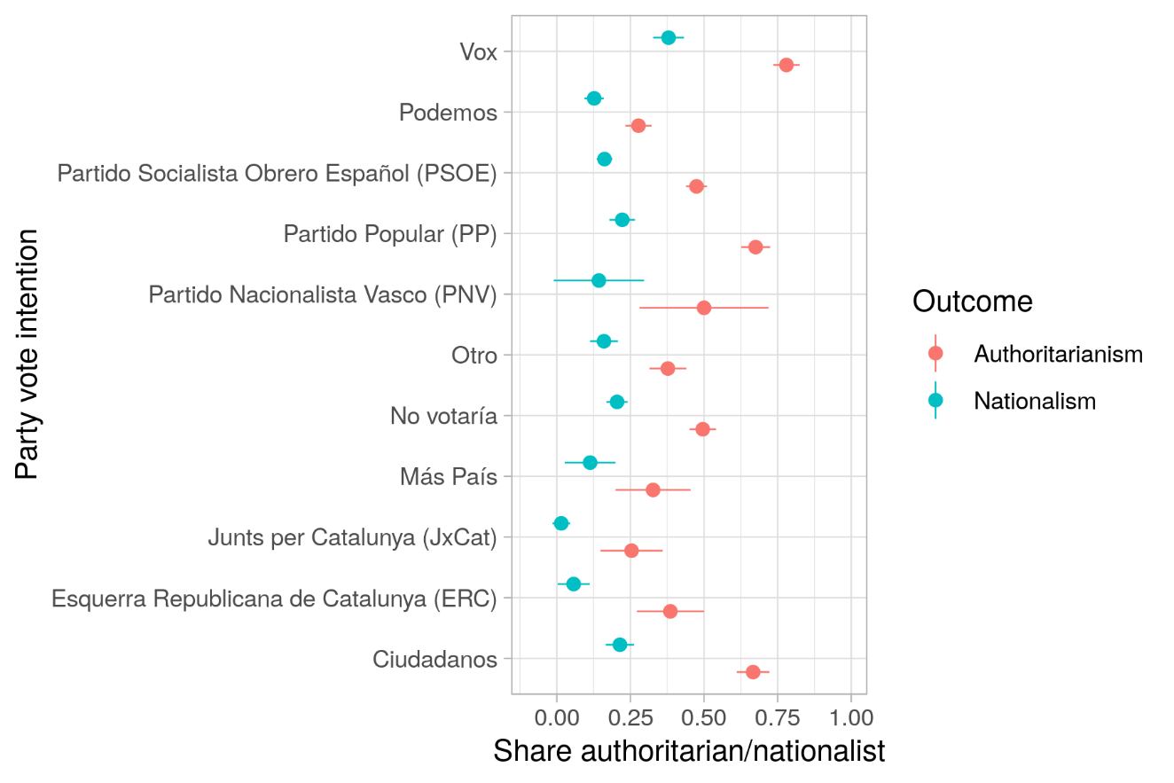
Figure D14: Authoritarianism and nationalism shares by party vote intention - Spain
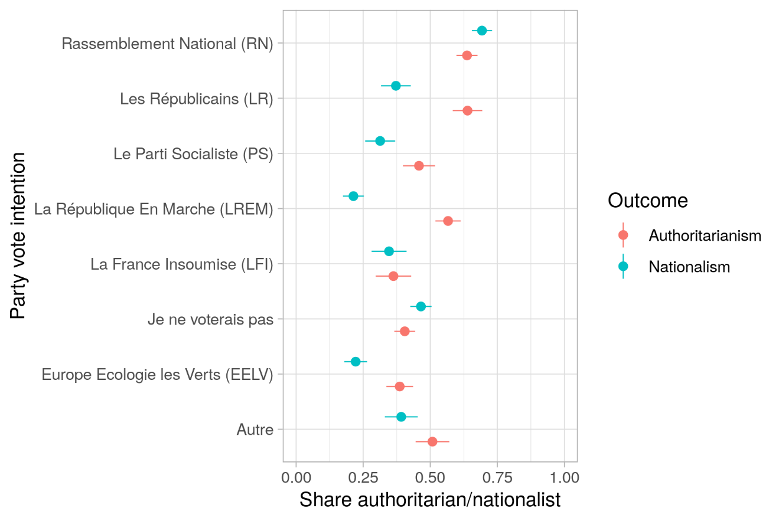
Figure D15: Authoritarianism and nationalism shares by party vote intention - Denmark

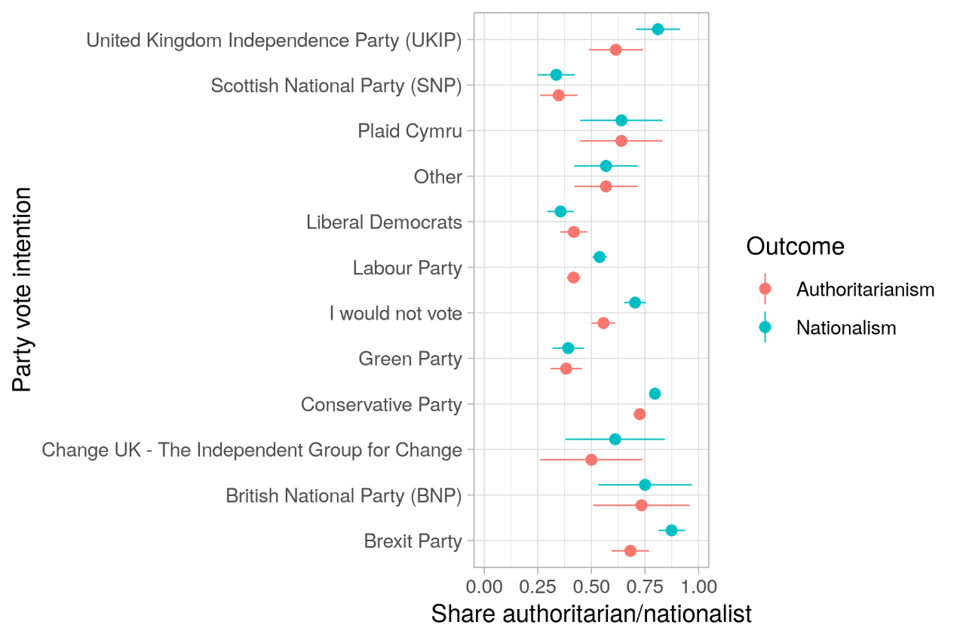
Figure D16: Authoritarianism and nationalism shares by party vote intention - Denmark
Interactions with voting intent for right-wing populist parties
The right-wing populist parties are: Dansk Folkeparti", "Nye Borgerlige","Rassemblement National (RN)", “Konfeder", “Prawo”, Vox", "Brexit Party", "UKIP", “BNP”

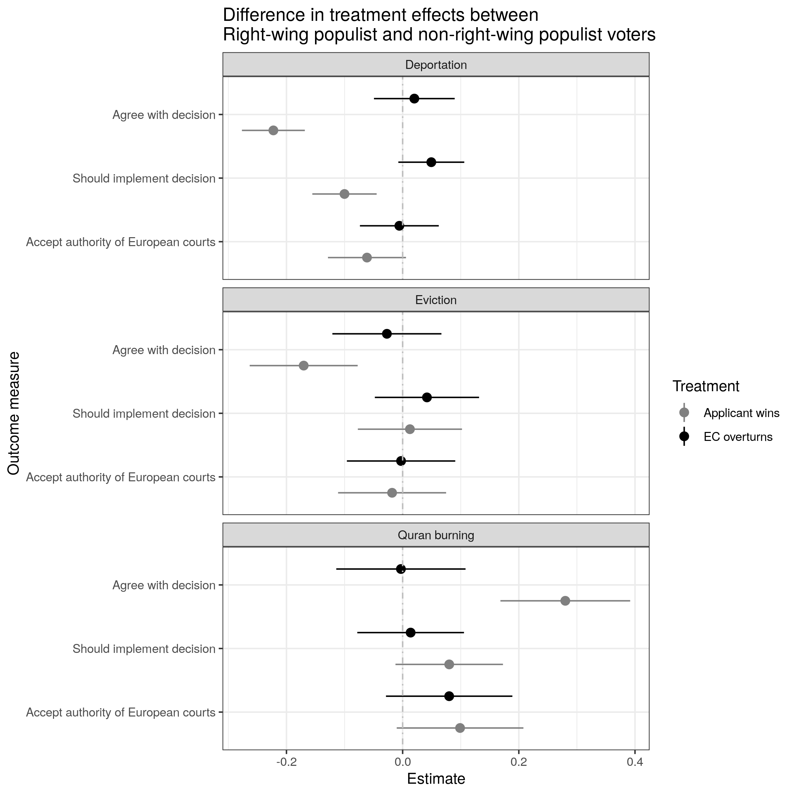
Figure D17: Differences in treatment effects by vote preference for right-wing populist parties – EC disagrees and applicant wins treatments

Interactions with attitudes towards EU membership
Euroskeptics are those who find EU membership either a “bad” or a “very bad” thing.
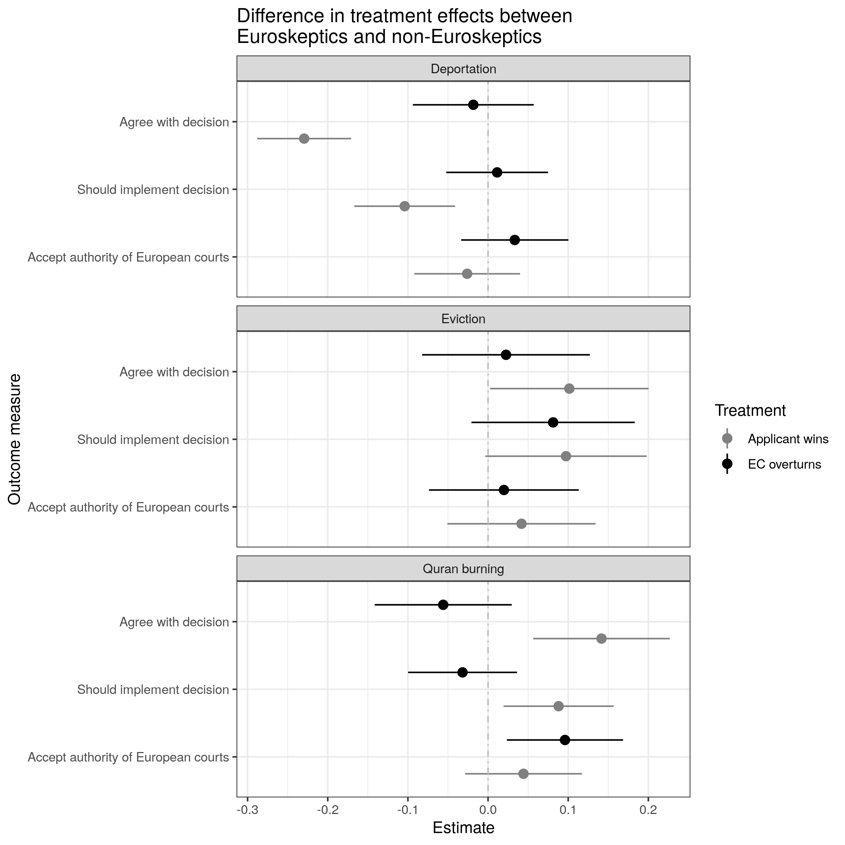
Figure D18: Differences in treatment effects by euroskepticism – EC disagrees and applicant wins treatments

Correlation matrices

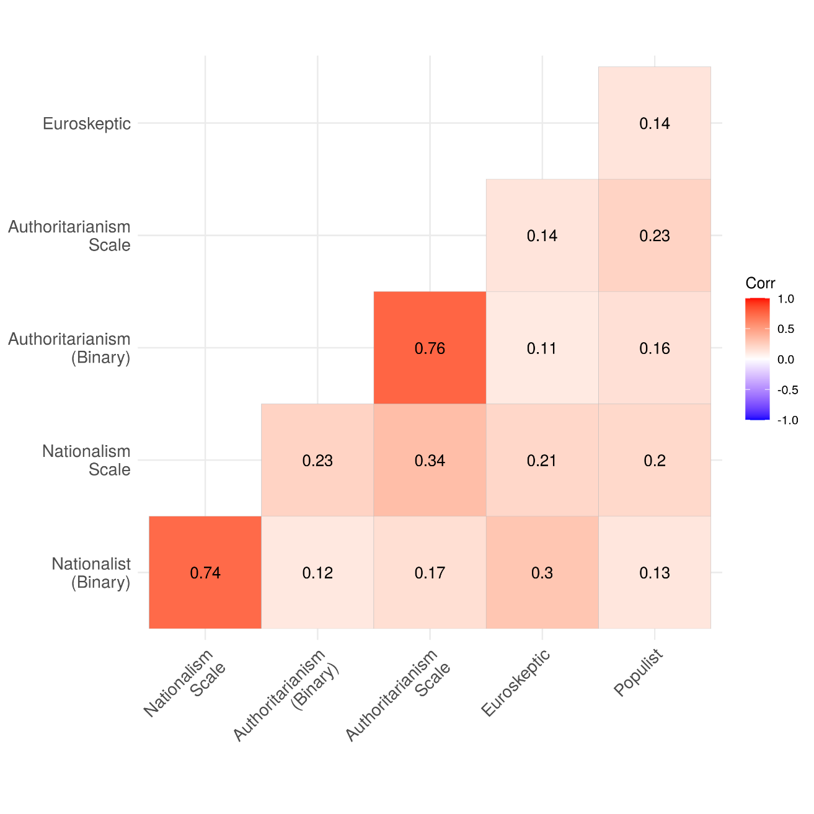
Figure D19: Correlations among nationalism and authoritarianism (binary indicators) the nationalism scale, EU skepticism and vote intentions for a right-wing populist party

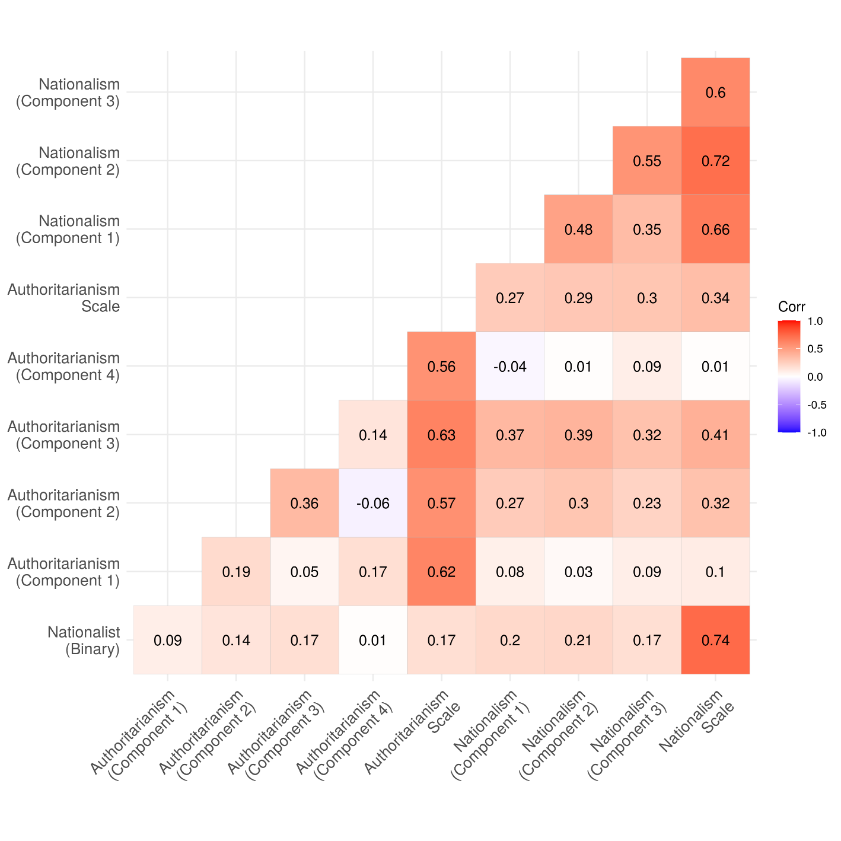
Figure D20: Correlations between different items of nationalism and authoritarianism scales

Appendix E. Regression tables

In this section we include numerical tables that reflect the results presented graphically in the main text.
Table E1: Average treatment effect of European court disagreeing with a domestic court
Vignette | Outcome | Estimate | Std. Error | Test Statistic
Deportation | Agree with decision | -0.038 | 0.013 | -2.837
 | Should implement decision | -0.026 | 0.011 | -2.291
 | Accept authority of European courts | 0.009 | 0.013 | 0.709
Eviction | Agree with decision | -0.027 | 0.017 | -1.560
 | Should implement decision | -0.005 | 0.016 | -0.287
 | Accept authority of European courts | -0.001 | 0.016 | -0.070
Quran burning | Agree with decision | -0.078 | 0.017 | -4.559
 | Should implement decision | -0.050 | 0.014 | -3.687
 | Accept authority of European courts | -0.028 | 0.017 | -1.671

Table E2: Treatment effect of European court disagreeing with a domestic court – Interaction with satisfaction with domestic rule of law
Vignette | Satisfaction with domestic rule of law | Outcome | Estimate | Std. Error | Test Statistic
Deportation | Not satisfied | Agree with decision | -0.022 | 0.018 | -1.190
 |  | Should implement decision | -0.011 | 0.016 | -0.708
 |  | Accept authority of European courts | 0.005 | 0.018 | 0.307
 | Satisfied | Agree with decision | -0.044 | 0.022 | -1.986
 |  | Should implement decision | -0.027 | 0.017 | -1.590
 |  | Accept authority of European courts | 0.012 | 0.021 | 0.588
 | Difference in effects | Agree with decision | -0.022 | 0.029 | -0.765
 |  | Should implement decision | -0.015 | 0.023 | -0.657
 |  | Accept authority of European courts | 0.007 | 0.027 | 0.248
Eviction | Not satisfied | Agree with decision | -0.036 | 0.021 | -1.675
 |  | Should implement decision | -0.019 | 0.021 | -0.910
 |  | Accept authority of European courts | -0.002 | 0.020 | -0.113
 | Satisfied | Agree with decision | -0.021 | 0.029 | -0.705
 |  | Should implement decision | 0.025 | 0.029 | 0.888
 |  | Accept authority of European courts | -0.006 | 0.027 | -0.217
 | Difference in effects | Agree with decision | 0.015 | 0.036 | 0.423
 |  | Should implement decision | 0.044 | 0.035 | 1.253
 |  | Accept authority of European courts | -0.004 | 0.034 | -0.106
Quran burning | Not satisfied | Agree with decision | -0.063 | 0.027 | -2.334
 |  | Should implement decision | -0.036 | 0.023 | -1.577
 |  | Accept authority of European courts | -0.028 | 0.028 | -1.004
 | Satisfied | Agree with decision | -0.099 | 0.023 | -4.246
 |  | Should implement decision | -0.047 | 0.017 | -2.721
 |  | Accept authority of European courts | -0.023 | 0.022 | -1.016
 | Difference in effects | Agree with decision | -0.036 | 0.036 | -1.006
 |  | Should implement decision | -0.011 | 0.029 | -0.371
 |  | Accept authority of European courts | 0.005 | 0.036 | 0.138

Table E3: Treatment effect of European court disagreeing with a domestic court – Interaction with respondent nationalism
Vignette | Nationalism | Outcome | Estimate | Std. Error | Test Statistic
Deportation | Nationalist | Agree with decision | -0.038 | 0.025 | -1.528
 |  | Should implement decision | -0.010 | 0.021 | -0.471
 |  | Accept authority of European courts | 0.043 | 0.025 | 1.698
 | Not nationalist | Agree with decision | -0.047 | 0.018 | -2.639
 |  | Should implement decision | -0.036 | 0.016 | -2.321
 |  | Accept authority of European courts | -0.007 | 0.017 | -0.411
 | Difference in effects | Agree with decision | 0.009 | 0.031 | 0.291
 |  | Should implement decision | 0.026 | 0.026 | 1.003
 |  | Accept authority of European courts | 0.050 | 0.030 | 1.634
Eviction | Nationalist | Agree with decision | -0.070 | 0.035 | -2.038
 |  | Should implement decision | -0.041 | 0.032 | -1.265
 |  | Accept authority of European courts | 0.008 | 0.033 | 0.234
 | Not nationalist | Agree with decision | -0.014 | 0.021 | -0.660
 |  | Should implement decision | 0.010 | 0.020 | 0.512
 |  | Accept authority of European courts | 0.007 | 0.019 | 0.366
 | Difference in effects | Agree with decision | -0.056 | 0.040 | -1.395
 |  | Should implement decision | -0.051 | 0.038 | -1.344
 |  | Accept authority of European courts | 0.001 | 0.038 | 0.025
Quran burning | Nationalist | Agree with decision | -0.099 | 0.024 | -4.088
 |  | Should implement decision | -0.080 | 0.020 | -4.011
 |  | Accept authority of European courts | -0.006 | 0.025 | -0.223
 | Not nationalist | Agree with decision | -0.062 | 0.028 | -2.268
 |  | Should implement decision | -0.024 | 0.023 | -1.045
 |  | Accept authority of European courts | -0.056 | 0.025 | -2.215
 | Difference in effects | Agree with decision | -0.036 | 0.037 | -0.992
 |  | Should implement decision | -0.056 | 0.030 | -1.861
 |  | Accept authority of European courts | 0.051 | 0.036 | 1.424

Table E4: Treatment effect of European court disagreeing with a domestic court – Interaction with respondent authoriarianism
Vignette | Authoritarianism | Outcome | Estimate | Std. Error | Test Statistic
Deportation | Authoritarian | Agree with decision | -0.029 | 0.019 | -1.495
 |  | Should implement decision | -0.016 | 0.016 | -0.990
 |  | Accept authority of European courts | 0.008 | 0.019 | 0.399
 | Not authoritarian | Agree with decision | -0.048 | 0.020 | -2.413
 |  | Should implement decision | -0.043 | 0.017 | -2.434
 |  | Accept authority of European courts | 0.017 | 0.018 | 0.897
 | Difference in effects | Agree with decision | 0.019 | 0.028 | 0.668
 |  | Should implement decision | 0.027 | 0.024 | 1.123
 |  | Accept authority of European courts | -0.009 | 0.026 | -0.342
Eviction | Authoritarian | Agree with decision | -0.079 | 0.025 | -3.178
 |  | Should implement decision | -0.032 | 0.023 | -1.352
 |  | Accept authority of European courts | -0.031 | 0.024 | -1.290
 | Not authoritarian | Agree with decision | 0.029 | 0.025 | 1.182
 |  | Should implement decision | 0.027 | 0.024 | 1.101
 |  | Accept authority of European courts | 0.033 | 0.022 | 1.469
 | Difference in effects | Agree with decision | -0.109 | 0.035 | -3.086
 |  | Should implement decision | -0.059 | 0.034 | -1.730
 |  | Accept authority of European courts | -0.064 | 0.033 | -1.943
Quran burning | Authoritarian | Agree with decision | -0.074 | 0.024 | -3.028
 |  | Should implement decision | -0.042 | 0.019 | -2.218
 |  | Accept authority of European courts | -0.032 | 0.024 | -1.322
 | Not authoritarian | Agree with decision | -0.067 | 0.026 | -2.609
 |  | Should implement decision | -0.052 | 0.021 | -2.466
 |  | Accept authority of European courts | -0.020 | 0.025 | -0.778
 | Difference in effects | Agree with decision | -0.007 | 0.035 | -0.201
 |  | Should implement decision | 0.010 | 0.028 | 0.349
 |  | Accept authority of European courts | -0.013 | 0.035 | -0.362

Table E5: Average treatment effect of case outcome
Vignette Outcome | Outcome | Estimate | Std.Error | Test Statistic
Deportation prohibited | Agree with decision | -0.467 | 0.009 | -49.638
 | Should implement decision | -0.094 | 0.009 | -10.173
 | Accept authority of European courts | -0.095 | 0.011 | -9.044
Eviction canceled | Agree with decision | 0.234 | 0.017 | 14.022
 | Should implement decision | 0.055 | 0.016 | 3.351
 | Accept authority of European courts | 0.061 | 0.016 | 3.802
Quran burning, no fine | Agree with decision | -0.213 | 0.017 | -12.837
 | Should implement decision | -0.041 | 0.014 | -2.975
 | Accept authority of European courts | -0.048 | 0.017 | -2.834

Table E6: Treatment effect of case outcome - Interaction with sympathy towards applicant
Vignette Outcome | Sympathy with applicant | Outcome | Estimate | Std. Error | Test Statistic
Deportation prohibited | More sympathetic | Agree with decision | -0.416 | 0.012 | -34.027
 |  | Should implement decision | -0.058 | 0.012 | -4.859
 |  | Accept authority of European courts | -0.086 | 0.013 | -6.556
 | Unsympathetic | Agree with decision | -0.555 | 0.015 | -37.250
 |  | Should implement decision | -0.146 | 0.015 | -9.573
 |  | Accept authority of European courts | -0.117 | 0.018 | -6.382
 | Difference in effects | Agree with decision | -0.138 | 0.019 | -7.171
 |  | Should implement decision | -0.087 | 0.019 | -4.510
 |  | Accept authority of European courts | -0.031 | 0.023 | -1.393
Eviction canceled | More sympathetic | Agree with decision | 0.328 | 0.020 | 16.789
 |  | Should implement decision | 0.081 | 0.020 | 4.113
 |  | Accept authority of European courts | 0.097 | 0.019 | 5.118
 | Unsympathetic | Agree with decision | 0.011 | 0.032 | 0.328
 |  | Should implement decision | -0.009 | 0.030 | -0.312
 |  | Accept authority of European courts | -0.036 | 0.031 | -1.159
 | Difference in effects | Agree with decision | -0.317 | 0.038 | -8.404
 |  | Should implement decision | -0.090 | 0.036 | -2.526
 |  | Accept authority of European courts | -0.133 | 0.037 | -3.637
Quran burning, no fine | More sympathetic | Agree with decision | -0.142 | 0.021 | -6.896
 |  | Should implement decision | -0.014 | 0.017 | -0.853
 |  | Accept authority of European courts | -0.039 | 0.022 | -1.791
 | Unsympathetic | Agree with decision | -0.369 | 0.030 | -12.342
 |  | Should implement decision | -0.111 | 0.027 | -4.134
 |  | Accept authority of European courts | -0.081 | 0.030 | -2.723
 | Difference in effects | Agree with decision | -0.227 | 0.036 | -6.257
 |  | Should implement decision | -0.097 | 0.032 | -3.068
 |  | Accept authority of European courts | -0.042 | 0.037 | -1.153

Table E7: Treatment effect of case outcome - Interaction with respondent nationalism
Vignette Outcome | Nationalism | Outcome | Estimate | Std. Error | Test Statistic
Deportation prohibited | Nationalist | Agree with decision | -0.562 | 0.016 | -34.249
 |  | Should implement decision | -0.114 | 0.017 | -6.877
 |  | Accept authority of European courts | -0.138 | 0.020 | -7.059
 | Not nationalist | Agree with decision | -0.391 | 0.013 | -29.539
 |  | Should implement decision | -0.075 | 0.013 | -5.867
 |  | Accept authority of European courts | -0.060 | 0.014 | -4.319
 | Difference in effects | Agree with decision | -0.171 | 0.021 | -8.124
 |  | Should implement decision | -0.039 | 0.021 | -1.856
 |  | Accept authority of European courts | -0.078 | 0.024 | -3.268
Eviction canceled | Nationalist | Agree with decision | 0.171 | 0.034 | 4.975
 |  | Should implement decision | 0.118 | 0.032 | 3.730
 |  | Accept authority of European courts | 0.105 | 0.035 | 3.019
 | Not nationalist | Agree with decision | 0.257 | 0.020 | 12.673
 |  | Should implement decision | 0.040 | 0.020 | 2.021
 |  | Accept authority of European courts | 0.038 | 0.019 | 2.028
 | Difference in effects | Agree with decision | -0.086 | 0.040 | -2.161
 |  | Should implement decision | 0.077 | 0.037 | 2.071
 |  | Accept authority of European courts | 0.067 | 0.039 | 1.698
Quran burning, no fine | Nationalist | Agree with decision | -0.149 | 0.024 | -6.139
 |  | Should implement decision | -0.003 | 0.021 | -0.129
 |  | Accept authority of European courts | -0.051 | 0.025 | -2.046
 | Not nationalist | Agree with decision | -0.268 | 0.026 | -10.323
 |  | Should implement decision | -0.084 | 0.022 | -3.766
 |  | Accept authority of European courts | -0.026 | 0.025 | -1.046
 | Difference in effects | Agree with decision | 0.119 | 0.036 | 3.347
 |  | Should implement decision | 0.081 | 0.030 | 2.680
 |  | Accept authority of European courts | -0.025 | 0.035 | -0.704

Table E8: Treatment effect of case outcome - Interaction with respondent authoriarianism
Vignette Outcome | Authoritarianism | Outcome | Estimate | Std. Error | Test Statistic
Deportation prohibited | Authoritarian | Agree with decision | -0.612 | 0.012 | -50.124
 |  | Should implement decision | -0.149 | 0.013 | -11.580
 |  | Accept authority of European courts | -0.132 | 0.015 | -8.721
 | Not authoritarian | Agree with decision | -0.299 | 0.015 | -20.100
 |  | Should implement decision | -0.030 | 0.014 | -2.069
 |  | Accept authority of European courts | -0.042 | 0.015 | -2.815
 | Difference in effects | Agree with decision | -0.312 | 0.019 | -16.219
 |  | Should implement decision | -0.119 | 0.019 | -6.179
 |  | Accept authority of European courts | -0.089 | 0.021 | -4.209
Eviction canceled | Authoritarian | Agree with decision | 0.154 | 0.025 | 6.218
 |  | Should implement decision | 0.028 | 0.024 | 1.184
 |  | Accept authority of European courts | 0.067 | 0.024 | 2.766
 | Not authoritarian | Agree with decision | 0.334 | 0.023 | 14.256
 |  | Should implement decision | 0.082 | 0.024 | 3.354
 |  | Accept authority of European courts | 0.055 | 0.022 | 2.490
 | Difference in effects | Agree with decision | -0.179 | 0.034 | -5.257
 |  | Should implement decision | -0.054 | 0.034 | -1.580
 |  | Accept authority of European courts | 0.012 | 0.033 | 0.352
Quran burning, no fine | Authoritarian | Agree with decision | -0.187 | 0.024 | -7.910
 |  | Should implement decision | -0.017 | 0.019 | -0.930
 |  | Accept authority of European courts | -0.060 | 0.024 | -2.468
 | Not authoritarian | Agree with decision | -0.222 | 0.025 | -8.902
 |  | Should implement decision | -0.067 | 0.021 | -3.244
 |  | Accept authority of European courts | -0.033 | 0.025 | -1.332
 | Difference in effects | Agree with decision | 0.036 | 0.034 | 1.044
 |  | Should implement decision | 0.050 | 0.028 | 1.791
 |  | Accept authority of European courts | -0.027 | 0.035 | -0.765

