Appendix for The Curious Case of Theresa May and the Public that Did Not Rally: Gendered Reactions to Terrorist Attacks can Cause Slumps Not Bumps
Table of Contents:

Table A1: Appendix to Table 1: Manchester attack and evaluations of May; OLS without Controls 3
Table A2: Adding Control Variables – Like May 3
Table A3: Adding Control Variables – May Best PM 4
Table A4: Alternative specifications: Adding May’s Likeability in previous wave 4
Table A5: Appendix to Table 2: Difference-in-Difference, with fixed effects and Average treatment effects 5
Table A6: Bridge Attack and Manchester Attack and Views of May 6
Table B1: Random Assignment evaluation 6
Table B2: Manchester bombing does not shape views of non-related item or evaluations of May in time n-1 and n+1 7
Table B3: Demographic Stability across Weeks of Wave 12 7
Appendix C: Within group differences 8
Negative views of women. 8
Figure C1: Effect of all gender views on Liking May 9
Table C1: Manchester attack, Gender attitudes, and view of leaders 9
Figure C2: Manchester attack, Gender attitudes, and view of leaders, with interactions for ideology and party 10
Table C2: Party ID (full results from Figure 2) 10
Table C3: Effect of Manchester Attack on Evaluations of May by Respondent Gender 11
Table C4: Effect of Manchester Attack on May’s Likeability by Respondent Ideology (predicted effects by ideological placement) 11
Appendix D: Party reputations and assessment of other party leaders 12
Table D1: Comparative Manifesto Project Data on Issue Ownership (2017) 12
Table D2: Mean ratings of Likeability of UK Parties, 1997, 2015, and 2015. 12
Figure D1: BES Expert Surveys of Party Reputations 12
Table D3: Effect of Manchester Attack on Evaluations of All Party Leaders 13
Table D4: Differences-in-Differences evaluation of all leaders, fixed effects 13
Table D5: Evaluations of leaders, including evaluations of likability from previous wave 14
Appendix E: Temporal Stability 15
Table E1: Split control group at median and estimate effect on DVs 15
Figure E1: Average Currency Value Across the 2017 Election 15
Table E2: Table to Accompany Figure 3a – May likability w controls for economy, Brexit, and reducing bandwidth to 10 and 4 days 16
Table E3: Table to Accompany Figure 3b – May best PM w controls for economy, Brexit, and reducing bandwidth to 10 and 4 days 17
Table E4: Effect of Manchester attack on May Likability with Time-related controls 18
Table E5: Effect of Manchester attack on May Best PM with Time-related controls 19
Figure E2: AFRIMA models of leader evaluations 20
Appendix F: Experimental results 21
Table F1. : OLS on Feeling Thermometers by Pooled Condition, IPSOS Study, 2012 21
Appendix G: Geographic effects 22
Table G1: Distance to Manchester & Change in Conservative Party Vote 22
Appendix H: Global Analysis 23
Figure H1: Effect of terrorist events on executive approval 23
Table H1: Gender-Revised Rally Effects 24
Table H2: Changing Thresholds and the Gender-revised Rally Effects 24
Table H3: Interactive effects with Executive Ideological Placement 25

Appendix A: Full results of all models presented in paper, plus auxiliary tests

Table A1: Appendix to Table 1: Manchester attack and evaluations of May; OLS without Controls

 | Like May | Like May | May Best PM | May Best PM | Like May | May Best PM
Surveyed after Manchester attack | -0.332* | -0.351* | -0.204* | -0.333* | -0.411* | -0.056*
 | (0.054) | (0.043) | (0.038) | (0.042)
Labour | -2.815* | -3.002* | -1.782* | -2.730*
 | (0.053) | (0.068) | (0.046) | (0.066)
Ethnically British |  | 0.436* |  | 0.779*
 |  | (0.065) |  | (0.078)
Gender |  | 0.440* |  | -0.160*
 |  | (0.041) |  | (0.035)
Other Party ID |  | -2.413* |  | -2.211*
 |  | (0.046) |  | (0.066)
Income |  | -0.015* |  | 0.022*
 |  | (0.007) |  | (0.007)
Ideology |  | 0.608* |  | 0.486*
 |  | (0.011) |  | (0.011)
Constant | 5.642* | 2.788* | 0.306* | -1.191* | 4.905* | 0.480*
 | (0.043) | (0.142) | (0.027) | (0.127) | (0.031) | (0.005)
Observations | 32642 | 26506 | 34394 | 27844 | 32642 | 34394
R² | 0.143 | 0.442 | 0.0899 | 0.3293 | 0.004 | 0.003
Clustered errors on day of survey. Survey weights applied. * p<.05. Final two columns are OLS without controls.

Table A2: Adding Control Variables – Like May
 | Model 1 | Model 2 | Model 3 | Model 4 | Model 5 | Model 6
Surveyed after Manchester attack | -0.332* | -0.335* | -0.364* | -0.366* | -0.349* | -0.351*
 | (0.054) | (0.054) | (0.049) | (0.047) | (0.044) | (0.043)
Labour | -2.815* | -2.822* | -4.973* | -4.992* | -3.035* | -3.002*
 | (0.053) | (0.053) | (0.042) | (0.051) | (0.069) | (0.068)
Gender |  | 0.355* | 0.363* | 0.316* | 0.443* | 0.440*
 |  | (0.045) | (0.039) | (0.041) | (0.041) | (0.041)
Other Party ID |  |  | -3.542* | -3.576* | -2.442* | -2.413*
 |  |  | (0.041) | (0.039) | (0.046) | (0.046)
Income |  |  |  | -0.027* | -0.017* | -0.015*
 |  |  |  | (0.007) | (0.007) | (0.007)
Ideology |  |  |  |  | 0.608* | 0.608*
 |  |  |  |  | (0.011) | (0.011)
Ethnically British |  |  |  |  |  | 0.436*
 |  |  |  |  |  | (0.065)
Constant | 5.642* | 5.467* | 7.629* | 7.911* | 3.639* | 5.467*
 | (0.043) | (0.044) | (0.039) | (0.056) | (0.103) | (0.044)
Observations | 32642 | 32642 | 32642 | 26506 | 26506 | 26506
R² | 0.143 | 0.146 | 0.337 | 0.342 | 0.440 | 0.442
Clustered errors on day of survey. Survey weights applied. * p<.05

Table A3: Adding Control Variables – May Best PM
 | Model 1 | Model 2 | Model 3 | Model 4 | Model 5 | Model 6
Surveyed after Manchester attack | -0.204* | -0.204* | -0.313* | -0.304* | -0.325* | -0.333*
 | (0.038) | (0.038) | (0.042) | (0.038) | (0.042) | (0.042)
Labour | -1.782* | -1.783* | -3.845* | -3.836* | -2.776* | -2.730*
 | (0.046) | (0.046) | (0.053) | (0.060) | (0.067) | (0.066)
Gender |  | -0.167* | -0.161* | -0.229* | -0.149* | -0.160*
 |  | (0.028) | (0.030) | (0.028) | (0.034) | (0.035)
Other Party ID |  |  | -2.859* | -2.838* | -2.246* | -2.211*
 |  |  | (0.065) | (0.062) | (0.067) | (0.066)
Income |  |  |  | 0.009 | 0.021* | 0.022*
 |  |  |  | (0.006) | (0.007) | (0.007)
Ideology |  |  |  |  | 0.478* | 0.486*
 |  |  |  |  | (0.012) | (0.011)
Ethnically British |  |  |  |  |  | 0.779*
 |  |  |  |  |  | (0.078)
Constant | 0.306* | 0.392* | 2.502* | 2.522* | -0.595* | -1.351*
 | (0.027) | (0.032) | (0.063) | (0.072) | (0.115) | (0.115)
Observations | 34394 | 34394 | 34394 | 27844 | 27844 | 27844
Pseudo R² | 0.090 | 0.091 | 0.259 | 0.259 | 0.322 | 0.329
Clustered errors on day of survey. Survey weights applied. * p<.05

Table A4: Alternative specifications: Adding May’s Likeability in previous wave
 | Like May | May Best PM
Surveyed after Manchester attack | -0.334* | -0.424*
 | (0.028) | (0.047)
Like May previous wave | 0.790*
 | (0.006)
May best PM previous wave |  | 2.725*
 |  | (0.049)
Ethnically British | 0.000 | 0.586*
 | (0.053) | (0.085)
Gender | 0.089* | -0.159*
 | (0.028) | (0.046)
Labour | -0.899* | -2.493*
 | (0.054) | (0.082)
Other Party ID | -0.647* | -2.060*
 | (0.041) | (0.070)
Income | -0.009* | 0.022*
 | (0.004) | (0.008)
Ideology | 0.108* | 0.386*
 | (0.010) | (0.015)
Constant | 0.894* | -1.822*
 | (0.089) | (0.155)
Observations | 20100 | 27844
R² /Pseudo R² | 0.794 | 0.488
Clustered errors on day of survey. Survey weights applied. * p<.05

Table A5: Appendix to Table 2: Difference-in-Difference, with fixed effects and Average treatment effects
 | Fixed effects |  | Average treatment effect model
 | Like May | May best PM | Like May | May best PM
Manchester Attack | 0.018 | -0.000 | 0.021 | -0.002
 | (0.028) | (0.004) | (0.028) | (0.004)
Time | -0.501* | 0.210* | -0.592* | 0.108*
 | (0.023) | (0.004) | (0.013) | (0.003)
Manchester Attack * Time | -0.127* | -0.050* | -0.126* | -0.048*
 | (0.019) | (0.004) | (0.019) | (0.005)
Ethnically British | 0.498* | 0.095* | 0.485* | 0.093*
 | (0.044) | (0.007) | (0.044) | (0.007)
Gender | 0.452* | 0.001 | 0.456* | 0.006
 | (0.025) | (0.004) | (0.025) | (0.004)
Labour | -2.473* | -0.440* | -2.475* | -0.441*
 | (0.042) | (0.006) | (0.042) | (0.006)
Other Party ID | -2.079* | -0.324* | -2.082* | -0.323*
 | (0.034) | (0.005) | (0.034) | (0.005)
Income | -0.006 | 0.007* | -0.003 | 0.007*
 | (0.004) | (0.001) | (0.004) | (0.001)
Ideology | 0.530* | 0.063* | 0.525* | 0.063*
 | (0.007) | (0.001) | (0.007) | (0.001)
Constant | 1.944* | 0.151* | 2.610* | 0.249*
 | (0.088) | (0.013) | (0.087) | (0.013)
Wave fixed effects
Observations | 143499 | 97155 | 143499 | 97155
* p<.05

Table A6: Bridge Attack and Manchester Attack and Views of May
 | Like May | Like May | May Best PM | May Best PM
Surveyed after Bridge attack | -0.317* | -0.134* | -0.273* | -0.085
 | (0.045) | (0.043) | (0.058) | (0.061)
Surveyed after Manchester attack |  | -0.300* |  | -0.299*
 |  | (0.045) |  | (0.047)
Ethnically British | 0.407* | 0.414* | 0.758* | 0.768*
 | (0.063) | (0.063) | (0.079) | (0.079)
Gender | 0.442* | 0.443* | -0.160* | -0.159*
 | (0.042) | (0.042) | (0.036) | (0.036)
Labour | -3.014* | -3.006* | -2.735* | -2.735*
 | (0.069) | (0.070) | (0.068) | (0.068)
Other Party ID | -2.410* | -2.413* | -2.209* | -2.221*
 | (0.048) | (0.048) | (0.069) | (0.068)
Income | -0.015* | -0.015* | 0.023* | 0.024*
 | (0.007) | (0.007) | (0.007) | (0.007)
Ideology | 0.609* | 0.609* | 0.485* | 0.486*
 | (0.012) | (0.011) | (0.012) | (0.012)
Constant | 3.131* | 3.241* | -1.448* | -1.347*
 | (0.133) | (0.128) | (0.136) | (0.120)
Observations | 25780 | 25780 | 27089 | 27089
R² /Pseudo R² | 0.439 | 0.441 | 0.3267 | 0.3287
Clustered errors on day of survey. Survey weights applied. * p<.05

Appendix B: Random assignment tests

Table B1: Random Assignment evaluation
 | Surveyed after Manchester attack
Ethnically British | 0.001
 | (0.044)
Gender | 0.005
 | (0.025)
Conservative | 0.058
 | (0.034)
Labour | 0.115*
 | (0.032)
Income | -0.001
 | (0.004)
Ideology | -0.007
 | (0.007)
How would you vote in another EU ref | -0.017
 | (0.029)
Constant | -0.104
 | (0.074)
Observations | 25848
R² | 0.0006
Survey weights applied. * p<.05

Table B2: Manchester bombing does not shape views of non-related item or evaluations of May in time n-1 and n+1
 | Support UK keeping Nuclear Submarines | Like May previous wave | Like May next wave
Surveyed after Manchester attack | 0.030 | -0.043 | -0.024
 | (0.022) | (0.046) | (0.044)
Ethnically British | 0.325* | 0.525* | 0.397*
 | (0.034) | (0.093) | (0.090)
Gender | -0.139* | 0.503* | 0.392*
 | (0.014) | (0.046) | (0.045)
Labour | -0.152* | -2.647* | -2.959*
 | (0.028) | (0.078) | (0.078)
Other Party ID | -0.299* | -2.230* | -2.250*
 | (0.017) | (0.058) | (0.061)
Income | 0.003 | -0.009 | -0.010
 | (0.002) | (0.007) | (0.007)
Ideology | 0.231* | 0.628* | 0.501*
 | (0.004) | (0.013) | (0.013)
Constant | 2.408* | 3.001* | 2.736*
 | (0.045) | (0.144) | (0.148)
Observations | 25746 | 20437 | 20973
R² | 0.215 | 0.417 | 0.387
Clustered errors on day of survey. Survey weights applied. * p<.05

Table B3: Demographic Stability across Weeks of Wave 12
 | % Ethnically British | % Women | % Conservative | % Labour | Income category | Ideology
Week 1 | 90% | 52% | 28% | 27% | 7.1 | 5.0
Week 2 | 90% | 51% | 28% | 27% | 7.0 | 5.0
Week 3 | 91% | 52% | 28% | 28% | 7.0 | 5.0
Week 4 | 91% | 52% | 28% | 29% | 7.1 | 5.0
Week 5 | 90% | 52% | 28% | 29% | 7.1 | 5.0

Appendix C: Within group differences

Negative views of women.
We construct a scale (0-1) of the following questions
Gender Roles: How much do you agree or disagree with the following statement?
A man’s job is to earn money, a woman’s job is to look after the home and family
1 "St. Disagree" 2 "Disagree" 3 "Neither" 4 "Agree" 5 "St. Agree"
Asked in Wave 10
Equal Opportunities
Please say whether you think these things have gone too far or have not gone far enough in Britain
Attempts to give equal opportunities to women
1 "Not gone nearly far enough" 2 "Not gone far enough" 3 "About right" 4 "Gone too far" 5 "Gone much too far"
Asked every wave
Discrimination against women
How much discrimination is there for or against the following groups? Women
1 "A lot of discrim against" 10 "A lot of discrim in favour"
Asked in Wave 10
Women in Office
To what extent do you believe that more or fewer MPs in Parliament should come from the following backgrounds? To what extent do you believe that Parliament should have more or fewer MPs with the following background? Women
1 "A lot more" 2 "Slightly more" 3 "Same as currently" 4 "Slightly fewer" 5 "A lot fewer"
Asked in wave 6
Women’s Jobs
How much do you agree or disagree with the following statement? Nowadays, women are given unfair advantages over men when applying for jobs
1 "St. disagree" 5 "St. agree"
Asked in wave 10

Figure C1: Effect of all gender views on Liking May
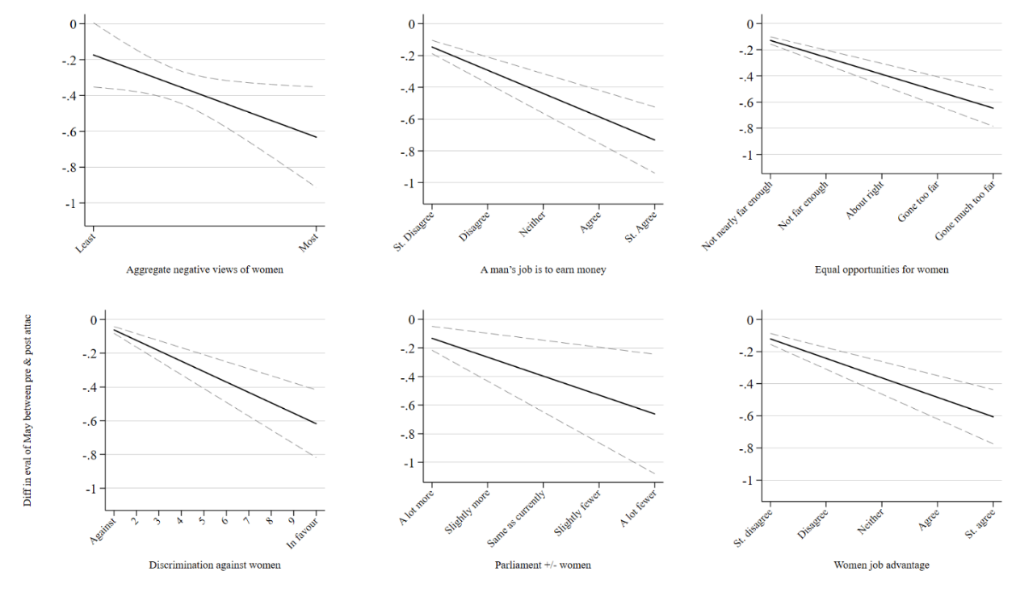

Table C1: Manchester attack, Gender attitudes, and view of leaders
 | Like/dislike: Theresa May | Think May would be best Prime Minister
Surveyed after Manchester attack | -0.174 | -0.450*
 | (0.088) | (0.096)
Gender Attitudes | 1.397* | 0.439*
 | (0.142) | (0.165)
Surveyed after Manchester attack * Gender Attitudes | -0.459* | -0.261
 | (0.207) | (0.228)
Ethnically British | 0.463* | 0.738*
 | (0.070) | (0.079)
Gender | 0.523* | -0.123*
 | (0.040) | (0.041)
Labour | -2.982* | -2.733*
 | (0.068) | (0.071)
Other Party ID | -2.394* | -2.168*
 | (0.045) | (0.061)
Income | -0.012 | 0.023*
 | (0.007) | (0.007)
Ideology | 0.579* | 0.478*
 | (0.011) | (0.015)
Constant | 2.735* | -1.440*
 | (0.131) | (0.129)
Observations | 25823 | 26918
R² /Pseudo R² | 0.449 | 0.3341
Standard errors in parentheses. Wave survey weights applied. * p<.05

Figure C2: Manchester attack, Gender attitudes, and view of leaders, with interactions for ideology and party
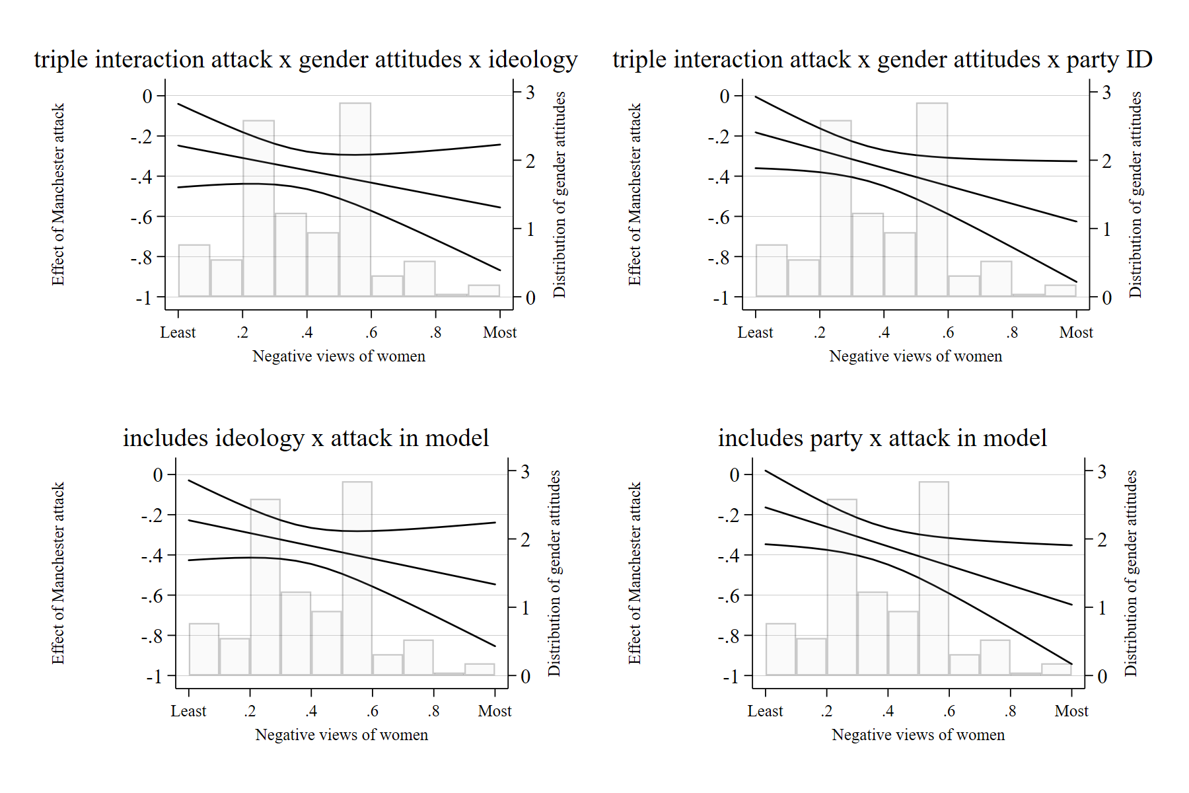

Table C2: Party ID (full results from Figure 2)
 | Like May | Like May | May best PM | May best PM
 | Labour | Conservatives | Labour | Conservatives
Surveyed after Manchester attack | -0.362* | -0.342* | -0.474* | -0.478*
 | (0.074) | (0.053) | (0.076) | (0.103)
Ethnically British | 0.154 | 0.613* | 0.853* | 0.629*
 | (0.133) | (0.150) | (0.151) | (0.180)
Gender | 0.200* | 0.376* | -0.341* | 0.136
 | (0.074) | (0.054) | (0.076) | (0.102)
Income | 0.003 | -0.057* | 0.026* | -0.006
 | (0.012) | (0.009) | (0.012) | (0.018)
Ideology | 0.625* | 0.299* | 0.440* | 0.361*
 | (0.022) | (0.018) | (0.023) | (0.032)
Constant | 0.416* | 5.495* | -3.814* | -0.334
 | (0.172) | (0.217) | (0.213) | (0.300)
Observations | 7589 | 7779 | 7775 | 7865
R² /Pseudo R² | 0.1738 | 0.0827 | 0.1074 | 0.0532
Clustered errors on day of survey. Survey weights applied. * p<.05

Table C3: Effect of Manchester Attack on Evaluations of May by Respondent Gender
 | Men | Women
Surveyed after Manchester attack | -0.428* | -0.279*
 | (0.056) | (0.053)
Ethnically British | 0.338* | 0.530*
 | (0.106) | (0.110)
Labour | -2.773* | -3.216*
 | (0.097) | (0.090)
Other Party ID | -2.410* | -2.421*
 | (0.075) | (0.068)
Income | -0.020* | -0.010
 | (0.009) | (0.009)
Ideology | 0.631* | 0.584*
 | (0.017) | (0.015)
Constant | 3.199* | 3.699*
 | (0.176) | (0.161)
Observations | 13139 | 13367
R² | 0.4494 | 0.4339
Clustered errors on day of survey. Survey weights applied. * p<.05

Table C4: Effect of Manchester Attack on May’s Likeability by Respondent Ideology (predicted effects by ideological placement)

 | Coefficient | Standard Error
Left | -0.077 | 0.072
 | -0.121* | 0.061
 | -0.165* | 0.05
 | -0.209* | 0.041
 | -0.252* | 0.035
 | -0.296* | 0.032
 | -0.340* | 0.035
 | -0.383* | 0.041
 | -0.427* | 0.051
 | -0.471* | 0.061
Right | -0.515* | 0.072

Appendix D: Party reputations and assessment of other party leaders

Table D1: Comparative Manifesto Project Data on Issue Ownership (2017)
Party name | Law & Order | Militarism
Conservative Party | 6.15 | 3.075
Labour Party | 4.142 | 2.636
Liberal Democrats | 2.653 | 2.476
Scottish National Party | 2.414 | 1.525
Note: Each variable provides “the share (percentage) of quasi sentences related to the focal category” in the party’s manifesto documents. Data from Volkens, Andrea, Burst, Tobias, Krause, Werner, Lehmann, Pola, Matthieß Theres, Merz, Nicolas, Regel, Sven, Weßels, Bernhard, Zehnter, Lisa (2020): The Manifesto Data Collection. Manifesto Project (MRG/CMP/MARPOR). Version 2020b. Berlin: Wissenschaftszentrum Berlin für Sozialforschung (WZB).

Table D2: Mean ratings of Likeability of UK Parties, 1997, 2015, and 2015.
 | 1997 | 2005 | 2015
Conservatives | 3.64 | 4.13 | 4.79
Labour | 6.12 | 5.16 | 4.13
Source: CSES Integrated Module Dataset [IMD], (version December 8, 2020).

Figure D1: BES Expert Surveys of Party Reputations

Note: Data from BES Expert Surveys, 2015-2019; Question: Some people feel that, in order to fight terrorism, we have to accept infringements on privacy and civil liberties, others feel that privacy and civil liberties are to be protected at all costs. Please place the following parties on a scale where: 0 Fighting terrorism should always have priority over civil liberties & 10 Civil liberties should always have priority over fighting terrorism.

Table D3: Effect of Manchester Attack on Evaluations of All Party Leaders
 | Like May | Like Corbyn | Like Farron | Like Sturgeon
Surveyed after Manchester attack | -0.351* | 0.398* | 0.059 | 0.115*
 | (0.043) | (0.057) | (0.053) | (0.041)
Ethnically British | 0.436* | -0.708* | -0.278* | -1.262*
 | (0.065) | (0.083) | (0.083) | (0.078)
Gender | 0.440* | 0.191* | 0.300* | 0.330*
 | (0.041) | (0.040) | (0.047) | (0.043)
Labour | -3.002* | 2.769* | 0.378* | 0.886*
 | (0.068) | (0.094) | (0.059) | (0.082)
Other Party ID | -2.413* | 1.001* | 0.486* | 0.987*
 | (0.046) | (0.063) | (0.057) | (0.056)
Income | -0.015* | -0.015* | 0.071* | 0.032*
 | (0.007) | (0.006) | (0.007) | (0.007)
Ideology | 0.608* | -0.528* | -0.212* | -0.520*
 | (0.011) | (0.015) | (0.013) | (0.012)
Constant | 3.227* | 5.851* | 3.894* | 5.708*
 | (0.125) | (0.165) | (0.125) | (0.135)
Observations | 26506 | 26330 | 23285 | 25636
R² | 0.4415 | 0.3608 | 0.0639 | 0.2231
Clustered errors on day of survey. Survey weights applied. * p<.05

Table D4: Differences-in-Differences evaluation of all leaders, fixed effects
 | May | Corbyn | Farron | Sturgeon
Manchester Attack * Time | -0.127*  (0.019) | 0.136*  (0.015) | 0.001  (0.020) | 0.027  (0.019)
 | (0.019) | (0.015) | (0.020) | (0.019)
Manchester Attack | 0.018 | -0.043 | 0.034 | -0.005
 | (0.028) | (0.027) | (0.028) | (0.033)
Time | -0.501* | -1.364* | -0.292* | -0.696*
 | (0.023) | (0.019) | (0.021) | (0.048)
Ethnically British | 0.498* | -0.575* | 0.047 | -1.090*
 | (0.044) | (0.046) | (0.046) | (0.054)
Gender | 0.452* | 0.221* | 0.311* | 0.229*
 | (0.025) | (0.027) | (0.026) | (0.031)
Labour | -2.473* | 2.384* | 0.250* | 0.651*
 | (0.042) | (0.044) | (0.044) | (0.051)
Other Party ID | -2.079* | 0.869* | 0.389* | 1.148*
 | (0.034) | (0.036) | (0.036) | (0.042)
Income | -0.006 | -0.024* | 0.060* | 0.025*
 | (0.004) | (0.004) | (0.004) | (0.005)
Ideology | 0.530* | -0.558* | -0.188* | -0.566*
 | (0.007) | (0.007) | (0.007) | (0.009)
Constant | 1.944* | 6.019* | 3.468* | 6.353*
 | (0.088) | (0.092) | (0.091) | (0.110)
Wave Fixed Effects
Observations | 143499 | 180204 | 109869 | 103237
* p<.05

Table D5: Evaluations of leaders, including evaluations of likability from previous wave
 | Like May | Like Corbyn | Like Farron | Like Sturgeon
Surveyed after Manchester attack | -0.334*  (0.041) | 0.460*  (0.059) | 0.056  (0.044) | 0.087*  (0.026)
Like May previous wave | 0.790*
 | (0.008)
Like Corbyn previous wave |  | 0.788*
 |  | (0.009)
Like Farron previous wave |  |  | 0.725*
 |  |  | (0.008)
Like Sturgeon previous wave |  |  |  | 0.839*
 |  |  |  | (0.006)
 | (0.041) | (0.059) | (0.044) | (0.026)
Ethnically British | 0.000 | -0.110 | -0.119* | -0.173*
 | (0.050) | (0.064) | (0.053) | (0.048)
Gender | 0.089* | 0.056* | 0.079 | 0.046
 | (0.028) | (0.024) | (0.049) | (0.028)
Labour | -0.899* | 0.863* | 0.154* | 0.129*
 | (0.057) | (0.078) | (0.066) | (0.053)
Other Party ID | -0.647* | 0.321* | 0.145* | 0.130*
 | (0.045) | (0.036) | (0.050) | (0.041)
Income | -0.009 | 0.003 | 0.014* | -0.003
 | (0.005) | (0.006) | (0.006) | (0.004)
Ideology | 0.108* | -0.141* | -0.073* | -0.089*
 | (0.010) | (0.012) | (0.012) | (0.011)
Constant | 0.894* | 1.338* | 1.226* | 1.051*
 | (0.097) | (0.128) | (0.126) | (0.105)
Observations | 20100 | 19915 | 16274 | 19288
R² | 0.7944 | 0.7439 | 0.5656 | 0.7718
Clustered errors on day of survey. Survey weights applied. * p<.05

Appendix E: Temporal Stability

Table E1: Split control group at median and estimate effect on DVs
 | Like May | May Best PM
Median of control group | -0.091 | -0.104
 | (0.058) | (0.065)
Ethnically British | 0.359* | 0.570*
 | (0.117) | (0.118)
Gender | 0.367* | -0.046
 | (0.058) | (0.065)
Labour | -2.454* | -2.497*
 | (0.106) | (0.121)
Other Party ID | -2.057* | -1.946*
 | (0.082) | (0.105)
Income | -0.024* | 0.016
 | (0.009) | (0.011)
Ideology | 0.687* | 0.487*
 | (0.018) | (0.022)
Constant | 2.356* | -1.108*
 | (0.215) | (0.242)
Observations | 11040 | 11214
R²/Pseudo R² | 0.491 | 0.3549
Survey weights applied. * p<.05

Figure E1: Average Currency Value Across the 2017 Election

Note: Values from OFX.com

Table E2: Table to Accompany Figure 3a – May likability w controls for economy, Brexit, and reducing bandwidth to 10 and 4 days
 | Control for economy | Control for Brexit | 10 day bandwidth | 4 day bandwidth
Surveyed after Manchester attack | -0.166* | -0.360* | -0.270* | -0.178*
 | (0.081) | (0.038) | (0.047) | (0.087)
Exchange rate | -9.336*
 | (3.458)
How would you vote in another EU ref |  | 1.582*
 |  | (0.046)
Ethnically British | 0.438* | 0.179* | 0.448* | 0.437*
 | (0.077) | (0.078) | (0.095) | (0.171)
Gender | 0.440* | 0.455* | 0.412* | 0.345*
 | (0.039) | (0.038) | (0.048) | (0.087)
Labour | -3.003* | -2.765* | -2.977* | -3.020*
 | (0.067) | (0.065) | (0.081) | (0.144)
Other Party ID | -2.426* | -2.221* | -2.434* | -2.485*
 | (0.052) | (0.050) | (0.063) | (0.113)
Income | -0.015* | 0.011 | -0.013 | -0.027
 | (0.006) | (0.006) | (0.008) | (0.014)
Ideology | 0.606* | 0.483* | 0.602* | 0.573*
 | (0.012) | (0.012) | (0.014) | (0.026)
Constant | 11.186* | 2.997* | 3.215* | 3.460*
 | (2.946) | (0.121) | (0.153) | (0.281)
Observations | 25760 | 25037 | 18012 | 5406
R² | 0.442 | 0.494 | 0.431 | 0.422
Clustered errors on day of survey. Survey weights applied. * p<.05

Table E3: Table to Accompany Figure 3b – May best PM w controls for economy, Brexit, and reducing bandwidth to 10 and 4 days
 | Control for economy | Control for Brexit | 10 day bandwidth | 4 day bandwidth
Surveyed after Manchester attack | -0.193* | -0.411* | -0.267* | -0.139
 | (0.082) | (0.043) | (0.048) | (0.087)
Exchange rate | -7.258*
 | (3.539)
How would you vote in another EU ref |  | 1.333*
 |  | (0.046)
Ethnically British | 0.796* | 0.512* | 0.876* | 0.912*
 | (0.077) | (0.084) | (0.096) | (0.165)
Gender | -0.167* | -0.136* | -0.173* | -0.203*
 | (0.040) | (0.043) | (0.048) | (0.087)
Labour | -2.737* | -2.708* | -2.723* | -2.641*
 | (0.070) | (0.073) | (0.084) | (0.151)
Other Party ID | -2.222* | -2.095* | -2.220* | -2.137*
 | (0.060) | (0.064) | (0.073) | (0.130)
Income | 0.023* | 0.048* | 0.025* | 0.009
 | (0.007) | (0.007) | (0.008) | (0.015)
Ideology | 0.484* | 0.400* | 0.484* | 0.494*
 | (0.014) | (0.015) | (0.017) | (0.032)
Constant | 4.833 | -1.479* | -1.470* | -1.516*
 | (3.016) | (0.144) | (0.166) | (0.295)
Observations | 27059 | 25848 | 18904 | 5649
Pseudo R² | 0.3307 | 0.3831 | 0.3279 | 0.3205
Clustered errors on day of survey. Survey weights applied. * p<.05

Table E4: Effect of Manchester attack on May Likability with Time-related controls
 | Cluster on day | Cluster on day, with date controls | Interaction btw date fixed effect and Manchester attack | Multilevel model with clustered errors on day
Surveyed after Manchester attack | -0.351* | -0.095 | -0.566* | -0.305*
 | (0.043) | (0.078) | (0.004) | (0.043)
Ethnically British | 0.436* | 0.436* | 0.433* | 0.566*
 | (0.065) | (0.064) | (0.063) | (0.054)
Gender | 0.440* | 0.441* | 0.443* | 0.366*
 | (0.041) | (0.041) | (0.041) | (0.031)
Labour | -3.002* | -3.003* | -3.002* | -2.812*
 | (0.068) | (0.068) | (0.068) | (0.051)
Other Party ID | -2.413* | -2.413* | -2.413* | -2.328*
 | (0.046) | (0.047) | (0.047) | (0.042)
Income | -0.015* | -0.015* | -0.015* | -0.021*
 | (0.007) | (0.007) | (0.007) | (0.005)
Ideology | 0.608* | 0.608* | 0.608* | 0.667*
 | (0.011) | (0.011) | (0.011) | (0.008)
Constant | 3.227* | 320.233* | 3.316* | 2.764*
 | (0.125) | (75.902) | (0.130) | (0.096)
Observations | 26506 | 26506 | 26506 | 26506
R² | 0.4415 | 0.4420 | 0.4429 | --
Survey weights applied. * p<.05

Table E5: Effect of Manchester attack on May Best PM with Time-related controls
 | Cluster on day | Cluster on day, with date controls | Interaction between date fixed effect and Manchester attack | Multilevel model with clustered errors on day
Surveyed after Manchester attack | -0.333* | -0.107 | -0.562* | -0.050*
 | (0.042) | (0.064) | (0.008) | (0.006)
Ethnically British | 0.779* | 0.781* | 0.781* | 0.114*
 | (0.078) | (0.077) | (0.077) | (0.008)
Gender | -0.160* | -0.161* | -0.158* | -0.024*
 | (0.035) | (0.035) | (0.035) | (0.005)
Labour | -2.730* | -2.733* | -2.737* | -0.445*
 | (0.066) | (0.066) | (0.066) | (0.008)
Other Party ID | -2.211* | -2.214* | -2.216* | -0.352*
 | (0.066) | (0.066) | (0.066) | (0.006)
Income | 0.022* | 0.022* | 0.023* | 0.002*
 | (0.007) | (0.007) | (0.007) | (0.001)
Ideology | 0.486* | 0.486* | 0.487* | 0.079*
 | (0.011) | (0.011) | (0.011) | (0.001)
Constant | -1.351* | 278.334* | -1.250* | 0.285*
 | (0.115) | (69.896) | (0.112) | (0.014)
Observations | 27844 | 27844 | 27839 | 27844
Pseudo R2 | 0.3293 | 0.3298 | 0.3308
Survey weights applied. * p<.05

Figure E2: AFRIMA models of leader evaluations
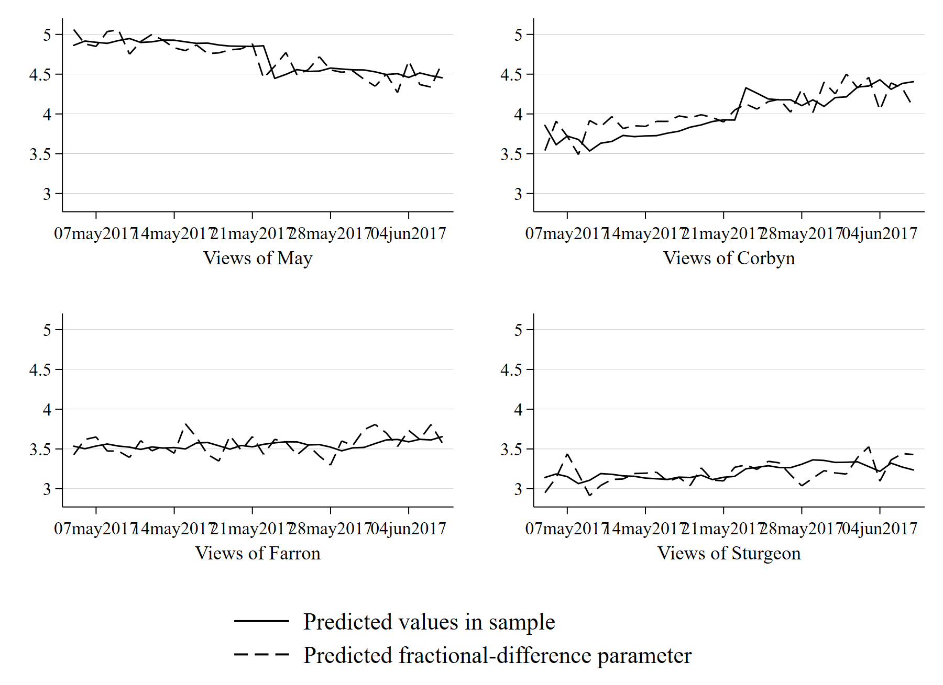

Appendix F: Experimental results

This study received approval from the Institutional Review Boards at Claremont Graduate University and Vanderbilt University and the protocols were consistent with APSA’s Principle and Guidelines for Human Subjects Research (https://connect.apsanet.org/hsr/principles-and-guidance/).

Table F1. : OLS on Feeling Thermometers by Pooled Condition, IPSOS Study, 2012
 | May | Cameron | Warsi | Clegg | Harman
Terror threat conditions | 6.728* | 5.839* | 5.197* | 5.113* | 5.966*
 | (2.225) | (2.427) | (2.451) | (2.288) | (2.233)
Constant | 36.000* | 36.931* | 35.711* | 35.817* | 38.526*
 | (1.799) | (1.978) | (1.974) | (1.868) | (1.806)
Observations | 462 | 563 | 384 | 558 | 451
R² | 0.01949 | 0.01021 | 0.01163 | 0.00890 | 0.01565
Beta coefficients listed with standard errors in parentheses. **p<.05. Treatments available from the authors.

Appendix G: Geographic effects

Table G1: Distance to Manchester & Change in Conservative Party Vote
 | Conservative vote change, 2015-2017 | Conservative vote change, 2010-2015
Distance to Manchester | 0.00405* | -0.00028
 | (0.00170) | (0.00191)
population | -0.00001 | 0.00000
 | (0.00002) | (0.00002)
Share of population over 65 | -0.18522** | 0.13591*
 | (0.06053) | (0.06823)
Ethnicity - White | -0.03880 | -0.05646^
 | (0.02949) | (0.03324)
Country of birth - UK | -0.06263 | 0.01853
 | (0.03999) | (0.04507)
Religion - Christian | 0.03155 | 0.03971
 | (0.02636) | (0.02971)
Unemployed | -0.81318*** | 1.22733***
 | (0.14804) | (0.16686)
Vote for Brexit | -30.67845*** | 1.55994
 | (1.89188) | (2.13227)
Constant | 24.91640*** | -8.76532*
 | (3.18002) | (3.58409)
Observations | 532 | 532
R² | 0.695 | 0.222
Standard errors in parentheses. * p<.05, ** p<.01, *** p<.001

Appendix H: Global Analysis

As the rally literature largely evaluates the effects of terrorist attacks on immediate or near-immediate attitudes towards the chief executive or using single case studies, we first engage in an inductive approach for identifying the threshold of deaths that might produce a rally. We do so by estimating a series of models that regress presidential approval on international terrorist attacks, varying the threshold of the number of deaths in the event. Because rally events are conceptualized as large, shocking events, we are interested in the effect of an attack overall, not the number of attacks nor the effect of the number of deaths in the attacks. Figure H1 presents the coefficients of the effect of the terrorist attack on presidential approval (measured in the next quarter) from these models. As Figure H1 shows, the presence of any international terrorist attack is not associated with an increase in presidential approval, nor are attacks with lower casualty counts. Indeed, it is not until the casualty count exceeds 15 deaths that we see a reliable positive relationship with executive approval. After that point, however, a terrorist event with a high casualty count is associated with an increase in executive approval in the next quarter. We thus use this threshold in our global analysis. Our framework applies to lead executives. In most countries, there is one head of government (e.g., in presidential systems and in constitutional monarchies like the UK where the prime minister is the head of government). In some countries, such as semi-presidential systems like France, both the prime minister and the president hold roles that can be considered chief executive positions; in our analyses we include approval of both these individuals when both can be considered governing executives.

Figure H1: Effect of terrorist events on executive approval

Note: Coefficients from linear regression with panel-corrected standard errors using time-series cross-sectional data. Dependent variable is lagged approval rating from the Executive Approval Database. Terrorism event data from the Global Terrorism Database. Controls for the presence of a female head of state, GDP, Inflation (logged), Executive ideology, and election in that quarter, with country fixed effects. Error bars are panel-corrected standard errors.

Table H1: Gender-Revised Rally Effects
 | Lagged approval
Int'l terrorist attack 16+ death | 3.112**
 | (0.875)
Woman head of state | -0.546
 | (0.875)
Int'l terrorist attack 16+ death * Woman head of state | -4.333**
 | (1.859)
Growth in real GDP | 1.43e⁻⁰⁶
 | (1.53e⁻⁰⁶)
Growth in real GDP _{t-1} | -1.29e⁻⁰⁶
 | (1.53e⁻⁰⁶)
ln(Inflation) | -0.172
 | (0.226)
ln(Inflation_{t-1}) | -0.037
 | (0.224)
Presidential Election | 3.107**
 | (0.287)
Presidential Election _{t+1} | 2.787**
 | (0.356)
Presidential Election _{t+2} | 2.046**
 | (0.375)
Presidential Election _{t+3} | 1.576**
 | (0.357)
Presidential Election _{t+4} | 0.796**
 | (0.286)
Right Ideology | 0.885
 | (0.986)
Center Ideology | 0.942
 | (1.231)
Left Ideology | 1.174
 | (1.058)
Constant | 46.030**
 | (3.091)
Observations | 4328
R² | 0.57705
Panel-corrected standard errors in parentheses. Country fixed effects. * p<.10, ** p<.05

Table H2: Changing Thresholds and the Gender-revised Rally Effects
 | 8+ deaths | 10+ deaths | 12+ deaths | 14+ deaths | 16+ deaths | 18+ deaths
Terrorist event | 1.332* | 1.703** | 2.077** | 3.060** | 3.112** | 3.870**
 | (0.682) | (0.746) | (0.791) | (0.844) | (0.875) | (0.950)
Woman head of state | -0.558 | -0.586 | -0.566 | -0.533 | -0.546 | -0.650
 | (0.876) | (0.875) | (0.875) | (0.875) | (0.875) | (0.874)
Terrorist event * woman head of state | -2.289* | -2.736* | -3.504** | -4.770** | -4.333** | -3.218*
 | (1.261) | (1.534) | (1.709) | (1.844) | (1.859) | (1.901)
Constant | 46.060** | 46.050** | 46.046** | 46.026** | 46.030** | 46.148**
 | (3.092) | (3.092) | (3.091) | (3.091) | (3.091) | (3.087)
Observations | 4328 | 4328 | 4328 | 4328 | 4328 | 4328
R² | 0.573 | 0.574 | 0.575 | 0.577 | 0.577 | 0.577
Linear regression using time-series cross-sectional data of country-quarters. Controls for the presence of a female head of state, GDP, Inflation (logged), the left-center-right placement of the leader, and election in that year, with country fixed effects. Panel-corrected standard errors in parentheses. Dataset includes all countries in the executive approval database that also appear in the Global Terrorism Database (N countries = 66). Dependent variable is executive approval. Standard errors in parentheses. * p<.10, ** p<.05

Table H3: Interactive effects with Executive Ideological Placement
 | Lagged approval
Int'l terrorist attack 16+ death | -0.583
 | (0.973)
Woman head of state | -0.559
 | (0.871)
Int'l terrorist attack 16+ death * Woman head of state | -5.379**
 | (1.978)
Right | 0.703
 | (0.985)
Center | 0.612
 | (1.235)
Left | 1.038
 | (1.056)
Right Ideology * Int'l terrorist attack 15+ death | 5.413**
 | (1.927)
Center Ideology * Int'l terrorist attack 15+ death | 5.535**
 | (2.542)
Left Ideology * Int'l terrorist attack 15+ death | 2.180
 | (1.971)
Constant | 46.346**
 | (3.076)
Observations | 4328
R² | 0.503
Linear regression using time-series cross-sectional data of country-quarters. Controls for the presence of a woman executive, GDP, Inflation (logged), and election in that year, with country fixed effects. Panel-corrected standard errors in parentheses. * p<.10, ** p<.05

We use the Global Terrorism Database classification of any attack that involved an international component.

